A Parallel Database System uses multiple processors or nodes working together to execute database operations simultaneously in order to improve performance, reliability, and availability.
It is designed to execute query operations in parallel by dividing data and workload among several processing units. Multiple resources like CPUs and Disks are used in parallel. The operations are performed simultaneously, as opposed to serial processing. A parallel server can allow access to a single database by users on multiple machines. It performs many parallelization operations like data loading, query processing, building indexes, and evaluating queries.

Advantages/ Goals :
- Performance Improvement - By connecting multiple resources like CPU and disks in parallel we can significantly increase the performance of the system.
- High availability - In the parallel database, nodes have less contact with each other, so the failure of one node doesn't cause for failure of the entire system. This amounts to significantly higher database availability.
- Proper resource utilization - Due to parallel execution, the CPU will never be idle. Thus, proper utilization of resources is there.
- Increase Reliability - When one site fails, the execution can continue with another available site which is having a copy of data. Making the system more reliable.

Performance Measurement of Databases :
- Speedup - The ability to execute the tasks in less time by increasing the number of resources is called Speedup.
Speedup=time original/time parallel
Where ,
time original = time required to execute the task using 1 processor
time parallel = time required to execute the task using 'n' processors
Diagram: Example:
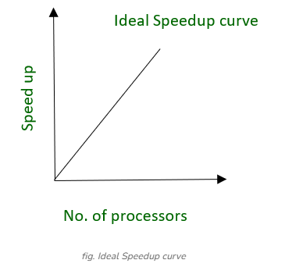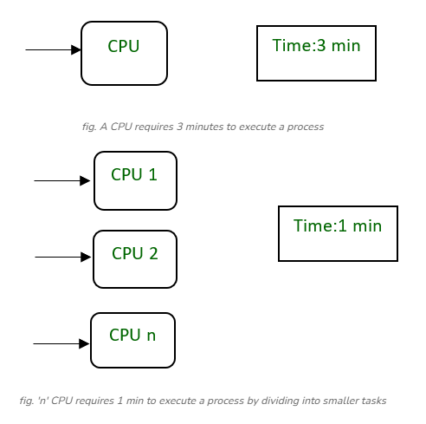

- Scale-up - The ability to maintain the performance of the system when both workload and resources increase proportionally.
Scaleup = Volume Parallel/Volume Original
Where ,
Volume Parallel = volume executed in a given amount of time using 'n' processor
Volume Original = volume executed in a given amount of time using 1 processor

Diagram: Example:
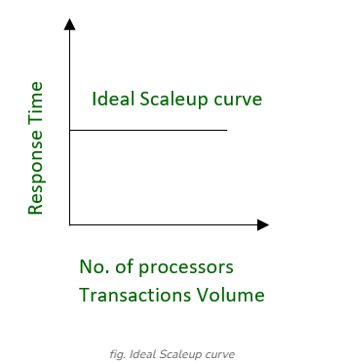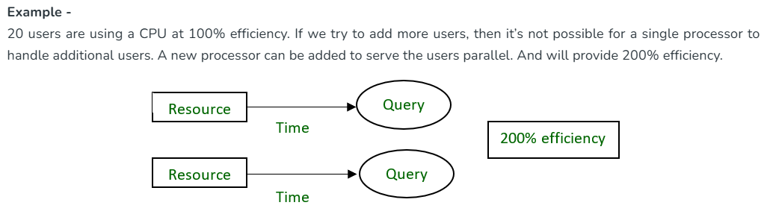
Types of Parallel Database Architecture
- Shared Memory Architecture-
- In Shared Memory Architecture, there are multiple CPUs that are attached to an interconnection network. They are able to share a single or global main memory and common disk arrays.
- In this architecture, a single copy of a multi-threaded operating system and multithreaded DBMS can support these multiple CPUs.
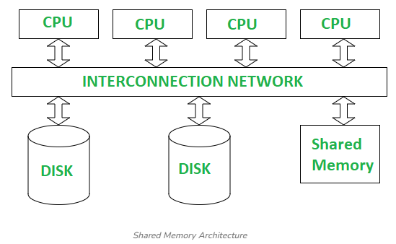
- Also, the shared memory is a solid coupled architecture in which multiple CPUs share their memory. It is also known as Symmetric multiprocessing (SMP).
Advantages:
- It has high-speed data access for a limited number of processors.
- The communication is efficient.
Disadvantages:
- It cannot use beyond 80 or 100 CPUs in parallel.
- Waiting time of processors is increased due to more number of processors.
- The bus or the interconnection network gets block due to the increment of the large number of CPUs i.e. Bandwidth problem.

- Shared Disk Architectures :
- Here, various CPUs are attached to an interconnection network. In this, each CPU has its own memory and all of them have access to the same disk. Also, note that here the memory is not shared among CPUs therefore each node has its own copy of the operating system and DBMS.
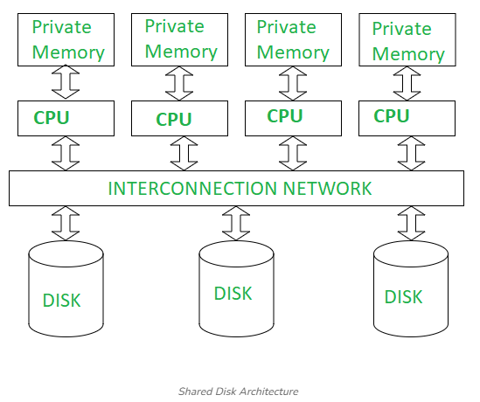
- Shared disk architecture is a loosely coupled architecture optimized for applications that are inherently centralized. They are also known as clusters.
Advantages:
- The interconnection network is no longer a bottleneck each CPU has its own memory.
- There is better fault tolerance i.e. if a processor or its memory fails, the other processor can complete the task.
Disadvantages:
- It has limited scalability as large amount of data travels through the interconnection channel.
- If more processors are added the existing processors are slowed down due to the problems of interference.

- Shared Nothing Architecture :
- It is multiple processor architecture in which each processor has its own memory and disk storage.
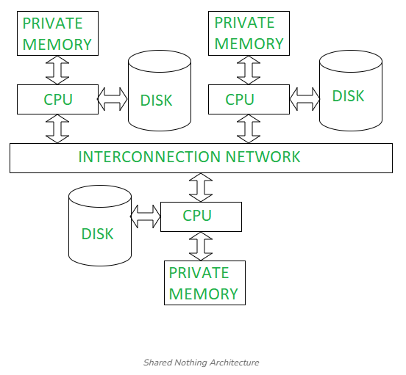
- In this, multiple CPUs are attached to an interconnection network through a node. Also, note that no two CPUs can access the same disk area.
- In this architecture, no sharing of memory or disk resources is done. It is also known as Massively parallel processing (MPP).
Advantages:
- It has better scalability as no sharing of resources is done
- Can support for many processor, which makes the system more scalable.
Disadvantages:
- The cost of communications is higher as it involves sending of data and software interaction at both ends
- Data partitioning is required

Techniques of query Evaluation

Query Parallelism refers to executing database queries using multiple processors simultaneously to improve system performance, reduce response time, and increase throughput.
Parallelism allows the workload to be divided among several processors or nodes, which work together either on different queries or on different parts of the same query.

Inter-query Parallelism
Definition: In Inter-query parallelism, different queries or transactions are executed in parallel on multiple processors.
Goal: To increase transaction throughput, i.e., the number of transactions executed per second.
How It Works:
- Each processor executes a different query independently.
- No inter-processor communication is needed.
- Locking and logging are easier to handle, especially in Shared Memory architecture.
Example:
- If six queries each take 3 seconds to execute sequentially, total time = 18 seconds.
- With 6 processors, all can run in parallel → total time = 3 seconds.
Supported Architectures: Works best in Shared Memory Systems because lock tables and logs are shared in memory.
Example systems: Oracle 8, Oracle Rdb
Advantages:
- Increases transaction throughput.
- Scales up the system for a larger number of users.
- Ideal for OLTP (Online Transaction Processing).
Disadvantages:
- Difficult to achieve perfect parallelism when query load is uneven.
- Less useful for long analytical queries.

Intra-query Parallelism
Definition: In Intra-query parallelism, a single query is divided into subqueries or tasks that execute simultaneously on multiple processors.
Goal: To speed up execution time of one complex or long-running query.
How It Works:
- A single query is broken down into smaller units such as sub-relations or sub-operations.
- Each processor executes its assigned part, and the results are combined.
Supported Architectures: Supported by Shared Memory, Shared Disk, and Shared Nothing architectures.
Best Suited For: Complex analytical or scientific queries (OLAP).
Example:
- SELECT * FROM Email ORDER BY Start_Date;
- If 10,000 records are divided among 10 processors (1,000 each), sorting is done in parallel and merged later.
Advantages
- Reduces response time for large, complex queries.
- Utilizes system resources efficiently.
Disadvantages
- Requires coordination to merge sub-results.
- More communication overhead.

Types of Intra-query Parallelism
Inter-operation Parallelism
- Different operations within a single query are executed in parallel on separate processors.
- Each operation can be assigned to a different processor.
Example:
- A query involving multiple joins such as
- r1 ⋈ r2 ⋈ r3 ⋈ r4
- One processor can perform (r1 ⋈ r2)
- Another can perform (r3 ⋈ r4)
- Both partial results can be combined later.
Advantages:
- Utilizes processors efficiently when query has multiple independent operations.
- Reduces overall query time.
Intra-operation Parallelism
- A single operation (like sort, join, selection, or aggregation) is executed in parallel by multiple processors.
- Each processor performs the same operation on a subset of data.
Example:
SELECT AVG(Salary) FROM Employee GROUP BY Dept_ID;
Each processor computes averages for a subset of departments, and results are merged.
Advantages:
- Greatly improves performance of heavy operations (Sort, Join).
- Provides scalability for large datasets.
Common Operations Parallelized:
- Sort (Range Partitioning, External Sort-Merge)
- Join (Partitioned Join, Hash Join, Fragment & Replicate Join)
- Selection, Projection, Aggregation, Duplicate Elimination

Types of Inter-operation Parallelism
Pipelined Parallelism
Definition: In Pipelined Parallelism, the output of one operation is directly fed as input to the next operation without storing intermediate results.
How It Works:
- As soon as one processor produces partial output, another processor begins processing that output immediately.
- This creates a pipeline of operations where data “flows” from one stage to the next.
Example
- For a query:
- r1 ⋈ r2 ⋈ r3 ⋈ r4
- One processor performs (r1 ⋈ r2)
- Another processor begins (result ⋈ r3)
- Another can continue (result ⋈ r4)
- Each operation consumes the previous one’s output as it is produced.
Advantages
- Eliminates the need to store intermediate results on disk.
- Reduces I/O cost.
- Improves performance for queries with few processors.
Disadvantages
- Not suitable for very high degrees of parallelism.
- Not all operations can be pipelined (e.g., blocking operations like sorting).
- Effective only for limited processor counts.
Independent Parallelism
Definition: Independent Parallelism occurs when operations that do not depend on each other are executed in parallel on different processors.
How It Works:
- Each processor executes an independent operation at the same time.
- Final results are combined at the end.
Example
- For:
- r1 ⋈ r2 ⋈ r3 ⋈ r4
- Processor 1 performs (r1 ⋈ r2)
- Processor 2 performs (r3 ⋈ r4)
- The outputs of both are then joined by a third processor to get the final result.
Advantages
- Increases system throughput when many independent operations exist.
- Effective when operations are logically separate.
Disadvantages
- Does not scale well with very high degrees of parallelism.
- Limited by the number of independent operations in a query.

Operations of Intra-operation Parallelism
Parallel Sort
Definition: Parallel Sorting is the process of sorting a large relation by dividing it into smaller parts and executing the sorting operation simultaneously on multiple processors.
- Each processor sorts a portion of data locally and then the results are merged to form the final globally sorted output.
- Parallel sort is a classic example of Intra-operation parallelism, where a single operation (sorting) is performed in parallel.
Goal: To reduce sorting time and efficiently handle large datasets that cannot be processed on a single processor or disk.
1. Range Partitioning Sort
Concept
- In this technique, data is divided among processors according to ranges of the sorting attribute.
- Each processor sorts the records in its assigned range locally and then all sorted results are merged.
Steps:
- Partition the Relation
    - Suppose there are n processors P₀, P₁, …, Pₙ₋₁ with disks D₀, D₁, …, Dₙ₋₁.
    - The relation R is first divided into n partitions (R₀, R₁, …, Rₙ₋₁) using Round-robin or Hash partitioning.
- Identify Range Vector (v)
- Select range boundaries on the sorting attribute.
    - Example: v = [14 000, 24 000] creates 3 ranges:
    - Range 0 → Salary ≤ 14 000
    - Range 1 → 14 001 ≤ Salary ≤ 24 000
    - Range 2 → Salary ≥ 24 001
- Redistribution of Records
- Each processor sends tuples that fall in range i to processor Pᵢ.
- This ensures all tuples belonging to a specific range are stored together.
- Local Sort
- Each processor sorts its local partition on the sorting attribute (e.g., Salary).
- Merge Results
- The sorted partitions are collected and concatenated in range order to produce the final sorted output.
Example
Relation: Employee(Emp_ID, EName, Salary)
Query: SELECT * FROM Employee ORDER BY Salary;
Assume: 3 processors (P₀, P₁, P₂) with 3 disks (D₀, D₁, D₂).
Range vector v = [14 000, 24 000] divides records into three salary ranges.
Processor | Range of Salary | Operation
P₀ | ≤ 14 000 | Sort records locally
P₁ | 14 001–24 000 | Sort records locally
P₂ | ≥ 24 001 | Sort records locally

After sorting locally, data from all processors is merged in order of salary ranges.
This gives the final globally sorted Employee table.
Advantages
- Exploits data parallelism (each processor sorts part of data).
- Final merge is easy since data is already range-partitioned.
- Reduces total sorting time drastically.
Disadvantages
- Requires good selection of range boundaries to avoid workload imbalance.
- Uneven data distribution can cause some processors to finish later.
2️ Parallel External Sort-Merge
Concept
- Used when data is too large to fit into memory.
- Each processor performs local sort and merge operations using its disk, followed by global merging.
Steps
- Each partition Rᵢ is sorted locally on the sorting attribute.
- A range vector v is defined for redistribution.
- Each processor sends its sorted sub-ranges to destination processors based on v.
- Receiving processors merge all incoming sorted ranges.
- Final concatenation of merged results gives the complete sorted relation.
Example
- Employee(Emp_ID, EName, Salary) partitioned across 3 disks (D₀, D₁, D₂).
- Each partition is locally sorted by Salary.
- Records are redistributed according to salary ranges (same vector v).
- Each processor merges received sorted records.
- Finally, the outputs are concatenated → complete sorted Employee table.
Advantages
- Suitable for large datasets that do not fit in memory.
- Minimizes disk I/O through local sorting and parallel merging.
- Achieves high throughput by overlapping computation and data transfer.

Parallel Join Techniques
Definition: A Parallel Join is a method of performing join operations by distributing data and workload across multiple processors so that different portions of the join can be executed simultaneously.
- This approach greatly reduces query execution time, especially for large relations.
- Parallel joins are a form of Intra-operation Parallelism since a single join operation is executed in parallel.
Goal: To speed up join processing by performing join operations in parallel across multiple processors or nodes.
Types of Parallel Join Techniques
- Partitioned Join
- Fragment and Replicate Join
- Partitioned Parallel Hash Join
1️ Partitioned Join
Concept
- In this technique, both input relations are partitioned on their join attributes using the same partitioning function.
- Each pair of corresponding partitions is then joined locally on a separate processor.
Steps
- Partitioning
- Suppose two relations r and s are to be joined on attributes r.A and s.B.
- Use the same partitioning function (e.g., hash or range) on both r.A and s.B.
- The relations are divided into:
- r0, r1, …, rn-1 and s0, s1, …, sn-1.
- Distribution
- Each partition pair (ri, si) is sent to processor Pi.
- Local Join
- Each processor performs the join locally on its partition pair.
- Result Collection
- Combine all local join results to form the final output.
Example
- Let’s consider:
- Relation STUDENT(RegNo, Name)
- Relation COURSE_REGD(RegNo, CourseID)
- Join condition: STUDENT.RegNo = COURSE_REGD.RegNo
- Use Hash Partitioning with h(RegNo) = RegNo mod 2.
- Records with even RegNo → Disk₀ / P₀
- Records with odd RegNo → Disk₁ / P₁
- Each processor performs the join locally:
- P₀ joins STUDENT₀ with COURSE_REGD₀
- P₁ joins STUDENT₁ with COURSE_REGD₁
- Finally, merge results from both processors.
Advantages
- Reduces comparisons drastically (e.g., 8 vs 16 in normal join).
- High degree of parallelism.
- Simple to implement when both tables are partitioned on join attributes.
Disadvantages
- Works only for Equi-Join and Natural Join.
- Requires identical partitioning function on both relations.
- Data redistribution overhead.
2️ Fragment and Replicate Join
Concept
- In this method, one relation is fragmented (partitioned) and the other is replicated across all processors.
- Each processor performs the join locally using its fragment and the replicated relation.
There are two versions of this technique:
(a) Asymmetric Fragment and Replicate Join
Steps
- Fragment one relation (r):
- Divide relation r into r₀, r₁, …, rₙ₋₁.
- Any partitioning technique (round-robin, hash, range) can be used.
- Replicate the other relation (s):
- Make n copies of s and send one copy to each processor.
- Local Join:
- Each processor Pi performs the join between its local fragment ri and the full relation s.
When to Use
When one relation is small, so replication cost is low.
Suitable for Non-equi joins as well.
Advantages
- Easy to implement when one table is small.
- Works with any partitioning method and any join condition.
Disadvantages
- Replication increases communication cost.
- Not suitable if both tables are large.
(b) General Fragment and Replicate Join
Concept
- Used when both relations are large and cannot be fully replicated.
Steps
- Fragment both relations:
- r into r₀ … rₘ₋₁
- s into s₀ … sₙ₋₁
- Replication:
- Each partition of r is replicated across all processors handling partitions of s.
- Similarly, each partition of s is replicated across processors handling partitions of r.
- Total processors required = m × n.
- Local Join:
- Each processor Pᵢⱼ performs join between rᵢ and sⱼ locally.
Advantages
- Works for both Equi and Non-equi joins.
- Reduces table size per processor.
- Supports any partitioning or join condition.
Disadvantages
- High communication and replication cost.
- Complex data distribution process.
Comparison: Asymmetric vs General
Feature | Asymmetric | General
Relations Fragmented | One | Both
Best for | One small table | Both large tables
Replication | Low | High
Works for | Equi & Non-equi joins | Equi & Non-equi joins
Processors Required | n | m × n

3️ Partitioned Parallel Hash Join
Concept
- This is a hash-based parallel join algorithm that uses two hash functions to distribute and locally join tuples.
Steps
- Hash Function h₁ (Distribution Phase):
- Select a hash function h₁ that maps tuples to processors based on the join attribute.
- Apply h₁ to both relations r and s.
- Build Phase (Smaller Table):
- The smaller relation (s) is chosen as the build relation.
- Each processor reads its local tuples of s and sends them to processors according to h₁.
- Local Partitioning (Hash Function h₂):
- On each destination processor, a second hash function h₂ further partitions the data for local joining.
- Probe Phase (Larger Table):
- The larger relation (r) is processed in the same way using h₁ and h₂.
- Each processor matches tuples of r with s using hash tables built locally.
- Local Join:
- Each processor executes the hash join locally on its own partitions.
Example
- Relations r and s are partitioned across 4 processors (P₀ to P₃).
- Join condition: r.A = s.B.
- Hash function h₁(x) = x mod 4.
- Each processor receives tuples where (join attribute mod 4) equals its ID, builds local hash tables, and joins matching pairs locally.
- Final results from all processors are merged.
Advantages
- Works efficiently for Equi-joins and Natural joins.
- Fully parallelized — all processors perform joins independently.
- Good load balancing if hash function is well chosen.
Disadvantages
- Communication overhead during data redistribution.
- Performance depends on hash function uniformity.
A distributed database is a database that is not confined to a single system but is spread across multiple sites, such as various computers or a computer network. It consists of loosely coupled sites that do not share any physical components, and the database systems at each site can operate independently. The primary goal of a distributed database is to improve efficiency and reduce costs and difficulties in accessing data. Transactions in this system can access data from one or more of these sites.
Types of Distributed databases:
HOMOGENEOUS
In a homogeneous distributed database, all sites use identical software and data structures, creating a uniform environment across all locations.
Key characteristics include:
- Identical Software: All sites utilize the same operating system and DBMS software.
- Common Database Structure: The structure of the database is the same across all sites.
- High Cooperation: The sites are aware of each other and agree to cooperate in processing user requests.
- Simplified Management: Because of their uniformity, they are simple to handle and can appear as a single central database system.

HETEROGENEOUS
In a heterogeneous distributed database, different sites use varied schemas and software. Unlike homogeneous systems, the components are not uniform across locations.
Key characteristics include:
- Varied Software: Different sites can use various operating systems, database applications, and even different data models.
- Schema Differences: The structure of the database may be different at each site, which can cause major problems for query processing.
- Limited Cooperation: The sites may not be aware of each other and offer limited cooperation for processing transactions.
- Need for Translation: Due to the differences in software and schemas, translations are required for the sites to communicate with each other.

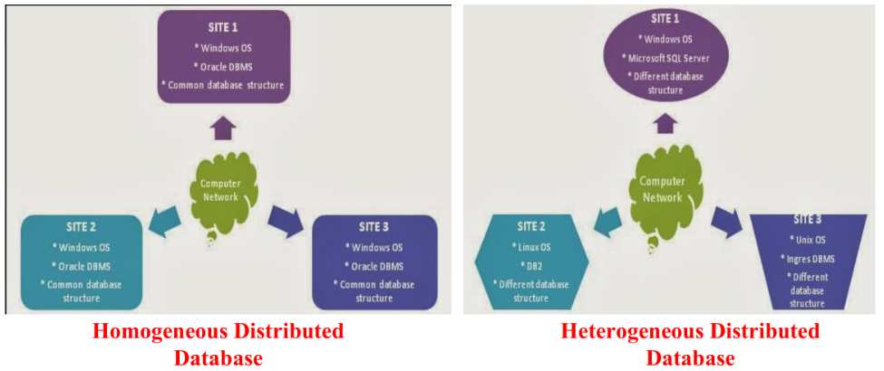

Distributed Database Management System (DBMS) architecture
A Distributed Database Management System (DBMS) architecture has two main components: the User Processor and the Data Processor. These components manage different aspects of handling user requests within a peer-to-peer distributed system.
User Processor
The User Processor handles the interaction with the user and the global coordination of query execution. Its sub-components include:
- User Interface Handler: Interprets user commands and formats the results to be displayed.
- Semantic Data Controller: Checks user requests against the Global Conceptual Schema to verify integrity constraints and user authorization for accessing the data.
- Global Query Optimizer: Creates the best possible execution plan to process a user request with minimal cost in terms of time, processing power, and memory. It must devise a strategy that is optimal on a global scale.
- Distributed Execution Monitor: Acts as the transaction manager for the system, communicating with transaction managers at other sites involved in the query to monitor the execution process.
Data Processor
The Data Processor is responsible for managing the local database and executing its part of a query. Its sub-components are:
- Local Query Optimizer: Optimizes data access at the local level by choosing the best access path, such as deciding which index to use to execute a query efficiently.
- Local Recovery Manager: Ensures the consistency of the local database. If a failure occurs, it is responsible for restoring the database to a consistent state.
- Run-time Support Processor: Serves as the interface to the operating system and physically accesses the database as directed by the local query optimizer's strategy. It also contains the database buffer manager, which handles main memory buffers and data access

Data fragmentation
- Data fragmentation in a distributed database involves breaking down a table into smaller pieces, or fragments. These fragments are then stored across different sites in the network. The goal is to ensure that the original table can be reconstructed from its fragments, preventing any data loss.
- The two major types of data fragmentation are horizontal and vertical. It is also possible to combine these two methods.
Horizontal Fragmentation
Horizontal fragmentation divides a table into fragments by assigning its rows (tuples) to different fragments. This split is typically based on the data within the rows, allowing tuples to be stored where they are most frequently accessed. This approach has the advantage of enabling parallel processing on the fragments of a relation.
There are two types of horizontal fragmentation:
Primary Horizontal Fragmentation
Derived Horizontal Fragmentation
Example of Horizontal Fragmentation
- Consider an account relation with the columns branch_name, account_number, and balance. This table can be horizontally fragmented based on the branch_name.
- Fragment 1 (account1) would contain all rows where the branch_name is "Hillside".

branch_name | account_number | balance
Hillside | A-305 | 500
Hillside | A-226 | 336
Hillside | A-155 | 62

- Fragment 2 (account2) would contain all rows where the branch_name is "Valleyview".
branch_name | account_number | balance
Valleyview | A-177 | 205
Valleyview | A-402 | 10000
Valleyview | A-408 | 1123
Valleyview | A-639 | 750

Horizontal Fragmentation Advantages
- It permits parallel processing on the different fragments of a relation.
- It allows a table to be divided so that its rows (tuples) are stored in the locations where they are accessed most often.

Vertical Fragmentation
Vertical fragmentation divides a table by splitting its schema, or columns, into smaller schemas. This allows different parts of a tuple to be stored where they are most frequently accessed. To ensure the fragments can be joined back together to reconstruct the original relation, all schemas must share a common candidate key or superkey. A special attribute, like a tuple-id, can be added for this purpose. This method also allows for parallel processing.
Example of Vertical Fragmentation
- Let's use an employee_info relation as an example. We can fragment it vertically, using a tuple_id to link the parts.
- Fragment 1 (deposit1) might contain the columns branch_name, customer_name, and tuple_id.

branch_name | customer_name | tuple_id
Hillside | Lowman | 1
Hillside | Camp | 2
Valleyview | Camp | 3
Valleyview | Kahn | 4
Hillside | Kahn | 5
Valleyview | Kahn | 6
Valleyview | Green | 7

- Fragment 2 (deposit2) could contain account_number, balance, and the linking tuple_id.
account_number | balance | tuple_id
A-305 | 500 | 1
A-226 | 336 | 2
A-177 | 205 | 3
A-402 | 10000 | 4
A-155 | 62 | 5
A-408 | 1123 | 6
A-639 | 750 | 7

Vertical Fragmentation Advantages
- It allows tuples to be split so that each part of the tuple is stored where it is most frequently accessed.
- Using a tuple-id attribute allows for the efficient joining of the vertical fragments back together.
- It enables parallel processing on a relation.
Distributed Transactions
In a distributed database, a transaction may need to access data located at several different sites. The system must have mechanisms to manage these complex operations and ensure consistency.
Transaction System Components
Each site in the distributed system has two key components to manage transactions:
Local Transaction Manager (TM): This component is responsible for operations at its specific site. Its duties include:
- Maintaining a log for recovery purposes.
- Helping to coordinate the concurrent execution of transactions running at that site.
Transaction Coordinator (TC): This component manages transactions that originate at its site. Its responsibilities are:
- Starting the execution of the transaction.
- Breaking down the transaction into subtransactions and distributing them to the appropriate sites for execution.
- Coordinating the termination of the transaction. It ensures the transaction is either committed at all participating sites or aborted at all sites, maintaining atomicity.
Commit Protocols
To guarantee that a transaction is either committed or aborted everywhere, distributed systems use commit protocols. It is not acceptable for a transaction to be committed at one site and aborted at another.
The most common protocols are:
Two-Phase Commit (2PC): This protocol is widely used to ensure atomicity across all sites involved in a transaction.
Three-Phase Commit (3PC): While this protocol is more complex and costly, it avoids some of the drawbacks of 2PC. However, it is not typically used in practice.
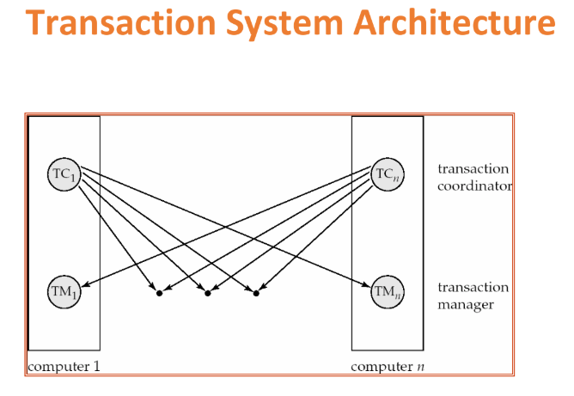

TWO phase commit protocol
- The Two-Phase Commit (2PC) protocol ensures that in a distributed system, a transaction is either committed at all participating sites or aborted at all sites, guaranteeing atomicity. It assumes a fail-stop model, where failed sites simply stop operating without sending incorrect messages.
- The protocol is initiated by the Transaction Coordinator (TC) after the final step of a transaction and involves all local sites where the transaction was executed.
Phase 1: Obtaining a Decision (Voting Phase)
- In this phase, the coordinator asks all participating sites if they are ready to commit the transaction.
- The coordinator first adds a <prepare T> record to its own log and sends a "prepare T" message to all participating sites.
- Upon receiving this message, each participating Transaction Manager (TM) determines if it can commit the transaction.
- If it can commit: The site adds a <ready T> record to its log, forces all transaction-related records to stable storage, and sends a "ready T" message back to the coordinator.
- If it cannot commit: The site adds a <no T> record to its log and sends an "abort T" message to the coordinator.
Phase 2: Recording the Decision (Completion Phase)
- In this phase, the coordinator makes a final, irrevocable decision based on the responses from the participants.
- Commit Decision:
  - If the coordinator receives a "ready T" message from all participating sites, it decides to commit the transaction.
  - It adds a <commit T> record to its log and forces it to stable storage.
  - It then sends a "commit T" message to all participants.
  - The participants receive the message, add a <commit T> record to their logs, and formally commit the transaction locally.
- Abort Decision:
  - If the coordinator receives an "abort T" message from any participant, or if it doesn't receive a "ready T" from all participants (e.g., due to a timeout), it must abort the transaction.
  - The coordinator adds an <abort T> record to its log.
  - It sends an "abort T" message to all participants.
  - The participants then locally abort (or undo) the transaction.

How 2PC Handles a Successful Commit
Here is a step-by-step illustration of a successful commit:
Step 1: The Transaction Coordinator (TC) at Site A writes <prepare T> to its log and sends this message to the Transaction Managers (TMs) at participating sites B and C.
Step 2: The TMs at sites B and C, upon being ready to commit, write <ready T> to their logs and send this message back to the TC at Site A.
Step 3: Since the TC received "ready T" from all participants, it decides to commit. It writes <commit T> to its log and sends this decision to Sites B and C.
Step 4: The TMs at all sites receive the commit message, write the decision to their logs, and commit the transaction locally.

How 2PC Handles an Abort
Here is an example of how the protocol handles an abort if a site is not ready:
Step 1: The TC at Site A sends the <prepare T> message to sites B and C.
Step 2: Site B is ready and responds with <ready T>. However, Site C is not ready, so it writes <no T> to its log and sends an <abort T> message to the TC.
Step 3: Because the TC received an abort message from at least one site, it decides to abort the entire transaction. It writes <abort T> to its log and sends this decision to all other sites.
Step 4: Upon receiving the abort decision, all participating sites write the <abort T> message to their logs and abort the transaction locally.

Failure of 2pc
The 2PC protocol has built-in procedures to handle the failure of a participating site, ensuring the transaction's atomicity is not compromised. The response to a failure is considered from two perspectives: the actions of the Transaction Coordinator (TC) at the time of failure, and the actions of the failed site when it recovers.

1. The Response of the Transaction Coordinator (TC)
- When a participating site fails, the coordinator's action depends on when the failure occurred:
- If the site fails before sending a <ready T> message: The coordinator will not receive a "ready" vote from the failed site. Because the 2PC protocol requires a unanimous "ready" vote to commit, the coordinator will eventually time out, decide to abort the transaction, and send an abort T message to all other active participants.
- If the site fails after sending a <ready T> message: The coordinator has received the site's promise to commit. The coordinator can proceed to make a final decision based on the votes from all other participants. If all others also voted "ready," the coordinator will decide to commit the transaction and will inform the other active sites. The failed site is expected to determine the outcome upon its recovery.
2. The Response of the Failed Site Upon Recovery
- When the failed site Si comes back online, it must determine the fate of any transactions that were active during the failure. It does this by examining its local log file. There are four possible scenarios:
- The log contains a <commit T> record: This means the coordinator had already sent the final commit decision before the site failed. The recovering site simply needs to re-apply the transaction's changes by executing redo(T) to ensure its local database is up-to-date.
- The log contains an <abort T> record: This indicates that the coordinator decided to abort the transaction. The site must roll back any partial changes made by the transaction by executing undo(T).
- The log contains a <ready T> record, but no <commit T> or <abort T>: This is the "in-doubt" state. The site voted to commit but crashed before receiving the final decision. To resolve this, the site must contact the coordinator (or another participant) to find out the transaction's final outcome.
- If the transaction was committed, the site performs redo(T).
- If it was aborted, the site performs undo(T).
- The log contains no control records for transaction T (no ready, commit, or abort): This means the site failed before it could even respond to the coordinator's prepare T message. In this case, the coordinator could not have received a "ready" vote from this site and therefore must have aborted the transaction. The recovering site knows it must execute undo(T).

Big Data
Big data refers to extremely large and complex sets of data that can't be managed or analyzed using traditional data processing tools. It is like a flood of information coming from many different places very quickly. The goal is to collect this data and find valuable insights within it to make better decisions.
The main features of big data are commonly referred to as the "Vs of Big Data." While initially there were three, the concept has expanded over time. Here are the most widely recognized characteristics:
V's of Big Data:
Volume: This refers to the enormous amount of data that is generated and collected. We're talking about terabytes, petabytes, and even exabytes of information that need to be stored and processed.
Velocity: This is about the speed at which new data is created and needs to be processed. In many cases, this happens in real-time or near real-time, such as with social media feeds or sensor data.
Variety: Big data comes in many different forms. It can be structured, like data in a traditional database, unstructured, such as text documents, images, and videos, or semi-structured, like XML or JSON files.
Veracity: This characteristic deals with the quality and reliability of the data. With such large volumes of information from various sources, there can be inconsistencies, inaccuracies, and biases. Ensuring data veracity is crucial for making sound decisions.
Value: Ultimately, the goal of collecting and analyzing big data is to extract meaningful value. This could be in the form of business insights, improved decision-making, or a better understanding of customer behavior.
Some experts also include other "Vs" such as Variability (the changing nature of the data) and Visualization (the importance of presenting the data in an understandable format).

ACID/rdbms properties
ACID is an acronym that stands for Atomicity, Consistency, Isolation, and Durability. These are a set of properties that guarantee that database transactions are processed reliably. In a Relational Database Management System (RDBMS), a transaction is a single logical unit of work that may consist of one or more operations. ACID properties ensure data integrity and reliability, especially in systems where multiple users are accessing data concurrently.
A - Atomicity ("All or Nothing" Rule)
What it is: This property ensures that a transaction is treated as a single, indivisible unit. Either all of the operations within the transaction are completed successfully, or none of them are. There is no partial completion.
How it works: The database system uses a transaction log. When a transaction begins, it marks a starting point. As it performs operations (e.g., INSERT, UPDATE, DELETE), it records these changes. If all operations are successful, the transaction is committed, and the changes are made permanent. If any single operation fails or if the system crashes, the entire transaction is rolled back, meaning all the changes recorded since the starting point are undone.
Analogy:
- A bank transfer. When you transfer $50 from Account A to Account B, two operations must happen:
- Debit $50 from Account A.
- Credit $50 to Account B.
- Atomicity ensures that if the credit to Account B fails for any reason, the debit from Account A is reversed. You will never have a situation where the money is gone from one account but hasn't appeared in the other.
C - Consistency ("Valid State" Rule)
What it is: This property guarantees that a transaction can only bring the database from one valid state to another. It ensures that any data written to the database must be valid according to all defined rules, including constraints, triggers, and cascades.
How it works: The RDBMS enforces data integrity rules. Before a transaction is committed, the system checks if the new state of the data will violate any of these rules. For example, it checks for unique keys, foreign key relationships, and data type constraints. If a transaction would result in an invalid state (e.g., creating a duplicate primary key), the transaction is rolled back.
Analogy: A rule in a product database states that the stock_quantity of an item cannot be a negative number. If you have 5 items in stock and a transaction tries to sell 10, the database will not allow this operation because it would violate the consistency rule and put the database in an invalid state (quantity = -5).
I - Isolation ("No Interference" Rule)
What it is: This property ensures that concurrently executing transactions do not interfere with each other. From any single transaction's perspective, it appears as if it is the only transaction running on the system.
How it works: This is achieved through concurrency control mechanisms, most commonly locking. When a transaction needs to read or write a piece of data (like a row in a table), it acquires a lock on that data. Other transactions are blocked from modifying (and sometimes even reading) that data until the first transaction is complete and releases the lock. This prevents issues like "dirty reads" (reading uncommitted data) or "lost updates" (two transactions overwriting each other's changes).
Analogy: Two ticket agents trying to book the last seat on a flight at the same time. Isolation ensures that one agent's transaction locks the seat record first. The second agent's transaction is forced to wait. It cannot see the seat as "available" while the first agent is in the middle of the booking process. This prevents the seat from being sold twice.
D - Durability ("Permanent" Rule)
What it is: This property guarantees that once a transaction has been successfully committed, its changes are permanent and will survive any subsequent system failure, such as a power outage or crash.
How it works: When a transaction is committed, its changes are written to a durable, non-volatile storage (like a hard drive). To ensure this, databases use a write-ahead log (WAL). Before the changes are made to the actual database files, a record of the transaction is written to a log file. If the system crashes, it can use this log upon restart to "replay" and complete any committed transactions that weren't fully saved, ensuring no data is lost.
Analogy: When you deposit cash at an ATM and get a printed receipt, that transaction is durable. Even if the ATM network goes down a minute later, the record of your deposit is saved and will be reflected in your account balance once the system is back online.

ACID Properties in RDBMS(short)
ACID is a set of properties that guarantee database transactions are processed reliably.
Atomicity (All or Nothing): Ensures that a transaction is an indivisible unit. Either all its operations are completed successfully (commit), or none are (rollback). There is no partial completion.
Consistency (Valid State): Guarantees that a transaction brings the database from one valid state to another. It enforces all rules and constraints (like unique keys), preventing any transaction that would corrupt the data.
Isolation (No Interference): Ensures that concurrent transactions do not interfere with one another. Each transaction appears to be executing alone, which is typically achieved through locking mechanisms to prevent data conflicts.
Durability (Permanent): Guarantees that once a transaction is successfully committed, its changes are made permanent and will survive any system failures, like a power outage. This is achieved by writing changes to a transaction log on non-volatile storage.

BASE/nosql properties
While RDBMS databases prioritize strong consistency with the ACID model, many NoSQL databases prioritize high availability and scalability, which is described by the BASE model.
BASE is an acronym that stands for Basically Available, Soft State, and Eventually Consistent. It is a model that accepts a trade-off: it sacrifices the immediate, strict consistency of ACID in favor of ensuring that the system is always running and can scale easily.
B - Basically Available
What it is: This property guarantees that the database system will always be available and will respond to a request. It doesn't guarantee that the response will contain the most recent write, but it does guarantee that the system will not be completely unavailable.
How it works: In a distributed NoSQL system, if one node (server) fails, the system doesn't shut down. Instead, requests are routed to another available node. This node will provide a response, perhaps with slightly older (stale) data, but the user gets a response nonetheless. It prioritizes uptime over data consistency.
Analogy: Imagine you are looking at a product's stock level on an e-commerce site. Basic Availability means the website will always show you the product page. It might show "5 in stock" even if someone just bought the last one a millisecond ago, but the page itself will load and respond. The system is available, even if the data is not perfectly up-to-the-second.
S - Soft State
What it is: This property indicates that the state of the system can change over time, even without any new input. This is because the data is constantly being updated in the background across different nodes as it moves towards consistency. The data is "soft" or "in flux."
How it works: Since the system doesn't enforce immediate consistency, different nodes might have different versions of the same data for a short period. These nodes are continuously communicating in the background to sync up. Because of this background synchronization, the state of any given data replica can change without a direct user write to that specific replica.
Analogy: Think of a shared online document where multiple people are editing. For a moment, your version of the document might be slightly different from your colleague's. The system is in a "soft state" because, without you doing anything, your view of the document will suddenly update as your colleague's changes are synced to your screen.
E - Eventually Consistent
What it is: This is the core of the BASE model. It guarantees that if no new updates are made to a given data item, eventually, all replicas of that item will become consistent and return the last updated value. "Eventually" means there's a short, undefined period of inconsistency.
How it works: When you write data to a NoSQL database, the change is first made to one primary node or a few nodes. The system then asynchronously replicates this change to all other nodes that hold a copy of that data. During this replication lag, reading from different nodes might give you different results (one node has the new data, another has the old). However, the system guarantees that this is temporary and all nodes will eventually catch up.
Analogy: When a celebrity posts on social media, the "like" count doesn't update instantly and perfectly for everyone around the world. You might see 10,000 likes, refresh, and see 9,950, then refresh again and see 10,200. The system is available and fast, but the like count is only eventually consistent. After a short while, if everyone stops liking the post, all users will see the same final number.
BASE properties(short)
The BASE model is a database design philosophy used by many NoSQL systems that prioritizes availability and scalability over the strict consistency of the ACID model.
Basically Available: The system guarantees that it is always available for queries, even if parts of it fail. It may return slightly stale data, but it will always respond.
Soft State: The state of the data across the system is fluid and can change over time (even without new input) as background processes work to synchronize all data replicas.
Eventually Consistent: The system guarantees that if no new updates are made, all replicas will eventually converge to the same state. It accepts a temporary period of inconsistency to achieve higher availability.

SQL vs NOSQL
Feature | SQL (Relational Databases) | NoSQL (Non-relational Databases)
Data Model | Stores data in tables with rows and columns, like a structured spreadsheet. | Stores data in various models like key-value pairs, documents (JSON), graphs, or wide-column stores.
Schema | Schema-on-write: A rigid, predefined structure (schema) is required before you can add data. | Schema-on-read: The schema is flexible and dynamic. Data can be stored without a predefined structure.
Scalability | Vertical Scalability: Scales by increasing the power (CPU, RAM) of a single server. This can be expensive and has limits. | Horizontal Scalability: Scales by adding more servers to a distributed system. This is generally cheaper and more flexible.
Consistency | ACID Properties: Guarantees Atomicity, Consistency, Isolation, and Durability for transactions, ensuring high data reliability. | BASE Properties: Prioritizes Basic Availability, Soft State, and Eventual Consistency, focusing on high availability even with temporary data inconsistencies.
Language | Uses SQL (Structured Query Language), a powerful and standardized language for complex queries. | Has no single standard query language. APIs or specific query languages (e.g., MongoDB's MQL) are used.
Use Cases | Applications requiring complex queries and transactions, like banking systems, e-commerce platforms, and accounting software. | Big data applications, real-time systems, social media platforms, and content management systems where speed and scalability are critical.

Types of NOSQL databases
There are four main types of NoSQL databases, each designed to handle data in a specific way, offering flexibility and scalability for different kinds of applications.
Key-Value Stores
This is the simplest type of NoSQL database. It stores data as a collection of key-value pairs, much like a dictionary or a hash map. Each item has a unique key, and that key is used to retrieve the associated value. The database doesn't care what's inside the value; it's just a blob of data.
How it works: You provide a key, and the database returns the value. It's incredibly fast for reading and writing data.
Analogy: Think of it like a coat check. You hand over your coat (the value) and get a ticket with a number (the key). To get your coat back, you just need to provide the ticket number.
Best for: Caching, session management, and storing user profiles where you need fast lookups.
Examples: Redis, Amazon DynamoDB.
Pros:
- Extremely Fast: Since you only look up data by a direct key, read and write operations are incredibly quick and efficient.
- Simple and Flexible: The model is very easy to understand. The value can be anything (a string, JSON, an image), so you don't have to worry about defining a structure.
- Highly Scalable: Key-value stores are easy to partition and scale horizontally across many servers.
Cons:
- Limited Querying: You can't query the data based on the value. You must know the exact key to retrieve its associated value. This makes complex searches and filtering impossible.
- Not for Complex Data: It's not suitable for storing data with complex relationships or structures, as all relationships between data points must be managed by the application itself.

Document Databases
Document databases store data in documents, which are typically in a format like JSON or BSON. These documents are self-contained and have a flexible structure. It's like a more advanced key-value store where the "value" is a structured document that the database can actually understand and query.
How it works: You can store complex data, like a whole user profile with all its details, in a single document. You can then query based on the fields inside that document.
Analogy: It's like a digital filing cabinet. Each file folder is a document containing all the information about one subject (e.g., a customer). Each folder can have a different set of papers inside, offering great flexibility.
Best for: Content management systems, e-commerce product catalogs, and applications with diverse data.
Examples: MongoDB, Couchbase.
Pros:
- Flexible Schema: You can store documents with different structures in the same collection, which is great for evolving applications.
- Rich Query Language: You can query based on any field within a document, allowing for powerful filtering and indexing.
- Natural Data Mapping: The document structure (e.g., JSON) often maps directly to objects in modern programming languages, making development easier.
Cons:
- No Joins: Performing joins across different document collections can be inefficient and is often not supported directly. This can lead to data duplication if you need to store related information together.
- Potential for Large Documents: Since related data is often embedded within a single document, these documents can become very large, which might impact performance.

Column-Family (or Wide-Column) Stores
These databases store data in tables with rows and flexible columns. Unlike SQL databases, each row doesn't have to have the same set of columns. Columns are grouped into "column families." This model is optimized for high performance on very large datasets.
How it works: Data is stored by columns instead of rows. This makes it extremely fast to aggregate and query specific columns across millions of rows (e.g., "get the average temperature from all sensors").
Analogy: Imagine a massive spreadsheet where each row can have its own unique set of columns. Row 1 might have columns for "Name" and "Age," while Row 2 has columns for "Name," "City," and "Job."
Best for: Big data analytics, logging systems, and handling time-series data from IoT devices.
Examples: Apache Cassandra, Google Bigtable, HBase.
Pros:
- Massively Scalable: These databases are designed from the ground up to run on large clusters of commodity hardware, handling petabytes of data.
- High Write Performance: They are optimized for very fast write operations, making them ideal for ingesting large streams of data (like logs or sensor data).
- Efficient Queries on Columns: Queries that only need to access a few columns from a table with many columns are extremely fast because the database doesn't have to read the entire row.
Cons:
- Complex to Manage: The architecture can be more complex to set up and maintain compared to other NoSQL types.
- Not for Transactions: They are generally not designed for ACID-style transactions or complex queries that require joins. The focus is on raw scale and performance.

Graph Databases
Graph databases are specifically designed to store and navigate relationships. The data is modeled as nodes (entities, like people or products) and edges (the relationships that connect the nodes).
How it works: The database focuses on the connections between data points. It's optimized to quickly traverse these connections to find patterns and relationships.
Analogy: It's like a social network map. People are the nodes, and the lines connecting them ("is friends with," "works with") are the edges. The database can instantly answer questions like, "Who are the friends of my friends who live in Mumbai?"
Best for: Social networks, fraud detection, recommendation engines, and network infrastructure mapping.
Examples: Neo4j, Amazon Neptune.
Pros:
- Optimized for Relationships: They are built to query relationships between data points. Performance for traversing these connections is incredibly fast, even with deep and complex relationships.
- Intuitive Data Model: Modeling data as nodes and edges can be a very natural way to represent complex, interconnected domains like social networks or supply chains.
- Powerful Relationship Queries: They can easily answer complex questions that would require multiple, slow JOIN operations in a SQL database, such as finding the shortest path between two nodes.
Cons:
- Niche Use Case: They are highly specialized. If your data doesn't have many relationships, using a graph database is overkill and will likely be less efficient than other models.
- Scalability Challenges: While they scale, scaling a graph database across a distributed cluster can be more complex than scaling other NoSQL types, especially for queries that need to traverse across different servers.

CAP theorem
The CAP theorem, also known as Brewer's theorem, is a fundamental principle for distributed database systems. It states that it's impossible for a distributed data store to simultaneously provide more than two of the following three guarantees: Consistency, Availability, and Partition Tolerance.Think of it as a trade-off triangle. In a distributed system, you can only pick two of the three properties.
C - Consistency
What it is: Consistency means that every read operation receives the most recent write or an error. When you ask any server in the system for a piece of data, you will always get the same, most up-to-date version.
Analogy: It's like a bank account balance. If you deposit money, you expect every ATM and the online banking app to show you the exact same, correct balance immediately.
A - Availability
What it is: Availability means that the system is always operational and every request receives a response, without guaranteeing that it contains the most recent write. The system will always work and won't return an error.
Analogy: Think of a popular social media feed. The site always loads and shows you posts. The posts it shows might be a few seconds old, and not the absolute latest, but the service is always available and responsive.
P - Partition Tolerance
What it is: This means the system continues to operate despite network partitions. A "partition" is a communication break between two sets of servers (nodes) in the database cluster. For any modern distributed system, partition tolerance is a must-have, as network failures are inevitable.
Analogy: Imagine a company with offices in Mumbai and New York connected by the internet. If the internet cable is cut (a network partition), the two offices can no longer communicate. Partition tolerance means both the Mumbai and New York systems must continue to function independently.
How it Works: The Trade-Off
Since network partitions are a reality for any distributed system, you must choose Partition Tolerance (P). This means the real-world trade-off is between Consistency (C) and Availability (A) when a partition occurs.
Here’s the dilemma when the network breaks (a partition happens):
Choose Consistency over Availability (CP System): If your system wants to maintain perfect consistency, it must stop serving requests that it can't guarantee are up-to-date. To ensure a read is consistent, all nodes must agree. If they can't communicate because of a partition, the system must return an error or time out to avoid returning stale data. In this scenario, you sacrifice Availability.
Example: A banking system. If the network between two data centers fails, the system might refuse to process a withdrawal to prevent an overdraw based on stale balance information. It chooses to be correct (consistent) rather than being always online (available).
Choose Availability over Consistency (AP System): If your system wants to remain highly available, it must respond to every request, even if it can't be sure the data is the latest version. During a partition, a server will return the best possible version of the data it has access to. After the partition is resolved, the system will work to synchronize and resolve any data conflicts. In this scenario, you sacrifice Consistency.
Example: A social media platform's "like" count. If the network partitions, you can still "like" a post. Your "like" is registered on your local server. A user connected to another server might not see your "like" immediately. The system remains available for you to use, and eventually, all servers will sync up to show the same total like count (eventual consistency).

How It Works: The Trade-Off(short)
Because network failures (Partition Tolerance) are a fact of life for any large system, you are always forced to choose between Consistency and Availability when a failure happens.
CP (Choose Consistency over Availability): When the network breaks, the system shuts down or returns an error to avoid giving out-of-date information. It prefers to be correct over being online.
Example: A banking system.
AP (Choose Availability over Consistency): When the network breaks, the system keeps working and responds with the best data it has, even if it's old. It prefers to be online over being perfectly correct.
Example: A social media "like" counter.

->Mongodb-database,collection&document;indexes,datatypes,operations
Data warehouse-conceptual view, oltp vs olap
Data mining-define and explain evolution process
->Hadoop ecosystem, cluster architecture, architecture and components, characteristics, advantages and disadvantages
->HDFs architecture, components and commands, advantages and disadvantages
->Map reduce what, how it works, advantages and disadvantages
->Yarn what, how it works, advantages and disadvantages
Hive vs hbase vs rdbms vs nosql vs hdfs

Mongodb-database,collection&document
In MongoDB, data is organized in a hierarchical structure using databases, collections, documents, and fields:
Database: This is the highest level of organization. A single MongoDB instance can host multiple databases.
Collection: Within a database, you'll find collections. A collection is similar to a table in a relational database, but it's "schema-less." This means that the documents within a collection do not need to share the exact same structure.
Document: This is the fundamental unit of data in MongoDB, comparable to a row in a relational database table. Documents are stored in BSON (Binary JSON) format, which allows for flexible key-value pairs. Each document automatically includes a unique _id field.
Field: A document is composed of one or more fields. A field is a key-value pair within a document, similar to a column in a relational database table.

Mongo DB indexes
Indexes in MongoDB are similar to indexes in traditional relational databases. They improve the speed of query operations by providing efficient access paths to documents in a collection. MongoDB primarily uses B+ tree indexes, a common data structure for efficient data retrieval. An index is automatically created on the _id field for every collection. This field acts as the primary key and is unique for each document.
In MongoDB, indexes are managed through a full lifecycle of creation, viewing, monitoring, and deletion. You can't directly "modify" an existing index; the standard practice is to drop and recreate it with new settings.
- Creating Indexes:
You create indexes using the createIndex() or createIndexes() methods. The most basic form specifies the field and the sort order (1 for ascending, -1 for descending). unique: true: Enforces that no two documents can have the same value for the indexed field.
// Creates a simple ascending index on the 'email' field
db.users.createIndex( { email: 1 } )
- Viewing and Monitoring Indexes:
Once indexes exist, you need to monitor them to see if they are being used, if they are redundant, or if they are harming performance.
Viewing All Indexes:
To see all indexes on a collection, use getIndexes()
db.users.getIndexes()
Checking Query Performance (explain()):
To see if a
specific query is using an index, use explain("executionStats")
db.users.find( { email: "test@example.com" } ).explain("executionStats")
- Modifying Indexes:
You cannot directly modify an existing index in most cases (e.g., you can't add a unique constraint to an existing index). The standard management procedure is to drop the old index and create a new one with the desired options. However we can hide or unhide least used indexes
- Deleting Indexes:
You can delete indexes using their name (found via getIndexes()) or their key-pattern.
To drop one specific index (recommended):
// Drop by name
db.users.dropIndex("my_custom_index_name")
// Or, drop by key pattern
db.users.dropIndex( { email: 1 } )

To drop multiple indexes:
db.users.dropIndexes( [ "index_name_1", "index_name_2" ] )
Note: You can never drop the default index on the _id field.
Types of Indexes:
MongoDB supports various types of indexes such as single-field indexes, compound indexes, multi-key indexes, text indexes, and geospatial indexes.
1. Single Field Index
This is the simplest index type. It creates an ordered index on a single field in a document. MongoDB automatically creates a unique, single-field index on the _id field for every collection.
Use Case: Speeding up queries and sort operations on a single, frequently queried field (like username, email, or timestamp).
Syntax: db.collection.createIndex( { email: 1 } ) (1 for ascending, -1 for descending)

2. Compound Index
This index is built on multiple fields within a single document. The order of fields in a compound index is very important. An index on { "city": 1, "zipcode": 1 } can support queries on just city, or on city and zipcode, but it cannot efficiently support queries on just zipcode.
Use Case: Supporting complex queries that filter or sort by multiple fields at once (e.g., finding all users in a specific city and sorting them by last_name).
Syntax: db.collection.createIndex( { city: 1, last_name: -1 } )

3. Multikey Index
You don't create this index type explicitly. MongoDB automatically creates a multikey index if you create an index on a field that contains an array. It creates an index key for each element in the array.
Use Case: Efficiently querying for documents where an array field contains a specific value (e.g., finding all articles that have "database" in their tags array).
Syntax: db.articles.createIndex( { tags: 1 } ) (This becomes a multikey index if tags is an array).

Data types in mongodb:
String: The most common data type. Stores text (UTF-8 encoded). { "name": "John Doe" }
Double: The default data type for all numbers. Used to store floating-point (decimal) values. { "pi": 3.14159, "price": 19.99 }
32-bit Integer (Int32): Stores integers from -2,147,483,648 to 2,147,483,647. If you need to store a 32-bit integer specifically, you use the NumberInt() constructor. { "age": NumberInt(30) }
Boolean: Stores true or false values. { "isAdmin": true, "isVerified": false }
Null: Stores a null value, often used to represent a missing or unknown field. { "middleName": null }
Array: Stores a list or set of values. The values in an array can be of different data types.
{
"hobbies": ["coding", "reading", "hiking"],
"scores": [10, 8.5, 9, { "final": 95 }]
}
ObjectId: The default primary key (_id) for all documents. It's a 12-byte value that is generated to be unique, consisting of:
A 4-byte timestamp
A 5-byte random value
A 3-byte incrementing counter
{ "_id": ObjectId("6724f7f24056b460c0b3f8a1") }

Operations in mongodb:
Here are four basic operations you'll constantly use in MongoDB, which are part of the CRUD (Create, Read, Update, Delete) model.
- Create (Insert Documents): This operation adds new documents (records) to a collection.
- insertOne(): For adding a single document.
Example: db.users.insertOne({ name: "John", age: 30, email: "john@example.com" });
- insertMany(): For efficiently adding multiple documents at once.
Example : db.users.insertMany([
{ name: "Alice", age: 28, email: "alice@example.com" },
{ name: "Bob", age: 25, email: "bob@example.com" }
]);

- Read (Find Documents): This operation retrieves documents from a collection that match the query filter. Using an empty query {} will find all documents in the collection.
- findOne(): To get the first document matching a query.
Example: db.users.findOne({ name: "John" });
- find(): To get all documents matching a query (using operators like $gt for "greater than").
Example: db.users.find({ age: { $gt: 25 } });

- Update (Modify Documents): This operation modifies existing documents in a collection. We use update operators (like $set) to specify what to change.
- updateOne(): To modify the first document matching a query.
Example: db.users.updateOne({ name: "John" }, { $set: { age: 31 } });
- updateMany(): To modify all documents matching a query.
Example: db.users.updateMany({ age: { $lt: 30 } }, { $set: { status: "young" } });

- Delete (Remove Documents): This operation permanently removes documents from a collection.
- deleteOne(): To remove the first document matching a query.
Example: db.users.deleteOne({ name: "John" });
- deleteMany(): To remove all documents matching a query.
Example: db.users.deleteMany({ age: { $lt: 30 } });

DATA Warehouse
A data warehouse is a large, centralized repository designed to store integrated historical data from various sources within an organization. Its primary purpose is to support business intelligence (BI) activities like reporting, analytics, and informed decision-making, focusing on providing insights rather than processing daily transactions.
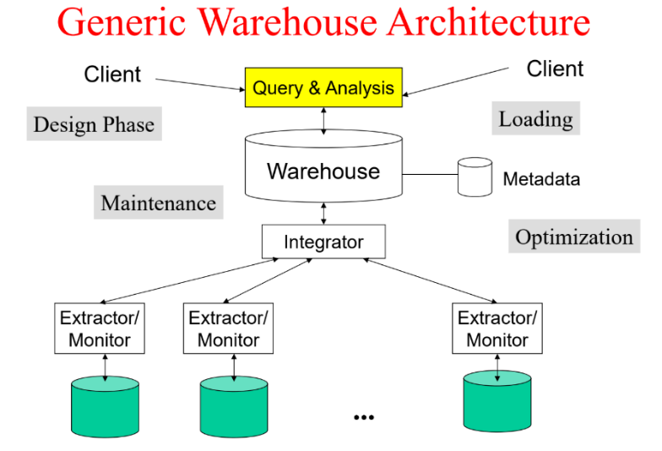
Key Characteristics
Subject-Oriented: Data is organized around key business subjects (e.g., customers, products, sales) instead of operational processes.
Integrated: Data from different sources is cleaned, transformed, and made consistent (e.g., standardizing naming conventions).
Time-Variant: It holds historical data over long periods, allowing for trend analysis. Data is often timestamped.
Non-Volatile: Once loaded, data is typically read-only and not updated or deleted, providing a stable historical record.
Data Warehouse vs. Transactional Database
Unlike transactional databases (OLTP) optimized for fast, frequent updates (like recording sales), data warehouses (OLAP) are optimized for complex queries and analysis over large volumes of historical data.

The conceptual view of data warehouse architectures can be understood through three main layers:
Single-layer: In this view, every data element is stored only once. It's often referred to as a "virtual warehouse" where operational and informational systems directly access "real-time data."
Two-layer: This is the most commonly used approach in the industry today. It involves "real-time data" from operational systems and a layer of "derived data" for informational systems.
Three-layer: This architecture extends the two-layer approach by adding an intermediate step in the transformation of real-time data to derived data. It includes:
Operational systems providing "real-time data."
Reconciled Data which is a transformed version of the real-time data.
Derived Data for informational systems, which further processes the reconciled data to meet "particular informational needs" at the view level.
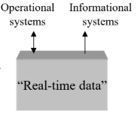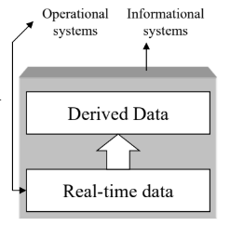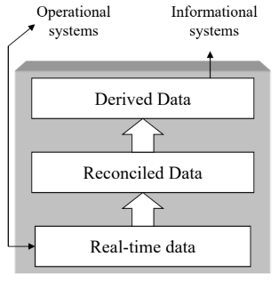
Feature | OLTP (Transaction Processing) | OLAP (Analytical Processing)
Primary Goal | Run the business (Operational) | Analyze the business (Informational)
Focus | Transactions, Current Data | Analysis, Historical Data
Operations | Fast, simple reads/writes (Insert/Update) | Complex queries, aggregations (Read)
Data Source | Original operational data | Consolidated data from OLTP systems
DB Design | Normalized | Denormalized (Star/Snowflake)
Data Volume | MBs to GBs per transaction | TBs to PBs for analysis
Users | Clerks, Front-line workers, Customers | Analysts, Managers, Executives
Metric | Transaction throughput | Query response time

Hadoop
Hadoop is an open-source framework designed to store and process very large datasets (Big Data) across clusters of computers using simple programming models. It allows for distributed processing, breaking down big problems into smaller pieces handled by multiple machines simultaneously. Its core components are HDFS (Hadoop Distributed File System) for storage and MapReduce/YARN for processing.

Characteristics
Distributed Processing: Data is processed in parallel across multiple machines in a cluster.
Scalability: You can easily add more machines (nodes) to the cluster to handle more data or processing power (horizontal scaling).
Fault Tolerance: Hadoop automatically detects hardware failures and redirects tasks to working nodes, ensuring reliability. If a node fails, data is replicated elsewhere.
Data Locality: Processing tasks are moved to the nodes where the data resides, minimizing network traffic and improving efficiency.
Flexibility: It can handle various data types, including structured (like SQL databases), semi-structured (like XML, JSON), and unstructured data (like text, images, videos).
Cost-Effective: It runs on commodity hardware (standard, inexpensive computers) rather than expensive specialized hardware.

Advantages
Handles Big Data: Designed specifically to store and process massive datasets (terabytes to petabytes) that traditional systems can't manage.
Highly Scalable: Easy to scale out horizontally by adding more nodes as data volume grows.
Cost Savings: Uses affordable commodity hardware, making large-scale data processing more economical.
Fast Processing: Parallel processing across many nodes significantly speeds up complex computations compared to single-machine systems.
Fault Tolerant & Reliable: Data replication and automatic failure handling ensure high availability and data integrity.
Schema Flexibility: Doesn't require a predefined schema before storing data, making it suitable for diverse and evolving datasets.

Disadvantages
Complexity: Setting up, configuring, and managing a Hadoop cluster can be complex and requires specialized skills.
Not Ideal for Real-Time Processing: MapReduce is primarily a batch processing system, making it less suitable for low-latency, real-time data analysis. (Though other ecosystem tools like Spark, Flink, etc., address this).
Small File Problem: HDFS is optimized for large files. Storing a huge number of small files can be inefficient and strain the NameNode (which manages the filesystem metadata).
Security Challenges: Security was not a primary focus initially, although it has improved significantly over time. Implementing robust security can still be challenging.
Update Issues: HDFS is optimized for write-once, read-many access patterns. In-place updates to files are not supported efficiently.

Hadoop Ecosystem
The Hadoop ecosystem is a set of open-source tools and frameworks designed for processing and analyzing large-scale data in a distributed computing environment. At its core, it includes:
- HDFS (Hadoop Distributed File System): A distributed storage system for storing large datasets.
- YARN (Yet Another Resource Negotiator): A resource management layer for managing and scheduling resources in a Hadoop cluster.
- MapReduce: A programming model for distributed data processing.

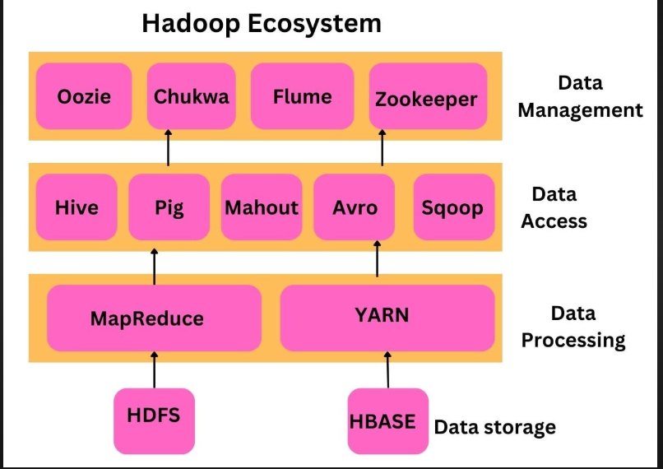
The ecosystem also includes complementary tools for various tasks:
- Hive: SQL-like querying of data in HDFS.
- Pig: High-level data processing with Pig Latin.
- HBase: A distributed NoSQL database for real-time data access.
- Spark: In-memory processing for faster batch and real-time data analytics.
- Flume: Data ingestion from logs and other sources into HDFS.
- Sqoop: Data transfer between Hadoop and relational databases.
- Oozie: Job scheduling for managing workflows.
- Mahout: Machine learning on Hadoop.

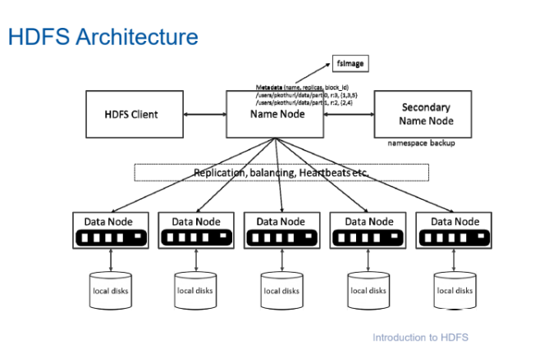
HDFS architecture and components
HDFS (Hadoop Distributed File System) is a distributed file system designed to store large data files across multiple machines and enable efficient, fault-tolerant data processing. HDFS is an essential component of the Hadoop ecosystem, known for its high reliability, scalability, and ability to manage large datasets. HDFS (Hadoop Distributed File System) uses a master-slave architecture to store very large files across multiple machines in a cluster.
Core Components
NameNode (Master):
The brain of HDFS. There's usually only one active NameNode.
Manages the filesystem namespace (directory tree, file names, permissions).
Maintains the metadata for all files and directories, including which blocks make up a file and which DataNodes store those blocks.
It doesn't store the actual data, only the map of where the data blocks are located.
Clients contact the NameNode first to locate data blocks.
DataNodes (Slaves):
The worker nodes. There are typically many DataNodes in a cluster.
They store the actual data blocks (usually 128MB or 256MB by default) on their local disks.
Handle read and write requests from clients for the blocks they store.
Periodically send heartbeats and block reports to the NameNode to report their status and the blocks they hold.
Secondary NameNode:
Not a backup NameNode for failover (that's handled differently, e.g., with a Standby NameNode in High Availability setups).
Its main job is to periodically connect to the NameNode and merge the filesystem metadata image (FsImage) with the edit log (EditLog) to create checkpoints.
This prevents the edit log from becoming too large and speeds up NameNode restarts.

How it Works
File Storage: Large files are split into smaller, fixed-size blocks. These blocks are distributed and replicated (usually 3 copies by default) across multiple DataNodes for fault tolerance.
File Access: To read a file, a client asks the NameNode for the locations of the blocks. The NameNode provides the addresses of the DataNodes holding those blocks. The client then reads the blocks directly from the DataNodes.
Fault Tolerance: If a DataNode fails, the NameNode detects this (via missed heartbeats) and arranges for the blocks that were on the failed node to be re-replicated from their existing copies onto other live DataNodes.

HDFS – User Commands (dfs)

HDFS User Commands (dfs)
These are the most common commands for interacting with files and directories in the Hadoop Distributed File System.

List Directory Contents
- Command: hdfs dfs -ls
- Explanation: This command is used to list the files and directories within a specified HDFS path, similar to the ls command in Linux.
- Examples:
Bash
# List the contents of your home directory in HDFS
hdfs dfs -ls

# List the contents of the HDFS root directory
hdfs dfs -ls /

# List all contents of the /var directory and its subdirectories recursively
hdfs dfs -ls -R /var

Display Disk Space Usage
- Command: hdfs dfs -du
- Explanation: This command displays the amount of disk space used by the files or directories specified.
- Examples:
Bash
# Show the disk usage for the root directory in a human-readable format (e.g., KB, MB, GB)
hdfs dfs -du -h /

# Show the disk usage for a specific directory
hdfs dfs -du /hbase/data/hbase/namespace/

# Show a summary of the total disk usage for a directory (not individual files within it)
hdfs dfs -du -s /hbase/data/hbase/namespace/

Create a Directory
- Command: hdfs dfs -mkdir
- Explanation: This command is used to create a new directory at a specified HDFS path.
- Example:
Bash
# Create a new directory named 'tdata' in your HDFS home directory
hdfs dfs -mkdir tdata

Copy Data to HDFS
- Command: hdfs dfs -copyFromLocal (or hdfs dfs -put)
- Explanation: This command copies a file or directory from your local filesystem to a destination in HDFS.
- Example:
Bash
# Copy the local file 'geneva.csv' from the 'tutorials/data/' directory
# into the 'tdata' directory in HDFS
hdfs dfs -copyFromLocal tutorials/data/geneva.csv tdata

Copy Data from HDFS
- Command: hdfs dfs -copyToLocal (or hdfs dfs -get)
- Explanation: This command copies a file or directory from HDFS back to your local filesystem.
- Example:
Bash
# Copy the file 'geneva.csv' from the 'tdata' directory in HDFS
# to the local filesystem with the new name 'geneva.csv.hdfs'
hdfs dfs -copyToLocal tdata/geneva.csv geneva.csv.hdfs

Display File Contents
- Command: hdfs dfs -cat
- Explanation: This command reads a file in HDFS and prints its contents to the console (stdout).
- Example:
Bash
# Display the contents of 'tfile.txt'
hdfs dfs -cat tdataset/tfile.txt

Remove a File
- Command: hdfs dfs -rm
- Explanation: This command removes (deletes) a file from HDFS.
- Example:
Bash
# Remove the file 'tfile.txt' from the 'tdataset' directory
hdfs dfs -rm tdataset/tfile.txt

Write to HDFS from Standard Input
- Command: hdfs dfs -put - <destination_path>
- Explanation: This command reads data from the standard input (stdin) and writes it to a new file in HDFS. The hyphen (-) signifies that the input is coming from stdin.
- Example:
Bash
# Take the string "blah blah blah", pipe it as input, and write it to
# a new file named 'tfile.txt' in the 'tdataset' directory
echo "blah blah blah" | hdfs dfs -put - tdataset/tfile.txt

HDFS Access Control & Statistics

List Access Control Lists (ACLs)
- Command: hdfs dfs -getfacl
- Explanation: This command displays the Access Control Lists (permissions) for a specific file or directory.
- Example:
Bash
# Get the ACL information for the file 'geneva.csv'
hdfs dfs -getfacl tdata/geneva.csv

List File Statistics
- Command: hdfs dfs -stat
- Explanation: This command prints statistics about a file or directory. You can use formatting options to specify what to print.
- Example:
Bash
# Print only the replication factor (%r) for the file 'geneva.csv'
hdfs dfs -stat "%r" tdata/geneva.csv

HDFS File System Check (fsck)
This command is used for diagnosing the health of the HDFS file system.

List File Blocks and Locations
- Command: hdfs fsck <path> -files -blocks -locations
- Explanation: This command checks the specified file or directory and lists all the blocks that make up the files, along with the datanode locations where those blocks are stored.
- Example:
Bash
# List all files, blocks, and block locations for 'geneva.csv'
hdfs fsck /user/cloudera/tdata/geneva.csv -files -blocks -locations

List Corrupt Blocks
- Command: hdfs fsck / -list-corruptfileblocks
- Explanation: This command checks the entire file system (starting from root /) and prints a list of any blocks that are missing or corrupt, along with the files they belong to.
- Example:
Bash
# Find all corrupt or missing blocks in HDFS
hdfs fsck / -list-corruptfileblocks

HDFS Administration Commands (dfsadmin)
These commands are used by Hadoop administrators to manage and monitor the HDFS cluster.

Get Cluster Status Report
- Command: hdfs dfsadmin -report
- Explanation: Provides a comprehensive status report of the HDFS cluster, including total capacity, used space, available space, and the status of all live and dead datanodes.
- Example:
Bash
hdfs dfsadmin -report

Print Cluster Topology
- Command: hdfs dfsadmin -printTopology
- Explanation: Prints a tree of the racks and the datanodes within those racks, showing the network topology known to the NameNode.
- Example:
Bash
hdfs dfsadmin -printTopology

Get Datanode Information
- Command: hdfs dfsadmin -getDatanodeInfo <datanode_address>
- Explanation: Pings a specific datanode and returns its live information and status.
- Example:
Bash
# Get info for a datanode running on localhost:50020
hdfs dfsadmin -getDatanodeInfo localhost:50020

Map reduce:
MapReduce is a Java-based framework in the Apache Hadoop ecosystem designed for processing large datasets across a cluster in a distributed manner. It works by breaking down the processing into two main phases: Map and Reduce.
How It Works:
Input & Splitting: Data, usually from HDFS, is split into smaller, independent blocks.
Map Phase:
Multiple "mapper" tasks run in parallel across the cluster nodes.
Each mapper takes one or more blocks, applies a specific function (the map function) to the data locally, and outputs intermediate key-value pairs to temporary storage.
The framework ensures redundant input copies aren't processed multiple times.
Shuffle & Sort: The intermediate results from all mappers are automatically collected, sorted, and grouped by key, then distributed to the reducers.
Reduce Phase:
Multiple "reducer" tasks run in parallel.
Each reducer takes the intermediate data associated with specific keys.
It applies a function (the reduce function) to aggregate, summarize, or transform the data for those keys.
Output: The final results from the reducers are typically written back to HDFS.
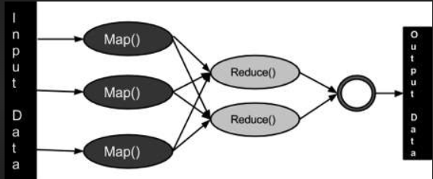
Good
Scales for huge datasets.
Fast due to parallel processing.
Reliable with automatic failure handling.
Cheap using standard hardware.
Flexible with data types.

Bad
Slow for real-time needs (batch only).
Inefficient for iterative tasks (no in-memory cache).
Complex to program and manage.
Latency from setup and disk use.

Example (Word Count):
**Input**:
```
Hello world
Hello Hadoop
Hadoop MapReduce
```

**Map Output**:
- ("Hello", 1)
- ("world", 1)
- ("Hadoop", 1)
- ("MapReduce", 1)

**Shuffle & Sort**:
- ("Hello", [1, 1])
- ("world", [1])
- ("Hadoop", [1, 1])
- ("MapReduce", [1])

**Reduce Output**:
- ("Hello", 2)
- ("world", 1)
- ("Hadoop", 2)
- ("MapReduce", 1)

**Final Result**:
```
Hello 2
world 1
Hadoop 2
MapReduce 1

YARN
YARN (Yet Another Resource Negotiator) is the resource management and job scheduling layer in Hadoop. It uses a master-slave architecture.
Key Components
ResourceManager (Master):
The central authority managing resources (CPU, memory) across the entire cluster.
It has two main parts:
Scheduler: Allocates resources to running applications based on needs and policies. It doesn't track application status.
ApplicationsManager: Accepts job submissions, negotiates the first container to start the ApplicationMaster for a job, and restarts the ApplicationMaster if it fails.

NodeManagers (Slaves):
Run on each worker node in the cluster.
Responsible for managing resources (CPU, memory) on that specific node.
Launch and monitor containers (isolated environments where tasks run).
Report resource usage and node health back to the ResourceManager.

ApplicationMaster (Per-Application Master):
When a job (application) starts, a dedicated ApplicationMaster instance is created.
It negotiates necessary resources (containers) from the ResourceManager's Scheduler.
Works directly with NodeManagers to launch, monitor, and manage the tasks running within the allocated containers for its specific job.

Containers:
Represent an allocation of resources (CPU, memory) on a specific NodeManager.
Tasks (like Map or Reduce tasks, or Spark executors) run within these containers. They provide an isolated environment for the task execution.

Workflow Overview
A client submits a job to the ResourceManager.
The ResourceManager allocates a container and instructs a NodeManager to start the ApplicationMaster for that job.
The ApplicationMaster registers with the ResourceManager.
The ApplicationMaster requests the necessary containers from the ResourceManager's Scheduler based on the job's needs.
The Scheduler allocates containers on available NodeManagers.
The ApplicationMaster instructs the NodeManagers to launch tasks within these containers.
NodeManagers monitor the tasks and resources, reporting back to the ApplicationMaster and ResourceManager.
The ApplicationMaster monitors the overall job progress.
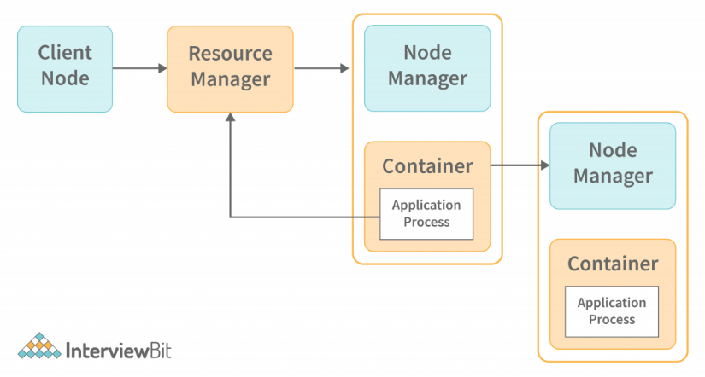
Good
Efficient: Manages resources well for diverse apps (Spark, MapReduce).
Flexible: Runs many frameworks, not just MapReduce.
Scalable: Handles large clusters better.
Shared: Improves cluster use by sharing resources.
Bad
Complex: Harder to manage than classic MapReduce.
Bottleneck: ResourceManager can fail (without HA).
Memory Heavy: Can use lots of RAM.

HBase Refresher
Apache HBase in a few words:
“HBase is an open-source, distributed, versioned, column-oriented store modeled after Google's
Bigtable”
Used for:
- Powering websites/products, such as StumbleUpon and Facebook’s Messages
- Storing data that’s used as a sink or a source to analytical jobs (usually MapReduce)
Main features:
- Horizontal scalability
- Machine failure tolerance
- Row-level atomic operations including compare-and-swap ops like incrementing counters
- Augmented key-value schemas, the user can group columns into families which are configured
independently
- Multiple clients like its native Java library, Thrift, and REST

Hive Refresher
Apache Hive in a few words:
“A data warehouse infrastructure built on top of Apache Hadoop”
Used for:
- Ad-hoc querying and analyzing large data sets without having to learn MapReduce
Main features:
- SQL-like query language called QL
- Built-in user defined functions (UDFs) to manipulate dates, strings, and other data-mining tools
- Plug-in capabilities for custom mappers, reducers, and UDFs
- Support for different storage types such as plain text, RCFiles, HBase, and others
- Multiple clients like a shell, JDBC, Thrift

Hive vs hbase vs rdbms vs nosql vs hdfs
Feature | RDBMS | NoSQL (General) | HBase (NoSQL) | Hive
Type | Relational Database | Non-Relational Database | Column-Family NoSQL DB | Data Warehouse Tool
Purpose | Transactions, Structured Data | Flexible Data Models, Scale | Real-time access on HDFS | SQL-like batch query on HDFS
Data Model | Tables (Rows, Columns) | Varies (Documents, KV, etc.) | Wide Columns (Families) | Tables (abstraction over HDFS)
Schema | Schema-on-write (Strict) | Flexible / Schema-less | Flexible Columns | Schema-on-read
Access | Real-time (OLTP) | Varies (often Real-time) | Real-time Random Read/Write | Batch (OLAP)
Underlying | Local/Networked FS | Varies | HDFS | HDFS
Interface | SQL | Varies (APIs, custom query) | Java API, CLI, Thrift/REST | HiveQL (SQL-like)
Latency | Low | Varies (often Low) | Very Low | High

