WHAT IS CLOUD COMPUTING?
Cloud computing is a technology that delivers computing resources such as servers, storage, databases, networking, and software over the Internet. Instead of owning and maintaining physical infrastructure, users can rent computing resources on demand from cloud providers like AWS, Microsoft Azure, or Google Cloud Platform (GCP) with pay as you go pricing. A cloud can be public, private or hybrid. Cloud computing can also be thought of as utility computing/on-demand computing. The name cloud computing was inspired by the cloud symbol that’s often used to represent the internet in flowcharts and diagrams.
CHARACTERISTICS OF CC:
- On-demand self-services: Users can independently provision computing resources like servers and storage as required. This eliminates the need for direct interaction with the service provider for basic resource acquisition.
- Broad network access: Cloud services are accessible across various devices through standard network protocols. This ensures ubiquitous access from different locations and client types.
- Rapid elasticity: Cloud capabilities can be quickly scaled up or down to match fluctuating demands. This flexibility allows users to adapt to changing resource needs efficiently.
- Resource pooling: Computing resources are shared among multiple users in a multi-tenant environment. This optimizes resource utilization and reduces costs for consumers.
- Measured service: Resource usage is tracked and reported, allowing for transparent billing based on consumption. This pay-as-you-go model ensures cost-effectiveness.
- Multi-tenancy: Cloud computing providers can support multiple tenants (users or organizations) on a single set of shared resources.
- Virtualization: Cloud computing providers use virtualization technology to abstract underlying hardware resources and present them as logical resources to users.
- Resilient computing: Cloud computing services are typically designed with redundancy and fault tolerance in mind, which ensures high availability and reliability.
- Flexible pricing models: Cloud providers offer a variety of pricing models, including pay-per-use, subscription-based, and spot pricing, allowing users to choose the option that best suits their needs.
- Security: Cloud providers invest heavily in security measures to protect their users’ data and ensure the privacy of sensitive information.
- Automation: Cloud computing services are often highly automated, allowing users to deploy and manage resources with minimal manual intervention.
- Sustainability: Cloud providers are increasingly focused on sustainable practices, such as energy-efficient data centers and the use of renewable energy sources, to reduce their environmental impact.
BENEFITS/ADVANTAGES OF CC:
- Cost Efficiency
- Scalability
- Flexibility and Mobility
- Enhanced Security
- Improved Collaboration
DISADVANTAGES OF CC:
- Risk of Vendor Lock-In
- Less Control Over Underlying Cloud Infrastructure
- Concerns About Security Risks
- Integration Complexity
- Unforeseen Costs
- Internet Dependency

CLOUD ARCHITECTURE:
Cloud computing architecture is divided into four primary layers that define how cloud services are structured and delivered. These layers ensure efficient management of resources, scalability, and security.
- Physical Layer (Hardware Layer)
🔹 Definition:
The Physical Layer consists of the hardware components that form the foundation of cloud computing. It includes data centers, physical servers, storage devices, and networking equipment.
🔹 Key Components:
- Data Centers: Large-scale facilities that host cloud infrastructure.
- Physical Servers: High-performance machines that support virtualization.
- Storage Systems: Hard drives (HDDs), Solid State Drives (SSDs), NAS, SAN.
- Networking Equipment: Routers, switches, and firewalls for connectivity.
🔹 Example:
- AWS, Azure, and Google Cloud have global data centers where physical servers are located.
- Google Cloud’s europe-west1 data center physically hosts data for European users.

- Infrastructure Layer (Virtualization Layer)
🔹 Definition:
The Infrastructure Layer is responsible for virtualization and resource management. It abstracts physical hardware and allows multiple virtual machines (VMs) and containers to run on shared physical resources.
🔹 Key Components:
- Hypervisors: Software that creates and manages virtual machines (VMware, KVM, Hyper-V).
- Virtual Machines (VMs): Software-based computers running on cloud hardware.
- Containers: Lightweight, portable execution environments (Docker, Kubernetes).
- Networking & Storage Virtualization: SDN (Software-Defined Networking) and SDS (Software-Defined Storage).
🔹 Example:
- Amazon EC2 provides virtual machines (VMs) to users.
- Google Kubernetes Engine (GKE) manages containerized applications.

- Platform Layer (Cloud Management & Services Layer)
🔹 Definition:
The Platform Layer provides tools, services, and middleware that allow developers to build, deploy, and manage applications in the cloud. This layer is commonly associated with Platform-as-a-Service (PaaS) offerings.
🔹 Key Components:
- Operating Systems: Cloud-optimized OS like Linux, Windows Server.
- Middleware: Software that connects applications to cloud resources (APIs, databases).
- Development Tools: SDKs, frameworks for building cloud-native applications.
- Database Services: Managed databases (AWS RDS, Google Cloud SQL).
🔹 Example:
- Microsoft Azure App Service allows developers to deploy web applications.
- Google Firebase provides backend services for mobile apps.
- Application Layer (User Interaction Layer)
🔹 Definition:
The Application Layer is the topmost layer where users interact with cloud services. It includes software applications and cloud-based services that run on cloud infrastructure. This layer is associated with Software-as-a-Service (SaaS) offerings.
🔹 Key Components:
- Cloud-Based Applications: Web apps, mobile apps, collaboration tools.
- User Interfaces: Web portals, APIs, and client applications.
- Security & Access Control: Authentication (OAuth, SSO), user roles.
🔹 Example:
- Google Drive, Dropbox: Cloud storage applications.
- Microsoft 365, Gmail: SaaS-based productivity tools.

CLOUD DEPLOYMENT MODEL-EXPLAIN, CHARACTERISTICS, ADVANTAGES, DISADVANTAGES, EXAMPLE:
Public cloud:
The public cloud is a cloud computing model where cloud services and infrastructure are available to the general public or a large industry group and are owned and operated by a cloud service provider (CSP). It is based on the pay-as-you-go model, meaning users only pay for the resources they use. These services can be accessed over the internet and are shared among multiple users (multi-tenancy).Moving to the public cloud ensures high security, reliability, and faster innovation without heavy infrastructure investment. Ideal for start-ups and businesses seeking flexibility, remote access, and disaster recovery.
Characteristics of Public Cloud:
- Multi-Tenancy: Multiple users share computing resources.
- Scalability: Highly scalable to accommodate varying workloads.
- Cost-Effective: No need for upfront infrastructure investment; pay-per-use model.
- Self-Service and Automation: Users can provision resources on demand.
- Broad Network Access: Services are accessible over the internet from anywhere.
- Security and Compliance: Security is managed by the provider, but users must configure settings properly.
Advantages of Public Cloud:
- Lower Costs: No need to buy or maintain physical infrastructure.
- High Reliability: Cloud providers offer redundancy and backup solutions.
- Global Accessibility: Services are available from anywhere via the internet.
- Scalability and Flexibility: Resources can be scaled up or down as needed.
- Easy Maintenance: The provider handles updates, security patches, and maintenance.
Disadvantages of Public Cloud:
- Security Risks: Data is stored on a shared infrastructure, making it vulnerable to breaches.
- Limited Customization: Less control over configurations compared to private clouds.
- Compliance Issues: May not meet strict regulatory requirements for certain industries.
- Latency Issues: Performance can be affected if the data center is far from users.
- Potential Downtime: Service outages may occur if the provider experiences issues.
Private cloud:
The private cloud is a cloud computing model where computing resources are dedicated to a single organization. Unlike the public cloud, where services are shared among multiple users, the private cloud offers greater control, security, and customization. It can be hosted on-premises (within the organization's data center) or by a third-party provider but is used exclusively by one entity. It is best suited for businesses that handle sensitive data and need a dedicated cloud environment.
Characteristics of Private Cloud:
- Single-Tenant Environment: Resources are not shared with other organizations.
- Dedicated Infrastructure: Exclusively used by a single organization.
- Higher Security & Privacy: Enhanced control over data, making it ideal for industries with strict compliance needs.
- Customization & Flexibility: Can be tailored to meet specific business needs.
- Higher Costs: Requires investment in hardware, software, and IT personnel for maintenance.
- Limited Scalability: Scaling up requires additional infrastructure investment.
- Centralized Control: Organizations have full control over resources, configurations, and security policies.
Advantages of Private Cloud:
- Enhanced Security & Privacy: Data remains within the organization’s control, reducing security risks.
- Customization: Can be designed to meet specific business and regulatory requirements.
- Better Performance: Dedicated resources ensure lower latency and higher reliability.
- Compliance-Friendly: Helps organizations meet industry-specific regulations (e.g., HIPAA, GDPR, PCI-DSS).
- Greater Control: Businesses can optimize cloud infrastructure according to their needs.
Disadvantages of Private Cloud:
- High Cost: Requires investment in hardware, software, and IT staff for maintenance.
- Limited Scalability: Scaling up requires additional capital investment.
- Complex Management: Requires dedicated IT expertise to manage and maintain the infrastructure.
- Longer Deployment Time: Setting up a private cloud can be time-consuming.
Hybrid cloud:
A hybrid cloud combines both public and private clouds, allowing data and applications to move between them. This model provides flexibility, scalability, and security. This model provides organizations with the flexibility to choose the most suitable environment for each workload. For example, a company may store customer data in a private cloud for security and compliance reasons but run customer-facing applications in a public cloud to handle variable traffic loads efficiently.
Characteristics of Hybrid Cloud:
- Combination of Public & Private Cloud: Organizations can use both environments as needed.
- Scalability & Flexibility: Public cloud resources can be scaled up during peak times.
- Cost Efficiency: Private cloud is used for critical operations, while public cloud reduces infrastructure costs.
- Seamless Integration: Data and applications can move between private and public clouds.
- Security & Compliance: Sensitive data can remain in the private cloud, while non-sensitive workloads use the public cloud.
Advantages of Hybrid Cloud:
- Optimized Costs: Organizations use private cloud for essential data and public cloud for cost-effective scalability.
- Flexibility & Scalability: Workloads can shift between environments as needed.
- Enhanced Security & Compliance: Confidential data stays private, while public cloud handles non-sensitive tasks.
- Disaster Recovery & Business Continuity: If one environment fails, operations can continue on the other.
- Performance Optimization: Sensitive applications run on private cloud, while high-traffic applications benefit from public cloud scalability.
Disadvantages of Hybrid Cloud:
- Complex Management: Requires expertise to manage integration between public and private clouds.
- Security Challenges: Data movement between clouds increases security risks if not managed properly.
- Higher Costs than Public Cloud: Maintaining a private cloud requires IT infrastructure and skilled personnel.
- Latency Issues: Moving data between clouds can cause delays if not optimized correctly.
Community cloud:
A community cloud is a cloud computing model where multiple organizations with similar requirements share a cloud infrastructure. It is owned, managed, and operated by one or more organizations in the community or a third-party provider. The goal is to provide better security, compliance, and cost-sharing for organizations with common interests (e.g., government agencies, healthcare institutions, financial groups). For example, a group of hospitals can use a community cloud to securely store and share patient records while complying with industry regulations.
Characteristics of Community Cloud:
- Shared Infrastructure: Used by multiple organizations within a specific industry or sector.
- Better Security & Compliance: Tailored to meet the regulatory requirements of the community.
- Cost-Sharing Model: Costs are divided among the participating organizations.
- Limited Public Access: Unlike public clouds, access is restricted to authorized members.
- Governance & Control: Managed by the community members or a third-party provider.
Advantages of Community Cloud:
- Industry-Specific Security & Compliance: Designed to meet sector-specific regulations (e.g., HIPAA for healthcare, GDPR for finance).
- Cost-Efficient: Lower costs compared to a private cloud since multiple organizations share the infrastructure.
- Improved Collaboration: Enables organizations in the same sector to share data and applications securely.
- Better Control than Public Cloud: Offers more privacy and customization compared to public cloud solutions.
Disadvantages of Community Cloud:
- Limited Scalability: Not as scalable as public clouds since resources are shared within a community.
- Potential Conflicts: Differences in policies, priorities, and governance may create management issues.
- Higher Cost than Public Cloud: While cost-effective, it is still more expensive than fully public cloud solutions.
- Security Risks: Though better than public cloud, shared resources still pose some risks if not properly managed.
Multi cloud:
A multi-cloud model involves using two or more cloud service providers (e.g., AWS, Azure, Google Cloud) to optimize performance, redundancy, and avoid vendor lock-in. Organizations distribute workloads across multiple public, private, or hybrid clouds, depending on their needs.
For example, a company might use AWS for data storage, Google Cloud for AI/ML services, and Azure for enterprise applications to maximize efficiency.
Characteristics of Multi-Cloud:
- Uses Multiple Cloud Providers: Services are spread across two or more clouds (public, private, or hybrid).
- No Vendor Lock-In: Avoids dependency on a single provider, increasing flexibility.
- Workload Optimization: Different clouds are chosen based on cost, performance, or compliance.
- Improved Disaster Recovery: Ensures high availability by distributing resources across clouds.
- Complex Management: Requires advanced orchestration and integration tools for seamless operation.
Advantages of Multi-Cloud:
- Reduces Vendor Lock-In: Organizations can switch providers easily and avoid pricing changes or service limitations.
- Optimized Performance: Workloads can be placed in the most efficient or cost-effective cloud.
- Better Disaster Recovery & High Availability: If one cloud fails, services continue running on another.
- Flexibility & Scalability: Different cloud environments can be used for different business needs.
- Regulatory Compliance: Businesses operating in multiple regions can comply with local regulations by choosing specific providers.
Disadvantages of Multi-Cloud:
- Complexity in Management: Maintaining multiple providers requires integration, monitoring, and security coordination.
- Higher Costs: Managing multiple clouds may increase operational costs and resource duplication.
- Security Challenges: Requires a strong security strategy to manage different access controls and compliance.
- Data Transfer Costs: Moving data between clouds may incur high bandwidth and migration costs.
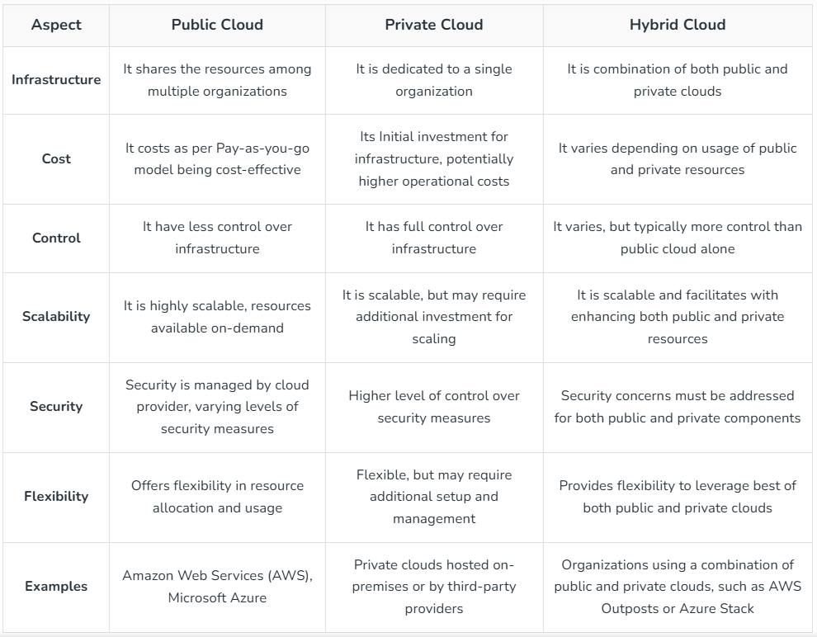
CLOUD SERVICE MODELS:
IAAS:
IaaS provides virtualized computing resources over the internet. It includes virtual machines, storage, networking, and servers, allowing users to scale infrastructure without managing physical hardware. Users are responsible for managing the operating system, applications, and data. Cloud provider manages hardware and networking.
Characteristics:
- On-demand access to computing resources.
- Scalable and flexible.
- Pay-as-you-go pricing.
Advantages:
- Full control over infrastructure.
- Scalability as per business needs.
- No need to maintain physical servers.
Disadvantages:
- Requires IT expertise to configure and manage resources.
- Security & compliance concerns due to shared infrastructure.
Examples:
- Amazon EC2 (Elastic Compute Cloud)
- Microsoft Azure Virtual Machines
- Google Compute Engine
PAAS:
PaaS provides a platform and development environment for building, testing, and deploying applications without worrying about managing infrastructure. It includes development tools, middleware, and database management systems. Users manage the applications and data, while the cloud provider manages the infrastructure.
Characteristics:
- Simplified application development and deployment.
- Reduced management overhead.
- Supports various programming languages and frameworks.
Advantages:
- Faster development & deployment (no need to manage infrastructure).
- Reduces complexity for developers.
- Cost-effective as infrastructure is managed by the provider.
Disadvantages:
- Less control over infrastructure compared to IaaS.
- Vendor lock-in (limited flexibility to migrate).
Examples:
- Google App Engine
- Microsoft Azure App Service
- AWS Elastic Beanstalk
SAAS:
SaaS delivers ready-to-use software applications over the internet.
Users access the software through a web browser or mobile app.
The cloud provider manages all aspects of the application, including infrastructure, maintenance, and updates.
Characteristics:
- Ready-to-use applications.
- No installation or maintenance required.
- Typically subscription-based.
Advantages:
- No installation or maintenance required.
- Accessible from anywhere with an internet connection.
- Cost-effective as no hardware is needed.
Disadvantages:
- Limited customization & control over software.
- Data security concerns as data is stored on the provider’s servers.
Examples:
- Google Workspace (Gmail, Docs, Drive)
- Microsoft 365 (Word, Excel, Outlook)
- Salesforce CRM

Serverless Computing (Function as a Service - FaaS):
Serverless computing, also known as Function as a Service (FaaS) model where developers write and deploy code without managing the underlying infrastructure. The cloud provider automatically handles server provisioning, scaling, and maintenance, allowing developers to focus only on writing code. Code is executed in response to events or triggers.
Characteristics:
- Event-driven execution.
- Automatic scaling (The cloud provider executes the code only when needed, scaling automatically).
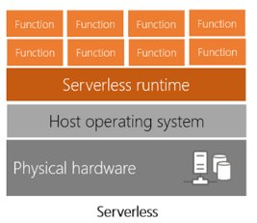
- Pay-per-execution pricing (Users are charged only for actual execution time instead of paying for always-on servers).
Advantages:
- No need to manage infrastructure and scale servers manually.
- Cost-efficient as you pay only for execution time.
- Best for event-driven applications (IoT, chatbots, notifications).
Disadvantages:
- Cold start latency (functions take time to initialize).
- Limited execution time (short-lived tasks only).
- Vendor Lock-in: Applications may become dependent on a specific cloud provider.
Examples:
- AWS Lambda
- Azure Functions
- Google Cloud Functions.
Suppose an e-commerce site wants to send an email notification whenever a new order is placed.
You can create an Azure Function that gets triggered by a new order in an Azure SQL Database.
The function will process the order and send an email notification via SendGrid API.
Key Benefit: No need to maintain a separate server; Azure manages scaling and execution automatically.
SLA:
A Service Level Agreement (SLA) is a contract between a cloud service provider and a customer that defines the expected level of service, including uptime, performance, and response time. It ensures that the provider meets agreed standards, and if they fail, penalties or compensation may apply.
Types of SLAs
- Customer-based SLA: A single agreement between a provider and one customer (e.g., AWS contract with a company).
- Service-based SLA: Covers a specific service for all customers (e.g., Office 365 uptime SLA).
- Multi-level SLA: Divided into levels like corporate, customer, and service level to handle large organizations.
Importance of SLA
✅ Ensures Reliability – Guarantees a minimum uptime (e.g., 99.9%).
✅ Defines Responsibilities – Outlines obligations of both provider and customer.
✅ Risk Management – Helps businesses plan for service disruptions.
✅ Performance Benchmark – Ensures service quality is maintained.
✅ Compensation Rules – Defines penalties if the provider fails to meet the SLA.
Key Components of an SLA
🔹 Service Scope
Defines the services covered, such as computing, storage, and networking.
🔹 Performance Metrics
Includes uptime percentage, response time, and transaction processing speed.
🔹 Availability & Uptime
Specifies the agreed uptime percentage (e.g., 99.9%).
🔹 Responsibilities of Provider & Customer
Outlines who is responsible for different aspects of service maintenance.
🔹 Penalties & Compensation
Defines penalties if the provider fails to meet SLA commitments (e.g., service credits).
🔹 Security & Compliance
Ensures adherence to regulations like GDPR, HIPAA, or ISO 27001.
🔹 Support & Maintenance
Details support availability (24/7, business hours) and expected response times.
How SLA is Calculated?
SLAs are usually measured in availability percentage, calculated as:
Availability (%) = ((Total Time−Downtime)/Total Time) × 100
Suppose a cloud provider offers 99.9% uptime SLA per month.
🔹 In a 30-day month, total minutes = 30 × 24 × 60 = 43,200 minutes.
🔹 Allowed downtime =(1−0.999)×43,200=43.2 minutes
🔹 If the provider exceeds 43.2 minutes of downtime, they violate the SLA and may need to compensate the customer.
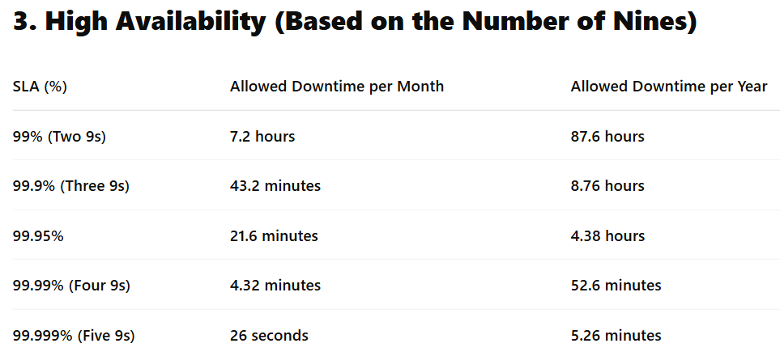
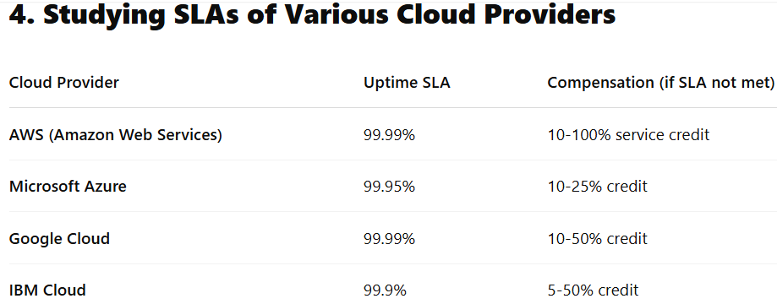

IAM:
Identity and Access Management (IAM) is a framework of policies and technologies used to control and manage user access to systems, networks, and data. It ensures that the right individuals have the appropriate access to resources securely.
Key Features of IAM:
- User Authentication – Verifies user identity (e.g., passwords, multi-factor authentication).
- Access Control – Grants or restricts access to specific resources.
- Role-Based Access Control (RBAC) – Assigns permissions based on user roles.
- Multi-Factor Authentication (MFA) – Adds extra security layers beyond passwords.
- Auditing & Logging – Tracks user activities for security and compliance.

Elasticity and scalability difference
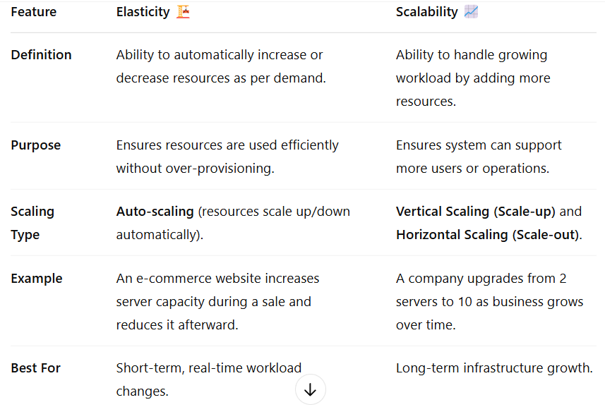
Resource pooling is a cloud computing model where computing resources (CPU, storage, network, memory) are shared among multiple users (tenants). These resources are dynamically allocated and reallocated based on demand.
Load Balancing: A process of distributing network traffic across multiple servers efficiently to improve response times and prevent failure. Helps in handling high traffic and maintaining application performance.
A load balancer is a hardware or software component that performs load balancing. It acts as a traffic director, distributing incoming requests across multiple servers.
Load Balancing Techniques
1. Round Robin
- Requests are distributed sequentially among all servers in a loop.
- Simple and efficient for servers with equal capacity.
2. Weighted Round Robin
- Assigns a weight to each server based on its capacity.
- Servers with higher weights receive more requests.
- Useful when servers have different performance levels.
3. Low Latency
- Routes requests to the server with the lowest network latency.
- Ensures faster response times for users.
- Common in content delivery networks (CDNs) and real-time applications.
4. Least Connections
- Directs requests to the server with the fewest active connections.
- Ideal for applications where request processing time varies.
5. Priority-Based Load Balancing
- Requests are assigned based on priority levels set for each server.
- High-priority servers handle critical traffic first.
- Useful in multi-tier applications where certain services are more important.
6. Overflow Load Balancing
- Redirects excess traffic to backup servers when primary servers reach capacity.
- Prevents server overload and ensures system stability.
- Common in cloud environments for auto-scaling and failover mechanisms.

UNIT_2
What is virtualization?
Virtualization is the process of creating virtual instances of computing resources (servers, storage, networks) on a single physical machine using a Hypervisor. It enables better resource utilization, scalability, and cost efficiency.
Snapshot Management
A snapshot captures the exact state of a VM at a specific time.
- Used for backups, testing, and disaster recovery.
- Snapshots can be reverted to restore a previous state.
- Efficient for rolling back failed updates or system crashes.
What is a Hypervisor?
A Hypervisor (also called a Virtual Machine Monitor, VMM) is software that creates and manages multiple virtual machines (VMs) on a single physical host. It allows each VM to run its own operating system (OS) while sharing the physical resources (CPU, memory, storage).
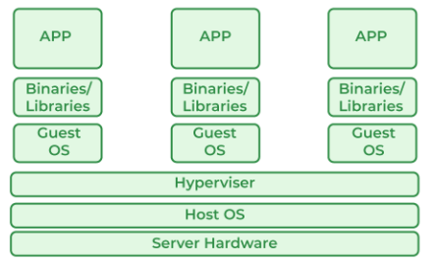
Architecture of hypervisor and its use in cc

Working of Hypervisor:
- The hypervisor abstracts the physical hardware and creates a virtualization layer.
- It allocates resources dynamically to each VM as per demand.
- Each VM operates independently with its own OS, applications, and security settings.
- Ensures isolation between VMs to prevent interference and enhance security.
How Hypervisors Enable Cloud Computing:
- Enable Virtualization: They allow cloud providers to create virtualized infrastructure (IaaS) that can be offered to multiple customers. New virtual machines (VMs) can be rapidly deployed for different tenants also.
- Resource Pooling: Multiple VMs share a single physical server, optimizing hardware usage.
- Scalability: Allows cloud providers to scale up/down resources as needed.
- Cost Efficiency: Reduces hardware costs by running multiple VMs on one server.
- Isolation & Security: Each VM runs independently, reducing risks of security breaches.
- High Availability & Fault Tolerance: If one VM fails, others continue running without disruption.
- Snapshot Support: VMs can be backed up and restored quickly.
- Live Migration: Move VMs across servers without downtime.

Role of a Hypervisor in Virtualization:
- Abstraction of Hardware:
  - The hypervisor creates an abstraction layer between the physical hardware and the virtual machines. This allows multiple operating systems to run concurrently on a single physical machine.
- Resource Allocation:
  - It manages the allocation of hardware resources, such as CPU, memory, storage, and network, to the VMs. This ensures that each VM has the resources it needs to operate efficiently.
- Isolation and Security:
  - The hypervisor isolates VMs from each other, preventing them from interfering with each other's operations. This provides a secure environment for running multiple operating systems on the same hardware.
- Virtual Machine Management:
  - It provides tools for creating, starting, stopping, and managing VMs. This includes tasks such as live migration, which allows VMs to be moved between physical servers without downtime.

Types of hypervisor
Type 1 Hypervisors (Bare-Metal Hypervisors):
- These hypervisors run directly on the host's hardware, without a host operating system.
- Provides high performance, low latency, and better security because it interacts directly with hardware.
- They are commonly used in enterprise environments and data centers.
- Examples: VMware ESXi, Microsoft Hyper-V, Xen (used by AWS)
- Best for: Cloud providers, data centers, large enterprises.
Type 2 Hypervisors (Hosted Hypervisors):
- These hypervisors run as an application on top of a host operating system.
- Easier to install and use but has higher latency because it rely on the host OS to access the hardware.
- Used for development, testing, and personal virtualization.
- Examples: Oracle Virtual Box, VMware Workstation
- Best for: Developers, testers, small-scale applications.
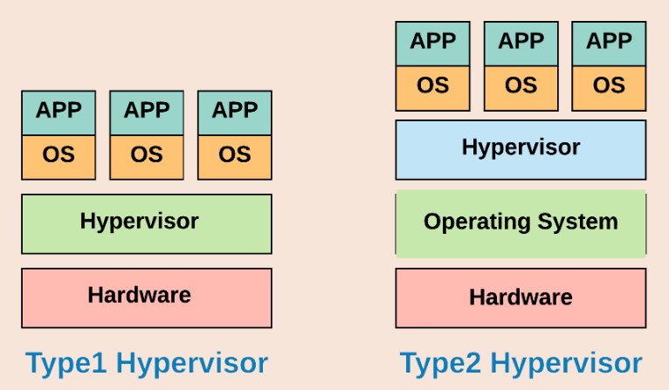

Techniques of hardware virtualization
Full Virtualization
Environment: Works in both virtualized and non-virtualized environments.
How It Works:
- In full virtualization, the hypervisor completely emulates the underlying hardware.
- The guest OS runs unmodified, as it believes it is operating on a real physical machine.
- The hypervisor uses binary translation to trap and convert privileged instructions into safe instructions.
- Example: VMware ESXi, Microsoft Hyper-V
Advantage: No modifications needed in the guest OS, making it highly compatible.
Disadvantage: High overhead due to hardware emulation.
| User Application |
| Unmodified OS | <-- Guest OS runs without modifications
| Virtual Machine Monitor (VMM) / Hypervisor | <-- Intercepts privileged instructions
| Hardware (CPU, RAM, Disk) |

Para-Virtualization
Environment: Works only in virtualized environments.
How It Works:
- In para-virtualization, the guest OS is modified to be “aware” that it is running in a virtualized environment.
- Instead of relying on binary translation, the OS directly communicates with the hypervisor using special API calls (Hypercalls).
- These hypercalls replace hardware-specific operations and reduce the need for hardware emulation.
- Example: Xen, KVM
Advantage: Lower overhead and better performance than full virtualization.
Disadvantage: Requires modifications to the OS, limiting compatibility.
| User Application |
| Modified OS | <-- Guest OS is aware of virtualization and optimized for hypervisor
| Virtual Machine Monitor (VMM) / Hypervisor |
| Hardware (CPU, RAM, Disk) |

Hardware-Assisted Virtualization
Environment: Works only in virtualized environments with CPU support (Intel VT-x, AMD-V).
How It Works:
- Hardware-Assisted Virtualization is an improvement over full virtualization where the CPU provides direct support for virtualization.
- Modern processors from Intel (VT-x) and AMD (AMD-V) include special instructions that allow the guest OS to run privileged instructions directly on hardware instead of being trapped and translated by the hypervisor.
- This greatly reduces the overhead caused by instruction emulation.
- Example: KVM, Microsoft Hyper-V.
Advantage: Improved performance and lower latency compared to full virtualization.
Disadvantage: Requires modern processors with hardware virtualization support.
| User Application |
| Unmodified OS | <-- Runs without modification, using CPU extensions
| Virtual Machine Monitor (VMM) / Hypervisor | <-- Uses hardware support for privileged instructions
| Hardware (CPU with Virtualization Support) |

Different types of cloud storage
Cloud storage is categorized into three main types based on how data is stored, accessed, and managed. Each type serves different use cases in cloud environments.
Block Storage
- Definition: Data is stored in fixed-size blocks, similar to traditional hard drives.
- How It Works: Each block is assigned a unique address and can be accessed independently.
- Use Case: Best for applications requiring low-latency, high-performance storage, such as databases and virtual machines (VMs).
- Examples:
  - AWS Elastic Block Store (EBS) – Used for EC2 instances.
  - Azure Managed Disks – Block storage for Azure VMs.
  - Google Persistent Disk – High-performance storage for Google Cloud VMs.
Object Storage
- Definition: Stores data as objects with metadata and a unique identifier, rather than in a structured hierarchy.
- How It Works: Data is retrieved using an API instead of traditional file paths. Highly scalable and used for unstructured data.
- Use Case: Ideal for storing large volumes of data, such as backups, media files, and logs.
- Examples:
  - Amazon S3 (Simple Storage Service) – Industry-leading cloud object storage.
  - Azure Blob Storage – Microsoft’s scalable object storage.
  - Google Cloud Storage – Durable storage for unstructured data.
File Storage
- Definition: Data is stored in a hierarchical file structure, just like traditional file systems.
- How It Works: Files are accessed via protocols like NFS (Linux) or SMB (Windows).
- Use Case: Best for shared storage environments, such as corporate file sharing and content management systems.
- Examples:
  - Amazon EFS (Elastic File System) – Scalable file storage for AWS.
  - Azure Files – Managed file shares for cloud and on-premises use.
  - Google Filestore – High-performance file storage for applications.
NAS is a dedicated file-level storage device connected to a network, providing centralized data access to multiple clients. (1 mark) It uses file-sharing protocols like NFS or SMB/CIFS, allowing users to retrieve and store files as if they were on a local drive. (1 mark) NAS simplifies file sharing and collaboration, offering scalable storage capacity and easy management, making it suitable for general-purpose file storage in homes and small to medium-sized businesses. (1 mark) Unlike DAS, which is directly connected, NAS operates over a network, and unlike SAN, which provides block-level access, NAS works at the file level. (1 mark)

DAS refers to storage devices directly connected to a computer or server, without network involvement, like an external USB drive. (1 mark) It offers simple setup and configuration, making it cost-effective for smaller storage needs and personal use. (1 mark) However, DAS has limited scalability and sharing capabilities, as data is only accessible from the directly connected device. (1 mark) Unlike NAS or SAN, which utilize networks, DAS relies on direct connections like SATA, SAS, or USB, impacting performance based on the connection type. (1 mark)

SAN is a high-speed, dedicated network that connects servers to storage devices, providing block-level access to data. (1 mark) It uses protocols like Fibre Channel or iSCSI, enabling fast, low-latency data transfers, ideal for demanding applications like databases and virtualization. (1 mark) SAN offers high scalability and availability, allowing for centralized storage management and efficient resource allocation in enterprise environments. (1 mark) Unlike NAS, which provides file-level access, SAN treats storage as local disks, and unlike DAS, which is directly attached, SAN utilizes a dedicated network for data access. (1 mark)

Container
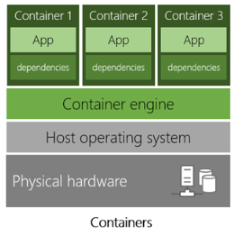
A container is a lightweight, standalone, and executable software package that includes everything needed to run an application—code, runtime, libraries, and dependencies that can run consistently across any infrastructure. Containers virtualize the operating system (OS) instead of hardware, making them faster and more efficient than traditional virtual machines (VMs).
Key Features:
- Portability: Runs consistently across different environments (Dev, Test, Prod).
- Lightweight: Shares the host OS kernel, unlike VMs.
- Fast Deployment: Starts in seconds.
- Scalability: Easily scales up or down.
- Isolation: Each container runs independently.
How Containers Work:
- Container Images: Containers are created from container images, which are read-only templates that contain the application and its dependencies.
- Container Runtime: A container runtime (like Docker or containerd) is responsible for running containers from images.
- Namespaces and Control Groups (cgroups): Containers use Linux namespaces to isolate processes, network interfaces, and file systems. Cgroups are used to limit and manage the resources (CPU, memory, disk I/O) that a container can use.

Types of container
Persistent Containers
- Definition: Containers that retain data even after they stop or restart.
- Use Case: Useful for applications requiring data persistence, such as databases.
- Storage: Uses persistent volumes (e.g., Azure Managed Disks, AWS EBS, Kubernetes Persistent Volumes).
- Example: Running a MySQL database in a container with an external volume to store data.
Transient (Ephemeral) Containers
- Definition: Containers that lose their data once stopped or restarted.
- Use Case: Ideal for temporary tasks, microservices, or stateless applications.
- Storage: Uses temporary filesystem (tmpfs) or non-persistent storage.
- Example: Running a temporary API service that processes requests but doesn’t store user data.

What is containerization and docker architecture
Containerization is the process of packaging an application and its dependencies into a single container image. It ensures that applications run consistently across different environments without worrying about system configurations.
Docker is a containerization platform that allows you to create, manage, and run containers.
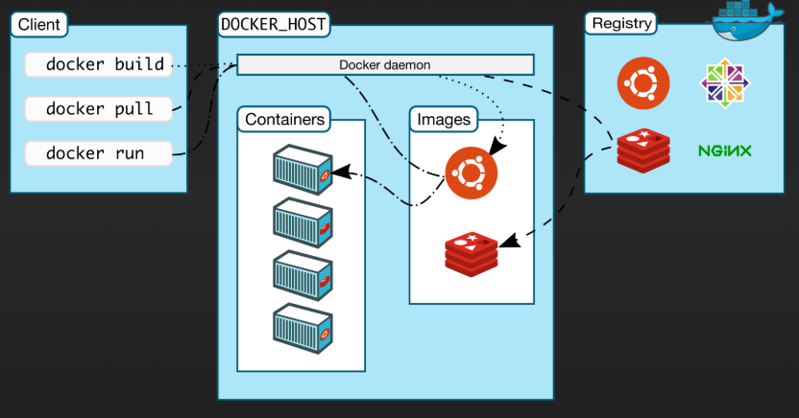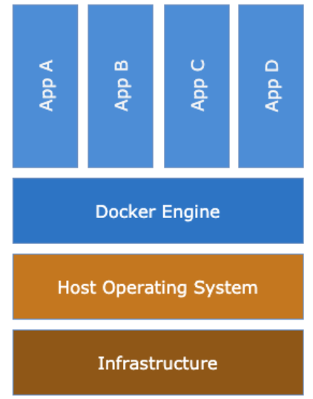
Docker Client:
User interface (CLI/GUI) to send commands to the Docker Daemon. It's how you tell Docker what to do (build, run, pull, etc.).
Docker Daemon (dockerd):
The Docker Daemon (dockerd) is the background engine of Docker. It listens for API requests from the Docker Client and manages Docker objects. It builds and stores images, creates and runs containers, handles networking and storage, and is the core process that orchestrates all Docker operations.
Docker Images:
Read-only templates for creating containers. They contain application code, dependencies, and instructions (Dockerfile).
Docker Containers:
Running instances of Docker Images. Isolated, lightweight environments that share the host kernel. They encapsulate applications and their dependencies.
Docker Registry (Hub):
Storage and distribution system for Docker Images. Docker Hub is the public default, but private registries exist. Used for pushing and pulling images.

Kubernetes
Docker cannot auto manage the services, it has to be done manually. Kubernetes is an open-source container orchestration system that automates the deployment, scaling, and management of containerized applications. Kubernetes orchestrates Docker containers.
Kubernetes Architecture
Kubernetes follows a master-worker architecture:
Control Plane (Master Node)
Manages the entire cluster and makes global decisions.
Components:
- API Server – Exposes the Kubernetes API, processes user requests.
- Controller Manager – Ensures desired state by managing controllers (replica sets, endpoints, etc.).
- Scheduler – Assigns workloads (Pods) to worker nodes based on resource availability.
- etcd – Stores cluster configuration and state.
Worker Nodes
Execute the actual workloads (containers inside pods).
Components:
- Kubelet – Manages containers on the node, communicates with the control plane.
- Container Runtime (Docker/CRI-O/containerd) – Runs the containers.
- Kube Proxy – Handles networking, load balancing, and inter-pod communication.
- Pods – The smallest deployable unit, containing one or more containers.
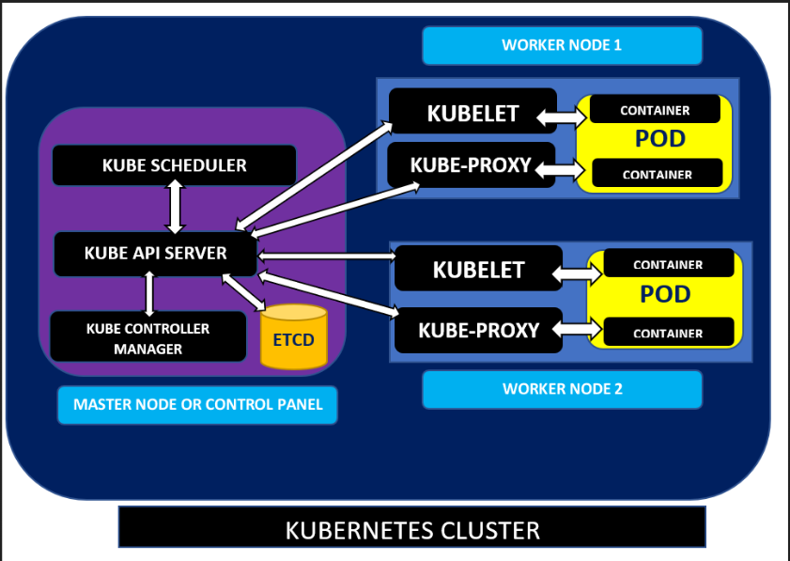
How Kubernetes Works?
1️.User sends a request via kubectl to the API Server.
2️.Scheduler assigns a node based on resource availability.
3️.Kubelet pulls the container image and starts the pod.
4️.Kube Proxy manages networking for communication between pods.
5️.Controller Manager ensures the pod runs as desired.

UNIT-3
What is Azure?
Microsoft Azure is a cloud computing platform that provides a wide range of services for computing, storage, networking, AI, analytics, and more. It enables businesses to build, deploy, and manage applications efficiently through Microsoft-managed data centers worldwide. It works on “Pay As You Go” pricing, which means how much you use, pay only for that.
Key Services Offered by Azure
1. Compute Services
- Azure Virtual Machines (VMs) – Run Windows/Linux-based virtual machines.
- Azure Kubernetes Service (AKS) – Manages containerized applications.
- Azure Functions – Serverless computing for event-driven execution.
- Azure App Services – Hosts web apps, REST APIs, and mobile backends.
2. Storage Services
- Azure Blob Storage – Scalable object storage for unstructured data.
- Azure File Storage – Managed file shares accessible via SMB.
- Azure Disk Storage – SSD/HDD storage for VMs.
3️. Networking Services
- Azure Virtual Network (VNet) – Secure network for Azure resources.
- Azure Load Balancer – Distributes traffic across resources.
- Azure CDN (Content Delivery Network) – Speeds up content delivery.
4️. Database Services
- Azure SQL Database – Managed relational database service.
- Azure Cosmos DB – Globally distributed NoSQL database.
- Azure Database for PostgreSQL/MySQL – Fully managed open-source databases.
5️. AI & Machine Learning
- Azure Machine Learning – Develop and deploy ML models.
- Azure Cognitive Services – AI-powered vision, speech, and language processing.
6️. Security & Identity
- Azure Active Directory (AD) – Identity management and authentication.
- Azure Security Center – Threat protection and security management.
7️. DevOps & Development
- Azure DevOps – CI/CD pipeline, repo management, and testing.
- Azure Logic Apps – Automate workflows without writing code.
Automation in DevOps is a Result of Cloud Computing Utilization
- Scalable Infrastructure: Cloud enables on-demand provisioning using Infrastructure as Code (IaC) (e.g., Terraform, AWS CloudFormation).
- CI/CD Pipelines: Cloud-based CI/CD tools (GitHub Actions, Jenkins, Azure DevOps) automate software building, testing, and deployment.
- Monitoring & Logging: Cloud services like AWS CloudWatch, Azure Monitor automate log collection, scaling, and issue detection.
- Containerization & Serverless: Kubernetes, AWS Lambda, Azure Functions automate deployment, scaling, and management.
DevOps automation is deeply integrated with cloud computing because cloud platforms provide scalable, flexible, and automated infrastructure, CI/CD pipelines, monitoring, and containerization solutions. This eliminates manual intervention, speeds up development, and enhances efficiency, making cloud computing a key driver of DevOps automation.
What is devops
DevOps is a set of practices that automates and integrates the processes between software development (Dev) and IT operations (Ops). It aims to shorten the systems development life cycle and provide continuous delivery with high software quality. It focuses on automation, continuous integration (CI), continuous delivery (CD), and monitoring to streamline the software lifecycle.
Three exes of devops
Culture:
- This focuses on people and collaboration. It emphasizes:
- Breaking down silos between development and operations.
- Promoting communication, transparency, and trust.
- Encouraging shared responsibility and ownership.
- Fostering continuous learning and a growth mindset.
Methods:
- This focuses on processes and practices. It includes:
- Adopting Agile methodologies (Scrum, Kanban).
- Implementing Continuous Integration and Continuous Delivery (CI/CD).
- Applying Lean principles to optimize workflows and eliminate waste.
Tools:
- This focuses on technology and automation. It involves:
- Utilizing automation tools for build, test, and deployment.
- Employing monitoring and logging tools for visibility.
- Using collaboration tools for communication and knowledge sharing.
Essentially, it's a holistic approach, recognizing that successful DevOps implementation requires more than just tools; it needs a supportive culture and efficient methodologies.
What is ci-cd
CI/CD stands for Continuous Integration and Continuous Delivery (or Continuous Deployment). It's a set of practices that automate the software release process, enabling faster and more reliable software delivery. Here's a breakdown:
Continuous Integration (CI):
- This involves developers frequently integrating their code changes into a central repository.
- Each integration is verified by an automated build and automated tests.
- The goal is to detect integration errors as early as possible.
- This helps to ensure that the code is always in a working state.
Continuous Delivery (CD):
- This extends CI by automatically deploying code changes to staging or testing environments.
- It ensures that the software can be released to production at any time.
- The focus is on automating the release process, but the final deployment to production might require manual approval.
Continuous Deployment (CD):
- This goes a step further than Continuous Delivery by automatically deploying code changes directly to production.
- It eliminates the need for manual intervention in the deployment process.
- This requires a high level of confidence in the automated testing and deployment processes.
CI-CD pipeline and stages
A CI/CD pipeline is an automated workflow that streamlines the process of building, testing, and deploying software. It's the practical implementation of Continuous Integration (CI) and Continuous Delivery/Deployment (CD) practices.
CI/CD Pipeline Stages & Tools:
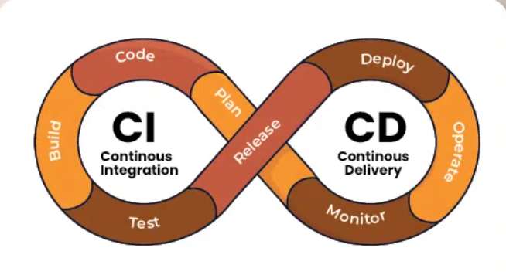
- Plan - Define project scope and tasks.
  - Tools: Jira, Trello, Azure Boards
- Code - Developers write and push code to a repository.
  - Tools: Git(GitHub, GitLab),Visual studio code
- Build - Compile code and manage dependencies.
  - Tools: Jenkins, Maven, Gradle,Docker
- Test - Automated testing to detect bugs.
  - Tools: JUnit, Selenium, TestNG, JMeter
- Release - Package and prepare for deployment.
  - Tools: JFrog Artifactory, Nexus, Docker Registry
- Deploy - Deploy the application to servers or cloud.
  - Tools: Kubernetes,Ansible,Terraform
- Operate - Run the application and manage resources.
  - Tools: Kubernetes, Docker, OpenShift
- Monitor - Track application health and performance.
  - Tools: Prometheus, Grafana, Splunk, ELK Stack

Q: List any 2 service categories in Azure and explain all services in it in detail.

✅ 1. Compute Services (Azure)
Azure’s Compute category provides resources to host applications, run workloads, and manage containers or VMs.

🔹 a) Azure Virtual Machines (VMs)
- IaaS-based compute service.
- Lets users create Linux or Windows-based virtual servers in the cloud.
- Fully customizable: you choose OS, storage, networking, etc.
- Used for: hosting apps, databases, or testing environments.
🛠 Features:
- Auto-scaling, Load balancing, Choice of regions and availability zones

🔹 b) Azure App Service
- PaaS solution to build and host web apps, REST APIs, and mobile backends.
- Supports multiple languages: .NET, Java, Python, Node.js, PHP, Ruby.
🚀 Benefits:
- Auto-scaling, Integrated CI/CD with GitHub, Azure DevOps, Built-in security & compliance

🔹 c) Azure Functions (Serverless)
- Event-driven, serverless compute platform.
- Automatically scales depending on workload.
- You only pay when your code runs.
📦 Use cases:
- Real-time data processing
- Scheduled tasks
- Responding to database updates or messages

🔹 d) Azure Kubernetes Service (AKS)
- Fully managed Kubernetes container orchestration.
- Simplifies deploying, managing, and scaling containerized apps using Kubernetes.
🔧 Key features:
- Integrated monitoring
- Automatic scaling
- Built-in CI/CD tools

🔹 e) Azure Batch
- Job scheduling service for parallel and high-performance computing (HPC) tasks.
- Automatically provisions VMs, runs jobs, and scales down resources.
💼 Example: Image processing, financial risk modeling, simulations.

✅ 2. Storage Services (Azure)
Azure’s Storage category provides scalable, secure, and durable cloud storage solutions for different data types.

🔹 a) Azure Blob Storage
- Object storage for unstructured data (images, videos, documents).
- Supports hot, cool, and archive access tiers for cost efficiency.
📁 Use cases:
- Backup and restore
- Data lake for analytics
- Static website hosting

🔹 b) Azure File Storage
- Shared file storage with SMB protocol.
- Can be mounted by Windows, Linux, or macOS systems.
🌐 Great for:
- File shares across multiple VMs
- On-premise to cloud file migrations

🔹 c) Azure Queue Storage
- Message queue service for communication between components.
- Ensures asynchronous message delivery between distributed applications.
📬 Scenario:
- Web app sends order request → processed by backend through the queue.

🔹 d) Azure Table Storage
- NoSQL key-value store.
- Stores structured, non-relational data.
- Offers fast read/write operations and horizontal scaling.
🧾 Use cases:
- Logging data
- Product catalogs
- IoT telemetry data

🔹 e) Azure Disk Storage
- Persistent block storage for Azure VMs.
- Types: Standard HDD, Standard SSD, Premium SSD, Ultra Disk.
💻 Used for:
- OS disks
- Application data storage
- Databases like SQL Server or Oracle
To create a Virtual Machine in Azure, follow these steps:
- Login to Azure Portal
  - Go to https://portal.azure.com and sign in.
- Start VM Creation
  - Click on "Virtual Machines" in the left menu.
  - Click “+ Create” > “Azure virtual machine”.
- Configure Basic Settings
  - Choose subscription, resource group, VM name, and region.
  - Select OS image (e.g., Windows/Linux), VM size, and create an admin username/password or SSH key.
- Configure Disks and Networking
  - Choose disk type (HDD/SSD).
  - Set up Virtual Network, subnet, public IP, and firewall rules (RDP for Windows, SSH for Linux).
- Management and Monitoring (Optional)
  - Enable options like auto-shutdown, boot diagnostics, or monitoring.
- Review and Create
  - Azure validates the settings. Click “Create”.
  - After deployment, use RDP/SSH to access the VM.
Aspect | Continuous Integration (CI) | Continuous Deployment (CD)
Purpose | Integrates code changes frequently into the main branch | Automates deployment of integrated code to production
Scope | Handles code testing, building, and merging | Handles automated release and deployment process
Automation | Automates code integration and testing | Automates deployment from integration to production
Frequency | Done several times a day | Deploys changes continuously or after each successful integration
Focus | Maintains a stable codebase | Ensures fast, reliable, and consistent releases
Purpose | Merge code frequently | Deliver software automatically
Tools | Jenkins, Travis CI | Spinnaker, AWS CodeDeploy
Benefit | Faster integration | Faster delivery to production

Service | Description
Azure DevOps Services | A suite of tools for planning, developing, testing, and delivering software. It includes Azure Boards, Repos, Pipelines, Test Plans, and Artifacts.
Azure Pipelines | A cloud service for automating builds and deployments. Supports CI/CD for various platforms and languages.
Azure Repos | Provides Git repositories for version control and collaborative development.
Azure Test Plans | Tools for manual and exploratory testing of your applications.
Azure Artifacts | A service to host and manage packages, enabling version control and distribution of dependencies.
Azure Kubernetes Service (AKS) | Managed Kubernetes service to deploy and manage containerized applications, supporting DevOps workflows for container-based apps.
Azure Container Registry (ACR) | A private registry for storing and managing Docker container images, integrated with Azure DevOps pipelines.
Azure Monitor | Provides full-stack monitoring and diagnostics for applications, helping ensure operational efficiency during the DevOps cycle.
Azure Automation | Automates repetitive tasks and orchestrates workflows, such as patch management, to streamline DevOps processes.
Azure DevTest Labs | Provides environments for continuous testing and development with pre-configured, reusable templates.

Creation of Storage Zones with Associated Users to Protect Cloud Storage and Ensure Proper Backups
Creating storage zones and associating them with specific users is an effective strategy to protect cloud storage from unauthorized access and ensure data integrity through proper backups. Here’s how this approach works:
- Data Isolation and Access Control: Storage zones allow for the logical segregation of data, ensuring that sensitive information is isolated from less critical data. Each storage zone can be assigned specific user access rights using Role-Based Access Control (RBAC) or Identity and Access Management (IAM) policies. This ensures that only authorized users can access specific zones.
- Encryption and Security: Data stored in each zone can be encrypted both at rest and in transit, providing an extra layer of security. Additionally, cloud providers offer monitoring tools to track access and detect suspicious activity, which helps prevent unauthorized data access.
- Backup and Disaster Recovery: Storage zones allow for targeted backup strategies. For example, sensitive data may be backed up more frequently with geo-redundant storage to protect against regional outages. Regular backups ensure that data can be restored in case of accidental deletion, corruption, or cyberattacks.
- Versioning and Data Integrity: By enabling versioning within storage zones, previous versions of files can be restored if data corruption or loss occurs. This ensures that data remains intact and can be recovered without compromising its integrity.
In conclusion, organizing cloud storage into storage zones with defined user access not only secures sensitive data but also facilitates robust backup and recovery processes, helping maintain business continuity and compliance with security standards.

In Azure (Using Azure Active Directory)

1. Create a User:
- Sign in to the Azure Portal.
- Navigate to Azure Active Directory.
- Under Manage, select Users.
- Click + New user at the top.
- Fill in the required details (username, name, etc.).
- Set the roles and group memberships (optional).
- Choose Create to add the user.

2. Create a User Group:
- In the Azure Active Directory section, go to Groups.
- Click + New group at the top.
- Choose Security or Microsoft 365 depending on the needs.
- Enter a name for the group and provide any necessary description.
- Add users to the group by selecting users from the directory.
- Click Create to create the group.

3. Assign Permissions to the Group:
- After creating the group, you can assign it roles or specific permissions by selecting the group and clicking Assign roles or Add permissions.
- This will allow you to control what the group members can access and modify within the Azure environment.

