FLOYD-WARSHALL
The Floyd-Warshall Algorithm is a dynamic programming algorithm used to find the shortest paths between all pairs of vertices in a weighted graph. It works with both directed and undirected graphs and supports graphs with negative edge weights (but no negative cycles). Efficient for small and dense graph but takes more memory space.The algorithm systematically updates the shortest distances by considering each vertex as an intermediate between every pair of vertices.
- Initialize the Distance Matrix:
- If there is a direct edge between two nodes, set the distance.
- If no direct edge exists, set the distance to ∞ (infinity).
- The distance from a node to itself is 0.
- Iterate Over All Intermediate Nodes (k): For each node k, check if passing through k gives a shorter path between any two nodes i and j. If yes, update the distance
- Repeat for Every Node k: Do this for every node k as an intermediate.
- Final Distance Matrix: After k iterations we get the shortest distance for every node i to node j.

DIJKSTRA
The Dijkstra Algorithm finds the shortest path from a single source node to all other nodes in a weighted graph. It is a greedy approach and works with both directed and undirected graphs but does not support graph with negative edges. Efficient for large and sparse graph and also takes less memory space. It works by iteratively selecting the node with the minimum distance and updating its neighbors.
STEPS:
- Initialize: Set start node’s distance = 0, others = ∞.
- Pick the smallest unvisited node.
- Update neighbour’s distances if a shorter path is found.
- Mark the node as visited.
- Repeat until all nodes are visited.
- Get shortest distances from start to all nodes.

MINIMUM SPANNING TREE
A spanning tree is a subset of the edges of the graph that forms a tree (acyclic) where every node of the graph is a part of the tree.
Properties:
- The number of vertices (V) in the graph and the spanning tree is the same.
- There is a fixed number of edges in the spanning tree which is equal to one less than the total number of vertices ( E = V-1 ).
- The spanning tree should not be disconnected, as in there should only be a single source of component, not more than that.
- The spanning tree should be acyclic, which means there would not be any cycle in the tree.
A minimum spanning tree (MST) is defined as a spanning tree that has the minimum weight among all the possible spanning trees. Like a spanning tree, there can also be many possible MSTs for a graph.
There are several algorithms to find the minimum spanning tree from a given graph such as prim’s mst algorithm and kruskal’s mst algorithm.
Kruskal’s Minimum Spanning Tree Algorithm
This is one of the popular algorithms for finding the minimum spanning tree from a connected, undirected graph. This is a greedy algorithm. This is used in a variety of practical applications such as network design, clustering, and data analysis.
The algorithm workflow is as below:
- First, it sorts all the edges of the graph by their weights,
- Then starts the iterations of finding the spanning tree.
- At each iteration, the algorithm adds the next lowest-weight edge one by one, such that the edges picked until now does not form a cycle.
Prim’s Minimum Spanning Tree Algorithm:
This is one of the popular algorithms for finding the minimum spanning tree from a connected, undirected graph. This is also a greedy algorithm. This algorithm can be used in various scenarios such as image segmentation based on color, texture, or other features. For Routing, as in finding the shortest path between two points for a delivery truck to follow.
This algorithm has the following workflow:
- It starts by selecting an arbitrary vertex and then adding it to the MST.
- Then, it repeatedly checks for the minimum edge weight that connects one vertex of MST to another vertex that is not yet in the MST.
- This process is continued until all the vertices are included in the MST.

Breadth-First Search (BFS) Algorithm:
BFS is used to explore a graph level by level, ensuring all nodes at the current level are visited before moving to the next level. BFS(Breadth First Search) uses Queue data structure for finding the shortest path. It works on the concept of FIFO (First In First Out).
STEPS:
- Start at the root node and add it to a queue.
- While the queue is not empty, dequeue a node and visit it.
- Enqueue all of its children (if any) into the queue.
- Repeat steps 2 and 3 until the queue is empty.

Depth-First Search (DFS) Algorithm:
DFS explores a graph by going as deep as possible along a branch before backtracking. DFS(Depth First Search) uses Stack data structure. It works on the concept of LIFO (Last In First Out).
1. Inorder Traversal (Practice):
Follow the below steps to solve the problem:
- Traverse the left subtree, i.e., call Inorder(left-subtree)
- Visit the root
- Traverse the right subtree, i.e., call Inorder(right-subtree)
2. Preorder Traversal (Practice):
Follow the below steps to solve the problem:
- Visit the root
- Traverse the left subtree, i.e., call Preorder(left-subtree)
- Traverse the right subtree, i.e., call Preorder(right-subtree)
3. Postorder Traversal (Practice):
Follow the below steps to solve the problem:
- Traverse the left subtree, i.e., call Postorder(left-subtree)
- Traverse the right subtree, i.e., call Postorder(right-subtree)
- Visit the root.

Unit-3
SVD
Singular Value Decomposition (SVD) is a matrix factorization technique used in linear algebra to decompose a matrix into three simpler matrices. It expresses a matrix as the product of three special matrices:
A=UΣVT
U represents rows of A and Column vectors of U are eigenvectors of A.AT
V represents columns of A and Column vectors of V are eigenvectors of AT.A
Singular values on diagonal of Σ is square roots of nonzero eigenvalues of both A.AT and AT.A
Where:
A is an m × n matrix
U is an m × m orthogonal matrix (left singular vectors)
Σ is an m × n diagonal matrix containing singular values σ1​, σ2​,...,σr​, where r is the rank of A.
VT is an n × n orthogonal matrix (right singular vectors)
If rank (A) = r, then we can use the reduced SVD:
A=UrΣrVrT
Where:
- Ur​ is m × r
- Σr​ is r × r
- VrT​ is r × n
This form is used in dimensionality reduction.
Geometric perspective:
- The right singular vectors (V) define input directions that are transformed.
- The singular values (Σ) scale these directions.
- The left singular vectors (U) define output directions after transformation.
Properties:
- SVD exists for all matrices (even non-square, non-invertible matrices).
- Singular values are always non-negative.
- The number of nonzero singular values = rank of matrix.
- SVD provides the best low-rank approximation (used in PCA).
- Eigenvalues of A.AT and AT.A are the squares of singular values.
- If A is symmetric (A=AT), then U=V, and SVD becomes Eigen Decomposition.

Advantages of SVD:
- Works for all matrices (square, rectangular, or singular).
- Used for data compression (removing low-importance components).
- Extracts important features in high-dimensional data.
- Robust to noise in machine learning applications.
- Provides best low-rank approximation (used in PCA).

Disadvantages of SVD:
- Computationally expensive (Time Complexity: O(mn2) for large matrices).
- Difficult to interpret singular vectors in some cases.
- Not scalable for large datasets without approximation techniques (like Truncated SVD).
Applications:
- Dimensionality Reduction-pca,lsa
- Ranking Documents and Web Pages
- Image compression
- Centering Data
- Clustering a Mixture of Spherical Gaussians
- An Application of SVD to a Discrete Optimization Problem
Imagine we have a restaurant sales data matrix, where:
- Rows = Different customers
- Columns = Different dishes
- Values = Amount spent on each dish
Let’s say we have a 4 × 3 matrix A representing this data:
A=[[10,0,2],
[4,2,1],
[2,3,2],
[8,5,1]]
A=UΣVT
- U → Shows customer preferences for specific dish types.
- Σ → identifies the most important spending patterns.
- VT → Represents dish categories based on sales.

Applications of Singular Value Decomposition:
3.9.1 Centering Data
3.9.2 Principal Component Analysis
3.9.3 Clustering a Mixture of Spherical Gaussians
3.9.4 Ranking Documents and Web Pages
3.9.5 An Application of SVD to a Discrete Optimization Problem

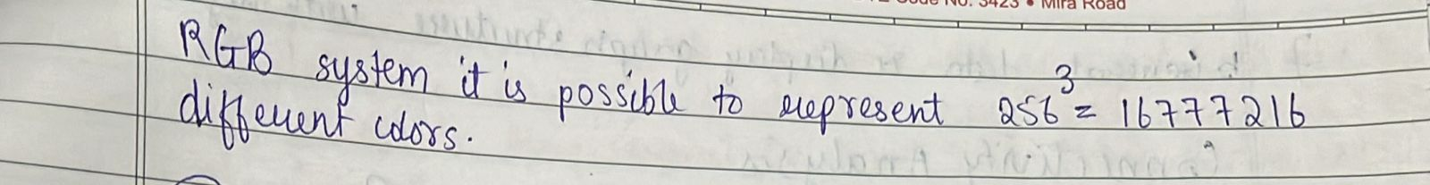
Unit-2
Page rank:
PageRank is an algorithm developed by Google to rank web pages based on their importance. It assigns a numerical weight to each webpage, indicating its significance in a network of links. The algorithm assumes that important pages are linked to by many other important pages. The PageRank algorithm outputs a probability distribution used to represent the likelihood that a person randomly clicking on links will arrive at any particular page. PageRank can be calculated for collections of documents of any size.
PageRank is not limited to websites. While it was originally designed to rank web pages, the same algorithm can be applied to any network or graph-based system where relationships matter like social networks, citation networks, etc.

Steps of the PageRank Algorithm:
- Initialize PageRanks:
  - Assign an equal initial PageRank to all pages (PR = 1/N, where N is the number of pages).
- Set the Damping Factor:
  - Use a damping factor d (usually 0.85) to account for the probability of a user randomly jumping to another page.
- Update PageRanks Iteratively:
  - For each page A, compute:
PR(A) = (1-β) + β * [PR(B) / Cout(B) + PR(C) / Cout(C)+ ...... + PR(N) / Cout(N)]
Where,
β is damping factor i.e. 0.8/0.85
PR(A) = PageRank of page A
PR(B) = PageRank of page B (linking to A)
Cout(B) = Number of outbound links from page B
- Check for Convergence:
  - Repeat the process until PageRank values stabilize (i.e., changes become very small).
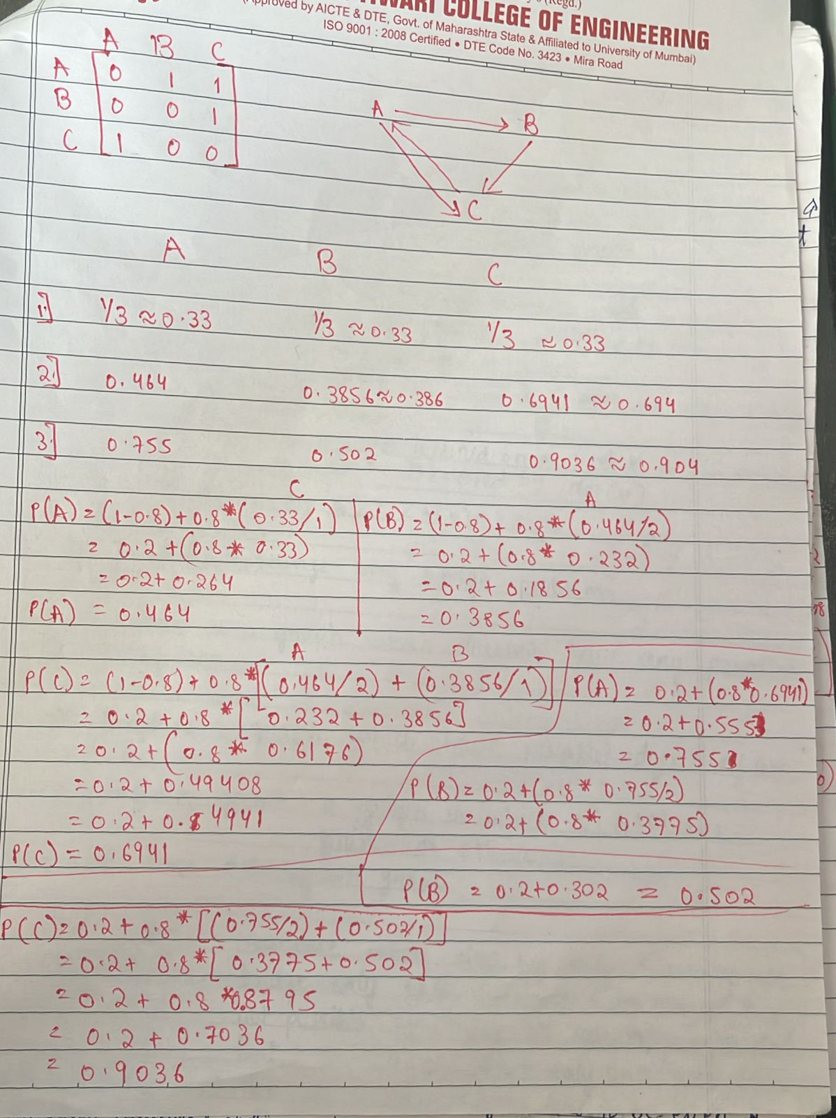

UNIT-2
Law of Large Number
As the sample size increases, biases and errors decrease, and the statistical function gets closer to the actual population function value.
The sample mean converges to the expected value of the random variable.
Let X1, X2,…, Xn be an independent and identically distributed (i.i.d) samples of random variables X then
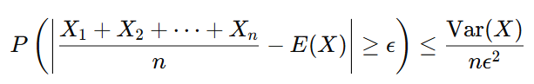
Where,
E(X) is the expected value (mean) of the random variable.
Var(X) is the variance of the random variable.
ϵ is a small positive number.
n is the number of observations.

Types of the Law of Large Numbers
1. Weak Law of Large Numbers (WLLN)
As the number of trials or observations increases, the sample mean converges in probability to the expected value. That is, for a large enough sample size, the probability that the sample mean deviates significantly from the expected mean becomes very small. This means that:
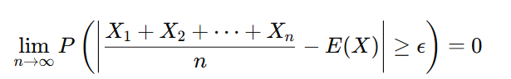
2. Strong Law of Large Numbers (SLLN)
This states that the sample mean almost surely (with probability 1) converges to the expected value. This is a stronger form of convergence than WLLN. This means that, in the long run, the sample average will almost certainly equal the expected value.
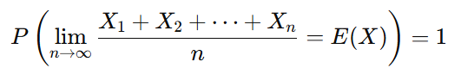

Example of LLN:
Coin Flipping:
- If you flip a fair coin, the probability of getting heads is 50%.
- If you flip it only a few times, you might get a skewed result (e.g., 3 heads in a row).
- However, if you flip it thousands of times, the proportion of heads will become very close to 50%.

Markovs inequalities:
Markov’s inequality states that the probability that a nonnegative random variable exceeds a is bounded by the expected value of the variable divided by a. Markov’s inequality is especially useful when we lack complete knowledge of the distribution but need a rough estimate of extreme values.
For a non-negative random variable X with expected value 𝐸 (𝑋) and for any a>0,
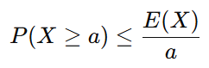
Let X be a random variable representing the number of minutes a person spends on a website, and suppose E(X)=20 minutes. Using Markov's inequality, we can estimate the probability that a visitor spends at least 50 minutes on the website:
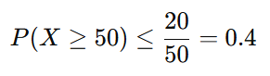
So, the probability that a visitor spends at least 50 minutes on the site is at most 40%.

Chebyshev’s Inequality
Chebyshev’s Inequality states that for any random variable X with finite mean E(X) and variance Var (X), the probability that X deviates from its mean by more than c is at most Var(X)/c²
It is useful for datasets where the exact distribution is unknown but variance is available.
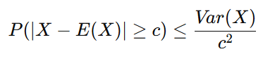
Example:
Suppose the height of students in a class has a mean of 160 cm and a variance of 25 cm². Using Chebyshev’s inequality, we can bound the probability that a student’s height is more than 170 cm or less than 150 cm (c=10):
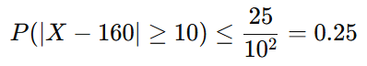
This means that at most 25% of students will have a height outside this range.

Bernoulli’s Inequality
Bernoulli’s inequality states that for any real number x≥−1 and any integer n≥0, the following holds:
(1+x)^{n} ≥1+nx

Prove that in high-dimensional space, the majority of the volume of a unit sphere is concentrated near its surface.
Explain why the majority of the volume of a unit sphere is concentrated near its surface.
Let’s consider a unit sphere in d-dimensional space and prove that as d increases, most of its volume is concentrated near its surface.
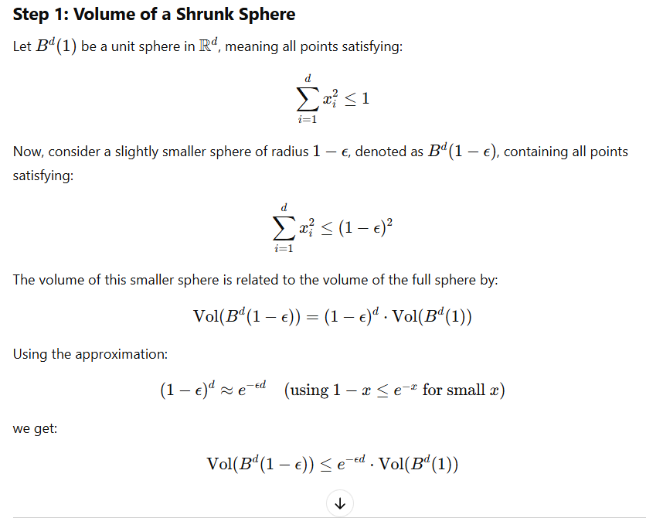
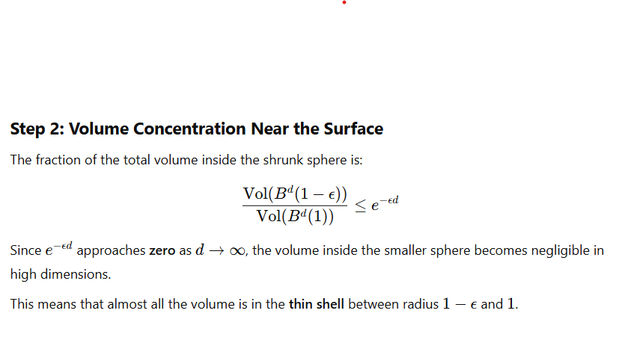
Thus, in high dimensions, the volume of a unit sphere is concentrated in a shell of thickness 1/d near the surface.
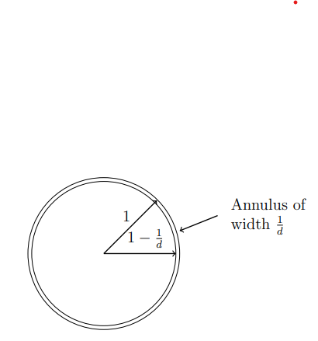
Most of the volume of the d-dimensional ball of radius r is contained in an annulus of width O(r/d) near the boundary.
Explain why the majority of the volume of a unit sphere is concentrated near its equator.
As the dimensionality increases, most of the volume shifts away from the center and poles, concentrating near the equator (the middle region).
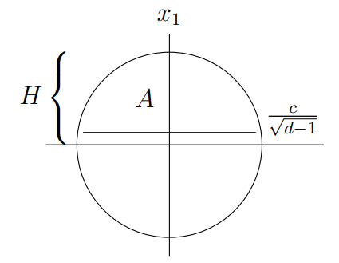
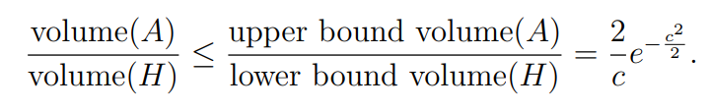
where:
A represents a subset of the sphere (e.g., a cap region near the poles).
H represents the hemi sphere.
The bound 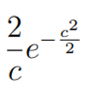 decreases exponentially as c (distance from the equator) increases.
This suggests that the fraction of the total volume in A is small compared to H.
Since the volume fraction near the poles (caps) is exponentially small, the majority of the volume must be in the equatorial region.

UNIT-3
Explain the concept of random graph using gnp/erdos renyi model and also degree distribution
A random graph is a graph where edges are formed based on some probability rather than a fixed pattern. The Erdős–Rényi (G(n, p)) model is one of the fundamental models used to generate random graphs.
Erdős–Rényi (G(n, p)) Model
- The model consists of n nodes.
- Each possible edge between any two nodes is included independently with probability p.
- The structure of the graph is determined by randomness, meaning different graphs can be generated for the same n and p values.
- The expected number of edges in the graph is given by: 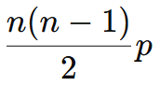
- The degree of a node follows a binomial distribution: 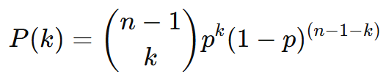,expected degree of node is (n-1)*p.
- G(n,p) model exhibits different structural properties based on the edge probability p. As p changes, the graph transitions through distinct phases.
- The G(n,p) model transitions from isolated nodes to a fully connected graph as p increases.
- This model is widely used to study the behavior of networks in different probability ranges, such as connectivity and clustering. This model helps in understanding random networks but may not always represent real-world complex networks like social or biological networks.
Example: N=5, P=0.5, Expected number of edges=((5*4)/2)*0.5=5
- Each edge appears with a probability of 0.5, meaning some edges will form randomly. The resulting graph may be connected or disconnected depending on which edges are selected.
Degree Distribution in G(n, p) Model
- In a graph, the degree of a node is the number of edges connected to it. The degree distribution describes how the degrees of nodes are distributed across the entire graph.
- In G(n,p) model, the degree of a node follows a binomial distribution
Where:
n−1 is the total possible neighbors of a node, p is the probability of an edge existing, k is the degree of a node.
- Expected degree=(n-1)*p
- For small p: The graph is sparse, and many nodes have low degrees (even isolated nodes).
- For large p: The degree distribution becomes more concentrated around (n−1)*p, resembling a normal distribution (due to the Central Limit Theorem).
- For very large p≈1: The graph is nearly complete, and most nodes have similar degrees close to n−1.

- As n ->∞ and p remains constant, the binomial distribution can be approximated by a Poisson distribution: 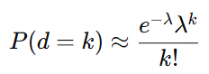
Where λ= (n−1)p
- The average degree of a node is (n-1)*p, meaning most nodes have degrees close to this value.
- Unlike real-world networks which often follow a power-law degree distribution where few nodes have a very high degree, while most have low degrees, random graphs in this model have a bell-shaped degree distribution where most nodes have a similar number of connections.
- Thus, the degree distribution in G(n,p) transitions from binomial to Poisson-like for sparse graphs and to normal-like for denser graphs.
What is sharp threshold / list and explain threshold
- A threshold in graph theory refers to a critical value of a probability (p) that causes transition in a property of random graph meaning a significant structural change occurs. In random graphs, thresholds help identify when properties like connectivity, giant components, or clustering emerge.
- A sharp threshold indicates a sudden change in the graph's properties as the probability 'p' crosses a certain value. In other words, the property changes rapidly from almost never occurring to almost always occurring within a very narrow range of 'p'.
- If Var(X) is small, it implies X is highly concentrated around E[X], meaning a sharp transition occurs.
- If Var(X) is large, the transition might be more gradual or random fluctuations might occur.
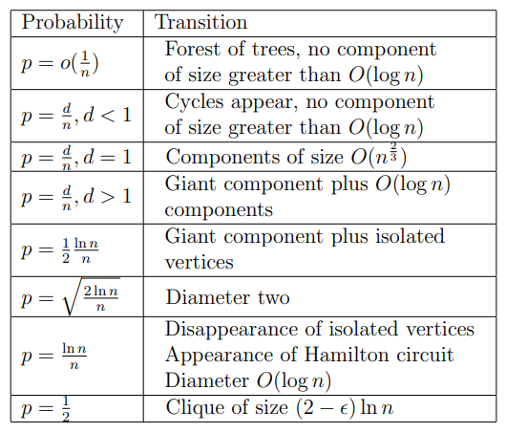

- This means p grows slower than 1/n. The graph is a forest of trees. This is a very gradual change, not a sharp threshold.

- Below this threshold (d<1): The graph consists of many small, disconnected components.

- At d=1 (Critical Point): A phase transition occurs, meaning a large component starts to form.

- Above this threshold (d>1): A giant component emerges, which means one connected component contains a significant fraction of all nodes. This is sharp threshold.

- Below this threshold, isolated vertices (nodes with no edges) still exist with high probability.
At this threshold, the probability of having an isolated vertex approaches zero, meaning every node has at least one connection. This is sharp threshold for giant component but it is not the sharp threshold for the disappearance of isolated vertices, but rather an approximate one.

- Below this threshold, some pairs of nodes still need three or more edges to connect, making the diameter greater than 2. This is a sharp threshold. At threshold, the diameter rapidly shrinks to 2 around this value.

- Below this, some nodes remain isolated (degree = 0).
Above this, the probability of isolated nodes vanishing approaches 1, meaning every node is connected to at least one other node.
At this probability, the graph almost surely contains a Hamiltonian cycle, meaning there is a cycle that visits each node exactly once. This is sharp threshold

Phase Transition in Random Graphs: First and Second Moment Analysis
In random graphs, a phase transition refers to a sudden structural change as the edge probability p increases.
One of the most well-known phase transitions in the Erdős–Rényi G(n,p) model is the emergence of a giant component when p crosses a critical threshold. This can be analyzed using the first moment method (expectation) and the second moment method (variance).
1. First Moment Method (Expectation-Based Analysis)
The first moment method estimates when certain properties (e.g., isolated vertices, small components) disappear or emerge by computing their expected number.
Example: Isolated Vertices and Giant Component
- The expected number of isolated vertices (nodes with no edges) is: E[X]= n(1−p)^{n-1}.
- When p≈ log n/n, we find E[X] → 0, meaning isolated nodes disappear, and the graph becomes connected.
- The giant component starts to form at p= 1/n, when the expected size of the largest connected component becomes a constant fraction of n.
However, the first moment method alone does not determine whether this transition is sharp or gradual. That’s where the second moment method becomes useful.
2. Second Moment Method (Variance-Based Analysis)
The second moment method considers variance to show how concentrated a property is around its expected value. For instance, for an event X, we calculate: Var(X)=E[X²]−(E[X])²
- If Var(X) is small, it implies X is highly concentrated around E[X], meaning a sharp transition occurs.
- If Var(X) is large, the transition might be more gradual or random fluctuations might occur.
Example: Number of Isolated Vertices
- The variance is: Var(X) = E[X²]−(E[X])²
- If p≫ log n/n, we find that Var(X) → 0, meaning all nodes are highly likely to be connected.
This confirms that connectivity undergoes a sharp phase transition.
The giant component transition at p=1/n is not sharp, because Var(X) is large as small components can still persist.
- The combination of the first and second moment methods allows us to identify both the critical threshold and the nature of phase transitions in random graphs.
- Some transitions, like connectivity and Hamiltonicity, are sharp, while others, like the formation of a giant component, occur more gradually.
