

EE/VAL/SRT/LB/2023-24/11/3680


Page No: 1 of 3

EE/VAL/SRT/LB/2023-24/11/3680

 |  | DESKTOP VALUATION REPORT
Sr No | Particulars |  | Details
1 | Name of The Customers |  | {myname}
2 | Report Date |  | <<my date>>
3 | Case Ref No. |  | EE/VAL/SRT/LB/2023-24/11/3680
Property Details
4 | Property Address |  | Plot No. 72, Green Park Vibhag - 2, Behind Shreeji Residency, Nr.
4 |  |  | Haldharu Village, Haldharu Road, Haldharu, Surat.
5 | Nearest Landmark |  | Haldharu Road
6 | Property Land Area |  | 432.17 Sq Ft
7 | Built Up Area / Carpet Area / Super Built |  | 259.30 (Permissible) Sq.Ft. (BUA)
 | Up Area
8 | Land Value |  | Rs.6,48,255.00
9 | Type of Property |  | Residential Plot
10 | Unit Rate considered for Land |  | Rs.1,500.00
11 | Unit Rate considered for CA / BUA / SBA |  | Rs.1,500.00 Sq.Ft. on Built-up Area
12 | Building Value |  | 259.30 (Permissible) X Rs.1,500.00
12 |  |  | Rs.3,88,950.00
13 | Final Valuation |  | Rs.10,37,205.00
14 | Final Valuation in Word |  | Rupees Ten Lakh Thirty Seven Thousand Two Hundred Five only
 | Remark if Any

1. We have considered Desktop Valuation for Subjected Property.

2. We have not done the Property Visit.

3. The Rate Considered is as per Surrounding Market Survey & on the basis of Sale Deed Document.

4. The Approved Layout Plan & Building Plan does not provide to us. So we have not verified it.

5. We have considered Construction Cost of Ground Floor Only.

PARTHKUMAR

VITTHALBHAI

VASOYA

Digitally signed by PARTHKUMAR VITTHALBHAI VASOYA Date: 2023.11.23 11:04:54 +05'30'


Page No: 2 of 3

EE/VAL/SRT/LB/2023-24/11/3680

Route Map
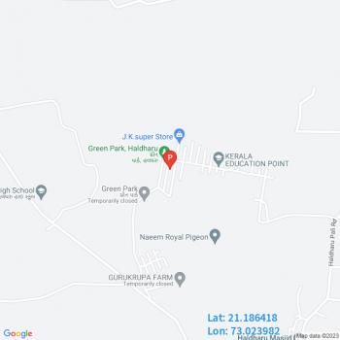

Satellite Map
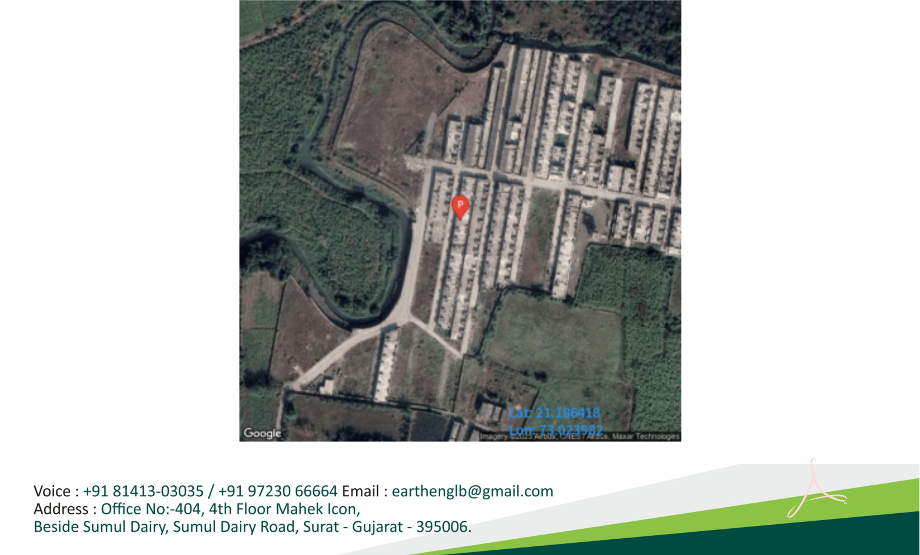

PARTHKUMAR

VITTHALBHAI

VASOYA

Digitally signed by PARTHKUMAR VITTHALBHAI VASOYA Date: 2023.11.23 11:05:06 +05'30'

Page No: 3 of 3

