

**EE/VAL/SRT/LB/2023-24/11/3680**



Page No: **1 of 3**



**EE/VAL/SRT/LB/2023-24/11/3680**

|  |  |  |  |  |
| --- | --- | --- | --- | --- |
|  |  | **DESKTOP VALUATION REPORT** | |  |
|  | | |  | |
| **Sr No** | **Particulars** | | **Details** | |
| 1 | Name of The Customers | | {data} |  |
|  |  | |  | |
| 2 | Report Date | | <<my date>> | |
|  |  | |  | |
| 3 | Case Ref No. | | EE/VAL/SRT/LB/2023-24/11/3680 | |
|  |  | |  |  |
| **Property Details** | | |  |  |
| 4 | Property Address | | Plot No. 72, Green Park Vibhag - 2, Behind Shreeji Residency, Nr. | |
| Haldharu Village, Haldharu Road, Haldharu, Surat. | |
|  |  |  |
|  |  | |  | |
| 5 | Nearest Landmark | | {land} | |
|  |  | |  | |
| 6 | Property Land Area | | 432.17 Sq Ft | |
|  |  | |  | |
| 7 | Built Up Area / Carpet Area / Super Built | | 259.30 (Permissible) Sq.Ft. (BUA) | |
|  | Up Area | |  |  |
| 8 | Land Value | | Rs.6,48,255.00 | |
|  |  | |  | |
| 9 | Type of Property | | Residential Plot | |
|  |  | |  | |
| 10 | Unit Rate considered for Land | | Rs.1,500.00 | |
|  |  | |  | |
| 11 | Unit Rate considered for CA / BUA / SBA | | Rs.1,500.00 Sq.Ft. on Built-up Area | |
|  |  |  |  | |
| 12 | Building Value | | 259.30 (Permissible) X Rs.1,500.00 | |
| Rs.3,88,950.00 | |
|  |  |  |
|  |  | |  | |
| 13 | Final Valuation | | Rs.10,37,205.00 | |
|  |  | |  | |
| 14 | Final Valuation in Word | | Rupees Ten Lakh Thirty Seven Thousand Two Hundred Five only | |
|  |  | |  |  |
|  | **Remark if Any** | |  |  |

1. We have considered Desktop Valuation for Subjected Property.

2. We have not done the Property Visit.

3. The Rate Considered is as per Surrounding Market Survey & on the basis of Sale Deed Document.

4. The Approved Layout Plan & Building Plan does not provide to us. So we have not verified it.

5. We have considered Construction Cost of Ground Floor Only.

PARTHKUMAR

VITTHALBHAI

VASOYA



Digitally signed by PARTHKUMAR VITTHALBHAI VASOYA Date: 2023.11.23 11:04:54 +05'30'



Page No: **2 of 3**



**EE/VAL/SRT/LB/2023-24/11/3680**

**Route Map**

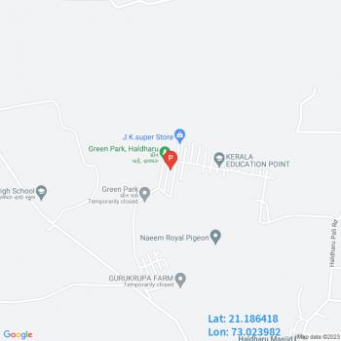

**Satellite Map**

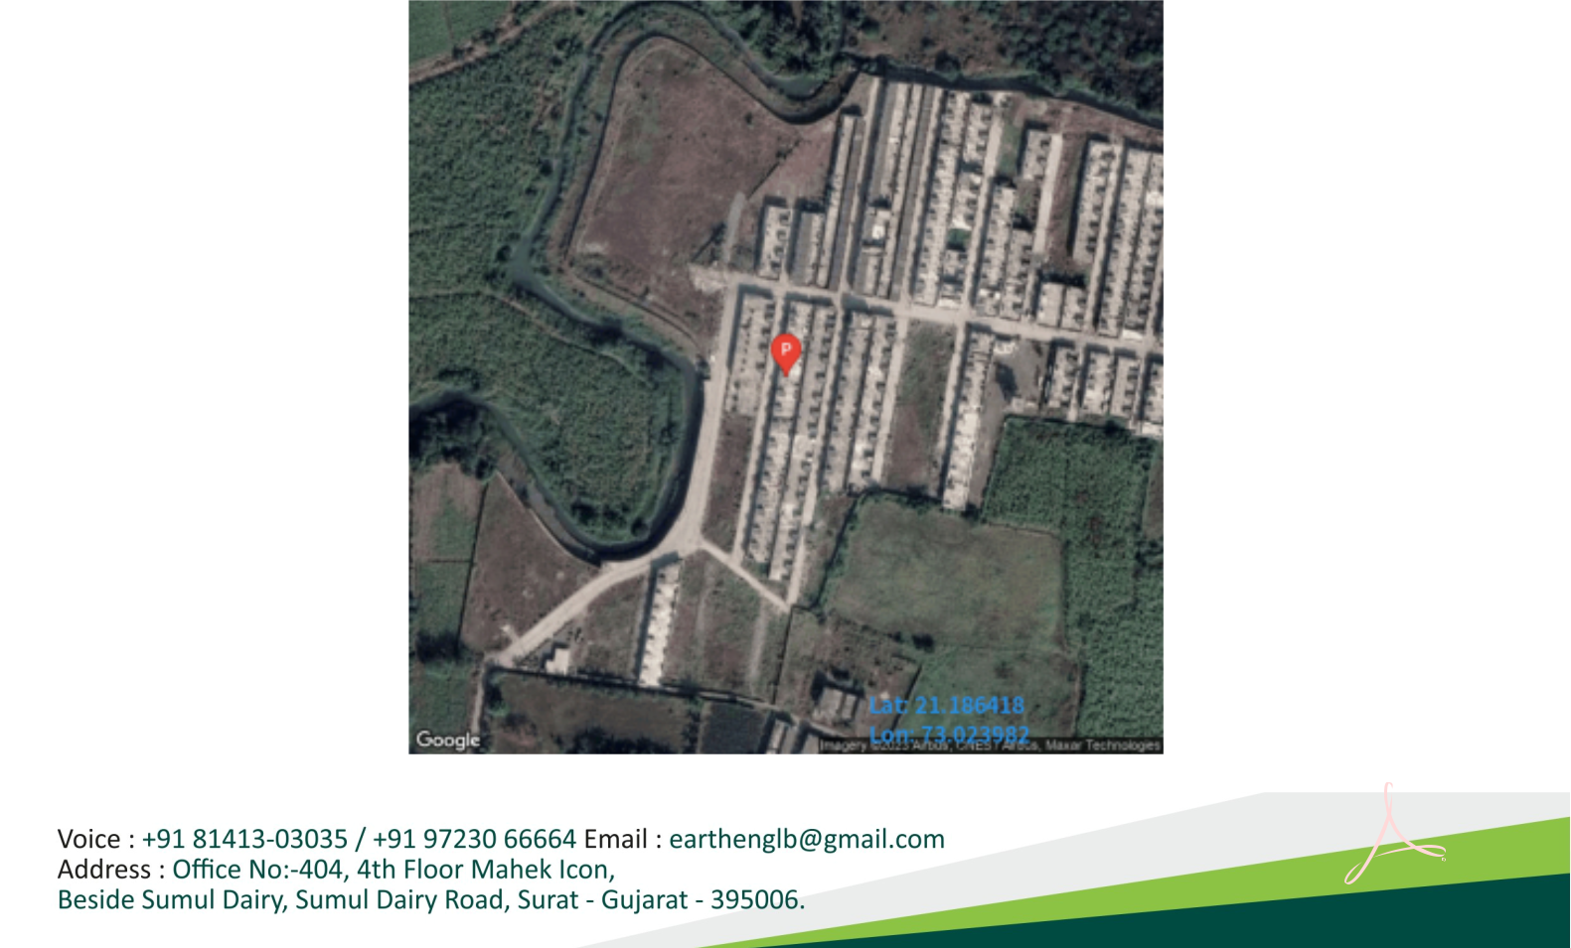

PARTHKUMAR

VITTHALBHAI

VASOYA

Digitally signed by PARTHKUMAR VITTHALBHAI VASOYA Date: 2023.11.23 11:05:06 +05'30'

Page No: **3 of 3**