**Assignment – 4**

-- 1. Create a stored procedure in the Northwind database that will calculate the average value of Freight for a specified customer. Then, a business rule will be added that will be triggered before every Update and Insert command in the Orders controller, and will use the stored procedure to verify that the Freight does not exceed the average freight. If it does, a message will be displayed and the command will be cancelled.

-- Create Procedure For Check Validate Freight

CREATE PROCEDURE sp_Validate_Freight

-- inputted customer

@CustomerID nvarchar(10),

-- returned average freight

@AverageFreight money output

AS

BEGIN

SELECT @AverageFreight = AVG(Freight)

FROM Orders

WHERE CustomerID = @CustomerID

END

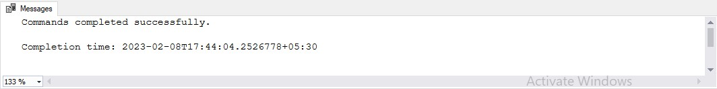

DECLARE @AvgFreight int;

EXECUTE sp_Validate_Freight 'VINET', @AvgFreight output;

PRINT @AvgFreight;

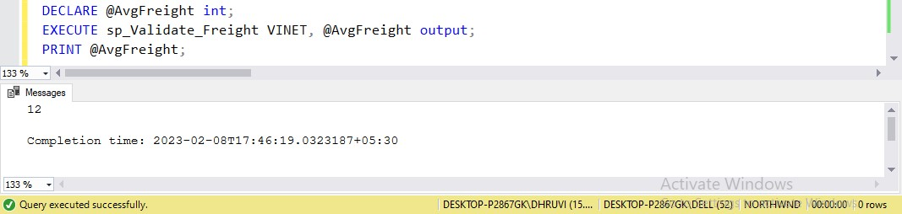

-- Procedure For Insert Details

CREATE PROCEDURE sp_Validate_Freight_Insert

@OrderID int, @CustomerID nchar(15),

@EmployeeID int, @OrderDate datetime,

@RequiredDate datetime, @ShippedDate datetime,

@ShipVia int, @Freight money, @ShipName nvarchar(50),

@ShipAddress nvarchar(60), @ShipCity nvarchar(20),

@ShipRegion nvarchar(20), @ShipPostalCode nvarchar(20),

@ShipCountry nvarchar(50)

AS

BEGIN

DECLARE @avgfraight money

SET @avgfraight = (

SELECT AVG(Freight) FROM Orders

WHERE CustomerID=@CustomerID )

IF(@avgfraight > @Freight)

BEGIN

INSERT INTO Orders(OrderID,CustomerID,EmployeeID,OrderDate,RequiredDate,ShippedDate,ShipVia,Freight,ShipName,ShipAddress,ShipCity,ShipRegion,ShipPostalCode,ShipCountry)

VALUES(@OrderID, @CustomerID, @EmployeeID, @OrderDate , @RequiredDate , @ShippedDate , @ShipVia , @Freight , @ShipName, @ShipAddress, @ShipCity, @ShipRegion, @ShipPostalCode, @ShipCountry)

END

ELSE

BEGIN

RAISERROR ('Inserted Freight is more than customer avg freight',10,1)

END

END

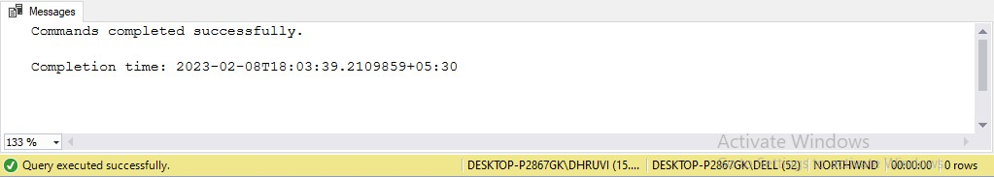

-- Insert Data

SET IDENTITY_INSERT Orders ON

EXECUTE sp_Validate_Freight_Insert '10246','VINET','5','','','','1','10','','','','','',''

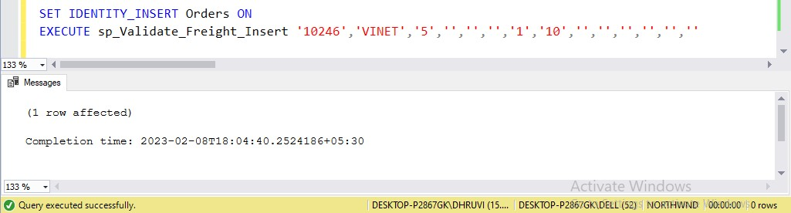

-- Insert Data

SET IDENTITY_INSERT Orders ON

EXECUTE sp_Validate_Freight_Insert '10246','VINET','5','','','','1','23','','','','','',''

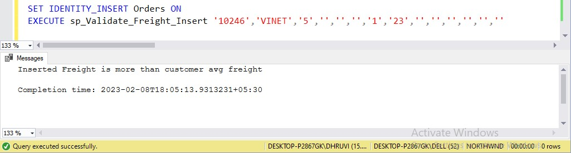

-- Procedure For Update Details

CREATE PROCEDURE sp_Validate_Freight_Update(

@OrderID int, @CustomerID nchar(15),

@EmployeeID int, @OrderDate datetime,

@RequiredDate datetime, @ShippedDate datetime,

@ShipVia int, @Freight money, @ShipName nvarchar(50),

@ShipAddress nvarchar(60), @ShipCity nvarchar(20),

@ShipRegion nvarchar(20), @ShipPostalCode nvarchar(20),

@ShipCountry nvarchar(50))

AS

BEGIN

DECLARE @avgfraight money

SET @avgfraight = (

SELECT AVG(Freight) FROM Orders

WHERE CustomerID=@CustomerID)

IF(@avgfraight > @Freight)

BEGIN

UPDATE Orders

SET EmployeeID=@EmployeeID,

OrderDate=@OrderDate,

RequiredDate=@RequiredDate,

ShippedDate=@ShippedDate,

ShipVia=@ShipVia,

Freight=@Freight,

ShipName=@ShipName,

ShipAddress=@ShipAddress,

ShipCity=@ShipCity,

ShipRegion=@ShipRegion,

ShipPostalCode=@ShipPostalCode,

ShipCountry=@ShipCountry

WHERE OrderID=@OrderID and CustomerID=@CustomerID

END

ELSE

BEGIN

RAISERROR('Updated Freight is more than avg freight',10,1)

END

END

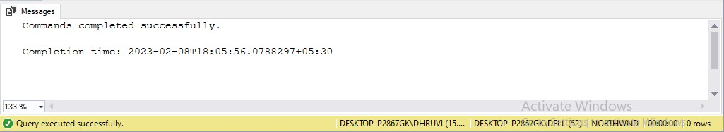

-- Update Data

EXECUTE sp_Validate_Freight_Update '10246','VINET','5','','','','2','23','','','','','',''

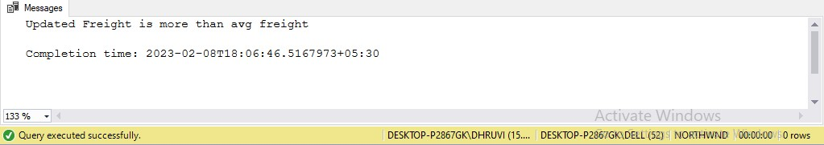

-- 2. Write a SQL query to Create Stored procedure in the Northwind database to retrieve Employee Sales by Country.

CREATE PROCEDURE Employee_Sales_By_Country

@Beginning_Date DateTime, @Ending_Date DateTime

AS

BEGIN

SELECT E.Country, E.FirstName,

SUM(CONVERT(money,(OD.UnitPrice * Quantity * (1 - Discount)/100))*100) AS SaleAmount

FROM Employees E

JOIN Orders O ON E.EmployeeID = O.EmployeeID

JOIN [Order Details] OD ON O.OrderID = OD.OrderID

GROUP BY E.Country,E.FirstName, O.ShippedDate

HAVING O.ShippedDate BETWEEN @Beginning_Date AND @Ending_Date;

END

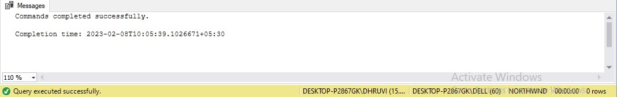

-- Execute Store Procedure Employee_Sales_By_Country

EXECUTE Employee_Sales_By_Country '1996-11-14', '1996-11-20';

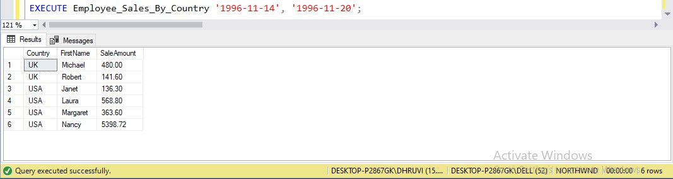

-- 3. Write a SQL query to Create Stored procedure in the Northwind database to retrieve Sales by Year.

CREATE PROCEDURE Sales_By_Year

AS

BEGIN

SELECT YEAR(O.ShippedDate) AS Year,

SUM(CONVERT(money,(OD.UnitPrice * Quantity * (1 - Discount)/100))*100) AS SaleAmount

FROM Orders O

JOIN [Order Details] OD

ON O.OrderID = OD.OrderID

GROUP BY YEAR(O.ShippedDate)

HAVING YEAR(O.ShippedDate) IS NOT NULL;

END

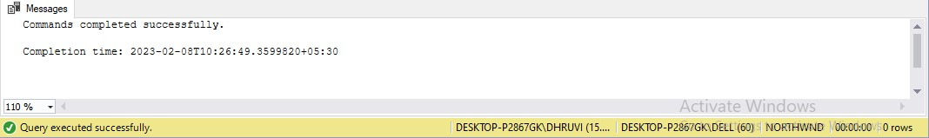

-- Execute Store Procedure Sales_By_year

EXECUTE Sales_By_Year

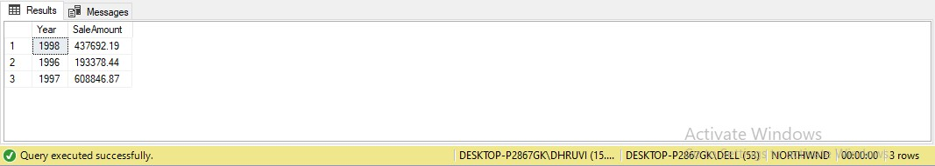

-- 4. Write a SQL query to Create Stored procedure in the Northwind database to retrieve Sales By Category.

ALTER PROCEDURE Sales_By_Category

@OrdYear nvarchar(4) = '1998'

AS

IF @OrdYear != '1996' AND @OrdYear != '1997' AND @OrdYear != '1998'

BEGIN

DECLARE @msg nvarchar(50)

SET @msg = 'Please Select Year among 1996, 1997, 1998'

PRINT @msg

END

ELSE

BEGIN

SELECT C.CategoryName,

TotalPurchase = ROUND(SUM(CONVERT(DECIMAL(14,2), OD.Quantity * (1-OD.Discount) * OD.UnitPrice)), 0)

FROM [Order Details] OD, Orders O, Products P, Categories C

WHERE OD.OrderID = O.OrderID

AND OD.ProductID = P.ProductID

AND P.CategoryID = C.CategoryID

AND SUBSTRING(CONVERT(nvarchar(22), O.OrderDate, 111), 1, 4) = @OrdYear

GROUP BY C.CategoryName

ORDER BY C.CategoryName;

END

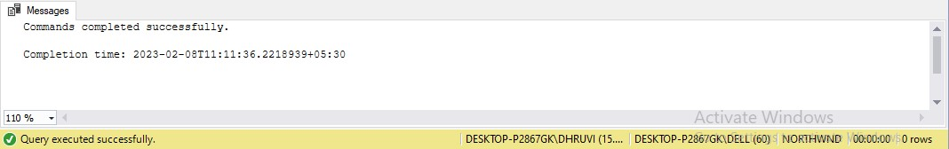

-- Execute Store Procedure Sales_By_Category

EXECUTE Sales_By_Category '1996';

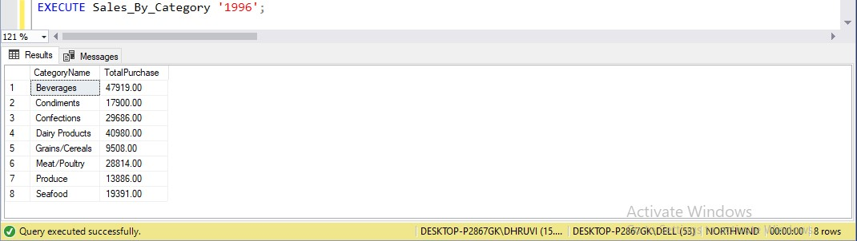

-- 5. Write a SQL query to Create Stored procedure in the Northwind database to retrieve Ten Most Expensive Products.

CREATE PROCEDURE Ten_Most_Expensive_Products

AS

BEGIN

SELECT TOP 10 ProductName AS Ten_Most_Expensive_Products, UnitPrice

FROM Products

ORDER BY UnitPrice DESC

END

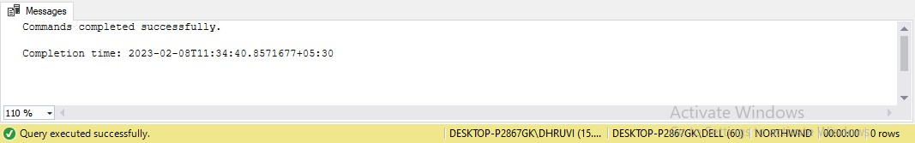

-- Execute Store Procedure Ten_Most_Expensive_Products

EXECUTE Ten_Most_Expensive_Products

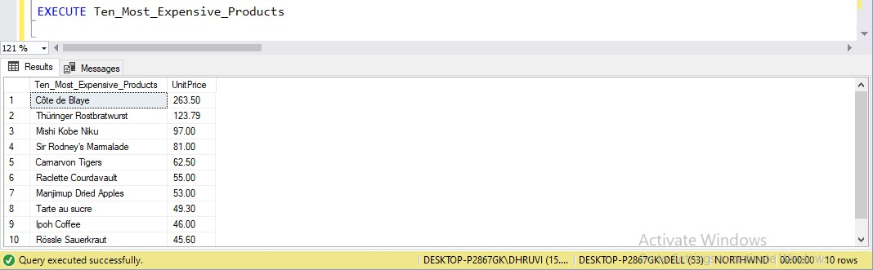

-- 6. Write a SQL query to Create Stored procedure in the Northwind database to insert Customer Order Details.

CREATE PROCEDURE Insert_Cust_Order_Details

@OrderId int, @ProductId int, @UnitPrince decimal(10,2),

@Quantity int, @Discouunt float

AS

BEGIN

INSERT INTO [Order Details]

VALUES (@OrderId,@ProductId,@UnitPrince,@Quantity,@Discouunt);

END

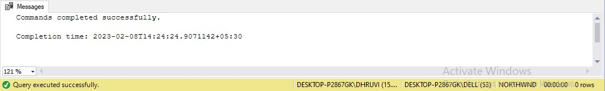

-- Execute Store Procedure Insert_Cust_Order_Details

EXECUTE Insert_Cust_Order_Details '10249','15','25.50','2','0.25'

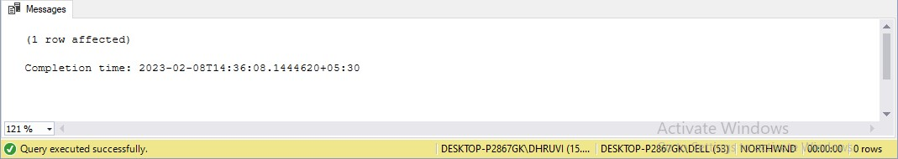

-- Verify

SELECT * FROM [Order Details]

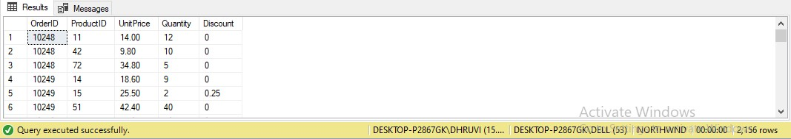

-- 7. Write a SQL query to Create Stored procedure in the Northwind database to update Customer Order Details.

CREATE PROCEDURE Update_Cust_Order_Details

@OrderID int = NULL, @ProductId int = NULL, @UnitPrice Decimal(10,2) = NULL,

@Quantity smallint = NULL, @Discount real = NULL

AS

BEGIN

UPDATE [Order Details]

SET

OrderID = CASE WHEN @OrderID IS NOT NULL AND @OrderID <> OrderID THEN @OrderID ELSE OrderID END,

ProductId = CASE WHEN @ProductId IS NOT NULL AND @ProductId <> ProductID THEN @ProductId ELSE ProductId END,

UnitPrice = CASE WHEN @UnitPrice IS NOT NULL AND @UnitPrice <> UnitPrice THEN @UnitPrice ELSE UnitPrice END,

Quantity = CASE WHEN @Quantity IS NOT NULL AND @Quantity <> Quantity THEN @Quantity ELSE Quantity END,

Discount = CASE WHEN @Quantity IS NOT NULL AND @Quantity <> Discount THEN @Quantity ELSE Discount END

WHERE OrderID = @OrderID AND ProductID = @ProductId;

END

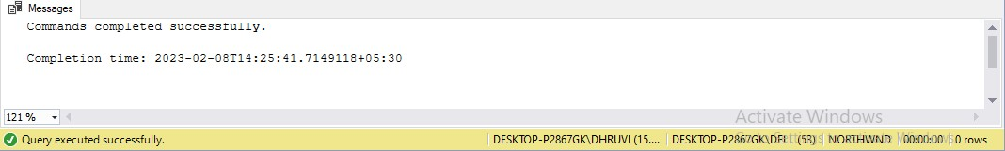

-- Execute Store Procedure Update_Cust_Order_Details

EXECUTE Update_Cust_Order_Details '10249','15','27.50','3','0.25'

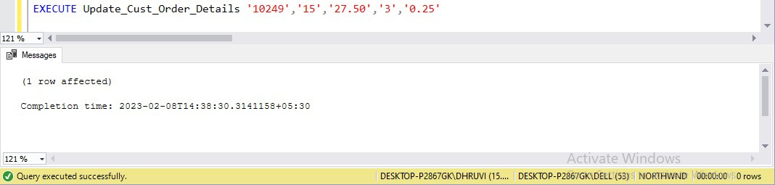

-- Verify

SELECT * FROM [Order Details]

