**Assignment-3**

-- Create Tables

CREATE TABLE Department(

dept_id int PRIMARY KEY NOT NULL,

dept_name varchar(50) NOT NULL

);

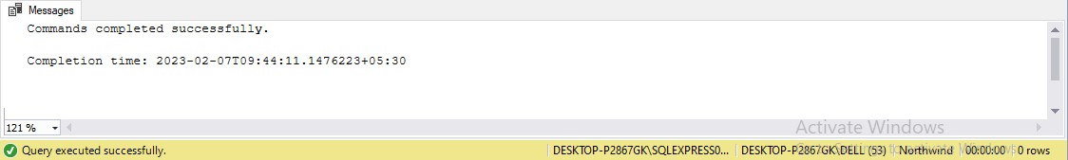

CREATE TABLE Employee(

emp_id int PRIMARY KEY NOT NULL,

dept_id int FOREIGN KEY REFERENCES Department(dept_id),

mngr_id int NOT NULL,

emp_name varchar(50) NOT NULL,

salary int NOT NULL

);

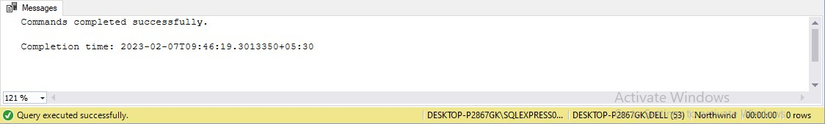

--Insert Data

INSERT INTO Department VALUES(101,'Managment'),

(102,'Design'),

(103,'HR'),

(104,'Development'),

(105,'QA');

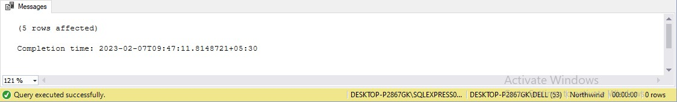

--Insert Data

INSERT INTO Employee VALUES(501,101,401,'Meet Patel',40000),

(502,102,402,'Suchi Mehta',450000),

(503,101,402,'Mayur Shah',20000),

(504,102,403,'Tirth Patel',40000),

(505,103,404,'Ansh Desai',65000),

(506,102,405,'Foram Sharma',60000),

(507,105,407,'Aarvi Birla',37000),

(508,105,407,'Ruhi Mehta',35000),

(509,102,403,'Bhautik Birla',55000),

(510,101,407,'Mansi Desai',50000),

(511,104,406,'Abhi Sharma',65000),

(512,104,404,'Ved Patel',62000);

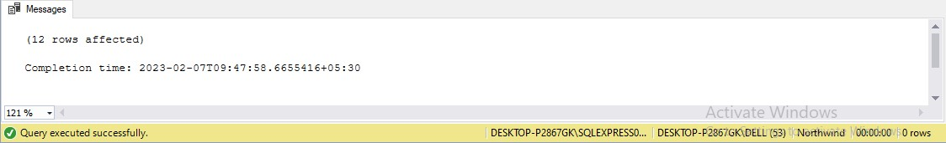

-- 1. Write a SQL query to find Employees who have the biggest salary in their Department.

SELECT e.emp_name, e.salary

FROM Employee e

JOIN Department d ON d.dept_id = e.dept_id

WHERE e.salary IN (

SELECT MAX(e.salary)

FROM Employee e

GROUP BY d.dept_id

HAVING e.dept_id = d.dept_id);

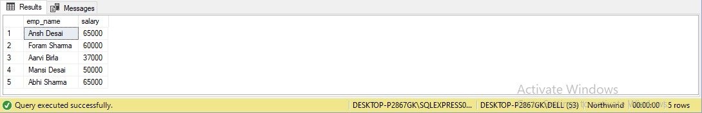

-- 2. Write a SQL query to find Departments that have less than 3 people in it.

SELECT d.dept_id ,d.dept_name

FROM Department d

LEFT JOIN Employee e ON d.dept_id = e.dept_id

GROUP BY d.dept_name, d.dept_id

HAVING COUNT(*) < 3;

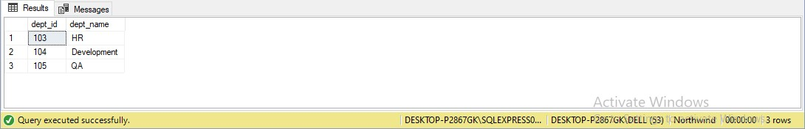

-- 3. Write a SQL query to find All Department along with the number of people there.

SELECT d.dept_name, COUNT(e.emp_name) AS No_Of_Employee

FROM Department d

LEFT JOIN Employee e ON d.dept_id = e.dept_id

GROUP BY d.dept_name;

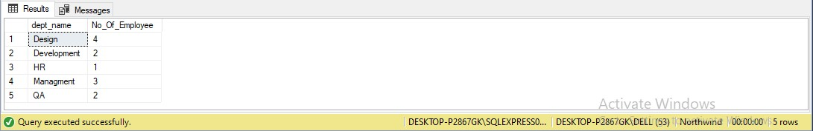

-- 4. Write a SQL query to find All Department along with the total salary there.

SELECT d.dept_name, SUM(salary) AS Total_Salary

FROM Department d

LEFT JOIN Employee e ON d.dept_id = e.dept_id

GROUP BY d.dept_name;

