**GROUP-13**

**COMPUTER NETWORKS PROJECT**

**IN**

**B.Tech Sem-V**

**BY:ADITYA SHAH (AU1741007)**

**JEEL PUJARA (AU1741013)**

**DHRUVIL SHAH (AU1741024)**

**HIMANSHU BHADANIA (AU1741055)**

**VARUN PATEL (AU1741080)**

**Under The Guidance of:**

**Shashi Prabh**

**Table of contents**

1. Introduction
2. Overview of what we have done
3. Server Description
4. Client Description
5. Results

**Introduction**

This project gives an insight into IP multicast and the nature of multimedia traffic, especially, video traffic. The video traffic is projected to be the main driver of mobile data traffic growth. We will be developing an Internet TV application that uses multicast. In this project we have : (a) sent data over a TCP connection (b) sent multimedia data over UDP, and (c) sent data in structured manner so that applications implemented differently running on different platforms remain inter-operable. We will be working with Any Source Multicast (ASM) model in which multicast messages are identified by the multicast group address alone, and more than one sender can exist in a group. Since in the ASM model, any message sent to a multicast address is received by all nodes that have joined the group, it is important that streams don’t get mixed up. We have assumed that the scope of multicast is limited to a LAN.

**Overview of what we have done**

We have implemented Server-Client model. In this model we have first sent station information using TCP to client. In the GUI window it’ll show all the information about available stations. Client can click on any station they wish to watch and streaming will start. Background transfer of data is done using UDP. Server will keep broadcasting all channels. So, whichever channel client select, he/she will be able to watch it. It’s like TV that if some client is watching show from start then he’ll be able to watch whole video and if some other client will join after 5 minutes then he/she will miss the first 5 mins and watch what’s broadcasting at the moment. User will have option to change channels using buttons in User friendly graphical interface. User can change channels, come back to watch previous channels, play/pause current channel and have an option to turn off the TV.

**Server Description**

Server will first establish a TCP connection and send the details of stations. Client will receive the information of the stations and it’ll select one station from it. In backend server will start broadcasting different channels using threads. We have used 4 different threads for 4 different channels. Server will broadcast all channels together. Client can select any channel he/she wishes. If there are multiple client, it’ll be multicast group where server is broadcasting the information and clients are receiving stream. The data which is sent over to clients is done using UDP transfer protocol. So, server will broadcast all the channels all the time and it’ll be on client to join any multicast group to watch streaming. If client will decide to change the channel, they’ll join and start receiving from other multicast group.

**Client Description**

Client will first establish a TCP connection and will receive information related to all the stations on graphical interface. Client will have option to choose any of the station. After selecting client will join respective multicast group. Client will start receiving data over UDP respective that multicast group. Client can choose any other station by clicking on the interface. If client changes the station, it’ll join new multicast group. If client comes few mins after streaming started, it’ll directly receive live stream.

**RESULT**

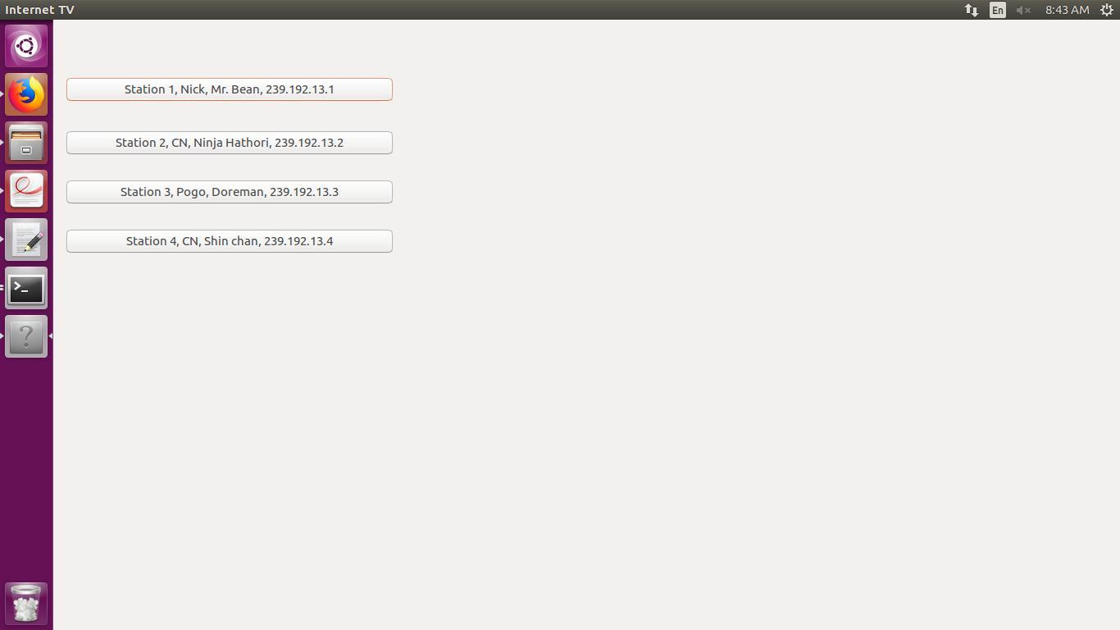

**NEW RESULT**

