PROGRAM : 1

**class U1P1{**

**public static void main(String args[])**

**{**

**int p,r,n,si=0;**

**p=20000;**

**r=5;**

**n=2;**

**si=(p*r*n)/100;**

**System.out.println("simple interest: " + si);**

**}**

**}**

**OUTPUT :**

# 

**PROGRAM-2**

import java.util.Scanner;

class U1P2

{

int loan;

double intr;

double emi;

Scanner in=new Scanner(System.in);

void get()

{

System.out.print("Enter loan : ");

loan=in.nextInt();

System.out.print("Enter interest : ");

intr=in.nextDouble();

}

void Emi()

{

emi=loan*intr/(100*60);

System.out.println("Emi of loan is : "+emi);

}

public static void main(String args[])

{

U1P2 e=new U1P2();

e.get();

e.Emi();

}

}

}

**OUTPUT:**

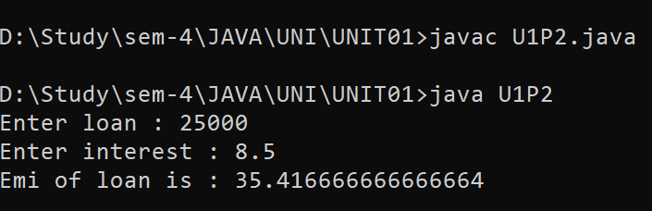

PROGRAM-3

import java.util.Scanner;

class CarAcc

{

static int prodprice[]={1,100,2,200,3,300,4,400,5,500,6,600};

static double salestax[]={2,3,4,2.5,1.2};

void getbill(int prcode,int qty)

{

double billamm;

switch(prcode)

{

case 1:

billamm=(prodprice[prcode]*qty*salestax[0]/100)+prodprice[prcode]*qty;

System.out.println("Price: "+billamm);

break;

case 2:

billamm=(prodprice[prcode]*qty*salestax[1]/100)+prodprice[prcode]*qty;

System.out.println("Price: "+billamm);

break;

case 3:

billamm=(prodprice[prcode]*qty*salestax[2]/100)+prodprice[prcode]*qty;

System.out.println("Price: "+billamm);

break;

case 4:

billamm=(prodprice[prcode]*qty*salestax[3]/100)+prodprice[prcode]*qty;

System.out.println("Price: "+billamm);

break;

case 5:

billamm=(prodprice[prcode]*qty*salestax[4]/100)+prodprice[prcode]*qty;

System.out.println("Price: "+billamm);

break;

default:

System.out.println("Please Enter proper value");

}

}

}

class U1P3{

public static void main(String args[])

{

int prcode,qty;

CarAcc b1 = new CarAcc();

Scanner in = new Scanner(System.in);

System.out.print("Enter Product Code: ");

prcode = in.nextInt();

System.out.print("Enter Quantity: ");

qty = in.nextInt();

b1.getbill(prcode,qty);

}

}

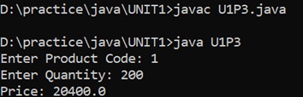

PROGRAM-4

import javax.swing.*;

class U1P4{

public static void main(String args[])

{

int a,b,c,max;

String in1=JOptionPane.showInputDialog(null,"Enter value of a: ");

a=Integer.parseInt(in1);

String in2=JOptionPane.showInputDialog(null,"Enter value of b: ");

b=Integer.parseInt(in2);

String in3=JOptionPane.showInputDialog(null,"Enter value of c: ");

c=Integer.parseInt(in3);

max=a > b?(a > c? a :c):(b>c? b : c);

System.out.println("Max among "+max);

}

}

**OUTPUT:**

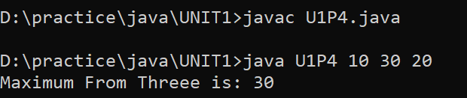

**PROGRAM-5**

import java.util.Scanner;

class U1P5{

public static void main(String args[])

{

int x,y;

double hyp;

Scanner in = new Scanner(System.in);

System.out.print("Enter value of x: ");

x=in.nextInt();

System.out.print("Enter value of y: ");

y=in.nextInt();

hyp=Math.sqrt(((x*x)+(y*y)));

System.out.println("Hypotenuse: "+hyp);

}

}

**OUTPUT:**

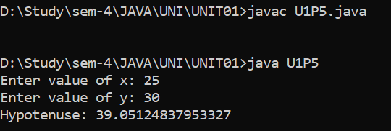

**PROGRAM-6**

class area

{

void area(int l,int b)

{

int ans;

ans=l*b;

System.out.println("\n area of rectangle: "+ ans);

}

void area(int l)

{

int ans;

ans=l*l;

System.out.println("\n area of square: "+ ans);

}

}

class U1P6{

public static void main(String args[])

{

int l;

int b;

l=Integer.parseInt(args[0]);

b=Integer.parseInt(args[1]);

area a1=new area();

a1.area(l);

a1.area(l,b);

}

}

**OUTPUT:**

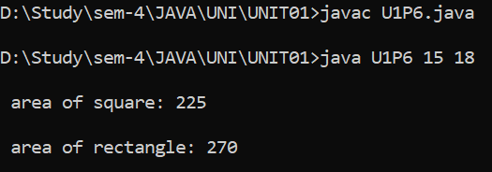

**PROGRAM-7**

//U01program07

class complex

{

int real,imag;

complex()

{

}

complex(int real1,int imag1)

{

real=real1;

imag=imag1;

}

complex addcomplex(complex c1,complex c2)

{

complex csum=new complex();

csum.real=c1.real+c2.real;

csum.imag=c1.imag+c2.imag;

return csum;

}

complex subcomplex(complex c1,complex c2)

{

complex csub=new complex();

csub.real=c1.real-c2.real;

csub.imag=c1.imag-c2.imag;

return csub;

}

complex mulcomplex(complex c1,complex c2)

{

complex cmul=new complex();

cmul.real=c1.real*c2.real-c1.imag*c2.imag;

cmul.imag=c1.imag*c2.imag+c1.real*c2.real;

return cmul;

}

}

public class U1P7

{

public static void main(String args[])

{

complex c1=new complex(4,8);

complex c2=new complex(5,7);

complex c3=new complex(3,4);

c3=c3.addcomplex(c1,c2);

System.out.println("Sum: "+c3.real+"+i"+c3.imag);

c3=c3.subcomplex(c1,c2);

System.out.println("Sub: "+c3.real+"+i"+c3.imag);

c3=c3.mulcomplex(c1,c2);

System.out.println("mul: "+c3.real+"+i"+c3.imag);

}

}

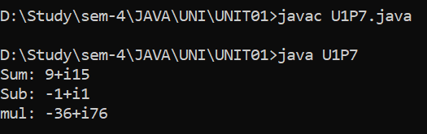

**PROGRAM-8**

public class U1P8

{

public static void main(String args[])

{

int a=1,i;

for(i=1;i<=10;i++)

{

a=a<<1;

System.out.println(a);

}

}

}

**OUTPUT:**

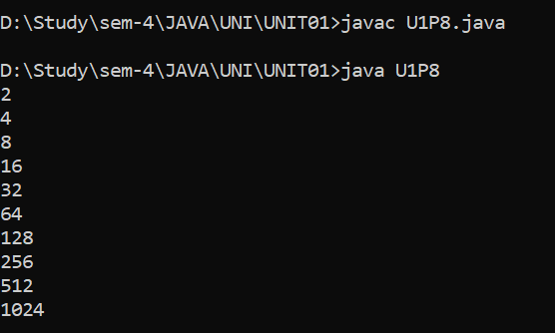

# **UNIT-2**

**PROGRAM-1**

class U2P1{

public static void main(String args[])

{

int i,j,n,temp;

n=args.length;

int a[]=new int[n];

for(i=0;i<n;i++)

{

a[i]=Integer.parseInt(args[i]);

}

for(i=0;i<n;i++)

{

for(j=i+1;j<n;j++)

{

if(a[i]>a[j])

{

temp=a[i];

a[i]=a[j];

a[j]=temp;

}

}

}

System.out.println("After sorting:");

for(i=0;i<n;i++)

{

System.out.println(a[i]);

}

}

}

**OUTPUT:**

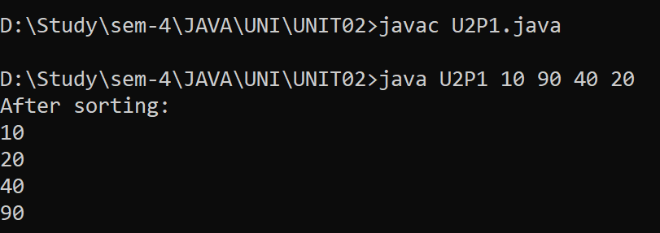

**PROGRAM-2**

class U2P2{

public static void main(String args[])

{

int i,arr[]={1,2,3,4,5};

System.out.println("Before reverse");

for(i=0;i<arr.length;i++)

{

System.out.println(arr[i]+" ");

}

System.out.println("After reverse");

for(i=arr.length-1;i>=0;i--)

{

System.out.println(arr[i]+" ");

}

}

}

**OUTPUT:**

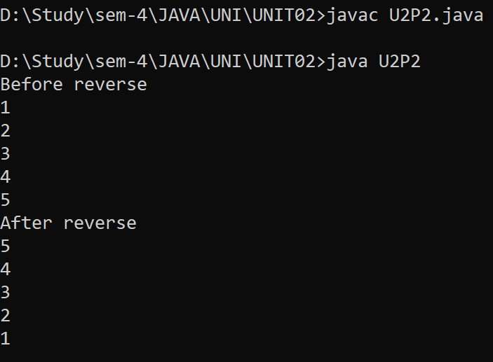

**PROGRAM-3**

import java.util.Scanner;

class U2P3

{

public static void main(String args[])

{

int row,column,i,j;

Scanner e = new Scanner(System.in);

System.out.print("Enter the row for matrix: ");

row = e.nextInt();

System.out.print("Enter the column for matrix: ");

column = e.nextInt();

int first[][]=new int[row][column];

int second[][]=new int[row][column];

int sum[][]=new int[row][column];

System.out.println(" ");

System.out.println("Enter The value for first matrix: ");

for(i=0 ; i<row ; i++)

{

for(j=0 ; j<column ; j++)

{

System.out.print("Enter value for first["+i+"]["+j+"]: ");

first[i][j]=e.nextInt();

}

}

System.out.println();

System.out.println("Enter The value for second matrix: ");

for(i=0 ; i<row ; i++)

{

for(j=0 ; j<column ; j++)

{

System.out.print("Enter value for second["+i+"]["+j+"]: ");

second[i][j]=e.nextInt();

}

}

for(i=0 ; i<row ; i++)

{

for(j=0 ; j<column ; j++)

{

sum[i][j]=first[i][j]+second[i][j];

}

}

System.out.println(" ");

System.out.println("The Addition of Two Array is: ");

System.out.println("Enter The value for first matrix: ");

for(i=0 ; i<row ; i++)

{

for(j=0 ; j<column ; j++)

{

System.out.print(sum[i][j] +" ");

}

System.out.println();

}

}

}

**OUTPUT:**

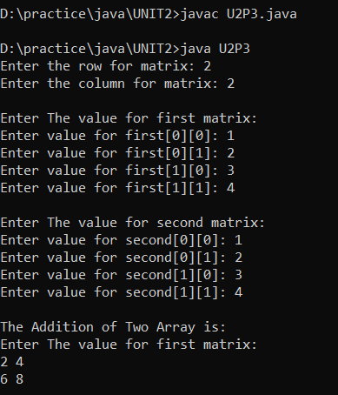

**PROGRAM-4**

class U2P4{

public static void main(String args[])

{

int i,n,low;

String company[]={"LG","SAMSUNG","PHILIPS","SONY","MI"};

int price[]={1000,20000,20020,50000,5000};

n=price.length;

low=price[0];

for(i=1;i<n;i++)

{

if(low>price[i])

{

low=price[i];

}

}

for(i=0;i<n;i++)

{

if(low==price[i])

{

System.out.println(company[i]);

}

}

}

}

**OUTPUT:**

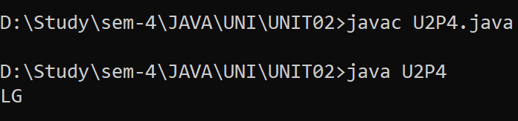

**PROGRAM-5**

interface numbers

{

public int process(int x,int y);

}

class sum implements numbers

{

public int process(int x,int y)

{

return(x+y);

}

}

class avg implements numbers

{

public int process(int x,int y)

{

return((x+y)/2);

}

}

public class U2P5

{

public static void main(String args[])

{

int a,b;

sum add=new sum();

a=add.process(10,20);

System.out.println("Sum: "+a);

avg avg=new avg();

b=avg.process(40,80);

System.out.println("Average: "+b);

}

}

**OUTPUT:**

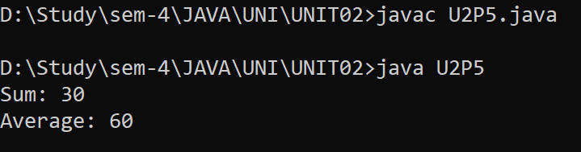

**PROGRAM-6**

abstract class vehicle

{

public abstract void numwheels();

}

class car extends vehicle

{

public void numwheels()

{

System.out.println("car has four wheels");

}

}

class truck extends vehicle

{

public void numwheels()

{

System.out.println("Truck has six wheels");

}

}

public class U2P6

{

public static void main(String args[])

{

car c=new car();

c.numwheels();

truck t=new truck();

t.numwheels();

}

}

**OUTPUT:**

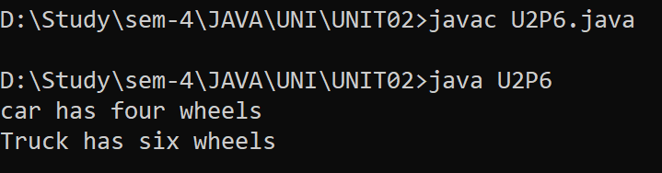

**PROGRAM-7**

import java.util.*;

interface exam

{

boolean pass(int mark);

}

interface classify

{

String division(int avg);

}

class result implements exam,classify

{

public boolean pass(int mark)

{

if(mark>=50)

{

return true;

}

else

{

return false;

}

}

public String division(int avg)

{

if(avg>=70)

{

return "DIST";

}

else if(avg>=60)

{

return "FIRST";

}

else if(avg>=50)

{

return "SECOND";

}

else

{

return "no-division";

}

}

}

public class U2P7

{

public static void main(String args[])

{

boolean pass;

int mark,avg;

String division;

Scanner in=new Scanner(System.in);

result res=new result();

System.out.println("Enter marks: ");

mark=in.nextInt();

System.out.println("Enter Average: ");

avg=in.nextInt();

pass=res.pass(mark);

division=res.division(avg);

if(pass)

{

System.out.println("Passed-"+division+".");

}

else

{

System.out.println("Failed-"+division+".");

}

}

}

**OUTPUT:**

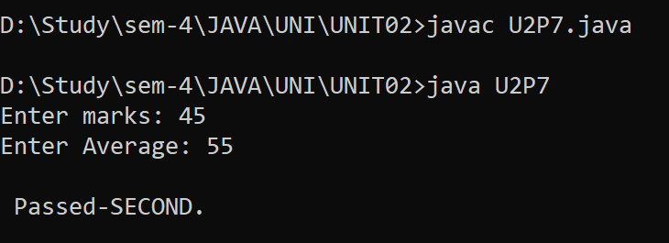

**PROGRAM-8**

abstract class shape

{

abstract void area();

double area;

}

class triangle extends shape

{

double b=60,h=20;

void area()

{

area=(b*h)/2;

System.out.println("Area of triangle: "+area);

}

}

class rectangle extends shape

{

double w=80,h=10;

void area()

{

area=w*h;

System.out.println("Area of rectangle: "+area);

}

}

class U2P8{

public static void main(String args[])

{

triangle t=new triangle();

rectangle r=new rectangle();

t.area();

r.area();

}

}

**OUTPUT:**

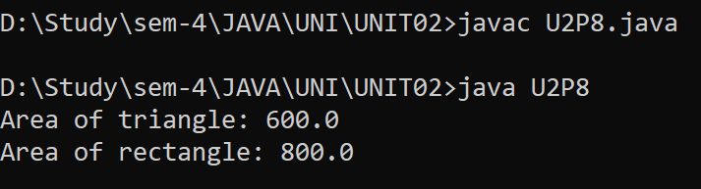

**PROGRAM-9**

abstract class vegetable

{

public String color;

}

class potato extends vegetable

{

public String toString()

{

color="Brown-skinned color";

return "potato -->"+color;

}

}

class brinjal extends vegetable

{

public String toString()

{

color="Purple color";

return "Brinjal -->"+color;

}

}

class tomato extends vegetable

{

public String toString()

{

color="red color";

return "Tomato -->"+color;

}

}

public class U2P9

{

public static void main(String args[])

{

potato p=new potato();

brinjal b=new brinjal();

tomato t=new tomato();

System.out.println(p);

System.out.println(b);

System.out.println(t);

}

}

**OUTPUT:**

