Dhruvil Dobariya
dhruvildobariya21@gmail.com
Abstract
In this module I learn about blazor which provide use to create single page client side as well as server side web application.
Blazor
Documentation

Index
1 What is Blazor 1
1.1 Introduction 1
1.2 Blazor Webassembly 1
1.3 Blazor Server 1
1.4 History of Blazor 1
2 Progressive App 3
2.1 Introduction 3
2.2 How to create 3

What is Blazor

Introduction
- Blazor is part of ASP.NET Core which is used to create single page client side as well as server side application.
- In blazor we are use HTML,CSS with C# instead of JavaScript.
- Using blazor we can create component based application so, we can easily increase reusability.
- Blazor component use Razor syntax to create web page.
- It have type of application,
  - Blazor Webassembly
  - Blazor Server

Blazor Webassembly
- Web assembly is a binary format instruction or virtual machine which allow to use any language for develop web app and convert that app code in to browser supported language.
- Blazor Webassembly provides functionality to create single page web application using HTML, CSS and write frontend logic using C# instead of Javascript.
- It also allow use to create progressive web app.

Blazor Server
- Blazor Server provides functionality to create server side single page web app using Razor pages.
- It provides build in component like web forms to create app, but we can also use pure html component.
- It also allow use to create SignalR server side real time web application.

History of Blazor
- The history of Blazor can be traced back to 2017 when Steve Sanderson, a developer at Microsoft, introduced the experimental project called "Blazor" at the Microsoft Build conference.
- The project aimed to explore the possibility of running .NET code directly in the browser using WebAssembly.
- At that time, WebAssembly was gaining momentum as a new web standard that provided a binary format for executing high-performance code on the web.
- Blazor leveraged this technology to execute .NET code in the browser, allowing developers to build web applications with languages like C#.
- It start experimental version in .NET Core 3.1.
- In May 2020, Microsoft announced the official release of Blazor WebAssembly and Blazor Server as part of .NET 5.
- This marked a significant milestone for Blazor, as it transitioned from an project to a supported and stable framework.
- After every version of .NET Microsoft do many improvements.

Progressive App

Introduction
- A progressive web app (PWA) is a type of web application that leverages modern web technologies to provide a user experience similar to that of a native mobile app.
- PWAs are designed to be reliable, fast, and engaging, and they work seamlessly across different devices and platforms.
- It provides following functionalities,
  - Progressive Enhancement
  - Responsive Design
  - App-like Experience
  - Offline Capabilities
  - Push Notifications
  - Secure Connections
  - Easy Installation
- It helps to the developer to reach wide range of audience with single codebase, reducing the need for separate development efforts for different platforms.
- Also user can accessing app-like experiences directly through their browsers, without the need to download and install traditional native apps.

How to create
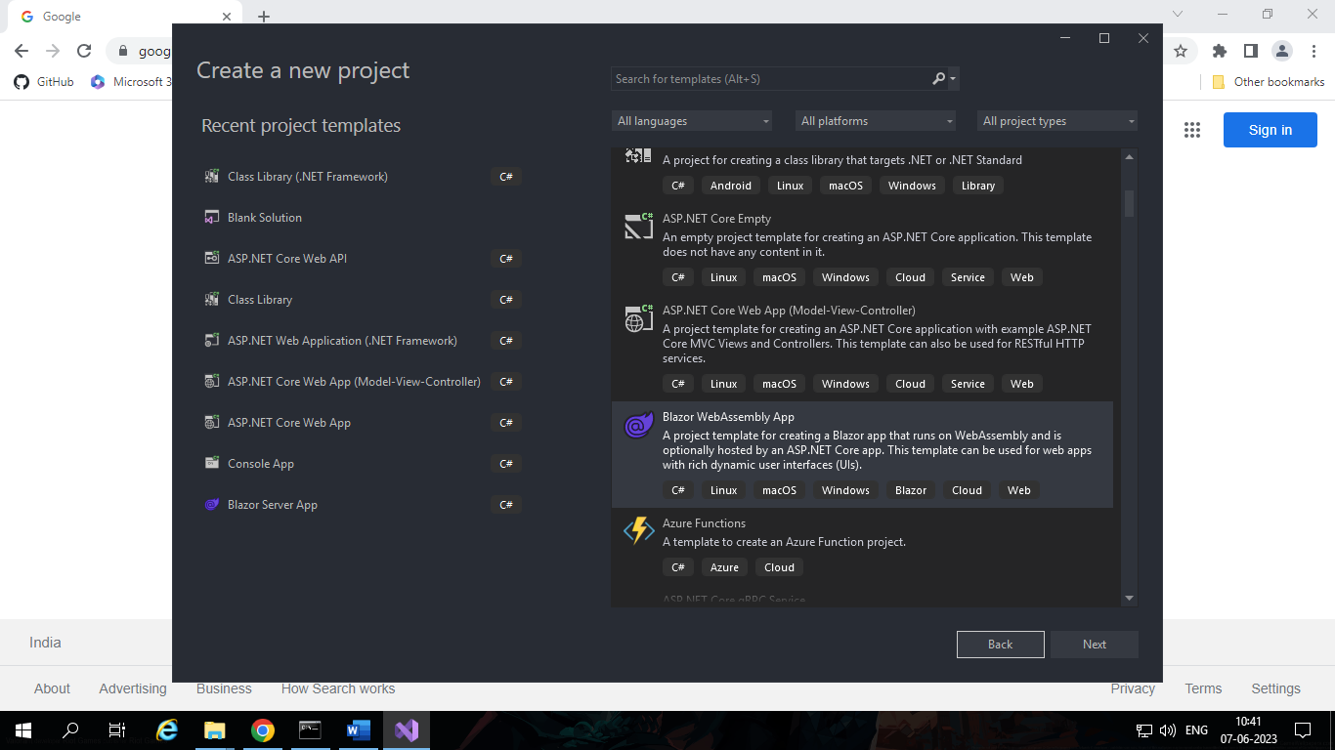
- First Open Visual studio and search “Blazor Webassembly”.
- Select Blazor Webassambly template and select next.
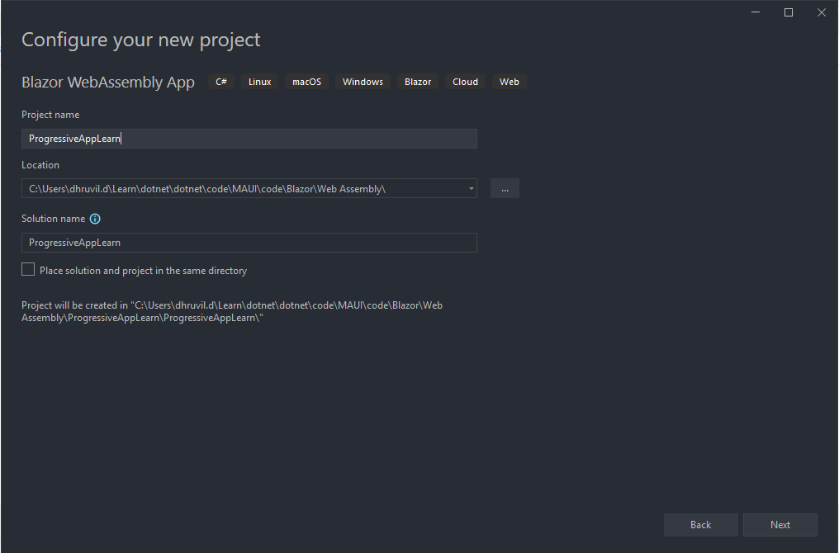
- Give name of project and location and select Next.

- Select version of .NET.
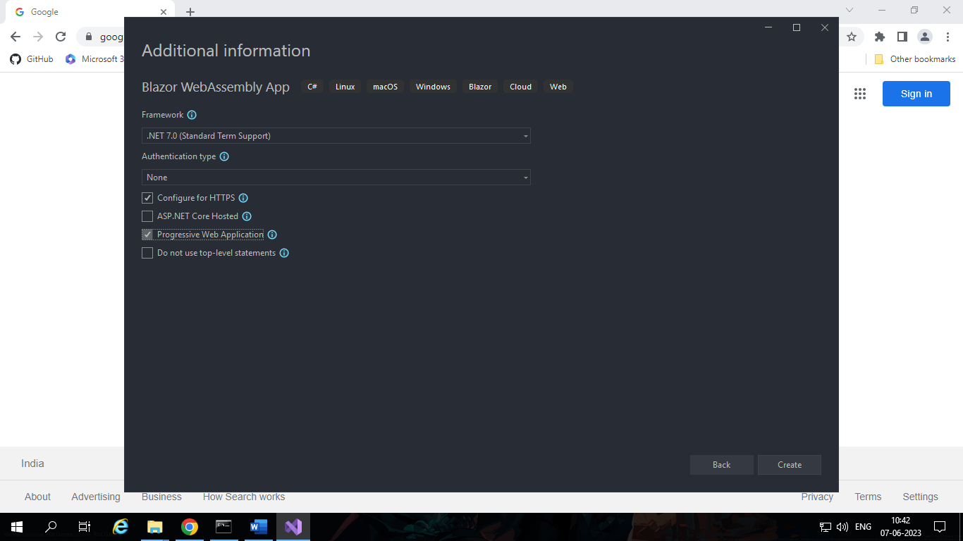
- Checked on Progressive Web Application and Select Create.
- No we have progressive app we just need to run it.
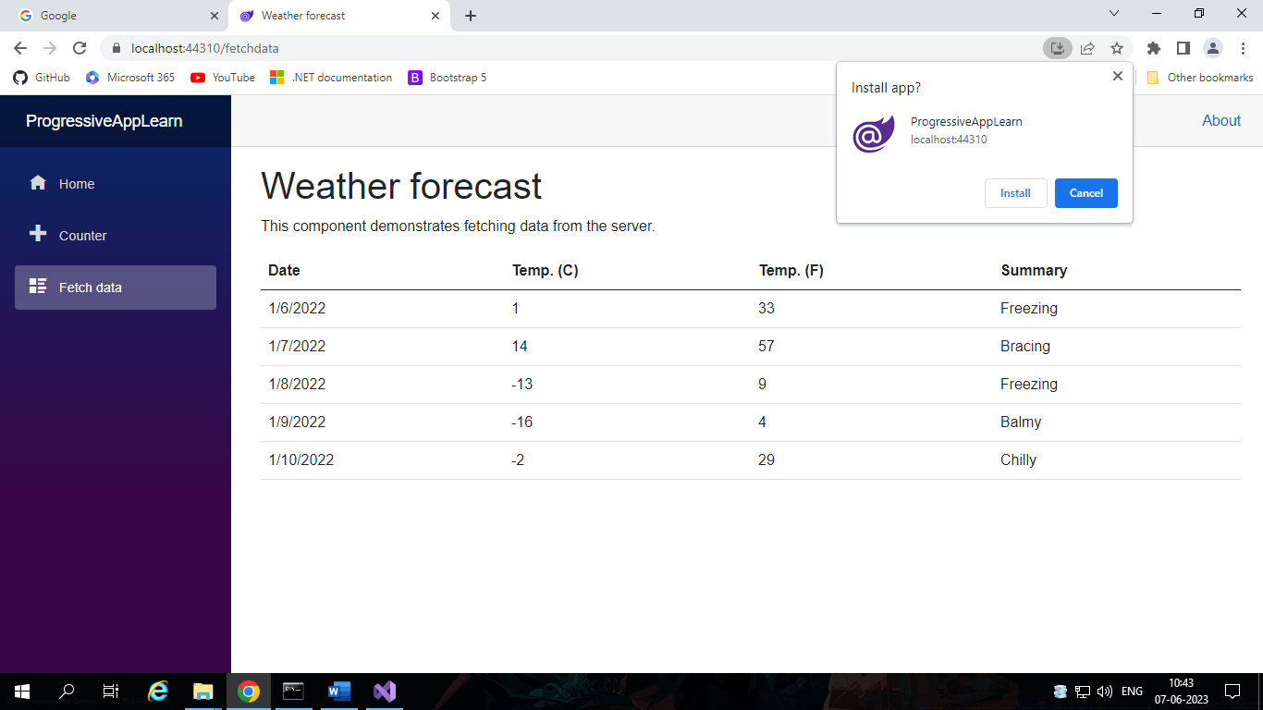
- It look like in browser.

- We have option in URL window for download app, we just need to click on install.
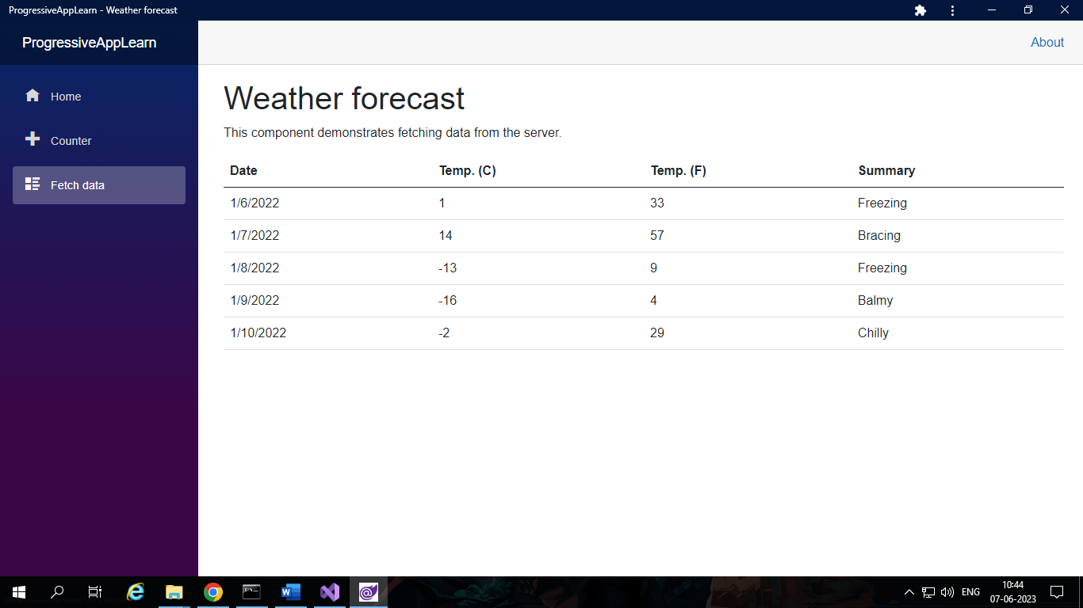
- After click we have desktop app in our computer and it’s look like…

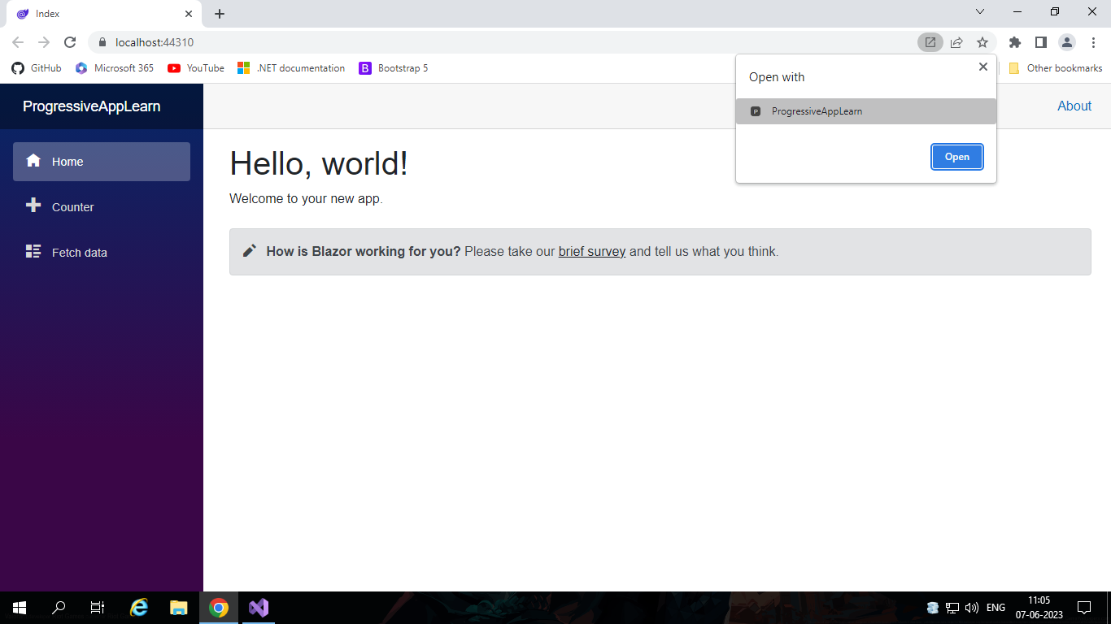
- Now we can open progressive app via both way, browser or double click on installed app.
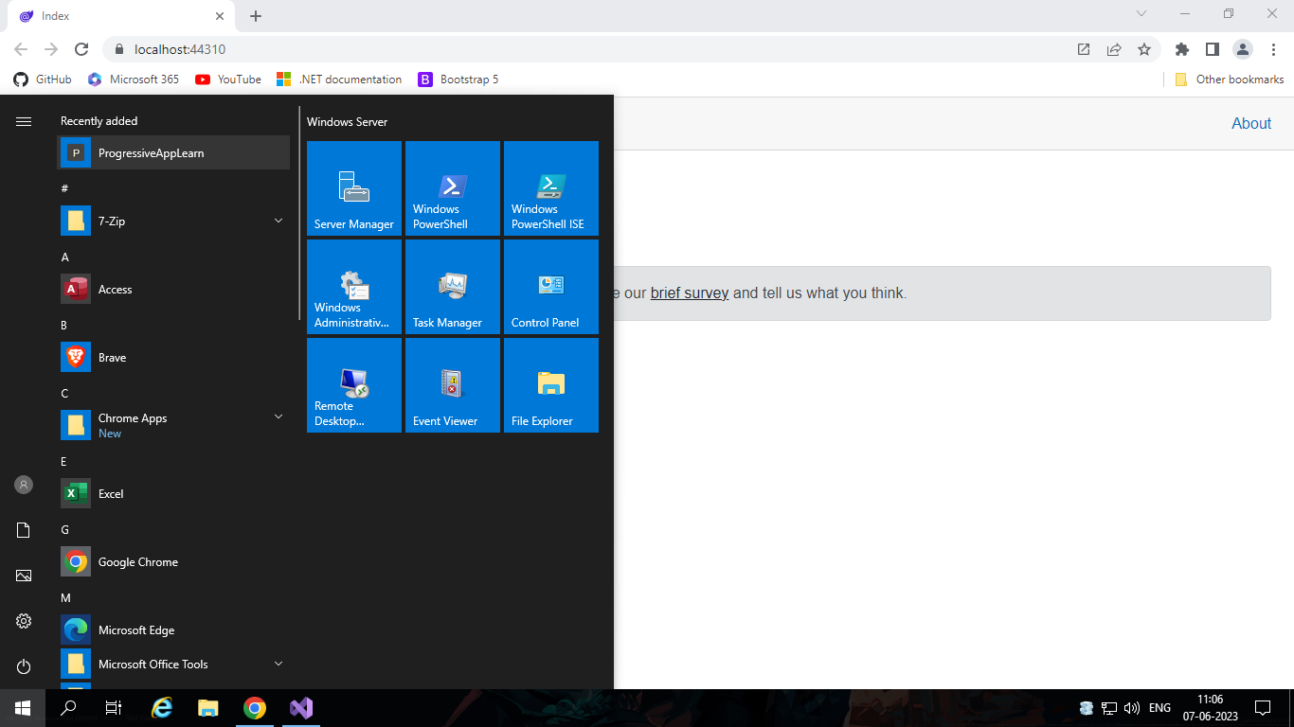

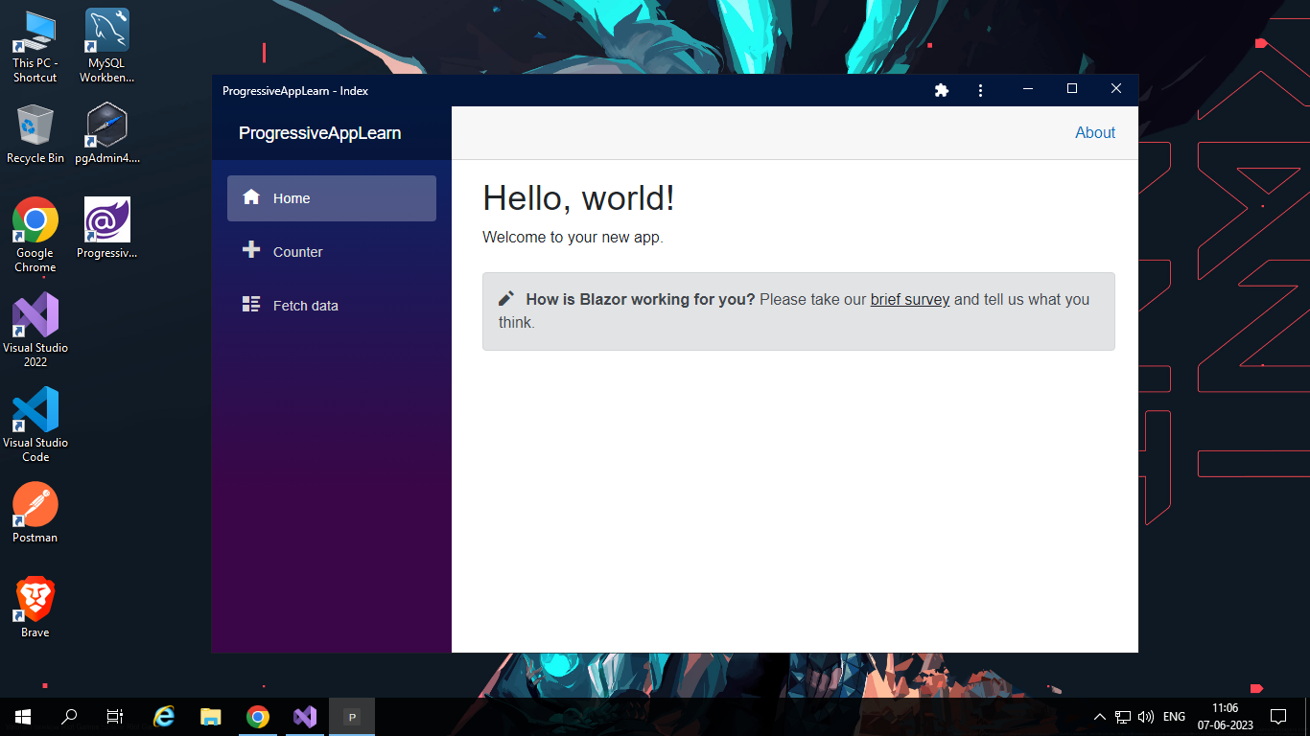
- It feel like it’s installed in our computer or mobile, like…

- In mobile we just need to open web app and click on “Add to Home screen” and after you have installed application on home screen.
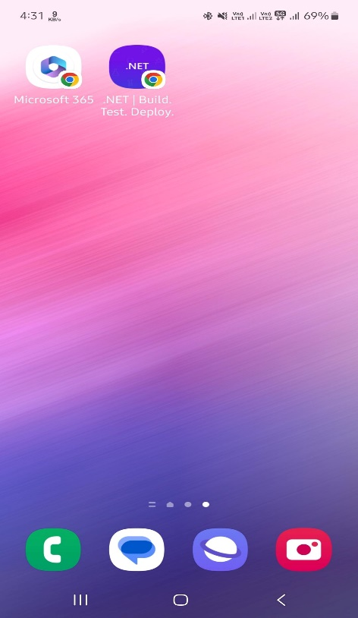
- Just we want to open application and it looks like…


