Dhruvil Dobariya

dhruvildobariya21@gmail.com

Abstract

[Draw your reader in with an engaging abstract. It is typically a short summary of the document.   
When you’re ready to add your content, just click here and start typing.]

DBMS Learn

Documentation

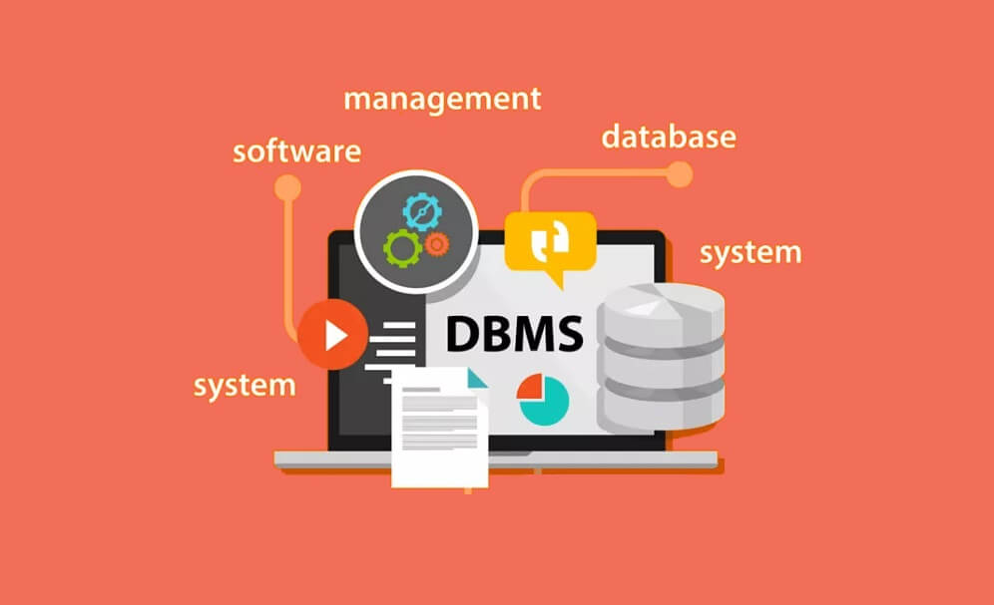

Index

1 Introduction To Database 1

1.1 Introduction 1

1.2 Advantages 1

1.3 Basic Terms 1

2 MySQL 4

2.1 Introduction 4

3 Overview of MySQL Workbench 5

3.1 Introduction 5

3.2 Functionality 5

3.3 Editions 6

3.4 Overview 6

4 Database Design 8

4.1 Introduction 8

4.2 Database development life cycle 8

4.3 Database Design Technique 9

1. Introduction To Database

# Introduction

**Data:**

* Fact that ca be record or stored
* For ex: Person Name, Age, Gender and Weight…

**Database:**

* Collection of logically related data
* For ex: Books Database in Library, Student Database in University…

**Management:**

* Manipulation, Searching and Securing of data.
* Viewing result in GTU website, Searching exam papers in GTU website…

**System:**

* Program or tool that used to manage database
* MS SQL, MySQL, Postgres SQL, Oracle…

**Database Management System:**

* It is a software designed to define, manipulate, retrieve and manage data in a database.

# Advantages

* Reduce data duplication
* Remove inconsistency
* Data isolation
* Guaranty of atomicity(0% or 100%)
* Allow implementing integrity constraints
* Sharing among the multiple user
* Restricted unauthorized access
* Provides backup and recovery services

# Basic Terms

**Data:**

* Data is raw, unorganized facts that need to be processed.
* For ex: Marks of students…

**Information:**

* When data is processed, organized, structured or presented in a given context so as to make it useful, it is called information.
* For ex: Result of students (Pass or Fail)…

**Metadata:**

* Metadata is data about data.
* Data such as table name, column name, data type, authorized user and user access privileges for any table is called metadata for that table.

**Data Dictionary:**

* A data dictionary is an information repository which contains metadata.

**Data Warehouse:**

* A data warehouse is an information repository which stores data.

**Field:**

* A field is a character or group of characters that have a specific meaning.
* For ex: The value of Emp_Name, Address, Mobile_No etc are all fields of Faculty table.

**Record/ Tuple:**

* A record is a collection of logically related fields.
* For ex: The collection of fields (Emp_Name, Address, Mobile_No, Subject) forms a record for the Faculty.

**Primary Key:**

* A key which is unique as well as not null.

**Unique Key:**

* A key which is unique but it could be null.

**Foreign Key:**

* A key which liked two table.

**Compose Key:**

* A key that consists of multiple columns, because one column is not sufficiently identify record uniquely.

1. MySQL

# Introduction

* MySQL is a fast, easy-to-use RDBMS being used for many small and big businesses.
* MySQL is developed, marketed and supported by MySQL AB, which is a Swedish company.
* MySQL is released under an open-source license.
* So you have nothing to pay to use it.
* MySQL is a very powerful program in its own right.
* It handles a large subset of the functionality of the most expensive and powerful database packages.
* MySQL uses a standard form of the well-known SQL data language.
* MySQL works on many operating systems and with many languages including PHP, PERL, C, C++, JAVA, etc.
* MySQL works very quickly and works well even with large data sets.
* MySQL is very friendly to PHP, the most appreciated language for web development.
* MySQL supports large databases, up to 50 million rows or more in a table.
* The default file size limit for a table is 4GB, but you can increase this (if your operating system can handle it) to a theoretical limit of 8 million terabytes (TB).
* MySQL is customizable.
* The open-source GPL license allows programmers to modify the MySQL software to fit their own specific environments.

1. Overview of MySQL Workbench

# Introduction

* MySQL Workbench is graphical user interface tool that used for working with database architects, developers, and Database Administrators.
* It is developed and maintained by Oracle.
* It provides SQL development, data modelling, data migration, and comprehensive administration tools for server configuration, user administration, backup, and many more.
* We can use this Server Administration for creating new physical data models, E-R diagrams, and for SQL development (run queries, etc.).
* It is available for all major operating systems like Mac OS, Windows, and Linux.
* MySQL Workbench fully supports MySQL Server version v5.6 and higher.

# Functionality

**SQL Development:**

* This functionality provides the capability that enables you to execute SQL queries, create and manage connections to the database Servers with the help of built-in SQL editor.

**Data Modelling (Design):**

* This functionality provides the capability that enables you to create models of the database Schema graphically, performs reverse and forward engineering between a Schema and a live database, and edit all aspects of the database using the comprehensive Table editor.
* The Table editor gives the facilities for editing tables, columns, indexes, views, triggers, partitioning, etc.

**Server Administration:**

* This functionality enables you to administer MySQL Server instances by administering users, inspecting audit data, viewing database health, performing backup and recovery, and monitoring the performance of MySQL Server.

**Data Migration:**

* This functionality allows you to migrate from Microsoft SQL Server, SQLite, Microsoft Access, PostgreSQL, Sybase ASE, SQL Anywhere, and other RDBMS tables, objects, and data to MySQL.
* It also supports migrating from the previous versions of MySQL to the latest releases.

**MySQL Enterprise Supports:**

* This functionality gives the support for Enterprise products such as MySQL firewall, MySQL Enterprise Backup, and MySQL Audit.

# Editions

* MySQL Workbench is mainly available in three editions…
  + Community Edition (Open Source, GPL)
  + Standard Edition (Commercial)
  + Enterprise Edition (Commercial)

**Community Edition:**

* The Community Edition is an open-source and freely downloadable version of the most popular database management system.
* It came under the GPL license and is supported by a hug community of developers.

**Standard Edition:**

* It is the commercial edition that provides the capability to deliver high-performance and scalable Online Transaction Processing (OLTP) applications.
* It has made MySQL famous along with industrial-strength, performance, and reliability.

**Enterprise Edition:**

* It is the commercial edition that includes a set of advanced features, management tools, and technical support to achieve the highest scalability, security, reliability, and uptime.
* This edition also reduces the risk, cost, complexity in the development, deployment, and managing MySQL applications.

# Overview

* When we open my sql workbench we have this type of window open.

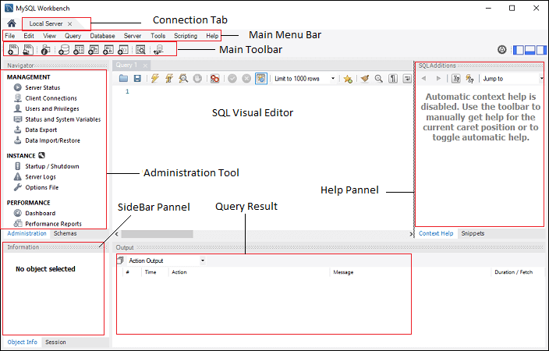

1. Database Design

# Introduction

* Database Design is a collection of processes that facilitate the designing, development, implementation and maintenance of enterprise data management systems.
* Properly designed database are easy to maintain, improves data consistency and are cost effective in terms of disk storage space.
* The database designer decides how the data elements correlate and what data must be stored.

# Database development life cycle

* The database development life cycle has a number of stages that are followed when developing database systems.
* 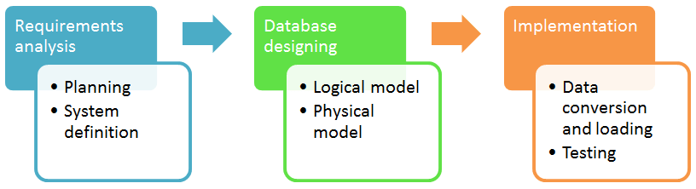But it is not necessary to follow every stapes.

## Requirement Analysis:

**Planning:**

* This stages of database design concepts are concerned with planning of entire Database Development Life Cycle.
* It takes into consideration the Information Systems strategy of the organization.

**System definition:**

* This stage defines the scope and boundaries of the proposed database system.

## Database designing:

**Logical model:**

* This stage is concerned with developing a database model based on requirements.
* The entire design is on paper without any physical implementations or specific DBMS considerations.

**Physical model:**

* This stage implements the logical model of the database taking into account the DBMS and physical implementation factors.

## Implementation:

**Data conversion and loading:**

* This stage of relational databases design is concerned with importing and converting data from the old system into the new database.

**Testing:**

* This stage is concerned with the identification of errors in the newly implemented system.
* It checks the database against requirement specifications.

# Database Design Technique

* We have two types of database design techniques.
  + Normalization
  + ER Modeling

## ER Modeling

* Entity Relationship Model (ER Modeling) is a graphical approach to database design.
* It is a high-level data model that defines data elements and their relationship for a specified software system.
* An ER model is used to represent real-world objects.

## Normalization

* Normalization is the process of removing redundant data from tables to improve data integrity(completeness, accuracy and consistency of data), scalability and storage efficiency.
* We have 6 type of normal forms
  + 1NF
  + 2NF
  + 3NF
  + BCNF
  + 4NF
  + 5NF

|  |  |
| --- | --- |
| Normal Form | Description |
| [1NF](https://www.javatpoint.com/dbms-first-normal-form) | A relation is in 1NF if it contains an atomic value. |
| [2NF](https://www.javatpoint.com/dbms-second-normal-form) | A relation will be in 2NF if it is in 1NF and all non-key attributes are fully functional dependent on the primary key. |
| [3NF](https://www.javatpoint.com/dbms-third-normal-form) | A relation will be in 3NF if it is in 2NF and no transition dependency exists. |
| BCNF | A stronger definition of 3NF is known as Boyce Codd's normal form. |
| [4NF](https://www.javatpoint.com/dbms-forth-normal-form) | A relation will be in 4NF if it is in Boyce Codd's normal form and has no multi-valued dependency. |
| [5NF](https://www.javatpoint.com/dbms-fifth-normal-form) | A relation is in 5NF. If it is in 4NF and does not contain any join dependency, joining should be lossless. |

1. Basic SQL

# Introduction

* SQL have basic five components,
  + Data Definition Language
  + DQL – Data Query Language
  + DML – Data Manipulation Language
  + DCL – Data Control Language
  + TCL – Transaction Control Language

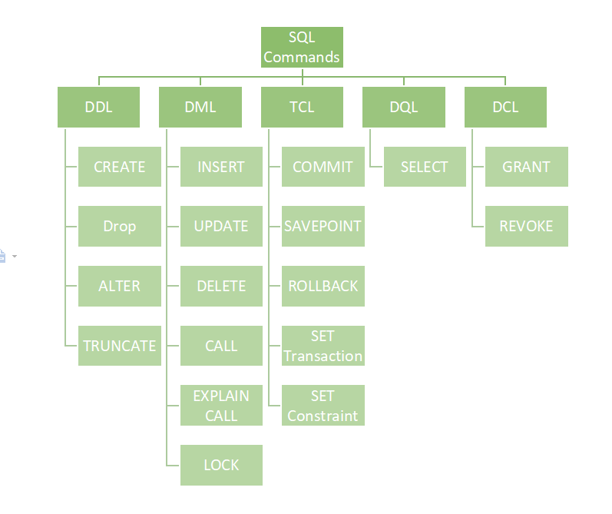

# Data Definition Language

* It contains SQL command that used for define schema.
* DDL is a set of SQL commands used to create, modify, and delete database structures but not data.
* DDL contains following commands,
  + Create
  + Drop
  + Alter
  + Truncate
  + Comment
  + Rename

**Create:**

* This command is used to create the database or its objects (like table, index, function, views, store procedure, and triggers).

**Drop:**

* This command is used to delete objects from the database.

**Alter:**

* This is used to update the structure of the database.

**Truncate:**

* This is used to remove all records from a table, including all spaces allocated for the records are removed.

**Comment:**

* This is used to add comments to the data dictionary.

**Rename:**

* This is used to rename an object existing in the database.

# Data Query Language

* DQL is used to perform a query on schema.
* It is used to retrieve data from schema.
* It have only one command which is select.
* When we fired select command on table that time data stored in temporary table and this table we should see in output window.

# Data Manipulation Language

* These commands is used for data manipulation in existing schema.
* It is the component of the SQL statement that controls access to data and to the database.
* Basically, DCL statements are grouped with DML statements.
* It contains following commands,
  + Insert
  + Update
  + Delete
  + Lock
  + Call
  + Explain Plan

**Insert:**

* It is used to insert data into a table.

**Update:**

* It is used to update existing data within a table.

**Delete:**

* It is used to delete records from a database table.

**Lock:**

* Data consistency is an important mechanism, and it can be done by means of SQL Locks.
* A lock is established in SQL Server when a transaction starts, and it will released when it is ended.
* We have different types of locks available in relational database,
  + **Shared (S) Locks:** 
    - When the object needs to be read, this type of lock will occur.
    - But this is not harmful.
  + **Exclusive (X) Locks:** 
    - It prevents other transactions like inserting/updating/deleting.
    - So no modifications can be done when we apply this type of lock on object.
  + **Update (U) Locks:** 
    - It’s like Exclusive lock but here the operation can be viewed as “read phase” and “write phase”.
    - During the read phase, other transactions are prevented.
  + **Intent Locks:**
    - Intent lock happens on a table, when the shared (S) lock or exclusive (X) lock or Update (U) lock happens on the row.
  + **Regular intent locks:**
    - Intent exclusive (IX)
    - Intent shared (IS)
    - Intent update (IU).
  + **Conversion locks:**
    - Shared with intent exclusive (SIX)
    - Shared with intent update (SIU)
    - Update with intent exclusive (UIX)
* 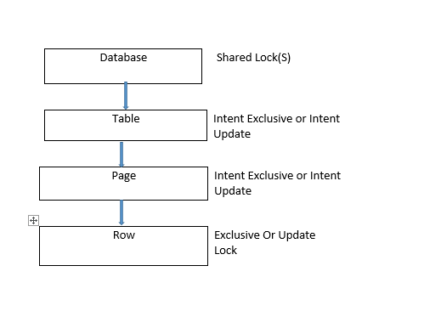We have hierarchy for lock.

(Select)

(Update/Insert/Delete)

**Call:**

* Call a PL/SQL

**Explain Plan:**

* It describes the access path to data.

# Data Control Language

* DCL includes commands which mainly use for user rights, permissions and other controls on database.
* It contains two command,
  + Grant
  + Revoke

**Grant:**

* This command is used to give user access privileges of database to user.

**Revoke:**

* This command revoke the user privileges of database from the user.

# Transaction Control Language

* We have group of some transection which used for execute single query.
* Transection done when this group of transections id done,
* If any one is failed then whole transection is failed.
* So transection have only two result, success and failure.
* Transection contains some commands,
  + Begin
  + Commit
  + Rollback
  + Savepoint
  + Set Transection

**Begin:**

* Opens a Transaction.

**Commit:**

* Commits a Transaction.

Rollback:

* Rollback transection if any error occur during transaction.

**Savepoint:**

* Set a save point within the transection.

**Set Transection:**

* Specify characteristics for transection.