Dhruvil Dobariya

dhruvildobariya21@gmail.com

Abstract

[Draw your reader in with an engaging abstract. It is typically a short summary of the document.   
When you’re ready to add your content, just click here and start typing.]

GUI Basics

Documentation

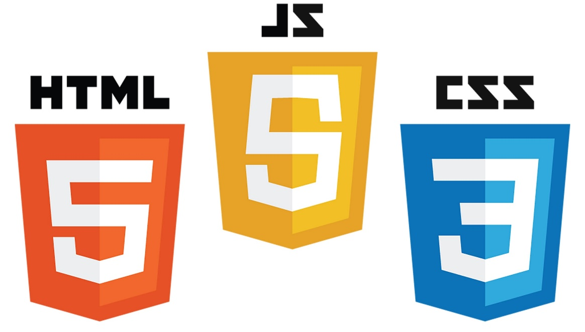

Index

1 Visual Studio 2019 IDE Overview 1

1.1 What is a Visual Studio? 1

1.2 Different types of windows 1

1.3 Solution and Project 2

1.4 Code editor features 4

1.5 Popular keyboard shortcuts for Visual Studio: 9

2 Project Types 17

2.1 Windows Development 17

2.2 Class Library 18

2.3 Mobile Development 19

2.4 Web Development 20

3 Introduction To C# 22

3.1 What is a C#? 22

3.2 “Hello World” Program 22

3.3 Namespace: 23

3.4 The “using” Keyword 24

3.5 Class 25

3.6 Methods 26

3.7 Variables 27

4 Understanding C# Program 28

4.1 Program flow 28

4.2 Understanding Syntax 28

4.3 Common Language Runtime (CLR) 29

5 Working with code files, projects & solutions 30

5.1 Structure of solution 30

5.2 Understanding structure of project 30

6 Understanding datatypes & variables with conversion 37

6.1 Data Type: 37

6.2 Datatype Conversion 41

7 Understanding Decision making & statements 46

7.1 If Else 46

7.2 Switch 53

8 Operators and Expressions 57

8.1 Operators 57

9 Loop Iteration 62

9.1 While 62

9.2 Do While 63

9.3 For 65

9.4 For Each 66

9.5 Break Statement 68

9.6 Continue Statement 69

9.7 Go To Statement 71

10 Understanding Arrays 72

10.1 Introduction 72

10.2 Declaring Array 72

10.3 Single dimensional array 73

10.4 Multidimensional array 74

10.5 Jugged array 77

10.6 Array Class 79

11 Defining and Calling Methods 83

11.1 Introduction 83

11.2 Defining the method 83

11.3 Calling Method 84

11.4 Passing Parameter to the method 85

12 Working with strings 86

12.1 Introduction 86

12.2 String 86

12.3 StringBuilder 87

13 Working with Datetimes 90

13.1 Introduction 90

13.2 DateTime 90

14 Understanding Classes 100

14.1 Introduction 100

14.2 Types of Classes 101

15 Depth in Classes 104

15.1 Object 104

16 Scope & Accessibility Modifiers 106

16.1 Introduction 106

16.2 Access Specifiers 106

17 Namespace & .Net Library 107

17.1 Introduction 107

17.2 Full Name 107

17.3 With “Using” Keyword 107

18 Creating and adding ref. to assemblies 109

18.1 Introduction 109

18.2 Create By Self 109

18.3 Provide By .NET 110

18.4 Provide By third-party 110

19 Working with collections 111

19.1 Introduction 111

19.2 System.Collection.Genaric Class 111

19.3 System.Collection Class 113

19.4 System.Collection.Concurrent 123

20 Enumerations 125

20.1 Enum: 125

21 Exception Handling 127

21.1 Introduction 127

21.2 Exception Class 128

22 Events 130

22.1 Introduction 130

22.2 Implement Event 131

22.3 Delegates 131

23 Basics of File Handling 133

23.1 Introduction 133

23.2 FileSteram Class 133

23.3 StreamWriter Class 134

23.4 SteamReader Class 135

23.5 BinaryWriter Class 136

23.6 BinaryRender Class 138

23.7 DirectoryInfo Class 139

23.8 FileInfo Class 140

24 Interface & inheritance 143

24.1 Inheritance 143

24.2 Interface 147

25 Introduction to WEB Development 148

25.1 ASP.NET Web Forms 148

25.2 ASP.NET MVC 158

25.3 ASP.NET Rest Web API 159

1. Visual Studio 2019 IDE Overview

# What is a Visual Studio?

* Microsoft Visual Studio is an integrated development environment (IDE) from Microsoft. It is used to develop computer programs, as well as websites, web apps, web services and mobile apps.
* Visual Studio supports 36 different programming languages and allows the code editor and debugger to support (to varying degrees) nearly any programming language, provided a language-specific service exists.

# Different types of windows

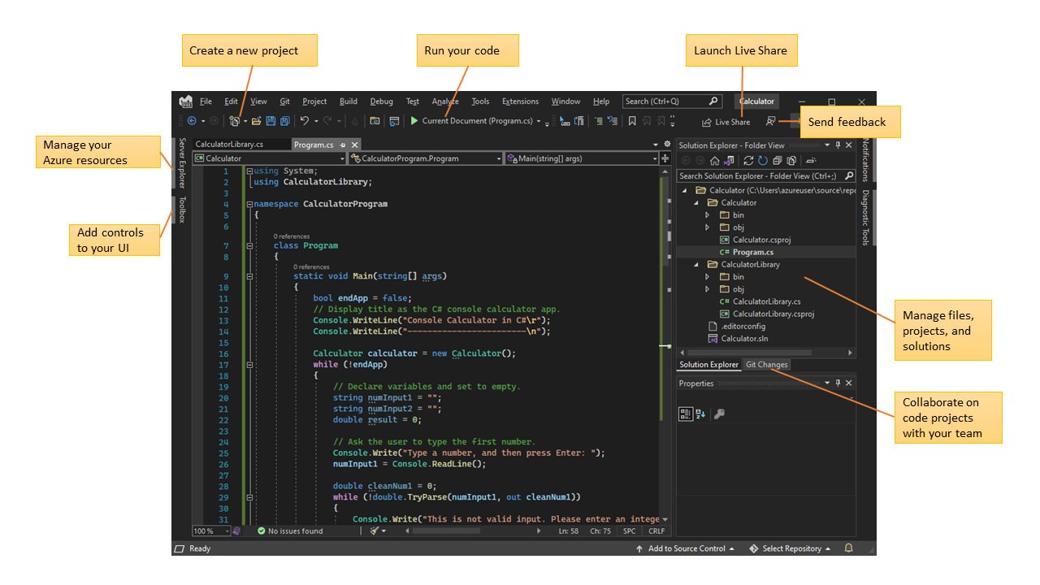

* In Solution Explorer, at upper right, you can view, navigate, and manage your code files. Solution Explorer can help organize your code by grouping the files into solutions and projects.
* The central editor window, where you'll probably spend most of your time, displays file contents. In the editor window, you can edit code or design a user interface such as a window with buttons and text boxes.
* The central editor window, where you'll probably spend most of your time, displays file contents. In the editor window, you can edit code or design a user interface such as a window with buttons and text boxes.

# Solution and Project

* We are used Solution Explorer to manage project. Using Solution Explorer we should manage folder structure and navigate different files.
* Solution Explorer have a file which is contain solution details and projects details.
* This file have *‘.sln’* extension.
* Solution contain one or more projects.
* Project have one file which containe details about project.
* Which have *‘.csproj’* extension(if project base on C#).

## Create a solution:

* Open Visual Studio, and on the start window, select Create a new project.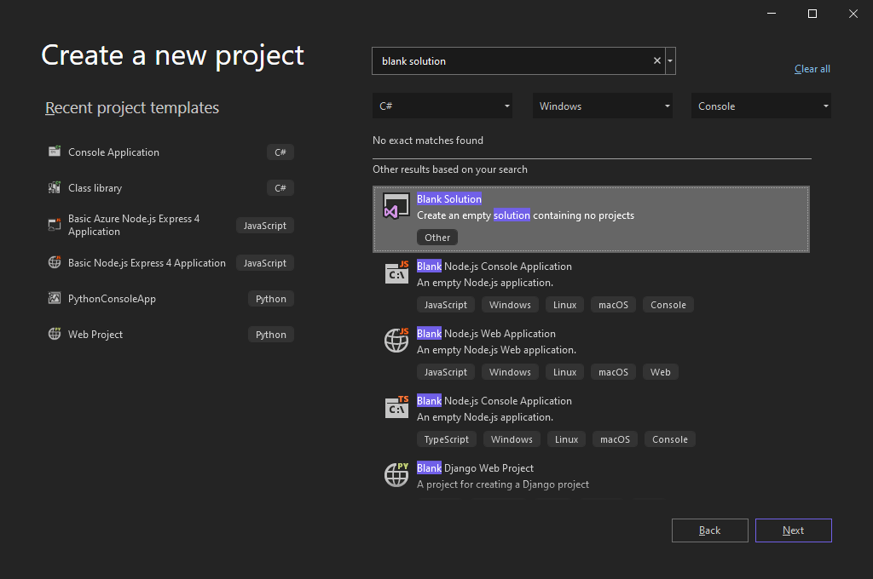
* On the Configure your new project page, give the name of Solution, and then select Create.
* Let say our solution name is **'QuickSolution'**.

## Add a project:

* Right-click Solution **'QuickSolution'** in Solution Explorer, and select Add > New Project from the context menu.
* On the Add a new project page, type empty into the search box at the top, and select C# under All languages.
* Select the C# Empty Project (.NET Framework) template, and then select Next.
* On the Configure your new project page, give the name of Project, and then select Create.
* Let say our solution name is **‘QuickDate’**.

## Add an item to the project:

* From the right-click or context menu of the **‘QuickDate’** project in Solution Explorer, select Add > New Item.
* Expand Visual C# Items, and then select Code. In the middle pane, select the Class item template. Under Name, give the name of file, and then select Add.
* Let say our file name is **‘Calander.cs’**.

## Add a second project:

* 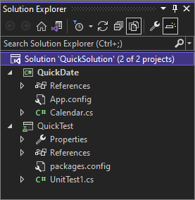From the right-click or context menu of Solution '**QuickSolution'** in Solution Explorer, select Add > New Project.
* In the Add a new project dialog box, type unit test into the search box at the top, and then select C# under All languages.
* Select the C# Unit Test Project (.NET Framework) project template, and then select Next.
* On the Configure your new project page, give the name of project, and then select Create.
* Let say our second project name is **‘QuickTest’.**
* Add one file inside the second project.
* Let say our file name is **‘UnitTest1.cs’**.

## Add a project reference:

* In Solution Explorer, right-click the References node of the **‘QuickTest’** project, and select Add Reference from the context menu.
* In the Reference Manager dialog box, under Projects, select the checkbox next to **‘QuickDate’,** and then select OK.
* 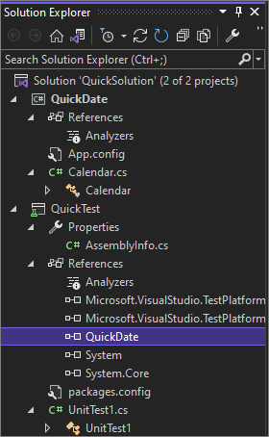Now a reference to the **‘QuickDate’** project appears under the **‘QuickTest’** project in Solution Explorer.

## Project properties:

* 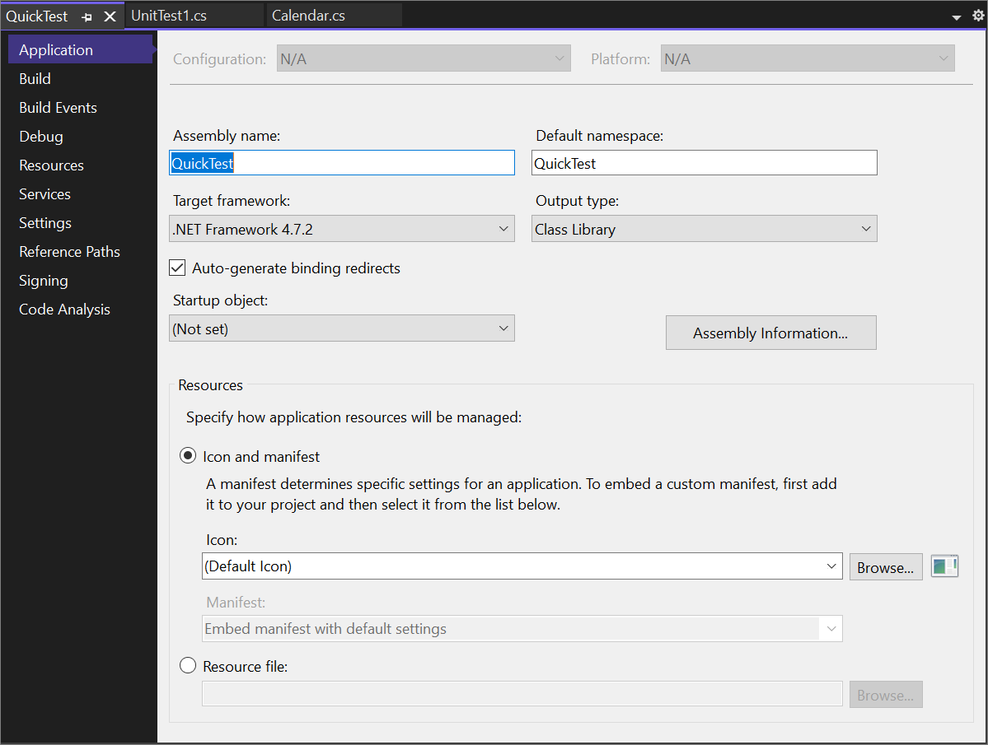In Solution Explorer, right-click the **‘QuickTest’** project and select Properties, or select the project and press Alt+Enter.

# Code editor features

* Some popular features in Visual Studio that improve your productivity when developing software include

## Squiggles and Quick Actions:

* Squiggles are wavy underlines that alert you to errors or potential problems in your code as you type.
* 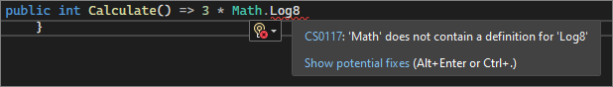These visual clues help you fix problems immediately, without waiting to discover errors during build or runtime.
* If you hover over a squiggle, you see more information about the error.
* A lightbulb might also appear in the left margin showing Quick Actions you can take to fix the error.

## Code Cleanup:

* With the click of a button, you can format your code and apply any code fixes suggested by your code style settings, .editorconfig conventions, and Roslyn analyzers.
* Code Cleanup, currently available for C# code only, helps you resolve issues in your code before it goes to code review.

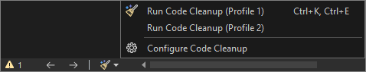

## Refactoring:

* Refactoring includes operations such as intelligent renaming of variables, extracting one or more lines of code into a new method, and changing the order of method parameters.

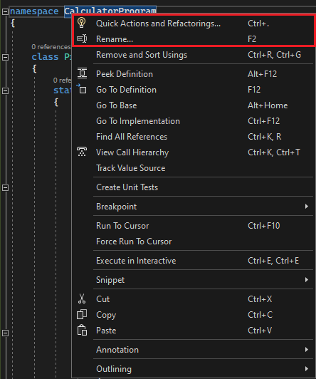

## IntelliSense:

* IntelliSense is a set of features that display information about your code directly in the edor and, in some cases, write small bits of code for you.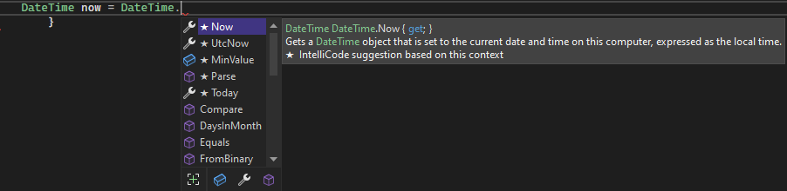
* It's like having basic documentation inline in the editor, so you don't have to look up type information elsewhere.

## Visual Studio search:

* Visual Studio menus, options, and properties can seem overwhelming at times.
* Visual Studio search, or *‘Ctrl+Q’*, is a great way to rapidly find IDE features and code in one place.

## Live Share:

* Collaboratively edit and debug with others in real time, regardless of your app type or programming language.
* You can instantly and securely share your project. You can also share debugging sessions, terminal instances, localhost web apps, voice calls, and more.

## Call Hierarchy:

* The Call Hierarchy window shows the methods that call a selected method.
* This information can be useful when you're thinking about changing or removing the method, or when you're trying to track down a bug.

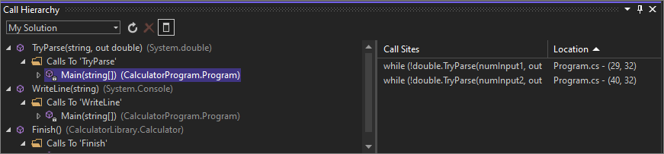

## CodeLens:

* CodeLens helps you find code references, code changes, linked bugs, work items, code reviews, and unit tests, without leaving the editor.

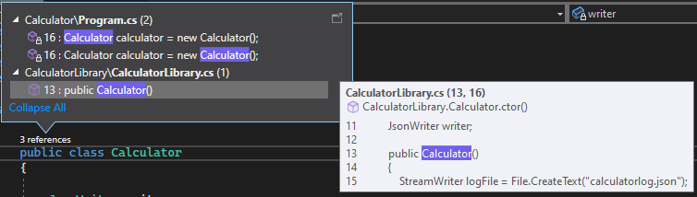

## Go To Definition:

* The Go To Definition feature takes you directly to the location of a function or type definition.

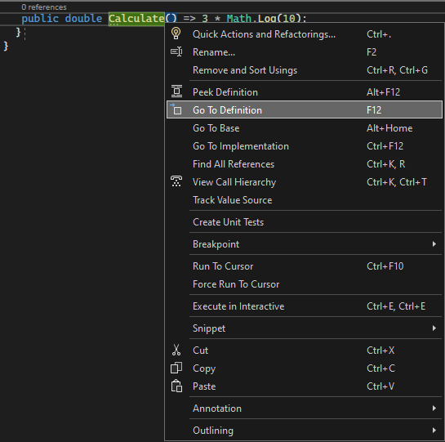

## Peek Definition:

* 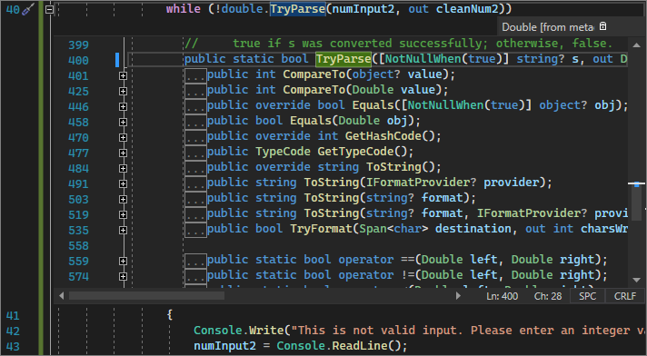The Peek Definition window shows a method or type definition without opening a separate file.

# Popular keyboard shortcuts for Visual Studio:

## Build:

|  |  |  |
| --- | --- | --- |
| Commands | Keyboard shortcuts | Command ID |
| Build solution | Ctrl+Shift+B | Build.BuildSolution |
| Cancel | Ctrl+Break | Build.Cancel |
| Compile | Ctrl+F7 | Build.Compile |
| Run code analysis on solution | Alt+F11 | Build.RunCodeAnalysisonSolution |

## Debug:

|  |  |  |
| --- | --- | --- |
| Commands | Keyboard shortcuts [Special contexts] | Command ID |
| Break at function | Ctrl+B | Debug.BreakatFunction |
| Break all | Ctrl+Alt+Break | Debug.BreakAll |
| Delete all breakpoints | Ctrl+Shift+F9 | Debug.DeleteAllBreakpoints |
| Exceptions | Ctrl+Alt+E | Debug.Exceptions |
| Quick watch | Ctrl+Alt+Q  or Shift+F9 | Debug.QuickWatch |
| Restart | Ctrl+Shift+F5 | Debug.Restart |
| Run to cursor | Ctrl+F10 | Debug.RunToCursor |
| Set next statement | Ctrl+Shift+F10 | Debug.SetNextStatement |
| Start | F5 | Debug.Start |
| Start without debugging | Ctrl+F5 | Debug.StartWithoutDebugging |
| Step into | F11 | Debug.StepInto |
| Step out | Shift+F11 | Debug.StepOut |
| Step over | F10 | Debug.StepOver |
| Stop debugging | Shift+F5 | Debug.StopDebugging |
| Toggle breakpoint | F9 | Debug.ToggleBreakpoint |

## Edit:

|  |  |  |
| --- | --- | --- |
| Commands | Keyboard shortcuts [Special contexts] | Command ID |
| Break line | Enter [Text Editor, Report Designer, Windows Forms Designer]  or Shift+Enter [Text Editor] | Edit.BreakLine |
| Collapse to definitions | Ctrl+M, Ctrl+O [Text Editor] | Edit.CollapseToDefinitions |
| Comment selection | Ctrl+K, Ctrl+C [Text Editor] | Edit.CommentSelection |
| Complete word | Alt+Right Arrow [Text Editor, Workflow Designer]  or Ctrl+Spacebar [Text Editor, Workflow Designer]  or Ctrl+K, W [Workflow Designer]  or Ctrl+K, Ctrl+W [Workflow Designer] | Edit.CompleteWord |
| Copy | Ctrl+C  or Ctrl+Insert | Edit.Copy |
| Cut | Ctrl+X  or Shift+Delete | Edit.Cut |
| Delete | Delete [Team Explorer]  or Shift+Delete [Sequence Diagram, UML Activity Diagram, Layer Diagram]  or Ctrl+Delete [Class Diagram] | Edit.Delete |
| Find | Ctrl+F | Edit.Find |
| Find all references | Shift+F12 | Edit.FindAllReferences |
| Find in files | Ctrl+Shift+F | Edit.FindinFiles |
| Find next | F3 | Edit.FindNext |
| Find next selected | Ctrl+F3 | Edit.FindNextSelected |
| Format document | Ctrl+K, Ctrl+D [Text Editor] | Edit.FormatDocument |
| Format selection | Ctrl+K, Ctrl+F [Text Editor] | Edit.FormatSelection |
| Go to | Ctrl+G | Edit.GoTo |
| Go to declaration | Ctrl+F12 | Edit.GoToDeclaration |
| Go to definition | F12 | Edit.GoToDefinition |
| Go to find combo | Ctrl+D | Edit.GoToFindCombo |
| Go to next location | F8 | Edit.GoToNextLocation |
| Insert snippet | Ctrl+K, Ctrl+X | Edit.InsertSnippet |
| Insert tab | Tab [Report Designer, Windows Forms Designer, Text Editor] | Edit.InsertTab |
| Line cut | Ctrl+L [Text Editor] | Edit.LineCut |
| Line down extend column | Shift+Alt+Down Arrow [Text Editor] | Edit.LineDownExtendColumn |
| Line open above | Ctrl+Enter [Text Editor] | Edit.LineOpenAbove |
| List members | Ctrl+J [Text Editor, Workflow Designer]  or Ctrl+K, Ctrl+L [Workflow Designer]  or Ctrl+K, L [Workflow Designer] | Edit.ListMembers |
| Navigate to | Ctrl+, | Edit.NavigateTo |
| Open file | Ctrl+Shift+G | Edit.OpenFile |
| Overtype mode | Insert [Text Editor] | Edit.OvertypeMode |
| Parameter info | Ctrl+Shift+Spacebar [Text Editor, Workflow Designer] or Ctrl+K, Ctrl+P [Workflow Designer] or Ctrl+K, P [Workflow Designer] | Edit.ParameterInfo |
| Paste | Ctrl+V or Shift+Insert | Edit.Paste |
| Peek definition | Alt+F12 [Text Editor] | Edit.PeekDefinition |
| Redo | Ctrl+Y or Shift+Alt+Backspace or Ctrl+Shift+Z | Edit.Redo |
| Replace | Ctrl+H | Edit.Replace |
| Select all | Ctrl+A | Edit.SelectAll |
| Select current word | Ctrl+W [Text Editor] | Edit.SelectCurrentWord |
| Selection cancel | Esc [Text Editor, Report Designer, Settings Designer, Windows Forms Designer, Managed Resources Editor] | Edit.SelectionCancel |
| Surround with | Ctrl+K, Ctrl+S (available only in Visual Studio 2019 and earlier) | Edit.SurroundWith |
| Tab left | Shift+Tab [Text Editor, Report Designer, Windows Forms Editor] | Edit.TabLeft |
| Toggle all outlining | Ctrl+M, Ctrl+L [Text Editor] | Edit.ToggleAllOutlining |
| Toggle bookmark | Ctrl+K, Ctrl+K [Text Editor] | Edit.ToggleBookmark |
| Toggle completion mode | Ctrl+Alt+Space [Text Editor] | Edit.ToggleCompletionMode |
| Toggle outlining expansion | Ctrl+M, Ctrl+M [Text Editor] | Edit.ToggleOutliningExpansion |
| Uncomment selection | Ctrl+K, Ctrl+U [Text Editor] | Edit.UncommentSelection |
| Undo | Ctrl+Z or Alt+Backspace | Edit.Undo |
| Word delete to end | Ctrl+Delete [Text Editor] | Edit.WordDeleteToEnd |
| Word delete to start | Ctrl+Backspace [Text Editor] | Edit.WordDeleteToStart |

## File: popular shortcuts:

|  |  |  |
| --- | --- | --- |
| Commands | Keyboard shortcuts [Special contexts] | Command ID |
| Exit | Alt+F4 | File.Exit |
| New file | Ctrl+N | File.NewFile |
| New project | Ctrl+Shift+N | File.NewProject |
| New web site | Shift+Alt+N | File.NewWebSite |
| Open file | Ctrl+O | File.OpenFile |
| Open project | Ctrl+Shift+O | File.OpenProject |
| Open web site | Shift+Alt+O | File.OpenWebSite |
| Rename | F2 [Team Explorer] | File.Rename |
| Save all | Ctrl+Shift+S | File.SaveAll |
| Save selected items | Ctrl+S | File.SaveSelectedItems |
| View in browser | Ctrl+Shift+W | File.ViewinBrowser |

## Project:

|  |  |  |
| --- | --- | --- |
| Commands | Keyboard shortcuts [Special contexts] | Command ID |
| Add existing item | Shift+Alt+A | Project.AddExistingItem |
| Add new item | Ctrl+Shift+A | Project.AddNewItem |

## Refactor:

|  |  |  |
| --- | --- | --- |
| Command | Keyboard shortcut [Special contexts] | Command ID |
| Extract method | Ctrl+R, Ctrl+M | Refactor.ExtractMethod |

## Tools:

|  |  |  |
| --- | --- | --- |
| Command | Keyboard shortcut [Special contexts] | Command ID |
| Attach to process | Ctrl+Alt+P | Tools.AttachtoProcess |

## View:

|  |  |  |
| --- | --- | --- |
| Commands | Keyboard shortcuts [Special contexts] | Command ID |
| Class view | Ctrl+Shift+C | View.ClassView |
| Edit label | F2 | View.EditLabel |
| Error list | Ctrl+\, Ctrl+E or Ctrl+\, E | View.ErrorList |
| Navigate backward | Ctrl+- | View.NavigateBackward |
| Navigate forward | Ctrl+Shift+- | View.NavigateForward |
| Object browser | Ctrl+Alt+J | View.ObjectBrowser |
| Output | Ctrl+Alt+O | View.Output |
| Properties window | F4 | View.PropertiesWindow |
| Refresh | F5 [Team Explorer] | View.Refresh |
| Server explorer | Ctrl+Alt+S | View.ServerExplorer |
| Show smart tag | Ctrl+.  or Shift+Alt+F10 [HTML Editor Design View] | View.ShowSmartTag |
| Solution explorer | Ctrl+Alt+L | View.SolutionExplorer |
| TFS Team Explorer | Ctrl+\, Ctrl+M | View.TfsTeamExplorer |
| Toolbox | Ctrl+Alt+X | View.Toolbox |
| View code | Enter [Class Diagram]  or F7 [Settings Designer] | View.ViewCode |
| View designer | Shift+F7 [HTML Editor Source View] | View.ViewDesigner |

## Window:

|  |  |  |
| --- | --- | --- |
| Commands | Keyboard shortcuts [Special contexts] | Command ID |
| Activate document window | Esc | Window.ActivateDocumentWindow |
| Close document window | Ctrl+F4 | Window.CloseDocumentWindow |
| Next document window | Ctrl+F6 | Window.NextDocumentWindow |
| Next document window nav | Ctrl+Tab | Window.NextDocumentWindowNav |
| Next split pane | F6 | Window.NextSplitPane |