Dhruvil Dobariya

dhruvildobariya21@gmail.com

Abstract

In this module I learn React

React

Documentation

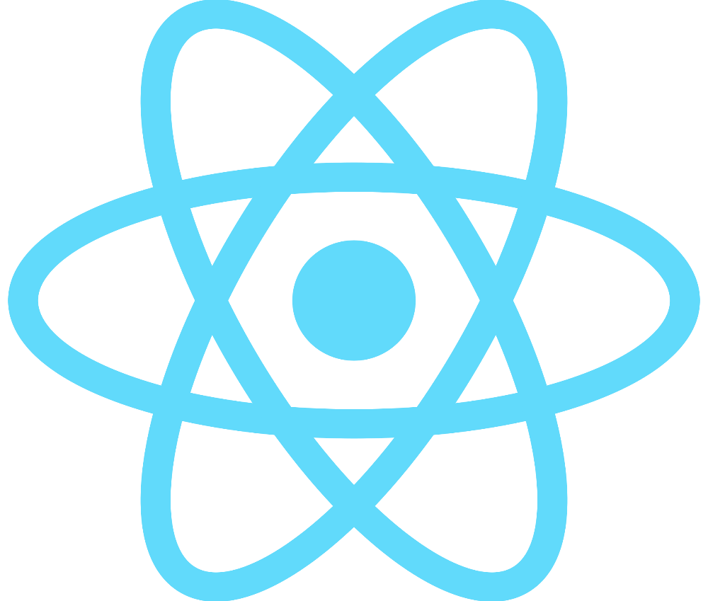

Index

1 Introduction to React 1

1. Introduction to React