Quantization, Not Just Scale: Reliability and Failure Anatomy of Small Open-Weight Tool Agents
Dhruvil Shah
Independent Researcher
[EMAIL — confirm before submission]
Abstract
Small open-weight language models (1–7B parameters) are the only agents most practitioners can run at zero cost, yet agent reliability has mostly been measured on frontier APIs. We build a five-tool agent harness with a 25-task suite spanning five probe slices (single-tool use, multi-tool chains, distractor tools, underspecified requests, and injected tool faults) and run 2,400 seeded episodes across a model-size × quantization × mitigation matrix, graded programmatically (blind-validated, κ = 0.86 for success and 0.94 for failure category). Three results stand out. First, quantization dominates: at 1.5B, the 8-bit build more than doubles task success over the default 4-bit download (31.0% vs 15.0%; +16 points, Holm-corrected exact McNemar p = 2×10⁻⁵), matching the gain from doubling parameters, and twice in our matrix a higher-precision smaller model matched a larger 4-bit one. The damage is qualitative, not just quantitative: the 4-bit model often never calls a tool, while the 8-bit model calls tools and fails later, at synthesis. Second, a deterministic verification-and-retry guardrail (schema validation, typed errors, bounded retries) never significantly improves overall success, and significantly reduces it in two different model families (−7.5 points at Qwen2.5-1.5B-Q8, −6.5 at Llama-3.2-1B); most failures originate at tool selection or answer synthesis, upstream of anything an argument-level check can reach. The same guardrail, however, triples recovery from injected tool faults at 3B, indicating the mechanism works once a model can act on error feedback. Third, reliability collapses under repetition: the best cell completes all eight seeded repeats of a task only 16% of the time, and 1.5B models recovered from 0 of 84 injected faults, typically hallucinating a concrete answer instead. The harness, raw logs, and analysis are public, every reported number regenerates from the logs in CI, and the full study reproduces in under four GPU-hours on a free tier or on a consumer CPU.

1 Introduction
If you want a language-model agent and cannot pay per token, your options narrow quickly: a 1–7B open-weight model, quantized to fit consumer hardware, served locally. A growing position in the literature holds that such small models are the economically rational substrate for agentic systems [1]. Whether they are *reliable* enough is a different question, and the evidence so far comes mostly from the other end of the spectrum: τ-bench showed that even GPT-4o solves fewer than half of its tasks and is inconsistent across repeated trials [2]; AgentBench found open-weight models trailing API models by large margins [3]; function-calling leaderboards rank models by single-shot accuracy [4]. None of this tells a practitioner what to expect from the quantized 1.5B model they just pulled, how it fails, or whether the obvious cheap fix is worth the latency.
We ask four questions about small open-weight tool agents. How reliably do they complete multi-step tool tasks, measured across repeated seeded trials rather than single shots? Where in the pipeline do failures start — tool selection, argument construction, error handling, or answer synthesis? Does a deterministic verification-and-retry guardrail close any of the gap, and at what cost? And how does weight quantization — the knob every local deployment turns — modulate all of the above?
We answer these with a deliberately transparent testbed: a five-tool customer-support agent over a fully synthetic world, a 25-task suite with five probe slices, programmatic grading validated blind against hand labels, and 2,400 episodes across five model×quantization settings, each with and without the guardrail. Hypotheses, contrasts, and gates were fixed in a design document before any experiment ran; one of the four hypotheses was falsified and is reported as such. Our contributions:
- A reliability-first measurement of 1–7B GGUF-quantized agents with pass^k, per-stage failure attribution, and paired statistics — the regime prior agent benchmarks mostly skip.
- Evidence that quantization is a first-order variable for agentic use: +16 points from Q4_K_M to Q8_0 at 1.5B (p = 2×10⁻⁵), with a qualitative shift in failure mode, and two instances where a smaller higher-precision model matched a larger 4-bit one. Static compression benchmarks predicted 1–3% [6].
- A cautionary result for the most common mitigation: schema validation with typed-error retries never significantly helped overall success in five settings and significantly hurt in two model families — while still tripling fault recovery at 3B, locating a capability threshold below which verification feedback is noise.
- A zero-cost, fully reproducible harness: every number in this paper is regenerated from committed raw logs by CI, and the whole study reruns in under four GPU-hours on a free tier.

2 Related work
Agent benchmarks and reliability. τ-bench introduced pass^k over repeated trials and an LLM-simulated user, applied to frontier API models [2]. We adopt pass^k and move the object of study to small local models; our clarification turns are scripted rather than LLM-simulated, which keeps the study free and deterministic. AgentBench established the API-vs-open gap across eight environments [3]. BFCL defines the standard schema-level grading of function calls [4], which our grader follows, but leaderboard accuracy is single-shot and unattributed; we add repetition, attribution, and a mitigation arm.
Mitigations and self-healing. Babu and Agrawal treat reliability as a bounded runtime-control problem and report 98.8% success on a 100-task fault-injection benchmark with budgeted recovery and verification [5]. Their evaluation abstracts the model away (unnamed, no repeated-trial metrics or intervals, call-count cost proxies), which is precisely the gap we fill with named quantized models, paired tests, and wall-clock accounting — and our results add a boundary condition their abstraction cannot see: below a capability threshold, verification feedback reduces success. PALADIN trains recovery behavior from failure-injected trajectories [10]; our guardrail is deliberately training-free. Tool-fault benchmarks (ToolMaze [8], AgentCE-Bench [9]) inject perturbations at larger scale than our S5 slice; we borrow the idea and add the small-model recovery numbers.
Compression and agentic ability. ACBench evaluated GPTQ/AWQ compression on agent-relevant benchmarks and found 4-bit quantization costs only 1–3% on tool use [6]. Our results disagree in the live-loop setting by an order of magnitude at 1.5B, suggesting single-shot static evaluation understates quantization damage to sequential agentic behavior. TinyLLM studies sub-3B function calling and improves it by fine-tuning [7]; we measure, rather than train, and target the inference-time question. MAST taxonomizes failures of multi-agent systems [11]; our taxonomy is single-agent and pipeline-staged, designed to be assignable by deterministic rules. ToolEmu uses an LM-emulated sandbox for safety risks [12]. Clarification under ambiguity is an active method area [14]; our S4 slice only measures the behavior. Long-context degradation [13] is out of scope by design.

3 Testbed
Agent loop. A minimal ReAct-style loop with native tool calling through Ollama's chat API — no agent framework, so every token the model sees is in the logs. System prompt, task, then up to ten model calls; temperature 0.7, top-p 0.9, context 4,096 tokens, seeds 1–8 per task. Episodes are logged in full (requests, responses, tool executions, timing) and written atomically, so runs resume losslessly.
Tools. Five local, deterministic tools: an AST-whitelisted calculator; BM25 search over a 64-document policy corpus; two parameterized SQLite lookups (get_order, find_products) over a seeded 40-product, 30-order database; and a sandboxed Python executor. The world (“Zephyra Outfitters”) is entirely fictional and generated from a fixed seed, so no answer can come from memorization: an ungrounded answer is detectably wrong.
Tasks. Twenty-five hand-written tasks in five slices: S1 single-tool (5), S2 multi-tool chains (8), S3 distractor — a plausible but wrong tool is available (4), S4 underspecified requests, where the harness answers one clarifying question with a scripted reply (4), and S5 injected tool faults (error, timeout, or empty result on the first call, clearing afterwards) (4). Gold answers are resolved from the generated world at grading time rather than stored, so data and answers cannot drift; S4 golds are conditional on whether the agent asked.
Grading and failure attribution. Success is a normalized match of the extracted final answer (numeric tolerance, ISO date, or fuzzy string). Each failed episode receives a first-failure label by deterministic rules over its event log: no_tool_call, wrong_tool, malformed_args, bad_arg_values, ignored_tool_error, synthesis_error, or max_turns; S4 episodes are additionally coded asked / looked-up / guessed, and S5 episodes carry recovery flags. No LLM judge is used anywhere. To validate the grader, 42 stratified episodes were hand-labeled blind (trajectories printed without classifier output): agreement was 40/42 on success (κ = 0.86) and 40/42 on failure category (κ = 0.94); both disagreements traced to one string-normalization gap (a contraction), fixed with an edit-distance rule, after which the same sample agrees 42/42 (in-sample). Two earlier grader defects caught in the pilot are documented in the repository log.
Guardrail. The mitigation under test is deterministic and model-free: every tool call is validated against its JSON schema before execution; violations return a typed error naming the exact problem, with at most two consecutive retries per tool and four extra model calls per episode; tool runtime errors are wrapped as structured, retriable error objects. The baseline passes calls through unchanged and lets the tool layer fail the way a real API does — terse strings. Schema validity is logged in both conditions, so malformed-call rates are always measurable.

4 Experimental design
Core matrix: Qwen2.5-Instruct at 1.5B-Q4_K_M, 1.5B-Q8_0, and 3B-Q4_K_M (GGUF builds as shipped by Ollama; digests pinned in run manifests), each baseline and guardrail: 6 cells × 25 tasks × 8 seeds = 1,200 episodes. Extension matrix (exploratory, same protocol): Llama-3.2-1B (Q8_0), Qwen2.5-3B-Q8_0, and Qwen2.5-7B-Q4_K_M, again both conditions: 1,200 further episodes. Episodes ran on a free Kaggle P100 in 56 minutes per 1,200; the identical harness runs on a consumer CPU (throughput measured and reported in the repository).
Statistics. Five contrasts were pre-registered and paired on (task, seed): the guardrail effect within each core model×quantization, Q8 vs Q4 at 1.5B, and 3B vs 1.5B at Q4 — exact McNemar tests with Holm correction, risk differences with cluster-bootstrap 95% intervals (10,000 resamples, clustered by task). Per-cell uncertainty uses Wilson intervals; reliability uses the unbiased pass^k estimator over 8 seeds, averaged over tasks. Analysis re-grades every episode from raw logs; grades stored at run time are advisory.

5 Results

5.1 No cell is reliable, and repetition is brutal
Table 1: Core matrix (200 episodes per cell). Wilson intervals; pass^8 is the estimated probability all eight seeds succeed.
Cell | Model | Condition | Success | 95% CI | pass^8
C1 | 1.5B Q4_K_M | baseline | 15.0% | 10.7–20.6 | 0.00
C2 | 1.5B Q4_K_M | guardrail | 12.5% | 8.6–17.8 | 0.00
C3 | 1.5B Q8_0 | baseline | 31.0% | 25.0–37.7 | 0.04
C4 | 1.5B Q8_0 | guardrail | 23.5% | 18.2–29.8 | 0.00
C5 | 3B Q4_K_M | baseline | 30.5% | 24.5–37.2 | 0.08
C6 | 3B Q4_K_M | guardrail | 33.5% | 27.3–40.3 | 0.08

Success rates sit between 12.5% and 33.5% (Table 1, Figure 1), and the decay under repetition is steep everywhere (Figure 2): the best core cell would survive eight repeats of a task 8% of the time. This extends the frontier-model inconsistency of [2] into the small-model regime, where it is far more severe (H1 supported).
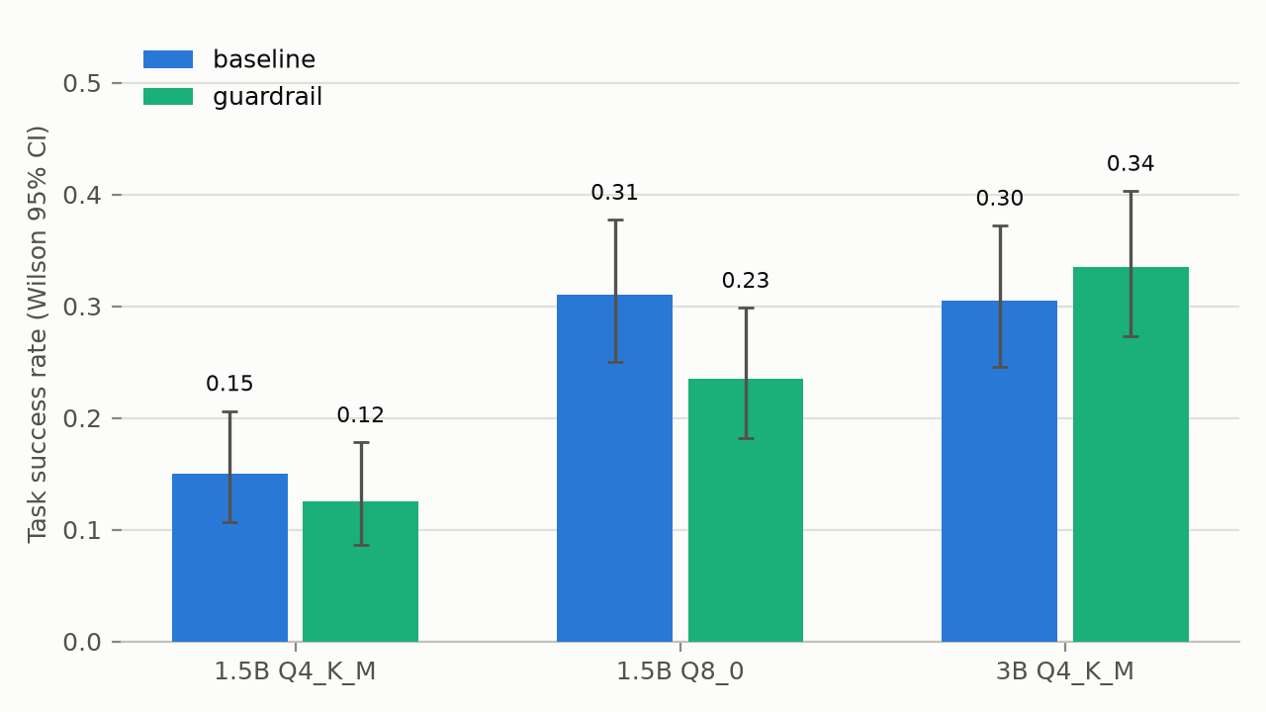
Figure 1: Task success rate by cell with Wilson 95% intervals (core matrix, n = 200 episodes per cell).
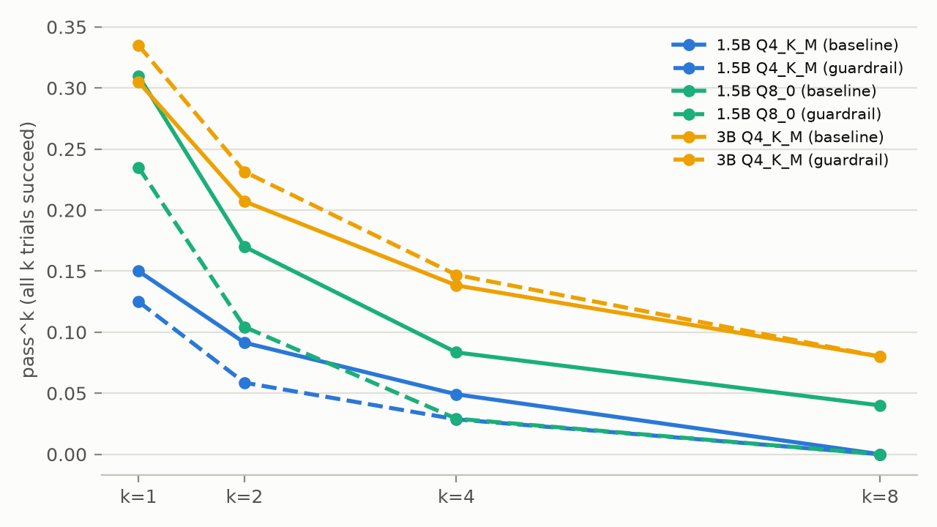
Figure 2: pass^k — the probability that all k seeded repeats of a task succeed — for the six core cells.

5.2 Quantization is a first-order variable
Q8_0 versus Q4_K_M at 1.5B (baseline): +16.0 points (cluster-bootstrap CI +6.0 to +27.0; discordant pairs 40:8; Holm p = 2×10⁻⁵) — the same magnitude as doubling parameters at fixed quantization (3B-Q4 vs 1.5B-Q4: +15.5, CI +0.5 to +31.0, p = 3.5×10⁻⁴). Figure 3 shows the effect is qualitative: the Q4 build's modal first failure is no_tool_call (61/200 — it answers from nothing, often emitting pseudo-JSON), which nearly vanishes at Q8 (5/200); Q8's failures migrate downstream to synthesis. On ambiguity probes the Q8 build asks a clarifying question twice as often (44% vs 22%). The pattern recurs in the extension matrix at 3B (Q8 43.5% vs Q4 30.5%, descriptive), and twice a smaller higher-precision model matched a larger 4-bit one (1.5B-Q8 ≈ 3B-Q4; 3B-Q8 ≈ 7B-Q4). Under a fixed memory budget, precision appears to buy as much agentic reliability as parameters — static compression benchmarks [6] do not predict this (H3 supported at 1.5B).
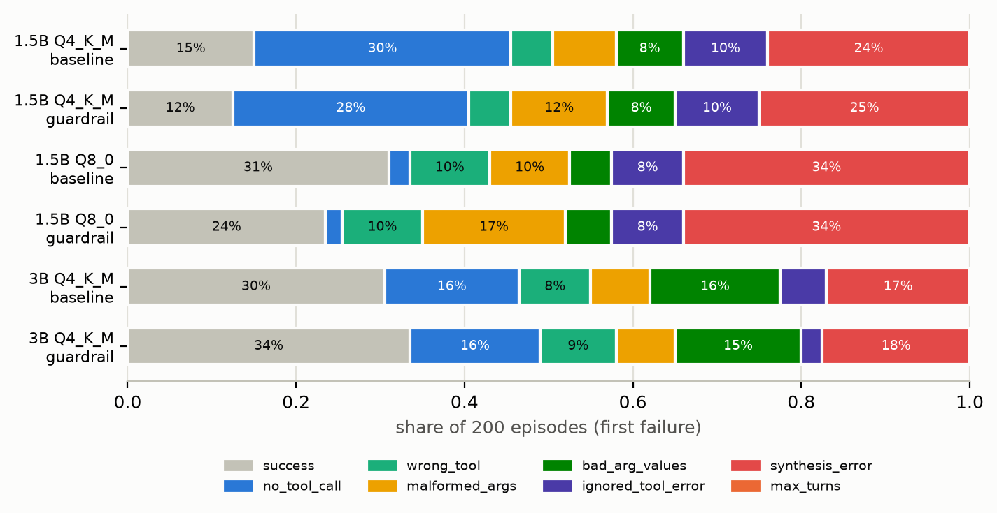
Figure 3: First-failure composition of all 200 episodes per core cell. Quantization changes how the 1.5B model fails, not only how often: no_tool_call dominates at Q4 and nearly vanishes at Q8.

5.3 The guardrail never helps overall — and can hurt (H2 falsified)
Table 2: Guardrail effect (risk difference, percentage points), paired on (task, seed). Core rows Holm-corrected within the pre-registered family; extension rows corrected within theirs.
Contrast | RD | 95% CI | Discordants | Holm p
guardrail @1.5B-Q4 | −2.5 | −9.5, +3.0 | 3:8 | 0.42
guardrail @1.5B-Q8 | −7.5 | −17.5, −0.5 | 1:16 | 8×10⁻⁴
guardrail @3B-Q4 | +3.0 | −4.0, +11.0 | 11:5 | 0.42
guardrail @1B (Llama, ext.) | −6.5 | −15.0, 0.0 | 2:15 | 7×10⁻³
guardrail @3B-Q8 (ext.) | −1.5 | −4.0, +0.5 | 4:7 | 1.0
guardrail @7B-Q4 (ext.) | −0.5 | −1.5, 0.0 | 0:1 | 1.0

In five model×quantization settings the guardrail never significantly improved success, and in two — from two different model families — it significantly reduced it (Table 2). At 1.5B-Q8 it flipped sixteen task-seed pairs from success to failure while rescuing one. The logs show why. First, most failures begin upstream of arguments (Figure 3): wrong or missing tool selection and bad synthesis are inert to schema validation. Second, when the guardrail does block a malformed call, the verbose typed error often derails a small model rather than repairing it — one Llama episode re-sent an invented order_by argument eight times, alternating blocked and passed-through, until the turn budget expired. Malformed-args as a first failure rises under the guardrail at 1.5B-Q8 (19 → 34) because retries multiply chances to fail at the same step. Llama-3.2-1B replicates the harm with a different fingerprint: its dominant failure is inventing argument names (malformed_args 86–97/200), and the guardrail still costs it 6.5 points.

5.4 Error recovery is a capability cliff — and the guardrail's one real win
Across all four 1.5B cells, zero of 84 fired faults were recovered — not one retry. Afterwards the models usually answered anyway: 22 of 25 fired faults in the 1.5B-Q4 baseline ended in a fabricated concrete answer (a status, a price), versus three honest refusals. Typed errors shift some fabrications to refusals (22 → 13) without enabling recovery — arguably the guardrail's only benefit at that scale, and a safety-relevant one. At 3B-Q4 the guardrail's structured, retriable errors raise recovery from 3/16 to 10/17 (Figure 4), and ignored_tool_error as a first failure halves. The extension matrix explains the mechanism: native recovery tracks model quality — 3B-Q8 recovers 15/24 with no guardrail at all, 7B-Q4 8/23 — so the guardrail at 3B-Q4 was compensating for what Q4 quantization had removed. Verification feedback, in short, is only useful to a model capable of acting on it.
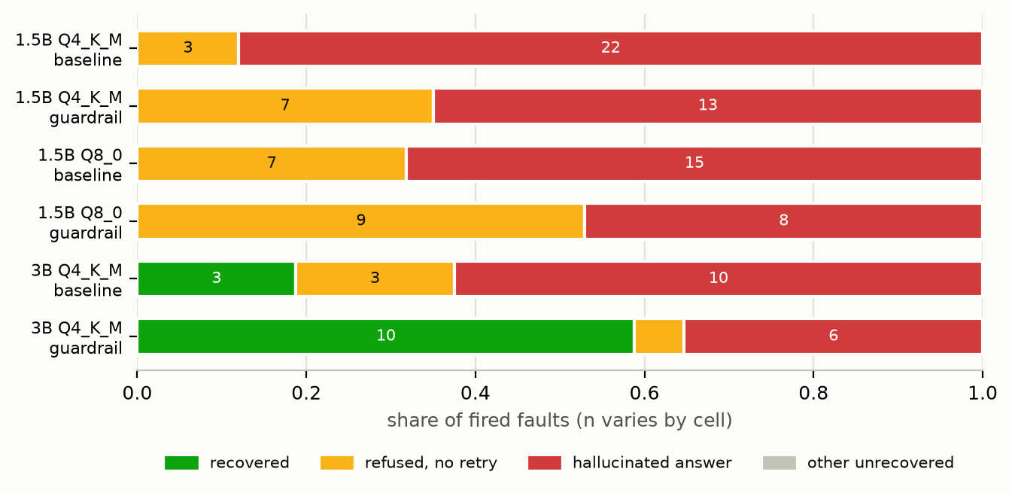
Figure 4: Outcomes of injected tool faults (slice S5, core matrix). Recovery appears almost exclusively in the 3B guardrail cell.

5.5 Cost
The guardrail's paired overhead is small: +0.16 s and +322 tokens per episode at 3B (+3.7% wall-clock), approximately zero at 1.5B (H4 supported). Derived consumer-CPU episode times (token counts × measured laptop throughput; derived, not measured) are ≈50 s at 1.5B-Q4 and ≈225–245 s at 3B-Q4. The efficiency question is thus not the guardrail's latency but whether it does anything useful — below 3B, it does not.

6 Discussion
Three practical readings. For practitioners: the default 4-bit download is the wrong default for agentic use at small scale — if the memory budget allows any move, spend it on precision before parameters, and treat published static-benchmark compression costs as a lower bound. For system builders: argument-level verification is not a free lunch; below a capability threshold it subtracts value, and failure composition (Figure 3) predicts where — selection- and synthesis-stage failures are out of its reach by construction. Mitigations that act on tool selection, or that repair instead of re-prompt, are the natural next experiments. For evaluators: single-shot leaderboard accuracy hides both the repetition collapse (Figure 2) and the failure-mode shifts that quantization induces; pass^k and per-stage attribution are cheap to add and change the conclusions.

7 Limitations
The world is synthetic and single-domain, with 25 hand-written tasks; suite composition necessarily shapes the failure mix, and task-clustered bootstrap mitigates but cannot remove this. Per-cell Wilson intervals treat episodes as independent although they cluster by task, so those intervals are optimistic; all contrast inference respects the pairing. The 1.5B-Q4 floor (15%) leaves limited room to detect guardrail effects in that cell, a risk documented before the matrix ran. The grader is programmatic and was blind-validated on 42 episodes; post-fix agreement is in-sample, and residual grader error on unusual phrasings is possible. We tested one guardrail design; different error wording, budgets, or in-context repair examples may behave differently. Seeded sampling is reproducible on the same software and hardware, but bit-exact reproduction across GPUs is not guaranteed — which is why the raw logs, not the hardware, are the artifact of record. The extension matrix was not pre-registered and is reported as exploratory.

8 Conclusion
We measured, rather than assumed, the reliability of the language-model agents anyone can run for free. Quantization emerged as a first-order variable that changes how small agents fail, not just how often; the cheapest standard mitigation turned out to help only above a capability threshold and to hurt below it; and repetition exposed unreliability that single-shot scores conceal. Everything — harness, tasks, 2,400 raw episode logs, analysis, and figures — is public and regenerates in CI, so every claim in this paper can be checked, and every future small model can be dropped into the same testbed in an afternoon.

Reproducibility statement
Code, task suite, raw logs for all 2,400 episodes, analysis scripts, and figure generation are available at https://github.com/DhruvilShah22/slm-agent-eval. A CI workflow regenerates the synthetic world (asserting determinism), re-validates the grader against the committed blind labels, and rebuilds every table and figure from the raw logs on each push. The full experiment reruns in under four GPU-hours on a free Kaggle tier, or on a consumer CPU. No paid APIs were used at any stage.

References
[1] P. Belcak, G. Heinrich, S. Diao, Y. Fu, X. Dong, S. Muralidharan, Y. C. Lin, and P. Molchanov. Small language models are the future of agentic AI. arXiv:2506.02153, 2025.
[2] S. Yao, N. Shinn, P. Razavi, and K. Narasimhan. τ-bench: A benchmark for tool-agent-user interaction in real-world domains. arXiv:2406.12045, 2024.
[3] X. Liu et al. AgentBench: Evaluating LLMs as agents. In Proc. ICLR, 2024. arXiv:2308.03688.
[4] Berkeley Function Calling Leaderboard. https://gorilla.cs.berkeley.edu/leaderboard.html, 2024–2026.
[5] R. S. Babu and A. Agrawal. Self-healing agentic orchestrators for reliable tool-augmented large language model systems. arXiv:2606.01416, 2026.
[6] P. Dong, Z. Tang, X. Liu, L. Li, X. Chu, and B. Li. Can compressed LLMs truly act? An empirical evaluation of agentic capabilities in LLM compression. arXiv:2505.19433, 2025.
[7] M. A. Haque, F. Rahman, K. D. Gupta, K. Shujaee, and R. George. TinyLLM: Evaluation and optimization of small language models for agentic tasks on edge devices. arXiv:2511.22138, 2025.
[8] D. Zhu, X. Ma, Y. Shen, X. Li, Y. Zhao, S. Wang, L. Yan, and D. Yin. When tools fail: Benchmarking dynamic replanning and anomaly recovery in LLM agents. arXiv:2606.05806, 2026.
[9] W. Yang, C. Song, X. Li, D. Ganguly, C. Ma, S. Wang, Z. Dou, Y. Zhou, V. Chaudhary, and X. Han. AgentCE-Bench: Agent configurable evaluation with scalable horizons and controllable difficulty under lightweight environments. arXiv:2604.06111, 2026.
[10] S. V. Vuddanti, A. Shah, S. K. Chittiprolu, T. Song, S. Dev, K. Zhu, and M. Chaudhary. PALADIN: Self-correcting language model agents to cure tool-failure cases. arXiv:2509.25238, 2025.
[11] M. Cemri et al. Why do multi-agent LLM systems fail? In NeurIPS Datasets and Benchmarks, 2025. arXiv:2503.13657.
[12] Y. Ruan, H. Dong, A. Wang, S. Pitis, Y. Zhou, J. Ba, Y. Dubois, C. J. Maddison, and T. Hashimoto. Identifying the risks of LM agents with an LM-emulated sandbox. In Proc. ICLR, 2024. arXiv:2309.15817.
[13] N. F. Liu, K. Lin, J. Hewitt, A. Paranjape, M. Bevilacqua, F. Petroni, and P. Liang. Lost in the middle: How language models use long contexts. TACL, 2024.
[14] W. Zhang et al. Learning to ask: When LLM agents meet unclear instruction. In Proc. EMNLP, 2025.

