**Lab-04:**

**23122138**

**1. Top Traffic Sources Driving Users to the Website**

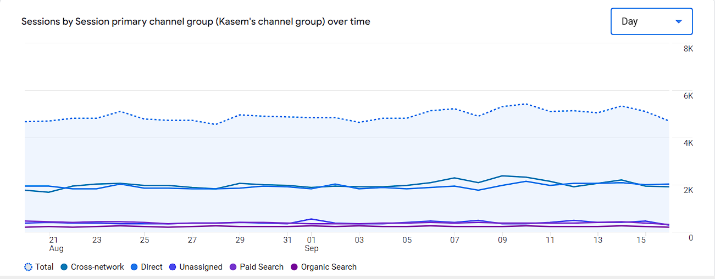Website traffic comes from multiple sources, each bringing different engagement levels. Organic search refers to users arriving through search engines like Google or Bing, usually with higher intent as they are actively seeking relevant content. Paid search traffic results from ads shown on these platforms, driving immediate but potentially less engaged visitors. Direct traffic involves users directly entering the website URL, often indicating brand familiarity or loyalty. Social media traffic comes from platforms like Facebook or Instagram, often leading to more casual browsing. Referral traffic comes through links on other websites, while email traffic originates from targeted campaigns.

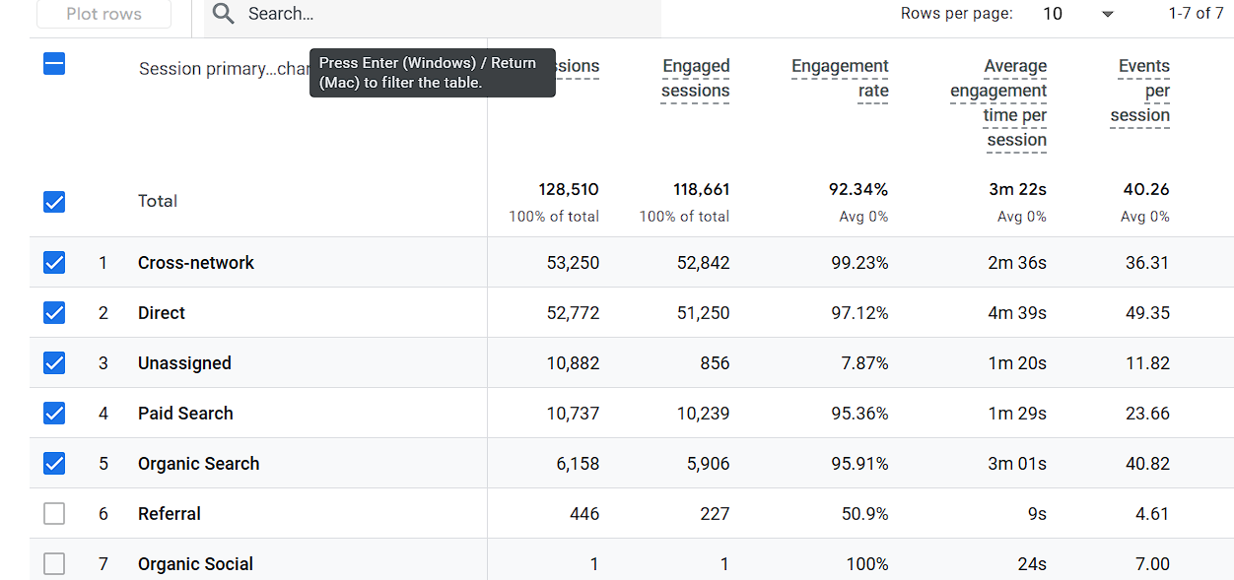

### 2. ****Differences in User Behavior Across Traffic Sources****

User behavior can vary significantly across traffic sources. **Organic search** typically drives highly engaged users with longer session durations, more page views, and lower bounce rates, as these visitors are actively seeking relevant content. **Paid search** may result in higher bounce rates, but with effective targeting, it can lead to faster conversions. **Direct traffic** often reflects the highest engagement, as these users already know the brand and are more likely to explore multiple pages. **Social media** users tend to have shorter sessions and higher bounce rates, as their visits are often driven by curiosity or casual interest.

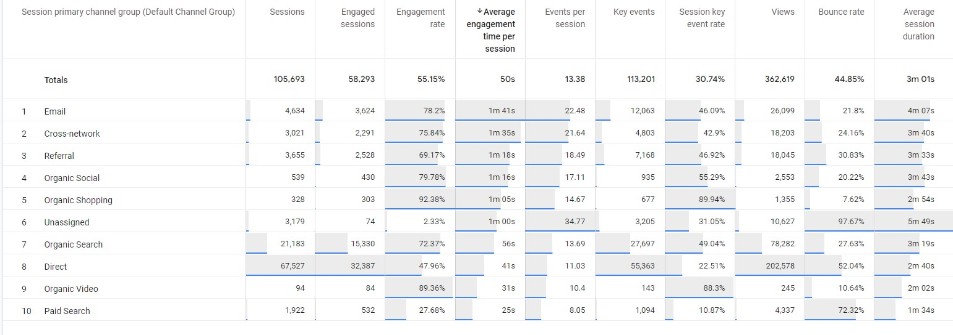

### 3. ****Highest Conversion Rate by Traffic Source****

When analyzing conversion rates by traffic source, paid search often emerges as the leader due to its highly targeted nature. These visitors are usually driven by specific ads tailored to their search queries, leading to higher conversion potential. Organic search also brings in valuable conversions, especially from users who are actively seeking information or solutions. However, while direct traffic can sometimes have high conversion rates due to repeat or loyal visitors, social media traffic tends to have lower conversion rates as the intent is often less focused. Understanding which sources convert best helps prioritize marketing spend.

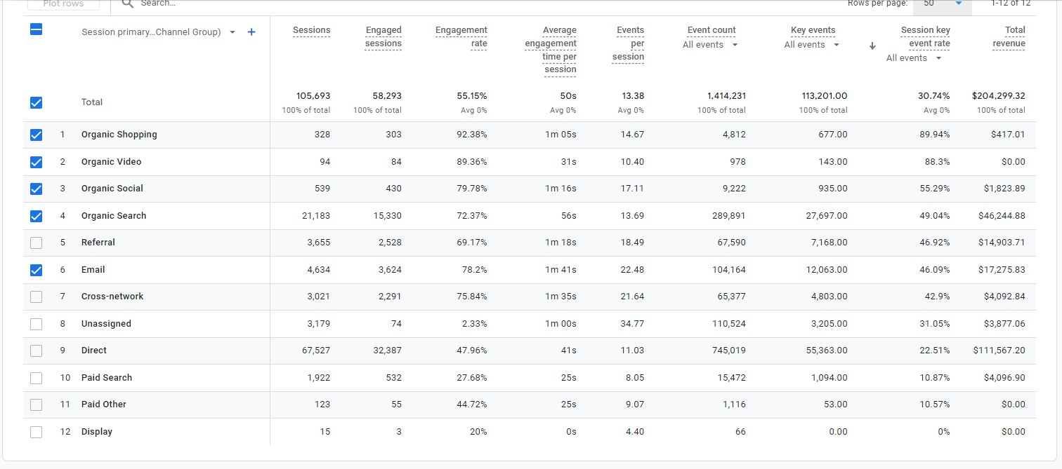

### 4. ****Geographic Locations Driving Most Traffic****

Traffic often varies by geographic region, influenced by location-based marketing efforts and the global appeal of your content. Analyzing which countries or regions drive the most traffic can offer insights into audience behavior and preferences. For example, a high percentage of **organic search** traffic from the U.S. may indicate strong local SEO performance. In contrast, a campaign targeting Europe might show higher conversion rates for **paid search** traffic from that region. Understanding geographic traffic sources helps optimize marketing strategies and tailor content to meet regional user needs and expectations, boosting both engagement and conversions.

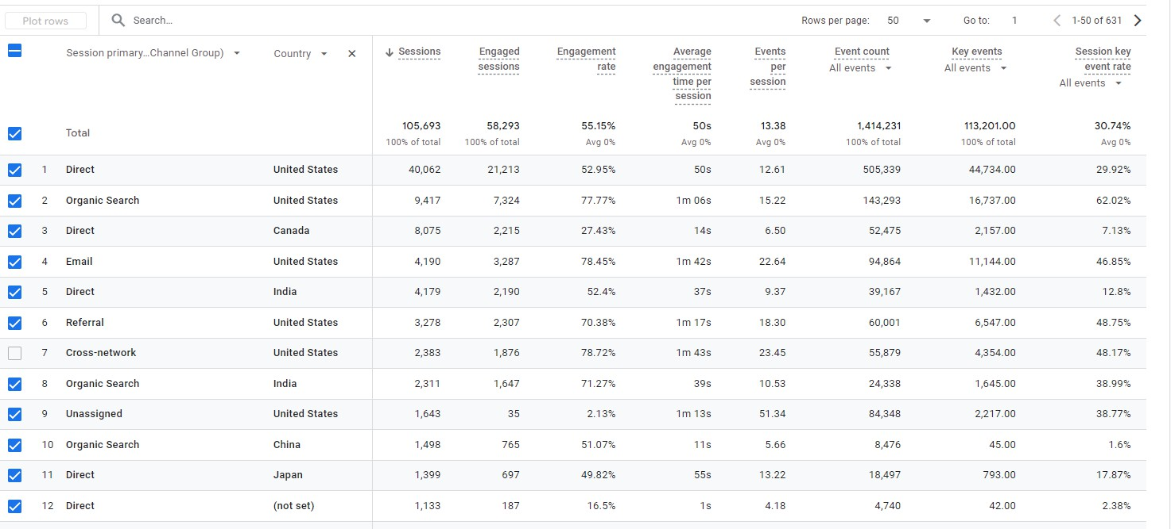

### 5. ****Devices Used by Users from Different Traffic Sources****

User devices vary across traffic sources, with mobile traffic being dominant in most cases. **Organic search** often sees a mix of desktop and mobile users, but mobile visitors tend to have shorter session durations. **Paid search** traffic may skew toward mobile if ads are optimized for mobile-first experiences. **Social media** traffic is predominantly mobile, as users browse platforms like Instagram and Facebook on their smartphones, leading to higher bounce rates. **Direct traffic** can have a balanced distribution between mobile and desktop users, particularly for visitors accessing the site for in-depth content or completing transactions.

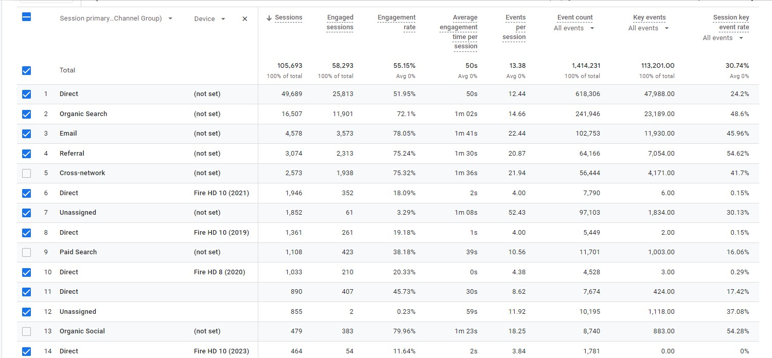

**6. Campaigns Generating the Most Traffic**

Campaign performance can be evaluated by analyzing the traffic they generate across different acquisition channels. Paid search campaigns, such as Google Ads, often drive significant traffic quickly, especially when targeted effectively. Social media campaigns, particularly on platforms like Facebook and Instagram, can generate a high volume of visitors, although their engagement might vary. Email marketing campaigns tend to have more personalized and direct impact, often leading to higher conversion rates from loyal customers. By tracking the effectiveness of each campaign, marketers can optimize spend, refine messaging, and focus on the channels that generate the highest traffic and conversions.

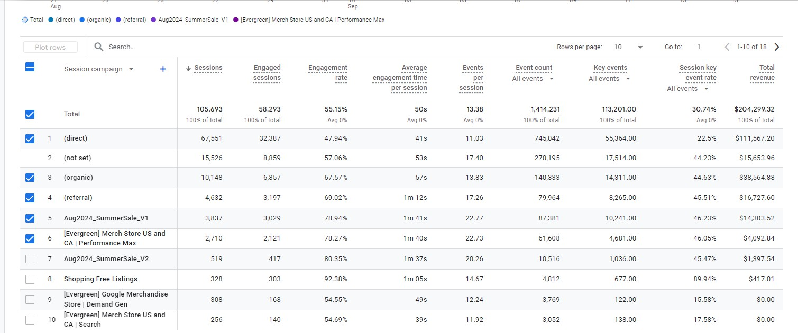

### 7. ****Comparing Organic vs. Paid Traffic in Conversions****

When comparing **organic** and **paid traffic** in terms of conversions, both play crucial roles but with distinct outcomes. **Organic traffic** brings in users who are actively searching for relevant content, often leading to more engaged users with longer sessions, but conversion rates may vary depending on the content. **Paid traffic**, on the other hand, is more immediate and often more targeted, leading to faster conversions, especially when ad campaigns are tailored to specific audiences or keywords. While organic traffic builds long-term, sustained engagement, paid traffic offers quicker results with measurable ROI when optimized correctly.

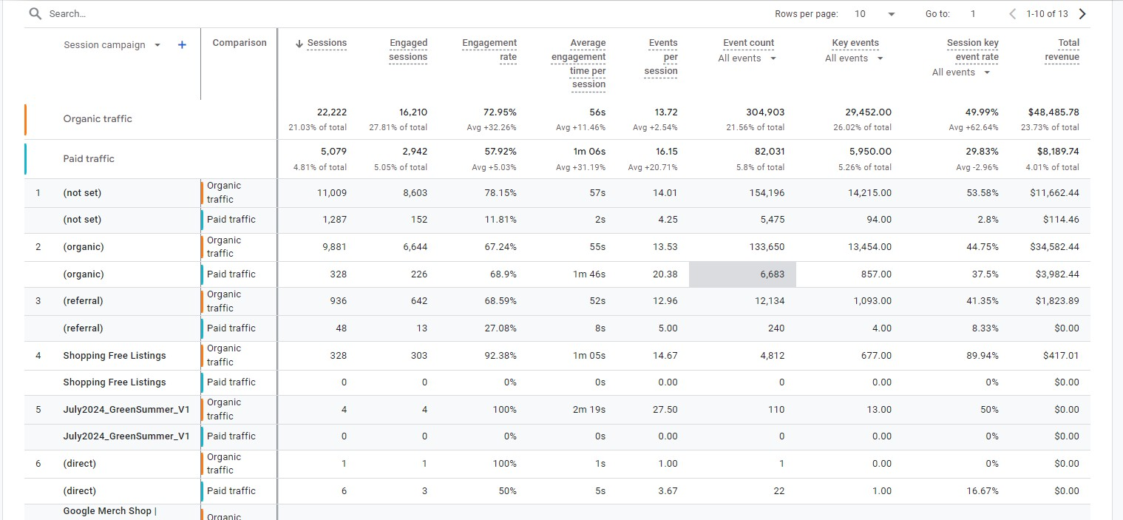

### 8. ****Top Landing Pages by Traffic Source****

Landing pages serve as the first impression for users arriving from various traffic sources. For **organic search**, landing pages optimized for relevant keywords often perform best, with users spending more time on product pages or in-depth blog posts. **Paid search** traffic is typically directed to highly specific landing pages focused on conversions, such as signup or product purchase pages. **Social media** landing pages usually feature more engaging, visual content, tailored to a casual browsing experience. **Direct traffic** might land on the homepage or specialized content pages, reflecting users' existing familiarity with the brand.

