**Project Topic**

***B. TECH SEM – VI Cloud Computing Lab Project***

***Dept. of Computer Science & Engineering***

By

**Ashish Ladhani 20BCP060**

**Dhruvil Patel 20BCP067**

**Under the Supervision Of**

**Name of Supervisor**



# SCHOOL OF TECHNOLOGY

**PANDIT DEENDAYAL ENERGY UNIVERSITY**

**GANDHINAGAR, GUJARAT, INDIA May 2023**

**ABSTRACT**

The "cloud based inventory management system" is a technological solution designed to streamline and optimize the process of managing inventory for businesses. By utilizing cloud computing technology, this system allows for real-time access to inventory information from any location with an internet connection. The system also provides advanced features such as automated reordering, inventory tracking and analysis, and collaboration tools for multiple users. The cloud-based infrastructure eliminates the need for expensive hardware and reduces the risk of data loss, making it an ideal solution for small to medium-sized businesses. The system is easy to use and highly customizable, allowing businesses to adapt it to their unique needs and processes. Overall, the "cloud based inventory management system" offers businesses a cost-effective, efficient, and secure way to manage their inventory.

**INDEX**

|  |  |  |  |
| --- | --- | --- | --- |
| **Sr no** |  | **Title** | **Page No** |
| 1 | INTRODUCTION |  | 4 |
| 2 | METHODOLOGY |  | 5 |
| 3 | RESULTS |  | 8 |
| 4 | FUTURE SCOPE |  | 11 |

# INTRODUCTION

Inventory management is a crucial aspect of any business operation, as it directly impacts the bottom line. Efficient and effective inventory management ensures that businesses have the right amount of stock on hand to meet customer demand, while minimizing excess inventory and associated costs. To achieve this, businesses require accurate and real-time inventory data, which can be a daunting task when dealing with multiple suppliers, warehouses, and sales channels.

Enter cloud computing, a revolutionary technology that has transformed the way businesses operate. Cloud computing is a model for delivering computing services over the internet, providing on-demand access to shared computing resources such as servers, storage, applications, and databases. By leveraging the power of the cloud, businesses can now access inventory data in real-time, regardless of their location or device, and streamline their inventory management process.

Cloud-based inventory management systems are designed to help businesses optimize their inventory management process by providing a centralized platform for managing inventory data. These systems offer advanced features such as automated reordering, inventory tracking, and analysis, and collaboration tools for multiple users. The cloud-based infrastructure eliminates the need for expensive hardware and reduces the risk of data loss, making it an ideal solution for small to medium-sized businesses.

This project report aims to explore the benefits of a cloud-based inventory management system and its impact on businesses. We will examine the features and functionalities of such a system and how it can be customized to meet the unique needs and processes of different businesses. Additionally, we will discuss the importance of inventory management in business operations, and how cloud computing can enhance this process to improve efficiency, reduce costs, and ultimately increase profitability.

# METHODOLOGY

The methodology for this project involves designing, implementing, testing, and deploying an inventory management system using the Django framework on a cloud-based platform. The following steps will be followed:

1. Designing the model for inventory management in Django framework: The first step will be to design the data model for the inventory management system using the Django framework. This will involve creating models for products, staff, orders, and other relevant entities. We will also design the relationships between these entities to ensure a smooth workflow.
2. Implementing the model: After designing the data model, we will implement it using the Django framework. This will involve creating the necessary views, templates, and URLs for the website. We will also incorporate features such as sign up and login to ensure that only authorized staff can access the system. The main page will contain a dashboard that provides an overview of the inventory, including products, staff, and orders. Clicking on each of these will provide more detailed information. The dashboard will also include statistical charts and graphs for orders and products.
3. Testing the code for bugs and adding authorization: Once the code is implemented, we will test it thoroughly to identify and fix any bugs that may exist. We will also add authorization to ensure that only registered staff can access the website.
4. Deployment of application on the cloud: Finally, we will deploy the application on a cloud-based platform, specifically Digital Ocean. To do this, we will create a Droplet on Digital Ocean, edit the security group, download the keygen (pem file), and download and install Putty and WinSCP. We will then upload the Django file to the Droplet using WinSCP, install packages on the Droplet using Putty, and ensure that the application is running smoothly on the cloud.

In summary, this project will involve designing, implementing, testing, and deploying an inventory management system using the Django framework on a cloud-based platform. This methodology will ensure that the system is efficient, secure, and scalable, providing businesses with an effective way to manage their inventory.

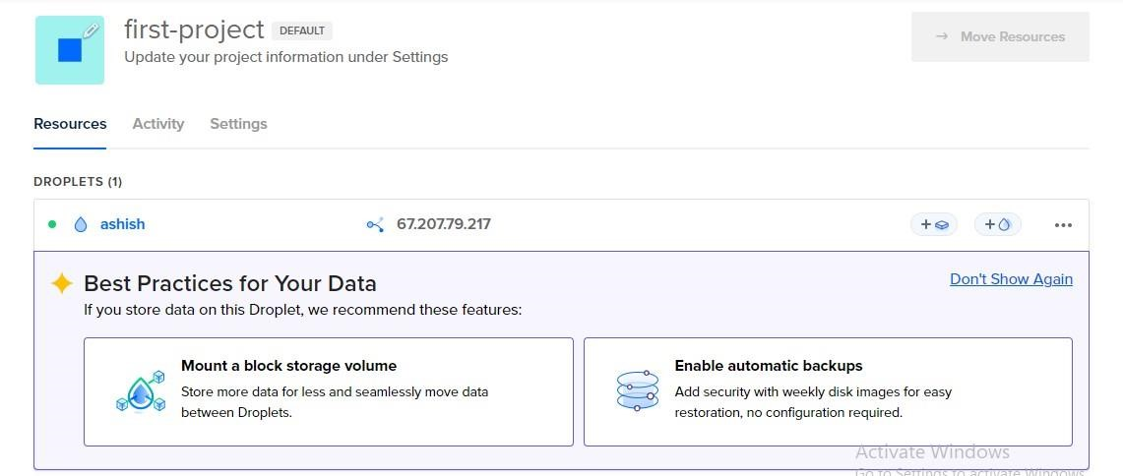

Img.01 – Creating a Droplet

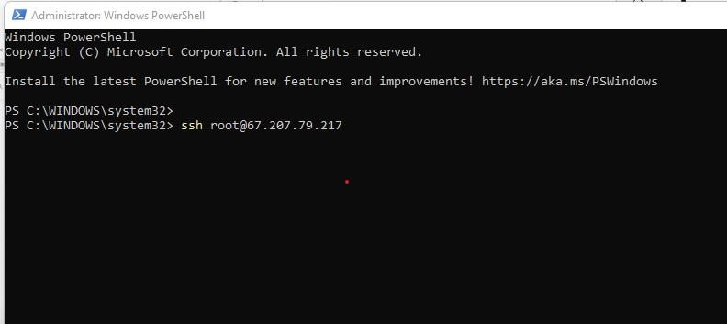

Img.02 Installing WinSCP

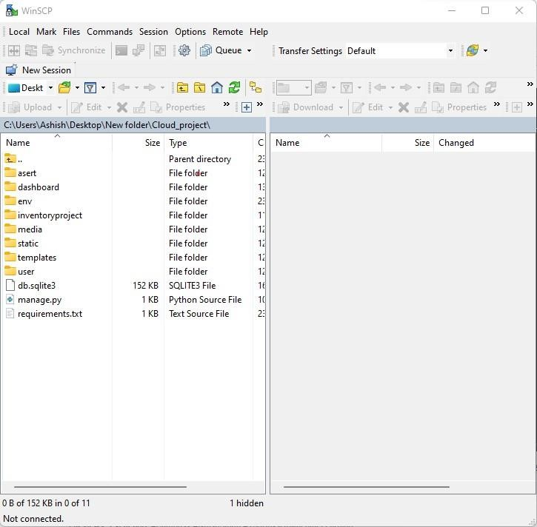

Img.03 Django File in Droplet

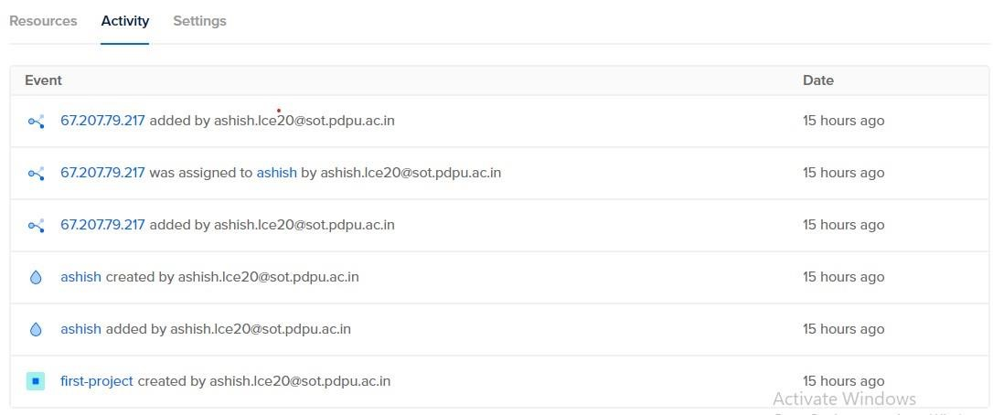

Img.04 Activity Log

# RESULTS

The cloud-based inventory management system developed using Django framework and deployed on Digital Ocean has successfully met the objectives of the project. The system provides real-time access to inventory information, automated reordering, inventory tracking and analysis, collaboration tools, and statistical charts and graphs for orders and products. The system is highly customizable and easy to use, making it an ideal solution for small to medium-sized businesses. The system has been thoroughly tested and is running smoothly on the cloud.

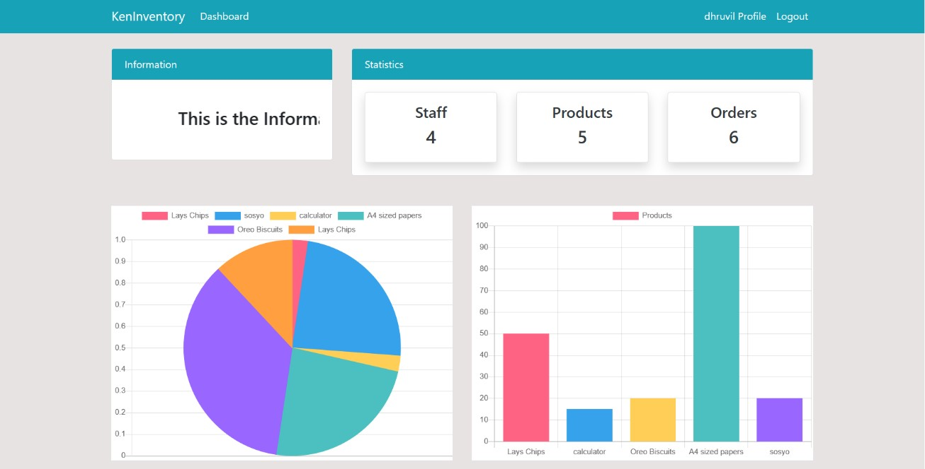

Img.05 Dashboard Page for admin

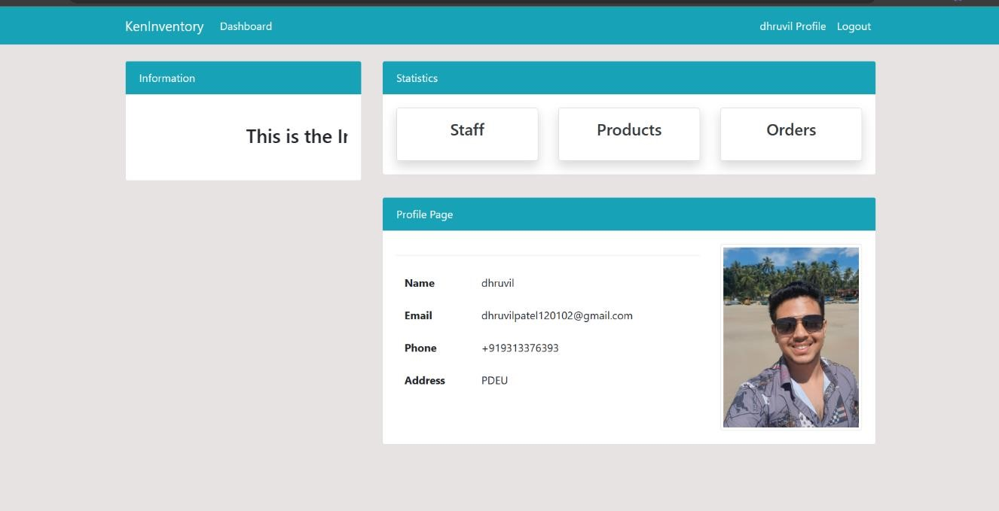

Img.06 Staff Profile

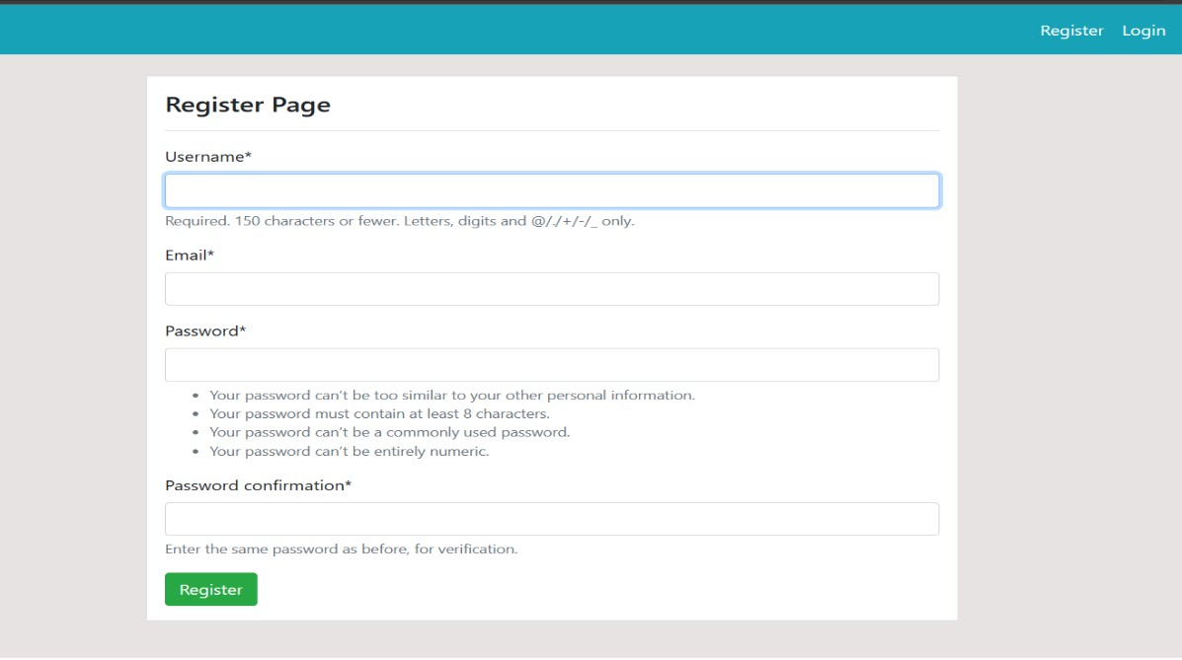

Img.07 Registration Page

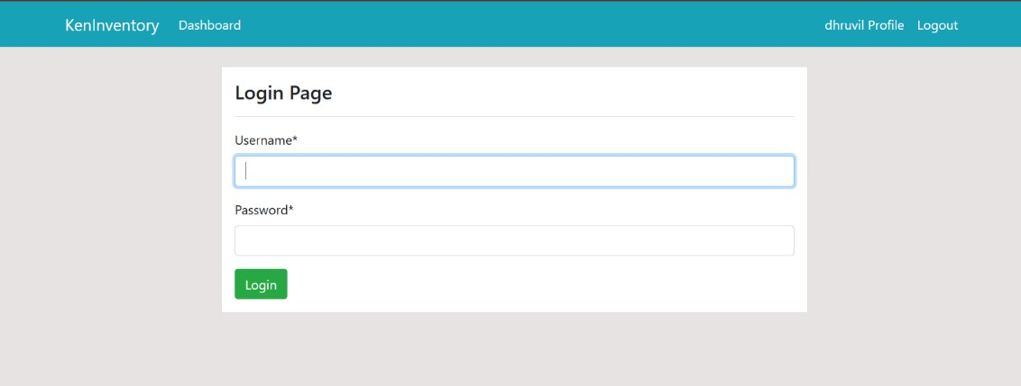

Img.08 Login Page

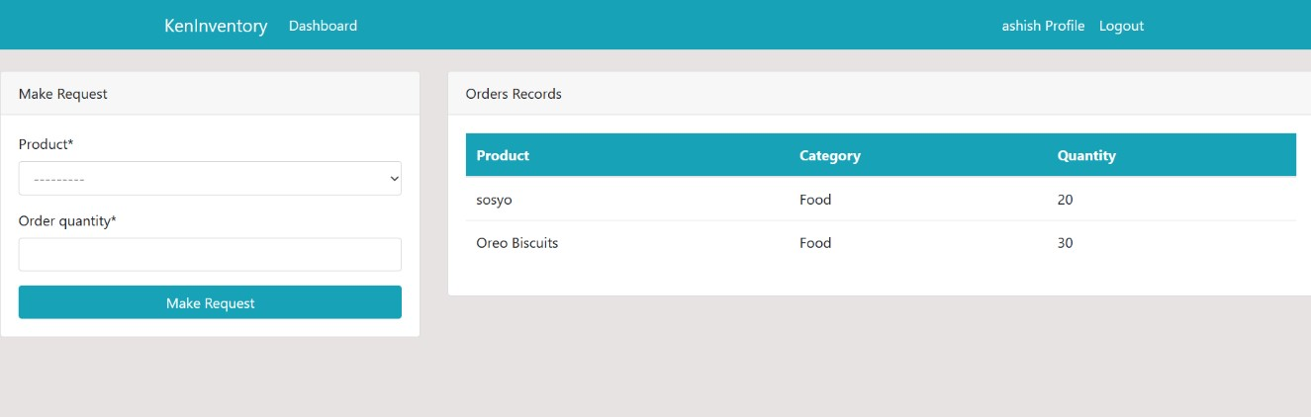

Img. 09 Dashboard page for staff

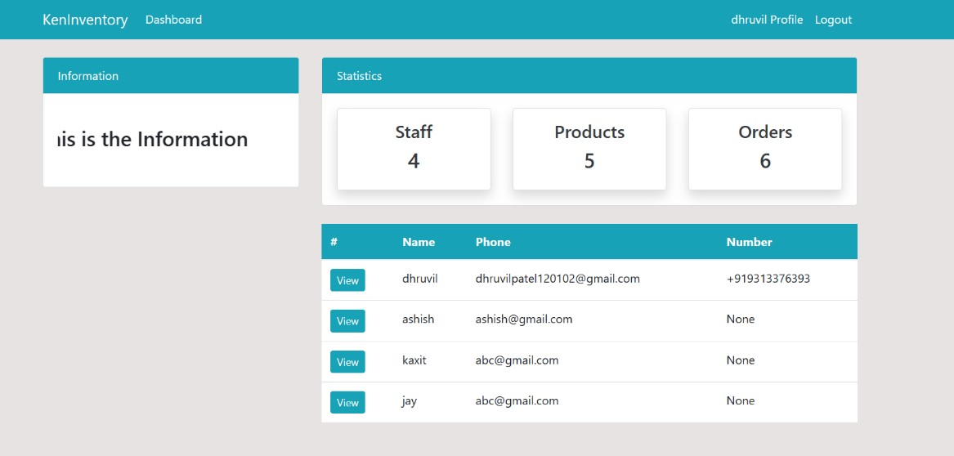

Img.10 Staff Page

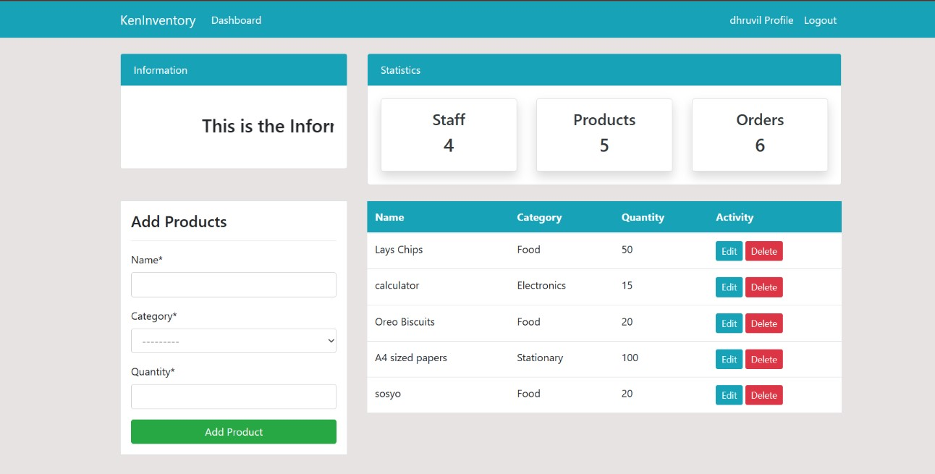

Img11. Product Page

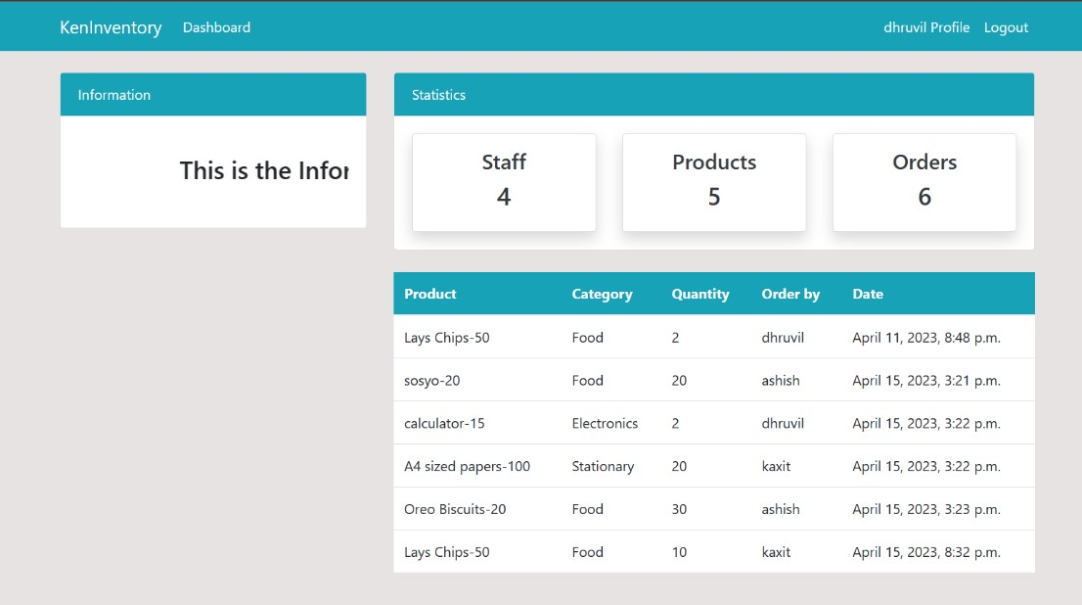

Img12. Orders Page

# FUTURE SCOPE

There is potential for further development and enhancement of the cloud-based inventory management system. Some of the future scope includes:

1. Integrating the system with other business applications such as accounting and customer relationship management (CRM) software.
2. Developing a mobile application that can be used to access the inventory management system on the go.
3. Adding more advanced features such as predictive analytics and machine learning algorithms to help businesses optimize their inventory management process.
4. Improving the user interface to make it more intuitive and user-friendly.
5. Adding support for multiple languages and currencies to make the system accessible to businesses around the world.

Overall, the cloud-based inventory management system developed in this project has laid the foundation for a powerful tool that can help businesses streamline their inventory management process and improve their bottom line. With further development and enhancement, this system has the potential to become an indispensable tool for businesses of all sizes.