**Name: Dhruvin Chawda SAP ID: 60004210159**

**Date of Performance: Date of Submission:**

**Experiment No: 1**

**Aim:** To study different networking devices and topologies.

**Theory:**

**Networking Devices:**

1. **Repeater:**
2. **Introduction:**

**Repeater is a buffer like device where in the weak signals are regenerated into strong signal so it basically is buffer.**

**It is operated at physical layer. This device has two ports.**

**Repeaters are commonly used in the Ethernet networks, where they can extend the distance over which data can be transmitted between network devices. They are often used in conjuction with other networking devices such as switches and routes to help extend the reach of network**

1. **Diagram:**

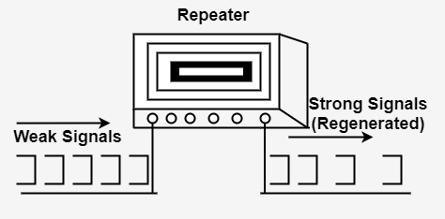

1. **Advantages:**

* The repeater provides the stability of the signals.
* These repeaters are cost-effective and easy to use
* They are transparent to the network meaning they don’t modify or alter the signal in any way.
* They increase the network range

1. **Disadvantages:**

* **It has limited capacity i.e. If more of them are deployed, it’ll create noises on the wire and increase the possibilities of packet collision**
* **It can cause signal degradation as each time a signal is regenerated there is loss of original signal which cause degradation, also it can amlify the noise.**
* **It has limited capability, they can regenerate the signal and extend the range but it cant perform function like filtering and directing traffic**

**2 Hub**

1. **Introduction:**

**It is a basic network device that is used to connect multiple device in a network. It is operated at physical layer of Osi model.**

**A hub works by receiving data packets from one device and broadcasting them to all other devices connected to it.**

**This means that any device connected to the hub can receive data sent by any other device connected to the hub. It has 4 ports**

1. **Diagram:**

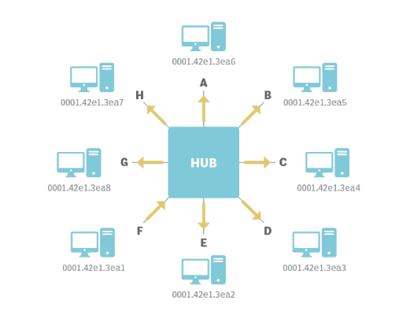

1. **Advantages:**

* **They are simple so they are easy to install All you need to do is plug in the devices, and they will start communicating with each other.**
* **They are cost effective solution for small network as it inexpensive**
* **Hubs do not require any configuration, which means they are plug-and-play devices. This makes them ideal for home networks or small offices.**
* **Hubs can be used to create a simple network topology with a star configuration. This makes it easy to manage and troubleshoot the network.**

1. **Disadvantages:**

* **Hubs do not have any built-in security features, which means that any device connected to the hub can access the network**
* **They are not highly scalable as more and more devices are connected to its network performance gets degrade.,**
* **It has no traffic management**
* **It also has limited bandwidth as all the devices connected to them share the same bandwidth. This can lead to network congestion and slow network speeds**

**3 Switch**

1. **introduction:**

**Switches are networking devices that connect devices together within a local area network (LAN). It is operated at the data link layer. They are commonly used network devices. When a switch receives a data packet, it examines the destination MAC address and forwards the packet only to the port that connects to the device with that MAC address. This process is called "switching."**

**Switches can have different port densities, ranging from 4 ports to 48 ports or more. They also differenet speeds. By connecting switches together, network administrators can increase network capacity and improve network reliability.**

1. **diagram:**

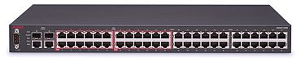

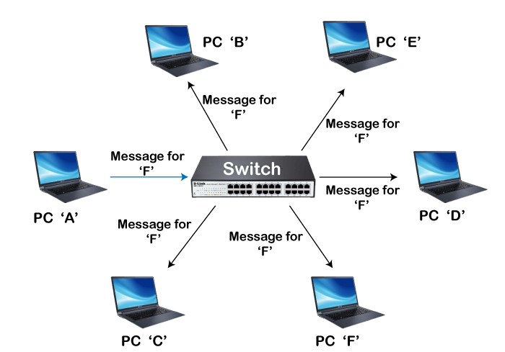

1. **advantages:**

* **it has increased network performance Switches allow for dedicated bandwidth between devices, meaning that data packets are sent only to their intended destination rather than being broadcast to all devices on the network.**
* **It reduces the network congestion and improves performance**
* **It has improved security as it sends the data packet to its desired destination.**
* **Switches can be connected together to create larger networks, allowing businesses to expand their networks as needed**

1. **Disadvantages:**

* **They are expensive than other networking devices**
* **They are also complex devices difficult to manage\**
* **Because switches are critical networking devices, a failure in the switch can bring down the entire network**
* **As switch is designed to use within LAN so they have limited distance capabilities**

**4 Brigde**

1. **introduction:**

**it is a network device used to connect two or more network segements together effectively creating a single network.**

**It is operated at the data link layer ,it is designed to forward data packets between different network segments based on their MAC addresses. A bridge can be used to connect different types of network technologies, such as Ethernet and Wi-Fi, and can also be used to connect different networks with different network addresses. In this case, the bridge will forward packets between the networks while maintaining their original network addresses.**

1. **diagram:**

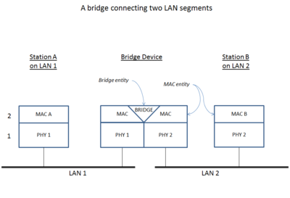

1. **advantages:**
2. **Disadvantages:**

**5 Router**

1. **introduction:**
2. **diagram:**
3. **advantages:**
4. **Disadvantages:**

**6 Gateway**

1. **introduction:**
2. **diagram:**
3. **advantages:**
4. **Disadvantages:**

**Networking Topologies:**

1. **Bus:**
2. **Introduction:**
3. **Diagram:**
4. **Advantages:**
5. **Disadvantages:**
6. **Applications:**

**Conclusion:**