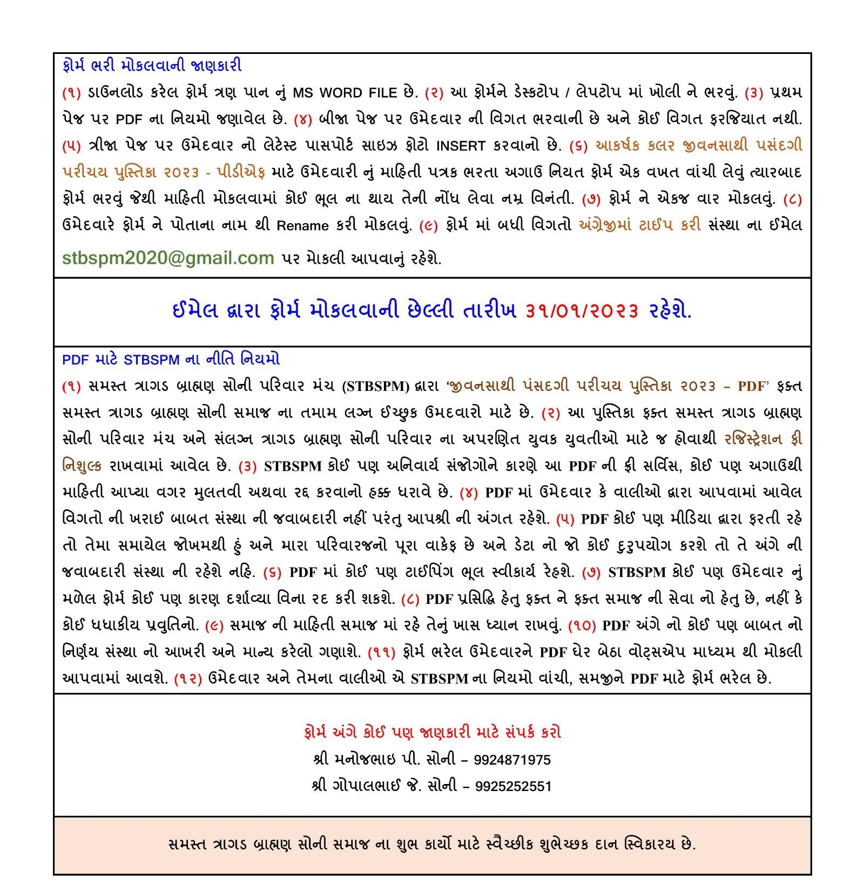

**Note: Rename downloaded file with applicant’s name - Enter details – Submit the MS WORD FILE by email.**

|  | | |
| --- | --- | --- |
| **Ref. No.** | Will be allotted by STBSPM | |
| **PERSONAL DETAILS** | | |
| **Full name**  **(Name-Middle Name-Surname)** | Dhruvin Kalpeshbhai Soni | |
| **Birth Date**  **(DD/MM/YYYY)** | 30/12/1997 | |
| **Birth Place** | Ahmedabad | |
| **Birth Time (am/pm)** | 3:07 PM | |
| **Height (cm)** | 170 | |
| **Weight (kg)** | 70 | |
| **Shani / Mangal** | No | |
| **Believe in Horoscope**  **(Yes/No)** | Yes | |
| **Gotra** | Bharadwaj | |
| **Marital Status**  **(Unmarried/Divorced/Widowed)** | Unmarried | |
| **Education** | B.Tech IT | |
| **Occupation** | Job | |
| **Monthly Income** | 85000 | |
| **Spectacles (Yes/No)** | Yes | |
| **Any Disability (Yes/No)** | No | |
| **I live in**  **(Name of City / Town / Village)** | Ahmedabad | |
| **FAMILY DETAILS** | | |
| **Father’s Name** | Kalpeshbhai Sureshchandra Soni | |
| **Father’s Occupation** | Incometax Practice (Business) | |
| **Mother’s Name** | Rupal Kalpeshbhai Soni | |
| **Mother’s Occupation** | Homemaker | |
| **Brother (Mention in digits)** | **Married -** | **Unmarried -** |
| **Sister (Mention in digits)** | **Married - 0** | **Unmarried - 1** |
| **Mosal Name & City**  **(Contact person’s name)** | Jitendrabhai Jayantilal Soni (Ahmedabad) | |
| **Mosal Contact No.** | 9106447956 (Pinal Soni) | |
| **CONTACT DETAILS** | | |
| **Whatsapp No.** | 9825465996 | |
| **Alternate Mobile No.** | 9714371457 | |
| **Email** | dksoni4530@gmail.com | |
| **We live in**  **(Name of City / Town / Village)** | Nadiad | |
| **Residential Address** | B/202 Jalsagar Apartment, Vaniya Vad, College Road, Nadiad, 387001 | |
| **Name of Samaj Mandal** | Bhinmaal Tragad Brahman Samaj | |

INSERT YOUR LATEST PASSPORT SIZE PHOTOGRAPH ON THIS PAGE