**PART-3. ASP.NET- Visual Studio**

**Aim :**

Create a Web application that illustrates the use of themes and master pages.

**Code :**

**Master page :**

<%@ Master Language="C#" AutoEventWireup="true" CodeBehind="Site.master.cs" Inherits="validation.SiteMaster" %>

<!DOCTYPE html>

<html lang="en">

<head runat="server">

<meta charset="utf-8" />

<meta name="viewport" content="width=device-width, initial-scale=1.0" />

<title><%: Page.Title %> - My ASP.NET Application</title>

<link href="~/Content/css/site.css" rel="stylesheet" />

<link href="~/favicon.ico" rel="shortcut icon" type="image/x-icon" />

</head>

<body>

<form runat="server">

<h1>Form validation :</h1>

<div class="container body-content">

<asp:ContentPlaceHolder ID="MainContent" runat="server">

</asp:ContentPlaceHolder>

</div>

</form>

</body>

</html>

**Default page :**

<%@ Page Title="Home Page" Language="C#" MasterPageFile="~/Site.Master" AutoEventWireup="true" CodeBehind="Default.aspx.cs" Inherits="validation._Default" %>

<asp:Content ID="BodyContent" ContentPlaceHolderID="MainContent" runat="server">

<div>

<asp:Label ID="lblName" runat="server" Text="Name:" AssociatedControlID="txtName"></asp:Label>

<asp:TextBox ID="txtName" runat="server"></asp:TextBox>

<asp:RequiredFieldValidator ID="rfvName" runat="server" ControlToValidate="txtName"

ErrorMessage="Name is required." ForeColor="Red"></asp:RequiredFieldValidator>

<br />

<asp:Label ID="lblEmail" runat="server" Text="Email:" AssociatedControlID="txtEmail"></asp:Label>

<asp:TextBox ID="txtEmail" runat="server"></asp:TextBox>

<asp:RequiredFieldValidator ID="rfvEmail" runat="server" ControlToValidate="txtEmail"

ErrorMessage="Email is required." ForeColor="Red"></asp:RequiredFieldValidator>

<asp:RegularExpressionValidator ID="revEmail" runat="server" ControlToValidate="txtEmail"

ErrorMessage="Invalid email format." ForeColor="Red"

ValidationExpression="\w+([-+.'']\w+)*@\w+([-.]\w+)*\.\w+([-.]\w+)*"></asp:RegularExpressionValidator>

<br />

<asp:Button ID="btnSubmit" runat="server" Text="Submit" OnClick="btnSubmit_Click" />

</div>

</asp:Content>

**Default.aspx.cs:**

using System;

using System.Web.UI;

namespace validation

{

public partial class _Default : Page

{

protected void btnSubmit_Click(object sender, EventArgs e)

{

if (Page.IsValid)

{

string name = txtName.Text;

string email = txtEmail.Text;

Response.Write($"Name: {name}<br />Email: {email}");

}

}

}

}

Student

**Output :**

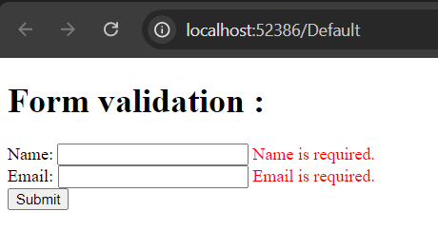



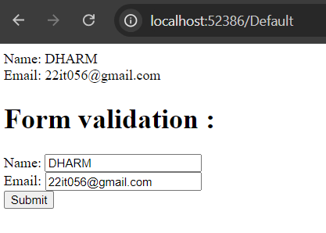

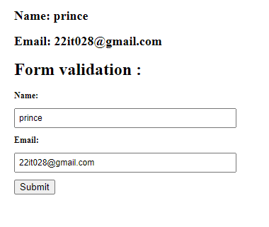

**Aim :**

Create a Web application that illustrates the use of themes and master pages.

**Code :**

**Master page :**

<%@ Master Language="C#" AutoEventWireup="true" CodeBehind="Site.master.cs" Inherits="Mastrepage_theam.SiteMaster" %>

<!DOCTYPE html>

<html lang="en">

<head runat="server">

<meta charset="utf-8" />

<meta name="viewport" content="width=device-width, initial-scale=1.0" />

<webopt:bundlereference runat="server" path="~/Content/css" />

<title>Ganesh Kothi Ice Cream</title>

<link rel="stylesheet" href="../Theam/Style.css" />

</head>

<body>

<header class="hed" id="header">

<h1>Home of CHARUSAT </h1>

</header>

<nav>

<ul>

<li><a href="Default.aspx">Home</a></li>

<li><a href="About.aspx">About</a></li>

<li><a href="Contact.aspx">Contact</a></li>

</ul>

</nav>

<div class="container body-content">

<asp:ContentPlaceHolder ID="MainContent" runat="server">

</asp:ContentPlaceHolder>

</div>

<div>

<section class="contact fade-in" id="contact">

</section>

<section class="fot">

<footer>

<p>&copy; Home of CHARUSAT </p>

</footer>

</section>

</div>

</body>

</html>

**Default page :**

<%@ Page Title="Home Page" Language="C#" MasterPageFile="~/Site.Master" AutoEventWireup="true" CodeBehind="Default.aspx.cs" Inherits="Mastrepage_theam._Default" %>

<asp:Content ID="BodyContent" ContentPlaceHolderID="MainContent" runat="server">

<h1 class="outlined-text" id="title">

Welcome to Ganesh Kothi Ice Cream

</h1>

</asp:Content>

**About page :**

<%@ Page Title="About" Language="C#" MasterPageFile="~/Site.Master" AutoEventWireup="true" CodeBehind="About.aspx.cs" Inherits="Mastrepage_theam.About" %>

<asp:Content ID="BodyContent" ContentPlaceHolderID="MainContent" runat="server">

<div>

<h1>About Us</h1>

</div>

<div class="description">

<p>

Welcome to…

</p>

</div>

</asp:Content>

**Contact page :**

<%@ Page Title="Contact" Language="C#" MasterPageFile="~/Site.Master" AutoEventWireup="true" CodeBehind="Contact.aspx.cs" Inherits="Mastrepage_theam.Contact" %>

<asp:Content ID="BodyContent" ContentPlaceHolderID="MainContent" runat="server">

<div class="contact-title">

<h1>Contact Us</h1>

</div>

<div class="contact-info">

<hr />

<p>

<span>Email:</span>

<p><span>Address:</span> Nadiad</p>

</div>

</asp:Content>

**Themes :**

html, body {

height: 100%;

margin: 0;

display: flex;

flex-direction: column;

font-family: sans-serif;

}

.main-content {

flex: 1;

}

.center-container {

display: flex;

justify-content: center;

align-items: center;

height: 100vh;

margin: 0;

}

.sticky {

position: fixed;

top: 0;

width: 100%;

background-color: #358fe9;

color: #fff;

padding: 10px 20px;

text-align: center;

z-index: 1000;

}

.sticky-title {

margin-top: 60px;

}

.hed {

width: 100%;

background-color: #2c3136a2;

color: #fff;

padding: 10px 20px;

text-align: center;

}

nav {

background-color: #d1d1d1;

padding: 10px 20px;

text-align: center;

}

nav ul {

list-style: none;

margin: 0;

padding: 10px;

display: inline-block;

}

nav li {

display: inline-block;

margin-right: 20px;

}

nav a {

text-decoration: none;

color: #333;

align-items: center;

padding: 30px;

position: relative;

}

nav a:hover {

color: #0080ff;

}

nav a::after {

content: '';

position: absolute;

bottom: -2px;

left: 50%;

transform: translateX(-50%);

width: 0;

height: 2px;

background-size: 200% 100%;

transition: background-position 0.3s ease, width 0.3s ease;

}

nav a:hover::after {

width: 100%;

background-position: 0 0;

}

.outlined-text {

text-shadow: -1px -1px 0 #040303, 2px -1px 0 #0b0a0a, -1px 2px 0 #0d0d0d, 1px 1px 0 #060606;

text-align: center;

margin-top: 150px;

}

.fot {

margin-top: 300px;

background-color: #333;

color: #fff;

padding: 10px 20px;

text-align: center;

}

**Output :**

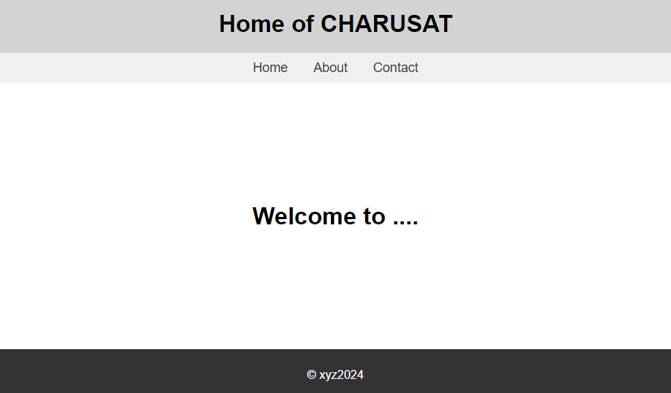

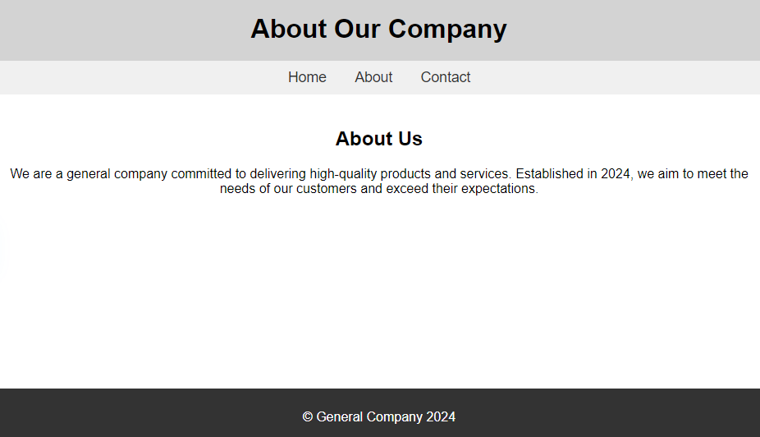

**Summary:**

* **Master Page**: Provides layout and shared elements.
* **ASPX Page**: Contains content and form controls.
* **Themes**: Applied via CSS or ASP.NET themes.
* **Validation**: Ensures user input is correct before processing.