

**Task:** Given a dataset of phishing & normal emails, your task is to detect if a given email is a phishing email or not using a ML-led solution.

**Dataset:** Phishing and Normal mails in .eml format provided by Canary mail

**Solution implemented by:** Dhruvin Kakadia (dhruvinkakadia@gmail.com)

**Approach**

* Extract the mails from the eml files provided.
* Pre-process the mails by removing extra spaces, line breaks, etc and extracting the main content of the mail using html parsers like beautiful soup
* Extract elements like the links in the mail, links embedded in the images, and keywords like dear, account, eBay, PayPal, etc. which are especially important in detecting phishing mails.
* Generate feature vector for a particular mail with the help of the elements extracted in the previous step.
* Generate training and testing sets of the given mails which contains both, phishing and normal mails.
* Try out different Machine learning models like Support Vector Classifier, Logistic Regression, Decision Trees and ensemble models like Random Forest, Gradient boosting, XGBoost, AdaBoost, Extra Trees and Voting Classifier.
* Tune all the models to find the best hyperparameter space for the respective models using Grid search cross validation.
* Evaluate models by comparing their accuracies on the holdout set and select the best model after the evaluation

**Attributes used for feature representation**

* **Links:** Numerical attribute representing the total number of links present in a given mail.
* **Dears:** Categorical attribute representing if the term ‘dear’ is present in a given mail.
* **HTML:** Numerical attribute representing the number of HTML tags/elements in a given email.
* **Please:** Categorical attribute representing if the term ‘please’ is present in the given mail.
* **Account:** Categorical attribute representing if the term ‘account’ or ‘accounts’ is present in the given mail.
* **Images:** Numerical attribute denoting the number of images present in the given mail.
* **Bank:** Categorical attribute representing if the term ‘bank’ is present in the given mail.
* **Protect:** Categorical attribute representing if the term ‘protect’ is present in the given mail.
* **Click:** Categorical attribute representing if the term ‘click’ or ‘select’ or ‘visit’ is present in the given mail.
* **Ebay and Paypal:** Categorical attribute representing if either the term ‘ebay’ or the term ‘paypal’ is present in the given mail.
* **Thank You:** Categorical attribute representing if the term ‘thank you’ is present in the given mail.

**Importance of attributes**

Importance of a particular attribute is given by the feature_importances_ attribute of the extra trees classifier. It is shown below

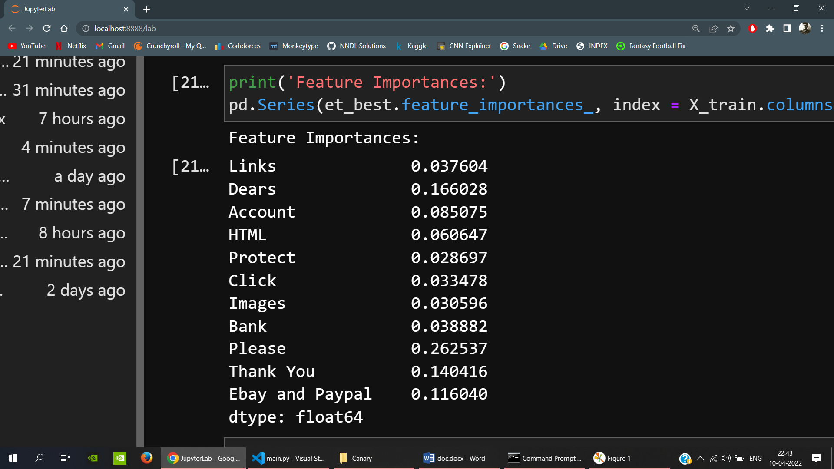

feature_importances_ returns a list of numbers, equal to the number of attributes in the dataset, and their sum is equal to one. This means that the number returned for a particular attribute is relative to other attributes.

The most important feature is the ‘Please’ feature with over 26% weightage, second most important feature being ‘Dears’ with over 16% weightage. ‘Dears’, ‘Thank You’ and ‘Please’ are the 3 most important features with their combined weightage in predicting if a mail is phishing or not being over 56%.

**Evaluation of models**

Below is the bar plot of the accuracies of all the models trained.

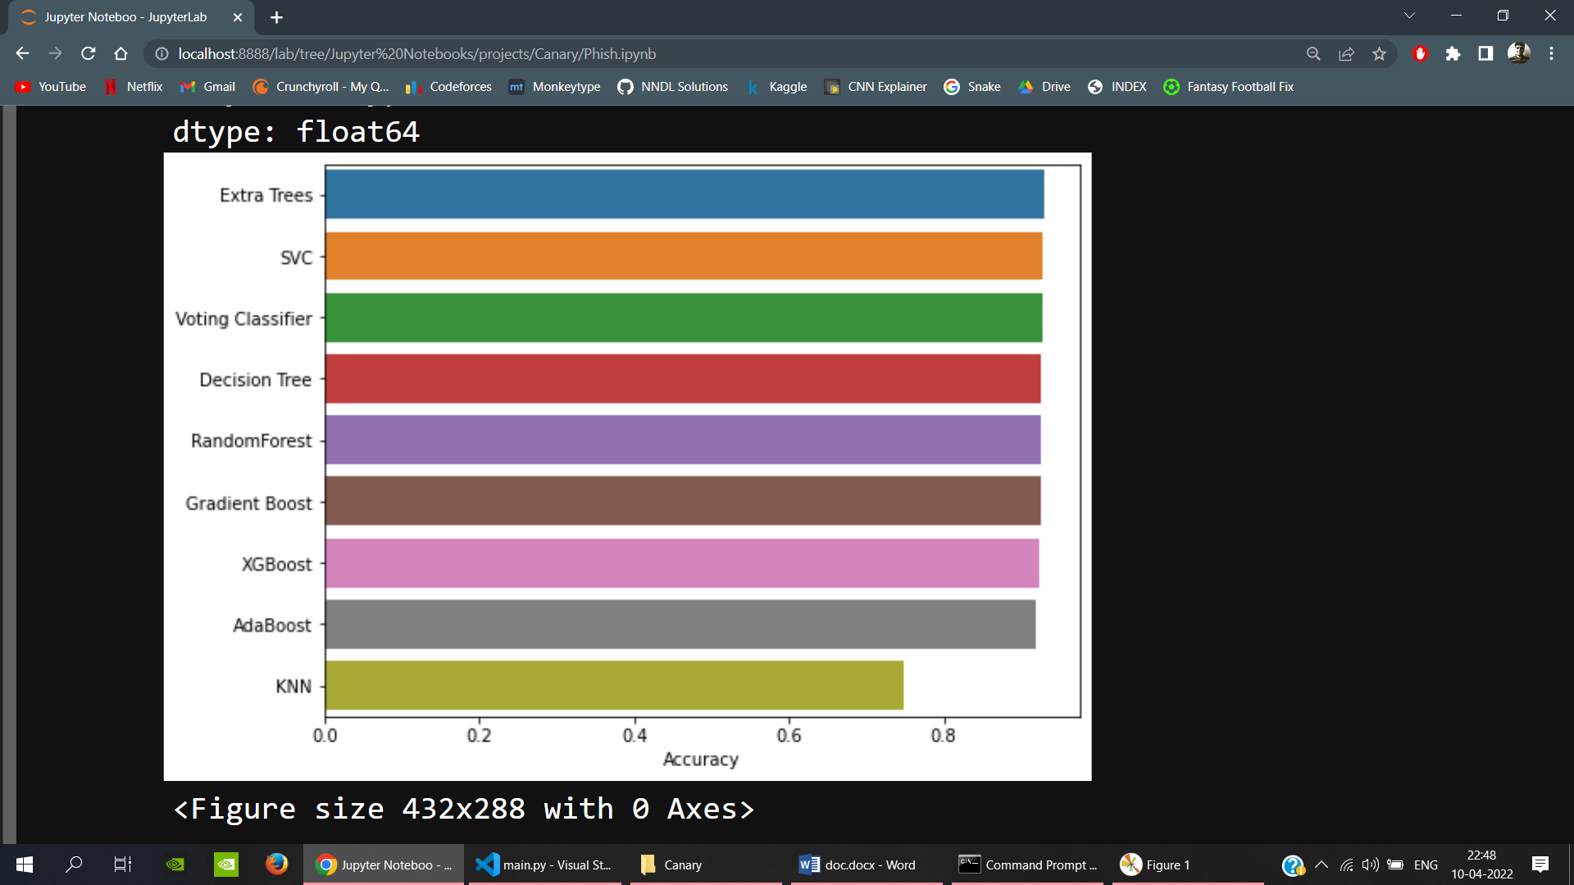

As you can see, the best model is Extra Trees Classifier with an accuracy of around 93%. Following are the accuracies of all the trained models:

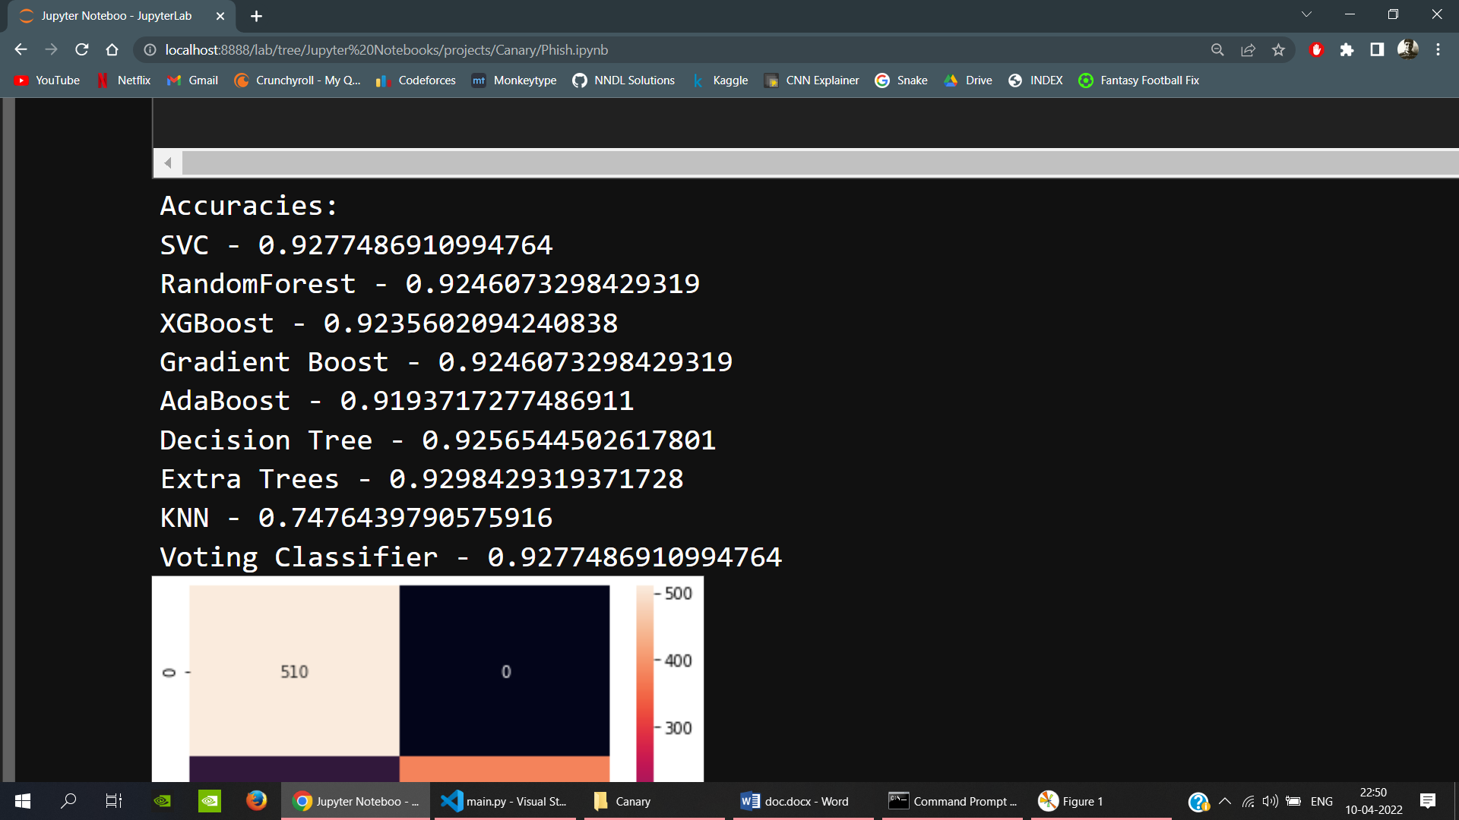

**Confusion matrix and Classification report for predictions on Extra Trees Classifier**

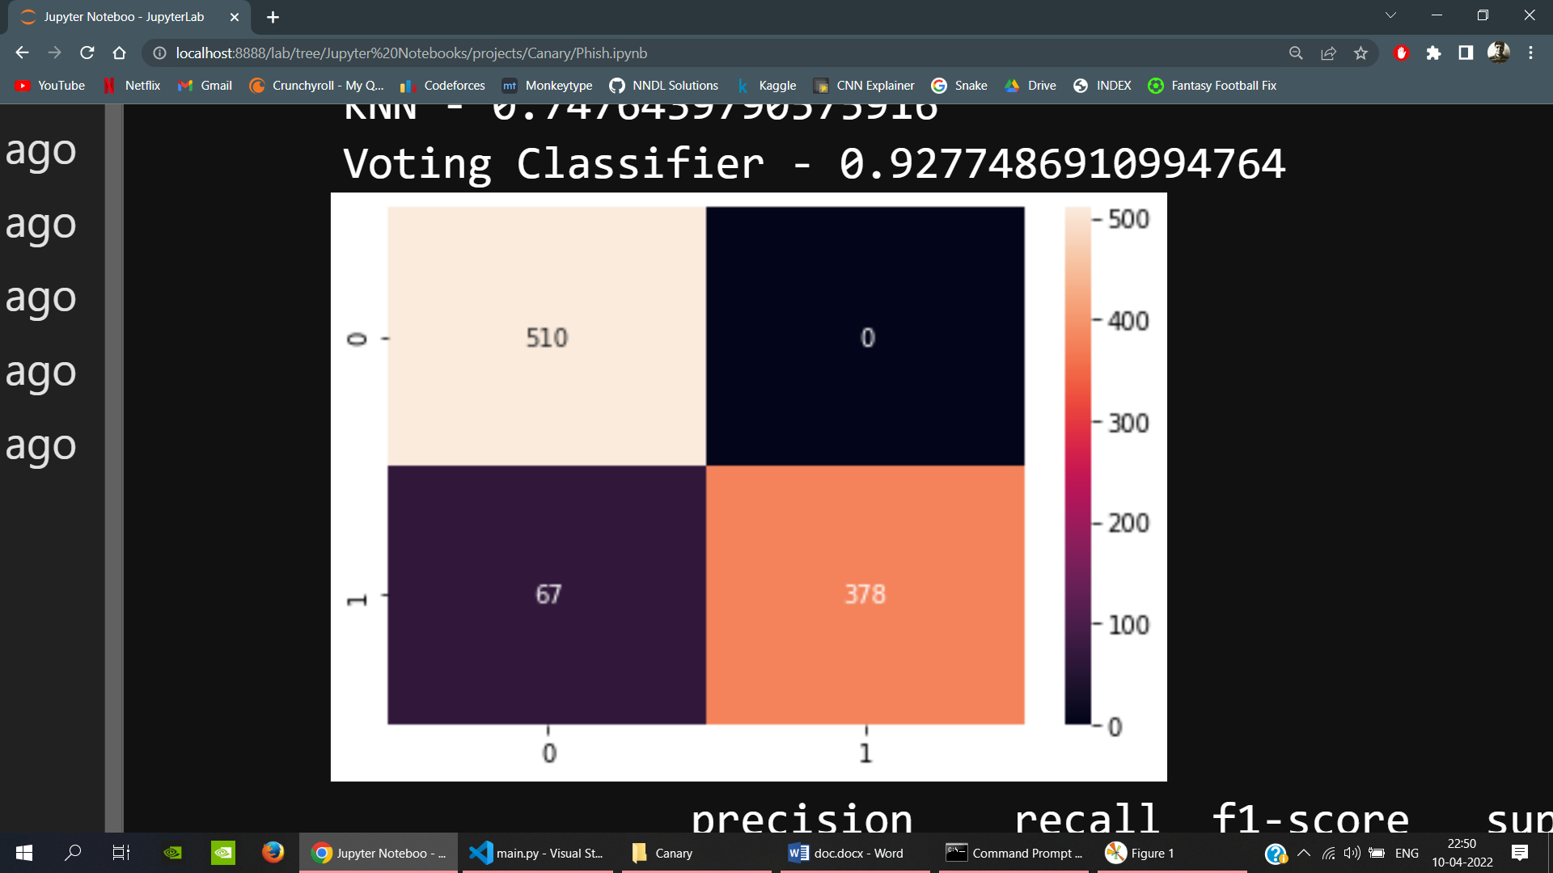

The given model has high precision but a fairly lower recall, which could be further improved by extracting and adding more relevant features. The following is the classification report for the Extra Trees Classifier model.

