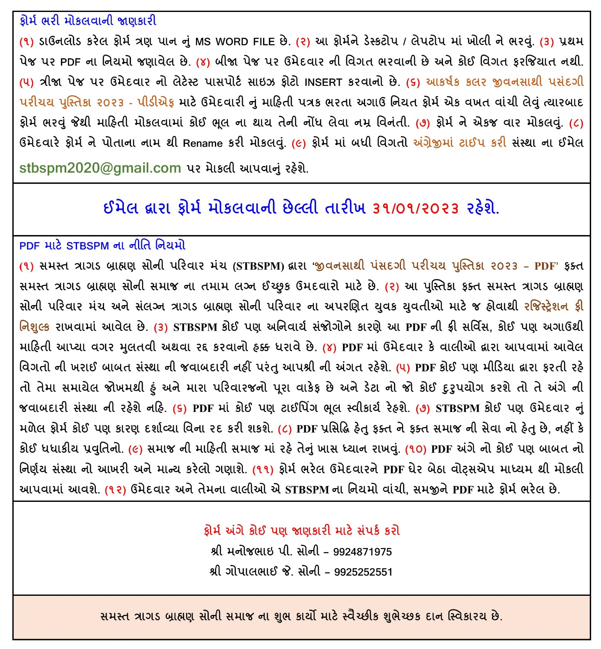
Note: Rename downloaded file with applicant’s name - Enter details – Submit the MS WORD FILE by email.

Ref. No. | Will be allotted by STBSPM
PERSONAL DETAILS
Full name
(Name-Middle Name-Surname)
Birth Date
(DD/MM/YYYY)
Birth Place
Birth Time (am/pm)
Height (cm)
Weight (kg)
Shani / Mangal
Believe in Horoscope
(Yes/No)
Gotra
Marital Status
(Unmarried/Divorced/Widowed)
Education
Occupation
Monthly Income
Spectacles (Yes/No)
Any Disability (Yes/No)
I live in
(Name of City / Town / Village)
FAMILY DETAILS
Father’s Name
Father’s Occupation
Mother’s Name
Mother’s Occupation
Brother (Mention in digits) | Married - | Unmarried -
Sister (Mention in digits) | Married - | Unmarried -
Mosal Name & City
(Contact person’s name)
Mosal Contact No.
CONTACT DETAILS
Whatsapp No.
Alternate Mobile No.
Email
We live in
(Name of City / Town / Village)
Residential Address
Name of Samaj Mandal

INSERT YOUR LATEST PASSPORT SIZE PHOTOGRAPH ON THIS PAGE

