**PROTOTYPE**

**(Smart Mall)**

The prototype which we have designed is the smart parking which is to be used in a smart mall. The system works in a way that as soon as your vehicle arrives, the camera would take the photo of the number plate and provide it to the machine learning model trained for our prototype. The model accepts the image then resizes it to 340 X 110 pixels (suited for our model to get better results) and automatically allocates the area for parking and enters the car number in the database.

**Images of some car license plates:**

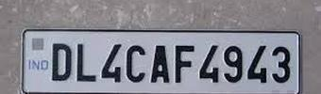

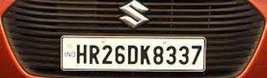

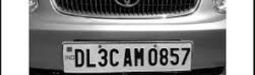

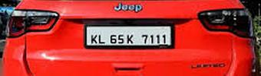

**The parking locations provided:**

These are the assumed parking spots available in the parking.

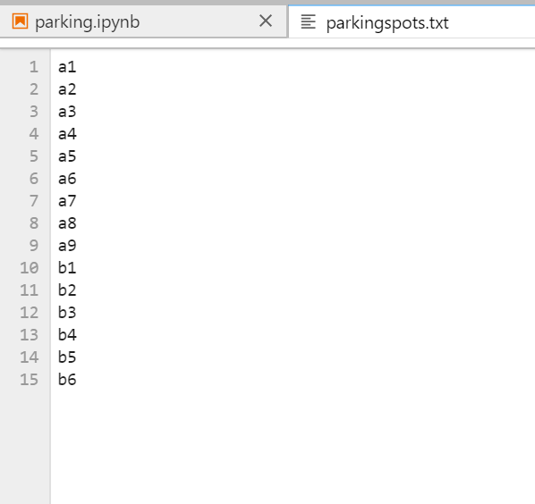

**Output provided by the model on encountering the first image:**

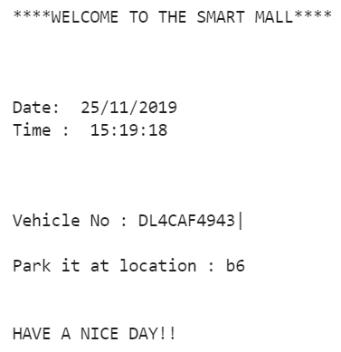

**Database where the parked cars are stored:**

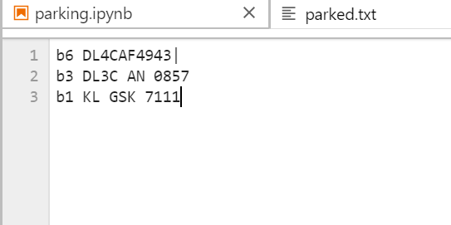:

**Images of the Machine learning model:**

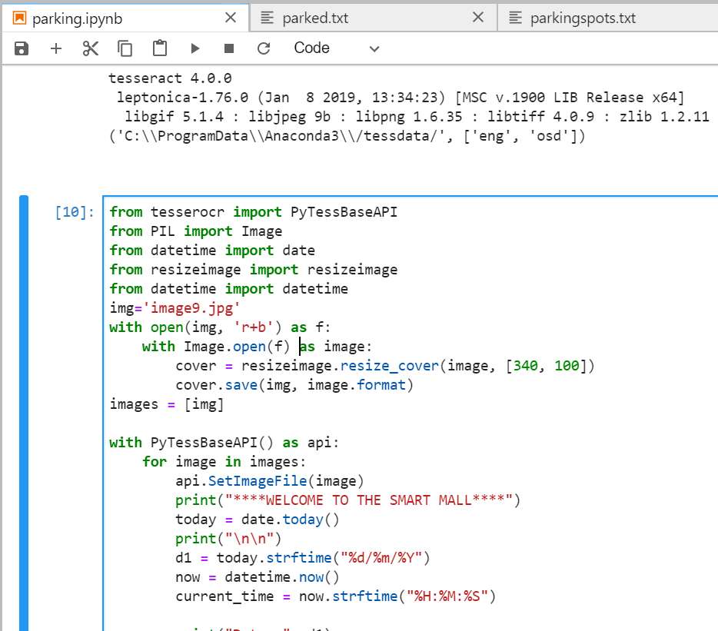

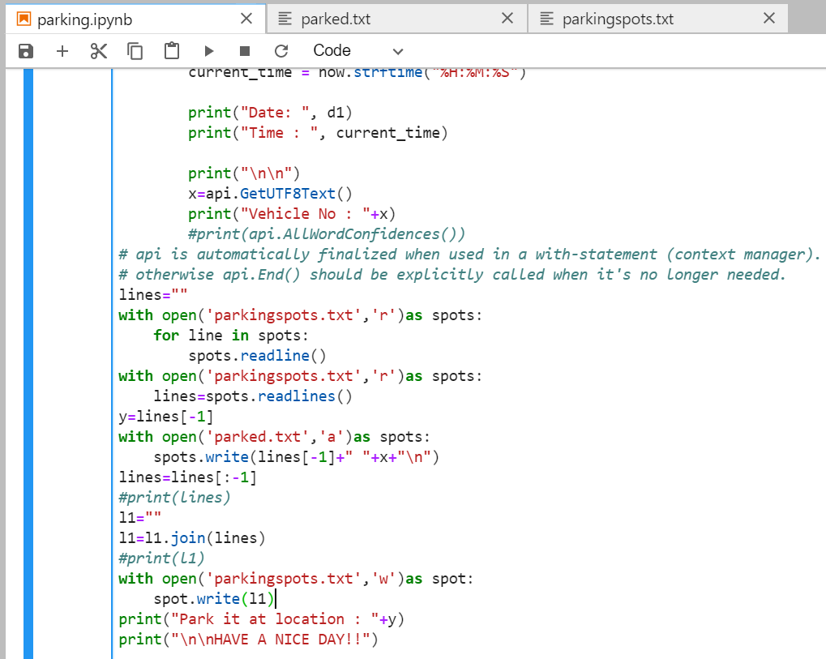

**Summary:**

As soon as the license plate is encountered by the model it reads the text from the image and out of the parking spots available, hands over a parking spot to it and enters the given spot and car number in another database. Thus, a smart way of parking where no need to look for parking spots and also it is easy to search for the car if forgotten the parking spot.