Assignment - 2

1) Create a C# application to demonstrate use of Generic Abstract class.

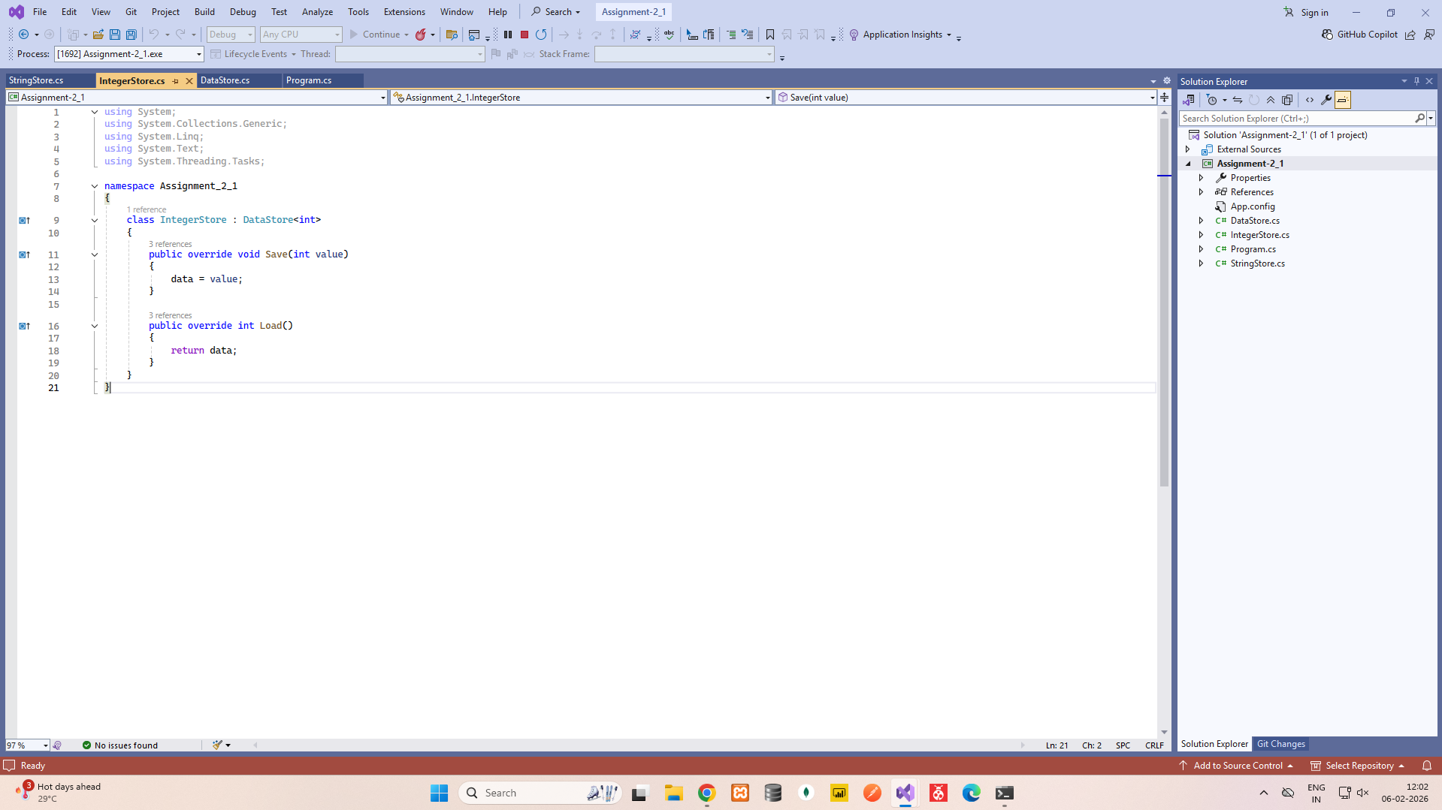
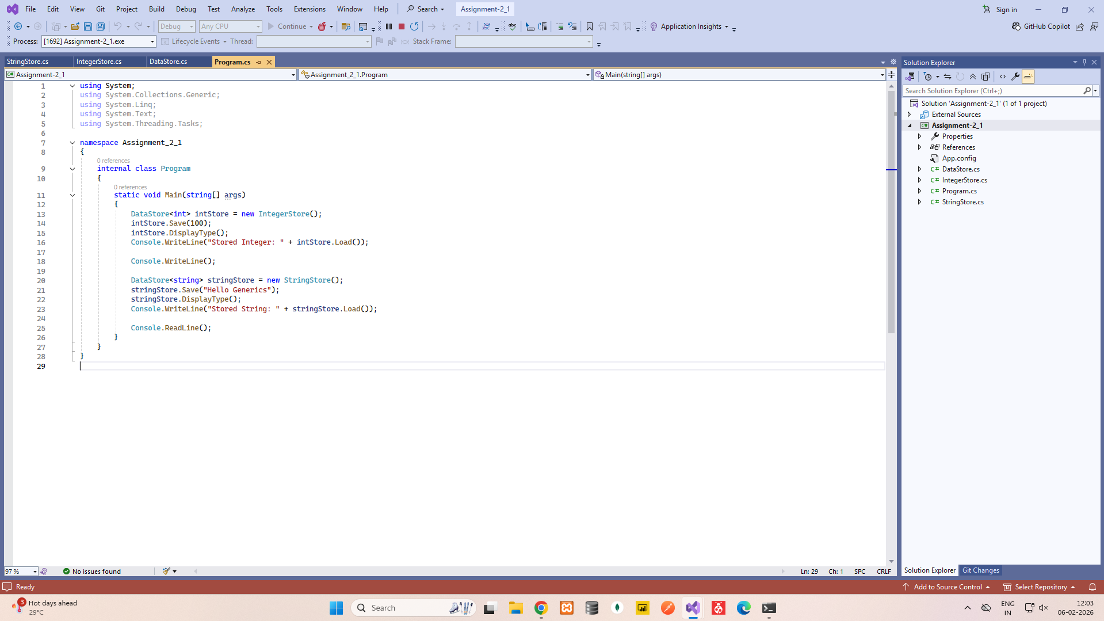
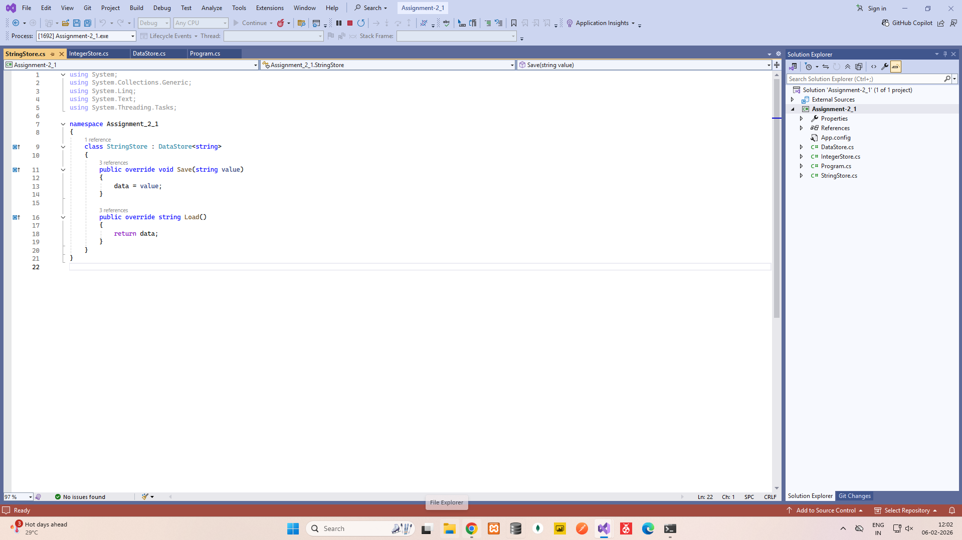

DataStore.cs

using System;
using System.Collections.Generic;
using System.Linq;
using System.Text;
using System.Threading.Tasks;

namespace Assignment_2_1
{
abstract class DataStore<T>
{
protected T data;

public abstract void Save(T value);
public abstract T Load();

public void DisplayType()
{
Console.WriteLine("Data type is : " + typeof(T));
}
}
}

IntegerStore.cs

using System;
using System.Collections.Generic;
using System.Linq;
using System.Text;
using System.Threading.Tasks;

namespace Assignment_2_1
{
class IntegerStore : DataStore<int>
{
public override void Save(int value)
{
data = value;
}

public override int Load()
{
return data;
}
}
}

StringStore.cs

using System;
using System.Collections.Generic;
using System.Linq;
using System.Text;
using System.Threading.Tasks;

namespace Assignment_2_1
{
class StringStore : DataStore<string>
{
public override void Save(string value)
{
data = value;
}

public override string Load()
{
return data;
}
}
}

Program.cs

using System;
using System.Collections.Generic;
using System.Linq;
using System.Text;
using System.Threading.Tasks;

namespace Assignment_2_1
{
internal class Program
{
static void Main(string[] args)
{
DataStore<int> intStore = new IntegerStore();
intStore.Save(100);
intStore.DisplayType();
Console.WriteLine("Stored Integer: " + intStore.Load());

Console.WriteLine();

DataStore<string> stringStore = new StringStore();
stringStore.Save("Hello Generics");
stringStore.DisplayType();
Console.WriteLine("Stored String: " + stringStore.Load());

Console.ReadLine();
}
}
}

Models/Employee.cs

using System;
using System.Collections.Generic;

namespace Assignment_2_2.Models;

public partial class Employee
{
public int EmployeeId { get; set; }

public string? EmployeeName { get; set; }

public string? Email { get; set; }

public string? Department { get; set; }

public DateOnly? JoiningDate { get; set; }

public bool? IsActive { get; set; }

public virtual ICollection<ProjectAllocation> ProjectAllocations { get; set; } = new List<ProjectAllocation>();
}

Models/Project.cs

using System;
using System.Collections.Generic;

namespace Assignment_2_2.Models;

public partial class Project
{
public int ProjectId { get; set; }

public string? ProjectName { get; set; }

public string? Description { get; set; }

public DateOnly? StartDate { get; set; }

public DateOnly? EndDate { get; set; }

public string? Status { get; set; }

public virtual ICollection<ProjectAllocation> ProjectAllocations { get; set; } = new List<ProjectAllocation>();
}

Models/ProjectAllocation.cs

using Microsoft.AspNetCore.Mvc.ModelBinding.Validation;
using System;
using System.Collections.Generic;

namespace Assignment_2_2.Models;

public partial class ProjectAllocation
{
public int AllocationId { get; set; }

public int EmployeeId { get; set; }

public int ProjectId { get; set; }

public DateOnly? AllocationDate { get; set; }

public string? Role { get; set; }

public bool? IsActive { get; set; }

[ValidateNever]
public virtual Employee Employee { get; set; } = null!;

[ValidateNever]
public virtual Project Project { get; set; } = null!;
}

Controllers/EmployeeController.cs

using System;
using System.Collections.Generic;
using System.Linq;
using System.Threading.Tasks;
using Microsoft.AspNetCore.Mvc;
using Microsoft.AspNetCore.Mvc.Rendering;
using Microsoft.EntityFrameworkCore;
using Assignment_2_2.Models;

namespace Assignment_2_2.Controllers
{
public class EmployeesController : Controller
{
private readonly Ict2projectAllocationDbContext _context;

public EmployeesController(Ict2projectAllocationDbContext context)
{
_context = context;
}

// GET: Employees
public async Task<IActionResult> Index()
{
return View(await _context.Employees.ToListAsync());
}

// GET: Employees/Details/5
public async Task<IActionResult> Details(int? id)
{
if (id == null)
{
return NotFound();
}

var employee = await _context.Employees
.FirstOrDefaultAsync(m => m.EmployeeId == id);
if (employee == null)
{
return NotFound();
}

return View(employee);
}

// GET: Employees/Create
public IActionResult Create()
{
return View();
}

// POST: Employees/Create
// To protect from overposting attacks, enable the specific properties you want to bind to.
// For more details, see http://go.microsoft.com/fwlink/?LinkId=317598.
[HttpPost]
[ValidateAntiForgeryToken]
public async Task<IActionResult> Create([Bind("EmployeeId,EmployeeName,Email,Department,JoiningDate,IsActive")] Employee employee)
{
if (ModelState.IsValid)
{
employee.IsActive = true;
_context.Add(employee);
await _context.SaveChangesAsync();
return RedirectToAction(nameof(Index));
}
return View(employee);
}

// GET: Employees/Edit/5
public async Task<IActionResult> Edit(int? id)
{
if (id == null)
{
return NotFound();
}

var employee = await _context.Employees.FindAsync(id);
if (employee == null)
{
return NotFound();
}
return View(employee);
}

// POST: Employees/Edit/5
// To protect from overposting attacks, enable the specific properties you want to bind to.
// For more details, see http://go.microsoft.com/fwlink/?LinkId=317598.
[HttpPost]
[ValidateAntiForgeryToken]
public async Task<IActionResult> Edit(int id, [Bind("EmployeeId,EmployeeName,Email,Department,JoiningDate,IsActive")] Employee employee)
{
if (id != employee.EmployeeId)
{
return NotFound();
}

if (ModelState.IsValid)
{
try
{
_context.Update(employee);
await _context.SaveChangesAsync();
}
catch (DbUpdateConcurrencyException)
{
if (!EmployeeExists(employee.EmployeeId))
{
return NotFound();
}
else
{
throw;
}
}
return RedirectToAction(nameof(Index));
}
return View(employee);
}

// GET: Employees/Delete/5
public async Task<IActionResult> Delete(int? id)
{
if (id == null)
{
return NotFound();
}

var employee = await _context.Employees
.FirstOrDefaultAsync(m => m.EmployeeId == id);
if (employee == null)
{
return NotFound();
}

return View(employee);
}

// POST: Employees/Delete/5
[HttpPost, ActionName("Delete")]
[ValidateAntiForgeryToken]
public async Task<IActionResult> DeleteConfirmed(int id)
{
var employee = await _context.Employees.FindAsync(id);
if (employee != null)
{
_context.Employees.Remove(employee);
}

await _context.SaveChangesAsync();
return RedirectToAction(nameof(Index));
}

private bool EmployeeExists(int id)
{
return _context.Employees.Any(e => e.EmployeeId == id);
}

public IActionResult SearchByProjectName()
{
return View();
}

[HttpPost]
public IActionResult SearchByProjectName(string projectName)
{
var employees = _context.Employees
.Include(e => e.ProjectAllocations)
.ThenInclude(pa => pa.Project)
.Where(e => e.ProjectAllocations.Any(pa => pa.Project.ProjectName.Contains(projectName)))
.ToList();

return View("SearchResult", employees);
}

public IActionResult SearchResult(List<Employee> employeeList)
{
return View(employeeList);
}
}
}

Controllers/ProjectsController.cs

using System;
using System.Collections.Generic;
using System.Linq;
using System.Threading.Tasks;
using Microsoft.AspNetCore.Mvc;
using Microsoft.AspNetCore.Mvc.Rendering;
using Microsoft.EntityFrameworkCore;
using Assignment_2_2.Models;

namespace Assignment_2_2.Controllers
{
public class ProjectsController : Controller
{
private readonly Ict2projectAllocationDbContext _context;

public ProjectsController(Ict2projectAllocationDbContext context)
{
_context = context;
}

// GET: Projects
public async Task<IActionResult> Index()
{
return View(await _context.Projects.ToListAsync());
}

// GET: Projects/Details/5
public async Task<IActionResult> Details(int? id)
{
if (id == null)
{
return NotFound();
}

var project = await _context.Projects
.FirstOrDefaultAsync(m => m.ProjectId == id);
if (project == null)
{
return NotFound();
}

return View(project);
}

// GET: Projects/Create
public IActionResult Create()
{
return View();
}

// POST: Projects/Create
// To protect from overposting attacks, enable the specific properties you want to bind to.
// For more details, see http://go.microsoft.com/fwlink/?LinkId=317598.
[HttpPost]
[ValidateAntiForgeryToken]
public async Task<IActionResult> Create([Bind("ProjectId,ProjectName,Description,StartDate,EndDate,Status")] Project project)
{
if (ModelState.IsValid)
{
_context.Add(project);
await _context.SaveChangesAsync();
return RedirectToAction(nameof(Index));
}
return View(project);
}

// GET: Projects/Edit/5
public async Task<IActionResult> Edit(int? id)
{
if (id == null)
{
return NotFound();
}

var project = await _context.Projects.FindAsync(id);
if (project == null)
{
return NotFound();
}
return View(project);
}

// POST: Projects/Edit/5
// To protect from overposting attacks, enable the specific properties you want to bind to.
// For more details, see http://go.microsoft.com/fwlink/?LinkId=317598.
[HttpPost]
[ValidateAntiForgeryToken]
public async Task<IActionResult> Edit(int id, [Bind("ProjectId,ProjectName,Description,StartDate,EndDate,Status")] Project project)
{
if (id != project.ProjectId)
{
return NotFound();
}

if (ModelState.IsValid)
{
try
{
_context.Update(project);
await _context.SaveChangesAsync();
}
catch (DbUpdateConcurrencyException)
{
if (!ProjectExists(project.ProjectId))
{
return NotFound();
}
else
{
throw;
}
}
return RedirectToAction(nameof(Index));
}
return View(project);
}

// GET: Projects/Delete/5
public async Task<IActionResult> Delete(int? id)
{
if (id == null)
{
return NotFound();
}

var project = await _context.Projects
.FirstOrDefaultAsync(m => m.ProjectId == id);
if (project == null)
{
return NotFound();
}

return View(project);
}

// POST: Projects/Delete/5
[HttpPost, ActionName("Delete")]
[ValidateAntiForgeryToken]
public async Task<IActionResult> DeleteConfirmed(int id)
{
var project = await _context.Projects.FindAsync(id);
if (project != null)
{
_context.Projects.Remove(project);
}

await _context.SaveChangesAsync();
return RedirectToAction(nameof(Index));
}

private bool ProjectExists(int id)
{
return _context.Projects.Any(e => e.ProjectId == id);
}
}
}

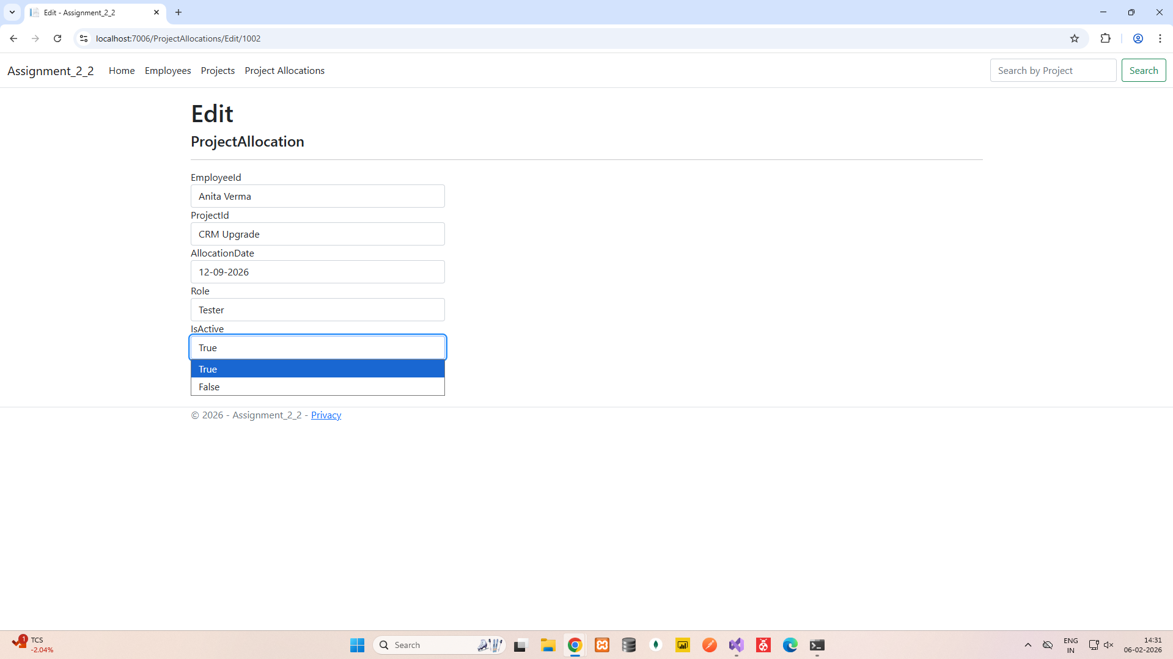

3) Demonstrate use of String Indexer and multivalued Indexer to search data from a Generic collection.

