Assignment - 3

Assignment - 3 -> Q - 1

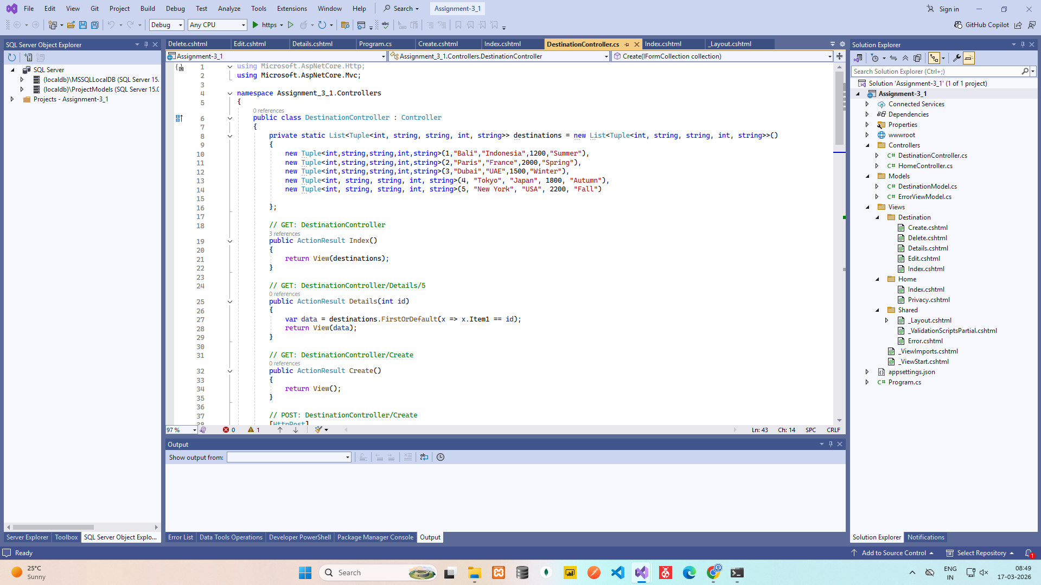

DestinationController.cs

using Microsoft.AspNetCore.Http;
using Microsoft.AspNetCore.Mvc;

namespace Assignment_3_1.Controllers
{
public class DestinationController : Controller
{
private static List<Tuple<int, string, string, int, string>> destinations = new List<Tuple<int, string, string, int, string>>()
{
new Tuple<int,string,string,int,string>(1,"Bali","Indonesia",1200,"Summer"),
new Tuple<int,string,string,int,string>(2,"Paris","France",2000,"Spring"),
new Tuple<int,string,string,int,string>(3,"Dubai","UAE",1500,"Winter"),
new Tuple<int, string, string, int, string>(4, "Tokyo", "Japan", 1800, "Autumn"),
new Tuple<int, string, string, int, string>(5, "New York", "USA", 2200, "Fall")

};

// GET: DestinationController
public ActionResult Index()
{
return View(destinations);
}

// GET: DestinationController/Details/5
public ActionResult Details(int id)
{
var data = destinations.FirstOrDefault(x => x.Item1 == id);
return View(data);
}

// GET: DestinationController/Create
public ActionResult Create()
{
return View();
}

// POST: DestinationController/Create
[HttpPost]
[ValidateAntiForgeryToken]
public ActionResult Create(IFormCollection collection)
{
try
{
int id = Convert.ToInt32(collection["DestinationId"].ToString());
string name = collection["DestinationName"].ToString() ?? "";
string country = collection["Country"].ToString() ?? "";
int cost = Convert.ToInt32(collection["EstimatedCost"].ToString());
string season = collection["BestSeason"].ToString() ?? "";

destinations.Add(new Tuple<int, string, string, int, string>(id, name, country, cost, season));

return RedirectToAction(nameof(Index));
}
catch
{
return View();
}
}

// GET: DestinationController/Edit/5
public ActionResult Edit(int id)
{
return View(destinations.SingleOrDefault(d => d.Item1 == id));
}

// POST: DestinationController/Edit/5
[HttpPost]
[ValidateAntiForgeryToken]
public ActionResult Edit(int id, IFormCollection collection)
{
try
{
var dest = destinations.SingleOrDefault(d => d.Item1 == id);

destinations.Remove(dest);

string name = collection["DestinationName"].ToString() ?? "";
string country = collection["Country"].ToString() ?? "";
int cost = Convert.ToInt32(collection["EstimatedCost"].ToString());
string season = collection["BestSeason"].ToString() ?? "";

destinations.Add(new Tuple<int, string, string, int, string>(id, name, country, cost, season));

return RedirectToAction(nameof(Index));
}
catch
{
return View();
}
}

// GET: DestinationController/Delete/5
public ActionResult Delete(int id)
{
return View(destinations.SingleOrDefault(d => d.Item1 == id));
}

// POST: DestinationController/Delete/5
[HttpPost]
[ValidateAntiForgeryToken]
public ActionResult Delete(int id, IFormCollection collection)
{
try
{
var dest = destinations.SingleOrDefault(d => d.Item1 == id);

if (dest != null)
destinations.Remove(dest);

return RedirectToAction(nameof(Index));
}
catch
{
return View();
}
}
}
}

____________________________________________________________________________

Create.cshtml

<h1>Create New Destination</h1>

<form method="post">
<p>
<label>Destination ID:</label><br />
<input type="number" name="DestinationId" required />
</p>
<p>
<label>Destination Name:</label><br />
<input type="text" name="DestinationName" required />
</p>
<p>
<label>Country:</label><br />
<input type="text" name="Country" required />
</p>
<p>
<label>Estimated Cost:</label><br />
<input type="number" name="EstimatedCost" required />
</p>
<p>
<label>Best Season:</label><br />
<input type="text" name="BestSeason" required />
</p>
<p>
<button type="submit">Save</button>
<a href="/Destination">Cancel</a>
</p>
</form>

Index.cshtml

@model List<Tuple<int, string, string, int, string>>

<h1>Destinations List</h1>

<p>
<a href="/Destination/Create">Add New Destination</a>
</p>

<table border="1" cellpadding="5" cellspacing="0">
<tr>
<th>ID</th>
<th>Name</th>
<th>Country</th>
<th>Estimated Cost</th>
<th>Best Season</th>
<th>Actions</th>
</tr>
@foreach (var d in Model)
{
<tr>
<td>@d.Item1</td>
<td>@d.Item2</td>
<td>@d.Item3</td>
<td>@d.Item4</td>
<td>@d.Item5</td>
<td>
<a href="/Destination/Details/@d.Item1">Details</a> |
<a href="/Destination/Edit/@d.Item1">Edit</a> |
<a href="/Destination/Delete/@d.Item1">Delete</a>
</td>
</tr>
}
</table>

Delete.cshtml

@model Tuple<int, string, string, int, string>

<h1>Delete Destination</h1>

<p>Are you sure you want to delete this destination?</p>

<table border="1" cellpadding="5">
<tr>
<th>ID</th>
<td>@Model.Item1</td>
</tr>
<tr>
<th>Name</th>
<td>@Model.Item2</td>
</tr>
<tr>
<th>Country</th>
<td>@Model.Item3</td>
</tr>
<tr>
<th>Estimated Cost</th>
<td>@Model.Item4</td>
</tr>
<tr>
<th>Best Season</th>
<td>@Model.Item5</td>
</tr>
</table>

<form method="post">
<input type="hidden" name="id" value="@Model.Item1" />
<button type="submit">Yes, Delete</button>
<a href="/Destination">Cancel</a>
</form>

Details.cshtml

@model Tuple<int, string, string, int, string>

<h1>Destination Details</h1>

<table border="1" cellpadding="5">
<tr>
<th>ID</th>
<td>@Model.Item1</td>
</tr>
<tr>
<th>Name</th>
<td>@Model.Item2</td>
</tr>
<tr>
<th>Country</th>
<td>@Model.Item3</td>
</tr>
<tr>
<th>Estimated Cost</th>
<td>@Model.Item4</td>
</tr>
<tr>
<th>Best Season</th>
<td>@Model.Item5</td>
</tr>
</table>

<p>
<a href="/Destination/Edit/@Model.Item1">Edit</a> |
<a href="/Destination">Back to List</a>
</p>

Edit.cshtml

@model Tuple<int, string, string, int, string>

<h1>Edit Destination</h1>

<form method="post">
<input type="hidden" name="id" value="@Model.Item1" />

<p>
<label>Destination Name:</label><br />
<input type="text" name="DestinationName" value="@Model.Item2" required />
</p>
<p>
<label>Country:</label><br />
<input type="text" name="Country" value="@Model.Item3" required />
</p>
<p>
<label>Estimated Cost:</label><br />
<input type="number" name="EstimatedCost" value="@Model.Item4" required />
</p>
<p>
<label>Best Season:</label><br />
<input type="text" name="BestSeason" value="@Model.Item5" required />
</p>
<p>
<button type="submit">Save Changes</button>
<a href="/Destination">Cancel</a>
</p>
</form>

OUTPUT
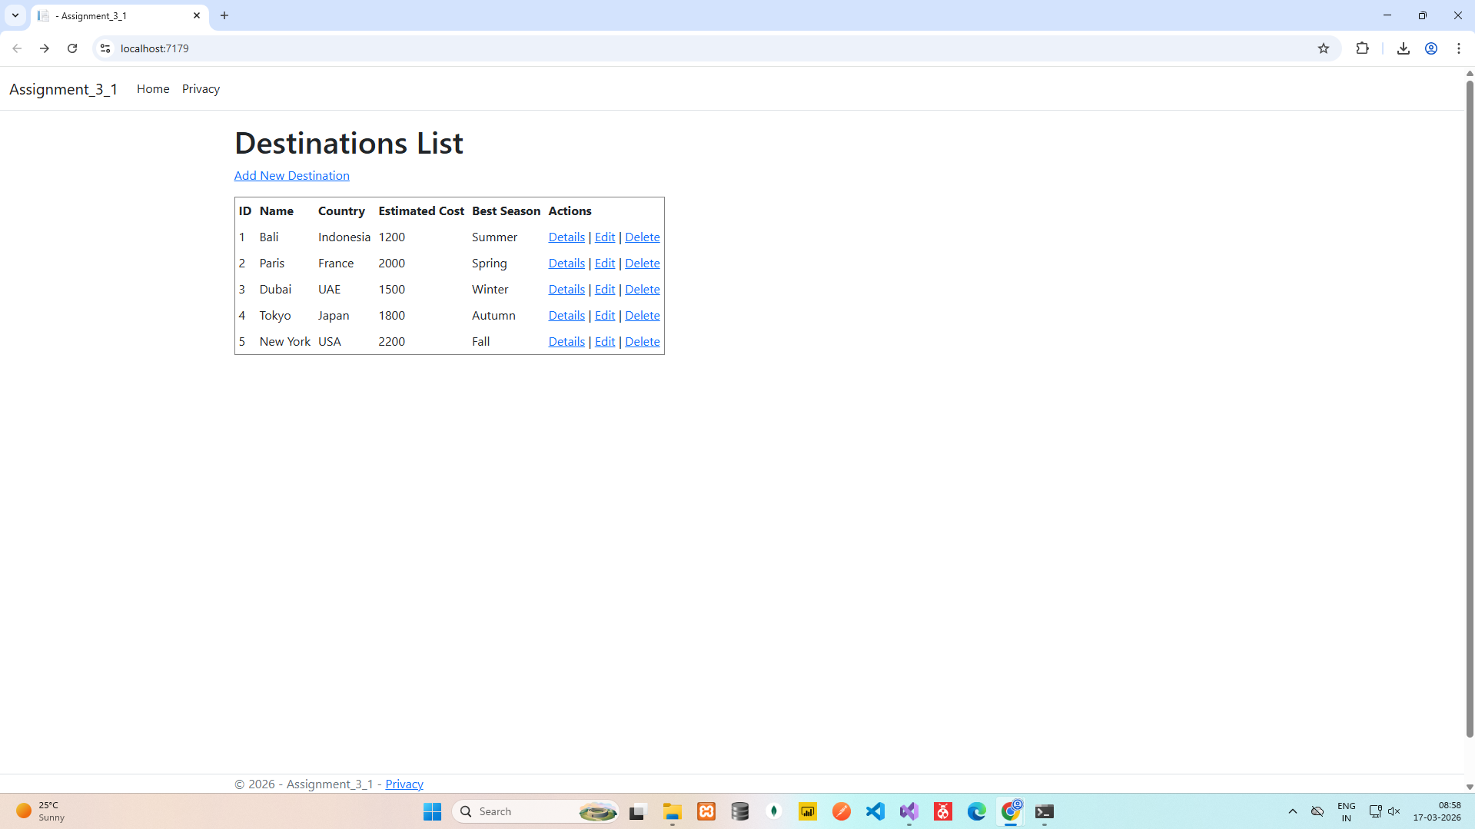
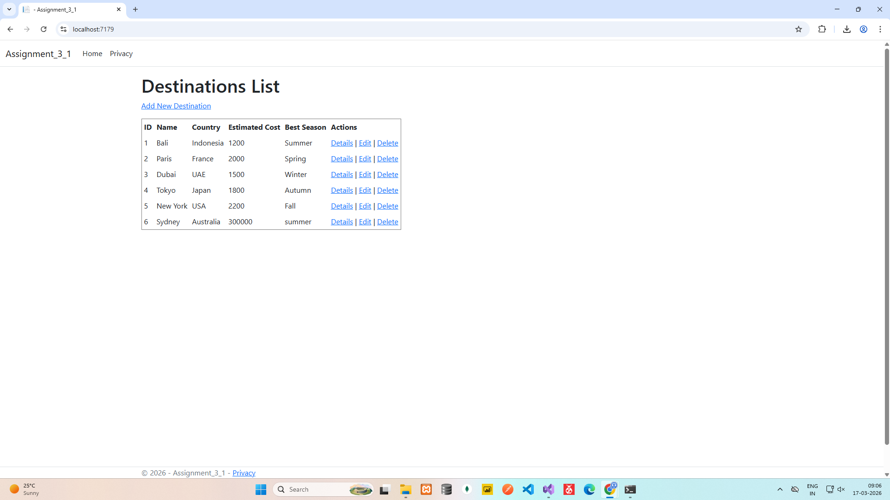
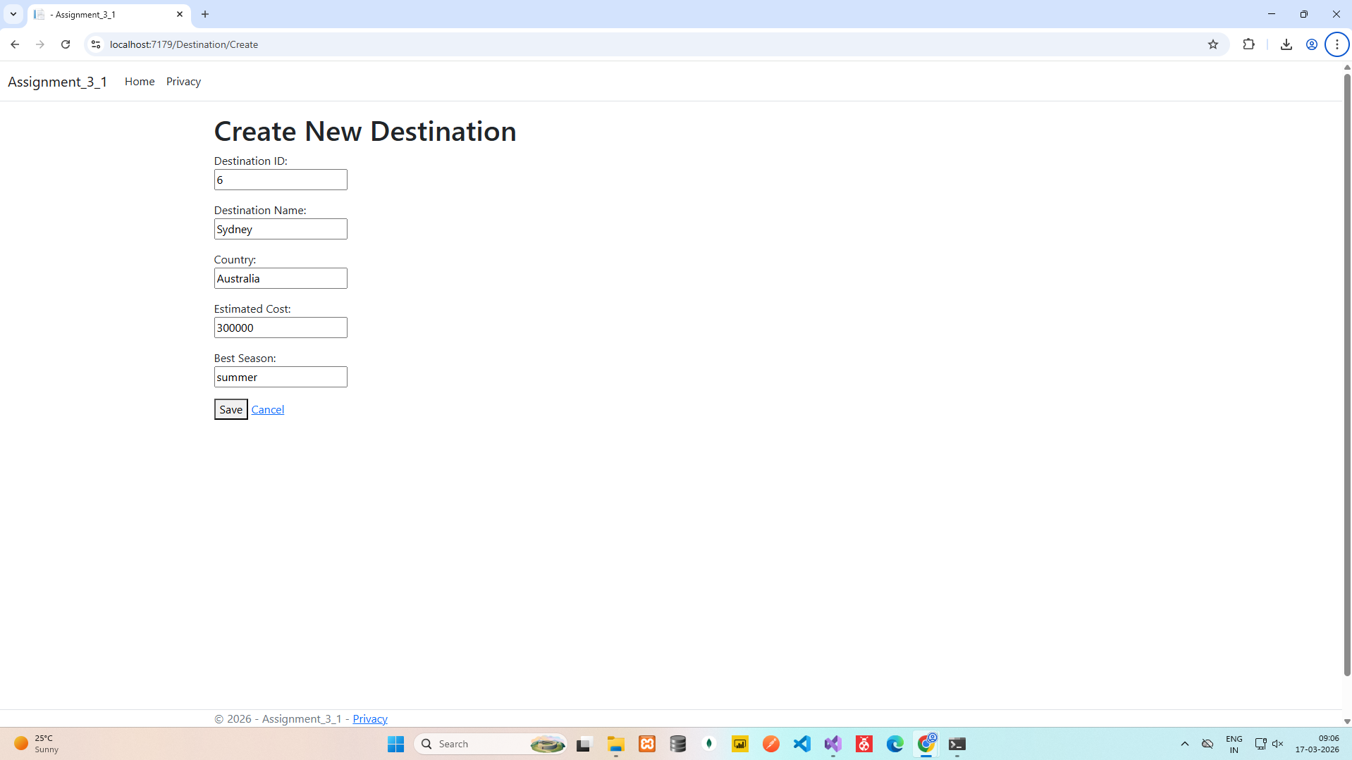

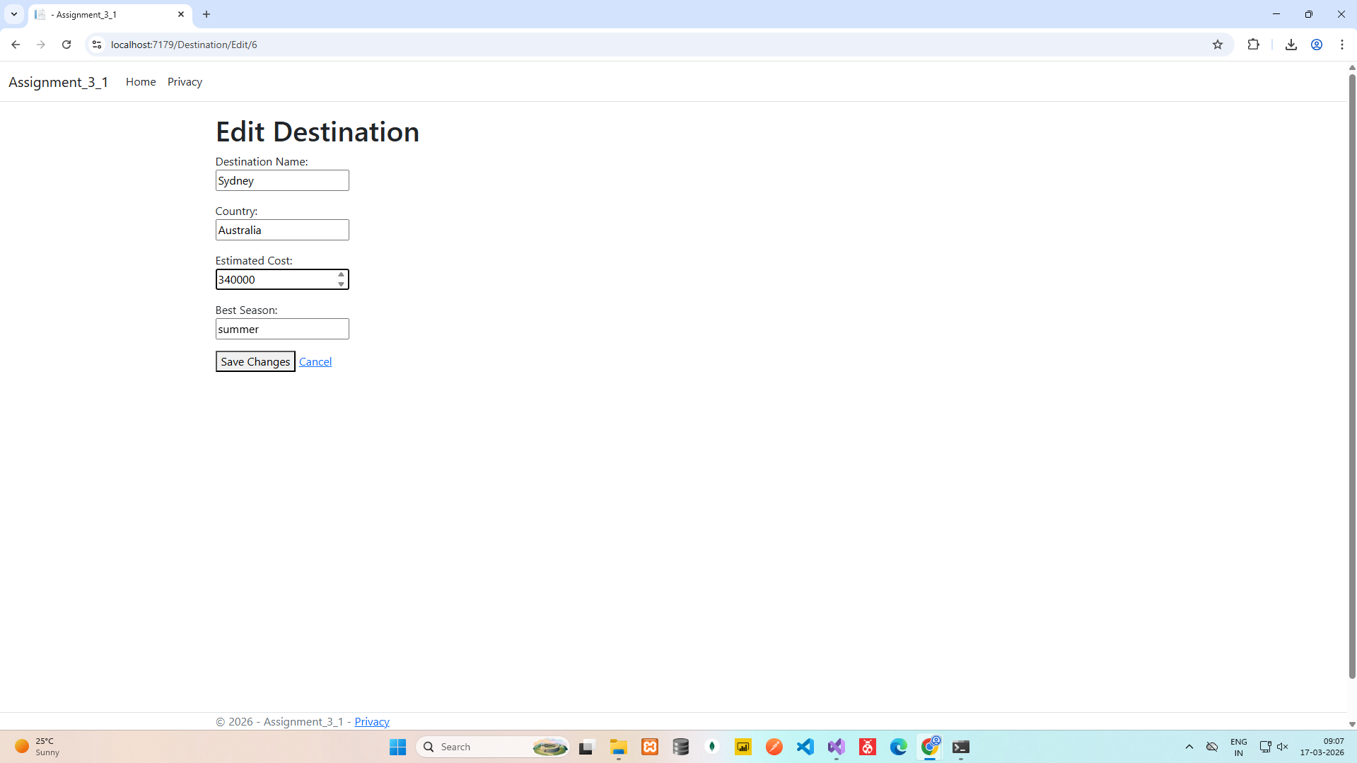
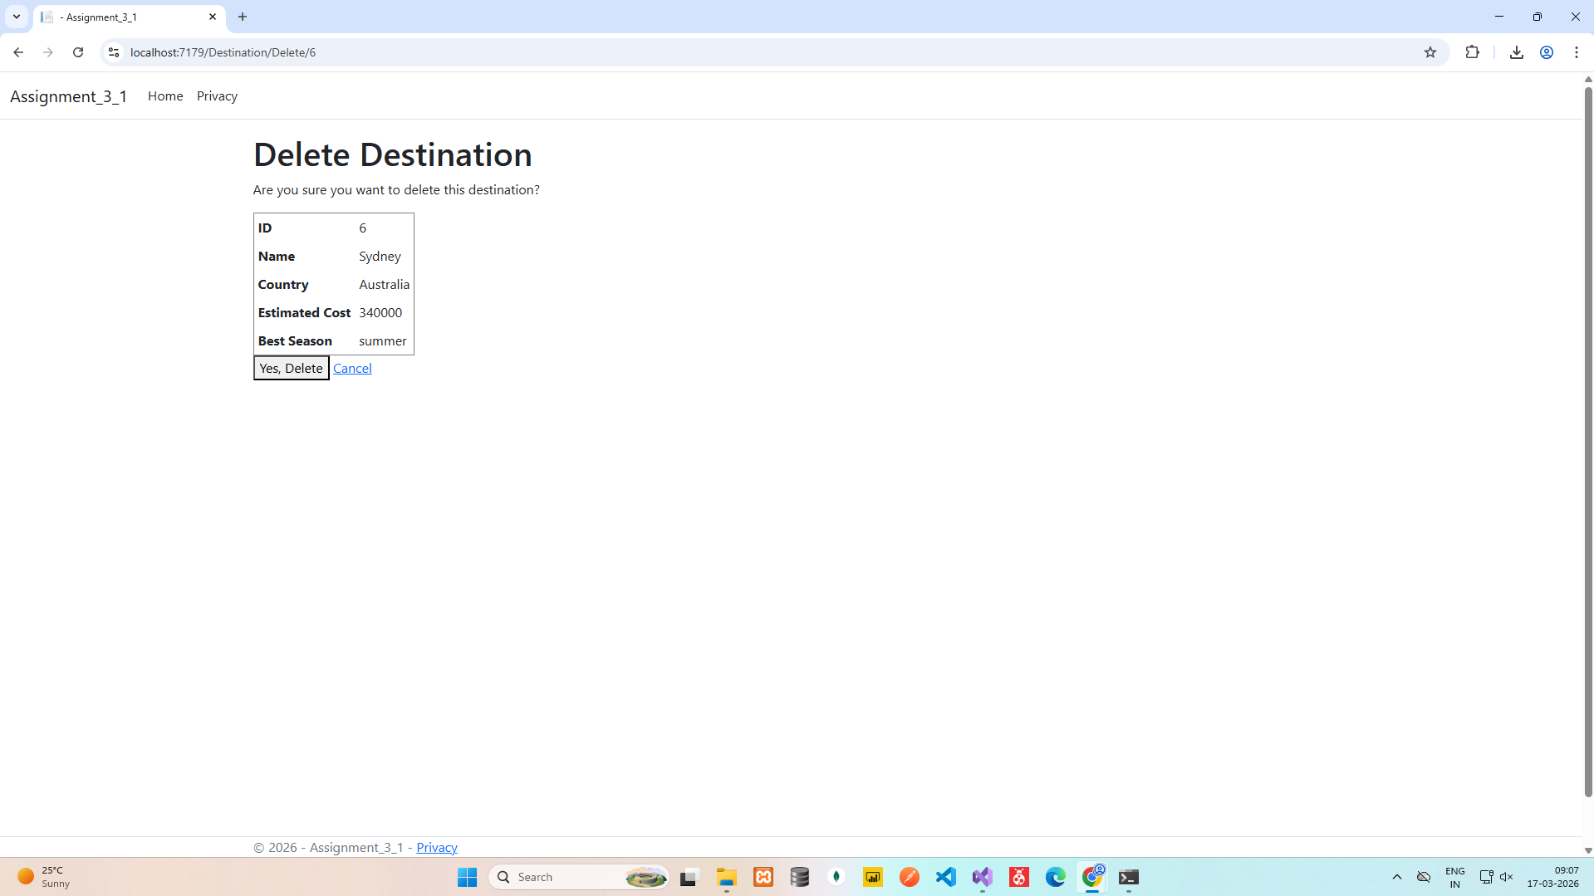

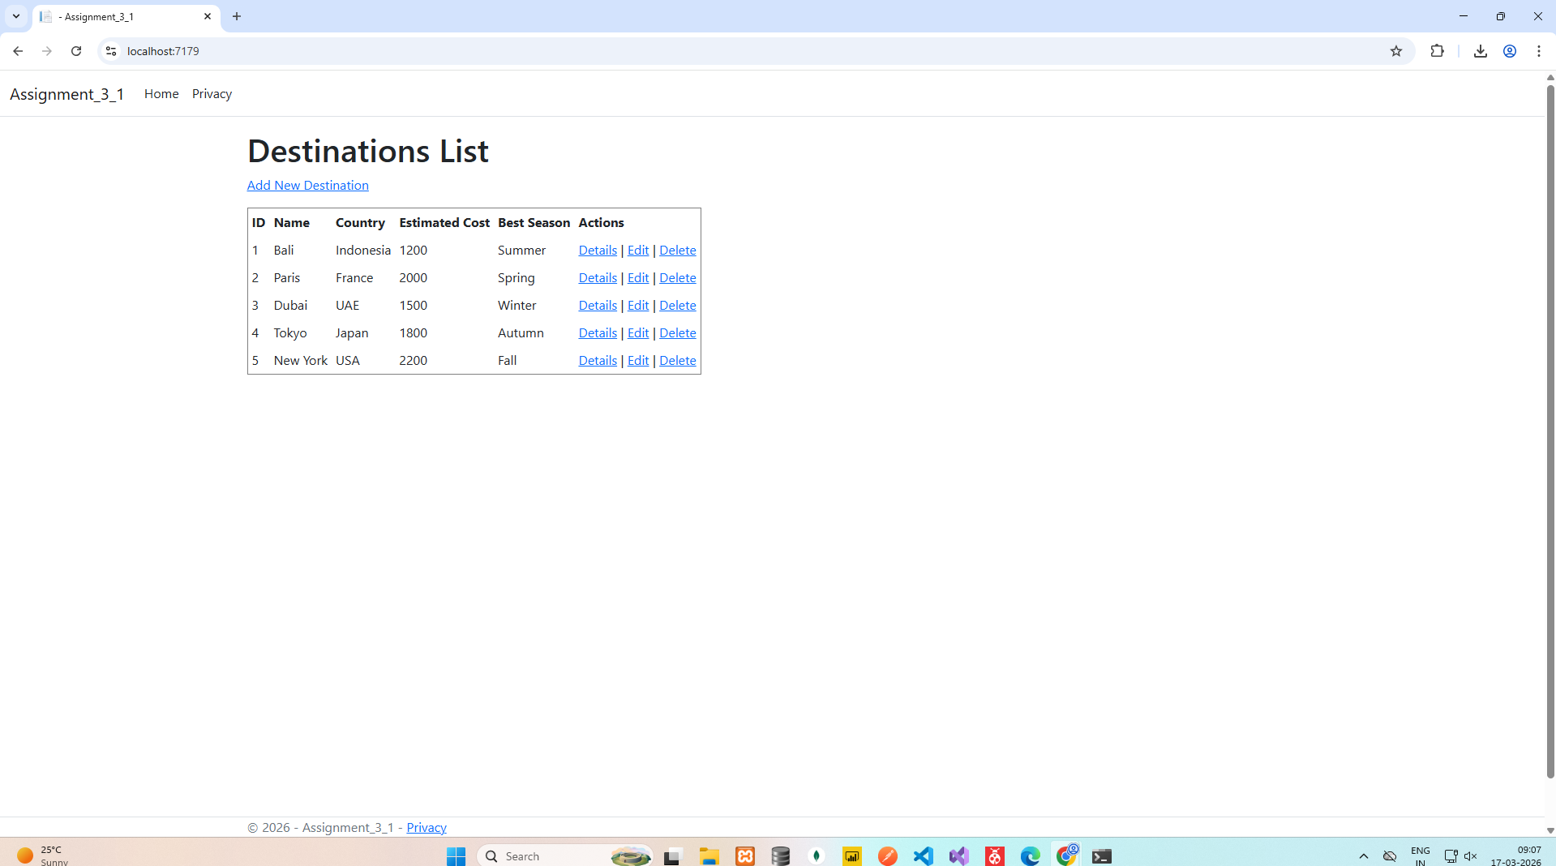

Assignment - 3 -> Q - 2

VehiclesController.cs

using System;
using System.Collections.Generic;
using System.Linq;
using System.Threading.Tasks;
using Microsoft.AspNetCore.Http;
using Microsoft.AspNetCore.Mvc;
using Microsoft.EntityFrameworkCore;
using Assignment_3_2.Models;

namespace Assignment_3_2.Controllers
{
[Route("api/[controller]")]
[ApiController]
public class VehiclesController : ControllerBase
{
private readonly Ict2vehicleDbContext _context;

public VehiclesController(Ict2vehicleDbContext context)
{
_context = context;
}

// GET: api/Vehicles
[HttpGet]
public async Task<ActionResult<IEnumerable<Vehicle>>> GetVehicles()
{
return await _context.Vehicles.ToListAsync();
}

// GET: api/Vehicles/5
[HttpGet("{id}")]
public async Task<ActionResult<Vehicle>> GetVehicle(int id)
{
var vehicle = await _context.Vehicles.FindAsync(id);

if (vehicle == null)
{
return NotFound();
}

return vehicle;
}

// PUT: api/Vehicles/5
// To protect from overposting attacks, see https://go.microsoft.com/fwlink/?linkid=2123754
[HttpPut("{id}")]
public async Task<IActionResult> PutVehicle(int id, Vehicle vehicle)
{
if (id != vehicle.VehicleId)
{
return BadRequest();
}

_context.Entry(vehicle).State = EntityState.Modified;

try
{
await _context.SaveChangesAsync();
}
catch (DbUpdateConcurrencyException)
{
if (!VehicleExists(id))
{
return NotFound();
}
else
{
throw;
}
}

return NoContent();
}

// POST: api/Vehicles
// To protect from overposting attacks, see https://go.microsoft.com/fwlink/?linkid=2123754
[HttpPost]
public async Task<ActionResult<Vehicle>> PostVehicle(Vehicle vehicle)
{
_context.Vehicles.Add(vehicle);
await _context.SaveChangesAsync();

return CreatedAtAction("GetVehicle", new { id = vehicle.VehicleId }, vehicle);
}

// DELETE: api/Vehicles/5
[HttpDelete("{id}")]
public async Task<IActionResult> DeleteVehicle(int id)
{
var vehicle = await _context.Vehicles.FindAsync(id);
if (vehicle == null)
{
return NotFound();
}

_context.Vehicles.Remove(vehicle);
await _context.SaveChangesAsync();

return NoContent();
}

private bool VehicleExists(int id)
{
return _context.Vehicles.Any(e => e.VehicleId == id);
}
}
}

Ict2vehicleDbContext.cs

using System;
using System.Collections.Generic;
using Microsoft.EntityFrameworkCore;

namespace Assignment_3_2.Models;

public partial class Ict2vehicleDbContext : DbContext
{
public Ict2vehicleDbContext()
{
}

public Ict2vehicleDbContext(DbContextOptions<Ict2vehicleDbContext> options)
: base(options)
{
}

public virtual DbSet<Vehicle> Vehicles { get; set; }

protected override void OnConfiguring(DbContextOptionsBuilder optionsBuilder)
#warning To protect potentially sensitive information in your connection string, you should move it out of source code. You can avoid scaffolding the connection string by using the Name= syntax to read it from configuration - see https://go.microsoft.com/fwlink/?linkid=2131148. For more guidance on storing connection strings, see https://go.microsoft.com/fwlink/?LinkId=723263.
=> optionsBuilder.UseSqlServer("Data Source=DESKTOP-E6KULOA;Initial Catalog=ICT2VehicleDB;Integrated Security=True;Encrypt=True;Trust Server Certificate=True");

protected override void OnModelCreating(ModelBuilder modelBuilder)
{
modelBuilder.Entity<Vehicle>(entity =>
{
entity.HasKey(e => e.VehicleId).HasName("PK__Vehicles__476B54920679FB30");

entity.Property(e => e.Color).HasMaxLength(50);
entity.Property(e => e.Price).HasColumnType("decimal(18, 0)");
});

OnModelCreatingPartial(modelBuilder);
}

partial void OnModelCreatingPartial(ModelBuilder modelBuilder);
}

Vehicle.cs

using System;
using System.Collections.Generic;

namespace Assignment_3_2.Models;

public partial class Vehicle
{
public int VehicleId { get; set; }

public string? Make { get; set; }

public string? Model { get; set; }

public int? Year { get; set; }

public string? Color { get; set; }

public decimal? Price { get; set; }
}

Program.cs

using Assignment_3_2.Models;
using Microsoft.EntityFrameworkCore;

namespace Assignment_3_2
{
public class Program
{
public static void Main(string[] args)
{
var builder = WebApplication.CreateBuilder(args);

// Add services to the container.

builder.Services.AddControllers();
// Learn more about configuring Swagger/OpenAPI at https://aka.ms/aspnetcore/swashbuckle
builder.Services.AddEndpointsApiExplorer();
builder.Services.AddSwaggerGen();
builder.Services.AddDbContext<Ict2vehicleDbContext>(
option => option.UseSqlServer(
builder.Configuration.GetConnectionString("Vehicleconstring")));

var app = builder.Build();

// Configure the HTTP request pipeline.
if (app.Environment.IsDevelopment())
{
app.UseSwagger();
app.UseSwaggerUI();
}

app.UseHttpsRedirection();

app.UseAuthorization();

app.MapControllers();

app.Run();
}
}
}

OUTPUT
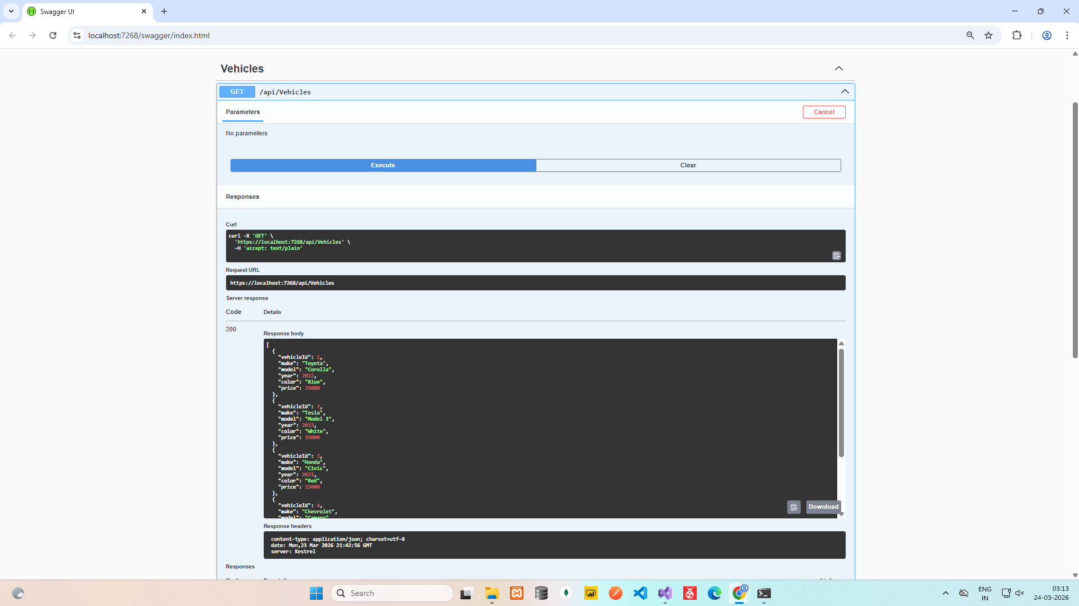
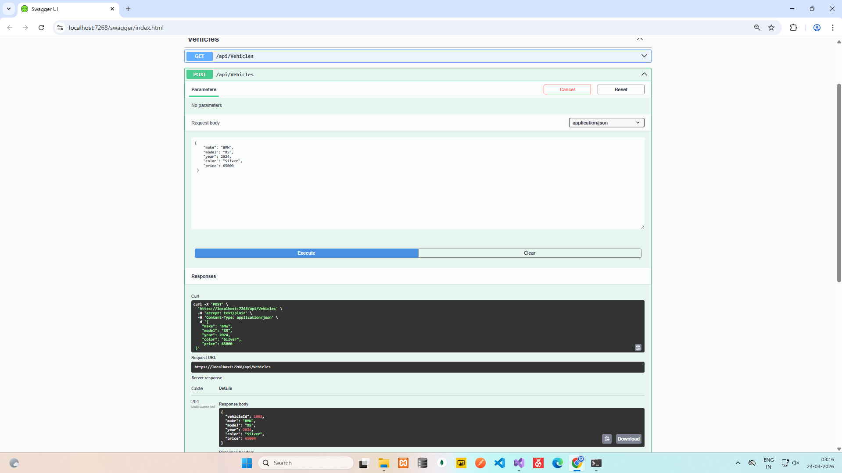
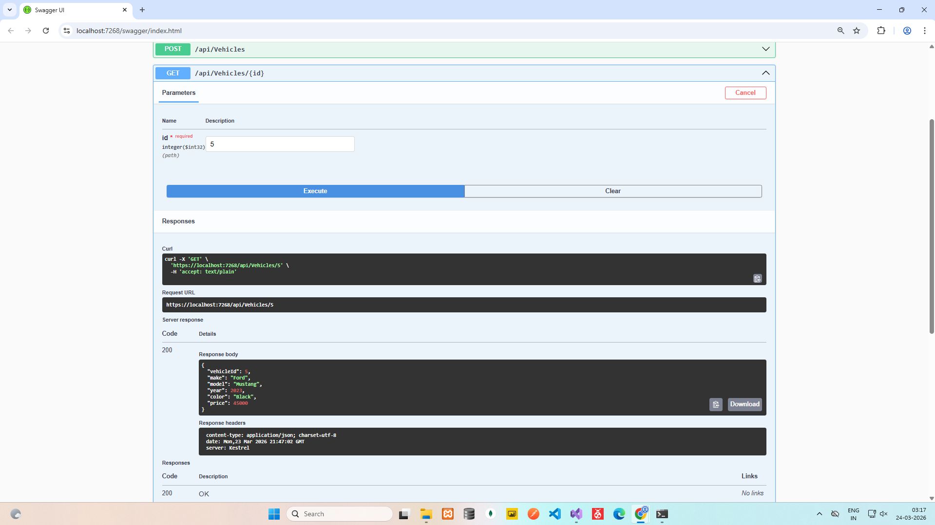

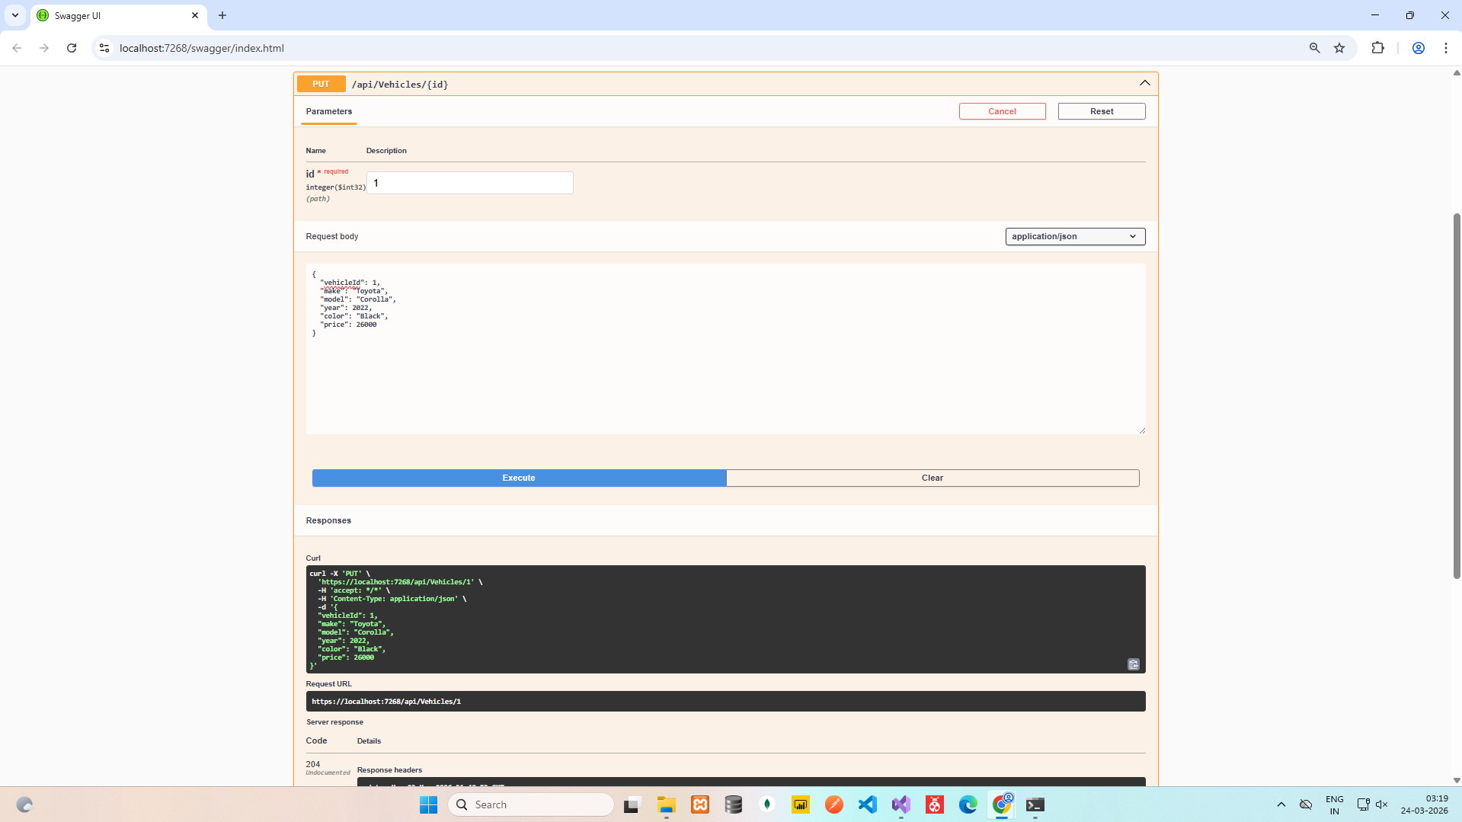
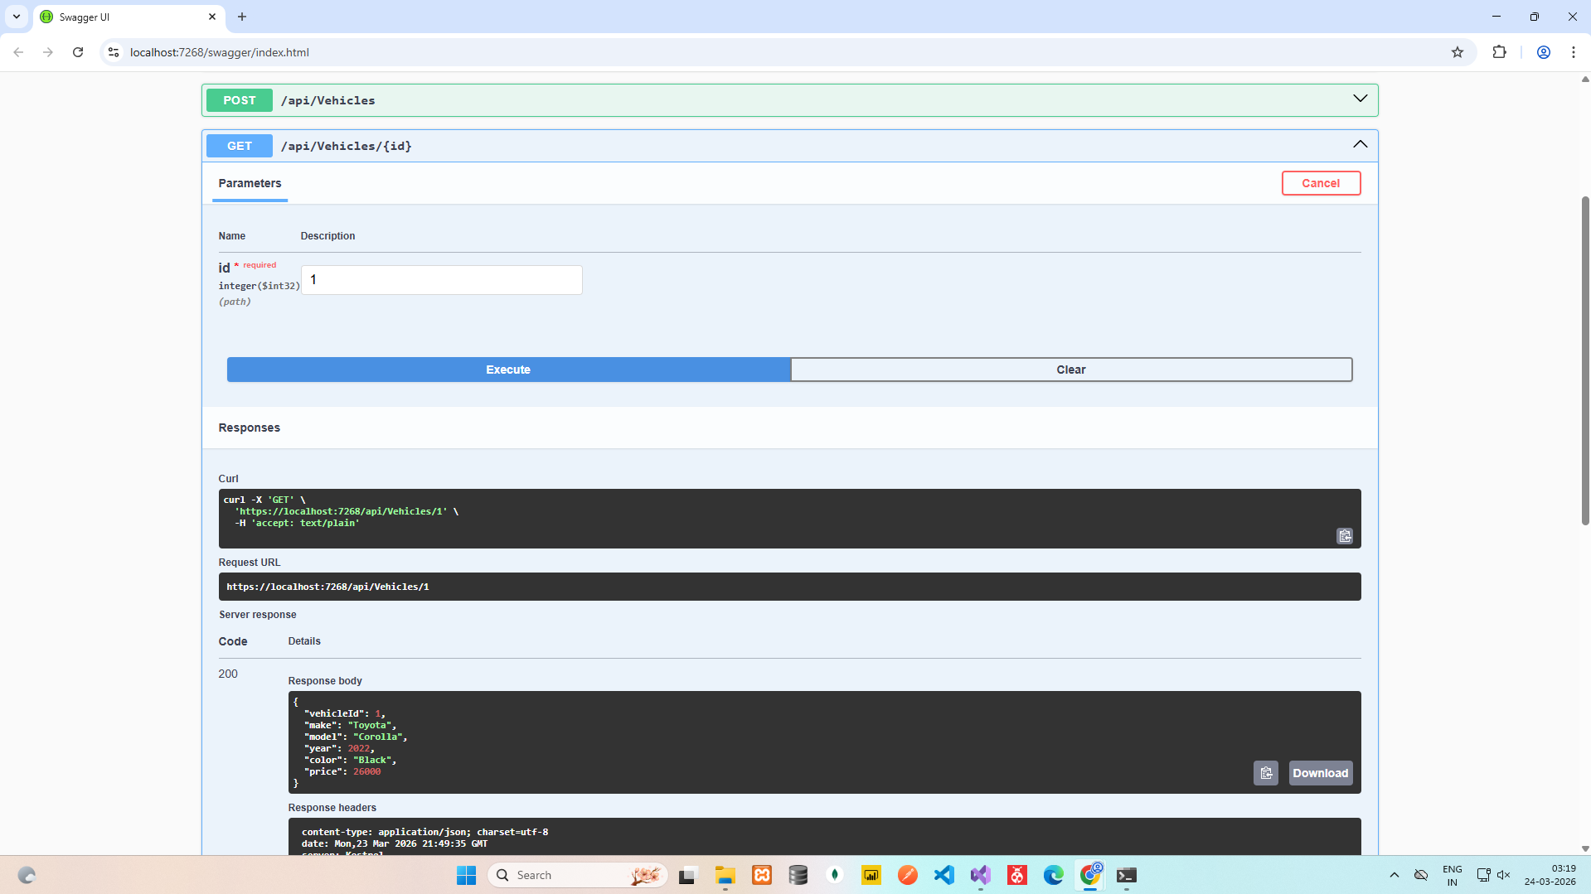
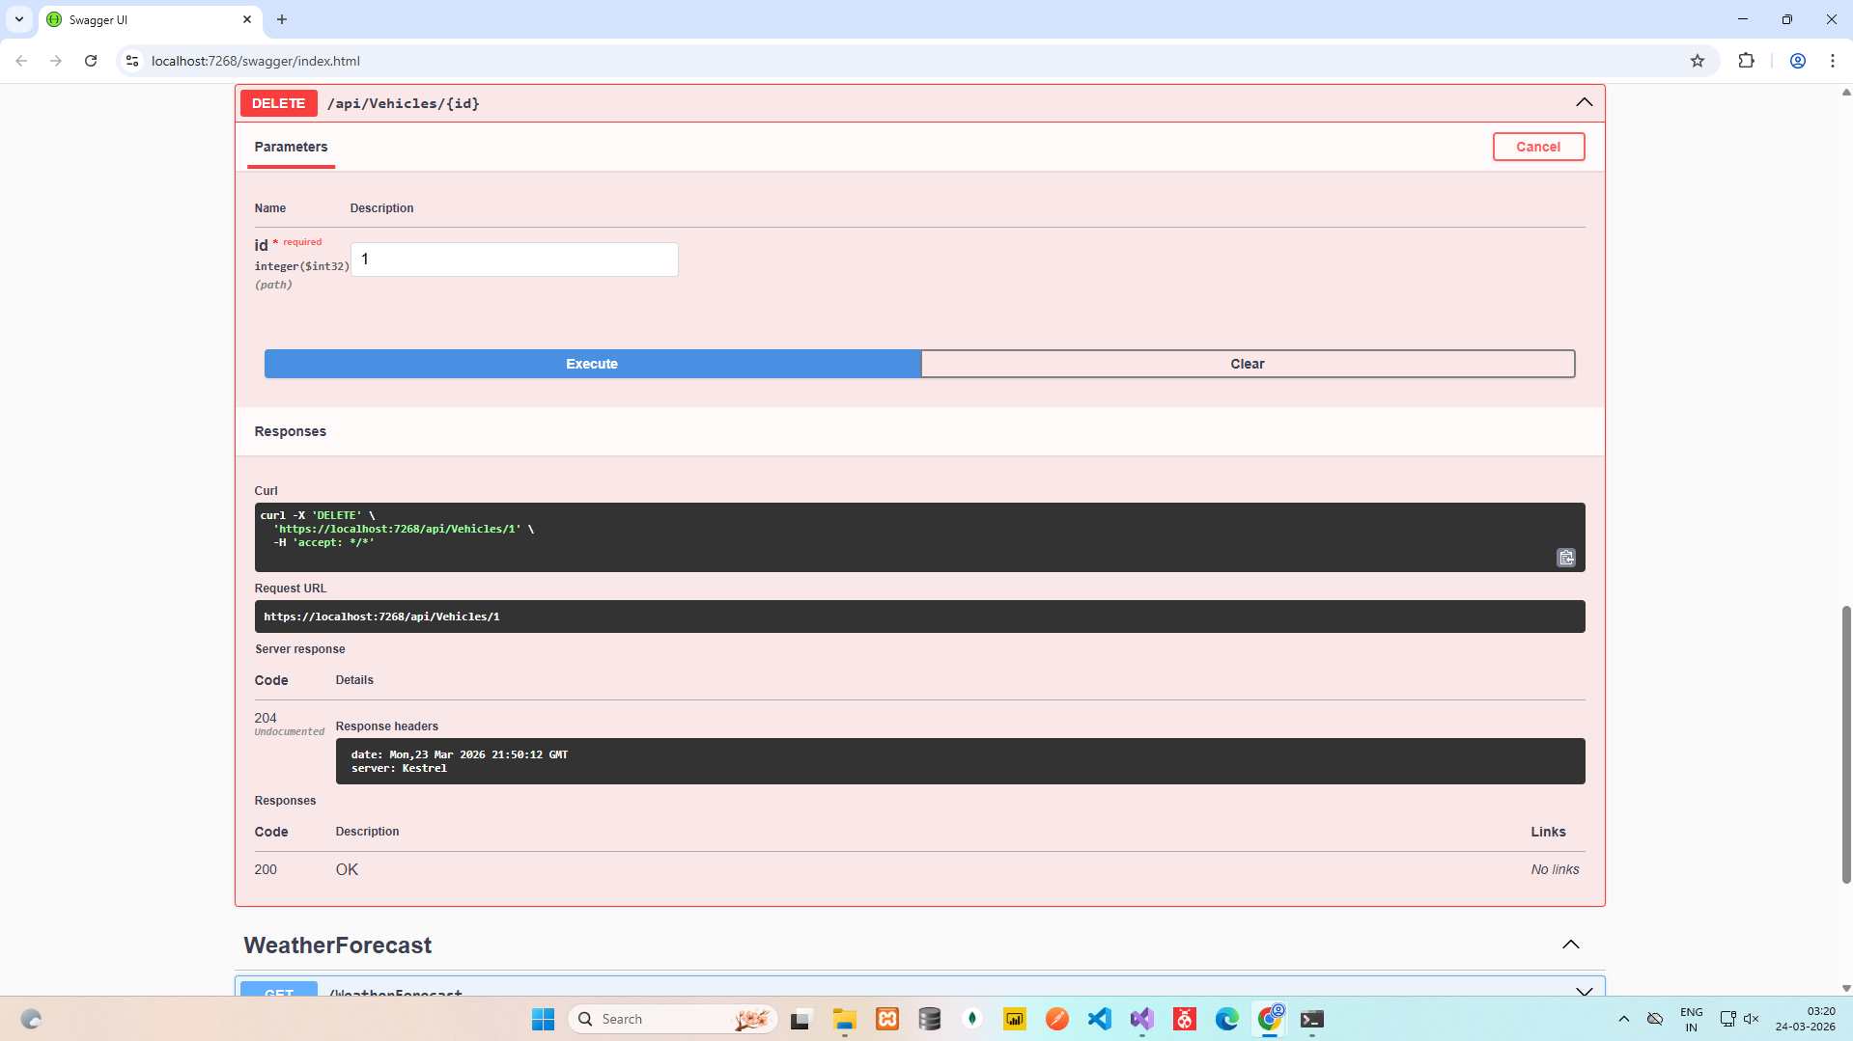
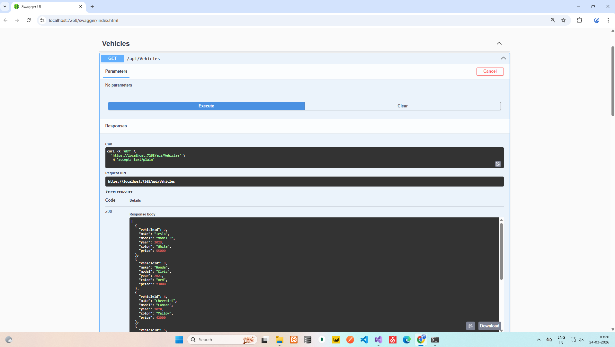

Assignment - 3 -> Q - 3

CreateIdentitySchema.cs

using System;
using Microsoft.EntityFrameworkCore.Metadata;
using Microsoft.EntityFrameworkCore.Migrations;

namespace Assignment_3_3.Data.Migrations
{
public partial class CreateIdentitySchema : Migration
{
protected override void Up(MigrationBuilder migrationBuilder)
{
migrationBuilder.CreateTable(
name: "AspNetRoles",
columns: table => new
{
Id = table.Column<string>(nullable: false),
Name = table.Column<string>(maxLength: 256, nullable: true),
NormalizedName = table.Column<string>(maxLength: 256, nullable: true),
ConcurrencyStamp = table.Column<string>(nullable: true)
},
constraints: table =>
{
table.PrimaryKey("PK_AspNetRoles", x => x.Id);
});

migrationBuilder.CreateTable(
name: "AspNetUsers",
columns: table => new
{
Id = table.Column<string>(nullable: false),
UserName = table.Column<string>(maxLength: 256, nullable: true),
NormalizedUserName = table.Column<string>(maxLength: 256, nullable: true),
Email = table.Column<string>(maxLength: 256, nullable: true),
NormalizedEmail = table.Column<string>(maxLength: 256, nullable: true),
EmailConfirmed = table.Column<bool>(nullable: false),
PasswordHash = table.Column<string>(nullable: true),
SecurityStamp = table.Column<string>(nullable: true),
ConcurrencyStamp = table.Column<string>(nullable: true),
PhoneNumber = table.Column<string>(nullable: true),
PhoneNumberConfirmed = table.Column<bool>(nullable: false),
TwoFactorEnabled = table.Column<bool>(nullable: false),
LockoutEnd = table.Column<DateTimeOffset>(nullable: true),
LockoutEnabled = table.Column<bool>(nullable: false),
AccessFailedCount = table.Column<int>(nullable: false)
},
constraints: table =>
{
table.PrimaryKey("PK_AspNetUsers", x => x.Id);
});

migrationBuilder.CreateTable(
name: "AspNetRoleClaims",
columns: table => new
{
Id = table.Column<int>(nullable: false)
.Annotation("SqlServer:ValueGenerationStrategy", SqlServerValueGenerationStrategy.IdentityColumn),
RoleId = table.Column<string>(nullable: false),
ClaimType = table.Column<string>(nullable: true),
ClaimValue = table.Column<string>(nullable: true)
},
constraints: table =>
{
table.PrimaryKey("PK_AspNetRoleClaims", x => x.Id);
table.ForeignKey(
name: "FK_AspNetRoleClaims_AspNetRoles_RoleId",
column: x => x.RoleId,
principalTable: "AspNetRoles",
principalColumn: "Id",
onDelete: ReferentialAction.Cascade);
});

migrationBuilder.CreateTable(
name: "AspNetUserClaims",
columns: table => new
{
Id = table.Column<int>(nullable: false)
.Annotation("SqlServer:ValueGenerationStrategy", SqlServerValueGenerationStrategy.IdentityColumn),
UserId = table.Column<string>(nullable: false),
ClaimType = table.Column<string>(nullable: true),
ClaimValue = table.Column<string>(nullable: true)
},
constraints: table =>
{
table.PrimaryKey("PK_AspNetUserClaims", x => x.Id);
table.ForeignKey(
name: "FK_AspNetUserClaims_AspNetUsers_UserId",
column: x => x.UserId,
principalTable: "AspNetUsers",
principalColumn: "Id",
onDelete: ReferentialAction.Cascade);
});

migrationBuilder.CreateTable(
name: "AspNetUserLogins",
columns: table => new
{
LoginProvider = table.Column<string>(maxLength: 128, nullable: false),
ProviderKey = table.Column<string>(maxLength: 128, nullable: false),
ProviderDisplayName = table.Column<string>(nullable: true),
UserId = table.Column<string>(nullable: false)
},
constraints: table =>
{
table.PrimaryKey("PK_AspNetUserLogins", x => new { x.LoginProvider, x.ProviderKey });
table.ForeignKey(
name: "FK_AspNetUserLogins_AspNetUsers_UserId",
column: x => x.UserId,
principalTable: "AspNetUsers",
principalColumn: "Id",
onDelete: ReferentialAction.Cascade);
});

migrationBuilder.CreateTable(
name: "AspNetUserRoles",
columns: table => new
{
UserId = table.Column<string>(nullable: false),
RoleId = table.Column<string>(nullable: false)
},
constraints: table =>
{
table.PrimaryKey("PK_AspNetUserRoles", x => new { x.UserId, x.RoleId });
table.ForeignKey(
name: "FK_AspNetUserRoles_AspNetRoles_RoleId",
column: x => x.RoleId,
principalTable: "AspNetRoles",
principalColumn: "Id",
onDelete: ReferentialAction.Cascade);
table.ForeignKey(
name: "FK_AspNetUserRoles_AspNetUsers_UserId",
column: x => x.UserId,
principalTable: "AspNetUsers",
principalColumn: "Id",
onDelete: ReferentialAction.Cascade);
});

migrationBuilder.CreateTable(
name: "AspNetUserTokens",
columns: table => new
{
UserId = table.Column<string>(nullable: false),
LoginProvider = table.Column<string>(maxLength: 128, nullable: false),
Name = table.Column<string>(maxLength: 128, nullable: false),
Value = table.Column<string>(nullable: true)
},
constraints: table =>
{
table.PrimaryKey("PK_AspNetUserTokens", x => new { x.UserId, x.LoginProvider, x.Name });
table.ForeignKey(
name: "FK_AspNetUserTokens_AspNetUsers_UserId",
column: x => x.UserId,
principalTable: "AspNetUsers",
principalColumn: "Id",
onDelete: ReferentialAction.Cascade);
});

migrationBuilder.CreateIndex(
name: "IX_AspNetRoleClaims_RoleId",
table: "AspNetRoleClaims",
column: "RoleId");

migrationBuilder.CreateIndex(
name: "RoleNameIndex",
table: "AspNetRoles",
column: "NormalizedName",
unique: true,
filter: "[NormalizedName] IS NOT NULL");

migrationBuilder.CreateIndex(
name: "IX_AspNetUserClaims_UserId",
table: "AspNetUserClaims",
column: "UserId");

migrationBuilder.CreateIndex(
name: "IX_AspNetUserLogins_UserId",
table: "AspNetUserLogins",
column: "UserId");

migrationBuilder.CreateIndex(
name: "IX_AspNetUserRoles_RoleId",
table: "AspNetUserRoles",
column: "RoleId");

migrationBuilder.CreateIndex(
name: "EmailIndex",
table: "AspNetUsers",
column: "NormalizedEmail");

migrationBuilder.CreateIndex(
name: "UserNameIndex",
table: "AspNetUsers",
column: "NormalizedUserName",
unique: true,
filter: "[NormalizedUserName] IS NOT NULL");
}

protected override void Down(MigrationBuilder migrationBuilder)
{
migrationBuilder.DropTable(
name: "AspNetRoleClaims");

migrationBuilder.DropTable(
name: "AspNetUserClaims");

migrationBuilder.DropTable(
name: "AspNetUserLogins");

migrationBuilder.DropTable(
name: "AspNetUserRoles");

migrationBuilder.DropTable(
name: "AspNetUserTokens");

migrationBuilder.DropTable(
name: "AspNetRoles");

migrationBuilder.DropTable(
name: "AspNetUsers");
}
}
}

ApplicationDbContextModelSnapshot.cs

// <auto-generated />
using System;
using Assignment_3_3.Data;
using Microsoft.EntityFrameworkCore;
using Microsoft.EntityFrameworkCore.Infrastructure;
using Microsoft.EntityFrameworkCore.Metadata;
using Microsoft.EntityFrameworkCore.Storage.ValueConversion;

#nullable disable

namespace Assignment_3_3.Data.Migrations
{
[DbContext(typeof(ApplicationDbContext))]
partial class ApplicationDbContextModelSnapshot : ModelSnapshot
{
protected override void BuildModel(ModelBuilder modelBuilder)
{
#pragma warning disable 612, 618
modelBuilder
.HasAnnotation("ProductVersion", "8.0.23")
.HasAnnotation("Relational:MaxIdentifierLength", 128);

SqlServerModelBuilderExtensions.UseIdentityColumns(modelBuilder);

modelBuilder.Entity("Microsoft.AspNetCore.Identity.IdentityRole", b =>
{
b.Property<string>("Id")
.HasColumnType("nvarchar(450)");

b.Property<string>("ConcurrencyStamp")
.IsConcurrencyToken()
.HasColumnType("nvarchar(max)");

b.Property<string>("Name")
.HasMaxLength(256)
.HasColumnType("nvarchar(256)");

b.Property<string>("NormalizedName")
.HasMaxLength(256)
.HasColumnType("nvarchar(256)");

b.HasKey("Id");

b.HasIndex("NormalizedName")
.IsUnique()
.HasDatabaseName("RoleNameIndex")
.HasFilter("[NormalizedName] IS NOT NULL");

b.ToTable("AspNetRoles", (string)null);
});

modelBuilder.Entity("Microsoft.AspNetCore.Identity.IdentityRoleClaim<string>", b =>
{
b.Property<int>("Id")
.ValueGeneratedOnAdd()
.HasColumnType("int");

SqlServerPropertyBuilderExtensions.UseIdentityColumn(b.Property<int>("Id"));

b.Property<string>("ClaimType")
.HasColumnType("nvarchar(max)");

b.Property<string>("ClaimValue")
.HasColumnType("nvarchar(max)");

b.Property<string>("RoleId")
.IsRequired()
.HasColumnType("nvarchar(450)");

b.HasKey("Id");

b.HasIndex("RoleId");

b.ToTable("AspNetRoleClaims", (string)null);
});

modelBuilder.Entity("Microsoft.AspNetCore.Identity.IdentityUser", b =>
{
b.Property<string>("Id")
.HasColumnType("nvarchar(450)");

b.Property<int>("AccessFailedCount")
.HasColumnType("int");

b.Property<string>("ConcurrencyStamp")
.IsConcurrencyToken()
.HasColumnType("nvarchar(max)");

b.Property<string>("Email")
.HasMaxLength(256)
.HasColumnType("nvarchar(256)");

b.Property<bool>("EmailConfirmed")
.HasColumnType("bit");

b.Property<bool>("LockoutEnabled")
.HasColumnType("bit");

b.Property<DateTimeOffset?>("LockoutEnd")
.HasColumnType("datetimeoffset");

b.Property<string>("NormalizedEmail")
.HasMaxLength(256)
.HasColumnType("nvarchar(256)");

b.Property<string>("NormalizedUserName")
.HasMaxLength(256)
.HasColumnType("nvarchar(256)");

b.Property<string>("PasswordHash")
.HasColumnType("nvarchar(max)");

b.Property<string>("PhoneNumber")
.HasColumnType("nvarchar(max)");

b.Property<bool>("PhoneNumberConfirmed")
.HasColumnType("bit");

b.Property<string>("SecurityStamp")
.HasColumnType("nvarchar(max)");

b.Property<bool>("TwoFactorEnabled")
.HasColumnType("bit");

b.Property<string>("UserName")
.HasMaxLength(256)
.HasColumnType("nvarchar(256)");

b.HasKey("Id");

b.HasIndex("NormalizedEmail")
.HasDatabaseName("EmailIndex");

b.HasIndex("NormalizedUserName")
.IsUnique()
.HasDatabaseName("UserNameIndex")
.HasFilter("[NormalizedUserName] IS NOT NULL");

b.ToTable("AspNetUsers", (string)null);
});

modelBuilder.Entity("Microsoft.AspNetCore.Identity.IdentityUserClaim<string>", b =>
{
b.Property<int>("Id")
.ValueGeneratedOnAdd()
.HasColumnType("int");

SqlServerPropertyBuilderExtensions.UseIdentityColumn(b.Property<int>("Id"));

b.Property<string>("ClaimType")
.HasColumnType("nvarchar(max)");

b.Property<string>("ClaimValue")
.HasColumnType("nvarchar(max)");

b.Property<string>("UserId")
.IsRequired()
.HasColumnType("nvarchar(450)");

b.HasKey("Id");

b.HasIndex("UserId");

b.ToTable("AspNetUserClaims", (string)null);
});

modelBuilder.Entity("Microsoft.AspNetCore.Identity.IdentityUserLogin<string>", b =>
{
b.Property<string>("LoginProvider")
.HasMaxLength(128)
.HasColumnType("nvarchar(128)");

b.Property<string>("ProviderKey")
.HasMaxLength(128)
.HasColumnType("nvarchar(128)");

b.Property<string>("ProviderDisplayName")
.HasColumnType("nvarchar(max)");

b.Property<string>("UserId")
.IsRequired()
.HasColumnType("nvarchar(450)");

b.HasKey("LoginProvider", "ProviderKey");

b.HasIndex("UserId");

b.ToTable("AspNetUserLogins", (string)null);
});

modelBuilder.Entity("Microsoft.AspNetCore.Identity.IdentityUserRole<string>", b =>
{
b.Property<string>("UserId")
.HasColumnType("nvarchar(450)");

b.Property<string>("RoleId")
.HasColumnType("nvarchar(450)");

b.HasKey("UserId", "RoleId");

b.HasIndex("RoleId");

b.ToTable("AspNetUserRoles", (string)null);
});

modelBuilder.Entity("Microsoft.AspNetCore.Identity.IdentityUserToken<string>", b =>
{
b.Property<string>("UserId")
.HasColumnType("nvarchar(450)");

b.Property<string>("LoginProvider")
.HasMaxLength(128)
.HasColumnType("nvarchar(128)");

b.Property<string>("Name")
.HasMaxLength(128)
.HasColumnType("nvarchar(128)");

b.Property<string>("Value")
.HasColumnType("nvarchar(max)");

b.HasKey("UserId", "LoginProvider", "Name");

b.ToTable("AspNetUserTokens", (string)null);
});

modelBuilder.Entity("Microsoft.AspNetCore.Identity.IdentityRoleClaim<string>", b =>
{
b.HasOne("Microsoft.AspNetCore.Identity.IdentityRole", null)
.WithMany()
.HasForeignKey("RoleId")
.OnDelete(DeleteBehavior.Cascade)
.IsRequired();
});

modelBuilder.Entity("Microsoft.AspNetCore.Identity.IdentityUserClaim<string>", b =>
{
b.HasOne("Microsoft.AspNetCore.Identity.IdentityUser", null)
.WithMany()
.HasForeignKey("UserId")
.OnDelete(DeleteBehavior.Cascade)
.IsRequired();
});

modelBuilder.Entity("Microsoft.AspNetCore.Identity.IdentityUserLogin<string>", b =>
{
b.HasOne("Microsoft.AspNetCore.Identity.IdentityUser", null)
.WithMany()
.HasForeignKey("UserId")
.OnDelete(DeleteBehavior.Cascade)
.IsRequired();
});

modelBuilder.Entity("Microsoft.AspNetCore.Identity.IdentityUserRole<string>", b =>
{
b.HasOne("Microsoft.AspNetCore.Identity.IdentityRole", null)
.WithMany()
.HasForeignKey("RoleId")
.OnDelete(DeleteBehavior.Cascade)
.IsRequired();

b.HasOne("Microsoft.AspNetCore.Identity.IdentityUser", null)
.WithMany()
.HasForeignKey("UserId")
.OnDelete(DeleteBehavior.Cascade)
.IsRequired();
});

modelBuilder.Entity("Microsoft.AspNetCore.Identity.IdentityUserToken<string>", b =>
{
b.HasOne("Microsoft.AspNetCore.Identity.IdentityUser", null)
.WithMany()
.HasForeignKey("UserId")
.OnDelete(DeleteBehavior.Cascade)
.IsRequired();
});
#pragma warning restore 612, 618
}
}
}

OUTPUT

