Name : Bhaliya Dhruvisha Ashokbhai
Roll No : 54
Course : MSC.ICT
Sem – 1
Subject : Frontend Development with React Js
Practical Assignment – 4

- Assignment-4\task_manager\src\components\TaskForm.jsx :-

import React, { useState } from 'react'

const TaskForm = ({ addTask }) => {
const [taskName, setTaskName] = useState('')

const handleSubmit = (e) => {
e.preventDefault()
addTask(taskName)
setTaskName('')
}

return (
<form className="task-form" onSubmit={handleSubmit}>
<input
type="text"
placeholder="Enter a new task..."
value={taskName}
onChange={(e) => setTaskName(e.target.value)}
/>
<button type="submit" disabled={!taskName.trim()}>
Add Task
</button>
</form>
)
}

export default TaskForm;

- Assignment-4\task_manager\src\components\TaskItem.jsx :-

import React from 'react'

const TaskItem = ({ task, deleteTask, toggleTask }) => {
return (
<div className={`task-item ${task.completed ? 'completed' : ''}`}>
<div className="left-section">
<input
type="checkbox"
checked={task.completed}
onChange={() => toggleTask(task.id)}
/>
<span className="task-name" onClick={() => toggleTask(task.id)}>
{task.name}
</span>
</div>
<button className="delete-btn" onClick={() => deleteTask(task.id)}>
Delete
</button>
</div>
)
}

export default TaskItem;

- Assignment-4\task_manager\src\components\TaskList.jsx :-

import React from 'react'
import TaskItem from './TaskItem'

const TaskList = ({ tasks, deleteTask, toggleTask }) => {
if (tasks.length === 0)
return <div className="no-tasks">No tasks yet. Add one to get started!</div>

return (
<div className="task-list">
{tasks.map((t) => (
<TaskItem
key={t.id}
task={t}
deleteTask={deleteTask}
toggleTask={toggleTask}
/>
))}
</div>
)
}

export default TaskList;

- Assignment-4\task_manager\src\components\TaskManager.jsx :-

import React, { useState } from 'react'
import TaskForm from './TaskForm'
import TaskList from './TaskList'

const TaskManager = () => {
const [tasks, setTasks] = useState([])
const [nextId, setNextId] = useState(1)

const addTask = (name) => {
if (!name.trim()) return
const newTask = { id: nextId, name: name.trim(), completed: false }
setTasks([...tasks, newTask])
setNextId(nextId + 1)
}

const deleteTask = (id) => {
setTasks(tasks.filter((t) => t.id !== id))
}

const toggleTask = (id) => {
setTasks(
tasks.map((t) => (t.id === id ? { ...t, completed: !t.completed } : t))
)
}

return (
<div className="task-manager">
<h1 className="app-title">Task Manager</h1>
<TaskForm addTask={addTask} />
<TaskList tasks={tasks} deleteTask={deleteTask} toggleTask={toggleTask} />
</div>
)
}

export default TaskManager;

- Assignment-4\task_manager\src\App.css :-

body {
margin: 0;
font-family: 'Poppins', sans-serif;
background: linear-gradient(135deg, #eef2f3, #dfe9f3);
display: flex;
justify-content: center;
align-items: flex-start;
min-height: 100vh;
}

.app-container {
width: 100%;
max-width: 700px;
margin: 60px 20px;
}

.task-manager {
background: #ffffff;
border-radius: 20px;
box-shadow: 0 10px 25px rgba(0, 0, 0, 0.08);
padding: 40px 45px;
transition: all 0.3s ease;
}

.app-title {
text-align: center;
font-size: 2rem;
font-weight: 700;
color: #1f2937;
margin-bottom: 30px;
}

.task-form {
display: flex;
gap: 12px;
margin-bottom: 25px;
}

.task-form input {
flex-grow: 1;
padding: 14px 16px;
border: 2px solid #d1d5db;
border-radius: 12px;
font-size: 16px;
transition: all 0.3s ease;
}

.task-form input:focus {
border-color: #2563eb;
box-shadow: 0 0 0 3px rgba(37, 99, 235, 0.15);
outline: none;
}

.task-form button {
padding: 14px 20px;
background: #2563eb;
color: #fff;
font-weight: 600;
border: none;
border-radius: 12px;
cursor: pointer;
font-size: 15px;
transition: all 0.3s ease;
}

.task-form button:disabled {
background: #a5b4fc;
cursor: not-allowed;
}

.task-form button:hover:not(:disabled) {
background: #1d4ed8;
transform: scale(1.04);
}

.task-list {
display: flex;
flex-direction: column;
gap: 12px;
}

.no-tasks {
text-align: center;
padding: 20px;
font-size: 1.05em;
color: #6b7280;
background: #f3f4f6;
border-radius: 12px;
}

.task-item {
display: flex;
justify-content: space-between;
align-items: center;
background: #fafafa;
border: 1px solid #e5e7eb;
border-left: 5px solid #2563eb;
padding: 14px 18px;
border-radius: 12px;
transition: all 0.3s ease;
}

.task-item:hover {
background: #f5faff;
box-shadow: 0 2px 8px rgba(0, 0, 0, 0.05);
}

.task-item.completed {
border-left-color: #16a34a;
background: #f0fdf4;
}

.task-item.completed .task-name {
text-decoration: line-through;
color: #6b7280;
}

.left-section {
display: flex;
align-items: center;
gap: 10px;
}

.task-name {
font-size: 1.05em;
color: #111827;
cursor: pointer;
}

.delete-btn {
background-color: #ef4444;
color: #fff;
border: none;
border-radius: 10px;
padding: 8px 14px;
font-size: 14px;
font-weight: 500;
cursor: pointer;
transition: all 0.3s ease;
}

.delete-btn:hover {
background-color: #dc2626;
transform: scale(1.05);
}

- Assignment-4\task_manager\src\App.jsx :-

import React from 'react'
import TaskManager from './components/TaskManager'
import './App.css'

function App() {
return (
<div className="app-container">
<TaskManager />
</div>
)
}

export default App;

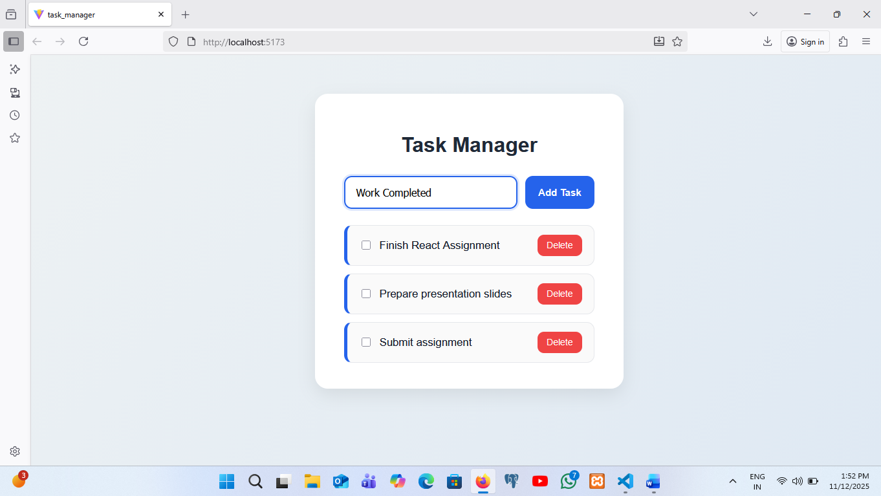
OUTPUT :-
