**Name : Dhruvit Savaliya**

● Write SQL query to solve the problem given below

* Country table :

CREATE TABLE Countries (

id INT PRIMARY KEY,

country_name VARCHAR(100) NOT NULL,

country_name_eng VARCHAR(100) NOT NULL,

country_code CHAR(3) NOT NULL

);

INSERT INTO Countries (id, country_name, country_name_eng, country_code) VALUES

(1, 'Deutschland', 'Germany', 'DEU'),

(2, 'Srbija', 'Serbia', 'SRB'),

(3, 'Hrvatska', 'Croatia', 'HRV'),

(4, 'United States of America', 'United States of America', 'USA'),

(5, 'Polska', 'Poland', 'POL'),

(6, 'España', 'Spain', 'ESP'),

(7, 'Rossiya', 'Russia', 'RUS');

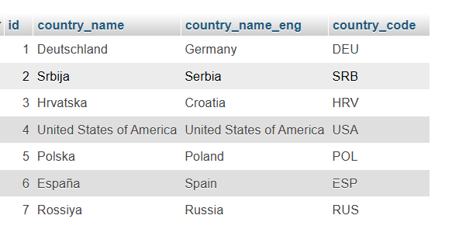

* city table :

CREATE TABLE Cities (

id INT PRIMARY KEY,

city_name VARCHAR(50) NOT NULL,

lat DECIMAL(10, 6),

long1 DECIMAL(10, 6),

country_id INT,

FOREIGN KEY(country_id) REFERENCES countries(id)

);

INSERT INTO Cities (id, city_name, lat, long1, country_id) VALUES

(1, 'Berlin', 52.520008, 13.404954, 1),

(2, 'Belgrade', 44.787197, 20.457273, 2),

(3, 'Zagreb', 45.815399, 15.966568, 3),

(4, 'New York', 40.730610, -73.935242, 4),

(5, 'Los Angeles', 34.052235, -118.243683, 4),

(6, 'Warsaw', 52.237049, 21.017532, 5);

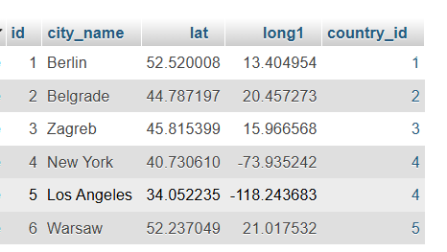

* Customer table :

CREATE TABLE Customers (

id INT PRIMARY KEY,

customer_name VARCHAR(100) NOT NULL,

city_id INT NOT NULL,

customer_address VARCHAR(255),

next_call_date DATE,

ts_inserted DATETIME,

FOREIGN KEY(city_id) REFERENCES cities(id)

);

INSERT INTO Customers (id, customer_name, city_id, customer_address, next_call_date, ts_inserted) VALUES

(1, 'Jewelry Store', 4, 'Long Street 120', '2020-01-21', '2020-01-09 14:01:20.000'),

(2, 'Bakery', 1, 'Kurfürstendamm 25', '2020-02-21', '2020-01-09 17:52:15.000'),

(3, 'Café', 1, 'Tauentzienstraße 44', '2020-01-21', '2020-01-10 08:02:49.000'),

(4, 'Restaurant', 3, 'Ulica lipa 15', '2020-01-21', '2020-01-10 09:20:21.000');

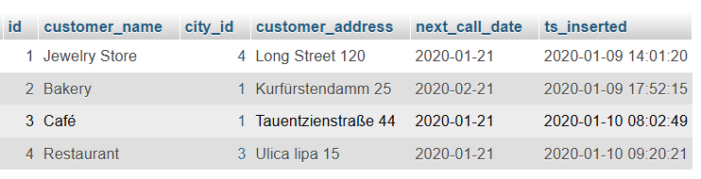

**Task : 1** (join multiple tables using left join)

* List all Countries and customers related to these countries.

SELECT

Countries.id AS country_id,

Countries.country_name,

Countries.country_name_eng,

Countries.country_code,

Customers.id AS customer_id,

Customers.customer_name,

Customers.customer_address,

Customers.next_call_date,

Customers.ts_inserted

FROM

Countries

LEFT JOIN

Cities ON Countries.id = Cities.country_id

LEFT JOIN

Customers ON Cities.id = Customers.city_id;

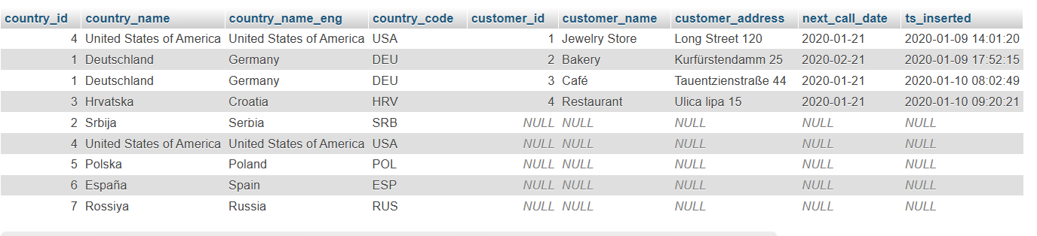

* For each country displaying its name in English, the name of the city customer is located in as well as the name of the customer.

SELECT

Countries.country_name_eng AS country_name,

Cities.city_name AS city_name,

Customers.customer_name AS customer_name

FROM

Countries

LEFT JOIN

Cities ON Countries.id = Cities.country_id

LEFT JOIN

Customers ON Cities.id = Customers.city_id;

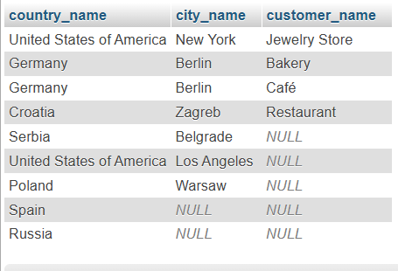

* Return even countries without related cities and customers.

SELECT

Countries.country_name_eng AS country_name,

Cities.city_name AS city_name,

Customers.customer_name AS customer_name

FROM

Countries

LEFT JOIN

Cities ON Countries.id = Cities.country_id

LEFT JOIN

Customers ON Cities.id = Customers.city_id;

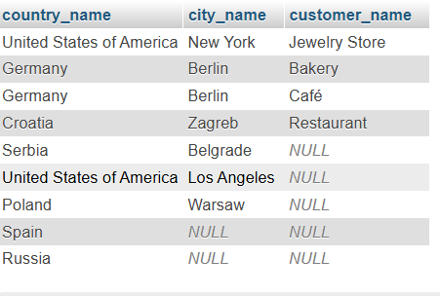

**Task : 2** (join multiple tables using both left and inner join)

* Return the list of all countries that have pairs(exclude countries which are not referenced by any city). For such pairs return all customers.

SELECT

Countries.country_name_eng AS country_name,

Cities.city_name AS city_name,

Customers.customer_name AS customer_name

FROM

Countries

INNER JOIN

Cities ON Countries.id = Cities.country_id

LEFT JOIN

Customers ON Cities.id = Customers.city_id;

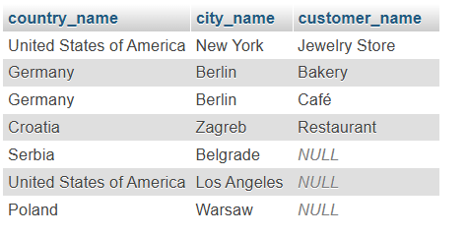

* Return even pairs of not having a single customer

SELECT

Countries.country_name_eng AS country_name,

Cities.city_name AS city_name,

Customers.customer_name AS customer_name

FROM

Countries

INNER JOIN

Cities ON Countries.id = Cities.country_id

LEFT JOIN

Customers ON Cities.id = Customers.city_id;

