**Name : Dhruvit Savaliya**

**MODULE: 1**

**Software Engineering**

1. **What is software? What is software engineering?**

* **What is software :**
* A set of instrusctions used to provide a specific output to reduce human efforts**.**
* Software is nothing but set of instractions or set of program are known as software
* Software is that part of a computer,which cannot be touched.
* Software tell a computer what to do and how to do it.
* **What is software engineering :**
* Software can be developed by following some set of rules, the process is called SE.
* Software engineering is the branch of computer science that deals with the design, development, testing, and maintenance of software applications.
* Software engineers apply engineering principles and knowledge of programming languages to build software solutions for end users.
* Software engineering is a technique through which we can developed or created software for computer systems and any other electronic devices.
* In other words,Software engineering is a process in which user heeds are analyzed and software is designed based on there heeds.

1. **Explain types of software**

* **System Software :**
* System software is a software designed to provide a platform to other software.
* System software control and manage the operations of computer hardware.
* E.X. Operating System (Windows,Android,linux etc.)
* Types of System software :
* Operating System : Computer memory,CPU,Printer
* Language Processor : Java,C,C++,Python
* Device Driver : device driver,Modem
* **Application Software :**
* The software that helps you to do a specific type of works is called application softaware.
* E.X. Ms word,Excel etc.
* Types of System software :
* General Purpose Software : MS-Word,MS-Excel
* Customized Software: railway reservation system
* Utility Software : disk fragmenter,memory tester,disk repair

1. **What is SDLC? Explain each phase of SDLC**

* A step by step approach to develop any software/product within the time and within the budget by high quality product.
* The software development lifecycle (SDLC) is the cost-effective and time-efficient process that development teams use to design and build high-quality software.
* Here are some benefits of SDLC:
* Increased visibility of the development process for all stakeholders involved
* Efficient estimation, planning, and scheduling
* Improved risk management and cost estimation
* Systematic software delivery and better customer satisfaction

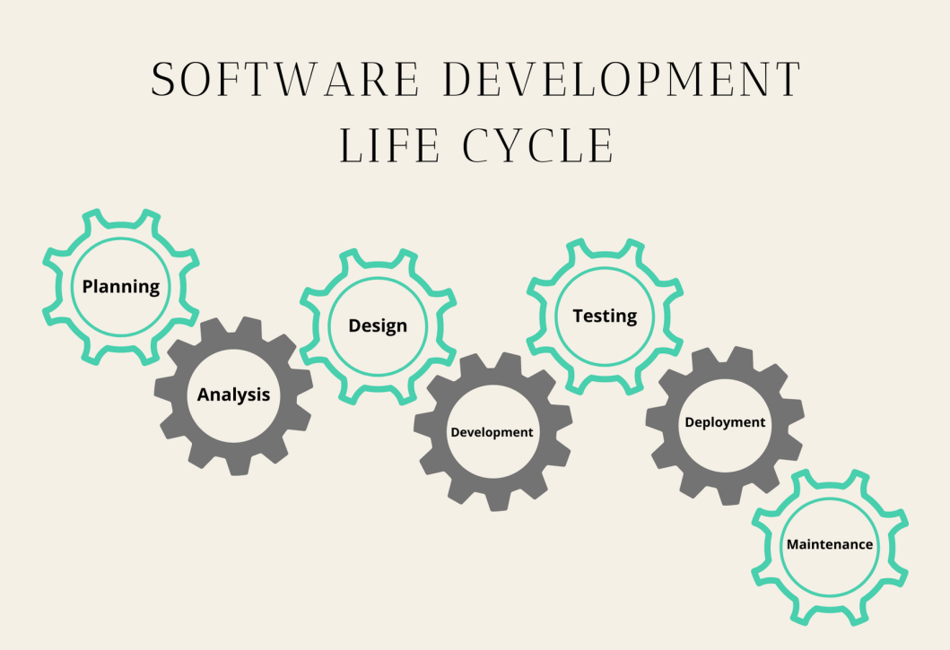

1. **Planning / Requirement Gathering :**

* In the planning phase, project goals are determined and a high-level plan for the intended project is established.
* Planning is the most fundamental and critical organizational phase.
* The three primary activities involved in the planning phase are i. Identification of the system for development ii. Feasibility assessment iii. Creation of project plan

1. **Analysis :**

* In the analysis phase, end-user business requirements are analyzed and project goals converted into the defined system functions that the organization intends to develop.
* The three primary activities involved in the analysis phase are i. Gathering business requirements ii. Creating process diagrams iii. Performing a detailed analysis.

1. **Design :**

* In the design phase, we describe the desired features and operations of the system.
* This phase includes business rules, pseudo-code, screen layouts, and other necessary documentation.
* E.x. DFD, ER-Diagram, Flowchart, Usecase

1. **Implementation :**

* In the development phase, the transformation of all the documents from the previous phase into the actual system.
* coding/building
* E.x. hardware/software

1. **Testing :**

* In the testing phase, all the pieces of code are integrated and deployed in the testing environment.
* To check the errors, bugs, and defects testers follow software testing life cycle activities.
* E.x. QA-QC

1. **Deployment :**

* During this next phase, the system is deployed to a real-life environment where the actual user begins to operate the system.
* All data and components are then placed in the production environment. This phase is also called referred to as ‘delivery.’

1. **Maintenance :**

* To make sure the system continues to work and stay updated to meet the business goals any necessary enhancements, corrections, and changes will be made in the maintenance phase.
* The three primary activities involved in the maintenance phase are i. Support the system users ii System maintenance iii. System changes and adjustment

1. **What is DFD? Create a DFD diagram on Flipkart**

* A data flow diagram is a graphical view of how data is processed in a system in terms of input and output.
* The Data flow diagram contains some symbol for drawing the data flow diagram.
* **0 Level DFD :**

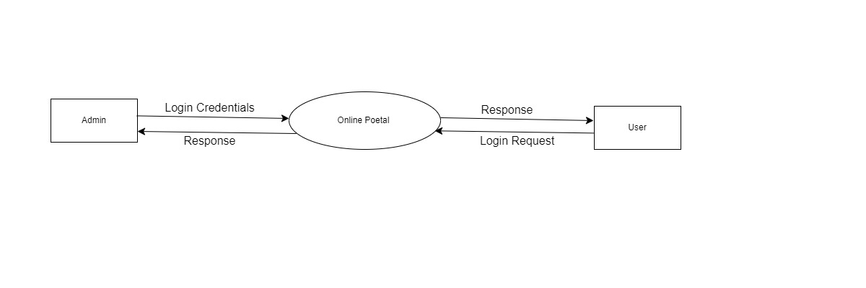

* **1 Level DFD :**

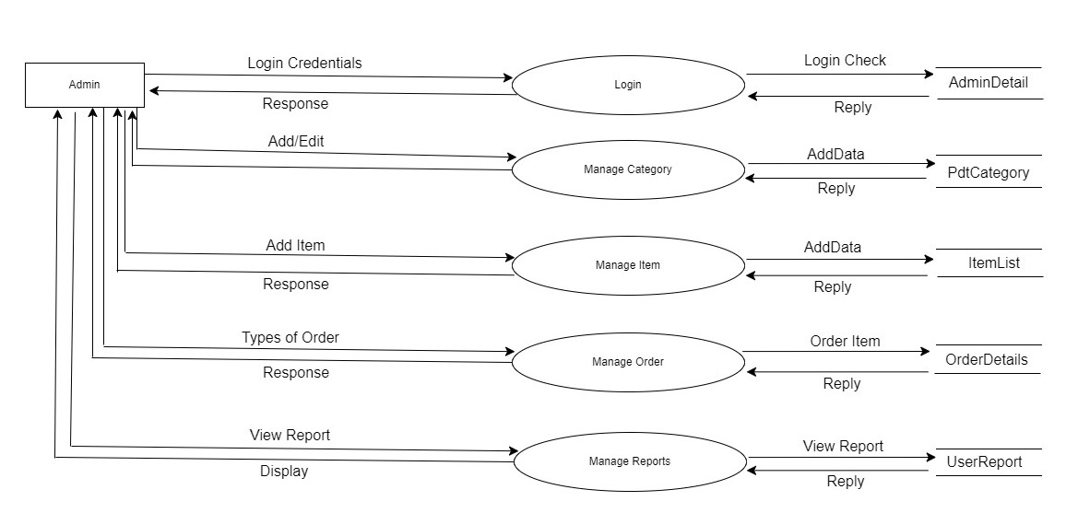

1. **What is Flow chart? Create a flowchart to make addition of two numbers**

* Graphical representation of the problem/program
* A flowchart is a diagram that illustrates the steps, sequences, and decisions of a process or workflow.
* A flowchart is a type of diagram that represents a workflow or process.
* This diagrammatic representation illustrates a solution model to a given problem.
* Flowcharts are used in analyzing, designing, documenting or managing a process or program in various fields.
* **Flowchart :**

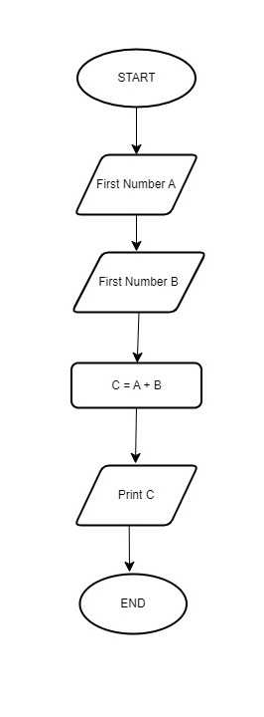

1. **What is Use case Diagram? Create a use-case on bill payment on paytm.**

* A UML use case diagram is the primary form of system/software requirements for a new software program underdeveloped.
* Use cases specify the expected behavior (what), and not the exact method of making it happen.
* Use cases once specified can be denoted both textual and visual representation.
* A key concept of use case modeling is that it helps us design a system from the end user's perspective.
* It is an effective technique for communicating system behavior in the user's terms by specifying all externally visible system behavior.

