

|  |  |  |  |
| --- | --- | --- | --- |
| **Programme** | B.Tech | **Semester** | FIS 2022-2023 |
| **Course** | Design & Analysis of Algorithms | **Code** | BCSE204P |
| **Faculty** | Dr. Dominic Savio M | **Slot** | L3+L4 |

Name: Dhruv Pandey

Reg No. : 21BCE5560

**Lab Assignment 1: Code Implementation**

1. **Matrix Chain Multiplication using Dynamic Programming (Source Code)**

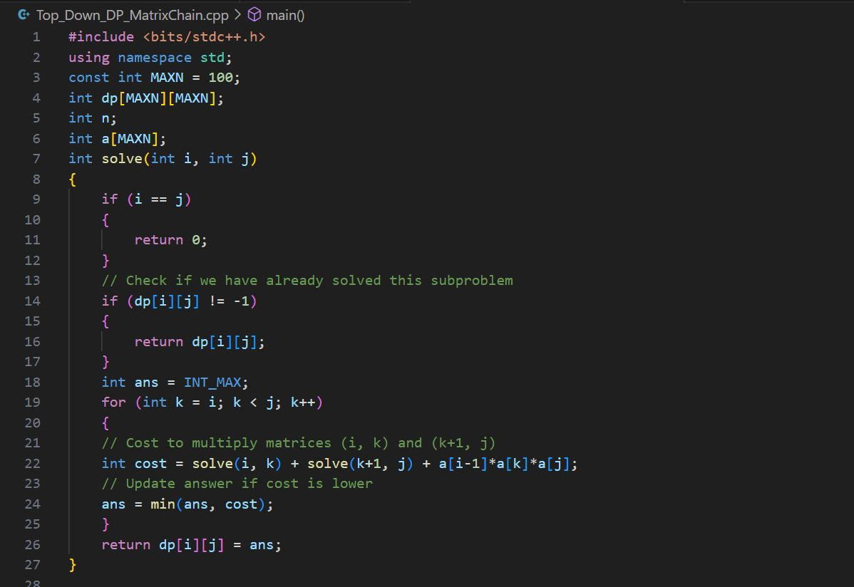

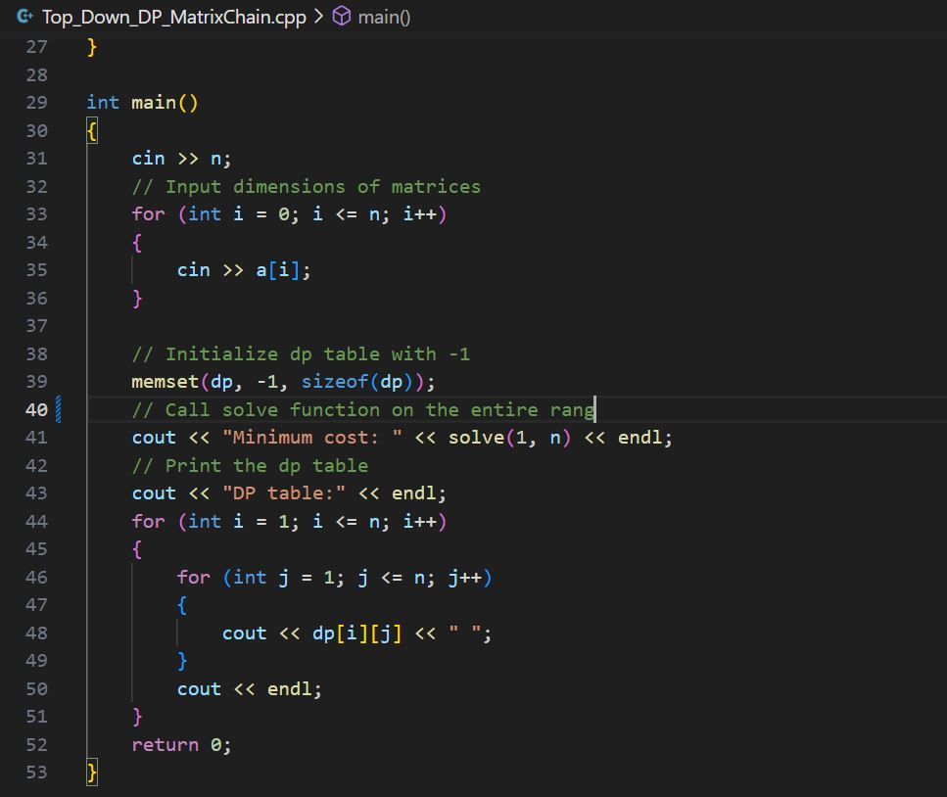

**Output**

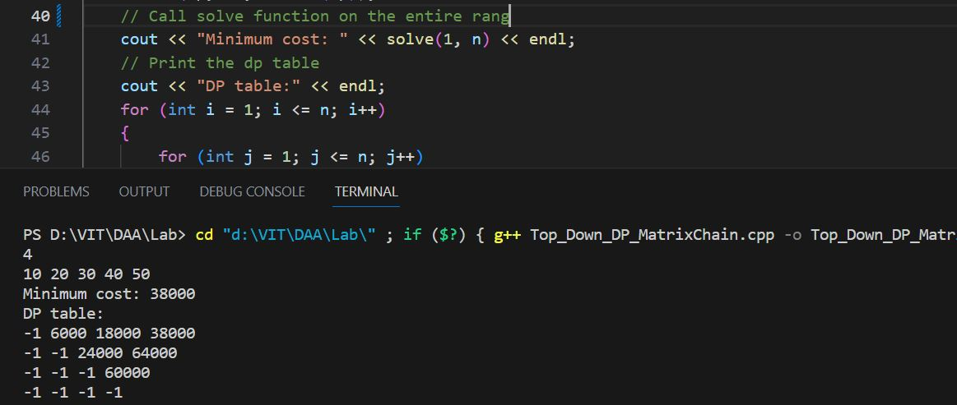

1. **Longest Common Subsequence using Dynamic Programming (Source Code)**