EXTRACTING COMMENTS FROM YOUTUBE FOR A SPECIFIED ACCOUNT USING PYTHON

BAKLIWAL MANAV RUPESH (21BCE5375)

DHRUV PANDEY (21BCE5560)

INTRODUCTION

In the contemporary digital landscape, social media platforms serve as dynamic spaces for communication, information dissemination, and community engagement. YouTube, as one of the most prominent platforms for sharing and consuming video content, harbours a vast ecosystem of creators and viewers. As a computer science student, this project endeavours to harness the power of programming, specifically Python, to extract and analyse comments from YouTube for a specified user account.

The ability to extract comments from YouTube not only provides valuable insights into audience engagement but also offers a means to comprehend the sentiments and opinions surrounding a particular content creator or their videos. By employing Python as the programming language of choice, the project aims to showcase the versatility and effectiveness of scripting for data retrieval and analysis.

The primary focus of this project is to develop a robust and efficient system for extracting comments from YouTube, taking into consideration factors such as API integration, data parsing, and storage. The utilization of Python's extensive libraries, such as `google-api-python-client` for YouTube API access and `pandas` for data manipulation, exemplifies the flexibility and power that the language brings to data-centric tasks.

Through the implementation of this project, we aspire to provide a valuable resource for content creators, researchers, and enthusiasts seeking to gain a deeper understanding of audience interactions on YouTube. The combination of technical skills, data analysis, and an exploration of the YouTube API showcases the interdisciplinary nature of computer science and its applicability in understanding and enhancing online communication platforms.

PROBLEM STATEMENT

Extracting comments from YouTube for a specified account using Python.

FLOWCHART

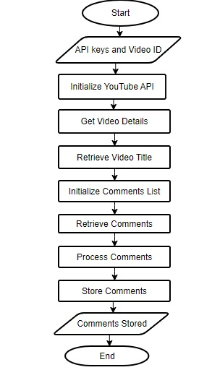

CODE & OUTPUT:

* PULL COMMENTS FROM YOUTUBE VIDEO
* Importing necessary modules from the Google API client library for YouTube Data API

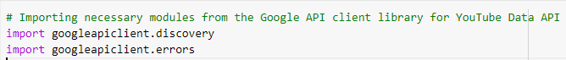

* Setting up the parameters for the YouTube Data API

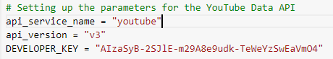

* Building the YouTube API client



* Creating a request to retrieve comment threads for a specific video

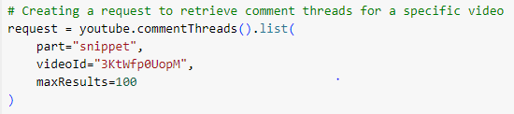

* Executing the request and storing the response



* Iterating through the items in the response and printing the text of each top-level comment



OUTPUT AFTER PULLING COMMENTS FROM VIDEO

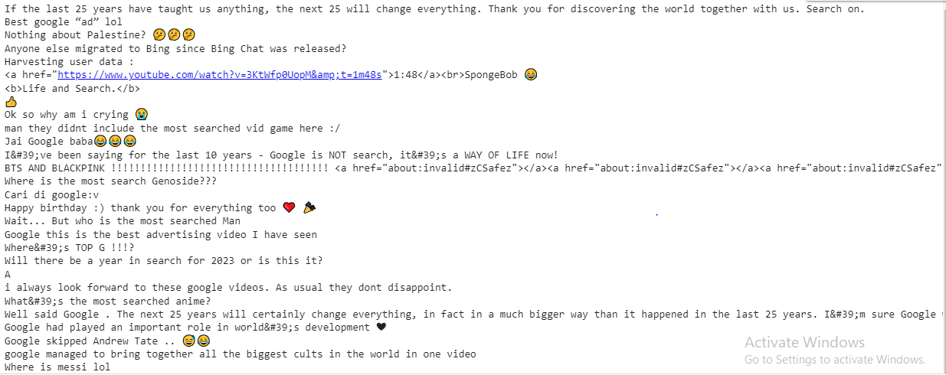

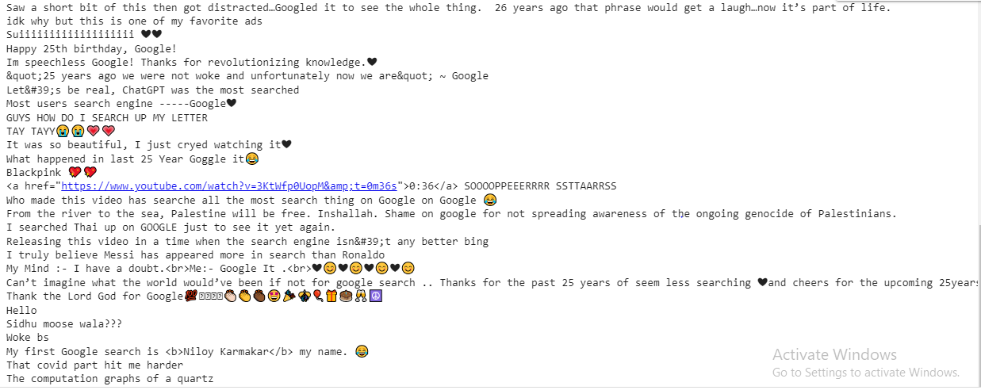

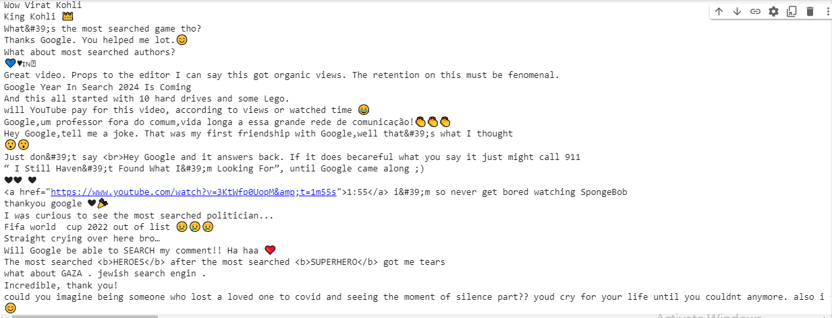

* SAVE DATA AS PANDAS
* Importing necessary modules from the Google API client library for YouTube Data API

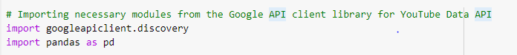

* Setting up the parameters for the YouTube Data API

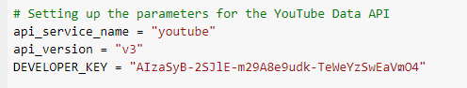

* Building the YouTube API client

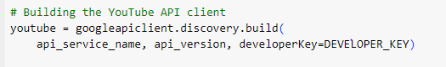

* Creating a request to retrieve comment threads for a specific video

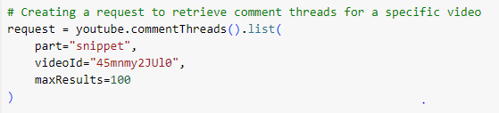

* Executing the request and storing the response



* Creating an empty list to store comment data



* Iterating through the items in the response and extracting relevant comment information

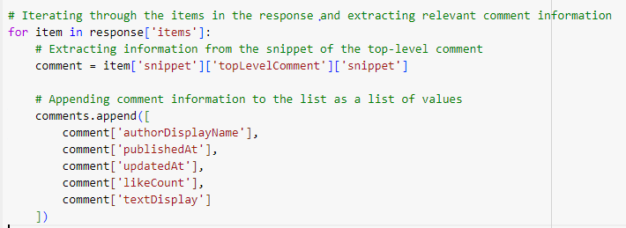

* Creating a Pandas Data Frame from the list of comments



* Displaying the first 20 rows of the Data Frame



OUTPUT FOR SAVING DATA AS PANDAS

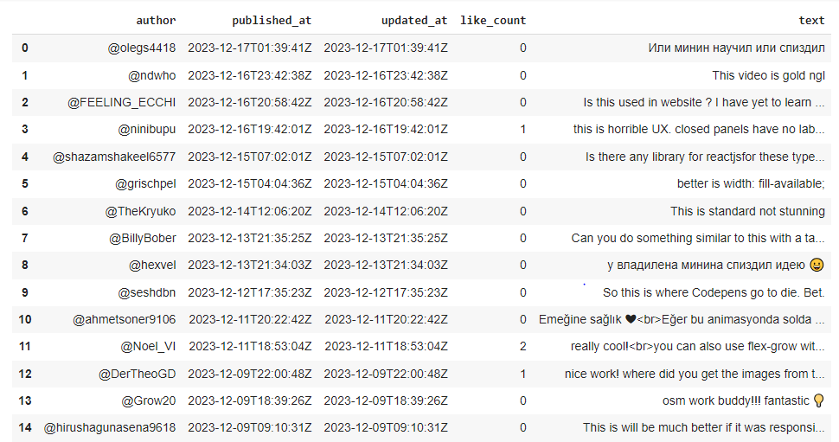

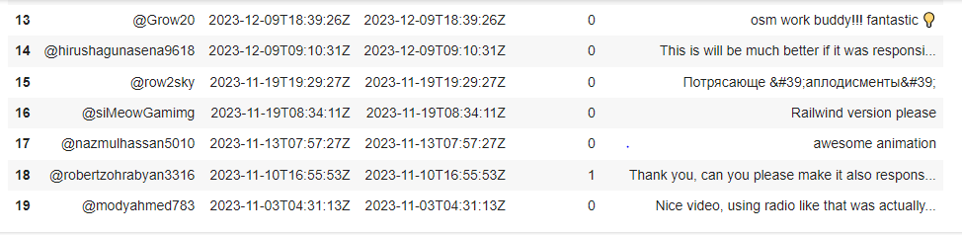

* SORT COMMENTS ON BASIS OF LIKES



OUTPUT FOR SORT COMMENTS ON BASIS OF LIKES

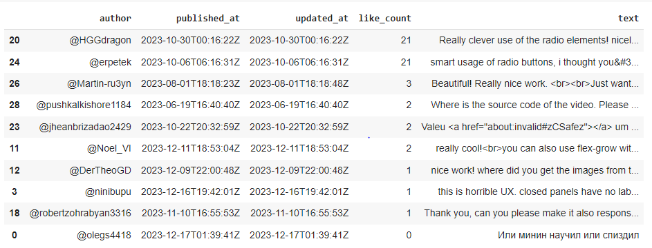

LINK FOR Source CODE AND OUTPUt

[Code Link](https://colab.research.google.com/drive/1oyRKA1Vp4WiQfjzIR1DYrcT1QjpzJjIs?usp=sharing#scrollTo=6U3Eh4lZwYZ-)