**SHRI J. H. BHALODIA WOMEN’S COLLEGE,**

**RAJKOT**

**Industrial Training Report On**

**“Hi-Bond Cement Pvt. Ltd.”**

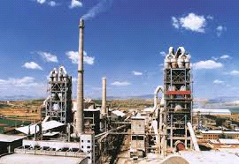

**Prepared by:**

**Soliya Denisha S.**

**B.B.A. Sem. IV**

**Academic Year: 2018-2019**

**Roll No. :75**

**Seat No.:**

**Guided by:**

**Prof. Parul S. Gangani**

**Submitted to:**

**Saurashtra University Rajkot**

**PREFACE**

Practical training is also important aspect in management course. The theoretical knowledge and classroom discussion is not enough for management student. For the knowledge about practical view points, problem, opportunities and situation of industrial unit’s practical studies is necessary.

“Education begins where classroom teaching ends.”

So, this context practical training program during our **academic year 2018-2019.** I have visited **“Hi-Bond Cement Pvt. Ltd.”** and also I have tried to prepare this report with the best of my knowledge and ability.

**ACKNOWLEDGEMENT**

First of all I would like to thank the promoter and the **Ashokbhai faldu** HR manager of the company for giving me proper information about the company. I would like to thank principal of **Shri. J. H. Bhalodia women’s collage** for providing me an opportunity to work on this project.

I am grateful to my **prof. Parul S. Gangani** for give me the guidance for prepare the project report on the **“Hi-Bond Cement Pvt. Ltd.”**

I would also like to thanks my family and friends for leading their support throughout the project report.

**Date:**

**Place: Rajkot**

. **Yours faithfully**

**(Soliya Denisha S.)**

**DECLARATION**

I undersigned. **Soliya Denisha S.** the student of **B.B.A. semester-IV** of the academic year **2018-2019** of **Shri J.H. Bhalodia Women’s College.** Hereby declare that this project report is my own work and has been carried out under the guidance of **prof. Parul S. Gangani.**

This project work has not been previously submitted to in any other university for any other examination.

**Date:**

**Place: Rajkot**

**Signature**

**(Soliya Denisha S.)**

**INDEX**

|  |  |  |
| --- | --- | --- |
| **NO.** | **SECTIONS** | **PAGE NO.** |
| **1.** | **General Information** |  |
|  | **A.Industry Information** |  |
|  | **B.Information about Company** |  |
| **2.** | **Production Department** |  |
| **3.** | **Human Resource Department** |  |
| **4.** | **Marketing Department** |  |
| **5.** | **Finance and Accounting Department** |  |
| **6.** | **Future plans** |  |
| **7.** | **Suggestions** |  |
| **8.** | **Bibliography** |  |



**A. INDUSTRY INFORMATION**

**INDEX**

|  |  |  |
| --- | --- | --- |
| **No.** | **Particular** | **Page No.** |
| A.1 | Introduction | 11 |
| A.2 | Growth rate of industry | 12 |
| A.3 | Spread of the unit | 13 |
| A.4 | Market share in India & world | 14 |
| A.5 | Top five units of the industry | 15 |

**1. INTRODUCTION**

According to Charles Dickens, “Industries is the soul of business and the key stone of prosperity.”

Industry is backbone of nation. The term of industry refers to the part of business activities which concerns it self with raising product, processing, fabrication of products. Any country cannot get development and prosperity without industries. Our nation is becoming more worthiness.

India wants industrialization and its all states also try the best for the same way. Indian government is encouraging to develop the many industrialisti cities etc. Hi - BOND CEMENT PVT. LTD. Is one of the stablined industries in gondal.

**2.GROWTH RATE OF INDUSTRY**

Cement industry in India for the last 6-7 years showed very dramatic growth with major players doubling their production capacity. The companies have also upgraded their manufacturing system. India’s current cement industry market size is almosct 500 Crore and in fact is growing at an annual growth rate of 8 % in the industry.

**3.SPREAD OF THE UNIT**

|  |  |
| --- | --- |
| **No.** | **Name of industry** |
| 1. | Rajsthan |
| 2. | Maharastra |
| 3. | Gujrat |
| 4. | Punjab |
| 5. | Uttar Pradesh |

**4.MARKET SHARE IN INDIA & WORLD**

Market share is very important for every company which is popular in market. Market share means which company is doing exporter also have share in market.

**“Hi-Bond Cement Pvt. Ltd.”** don’t have market share.

.

**5. TOP FIVE UNITS OF THE INDUSTRY**

|  |  |
| --- | --- |
| **No.** | **Company Name** |
| 1. | Ambuja cement |
| 2. | Hathi Cement |
| 3. | Ultra teach cement |
| 4. | Shree Cement |
| 5. | Indian Cement |

**B.INFORMATION ABOUT COMPANY**

**INDEX**

|  |  |  |
| --- | --- | --- |
| **No.** | **Particular** | **Page No.** |
| B.1 | Establishment and History of the unit | 17 |
| B.2 | Location map | 18 |
| B.3 | Company profile | 19,20,21 |
| B.4 | Size & form of the organization | 22,23 |
| B.5 | Mission, vision & goals of the firm | 24 |
| B.6 | Promoters & managing group | 25 |
| B.7 | Organization structure | 26 |
| B.8 | Contribution of firm in the Industry | 27 |

**1. ESTABLISHMENT AND HISTORY OF THE UNITS**

This proposal is for expansion and modernization of cement unit of **“Hi-Bond Cement Pvt. Ltd.”** At Gondal by Hi-Bond Cement is a privet firm started 01/11/2010. Which is to be carried out at **“Hi-Bond Cement Pvt. Ltd.” National Highway No.8-B, Gomta patia, village patidad, Ta.: Gondal, Did.: Rajkot.**

The firm has confirmed order from well–knows companies and has good business opportunities. The firm’s investment includes land and building, production process, machinery, labor, electricity, power, raw material etc.

**2. LOCATION MAP**

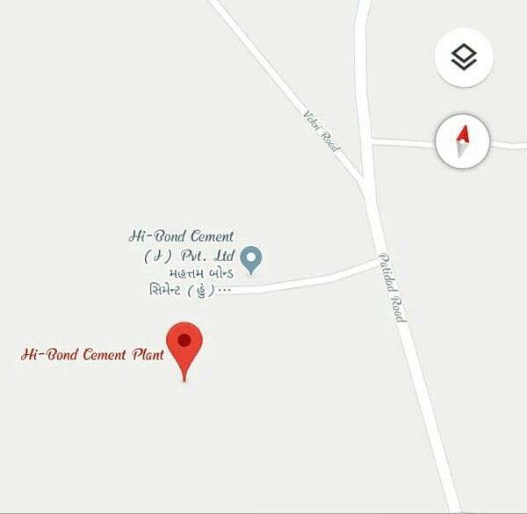



**3. COMPANY PROFILE**

**COMPANY DETAILS**

|  |  |  |
| --- | --- | --- |
| **No.** | **TOPICS** | **CONTENTS** |
| **1.** | **Name of the unit** | **“Hi-Bond Cement Pvt. Ltd.”** |
| **2.** | **Location** | **Hi-Bond Cement Pvt. Ltd.**  **Gondal (near patidad),**  **National highway 8B**  **Dist. Rajkot.**  **Gujarat-India.** |
| **3.** | **Registered office address** | **Hi-Bond Cement Pvt. Ltd.**  **Gondal (near patidad)**  **Dist. Rajkot.**  **Gujarat-India.** |
| **4.** | **Establishment** | **01/11/2010** |
| **5.** | **Phone number** | **9099510070** |
| **6.** | **Time schedule** | **Day Sift: 8:00 am to 8:00 pm**  **Night sift: 8:00 pm to 8:00 am** |
| **7.** | **Number of employee** | **400 Member** |
| **8.** | **Accounting year** | **1st April to 31st March** |
| **9.** | **Size of the firm** | **Large scale industry** |
| **10.** | **Form of organization** | **Partnership** |
| **11.** | **Weekly off** | **Wednesday** |
| **12.** | **Market** | **National** |
| **13.** | **Auditor** | **Ashokbhai patel** |

**4. SIZE & FORM OF THE ORGANIZATION**

* **Small scale industry** :

The industry whose investment is plant and machinery less than 5Crore is known as **“Small Scale industry”.**

* **Medium scale industry** :

The industry whose investment is plant and machinery more than 5Crore to 100crore is known as **“Medium scale industry”.**

* **Large scale industry :**

The industry whose investment is plant and machinery more than 100 Crore is known as **“Large scale industry”.**

**“Hi-Bond Cement Pvt. Ltd.”** has investment in plant and machinery about **400 Crore**  so, it is **“Large scale industry.”**

**FORM OF ORGANIZATION**

* There are mainly four form of organization.

1. Sole proprietorship
2. Joint stock company

* Private company
* Public company

1. Partnership
2. Co-operative

**“Hi-Bond Cement Pvt. Ltd” is ‘Partnership Company’ .**

**5.MISSION, VISSION & GOALS OF THE FIRM**

**Mission**

* **“Hi-Bond Pvt. Ltd.”** Is committed to provide the best quality cables with high standard, innovation and best customer service.

**Vision**

* “**Hi-Bond Cement Pvt. Ltd.”** Vision is, to achieve 100% customer satisfaction.
* To attempt 100% delivery conformance to customers.

**Goals**

* Reasonable Profit
* More Customers
* Improve Company Reputation
* Maintain Product Standard

**6.PROMOTERS & MANAGING GROUP**

**Promoter:-**Ashokbhai patel

**Existing managing group:-**

* **Production manager –**H. H. Kalariya
* **Marketing manager** – M. G. Jadaja
* **Financial manager** – Deneshbhai patel
* **HR manager** – Ashokbhai faldu.

**7.ORGANISATION STRUCTURE**

**jhjhjkkk**

Director

B. O. D.

HR

Department

Finance Department

Marketing Department

Production Department

HR

Manager

Financial

Manager

Marketing Manager

Production Manager

Employees

Accountant

Sales Executive

Engineer

Quality Control manager

Supervision

**8.CONTRIBUTION OF FIRM IN THE INDUSTRY**

“Industries are the lubricant of the country economy” Every country economy depends on it foreign trade namely import and export. Our country is basically agricultural growth as well as overall growth in business and industrial activities.

The firm provides employment directly or indirectly. The unit is a profit making so it is useful to economy of the country.



**INDEX**

|  |  |  |
| --- | --- | --- |
| **NO.** | **particular** | **Page No.** |
| 2.1 | Introduction | 27 |
| 2.2 | Organisation structure | 28 |
| 2.3 | Types of products | 29,30 |
| 2.4 | Raw material & Sources of Row Material | 31,32 |
| 2.5 | Manufacturing process | 33 to 37 |
| 2.6 | Plant Lay out | 38 |
| 2.7 | Installed & utilized capacity | 39 |
| 2.8 | Quality control & inspection | 40 |

**1. INTRODUCTION**

**“Manufacturing department is called as production department”.** Production means creation of utilities and it covers all the activities of procurement allocation and utilization of resources such as labour, energy material equipment, machinery etc.

The production manufacturing is the main process of any firm Production must be operated in a vital factor in affecting market competition and in ensuring normal profit or relation investment.

They have effective production department the firm has best productivity and better mgt. Of production department & technology.

**2. ORGANISATION STRUCTURE**

**Managing**

**Director**

**Executive**

**Director**

**Production**

**Manager**

**Supervisor**

**Workers**

**3.TYPES OF PRODUCTS**

* **O.P.C.(Ordinary Portland Cement)**

**Use for O.P.C.:**

* Residential,
* Industrial complex,
* Commercial,
* Overhead and underground water tanks, flooring tiles etc.

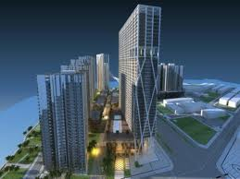

* **P.P.C.(Pozzolana Portland cement)**

**Use for P.P.C.:**

* underground water mains,
* like sewer pipes, septic tank,
* underground tank mass like dams lining of canals, repairing work.

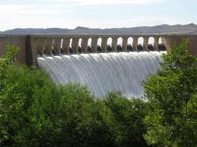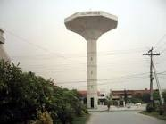

**4. RAW MATERIAL & SOURCES OF RAW MATERIAL**

**Raw-Materials**

Raw material is the basic components of the product. Raw material cost is the major cost in the overall cost of production. For manufacturing the cement we require the raw material like Clinker, Gypsum, Fly ash, Lime stone etc. the calculation of requirement of raw material is calculated as per scheduled XVII.

* Clinker
* Lime Stone
* Fly ask
* Gypsum

**Sources of raw-material**

* **Clinker –** Chotila
* **Lime Stone -** Dhank
* **Fly ask-** Dhank
* **Gypsum** – hajira
* **Power –** GEB (Gujarat Electricity Board)
* **Labour –** Village gets skill, Unskilled or semi-skilled workers from Gondal and other near to the firm.

**RAW MATERIAL**

**Clincer Lime Stone**

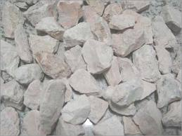

**Fly ask Raw- Material**

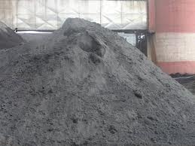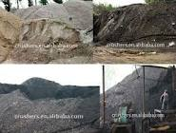

**5.MANUFACTURING PROCESS**

**Lime stone stock pile**

**Crusher**

**Grinding**

**Homogenization**

**Preheating & calcinations**

**Burning**

**Cooling**

**Store**

**Grinding**

**Storage**

**Packing**

**Dispatch**

**1) Lime Stone stock pile :-**

The basic raw material for cement and clinker is limestone. Near about 90% of finished product is limestone. The requirement of limestone is half more than finished product, means if 100-tones cement is to be manufactured, than 150-tones limestone required.

GCW has its own mine for limestone. There mine plant is 3 sot the plant through conveyor belt.

**2) Crusher:-**

After mining the limestone it is crushed by Crusher. Crusher crushes the stone type limestone into powder form. Its capacity of crushing is 950 tones per hour. Than it is collected and stocked as piles by Dampers. In the store, the crushed stone is stacked in several layers by the Stacker, so that a variation in quality of incoming limestone is equalized.

**3)Grinding:-**

The machine, which grinds the raw material, is called RAW MILL. That converts raw material into powder form by grinding it. Crushed limestone, shale & hematite are fed in the required proportion to the raw grinding unit.

**4) Homogenization:-**

In this stage mixed powder from raw mill transfer to CF silo, where some additives are added to mixture. Here drying process of raw material is also carried out, because the basic raw material contains some moisture.

**5) Preheating & Calcinations:-**

Before moving the mixture to Kiln, the powder must obtain some temperature. Pre-heater performs that task. Calcinations is defined as removing of carbon-di-oxide and other organic matters from the raw material. The process of calcinations before Kiln reduces the thermal load in the rotary Kiln. The advantage of this system is that the Kiln capacity increases by 2-2.5 times.

**6)Burning:-**

The raw material is fed into the rotary kiln and coal is fired at a temperature of 1600-1800 degree centigrade on the other end. Here after burning process the powder form is transferred into small stone type form, which is called Clinker.

**7) Cooling**: -

The clinker is cooled in cooler, because it is very hot after passing though a very high temperature. There are three high power fans, which reduces the temperature of the clinker. Cooler brings down the temperature of clinker from 1200 centigrade to 200 centigrade.

**8) Store:-**

Clinker is stored in the Clinker Silo. For converting it into cement, gypsum is mixed and grinded further in grinding process.

**9) Grinding:-**

In this stage raw material is passed to Cement Mill, where the clinker and gypsum are mixed and grinded to make powder form. Here some needed chemical are also added to mixture. This grey mixture is called cement.

**10) Storage:-**

Cement is stored in Cement Silo in powder form before packing. From cement silo, needed quantity is taken for packing, while the bulk quantity without packing is goes to Jetty though conveyer belt.

**11)**  **Packing:-**

Packing plant for packing of cement in bags is located in the plant itself.

**12)**  **Dispatch:-**

After packing, cement is dispatched to various locations through road or sea. Here cement is loaded in truck by machine automatically.

**6. PLANT LAY OUT**

Plant lay out means the arrangement of the physical facilities including production center for the manufacturing products.

By plant lay out, the work become easy and improve this product and relationship among wok - center is one of the most important item.

So Hi - Bond cement pvt. Ltd. Industry made it plant lay out more facilitate and suitable smoothness of unit.

**7. INSTALLED & UTILIZED CAPACITY**

1. **Installed capacity:-**

* 3000 turn per day.
* 90,000 turn per month
* Yearly Installed capacity is

3000turn x 300 day=9,00,000 turn

**2) Utilized capacity:-**

* 80% i.e. 2400 turn per day.
* 72,000 turn per month
* Yearly Utilized capacity is

2400 turn x 300 days=7,20,000 turn

|  |  |  |
| --- | --- | --- |
| **Particular** | **Installed capacity** | **Utilized capacity** |
| Per Day | 3,000 turn | 2,400 turn |
| Per month | 90,000 turn | 72,000 turn |
| Yearly | 9,00,000 turn | 7,20,000 turn |

**8.QUALITY CONTROL & INSPECTION**

Today is a competitive era because, everywhere production of any goods through machines at fastest and in bulk quality. So goods are available at lower rate. So today consumer become the king of market. Consumers are ready to pay at best quality product. So quality of the goods is very important today. The **“Hi-Bond Cement Pvt. Ltd.”** tested quality of cement during production procedure at least 3 or 4 times.

1) At raw material inputs mixture at starting

2) Pre-heater temperature at every hour.

3) At reclaimed silo at every 4 hours.

4) At cement mill where in gradients added.

The **“Hi-Bond Cement Pvt. Ltd.”** has won any other company productivity quality.



**INDEX**

|  |  |  |
| --- | --- | --- |
| **NO.** | **PARTICULAR** | **PAGE NO.** |
| 3.1 | Introduction |  |
| 3.2 | Organisation structure |  |
| 3.3 | Employee details & classification |  |
| 3.4 | Recruitment, Selection and Infuction |  |
| 3.5 | Training and Development Program |  |
| 3.6 | job Description |  |
| 3.7 | Promotion and Transfer |  |
| 3.8 | Wages and salary Administration |  |
| 3.9 | E.S.I. Scheme |  |
| 3.10 | Provident Fund Scheme |  |
| 3.11 | Grievance Handling Procedure |  |
| 3.12 | Time keeping system |  |
| 3.13 | Employee benefits & services |  |

**1. INTRODUCTION**

Manpower is the most important resource among all the resources, How many funds you have, how many machines you have, how much technology advancement you have; nothing will work if you don’t have sufficient manpower. So man is the most important resource so a department. Managing human resources is a most challenging job because every person differs from each other and there is no perfect formula to manage people successfully.

Personnel Management is the planning, organizing, directing and controlling of the procurement, development, compensating, integration, maintain ace and separation of human resource to the end that individual organizational and social objective are accomplished.

In the “Hi-Bond Cement Pvt. Ltd.” human/labor is given more important because the real asset of the company is the skilled labour. Without the human no production is done so, it is very important. Human resources is a relatively modern management term, coined as late as the 1960s.

**3. ORGANISATION STRUCTURE**

**Managing Director**

**Executive Director**

**Personnel Manager**

**Time Keeping & Security Officer**

**Supervisor**

**Worker**

**3. EMPLOYEE DETAILS & CLASSIFICATION**

**4.RECRUITMENT, SELECTION AND INDUCTION**

**5.TRAINING AND DEVELOPMENT PROGRAM**

**6.JOB DESCRIPTION**

**7.PROMOTION AND TRANSFER**

**8. WAGES AND SALARY ADMINISTRATION**

**9. E.S.I. SCHEME**

**10. PROVIDENT FUND SCHEME**

**11. GRIEVANCE HANDLING SYSTEM**

**12 TIME KEEPING SYSTEM**

**13. EMPLOYEE BENEFITS & SERVICES**