RESUME

**P E R S O N A L I N F O R M A T I O N**

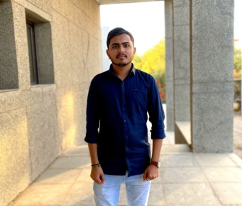

**CHANDRESH**

**DOBARIYA**

# C A R E E R O B J E C T I V E

To become a successful professional in the Chemical field by utilizing my skill and enable further personal & professional development and work towards the prosperity of the company. To achieve a challenging and responsible position in the Chemical Industry.

# E X P E R I E N C E

# 4 Month QC Chemist in Dial Pharmaceuticle, Bavla Ahmedabad

**Name** : Dobariya Chandresh c.

**Date Of Birth** : 26/12/1998

**Gender** : Male

**Languages Known** : Gujarati, Hindi, English

**Marital Status** : Single

# A C A D E M I C P R O F I L E

## Department Of Chemistry, Saurashtra University, Rajkot.

M.Sc in Organic Chemistry, 2021

- SCORE : 73%

## Kamani Science College Amreli.

B.Sc. Chemistry, 2019.

- SCORE : 63.71%

## Shree Sarkari School Liliya.

Higher Secondary School Certificate, 2016.

- SCORE : 54%

## Shreeji vidhyarthi Bhuvan.

Secondary School Certificate, 2014.

- SCORE : 81%

# S T R E N G H I N T E R P E R S O N A L S K I L L S

 Positive Attitude  Honesty

 Hard Working

 Vision For Growth

 Able To Team Work.  Leadership

 Creativity

 Communication

# C O N T A C T

 +91 82382 66841

 [chandresh.dobariya98@gmaiI.com](mailto:chandresh.dobariya98@gmaiI.com)

 Adress : 302,Satyanarayan Society, Ramdev cheri, Murgha Kendra ni pachal,Varachha rode Surat

# R E F E R E N C E

## Dr. Ranjan Khunt

Assistant Professor At Department of

Chemistry, Saurashtra University, Rajkot. MO. - 8128700900

## Dr. Viral Shah

Professor At Department of Chemistry, Kamani Science College, Amreli.

MO. - 9825479718 , 8320295397

**D E C L A R A T I O N**

I genuinely declare that all the facts mentioned above are true to my faith, and I am answerable for its accuracy.