ACADEMIC PROJECT — SOFTWARE ENGINEERING
MURDER MYSTERY INVESTIGATION
USER FLOW DIAGRAM
An Interactive Browser-Based Detective Investigation Experience

Project Milestone: User Flow Diagram
Submission Deadline: 04 September
Submitted by: Dhruvi Srivastava
Roll Number: 22515000045
Under the Guidance of: Mr. Gautam Mukherjee
Department: Computer Science Engineering (AI & DS)
Institution: GLA University
Document Version: 1.0

Structural reference: Logic Puzzle Arena — User Flow Diagram

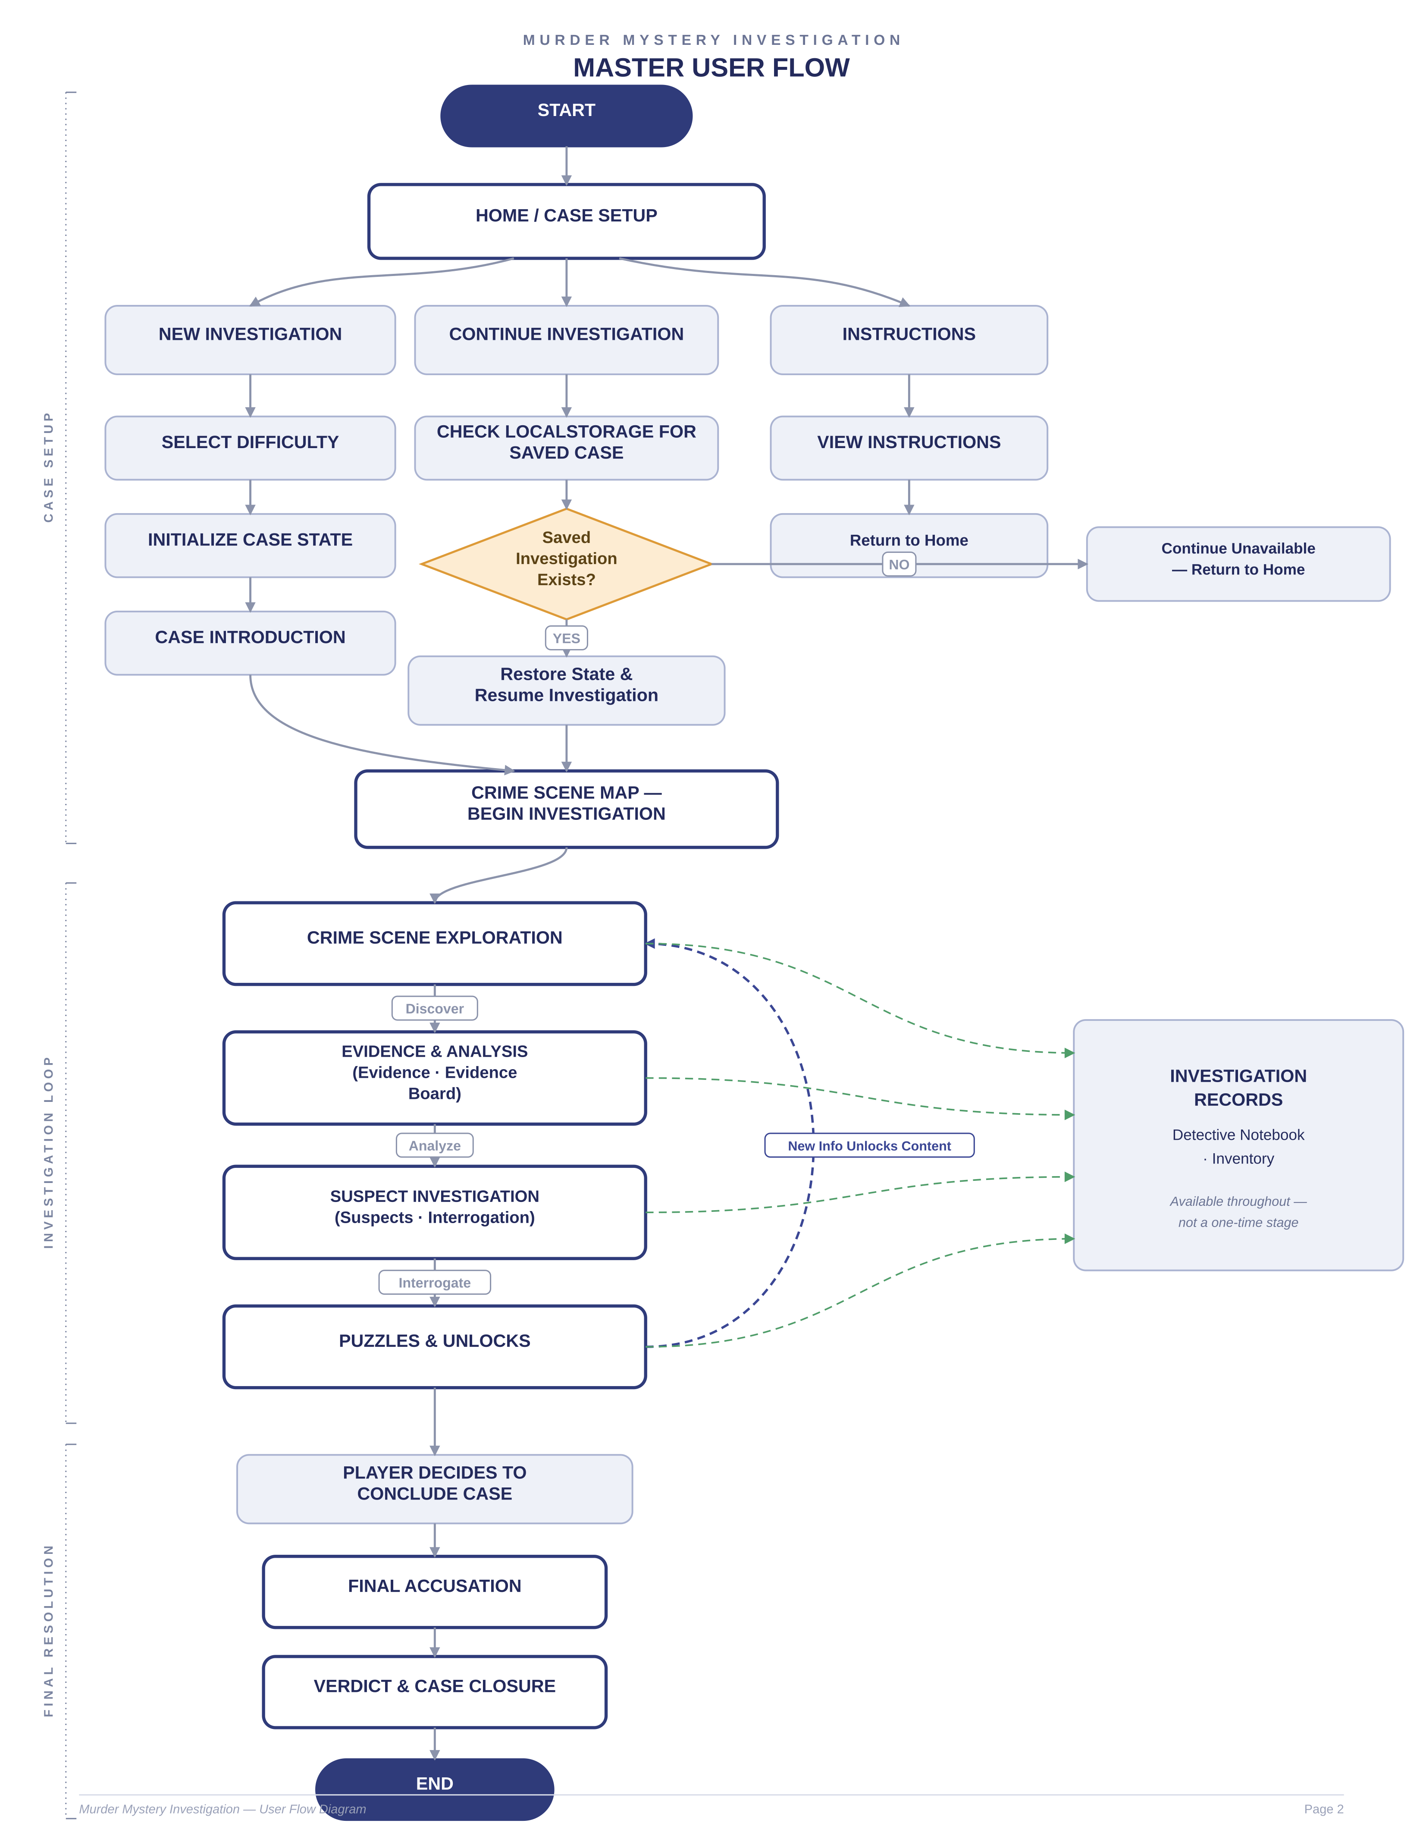

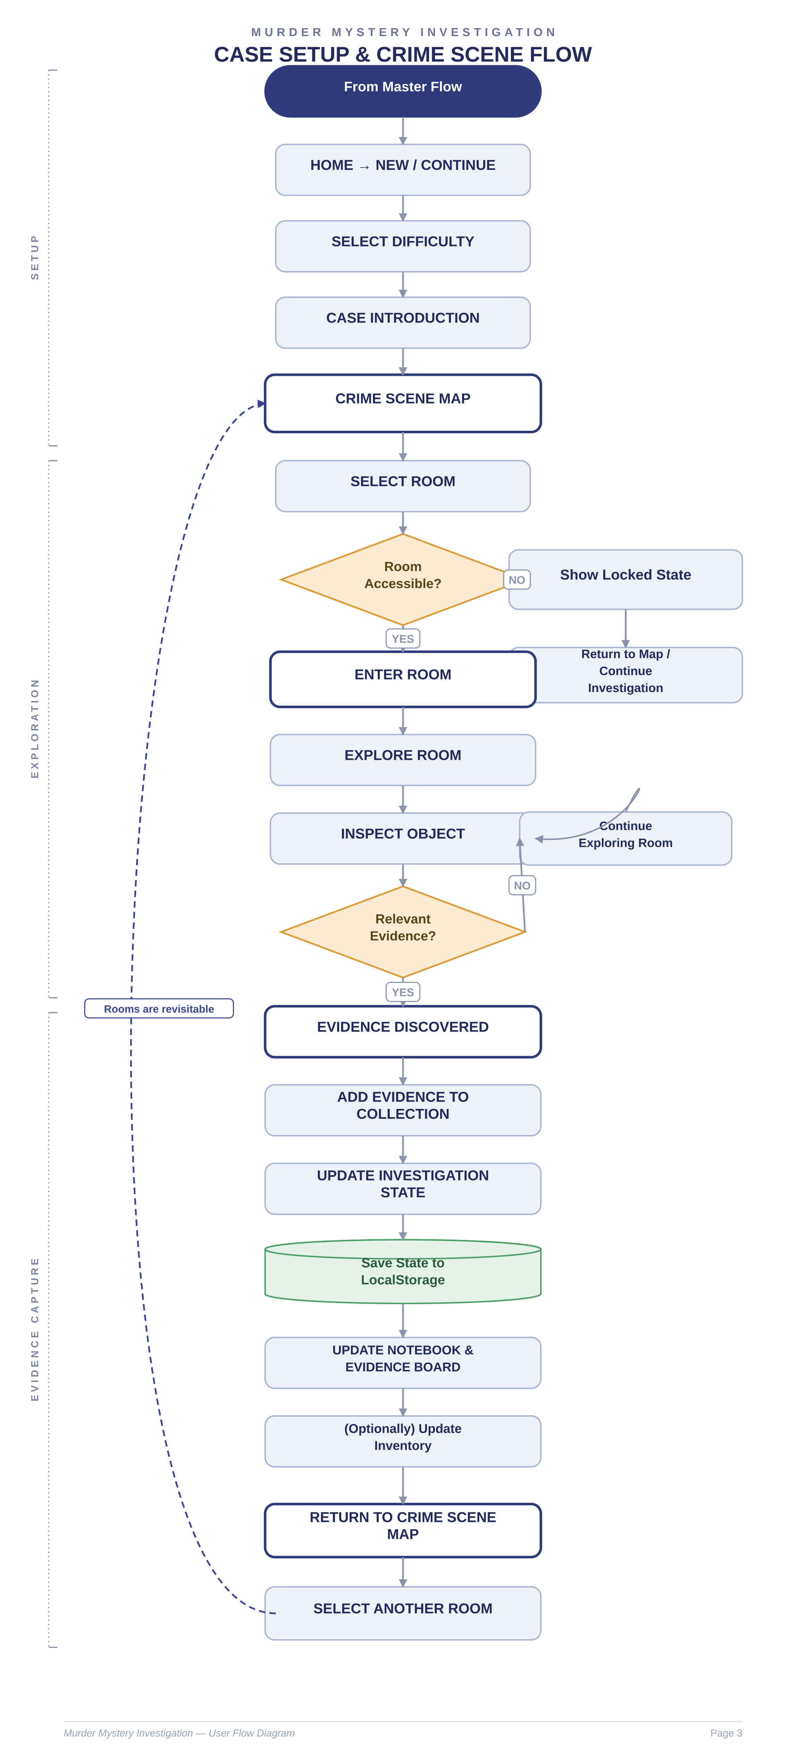

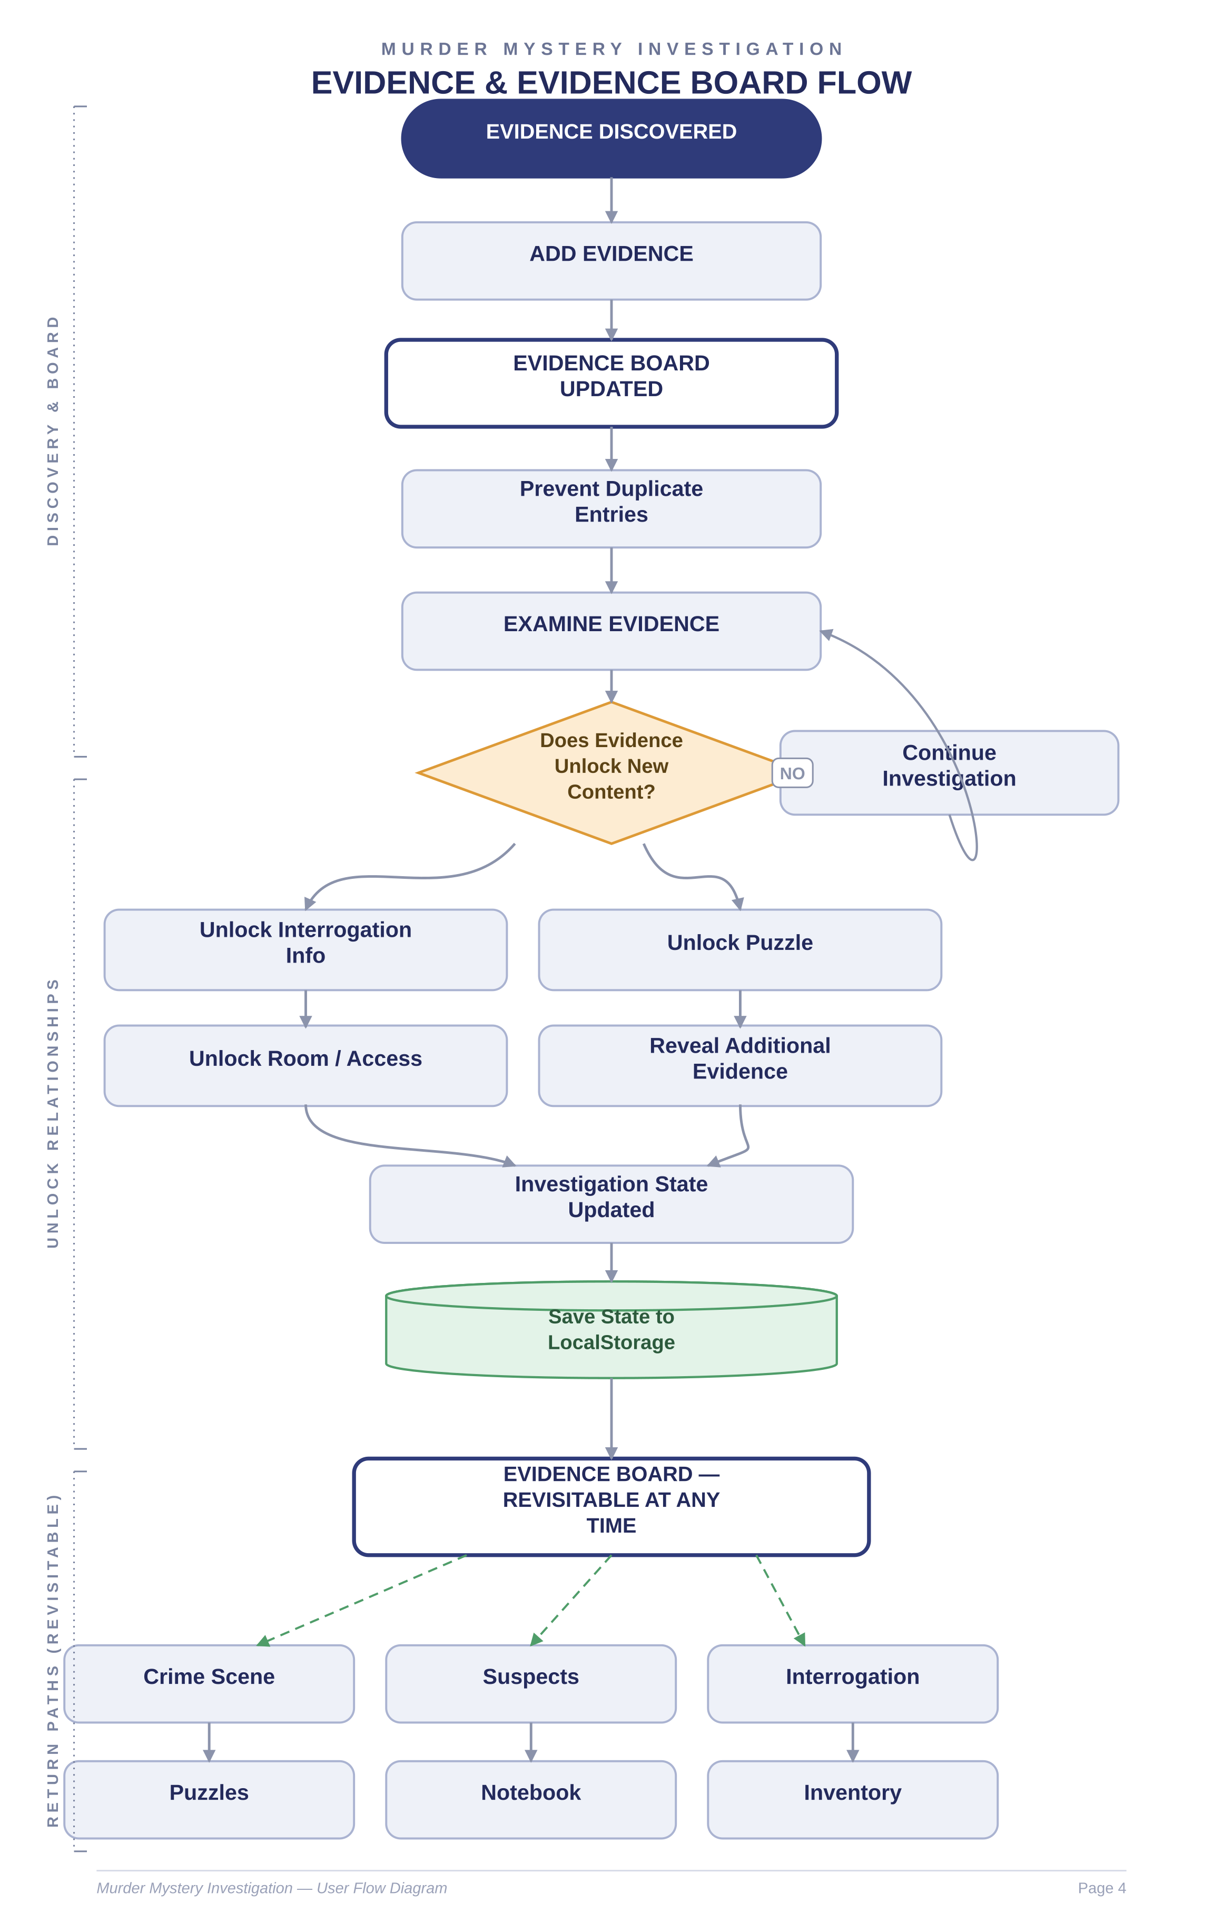

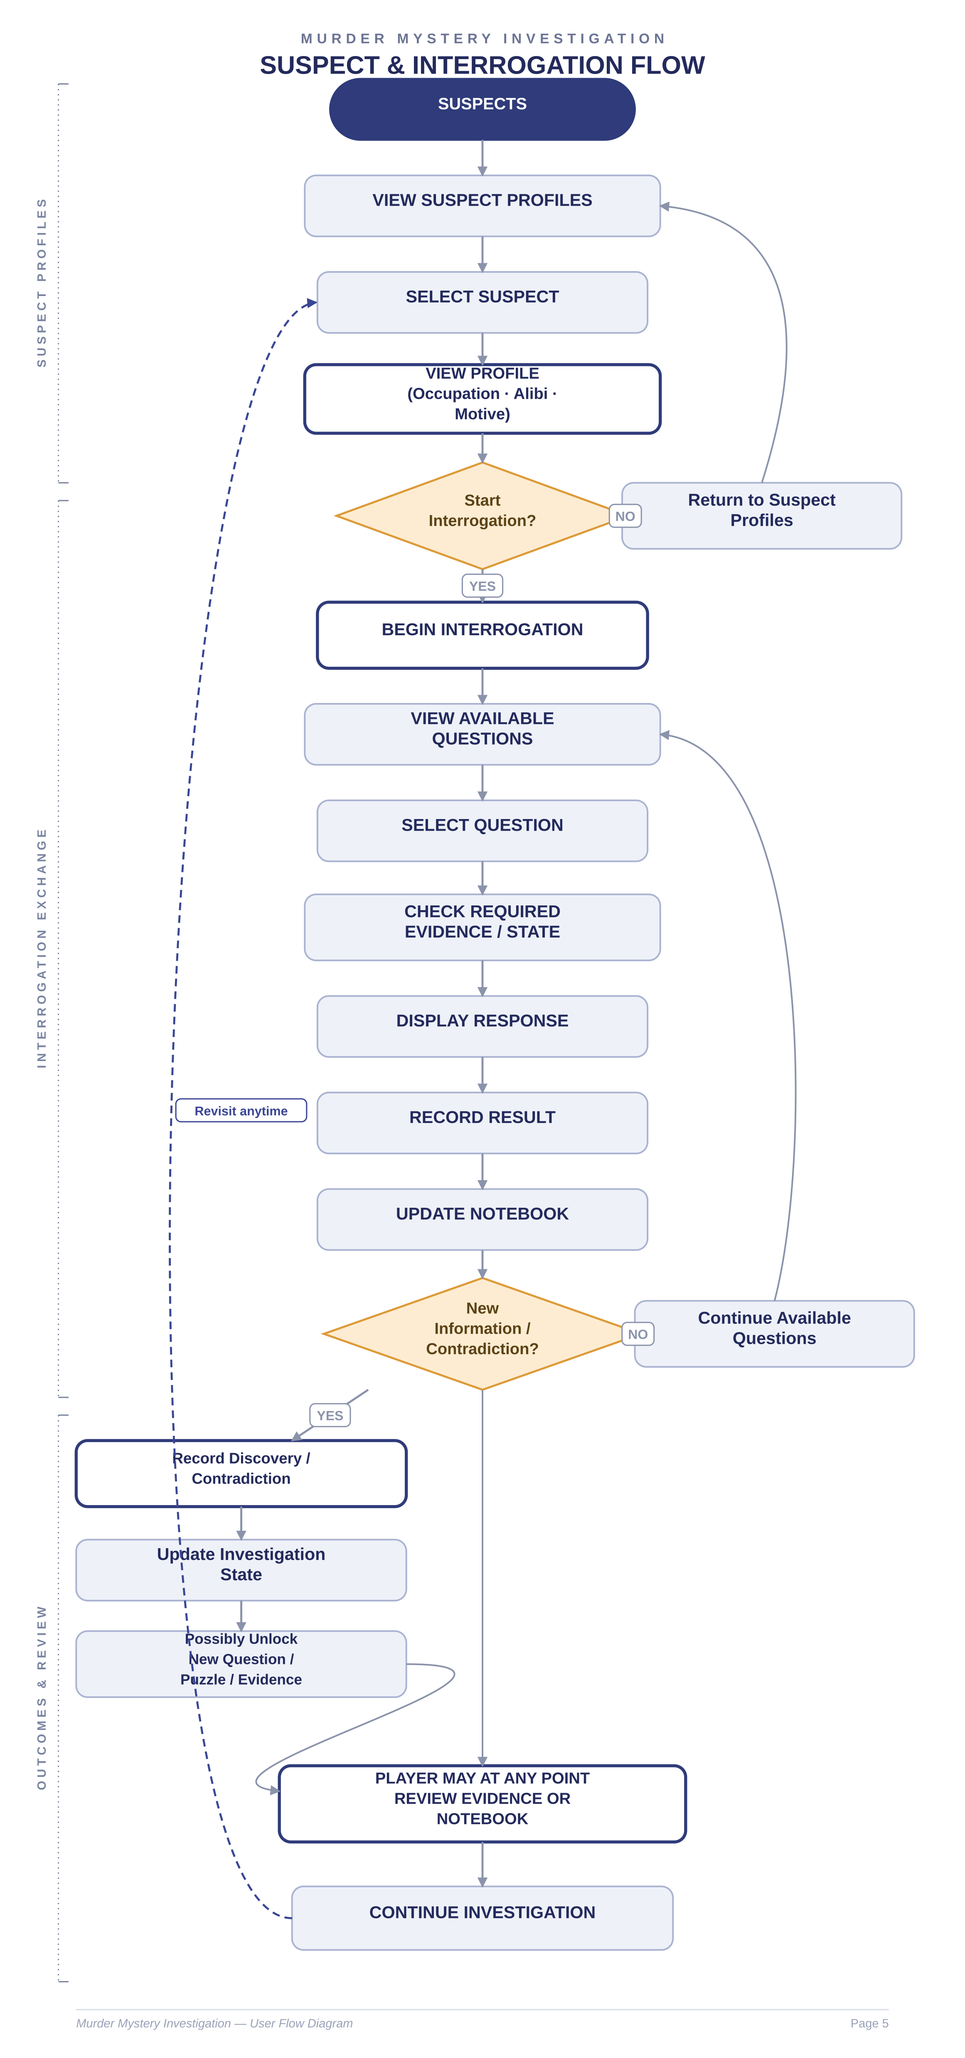

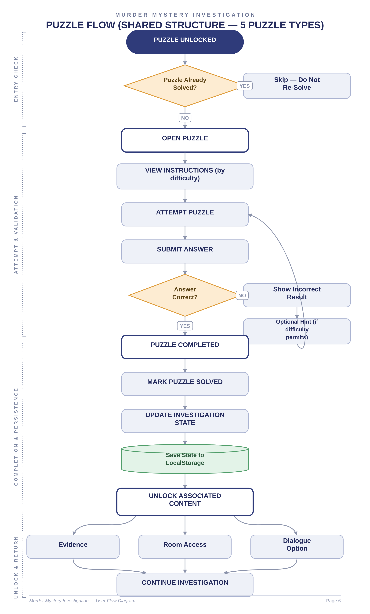

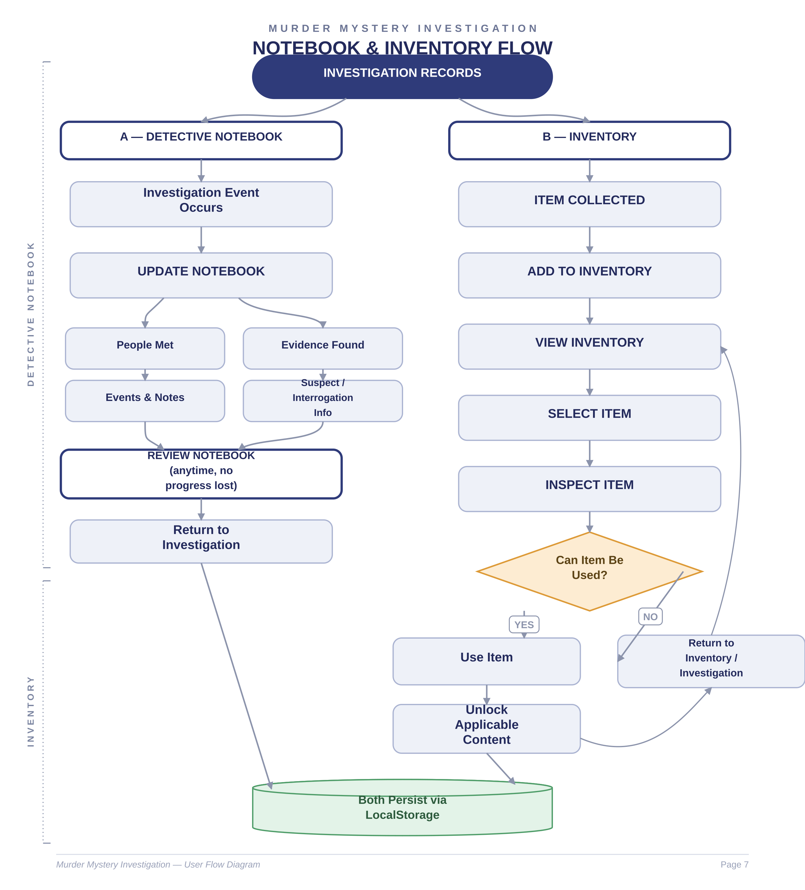

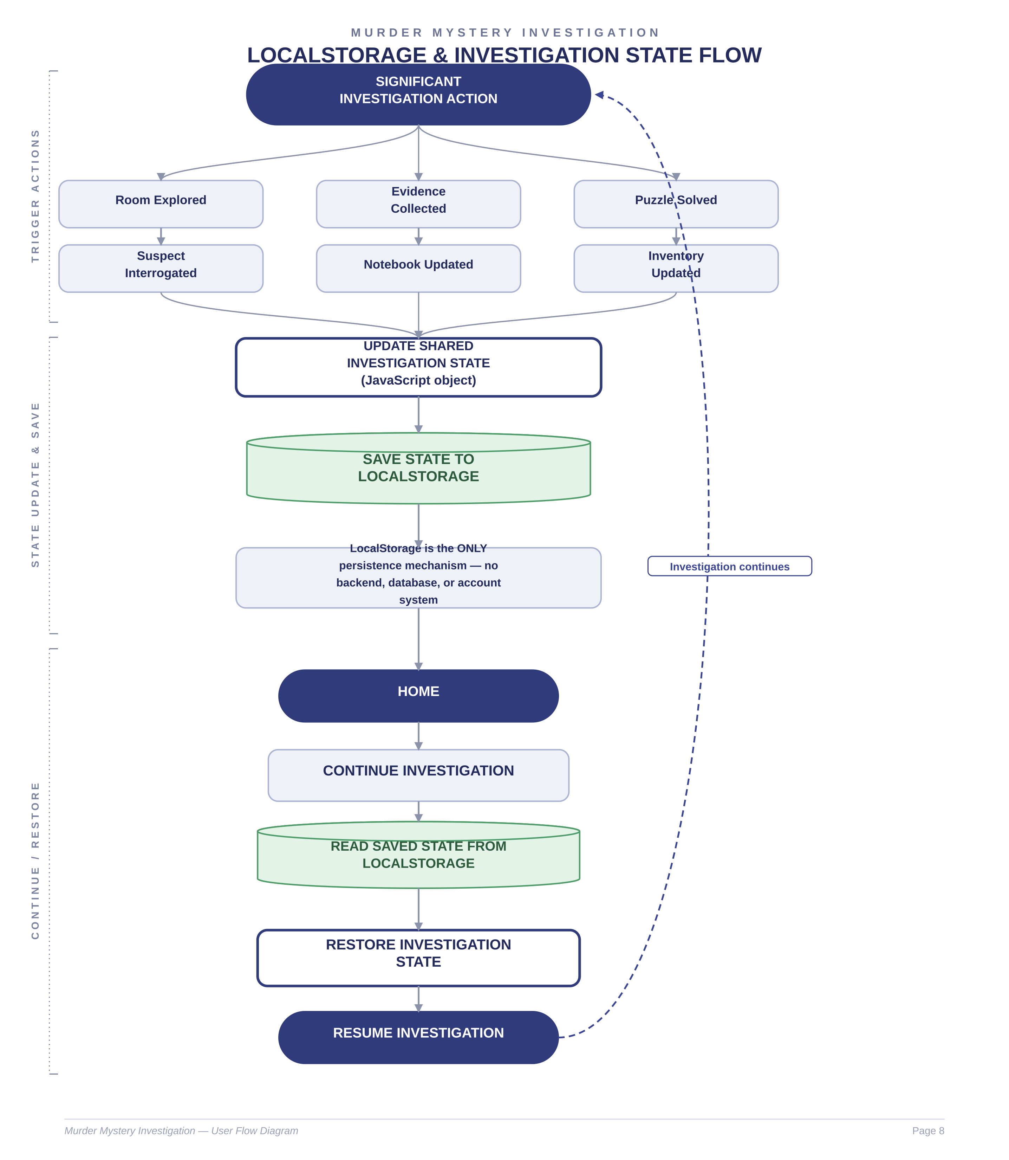

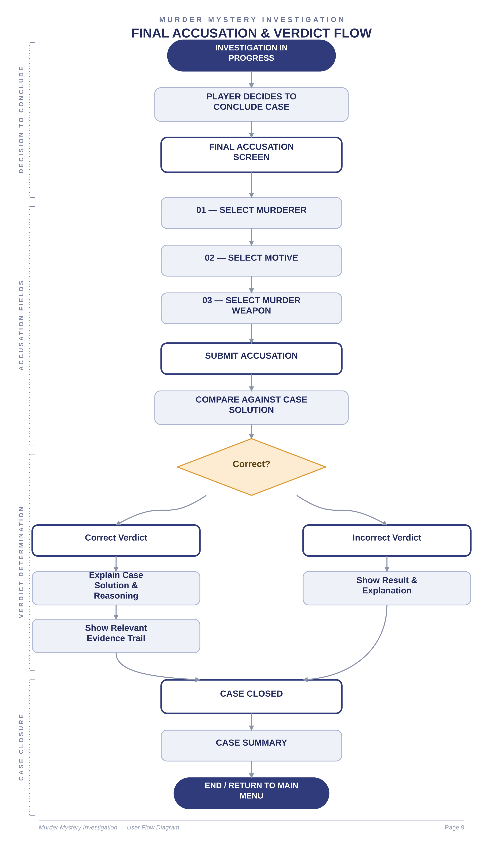

MURDER MYSTERY INVESTIGATION
Requirement Traceability & Notes
Traceability Matrix
Each functional module is mapped to its governing SRS section, the corresponding requirement identifiers, and the page(s) of this document where its user flow is represented.
Module | SRS Section | Requirement IDs | Represented In
Home & Case Setup | 3.1 Home and Case Setup Module | FR-3.1.1 – FR-3.1.4 | Page 2, Page 3
Crime Scene & Room Exploration | 3.2 Crime Scene and Room Exploration Module | FR-3.2.1 – FR-3.2.5 | Page 2, Page 3
Evidence Collection & Evidence Board | 3.3 Evidence Collection and Evidence Board Module | FR-3.3.1 – FR-3.3.4 | Page 2, Page 4
Suspect Profiles | 3.4 Suspect Profile Module | FR-3.4.1 – FR-3.4.4 | Page 2, Page 5
Interrogation | 3.5 Interrogation Module | FR-3.5.1 – FR-3.5.5 | Page 5
Puzzle System | 3.6 Puzzle Module | FR-3.6.1 – FR-3.6.5 | Page 2, Page 6
Detective Notebook | 3.7 Detective Notebook Module | FR-3.7.1 – FR-3.7.4 | Page 7
Inventory | 3.8 Inventory Module | FR-3.8.1 – FR-3.8.4 | Page 7
Persistence (LocalStorage) | 3.1, 3.7, 3.8 (Setup, Notebook, Inventory) | FR-3.1.3, FR-3.7.4, FR-3.8.4 | Page 8
Final Accusation & Verdict | 3.9 Final Accusation and Verdict Module | FR-3.9.1 – FR-3.9.5 | Page 9
Notes — Non-Linear Investigation Design
- The investigation is non-linear: the player may explore rooms, evidence, suspects, puzzles, notebook, and inventory in any order once they are unlocked (Section 3.2–3.8).
- Rooms, the Evidence Board, suspect profiles, the Notebook, and the Inventory are revisitable at any time and are not single-use stages (FR-3.2.4, FR-3.3.2, FR-3.4.3, FR-3.7.3).
- Evidence and interrogation are interconnected — interrogation responses can depend on previously collected evidence, and new evidence can unlock further questions (FR-3.5.2, FR-3.5.3).
- Puzzle completion may unlock investigation content such as evidence, room access, or dialogue, and solved puzzles are not repeated (FR-3.6.3, FR-3.6.4).
- The Detective Notebook and Inventory are persistent investigation tools that are updated automatically and can be reviewed throughout the investigation (FR-3.7.1–FR-3.7.4, FR-3.8.1–FR-3.8.4).
- LocalStorage is the sole persistence mechanism for investigation state; the system introduces no backend, database, or user-account layer (FR-3.1.3).
- The final accusation is submitted only when the player chooses to conclude the case, and is evaluated against the collected investigation information (FR-3.9.1–FR-3.9.5).
Document Notes
- This diagram set uses the Logic Puzzle Arena User Flow Diagram as a structural and presentation reference only; all content reflects the Murder Mystery Investigation Synopsis and SRS exclusively.
- Flowchart conventions: rounded rectangles denote screens, rectangles denote system processes, diamonds denote decisions, cylinders denote LocalStorage persistence, and pill shapes denote start/end terminators.
- Dashed navy connectors indicate loop-back or revisit paths; dashed green connectors indicate an investigation tool that remains accessible throughout play.

