A Project Synopsis on
“Murder Mystery Investigation”
An Interactive Browser-Based Detective Investigation Experience
Submitted in partial fulfilment of the requirements for the degree of
Bachelor of Technology in Computer Science Engineering (AI & DS)
Department of Computer Science Engineering
GLA University

Submitted by
Dhruvi Srivastava | 22515000045
2nd Year, B.Tech (Computer Science & Engineering)
Under the Guidance of
Mr. Gautam Mukherjee

1. Introduction
“Murder Mystery Investigation” is a browser-based, front-end interactive application that places the user in the role of a detective tasked with solving a fictional homicide. Rather than presenting information to the user in a linear or passive format, the system requires the user to actively explore a simulated crime scene, discover and interpret physical evidence, examine suspect profiles, conduct structured interrogations, and solve a series of narrative-linked puzzles before arriving at a final, evidence-supported accusation. The project is built entirely using HTML5, CSS3, and JavaScript, with browser-based storage (LocalStorage) used to persist investigation progress across sessions.
The application is designed to demonstrate that a purely front-end system, when supported by careful interaction design and structured state management, can deliver an experience that is investigative and deduction-driven rather than a simple sequence of static pages or a linear quiz. The emphasis of the project is on how JavaScript is used to track, connect, and progressively reveal information gathered by the user, and on how the individual modules of the application – exploration, evidence collection, suspect investigation, interrogation, puzzles, and the detective notebook – are made to work together as a single coherent system.

2. Problem Statement
A large proportion of introductory and academic web-development projects are built as static, content-display websites or as simple form-driven applications with little genuine interactivity. Such projects typically demonstrate basic HTML and CSS skills but do not require meaningful client-side state management, conditional logic, or the design of interconnected data structures. There is a need for a front-end project that goes beyond static content presentation and instead requires the design of an internally consistent system in which user actions in one part of the application meaningfully affect what is available or discoverable in another part.
The problem this project addresses is the design and implementation of such a system: an investigation experience in which exploration, evidence, suspects, interrogation responses, and puzzles are not independent, isolated components, but are linked together through a shared, JavaScript-managed investigation state, so that the user's progress and choices are reflected consistently throughout the application.

3. Motivation / Need for the Project
Conventional academic web projects are frequently limited to displaying content or accepting simple form input, offering limited scope for demonstrating skills such as client-side state management, conditional rendering, modular JavaScript design, and interaction-driven user interfaces. An interactive investigation experience provides a natural and well-bounded context in which these concepts can be demonstrated meaningfully: evidence must be discovered before it can be reviewed, interrogation outcomes may depend on evidence already collected, puzzle completion may be a precondition for unlocking new information, and the final accusation must be evaluated against an internally defined solution.
This project is motivated by the goal of building a front-end application whose complexity arises from its interaction design, its investigative state management, and the relationships between its modules, rather than from the use of additional technologies such as a backend server, a database, or artificial intelligence. It is intended to demonstrate that substantial, technically meaningful systems can be built using HTML, CSS, and JavaScript alone.

4. Objectives
- To design and implement an interactive, browser-based murder mystery investigation experience using HTML5, CSS3, and JavaScript.
- To implement a crime scene exploration system in which the user navigates between multiple rooms and inspects interactive objects to discover evidence.
- To design an evidence board and detective notebook that consolidate discovered evidence, suspect information, and investigation notes for the user.
- To implement suspect profiles and a structured, dialogue-tree-based interrogation system driven by JavaScript logic rather than generated conversation.
- To design a set of investigation puzzles that are narratively integrated with the case, such that solving a puzzle reveals information relevant to the murder rather than functioning as an isolated mini-game.
- To implement a JavaScript-based investigation-state management system that tracks discovered clues, collected inventory items, visited rooms, interrogation progress, and solved puzzles.
- To use browser LocalStorage to persist investigation progress so that a user may continue an in-progress case across browser sessions.
- To implement a final accusation module that evaluates the user's selected murderer, motive, and weapon against the case solution and presents a corresponding verdict.

5. Proposed System
The proposed system is a single-page or multi-view front-end application structured around a central investigation state object maintained in JavaScript. The user begins at a home screen, from which a new investigation may be started or an existing one resumed, and where a difficulty level (Easy, Medium, or Hard) may be selected. Difficulty is used to vary aspects such as the visibility of clues, the complexity of puzzles, and the availability of investigative hints, without altering the underlying investigation logic.
From the crime scene map, the user may enter individual rooms – for example, the living room, bedroom, office, garden, and basement – each of which contains a distinct set of interactive objects. Selecting an object opens a detailed inspection view; where relevant, this action adds a corresponding entry to the user's evidence collection and detective notebook. Evidence gathered in this way becomes available on a centralized evidence board, where the user may review items and consider their relationship to the suspects, the timeline of events, the possible motive, and the possible murder weapon.
Suspect profiles present background information – name, occupation, relationship to the victim, stated alibi, and possible motive – that the user may compare against the evidence already collected. The interrogation module allows the user to select from a predefined set of investigative questions for each suspect; responses are determined by dialogue-path logic implemented in JavaScript and may reveal new information, corroborate existing evidence, or expose contradictions depending on what the user has already discovered. Investigation puzzles – such as a safe-code puzzle, a torn-letter reconstruction, a cipher, a chronological CCTV-ordering exercise, and a fingerprint-matching exercise – are placed at points in the investigation where their solution unlocks a room, a piece of evidence, or a dialogue option, so that each puzzle contributes directly to the user's ability to solve the case.
Once the user considers the investigation sufficiently advanced, a final accusation may be submitted, in which the user selects the suspected murderer, the motive, and the murder weapon. The system compares this selection against the predefined case solution and presents a verdict, along with a summary explanation connecting the relevant evidence and events.

6. Major Modules / Features

6.1 Home and Case Setup Module
Provides entry points for starting a new investigation, continuing a saved investigation retrieved from LocalStorage, viewing instructions, and selecting a difficulty level that adjusts clue visibility, puzzle complexity, and hint availability.

6.2 Crime Scene and Room Exploration Module
Renders the crime scene as a set of navigable rooms, each containing interactive objects. Handles user navigation between rooms and manages the click/inspection events used to reveal object details and trigger evidence discovery.

6.3 Evidence Collection and Evidence Board Module
Maintains the list of evidence discovered by the user (for example, a bloody knife, a broken phone, a diary, a medicine bottle, footprints, letters, keys, photographs, a USB drive, and fingerprint reports) and presents this evidence in a consolidated board view to support the user's deductions regarding suspect, motive, and weapon.

6.4 Suspect Profile Module
Displays structured profile information for each suspect, including name, occupation, relationship with the victim, alibi, possible motive, and any case-relevant information the user has uncovered during the investigation.

6.5 Interrogation Module
Implements a predefined set of investigative questions per suspect (for example, questions concerning whereabouts at the time of the murder, prior acquaintance with the victim, or explanations for contradictory evidence) and resolves each response through JavaScript dialogue-path logic, which may depend on evidence the user has already collected.

6.6 Puzzle Module
Implements narratively integrated puzzles – including a four-digit safe-code puzzle, a torn-letter jigsaw reconstruction, a cipher-decoding puzzle, a chronological CCTV-event-ordering puzzle, and a fingerprint-matching puzzle – each of which, upon completion, unlocks evidence, a room, or dialogue relevant to the case.

6.7 Detective Notebook Module
Automatically records people encountered, evidence discovered, notable events, suspect information, and investigation notes, allowing the user to review the state of the investigation without needing to recall every detail independently.

6.8 Inventory Module
Maintains a list of collected physical items (for example, a key, a USB drive, a letter, a photograph, or a fingerprint report) that may be inspected in detail and, where applicable, used to unlock further interactions.

6.9 Final Accusation and Verdict Module
Allows the user to select a murderer, motive, and murder weapon, compares this selection against the predefined solution, and presents a verdict together with a summary explanation of the relevant evidence.

7. System Workflow
The application is organized around a single, ongoing investigation flow, in which each module both consumes and contributes to a shared investigation state. Room exploration leads to clue discovery, which leads to evidence collection; evidence collection updates the detective notebook and the evidence board; the accumulated evidence informs suspect investigation and interrogation, since certain interrogation outcomes are only accessible once specific evidence has been collected; interrogation responses and puzzle solutions in turn reveal further clues or unlock previously inaccessible rooms or dialogue; and the complete set of deductions the user has assembled is ultimately used to inform the final accusation. This progression is illustrated in the workflow diagram below.
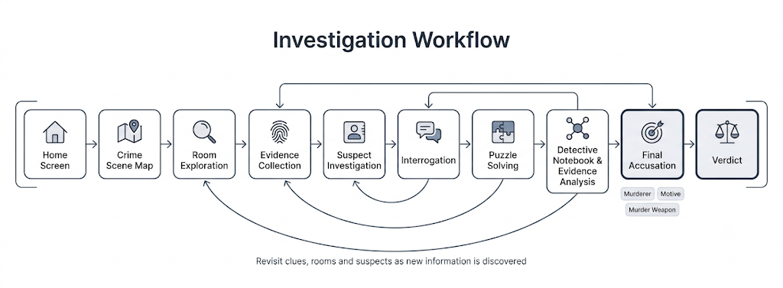
Because puzzles and interrogation outcomes are deliberately tied to previously discovered evidence, the workflow is not strictly linear: the user may revisit rooms, the evidence board, or suspect profiles at any point before submitting a final accusation, and the system is designed so that later stages of the investigation depend on, and make use of, information gathered in earlier stages.

8. Technology Stack
- HTML5 – semantic page structure for the home screen, crime scene views, evidence board, suspect profiles, interrogation interface, puzzle interfaces, and notebook/inventory views.
- CSS3 – layout, responsive design, visual styling, and animation used to create a consistent, investigation-themed user interface across all views.
- JavaScript – DOM manipulation, event handling, navigation logic, clue-discovery logic, evidence and inventory management, interrogation dialogue-path resolution, puzzle logic, detective-notebook updates, investigation-state management, and final-verdict evaluation.
- Browser LocalStorage – persistence of investigation progress, including discovered evidence, solved puzzles, visited rooms, interrogation progress, and case-selection state, so that an in-progress investigation may be resumed across browser sessions.
The application is designed to run entirely within the browser and does not require a backend server, database, or external API for its core functionality.

9. System Architecture / Implementation Approach
The implementation is organized around a central investigation-state object, maintained in JavaScript, which records the set of rooms visited, the evidence discovered, the inventory items collected, the interrogation questions asked and their outcomes, the puzzles solved, and the difficulty level selected for the current case. Individual modules – room exploration, the evidence board, suspect profiles, interrogation, puzzles, the notebook, and the inventory – are implemented as separate, modular JavaScript components that read from and update this shared state, rather than as independent scripts operating on isolated data.
User interface updates are handled through DOM manipulation driven by this state: for example, when a piece of evidence is discovered, the corresponding entry is added to the state object, the evidence board and detective notebook views are re-rendered to reflect the addition, and any interrogation questions or puzzle conditions that depend on that evidence become accessible. Conditional rendering is used throughout the application so that content such as locked rooms, unavailable dialogue options, or unsolved puzzles are presented differently from content the user has already unlocked.
At appropriate points – for example, after a room is explored, an item is collected, a puzzle is solved, or an interrogation is completed – the current investigation state is serialized and written to LocalStorage. On subsequent visits, this stored state is read back and used to reconstruct the user's progress, allowing the “Continue Game” option on the home screen to resume an investigation from where it was left off. The final accusation module compares the user's selected murderer, motive, and weapon against a predefined solution object and generates a verdict, together with an explanation drawing on the evidence and events recorded in the investigation state.
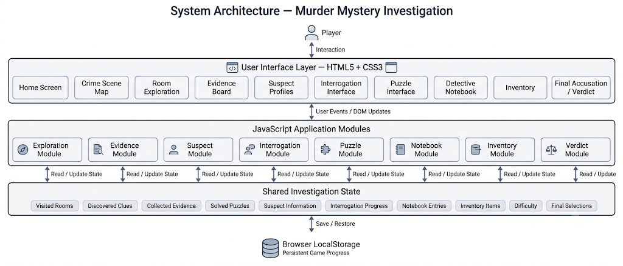

10. Expected Outcomes
- A functional, browser-based murder mystery investigation application built using HTML5, CSS3, and JavaScript.
- A crime scene exploration interface allowing navigation between multiple rooms and inspection of interactive objects.
- A working evidence-collection system linked to a centralized evidence board and an automatically updated detective notebook.
- Suspect profiles and a structured interrogation system driven by predefined, JavaScript-based dialogue logic.
- A set of narratively integrated puzzles whose completion reveals case-relevant information.
- A JavaScript-based investigation-state management system that consistently tracks the user's progress across all modules.
- Persistence of investigation progress across browser sessions using LocalStorage.
- A final accusation and verdict system that evaluates the user's conclusions against the case solution.

11. Scope and Future Enhancements
The current scope of the project is limited to a single investigation case, implemented entirely as a front-end, browser-based application using HTML, CSS, JavaScript, and LocalStorage, without a backend server, database, external API, authentication system, multiplayer functionality, or artificial intelligence component.
The following enhancements are identified as possible future work and are explicitly outside the scope of the current implementation:
- Support for additional, independent murder-mystery cases within the same application framework.
- More complex branching narratives with a greater number of interrogation paths and suspect outcomes.
- Enhanced evidence-board interactions, such as user-arranged connection diagrams linking evidence, suspects, and events.
- Improved animations and transition effects to strengthen the investigative atmosphere of the interface.
- Accessibility improvements, such as keyboard-only navigation and screen-reader-friendly markup, for a wider range of users.
- Procedurally varied case elements, such as randomized placement of evidence or suspect details, to increase replayability.
- Optional backend integration for features such as case sharing or persistent leaderboards, should the project be extended beyond its current front-end scope.

12. Conclusion
“Murder Mystery Investigation” is proposed as a front-end web application that demonstrates how HTML5, CSS3, and JavaScript can be used to build an interactive, state-driven investigative experience rather than a static or purely linear website. Its technical substance arises from the design of an interconnected system of modules – exploration, evidence collection, suspect investigation, interrogation, puzzle-solving, and the detective notebook – all coordinated through a shared, JavaScript-managed investigation state, with LocalStorage used to persist progress across sessions. The project is intended to demonstrate practical competence in DOM manipulation, event handling, client-side state management, conditional rendering, modular JavaScript design, and responsive interface design, within a realistic and clearly bounded front-end technical scope.

