Project Arduino Solar Tracker

Table of Contents
Subject Specification 2
Context 3
Hardware Requirements 3
Scheme 3
Pin Configuration 3
Operation 4
Automatic Control 4
Manual Control 4
Conclusion 4

Subject Specification
This Arduino-based Solar Tracker is designed to automatically adjust its position to follow the sun's path across the sky, optimizing solar energy absorption. It uses a set of Light Dependent Resistors (LDRs) and servo motors to adjust its orientation. The system also includes a manual control mode by using a phone, allowing for specific positioning via serial commands.

Context
We choose this project, because is exceptional for learning Arduino and to use many components like sensors, servo motors and solar panel. Also, beyond educational purposes, such a project can be used in real-world applications. It can be implemented in small-scale solar projects, like solar-powered lighting systems, charging stations, or as a part of a larger home solar setup.

Hardware Requirements
- Arduino board
- 2 Servo Motors
- 4 LDRs (Light Dependent Resistors)
- 1 Solar Panel
- 1 Push Button
- 1 LED
- Resistors, wires, and a breadboard for connections

Scheme
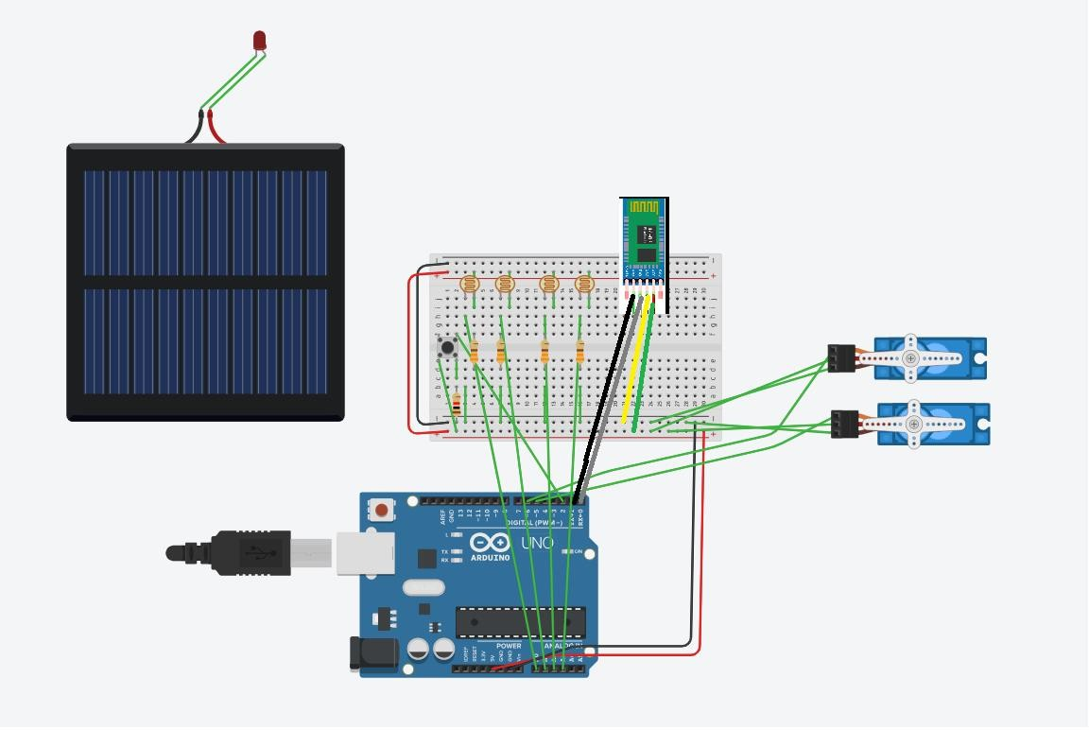

Pin Configuration
- Servo Motors: Connected to digital pins 5 (up-down movement) and 6 (left-right movement).
- LDRs: Connected to analog pins A0 (top-right), A1 (top-left), A2 (bottom-right), and A3 (bottom-left).
- LED: Connected to digital built-in pin 13.
- Button: Connected to digital pin 2.

Operation
The system can operate in tow modes. Pressing the button toggles between automatic and manual modes. In manual mode, the LED turns off and it remains on in automatic mode.

- Automatic Tracking Mode: The tracker automatically adjusts its position based on LDR readings to maximize exposure to sunlight.
- Manual Control Mode: Triggered by pressing the button. Allows manual adjustment of the tracker via serial commands.

Automatic Control
In automatic mode, the Arduino Solar Tracker automatically adjusts its position to optimize solar energy absorption. This mode primarily relies on data from four Light Dependent Resistors (LDRs) positioned at the corners of the solar panel. We calculate the average light levels for top, bottom, left, and right pairs of LDRs. This involves averaging the readings from the top two LDRs, the bottom two, the left two, and the right two. Therefore, the tracker only adjusts its position if the difference in light intensity between opposite LDRs exceeds a predefined threshold value. This threshold prevents unnecessary adjustments in response to minor or insignificant changes in light intensity.

Manual Control
The manual control mode allows the user to adjust the position of the solar panel through serial commands. Once the tracker is in manual mode, achieved by pressing the button, the user can input specific commands through the serial monitor. Using 'u' or 'd' followed by a number, the user can precisely control the left-right and up-down servo motors, respectively. This mode provides direct and customized control over the tracker's orientation, bypassing the automatic LDR-based adjustments. The process needs to be terminated by sending the 'q' command.

Example:
u40q = the command sets the position of the left-right servo motor to 40 degrees

Conclusion
In short, the Arduino Solar Tracker is a cool, smart gadget for getting the most out of solar energy. It automatically follows the sun or lets you take the reins when needed, blending tech smarts with green energy in a fun, practical way.

