PROGRAM NO. 1

AIM: Design simple calculation to implement Addition, Subtraction and Multiplication and division. ( CSVTU)
Coding:
Public Class Form1

Private Sub Button1_Click(ByVal sender As System.Object, ByVal e As System.EventArgs) Handles Button1.Click
TextBox3.Text = Val(TextBox1.Text) + Val(TextBox2.Text)
End Sub

Private Sub Button2_Click(ByVal sender As System.Object, ByVal e As System.EventArgs) Handles Button2.Click
TextBox3.Text = Val(TextBox1.Text) - Val(TextBox2.Text)
End Sub

Private Sub Button3_Click(ByVal sender As System.Object, ByVal e As System.EventArgs) Handles Button3.Click
TextBox3.Text = Val(TextBox1.Text) * Val(TextBox2.Text)
End Sub

Private Sub Button4_Click(ByVal sender As System.Object, ByVal e As System.EventArgs) Handles Button4.Click
TextBox3.Text = Val(TextBox1.Text) / Val(TextBox2.Text)
End Sub

Private Sub Button5_Click(ByVal sender As System.Object, ByVal e As System.EventArgs) Handles Button5.Click
TextBox3.Text = " "
TextBox1.Text = " "
TextBox2.Text = " "
End Sub
End Class
Output:-
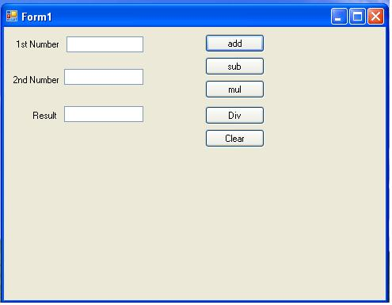

PROGRAM NO. 2

AIM: Design the marks sheet of student. Which Display all details including the total marks of student and percentage. ( CSVTU)
Coding:
Public Class Form1

Private Sub Button1_Click(ByVal sender As System.Object, ByVal e As System.EventArgs) Handles Button1.Click
Label9.Text = ((Val(TextBox3.Text) + Val(TextBox4.Text) + Val(TextBox5.Text)) / 300) * 100
Label10.Text = Val(TextBox3.Text) + Val(TextBox4.Text) + Val(TextBox5.Text)
End Sub
Output:-
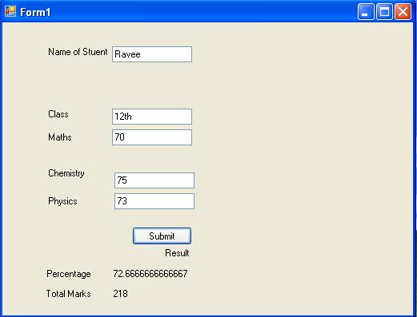

PROGRAM NO. 3

AIM: Create a from using button to give the effect of fonts such as Bold ,italic , underline strike through respectively for the text entered in the Rich Text Box.( CSVTU)
Coding:
Public Class Form1
Private Sub Button1_Click(ByVal sender As System.Object, ByVal e As System.EventArgs) Handles Button1.Click
If RichTextBox1.SelectedText <> "" Then
RichTextBox1.SelectionStart = RichTextBox1.Find(RichTextBox1.SelectedText)
Dim CurrentFont As Font = RichTextBox1.SelectionFont
Dim NewFontStyle As New FontStyle
With CurrentFont
NewFontStyle = -((Not .Bold) * FontStyle.Bold)
NewFontStyle += -(.Italic * FontStyle.Italic)
NewFontStyle += -(.Underline * FontStyle.Underline)
RichTextBox1.SelectionFont = New Font(CurrentFont, NewFontStyle)
End With
RichTextBox1.Focus()
End If
End Sub
Private Sub Button7_Click(ByVal sender As System.Object, ByVal e As System.EventArgs) Handles Button7.Click
End
End Sub
Private Sub Button2_Click(ByVal sender As System.Object, ByVal e As System.EventArgs) Handles Button2.Click
If RichTextBox1.SelectedText <> "" Then
RichTextBox1.SelectionStart = RichTextBox1.Find(RichTextBox1.SelectedText)
Dim CurrentFont As Font = RichTextBox1.SelectionFont
Dim NewFontStyle As New FontStyle
With CurrentFont
NewFontStyle = -((Not .Italic) * FontStyle.Italic)
NewFontStyle += -(.Bold * FontStyle.Bold)
NewFontStyle += -(.Underline * FontStyle.Underline)
RichTextBox1.SelectionFont = New Font(CurrentFont, NewFontStyle)
End With
RichTextBox1.Focus()
End If
End Sub
Private Sub Button3_Click(ByVal sender As System.Object, ByVal e As System.EventArgs) Handles Button3.Click
If RichTextBox1.Text <> "" Then
RichTextBox1.SelectionStart = RichTextBox1.Find(RichTextBox1.SelectedText)
Dim CurrentFont As Font = RichTextBox1.SelectionFont
Dim NewFontStyle As New FontStyle
NewFontStyle = -((Not CurrentFont.Underline) * FontStyle.Underline)
NewFontStyle += -(CurrentFont.Bold * FontStyle.Bold)
NewFontStyle += -(CurrentFont.Italic * FontStyle.Italic)
RichTextBox1.SelectionFont = New Font(CurrentFont, NewFontStyle)
End If
RichTextBox1.Focus()
End Sub
Private Sub Button11_Click(ByVal sender As System.Object, ByVal e As System.EventArgs)
If RichTextBox1.Text <> "" Then
RichTextBox1.SelectionStart = RichTextBox1.Find(RichTextBox1.SelectedText)
RichTextBox1.SelectionFont = New Font(RichTextBox1.Font, FontStyle.Regular)
RichTextBox1.Focus()
End If
End Sub
Private Sub Button4_Click(ByVal sender As System.Object, ByVal e As System.EventArgs) Handles Button4.Click
If RichTextBox1.SelectedText <> "" Then
RichTextBox1.SelectionStart = RichTextBox1.Find(RichTextBox1.SelectedText)
RichTextBox1.SelectionColor = Color.Red
RichTextBox1.Focus()
End If
End Sub
Private Sub Button5_Click(ByVal sender As System.Object, ByVal e As System.EventArgs) Handles Button5.Click
If RichTextBox1.SelectedText <> "" Then
RichTextBox1.SelectionStart = RichTextBox1.Find(RichTextBox1.SelectedText)
RichTextBox1.SelectionColor = Color.Green
RichTextBox1.Focus()
End If
End Sub
Private Sub Button6_Click(ByVal sender As System.Object, ByVal e As System.EventArgs) Handles Button6.Click
If RichTextBox1.SelectedText <> "" Then
RichTextBox1.SelectionStart = RichTextBox1.Find(RichTextBox1.SelectedText)
RichTextBox1.SelectionColor = Color.Blue
RichTextBox1.Focus()
End If
End Sub
Private Sub Button8_Click(ByVal sender As System.Object, ByVal e As System.EventArgs)
If RichTextBox1.SelectedText <> "" Then
RichTextBox1.SelectionStart = RichTextBox1.Find(RichTextBox1.SelectedText)
RichTextBox1.SelectionColor = Color.Black
RichTextBox1.Focus()
End If
End Sub
Private Sub Button10_Click(ByVal sender As System.Object, ByVal e As System.EventArgs)
Try
RichTextBox1.LoadFile("File.rtf")
Catch ex As Exception
MsgBox(ex.Message)
End Try
End Sub
Private Sub Button9_Click(ByVal sender As System.Object, ByVal e As System.EventArgs)
Try
RichTextBox1.SaveFile("File.rtf")
Catch ex As Exception
MsgBox(ex.Message)
End Try
End Sub
Private Sub Button3_Click_1(ByVal sender As System.Object, ByVal e As System.EventArgs) Handles Button3.Click
End Sub
End Class
Output:-
