


Chatgpt@280789
www.hexaware.com

© Hexaware Technologies Limited. All rights reserved.

© Hexaware Technologies Limited. All rights reserved.
Version: 1.1| Date: 9 January 2024| Author: Dhara Shah

VENDOR ASSESSMENT TOOL
Business Requirement Document
www.hexaware.com
© Hexaware Technologies Limited. All rights reserved.
Version: 1.1| Date: 14th Apr 2022| Author: Swati Pawar

KYC Training Tool
Business Requirement Document
- Content Area Content Area Content Area Content Area Content Area Content Area Content Area
- Content Area Content Area Content Area Content Area Content Area Content Area Content Area
- Content Area Content Area Content Area Content Area Content Area Content Area Content Area
- Content Area Content Area Content Area Content Area Content Area Content Area Content Area
- Content Area Content Area Content Area Content Area Content Area Content Area Content Area
Grow Digital >>

Shrink IT <<

VERTICALS
Table of Contents
1 Revision History 6
2 Approvals & Project Team 7
3 Introduction 8
3.1 Introduction to Vendor Assessment Tool 8
4 Objective and Scope 9
4.1 Objective: 9
4.2 Benefits: 9
4.3 Scope: 9
5 Business Requirements 11
5.1 Access Control 11
5.1.1 Admin 11
5.1.2 User 11
5.1.3 L1 12
5.1.4 L2 13
6 Process Flow 14
7 Login Module 16
7.1 Login 16
8 Admin 19
8.1 Home Page 19
8.2 App Master 19
8.3 User Role Mapping Master 21
9 User 25
9.1 Home Page 25
9.2 Dashboard 27
9.3 Vendor Registration Form 28
9.4 Vendor Assessment Form 32
9.5 Status of Vendor Assessment-User 41
9.6 Facility to edit parameters of Vendor Assessment Form 45
10 L1 46
10.1 Home Page 46
10.2 Dashboard 47
10.3 Approve | Reject Vendor Assessment – L1 48
10.4 Status of Vendor Assessment- L1 55
10.5 Reports 59
65
11 L2 69
11.1 Home Page 69
11.2 Dashboard 70
11.3 Approve | Reject Vendor Assessment – L2 71
11.4 Status of Vendor Assessment- L2 77
11.5 Reports 80
86
12 Overall Description 91
12.1 Product Perspective 91
12.2 Constrains 91
12.3 Assumptions 91
12.4 Dependencies 91

Revision History

Date | Version | Author | Comment/changes
11-09-2023 | 1.0 | Dhara Shah | Initial Draft
09-01-2024 | 1.1 | Dhara Shah | - Need to add post 6 months date in “Period To” field based on date from “Period from” field in Vendor Registration page. System should auto-calculate.  - The reminder mail to perform Vendor Assessment should be sent 7 days prior to Vendor assessment date to the User. There should be only 1 reminder mail.  - There should be a 7 day window open for User to perform Vendor assessment post the actual vendor assessment date.  - 1st escalation mail should go to L1 if user fails to perform vendor assessment in 7 day window.  - After 2 days of 1st escalation if user fails to perform vendor assessment, mail should be escalated to L2.  Note : Changes are highlighted in RED

Approvals & Project Team

Name | Position | Email ID | Reviewer (only) | Reviewer and Approver
Guttula Venkateshwarrao | Senior Manager (TNT) | GuttulaV@hexaware.com | X | X
Amit Shinde | Manager(AFI) | AmitShinde@hexaware.com | X | X
Ajay Wadekar | Senior Officer(AFI) | AjayW2@hexaware.com | X | X
Amit Sawant | Senior Developer(TNT) | AmitS3@hexaware.com | X | X
Dhara Shah | Business Analyst(TNT) | DharaS@hexaware.com | X

Introduction

Introduction to Vendor Assessment Tool
The Vendor Assessment Tool would be a powerful software solution designed to streamline and enhance the process of evaluating and managing vendor assessments within the organization."

Objective and Scope

Objective:
- The objective of the tool is to provide a comprehensive platform for assessing, monitoring, and optimizing vendor performance
- Efficient vendor management begins with the Vendor Assessment Tool, it will help the organization evaluate, collaborate with, and make informed decisions about the Vendors
- With the Vendor Assessment Tool, you gain access to a robust platform that empowers your team to assess, communicate with, and make data-driven decisions about your vendors with ease.

Benefits:
- Forms will be generated & documented digitally
- Feedback to Vendors will be given digitally
- No Cost is involved as Forms are digital
- Digital Signoff can be done
- Yearly Reports can be generated with Graphical Presentation, Parameters can be measured per vendor, Improvement Plans can be made accordingly by the Vendor
- Gain real-time visibility into vendor performance and compliance, enabling quick responses to issues or opportunities.

Scope:
- ADMIN
- Admin will also manage Masters like :-
- App Master
- User Role Mapping Master
- USER
- User will have access to :-
- Dashboard(Graphs)
- Vendor assessment form
- Vendor registration form
- Status of Vendor Assessment
- Facility to edit parameters of Vendor assessment form
- L1
- L1 will have access to:-
- Dashboards (Graphs)
- Approve/ reject Vendor assessment screen
- Status of Vendor assessment form
- Reports
- L2
- L2 will have access to:-
- Dashboards (Graphs)
- Approve/ reject Vendor assessment screen
- Status of Vendor assessment form
- Reports

Business Requirements

Access Control
Will create access control for the following users:
- Admin
- User
- L1(Approver)
- L2(Approver)

Admin
Admin will have following access
Admin Page Name | Access Type
App Master | Full control over App Master, including configuration settings for the application:--  - View  - Add  - Edit  - Active/Inactive
User Role Mapping Master | Full control over User Master, allowing user account creation & modification :-  - View  - Add  - Active/Inactive

User
User will have the following access
User Page Name | Access Type
Dashboard | View
Vendor Assessment Form | Full access to complete and submit the vendor assessment form:-  - View  - Submit
Status of Vendor Assessment Form | Read-only access to view the status of assessments they have submitted:-  - Search  - View  - Update
Edit Parameters of Vendor Assessment Form | Edit or to add Parameters:-  - Edit  - Add  - Save
Vendor Registration Form | Full access to register new vendors using the registration form  - Add  - Save

L1
L1 will have the following access.
L1 Page Name | Access Type
Dashboard | View
Approve/Reject Vendor Assessment Screen | Full access to review and approve or reject vendor assessment submissions :-  - View  - Approve  - Reject
Reports | Read-only access to reports, which may include assessment summaries and trends  - View  - Search
Status of Vendor Assessment Form | Read-only access to the status of all vendor assessment forms  - View  - Search

L2
L2 will have the following access.
L2 Page Name | Access Type
Dashboard | View
Approve/Reject Vendor Assessment Screen | Full access to review and approve or reject vendor assessment submissions, including those escalated from L1.  - View  - Approve  - Reject
Reports | Similar to L1, read-only access to reports that may include broader assessment summaries and trends.  - View  - Search
Status of Vendor Assessment Form | Read-only access to the status of all vendor assessment forms  - View  - Search

Process Flow
- Process Flow of Vendor Assessment Portal
- "There would be 4 roles in tool :
- a. User
- b. L1
- c. L2
- d. Admin (L1's will be generally Admins)"
- User would login to the tool
- User gets two tabs One is Vendor Registration & Other is Vendor Assessment form
- User needs to click on Vendor Assessment form & search the Vendors registered, if he doesn’t finds the Vendor then has to register it by clicking the Vendor registration Tab. If User wants to add parameters in the form he can edit the form
- User needs to click on the Vendor name which is in the Vendor Assessment Form List
- Vendor Assessment Form will be displayed with all the parameters with rating Tabs
- User needs to select the rating in the dropdown between (1-5) rating. (5 – Excellent, 4 – Very Good, 3 – Average, 2- Poor, 1- Very Poor
- If vendor needs to be blacklisted then User will have to click on the Blacklist Vendor tab with a reason
- User needs to rate all the parameters & then click on Save button
- User can make changes before clicking on the Submit button
- User then needs to click on the Submit button, Once he clicks on the submit button the Form will be sent to his L1 Approver
- L1 Approver will review the Form, thus has two options -Approve & Reject
- If L1 Approver approves the Form which has ratings Less than 3.5 then L2 will get Vendor termination mail & if L1 rejects it will be redirected to the user
- L2 has two options Approve & Reject, If L2 approves same will be documented as Inactive, Vendor will receive an Email for Vendor termination
- If L2 rejects then same will be redirected to L1
- If L1 Approver approves the Form which has ratings more than 3.5 then L2 will get email & if L2 rejects it will be redirected to the L1
- If L2 Approves then same will be digitally documented as ACTIVE VENDOR. Also the feedback for the same will go to the Vendor
- Flowchart of Vendor Assessment Tool

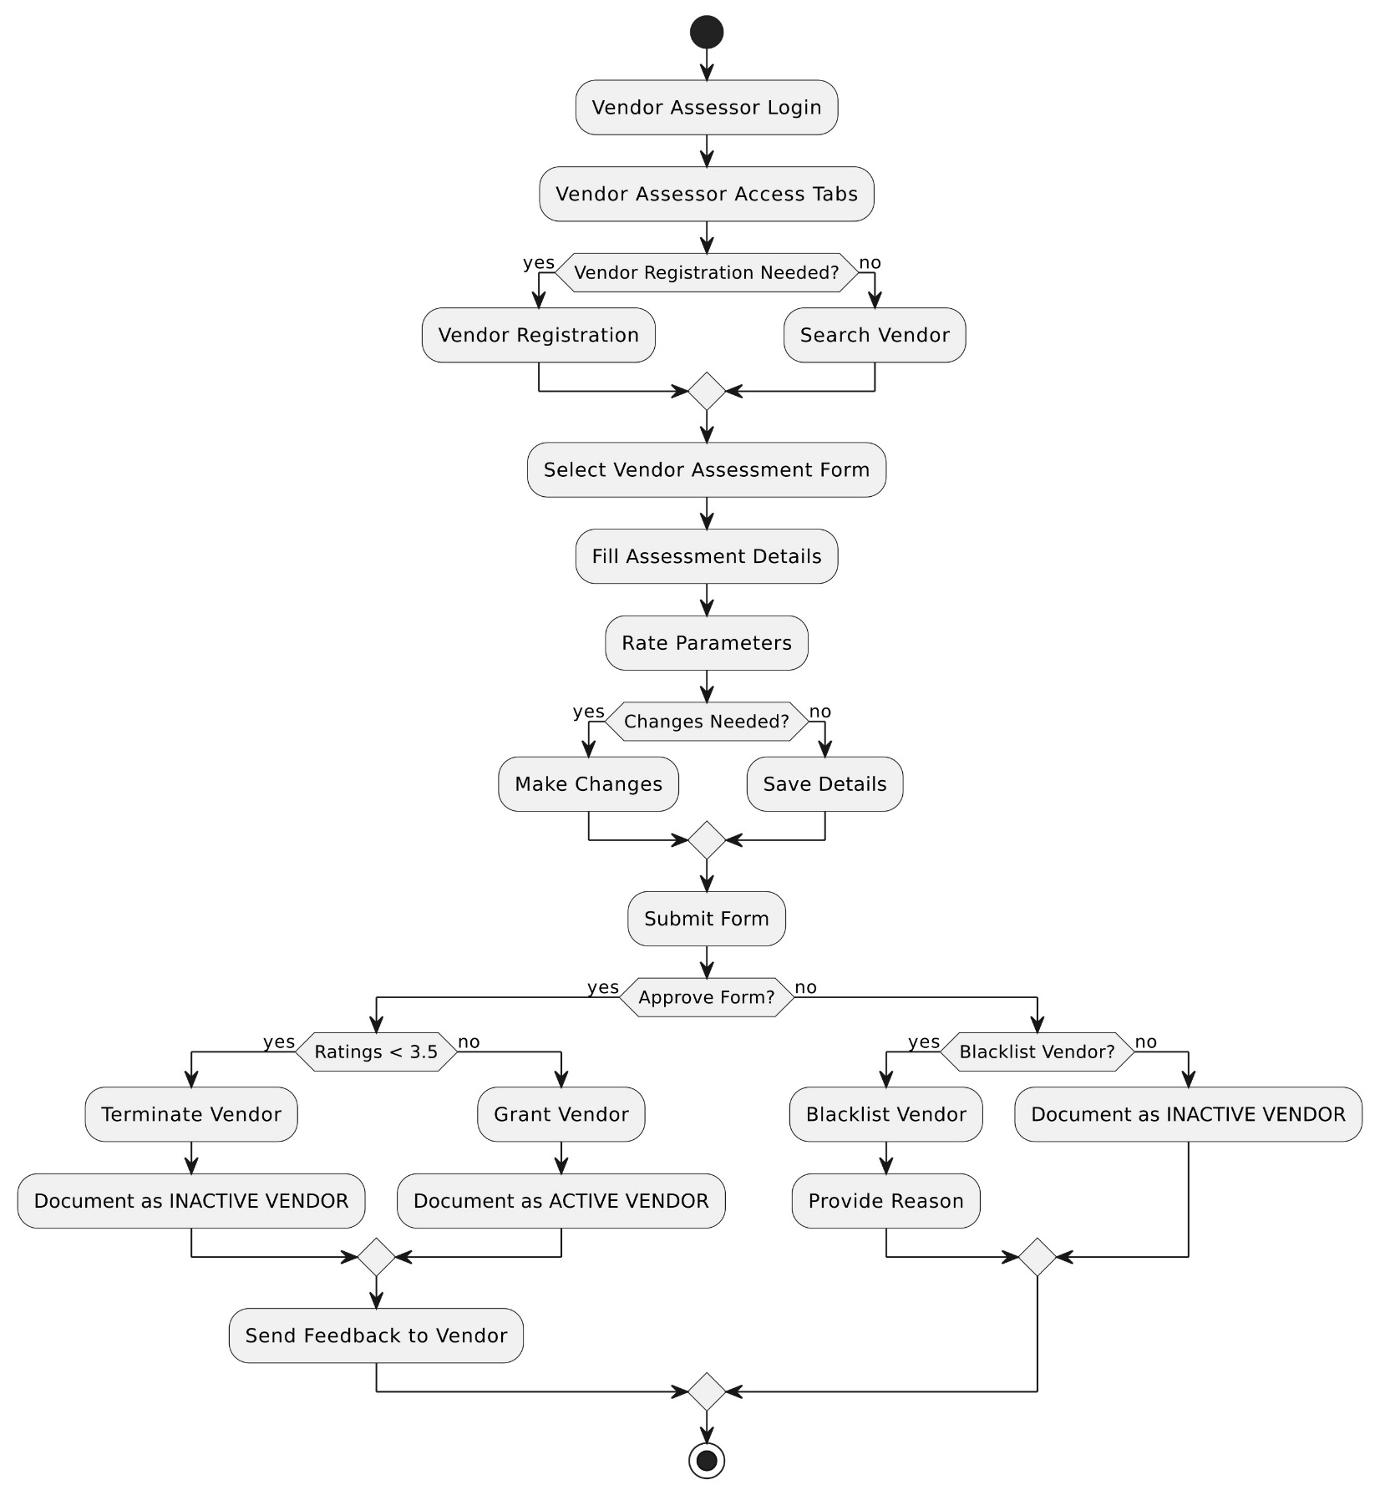

Login Module

Login
- The Vendor Assessment tool is accessible to only those users who are registered in the tool with a specific role
- As per their role , the Admin/user/L1/L2 would have access
- When Admin / User/ L1/L2 will open the application he/she will get the login page.
- Here user will provide his/her User ID, Password and select Role (Admin / User/ L1/L2)
- Login would be based on Windows Credentials i.e. Windows User ID and password. The login credentials would be verified with ESS data.
- Main Success Scenario
- The Admin/User/L1/L2 launches the Vendor Assessment Tool application.
- The system presents the Login screen, which includes fields for:[Refer Figure 1]
- Username
- Password
- "Login" button
- The Admin/User/L1/L2 enter their username and password.
- The system validates the entered credentials against the ESS data and role saved in the system.
- If the credentials are valid:
- The system grants access to the Admin/User/L1/L2.
- The user is redirected to their dashboard or landing page.
- If the credentials are invalid:
- If the entered credentials (username and/or password) are incorrect, the system displays an error message and prompts the user to re-enter the information.(Refer Figure 2)
- The user has a limited number of login attempts (e.g., three attempts) before being temporarily locked out for security reasons

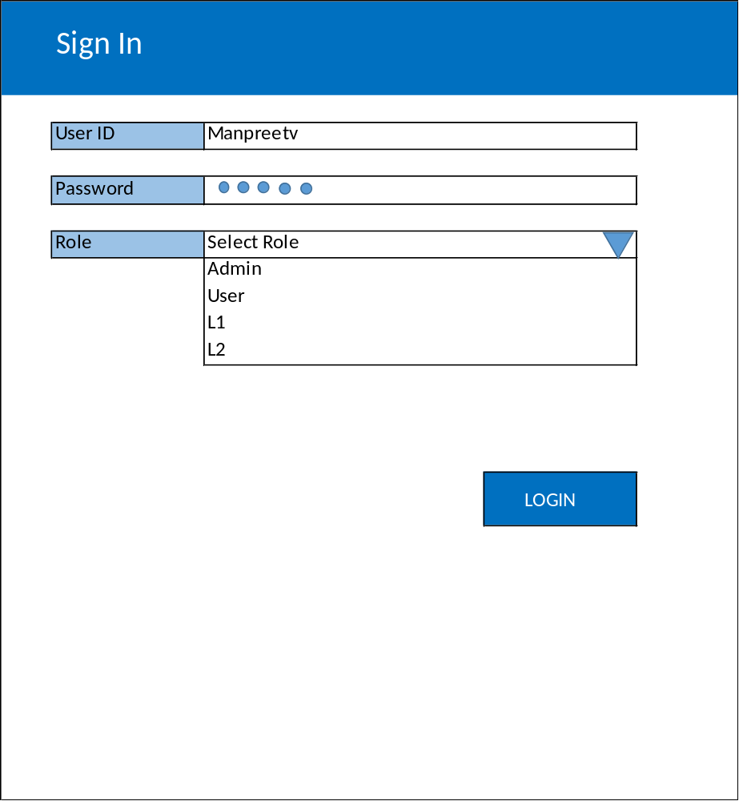
Figure 1
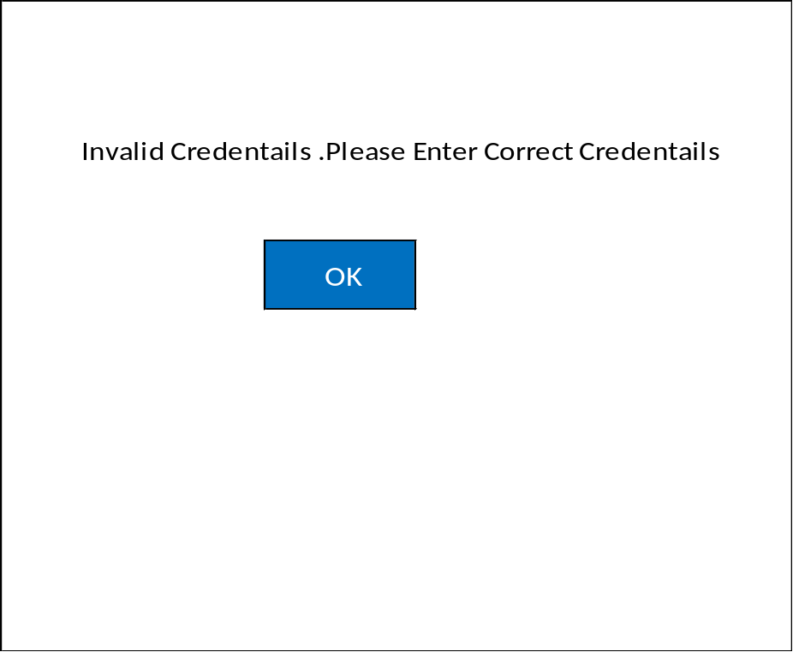
Figure 2

Admin

Home Page
- The Admin will have access to following :-
- Masters :-
- App Master
- User Role Mapping Master

App Master
- The App master would be used to enter all details that would be used commonly throughout the Application
- The App master would store values for following sections:-
- Location
- Role
- AMC Status
- Contract Type
- Note: There could be even more section type’s added as and when required
- Please refer the following screen :-
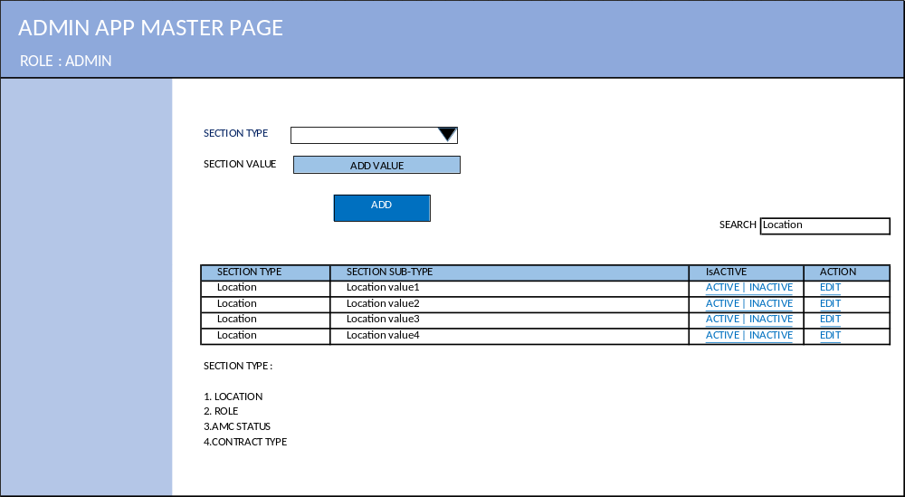
Figure 3
- Following controls would be present on the screen :-
Control Name | Control Type | Data Type
Section Type | Dropdown [Values fetched from Database] | Text
Section Value | Text Box [Enter value for Section type selected] | Text
Add | Button[To save details in database] | NA
Search | Search Box[Search Values in Grid] | Text
Grid Name- App master Values | Grid[To display values added in system] | NA

- The Admin needs to select a particular section type from dropdown [Section type would be predefined and coming from Database]
- The Admin needs to enter the Section value against that and click on Add button. Value would be saved into the System
- Once the value is saved into the system , it would display in the grid[Refer figure 3]
- Following fields would be present in the screen :-
Field Name | Field Type
Section Type | Varchar
Section Value | Varchar
Is Active | Hyperlink
Action | Hyperlink

- The Section type and Section value would be displayed
- Against each record there would be 2 hyperlinks :-
- Is Active
- Action
- Is Active :-
- So in case if a particular Section type is no longer required , the Admin can simply change the status of it from Active to In active or vice - versa
- If the status of a section type is changed to Inactive, it would no longer be used in the system.
- By default, the value of each Section type stored would be Active.
- Action :-
- If the Admin wants to edit the Section value for a particular section type , can simply click on Edit
- Section type would be non-editable. Only Section value would be available for edit.

User Role Mapping Master
- In the Vendor Assessment Portal , there would also be an additional master i.e. User Role Mapping Master
- User Role Mapping Master would be used to assign role to a particular user. So at the time of logging, the particular User would enter his/her credentials and select role from role dropdown, based on that system will verify the role of the user stored in User role Mapping master and if that role is active, provide access as per his/her role.
- Please find the below screen shot of where the tab would come under masters.
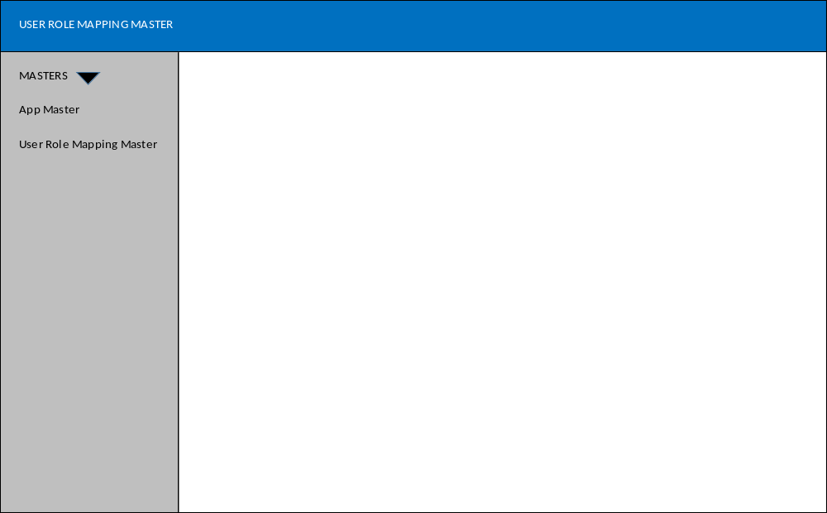
User Role Mapping Master
Figure 4
- When the Admin clicks on User role Mapping master, he/she would be redirected to below screen
(Refer Figure 5)
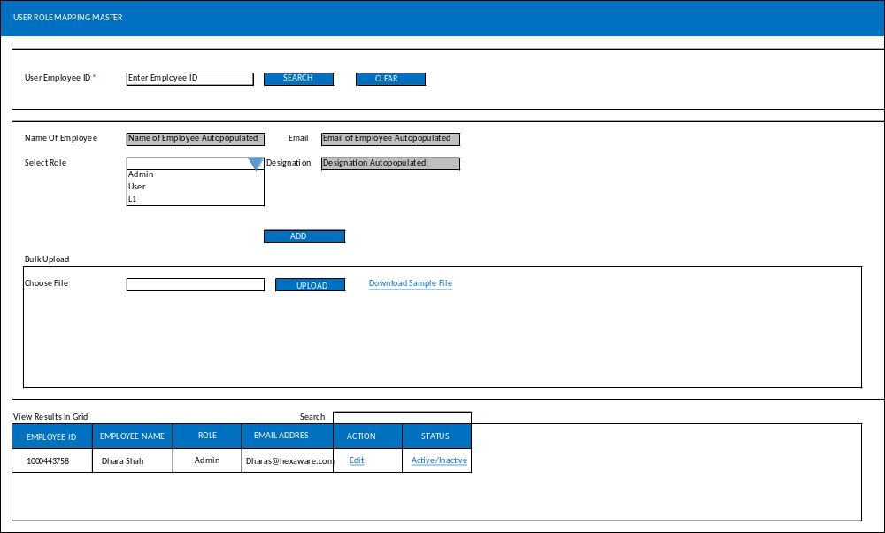
Figure 5
- There would be 2 ways to assign Role to an existing employee
- Manual Entry
- Bulk Upload
- Following elements would be present on User Role Mapping master Screen Single Entry
Element Name | Control Type | Data Type
*User Employee ID(Mandatory if Single entry) | Text Box | Text
Search | Button | NA
Clear | Button | NA
Name of employee | Text Box(Value Auto populated) | Text
Email ID | Text Box(Value Auto populated) | Text
Designation | Text Box(Value Auto populated) | Text
Location | Text Box(Value Auto populated)
*Select Role(Mandatory if Single entry) | Dropdown | Text
Add | Button | NA
Choose File | File Upload | NA
Upload | Button | NA
Download Sample File | Hyperlink | NA
View results in Grid | Grid | NA
Search | Text Box | Text

- Note: Can change as per requirement
- Manual entry
- The Admin needs to enter the employee ID of the User and click on Search button
- When the Admin hits the search button , the system auto populates details like Name of employee ,Email ID , Location and Designation from ESS
- Then the Admin needs to select appropriate role from the Select role dropdown i.e. “Admin”/”User”/”L1”/”L2”
- After that the Admin will click on Add button
- On Clicking Add button, the System validates the mandatory fields as mentioned in above table.
- The entry would be saved in database and displayed under Grid
- Bulk Upload
- Following fields would be present on User Role Mapping master Screen Bulk Upload
- * Employee ID
- * Name of Employee
- Designation
- Email ID
- * Location
- * Role
- The Admin can refer to download sample file
- All the records added would be displayed in the grid. The Admin has two additional options in grid against each record i.e. Action and Status
- Following Fields would be displayed in the Grid:-

Field Name | Field Type
Employee ID | Alphanumeric
Employee Name | Varchar
Role | Varchar
Email Address | Alphanumeric
Designation | Varchar
Action | Hyperlink
Status | Hyperlink

- Edit
- With the edit functionality , the Admin can change the role of the employee
- Active | Inactive
- The Admin can change the status of employee from active to inactive or vice versa
- By default the status would be active, if the employee is no longer active in the organization, the admin can change the status to inactive.
- That employee would no longer be allowed to login to the tool
- Clear
- Clear button will clear all the details on the page
- Search
- Search box would be used as a generic search to search records in grid by employee id, employee name, email id or role, etc.

User

Home Page
- The User will be initiating the Vendor Assessment for a particular Vendor that belongs to his/her respective location
- The User will have access to following :-
- Dashboard (Graphs)
- Vendor Registration Form
- Vendor Assessment Form
- Status of Vendor Assessment
- Edit Parameters of Vendor Assessment Form
- Please refer the below screen
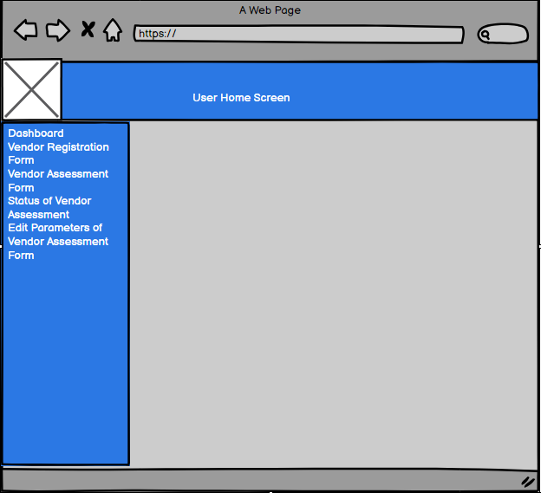
Figure 6

Dashboard
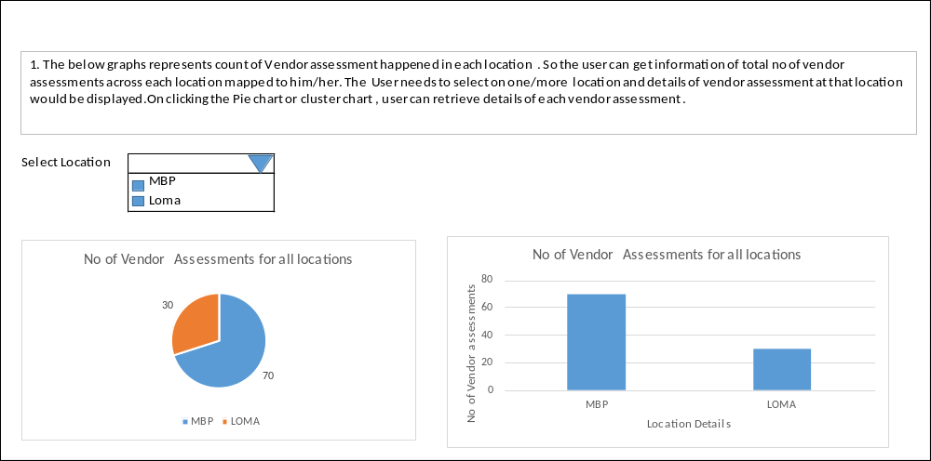
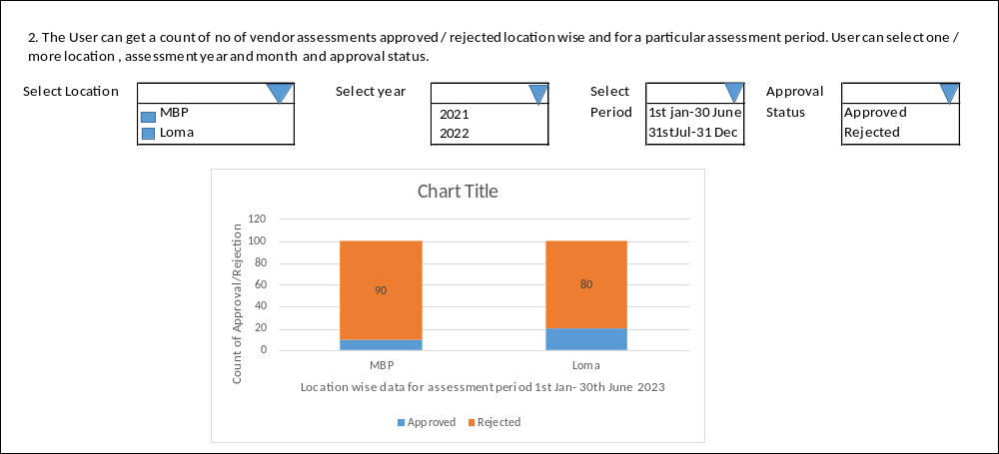
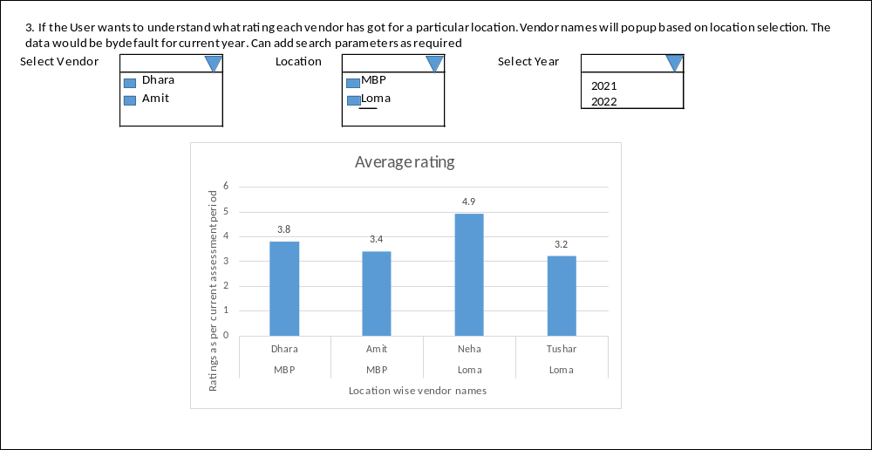
- Note – The dashboard filters and parameters can change as per development.

Vendor Registration Form
- The Vendor Registration functionality is designed to allow users to register new vendors into the Vendor Assessment Tool.
- So before a Vendor is eligible for Vendor assessment , he/she needs to be registered into the system
- So after the Vendor is registered for a particular location as that of a user , the Vendor can be assessed
- The User can only assess Vendor that belongs to his/her location
- When the User clicks on Vendor Registration Page , below screen will open up
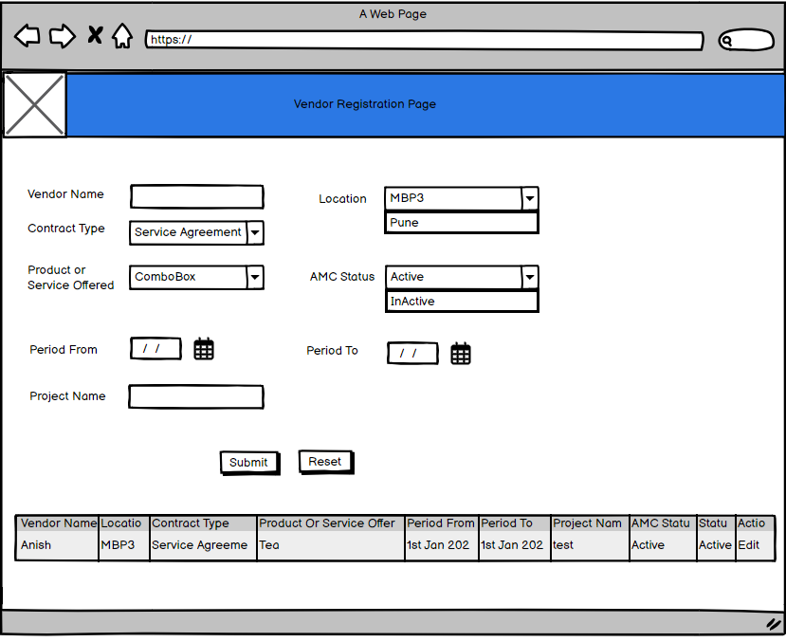
Figure 7
- 1. Registration Process Overview
- 1.1. Initiating Registration:
- Users can initiate vendor registration through the Vendor Assessment Tool.
- 1.2. Registration Form:
- A registration form shall be provided to collect vendor information.[Refer figure 7]
- Following elements would be present on vendor Registration Screen :-

Element Name | Control Type | Data Type
*Vendor Name(Manual entry) | Text Box | Text
*Location | Location value as that of User | NA
*Contract Type | Dropdown Value fetched from App master | NA
*Product Or Service Offered | Dropdown Value fetched from App master (Should Provide a provision to add multiple Product Or Service Offered) | NA
* AMC Status | Dropdown Value fetched from App master(Active/Inactive/Blacklisted) | NA
* Period From | Date Picker | NA
* Period To | Date Picker – 6 months post “Period From” date. Automatically calculated by system. | Text
* Project Name(Manual Entry) | Text Box | Text
Submit | Button | NA
Reset | Button | NA

- Note : * Marked fields are mandatory
- Submit
- The User needs to fill following details as per above table and click on Submit button
- The System shall validate entered information is correct and in proper format
- The System shall also validate whether duplicate record is present or not in the database. If all the fields are matching and location value is different, system should allow to save the Vendor details in table.
- Upon successful registration, the system shall generate and assign a unique Vendor ID to the registered vendor. Refer below figure 8
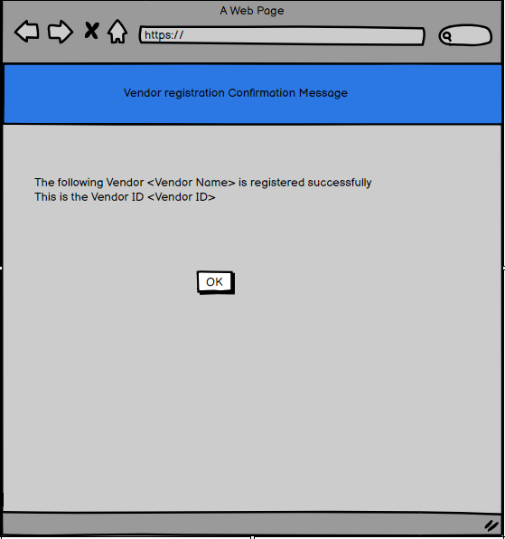
Figure 8
- Also the details will get added in database and displayed on the grid[Refer figure 7]
Field Name | Field Type
Vendor Name | Varchar
Location | Varchar
Contract Type | Varchar
Product or Service Offered | Varchar
AMC Status | Varchar
Period From | Date
Period To | Date
Project Name | Varchar
Status | Hyperlink
Action | Hyperlink

- Status Hyperlink
- The User has a facility to change the status of vendor i.e. from active to Inactive and vice versa.
- If the status of Vendor is changed to Inactive, the AMC status would also change to Inactive and vice –versa.
- If the vendor status is changed to Inactive, he/she would no longer be eligible for Vendor assessment
- Note: If the Vendor is marked inactive by Approvers and in future if the User wants to change the AMC status from Inactive to Active, they can come on this screen and change it. The Vendor if again made active will be available for assessment and also period from would be from Current month till next 6 months.
- Action Hyperlink
- The User will have the ability to edit all details of Vendor except name.
- Clear
- Clear button will reset all the fields on Vendor Registration page

Vendor Assessment Form
- Once a vendor is registered, he/she is eligible for the assessment.
- User needs to click on Vendor Assessment form & search the Vendors registered, If he doesn’t finds the Vendor then has to register it by clicking the Vendor registration Tab[Refer Section 9.3]
- Vendor Assessment will be done twice a year i.e. between 1st Jan -30 Th June and 1st July - 31st Dec. So if a vendor is registered on 1st February, then his/her vendor assessment should happen post 6 months i.e. on 31st August. So system has to calculate 6 months post the joining date of vendor.
- The User will get vendor assessment reminder mail 7 days prior to the Assessment date i.e. on 24th /25th August as per previous example. The User will be allowed to take up vendor assessment post 31st August i.e. till 7 days form 1st -7th September. The window would be open for 7 days.
- Note: The User would not be allowed to take any assessment before 31st August.
- Vendor assessment would be done for 2 kinds of vendor :-
a. Service Vendor
b. Technical Vendor
- Vendor assessment is done to check and rate the vendor's service in past 6 months
- Every 6 months vendor assessment should be performed
- There could be a case that if one vendor belongs to two different locations , then vendor assessment has to be performed separately for that vendor based on his/her joining date and location and services provided.
- So there should also be a different vendor assessment for same vendor for two different services provided
- Please find the below screen
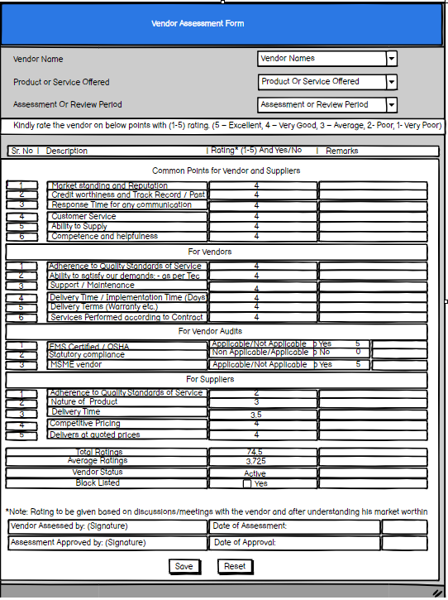
Figure 9
- When the User clicks on Vendor Assessment form above screen would be displayed{Refer Figure 9]
- Assessment process Overview
- As per above screen , following elements would be present on the screen

Element Name | Control Type | Data Type
*Vendor Name | Dropdown Value (Coming from Vendor master i.e. vendor names whose location is same as that of user and whose Vendor assessment is pending) | NA
*Product or Service Offered | Dropdown Value(Coming from Vendor Master) | NA
*Assessment Or review Period | Dropdown Value –Actual vendor assessment date post 6 months of registration date calculated from the system | NA
*Grid | Select parameters Consisting of SrNo, Description, Ratings and Remarks(Total 20 parameters) | NA
Total ratings | Total value of ratings of all 20 parameters | Greyed out field- Auto calculated by System
Average Ratings | Calculate Average Rating = Sum of all Rating / No of Parameters | Greyed out field- Auto calculated by System
Vendor Status | Whether Active / Inactive. Calculated based on Average rating | Greyed out field – Text
Blacklisted | Checkbox Yes/No | NA
Vendor Assessed By : Signature | Signature of L1 | Value filled by L1 when sent for approval
Date of Assessment | Approved by L1 | Date of Approval
Assessment Approved By :Signature | Signature of L2 | Value filled by L2 when sent for approval
Date of Approval | Approved by L2 | Date of Approval
Save | Button | NA
Reset | Button | NA

- Firstly, the User will have access to list of all vendors that belong to his/her location and whose assessment is due and who are active.
- Then the products Or service offered will have list of different products and services that vendor offers
- Note: - Assessment or review Period would be automatically calculated based on the assessment period i.e. between 1st Jan -30 Th June and 1st July - 31st Dec. So if a vendor is registered in February, then his/her vendor assessment should happen post 6 months i.e. in August. So system has to calculate 6 months post the joining date of vendor. So need to calculate the assessment period based on that.
- Note: - Every 6 months the assessment should be performed. If the vendor is marked Active, then his service with the company extends for next 6 months. Post those 6 months, again a vendor assessment is performed
- After that User will get access to the total 20 parameters which would have Rating and Remark Column[Refer figure 9]
- The User has to provide a rating between 1-5 for each parameter
- Also the User can also provide remark against each parameter. User Remarks are not mandatory.
- Note : For Vendor Audits Section , there would be a checkbox whether Applicable/Not applicable for the 3 parameters in that section and basis rating would be generated
- Applicable – 5
- Not Applicable – 0
- Note : All parameters are mandatory in Vendor assessment form
- Once all the ratings for all parameters are given , there is a field called Total ratings which gives the total value of all ratings
- Then there is one more field i.e. Average Ratings. The calculation for this field is
- Average Rating = Sum of all Rating / No of Parameters
- Then there is a field called Vendor Status that will display whether the Vendor is active / Inactive. It would be a greyed out field. The final status of vendor in this field would change based on average rating and approval of L1 and L2.By default it would be active
- Then there would be a field called Blacklisted, against which there would be a checkbox for Yes/No. If user wants to mark that vendor as Blacklisted , can simply do that by checking the checkbox
- Note: If a vendor is marked Blacklisted, then when the assessment goes for approval to L1 and L2, then if the L1 and L2 approve it, the vendor would be marked as blacklisted otherwise the vendor would be marked as “Inactive”.
- Then there would be following fields :-
- Vendor Assessed By : Signature
- Date of Assessment
- Assessment Approved By :Signature
- Date of Approval
- These fields would be greyed out , they would only be accessible to L1 and L2 at the time of approval
- Save
- Once all ratings are provided against each parameter and Total ratings and average ratings are calculated , User will hit save button
- The system will verify whether ratings against each parameter is provided or not,
- If the ratings against each parameter is not provided, then system will highlight those parameters and would prompt the user to provide rating against each parameter.
- If yes, it will send the mail and form as an attachment to L1 who belongs to same location [Need to fetch location of all L1 saved in User Role mapping master that matches with that of Vendor] and then to L2 [There would be only 1 L2 and he/she would have access to all vendor assessments across all locations]. Also the details would be saved in database and unique vendor assessment Id would be created
- Please find the below screen
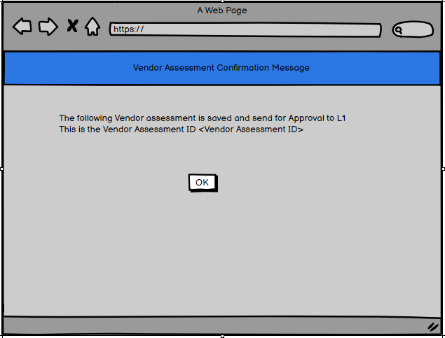
Figure 10
- Also the status of Vendor Assessment would be “pending” ”[Refer status table in section 10.3 ]
- Please find the below email format when the User creates a vendor assessment, mail should go to L1 for approval

- Email Subject: Vendor assessment approval request: [Vendor name]
- Email Content:

Dear < L1 approver name>,
Please approve Vendor Assessment for [Vendor Name]

To approve/reject the assessment, please log in to the vendor assessment tool and click on the " Approve/ reject Vendor assessment-L1” tab

Approve: If you approve the assessment, the assessment will go to L2
Reject: If you reject the assessment, it will be returned to User.

Please find the below details

Vendor Assessment ID | [Vendor Assessment Id]
Vendor Name : | [Vendor Name]
Assessment Date: | [Assessment Date]

Please find the attached Vendor Assessment Form

If you have any questions, please contact at [Email address].
Thank you for your cooperation.

Regards,
(Required From Business)

- L1 and L2 would have 2 options after reviewing the Form :- Approve & Reject
- If L1 Approver approves the Form which has ratings Less than 3.5 then L2 will get Vendor termination mail & if L1 rejects it will be redirected to the user
- L2 has two options Approve & Reject, If L2 approves same will be documented as Inactive Vendor will receive an Email for Vendor termination
- If L2 rejects then same will be redirected to L1
- If L1 Approver approves the Form which has ratings more than 3.5 then L2 will get email & if L2 rejects it will be redirected to the L1
- If L2 Approves then same will be digitally documented as ACTIVE VENDOR. Also the feedback for the same will go to the Vendor
- Reset
- Reset option will clear all ratings and remarks against each parameter on Vendor assessment form
- Note: Before the Vendor assessment date, mail should go on 7th day prior to vendor assessment date to User that assessment for following vendor is upcoming. Please complete it. Say for e.g. the Vendor assessment date is 31st August then the reminder mail should go on 25th August. There should be only 1 reminder mail .
- Here is a mail format for sending a reminder to the user about an upcoming vendor assessment:
- Note : Number of Days :7
- Date Range : 7 day window after actual vendor assessment date
- Email Subject: Vendor assessment reminder: [Vendor name] ([Number of days] days remaining)
- Email Content:

Dear < User Name>,
This is a reminder that the vendor assessment for [Vendor name] is due in [Number of days] days. Please complete the assessment between this [Date Range] .To complete, click on the "Vendor Assessment Form" tab.

Please find the below details

Vendor Name : | [Vendor Name]
Assessment Date Range: | [Date Range]

If you have any questions, please contact the vendor assessment team at [Email address].
Thank you for your cooperation.

Regards,
(Required From Business)

- Here is an example of how you would use this mail format to send a reminder to the user 7 days prior to the vendor assessment date:
- 15th Day:-
- Email Subject: Vendor assessment reminder: <Vendor Name> (15 days remaining)
- Email Content:

Dear < User Name>,
This is a reminder that the vendor assessment for [Vendor name] is due in 15 days. Please complete the assessment by [Due date]

To complete the assessment, please log in to the vendor assessment tool and click on the "Vendor Assessment Form" tab.

Please find the below details

Vendor Name : | [Vendor Name]
Assessment Deadline: | [Assessment Date]

If you have any questions, please contact the vendor assessment team at [Email address].
Thank you for your cooperation.

Regards,
(Required From Business)

- 10th Day:-
- Email Subject: Vendor assessment reminder: <Vendor Name> (10 days remaining)
- Email Content:

Dear < User Name>,
This is a reminder that the vendor assessment for [Vendor name] is due in 10 days. Please complete the assessment by [Due date]

To complete the assessment, please log in to the vendor assessment tool and click on the "Vendor Assessment Form" tab.

Please find the below details

Vendor Name : | [Vendor Name]
Assessment Deadline: | [Assessment Date]

If you have any questions, please contact the vendor assessment team at [Email address].
Thank you for your cooperation.

Regards,
(Required From Business)

- 5th Day:-
- Email Subject: Vendor assessment reminder: <Vendor Name> (5 days remaining)
- Email Content:

Dear < User Name>,
This is a reminder that the vendor assessment for [Vendor name] is due in 5 days. Please complete the assessment by [Due date]

To complete the assessment, please log in to the vendor assessment tool and click on the "Vendor Assessment Form" tab.

Please find the below details

Vendor Name : | [Vendor Name]
Assessment Deadline: | [Assessment Date]

If you have any questions, please contact the vendor assessment team at [Email address].
Thank you for your cooperation.

Regards,
(Required From Business)

- Also there could be a scenario that in spite of sending so many reminders , the user does not perform Vendor assessment
- If User fails to assess a vendor in the 7 days window post assessment date as described above , mail should escalate to L1 and CC: User
- Email Subject: Vendor assessment escalation: [Vendor name]
- Email Content:
Dear < L1 Approver Name>,
CC : < User Name >
I am writing to escalate the vendor assessment for [Vendor name]. The vendor assessment was due on [Due date], but the user, [User name], has not yet assessed the vendor or submitted the vendor assessment form

I am requesting your assistance in completing the vendor assessment for [Vendor name].

Please find the below details

Vendor Name : | [Vendor Name]
Assessment Deadline: | [Assessment Date]

If you have any questions, please contact me at [Email address].

Thank you for your time and assistance.

Regards,
(Required From Business)

- If User still fails to perform vendor assessment , then post 2 days of L1 escalation , mail will get escalated to L2
- Note: In all cases User will only perform the Vendor assessment.
- Email Subject: Vendor assessment escalation: [Vendor name]
- Email Content:
Dear < L2 Approver Name>,
CC : <L1>< User Name >
I am writing to escalate the vendor assessment for [Vendor name]. The vendor assessment was due on [Due date], but the user, [User name], has not yet assessed the vendor or submitted the vendor assessment form

I am requesting your assistance in completing the vendor assessment for [Vendor name].

Please find the below details

Vendor Name : | [Vendor Name]
Assessment Deadline: | [Assessment Date]

If you have any questions, please contact me at [Email address].

Thank you for your time and assistance.

Regards,
(Required From Business)

Status of Vendor Assessment-User
- Once the User saves the Vendor assessment , it gets sent to L1 and then L2 for approval
- Meanwhile if the User wants to check that Vendor assessment is at which stage , he/she can come to this screen “Status of Vendor Assessment” and check the status
- Please check the below screen:-
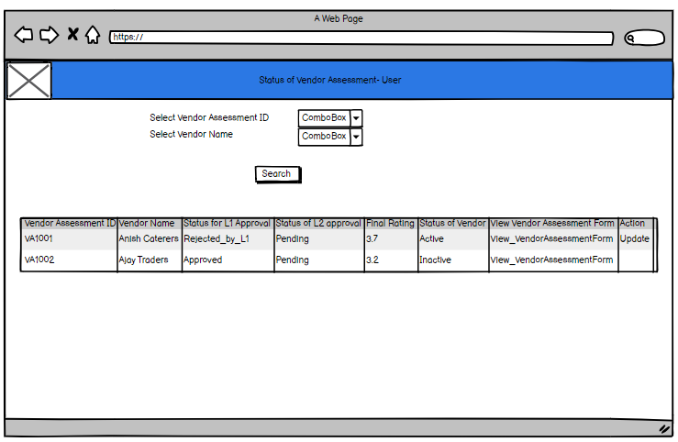
Figure 11
- Following elements would be present on the screen

Element Name | Control Type | Data Type
Vendor Assessment ID | Dropdown Value (Coming from Vendor Assessment master raised by user) | NA
Vendor Name | Dropdown Value(Coming from Vendor Master only active Vendors and list of vendors that have same location as that of user, please match it with vendor assessment id) | NA
Search | Dropdown Value -Auto calculated from System | NA
Grid | Grid consists of following :-  - Vendor Assessment ID  - Vendor Name  - Status for L1 approval  - Status of L2 approval  - Final Rating  - Status of Vendor  - View – View the Vendor Assessment Form  - Update – This option would only be available if L1 rejects a particular Vendor assessment and it again comes to User | NA

- When the User comes to this screen, he /she will have 2 search filters i.e. Vendor Assessment ID and Vendor Name
- Note : Filters can change as per development
- The User can select one or both filters and click on search button. If none of the filters are selected, data in grid would be displayed for all vendor assessment ID and Vendor list w.r.t User.
- The User can only view Vendor assessments raised by him/her and which belong to his/her location.
- Fields present in grid:-

Field Name | Field Type
Vendor Assessment ID | Alphanumeric
Vendor Name | Varchar
Status for L1 Approval | Varchar
Status for L2 Approval | Varchar
Final Rating | Numeric[Up to 2 decimal]]
Status of Vendor | Varchar
View | Hyperlink
Update | Hyperlink

- Note: The values in the grid can change as per development.
- View:-
- When the User wants to view the vendor assessment form , he/she can click on View hyperlink against any record
- There would be 2 options for the User either to export the Vendor Assessment or take a print out of it.
- Please find the below screen:-
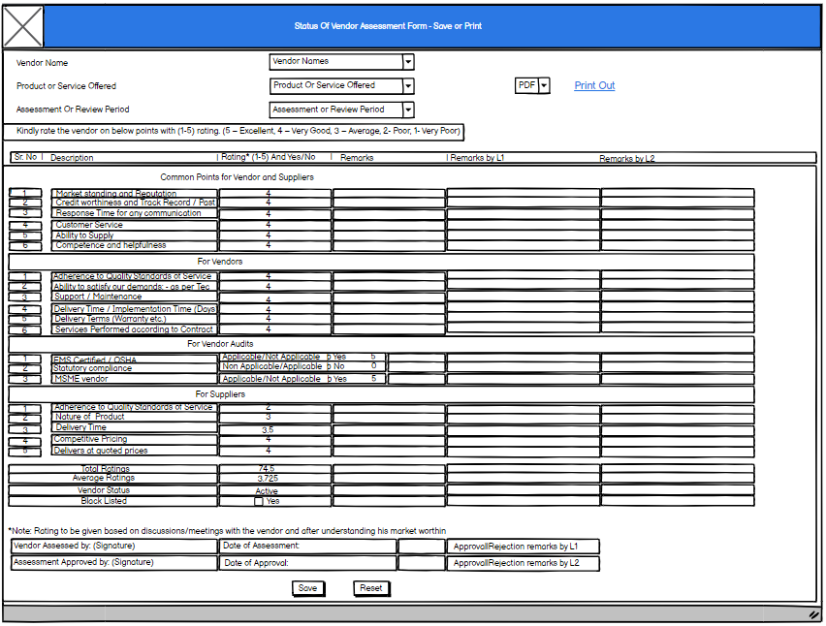

- Update :-
- When the L1 rejects a vendor Assessment, it again comes to user bucket. At that time the status of Vendor Assessment would be “Rejected_by_L1” [Refer status table in section 10.3 ]
- The User can again come to this screen and hit the update hyperlink against those records which are rejected by L1
- Note: Update hyperlink would only be available for records rejected by L1
- The entire form would be editable to User along with remarks for each parameter. The user cannot edit the remarks given by L1 or L2, he/she can only view it.
- The User can again edit the ratings based on L1/L2 remark and again save the form .The updated details would be saved in the database and the form would be again sent to L1 for approval. Also at this time the status of Vendor Assessment would be “Pending_Post_Rejection L1”[Refer status table in section 10.3 ]
- There would be 2 options to either to save the updated Vendor assessment form or reset all the ratings or parameters selected and entered by User.

Facility to edit parameters of Vendor Assessment Form
- There could be a scenario where the User can edit the parameters of the Vendor Assessment form
- So need to keep all the parameters on form editable
- The User can add or delete the parameter
- Once the parameters are edited, can save the details and the same vendor assessment form would be used further for assessment.

L1

Home Page
- The L1 will be approving/rejecting the vendor assessment initiated by User
- The L1 will have authority to approve/reject a particular vendor’s assessment who belongs to same location as that of him/her
- The L1 will have access to following :-
- Dashboards (Graphs)
- Reports
- Approve/ reject Vendor assessment screen
- Status of Vendor assessment form
- Please refer the below screen
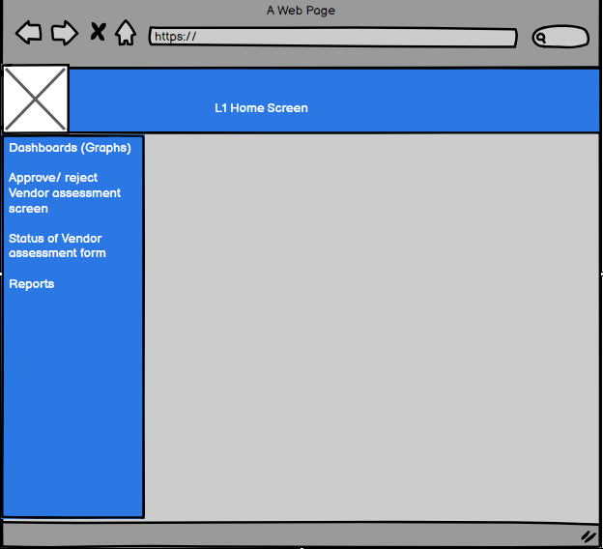
Figure 12

Dashboard
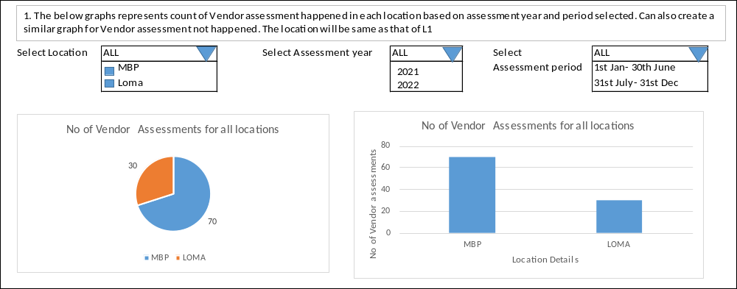
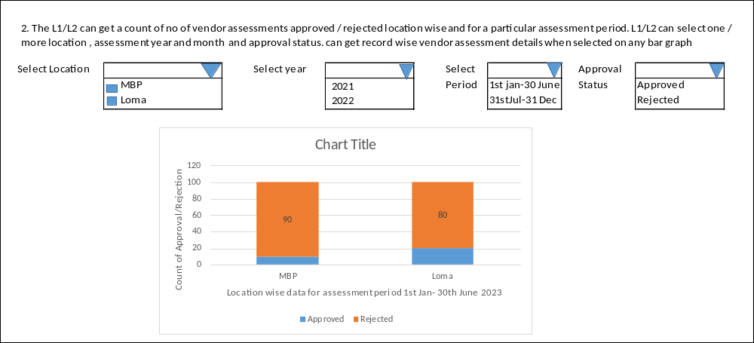
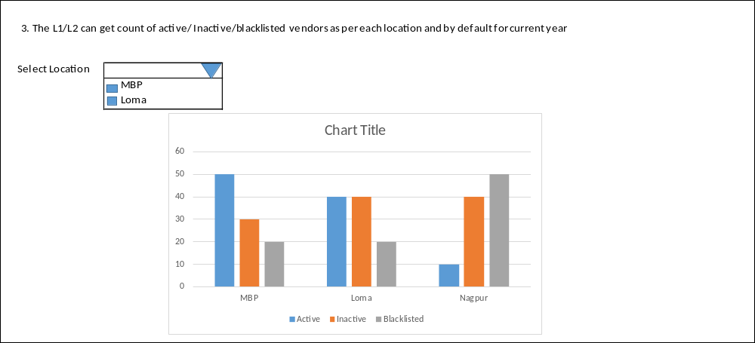
- Note: - All L1 will have access to details specific to his/her location
- Note – The dashboard filters and parameters can change as per development.

Approve | Reject Vendor Assessment – L1
- When the User initiates the Vendor Assessment of a particular Vendor who belongs to his/her location , then a mail is triggered to L1 for approval | Rejection.
- Note: Need to restrict only 1 L1 for a particular location. If vendor assessments are created in same location and different department then whoever is the respective L1 for that department will get approval form
- Also the L1 will have visibility of that form on this screen
- L1 Approver will review the Form, thus has two options -Approve & Reject
- Please refer below screen
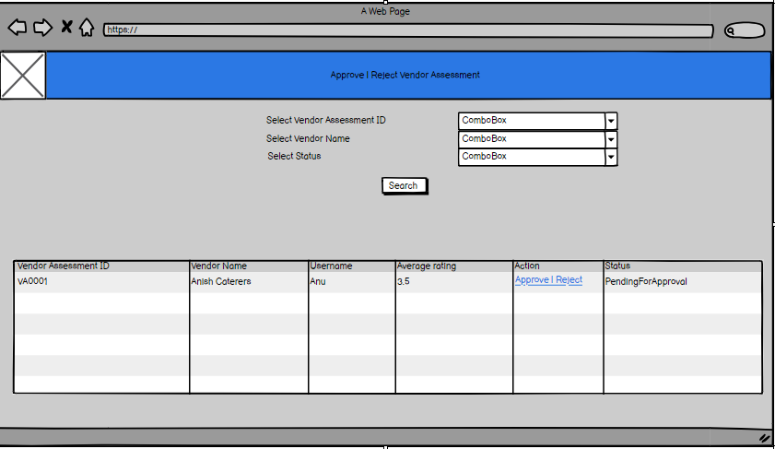
Figure 13
- Note: The fields in the grid can change as per development.
- So the L1 will come to this screen to Approve | reject the vendor assessment
- Following elements are present on the Screen :-

Element Name | Control Type | Data Type
Vendor Assessment ID | Dropdown Value (Coming from Vendor Assessment master) | NA
Vendor Name | Dropdown Value(Coming from Vendor Master only active Vendors and list of vendors that have same location as that of L1) | NA
Status | Dropdown Value (Coming from App Master with this status i.e. “Pending”,”Pending_Post_Rejection_L1”,”Pending_Post_Rejection L2”)
Search | Button | NA
Grid | Grid consists of following :-  - Vendor Assessment ID  - Vendor Name  - User Name  - Average Rating  - Action  - Status | NA

- The L1 will select either of the filters i.e. Vendor Assessment ID, Vendor Name or the status
- Only records that have status as “Pending”,”Pending_Post_Rejection_L1”,”Pending_Post_Rejection L2” will be displayed in the grid.[Refer figure 13]
- Following Status and their meaning w.r.t L1
Status | Description
Pending | When User initiates the Vendor Assessment form, the form is available under L1 bucket for approval. At that time it is available under Approve | Reject Vendor Assessment Screen –L1 with Status as “Pending” and Status of Vendor Assessment Screen-L1
Approved_By_L1 | When the L1 approves a particular Vendor Assessment, then it goes to L2 for Approval. At that time the status of the Vendor Assessment would be “Approved by L1”. This kind of record would be visible under Status of Vendor Assessment Screen-L1
Rejected_By_L1 | When the L1 rejects a particular Vendor Assessment, it again goes to user. At that time the status of Vendor Assessment would be “Rejected_by_L1”. This kind of record would be visible under Status of Vendor Assessment Screen-L1
Pending_Post_Rejection L1 | When the User updates the vendor Assessment form post rejection by L1 and sends it back to L1, then it again comes under L1 bucket, the status of that Vendor Assessment would be “Pending_Post_Rejection L1”. It will be visible under Approve | Reject Vendor Assessment Screen –L1 and Status of Vendor Assessment Screen-L1
Pending_Post_Rejection_L2 | When the L1 approves a particular vendor assessment, it goes to L2 for approval. So in case if the L2 rejects a particular Vendor Assessment then it comes to L1 again for approval. At that time the status of the Vendor Assessment form is “Pending_Post_Rejection_L2”. It will be visible under Approve | Reject Vendor Assessment Screen –L1 and Status of Vendor Assessment Screen – L1

- Then the L1 needs to click on Action Column “Approve | Reject” against a particular record in the grid
- Following screen will be displayed
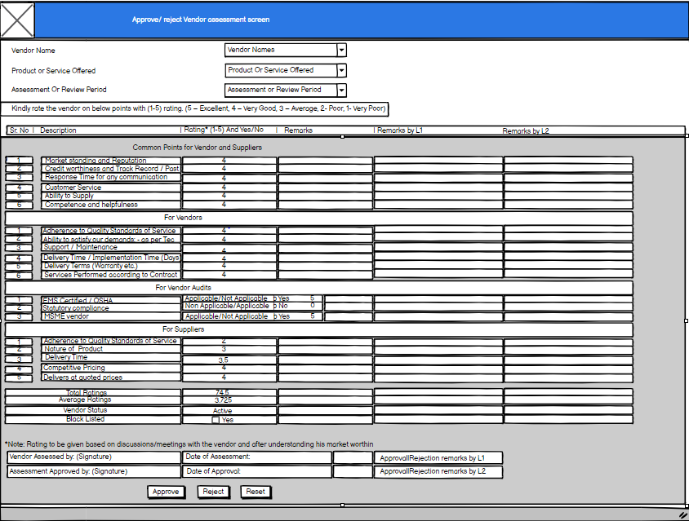
Figure 14
- Following elements would be visible on the form:-

Element Name | Control Type | Data Type
*Vendor Name | Dropdown value – Not editable | NA
*Product or Service Offered | Dropdown value – Not editable | NA
*Assessment Or review Period | Dropdown value – Not editable | NA
*Grid | Parameters Consisting of SrNo, Description, Ratings and Remarks, Remarks by L1, Remarks by L2 if rejected by L2 and again sent to L1. Only L1 remarks would be editable and rest fields non-editable | NA
Total ratings | Total value of ratings of all 20 parameters – Non editable | Greyed out field- Auto calculated by System
Average Ratings | Calculate Average Rating = Sum of all Rating / No of Parameters – Non editable | Greyed out field- Auto calculated by System
Vendor Status | Whether Active / Inactive – Non editable. Based on Average rating | Greyed out field – Text
Blacklisted | Non-editable | NA
Vendor Assessed By : Signature | Signature of L1 | Value filled by L1 when sent for approval by user
Date of Assessment | Approved by L1 | Date of Approval by L1
Approval | Rejection Remarks by L1 | Textbox - Editable | Text filled by L1. Mandatory in case of rejection
Assessment Approved By :Signature | Signature of L2 | Value filled by L2 when sent for approval by L1
Date of Approval | Approved by L2 | Date of Approval by L2
Approval | Rejection remarks by L2 | Textbox – Non editable | Remarks by L2
Approve | Button | NA
Reject | Button | NA
Reset | Button | NA

- The rest of the fields would be uneditable in the form only the “Remarks column by L1” against each parameter and “Approval or Rejection remarks by L1” would be editable.
- The L1 will be able to view the remarks given by User against each parameter and then provide his/her remarks against each parameter
- The Final remarks i.e. “Approval or Rejection remarks by L1” is mandatory in case of rejection by L1. Rest remarks against each parameter are not.
- There should be a provision to capture digital signature for L1 approver which would be displayed against “vendor Assessed By : Signature” field on the Vendor Assessment form
- Also the Date of Assessment would be captured as current date.
- The L1 approver will have 3 options i.e. either to Approve , Reject Vendor assessment form and Reset the remarks on the form
- Approve
- If L1 Approver approves the Form which has average ratings Less than 3.5 then L2 will get Vendor termination mail & status of the Vendor assessment would be “Approved_By_L1”
- Also If L2 approves same , Vendor will be documented as Inactive Vendor and will receive an Email for Vendor termination
- If L1 Approver approves the Form which has average ratings more than 3.5 then L2 will get email & status of the Vendor assessment would be “Approved_By_L1”
- If L2 Approves then same will be digitally documented as ACTIVE VENDOR. Also the feedback for the same will go to the Vendor
- Case:-When L1 approves Vendor Assessment, mail will go to L2 for approval. CC: User who initiated Vendor assessment.
- Email Subject: When L1 Approves the Vendor Assessment
- Email Content:

Dear < L2 approver name>,
CC <User Name who initiated the Vendor Assessment>
I am writing to request your approval for the vendor assessment for [Vendor name]. The vendor assessment has already been approved by L1[L1 Approver Name]

To approve/reject the assessment, please log in to the vendor assessment tool and click on the " Approve/ reject Vendor assessment-L2” tab

Approve: If you approve the assessment, the vendor will be marked as active/Inactive based on rating and will receive feedback.
Reject: If you reject the assessment, it will be returned to me for further review.

Please find the below details

Vendor Assessment ID | [Vendor Assessment Id]
Vendor Name : | [Vendor Name]
Assessment Date: | [Assessment Date]

Please find the attached Vendor Assessment Form

If you have any questions, please contact at [Email address].
Thank you for your cooperation.

Regards,
(Required From Business)

- Reject
- If L1 rejects it will be redirected to the user, the status would be “Rejected by L1”. The final remark i.e. “Approval | rejection remarks by L1” is mandatory on rejection.
- The User will receive email
- Case : When L1 rejects Vendor assessment , mail will be sent to User who initiated the Vendor assessment
- Email Subject: Vendor assessment rejection: [Vendor name]
- Email Content:

Dear < User>,
I am writing to inform you that the vendor assessment for [Vendor name] has been rejected.

Please address the issues listed in the form and resubmit the vendor assessment form.
To resubmit the assessment, please log in to the vendor assessment tool and click on the "Status of Vendor Assessment – User” tab and search for the record and click Update hyperlink.

If you have any questions, please contact at [Email address].
Thank you for your cooperation.

Regards,
(Required From Business)

- The user will have the entire form editable along with its ratings and remarks. Remarks by L1/L2 would not be editable
- When The User again updates the vendor Assessment and sends it back to L1 , then the status of the Vendor assessment would be “Pending_Post_Rejection L1”
- Also the L1 can again come to this screen, search for the record and either Approve | reject the record by updating his/her remarks. Only the “remarks by L1” field against each parameter and
Final remarks “Approval | rejection remarks by L1” would be enabled.
- Note: Also when the L2 rejects a particular vendor Assessment that is approved by L1, then that record again comes back to L1. The status of the Vendor Assessment would be “Pending_Post_Rejection L2”. Also the L1 can again come to this screen, search for the record and either Approve | reject the record by updating his/her remarks. Only the “remarks by L1” field against each parameter and Final remarks “Approval | rejection remarks by L1” would be enabled. L1 can only view the remarks given by L2.
- Note : The Approve or Reject hyperlink in grid would be only active for those Vendor Assessment records whose status would be following :-
- Pending
- Pending_Post_Rejection L1
- Pending_Post_Rejection_L2
- Reset
- The Reset option will help to clear all the remarks field on the Vendor Assessment form.

Status of Vendor Assessment- L1
- The L1 after approving/rejecting a particular vendor assessment , can check the status of that vendor assessment from this screen
- Please check below screen
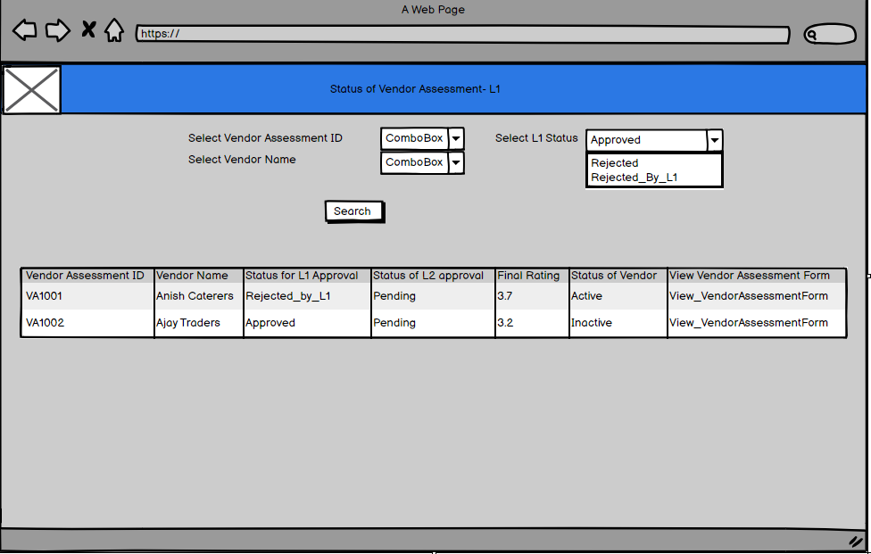
Figure 15
- Following elements would be present on the screen

Element Name | Control Type | Data Type
Vendor Assessment ID | Dropdown Value (Coming from Vendor Assessment master. All records:-  - pending,  - Approved_By_L1  - Rejected_By_L1  - Pending_Post_Rejection L1  - Pending_Post_Rejection_L2)  Would be displayed. | NA
Vendor Name | Dropdown Value(Coming from Vendor Master only active Vendors and list of vendors that have same location as that of L1) | NA
L1 Status | Dropdown Value(Unique L1 status value Coming from table where Vendor assessments are saved)
Search | Button | NA
Grid | Grid consists of following :-  - Vendor Assessment ID  - Vendor Name  - Status for L1 approval  - Status of L2 approval  - Final Rating  - Status of Vendor  - View – View the Vendor Assessment Form | NA

- When the L1 comes to this screen, he /she will have 3 search filters i.e. Vendor Assessment ID , Vendor Name and Status
- Note : Filters can change as per development
- The L1 can select one or more filters and click on search button. If none of the filters are selected, data in grid would be displayed for all vendor assessment ID and Vendor list w.r.t L1 and all status.
- Fields present in grid:-

Field Name | Field Type
Vendor Assessment ID | Alphanumeric
Vendor Name | Varchar
Status for L1 Approval | Varchar
Status for L2 Approval | Varchar
Final Rating | Numeric[Up to 2 decimal]]
Status of Vendor | Varchar
View | Hyperlink

- Note: The values in the grid can change as per development.
- View:-
- When the L1 wants to view the vendor assessment form , he/she can click on View hyperlink against any record
- There would be 2 options for the L1 either to export the Vendor Assessment form or take a print out of it.
- Please find the below screen:-
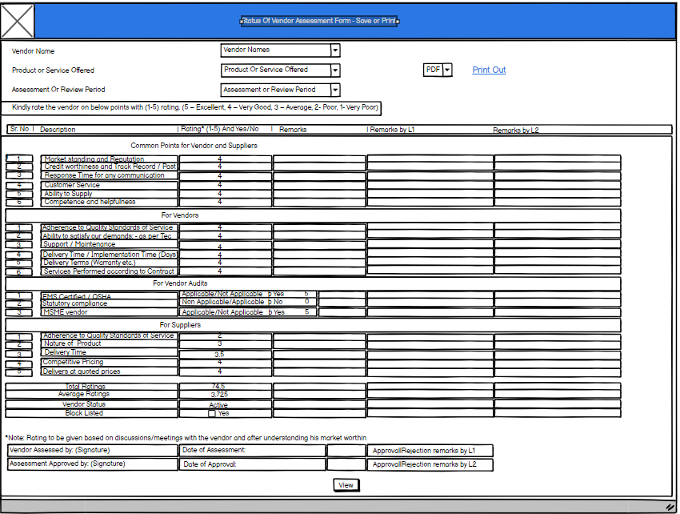
Figure 16

Reports
- When the L1 would come to this screen , he/she can access below reports :-
- Total No. of Vendor Assessed-Location wise
- Total No. of Vendor Assessed Active, Inactive, Blacklisted-Location wise
- Total No. of Vendor needs to be accessed-Location wise
- Total No. of Vendor exceeded due date-Location wise

- Total No. of Vendor Assessed – Location Wise :-
- This report will give information as to how many total no of vendor’s are assessed for a particular location
- So the L1 will only have list of locations for which he/she is mapped to. Also there would be a filter for selecting year and basis on selection of year , there would a filter of Assessment period
- So say for e.g. for MBP location , for Year 2021 and Assessment period between 1st Jan to 30th June , 20 vendor assessments were done
- Note : There would be 2 assessment period by default i.e. from :-
- 1st Jan – 30th June
- 1st July – 31st Dec
- Please find the below screen
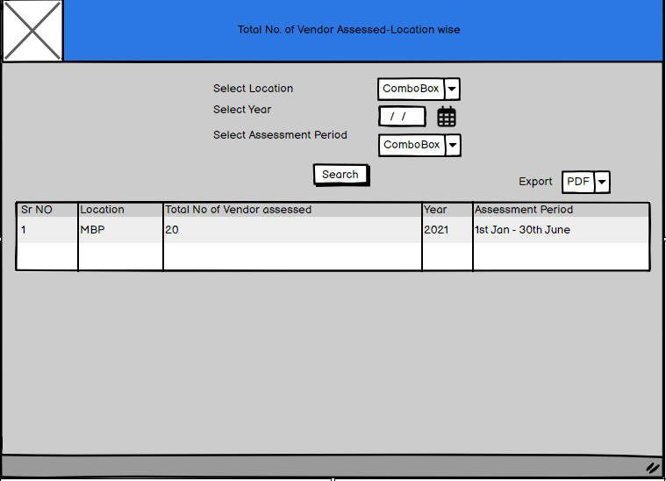
Figure 25
- L1 can even export the Report in Excel or PDF format
- Also if none of the filters are selected , data would be generated based on all locations mapped o L1 , for all years and for both assessment periods
- Following elements would be present on the screen

Element Name | Control Type | Data Type
Location | Dropdown Value (Unique locations mapped to L1) | NA
Year | Date picker | NA
Assessment Period | Dropdown Value(2 assessment periods as i.e. 1st Jan – 30th June and 1st July – 31st Dec) | NA
Search | Button | NA
Grid | Grid consists of following :-  - Sr No  - Location  - Total No of Vendor assessed  - Year  - Assessment period | NA
Export | Dropdown Value (Excel or PDF) | NA

- Can also give an expand functionality on clicking a particular record, individual list of all vendors assessed in that location would be displayed
- Also along with that each Vendor’s name, total rating, average rating and status would be displayed. Please refer below screen
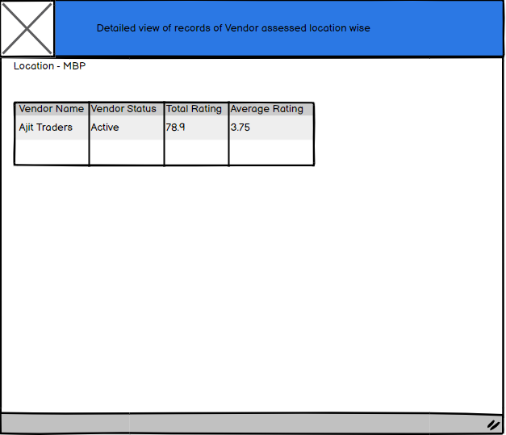
Figure 24
- Total No. of Vendor Assessed Active, Inactive, Blacklisted-Location wise:-
- This report will give total count of how many vendors are Active , Inactive or blacklisted for a particular location and Year
- There would be 3 filters on Screen –
- Location
- Year
- Status
- L1 will get list of all locations mapped to him/her. He/she can select a location and year and status whether Active / Inactive/Blacklisted
- If none of the filters are selected , data would be populated for all locations mapped to L1 , all year till date and all status
- Please find the below screen
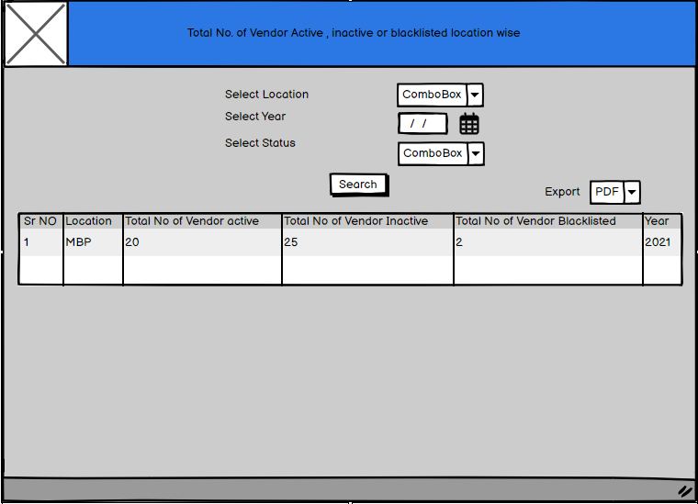
Figure 23

- Following elements would be present on the screen

Element Name | Control Type | Data Type
Location | Dropdown Value (Unique locations mapped to L1) | NA
Year | Date picker | NA
Status | Dropdown Value ( Unique values from App master) | NA
Search | Button | NA
Grid | Grid consists of following :-  - Sr No  - Location  - Total No of Vendor active  - Total No of Vendor Inactive  - Total No of Vendor blacklisted  - Year | NA
Export | Dropdown Value (Excel or PDF) | NA

- Can also give an expand functionality on clicking a particular record, list of all individual Vendors active, blacklisted or inactive location wise would be displayed.
- Also along with that each Vendor’s name, total rating, average rating and status would be displayed. Please refer below screen
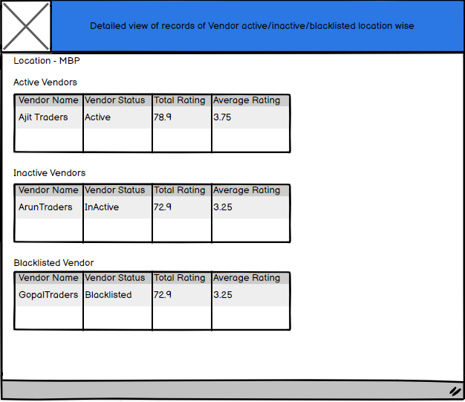
Figure 24
- Total No. of Vendor needs to be accessed-Location wise
- This report will give total count of how many vendors are to be assessed location wise and for a particular year
- There would be 2 filters on Screen –
- Location
- Year
- L1 will get list of all locations mapped to him/her. He/she can select a location and year
- If none of the filters are selected , data would be populated for all locations w.r.t L1 , all year till date
- Please find the below screen

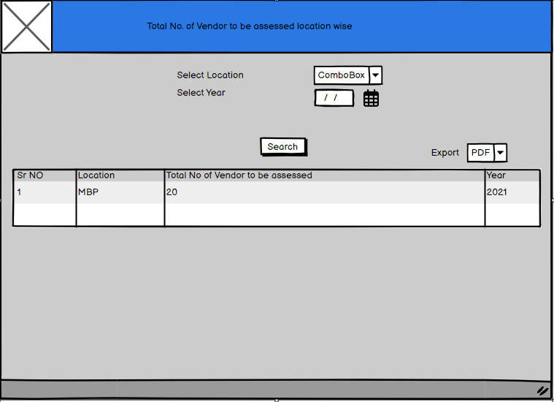
Figure 25
- Following elements would be present on the screen

Element Name | Control Type | Data Type
Location | Dropdown Value (Unique locations mapped to L1) | NA
Year | Date picker | NA
Search | Button | NA
Grid | Grid consists of following :-  - Sr No  - Location  - Total No of Vendor to be assessed  - Year | NA
Export | Dropdown Value (Excel or PDF) | NA

- Can also give an expand functionality on clicking a particular record, list of all individual Vendors to be assessed location wise will be displayed.
- Also along with that each Vendor’s name, status and assessment date would be displayed.
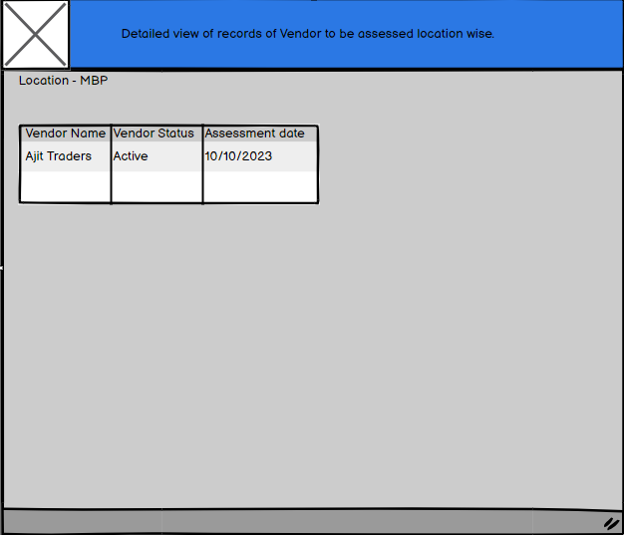
Figure 26
- Total No. of Vendor exceeded due date-Location wise
- This report will give total count of how many vendors exceeded due date location wise and for a particular year
- There would be 2 filters on Screen –
- Location
- Year
- L1 will get list of all locations mapped to him/her. He/she can select a location and year
- If none of the filters are selected , data would be populated for all locations w.r.t L1 , all year till date
- Please find the below screen
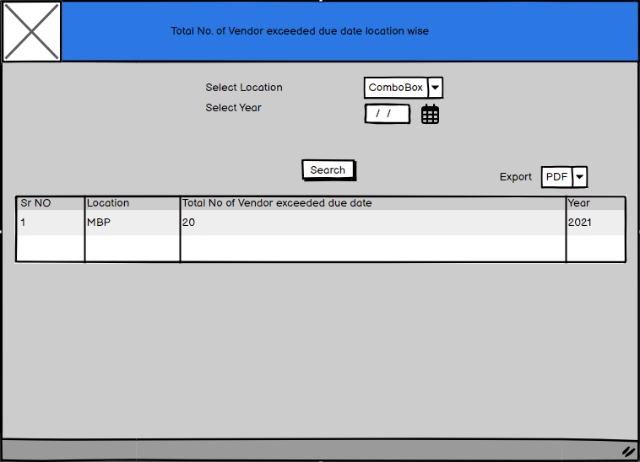
Figure 27
- Following elements would be present on the screen

Element Name | Control Type | Data Type
Location | Dropdown Value (Unique locations mapped to L1) | NA
Year | Date picker | NA
Search | Button | NA
Grid | Grid consists of following :-  - Sr No  - Location  - Total No of Vendor exceeded due date  - Year | NA
Export | Dropdown Value (Excel or PDF) | NA

- Can also give an expand functionality on clicking a particular record, list of all individual Vendors whose assessment date exceeded due date location wise will be displayed.
- Also along with that each Vendor’s name, assessment due date would be displayed.
- Note : Wireframe for this screen is pending as not sure about the columns to be displayed
- Note : Search filters and fields in report are subject to change as per development

L2

Home Page
- The L2 will be approving/rejecting the vendor assessment initiated by User after L1 approval.
- The L2 will have access to vendor assessments across all locations.
- The L2 will have access to following :-
- Dashboards (Graphs)
- Reports
- Approve/ reject Vendor assessment screen
- Status of Vendor assessment form
- Please refer the below screen
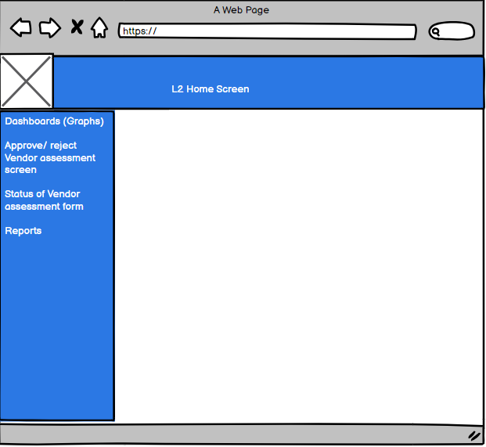
Figure 18

Dashboard
- Note: - All L2 will have access to details of all locations.
- Note – The dashboard filters and parameters can change as per development.

Approve | Reject Vendor Assessment – L2
- When the User initiates the Vendor Assessment of a particular Vendor who belongs to his/her location , then a mail is triggered to L1 for approval | Rejection.
- Post L1 approval , the vendor assessment flows for approval to L2
- L2 Approver will review the Form, thus has two options -Approve & Reject
- Please refer below screen
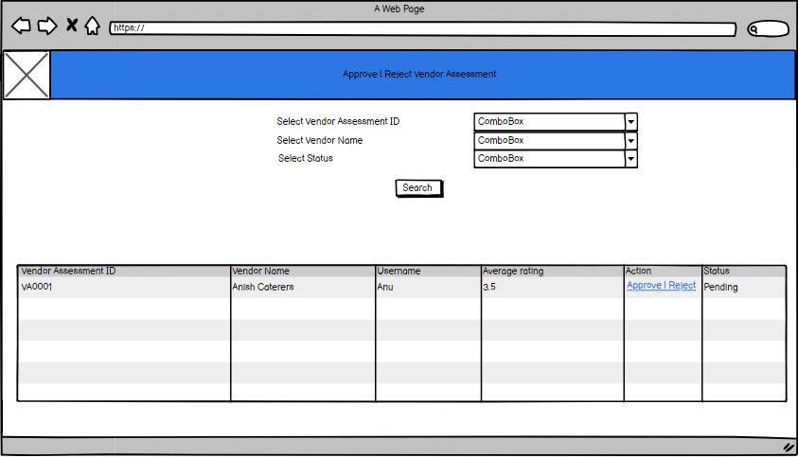
Figure 19
- Note: The fields in the grid can change as per development.
- So the L2 will come to this screen to Approve | reject the vendor assessment
- Following elements are present on the Screen :-

Element Name | Control Type | Data Type
Vendor Assessment ID | Dropdown Value (Coming from Vendor Assessment master) | NA
Vendor Name | Dropdown Value(All active Vendor List) | NA
Status | Dropdown Value (Coming from App Master)
Search | Button | NA
Grid | Grid consists of following :-  - Vendor Assessment ID  - Vendor Name  - User Name  - Average Rating  - Action  - Status | NA

- The L2 will select either of the filters i.e. Vendor Assessment ID, Vendor Name or the status
- When first time the L1 approves the vendor assessment, then that vendor assessment form flows to L2. At that time the status for Vendor assessment under L2 bucket would be “Pending”.
- If L2 rejects the form, it will flow back to L1. And post approval of L1, the form will again flow to L2 , at that time the status of the Vendor assessment would be “Pending_Post_Rejection” under L2.
- Only records that have status as “Pending”,”Pending_Post_Rejection” will be displayed in the grid.[Refer figure 18]
- Following Status and their meaning w.r.t L2
Status | Description
Pending | When User initiates the Vendor Assessment form, the form is available under L1 bucket for approval. After L1 approval, it flows to L2. At that time it is available under Approve | Reject Vendor Assessment Screen –L2 and Status of Vendor Assessment Screen-L2 screen with Status as “Pending”
Approved_By_L2 | When the L1 approves a particular Vendor Assessment, then it goes to L2 for Approval. After L2 approves the vendor assessment, status of the Vendor Assessment would be “Approved by L2”. This kind of record would be visible under Status of Vendor Assessment Screen-L2 screen post approval
Rejected_By_L2 | When the L2 rejects a particular Vendor Assessment, it again goes to L1. At that time the status of Vendor Assessment would be “Rejected_by_L2”. This kind of record would be visible under Status of Vendor Assessment Screen-L2 post rejection
Pending_Post_Rejection | When the L1 approves vendor assessment form post rejection by L2 and sends it back to L2, then it again comes under L2 bucket, the status of that Vendor Assessment would be “Pending_Post_Rejection”. It will be visible under Approve | Reject Vendor Assessment Screen –L2 and Status of Vendor Assessment Screen-L2 screen

- Then the L2 needs to click on Action Column “Approve | Reject” against a particular record in the grid
- Following screen will be displayed
Figure 20
- Following elements would be visible on the form:-

Element Name | Control Type | Data Type
*Vendor Name | Dropdown value – Not editable | NA
*Product or Service Offered | Dropdown value – Not editable | NA
*Assessment Or review Period | Dropdown value – Not editable | NA
*Grid | Parameters Consisting of SrNo, Description, Ratings and Remarks, Remarks by L1, Remarks by L2. Except for Remarks by L2 rest all fields would be non-editable | NA
Total ratings | Total value of ratings of all 20 parameters – Non editable | Greyed out field- Auto calculated by System
Average Ratings | Calculate Average Rating = Sum of all Rating / No of Parameters – Non editable | Greyed out field- Auto calculated by System
Vendor Status | Whether Active / Inactive – Non editable. Would be calculated based on Average rating | Greyed out field – Text
Blacklisted | Non editable text | NA
Vendor Assessed By : Signature | Signature of L1 | L1 Digital Signature
Date of Assessment | Approved by L1 | Date of Approval by L1
Approval | Rejection Remarks by L1 | Textbox- Non editable | Text
Assessment Approved By :Signature | Signature of L2 | L2 Digital Signature
Date of Approval | Approved by L2 | Date of Approval by L2
Approval | Rejection Remarks by L2 | Text-Editable | Remarks by L2
Approve | Button | NA
Reject
Reset | Button | NA

- The rest of the fields would be uneditable in the form only the “Remarks column by L2” against each parameter and “Approval or Rejection remarks by L2” would be editable.
- The L2 will be able to view the remarks given by L1 and User against each parameter and then provide his/her remarks against each parameter
- The Final remarks i.e. “Approval or Rejection remarks by L2” is mandatory if vendor assessment rejected. Rest remarks against each parameter are not.
- There should be a provision to capture digital signature for L2 approver which would be displayed against “Assessment Approved By :Signature” field on the Vendor Assessment form
- Also the Date of Approval would be captured as current date.
- The L2 approver will have 3 options i.e. either to Approve , Reject Vendor assessment form and Reset the remarks on the form
- Approve
- If L2 Approver approves the Form which has Average ratings Less than 3.5 then Vendor will get Vendor termination mail & vendor would be documented as “Inactive” Vendor .Status of the Vendor assessment would be “Approved_By_L2”
- If L2 Approver approves the Form which has ratings more than 3.5 then Vendor will be digitally documented as “ACTIVE” VENDOR. Status of the Vendor assessment would be “Approved_By_L2”
- Also the feedback for the same will go to the Vendor
- Please refer below email format
- Email Subject: Vendor status update: [Vendor name]
- Email Content:

Dear < Vendor name>,
CC <User name>, <L1 approver name>
I am writing to inform you that the vendor status for [Vendor name] has been updated to [Status].
Status can be either:

Active: The vendor has met all of our requirements and is now approved to provide services to our company.
Terminated: The vendor has failed to meet our requirements and is no longer approved to provide services to our company.
Please update your records accordingly.

If you have any questions, please contact me at [Email address].

Thank you for your cooperation.
Sincerely, [L2 Name]

- Reject
- If L2 rejects it will be redirected to the L1, the status of vendor assessment would be “Rejected by L2” at L2 side. At L1, the status of Vendor assessment would be “Pending_Post_Rejection_L2”.The final remark i.e. “Approval | rejection remarks by L2” is mandatory on rejection.
- L1 will receive email
- Email Subject: Vendor assessment rejection: [Vendor name]
- Email Content:

Dear < L1 Name>,
I am writing to inform you that the vendor assessment for [Vendor name] has been rejected.

Please address the issues listed in the form and reapprove the vendor assessment form.
To reapprove the assessment, please log in to the vendor assessment tool and click on the " Approve | Reject Vendor Assessment-L1” tab and search for the record.

If you have any questions, please contact at [Email address].
Thank you for your cooperation.

Regards,
(Required From Business)

- The L1 can either provide his/her comments and approve the form or reject the form
- On approval by L1, the form will again flow to L2. At that time the status for vendor assessment form would be “Pending_Post_Rejection” under L2’s bucket. On rejection by L1 , the form will be sent back to user
- Note : The Approve or Reject hyperlink in grid would be only active for those Vendor Assessment records whose status would be following :-[Refer figure 18]
- Pending
- Pending_Post_Rejection
- Reset
- The Reset option will help to clear all the remarks field on the Vendor Assessment form.

Status of Vendor Assessment- L2
- The L2 after approving/rejecting a particular vendor assessment , can check the status of that vendor assessment from this screen
- Please check below screen
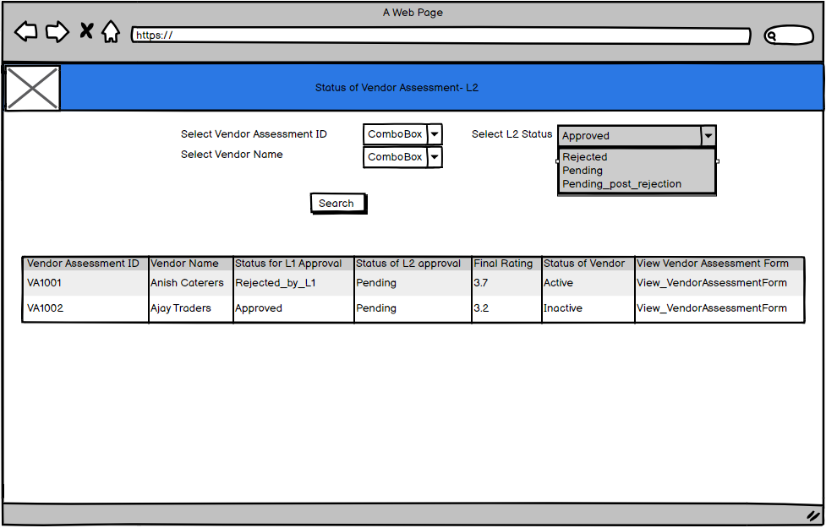
Figure 21
- Following elements would be present on the screen

Element Name | Control Type | Data Type
Vendor Assessment ID | Dropdown Value (Coming from Vendor Assessment master. All records:-  - pending,  - Approved_By_L2  - Rejected_By_L2  - Pending_Post_Rejection Would be displayed | NA
Vendor Name | Dropdown Value(Coming from Vendor Master only active Vendors) | NA
L2 Status | Dropdown Value(Unique L2 status value Coming from table where Vendor assessments are saved)  - pending,  - Approved_By_L2  - Rejected_By_L2  - Pending_Post_Rejection Would be displayed
Search | Button | NA
Grid | Grid consists of following :-  - Vendor Assessment ID  - Vendor Name  - Status for L1 approval  - Status of L2 approval  - Final Rating  - Status of Vendor  - View – View the Vendor Assessment Form | NA

- When the L2 comes to this screen, he /she will have 3 search filters i.e. Vendor Assessment ID , Vendor Name and Status
- Note : Filters can change as per development
- The L2 can select one or more filters and click on search button. If none of the filters are selected, data in grid would be displayed for all vendor assessment ID , vendor’s and all status across all locations.
- Fields present in grid:-

Field Name | Field Type
Vendor Assessment ID | Alphanumeric
Vendor Name | Varchar
Status for L1 Approval | Varchar
Status for L2 Approval | Varchar
Final Rating | Numeric[Up to 2 decimal]]
Status of Vendor | Varchar
View | Hyperlink

- Note: The values in the grid can change as per development.
- View:-
- When the L2 wants to view the vendor assessment form , he/she can click on View hyperlink against any record
- There would be 2 options for the L2 either to export the Vendor Assessment or take a print out of it.
- Please find the below screen:-
Figure 22

Reports
- When the L2 would come to this screen , he/she can access below reports :-
- Total No. of Vendor Assessed-Globally, Location wise
- Total No. of Vendor Assessed Active/Inactive/Blacklisted-Globally, Location wise
- Total No. of Vendor needs to be accessed-Globally, Location wise
- Total No. of Vendor exceeded due date-Globally, Location wise

- Total No. of Vendor Assessed –Globally, Location Wise :-
- This report will give information as to how many total no of vendor’s are assessed for a particular location
- So the L2 will get list of all locations globally. Also there would be a filter for selecting year and basis on selection of year , there would a filter of Assessment period
- So say for e.g. for MBP location , for Year 2021 and Assessment period between 1st Jan to 30th June , 20 vendor assessments were done
- Note : There would be 2 assessment period by default i.e. from :-
- 1st Jan – 30th June
- 1st July – 31st Dec
- Please find the below screen
Figure 25
- L2 can even export the Report in Excel or PDF format
- Also if none of the filters are selected , data would be generated based on all locations , for all years and for both assessment periods
- Following elements would be present on the screen

Element Name | Control Type | Data Type
Location | Dropdown Value (Unique global locations) | NA
Year | Date picker | NA
Assessment Period | Dropdown Value(2 assessment periods as i.e. 1st Jan – 30th June and 1st July – 31st Dec) | NA
Search | Button | NA
Grid | Grid consists of following :-  - Sr No  - Location  - Total No of Vendor assessed  - Year  - Assessment period | NA
Export | Dropdown Value (Excel or PDF) | NA

- Can also give an expand functionality on clicking a particular record, individual list of all vendors assessed in that location would be displayed
- Also along with that each Vendor’s name, total rating, average rating and status would be displayed. Please refer below screen
Figure 24
- Total No. of Vendor Assessed Active, Inactive, Blacklisted- Globally , Location wise:-
- This report will give total count of how many vendors are Active , Inactive or blacklisted for a particular location and Year
- There would be 3 filters on Screen –
- Location
- Year
- Status
- L2 will get list of all locations mapped to him/her. He/she can select a location and year and status whether Active / Inactive/Blacklisted
- If none of the filters are selected , data would be populated for all locations globally , all year till date and all status
- Please find the below screen
Figure 23

- Following elements would be present on the screen

Element Name | Control Type | Data Type
Location | Dropdown Value (Global location values) | NA
Year | Date picker | NA
Status | Dropdown Value ( Unique values from App master) | NA
Search | Button | NA
Grid | Grid consists of following :-  - Sr No  - Location  - Total No of Vendor active  - Total No of Vendor Inactive  - Total No of Vendor blacklisted  - Year | NA
Export | Dropdown Value (Excel or PDF) | NA

- Can also give an expand functionality on clicking a particular record, list of all individual Vendors active, blacklisted or inactive location wise would be displayed.
- Also along with that each Vendor’s name, total rating, average rating and status would be displayed. Please refer below screen
Figure 24
- Total No. of Vendor needs to be accessed-globally, Location wise
- This report will give total count of how many vendors are to be assessed location wise and for a particular year
- There would be 2 filters on Screen –
- Location
- Year
- L2 will get list of all global locations. He/she can select a location and year
- If none of the filters are selected , data would be populated for all locations, all year till date
- Please find the below screen
Figure 25
- Following elements would be present on the screen

Element Name | Control Type | Data Type
Location | Dropdown Value (global location values ) | NA
Year | Date picker | NA
Search | Button | NA
Grid | Grid consists of following :-  - Sr No  - Location  - Total No of Vendor to be assessed  - Year | NA
Export | Dropdown Value (Excel or PDF) | NA

- Can also give an expand functionality on clicking a particular record, list of all individual Vendors to be assessed location wise will be displayed.
- Also along with that each Vendor’s name, status and assessment date would be displayed.
Figure 26
- Total No. of Vendor exceeded due date-Location wise
- This report will give total count of how many vendors exceeded due date location wise and for a particular year
- There would be 2 filters on Screen –
- Location
- Year
- L2 will get list of all global locations. He/she can select a location and year
- If none of the filters are selected , data would be populated for all locations, all year till date
- Please find the below screen
Figure 27
- Following elements would be present on the screen

Element Name | Control Type | Data Type
Location | Dropdown Value (Global location values) | NA
Year | Date picker | NA
Search | Button | NA
Grid | Grid consists of following :-  - Sr No  - Location  - Total No of Vendor exceeded due date  - Year | NA
Export | Dropdown Value (Excel or PDF) | NA

- Can also give an expand functionality on clicking a particular record, list of all individual Vendors whose assessment date exceeded due date location wise will be displayed.
- Also along with that each Vendor’s name, assessment due date would be displayed.
- Note : Wireframe for this screen is pending as not sure about the columns to be displayed
- Note : Search filters and fields in report are subject to change as per development

Overall Description

Product Perspective
The Vendor Assessment tool is a web based application. This tool would be hosted on intranet which will be accessible only in Hexaware environment.

Constrains
- This project is limited to Web browser.
- This application will work independently without any other applications dependency.

Assumptions
- All the wireframes are samples and might change based on development.
- All the Email templates might change based on development

Dependencies
- Email triggering based on scenarios.

