**Wiring diagrams**

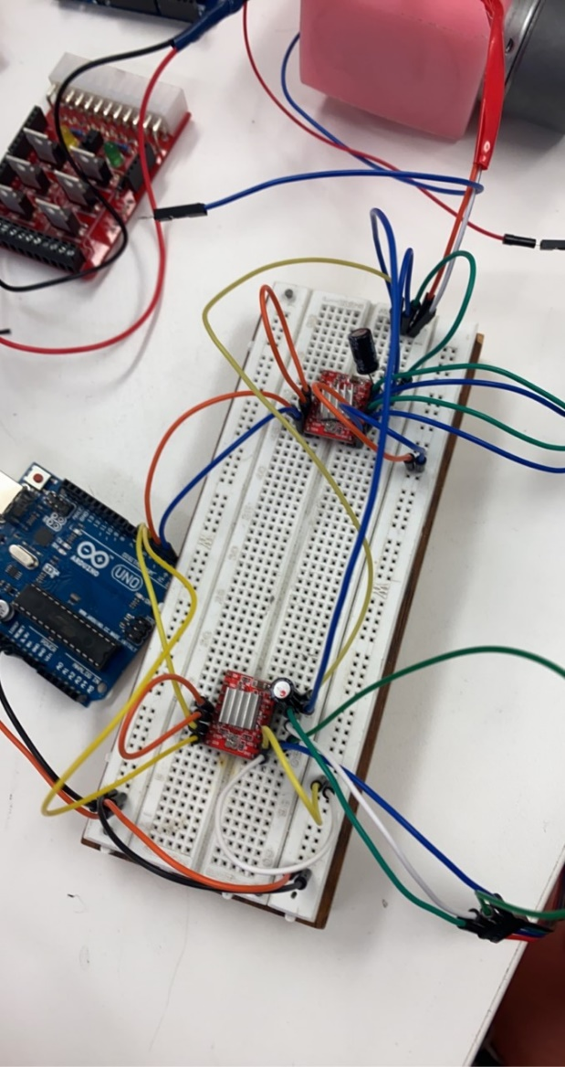**2x Slave board for the front and back motor set. Drivers are slightly different, but wiring is easy. External power for all the Arduinos and motor drivers from the PSU (hopefully) using the spark fun shield driver kit**

**Powering each Arduino using the 12v connector and the stepper drivers using the 5v**

**Slave board for the middle motors, very basic setup, can also use a TB6612FNG driver if it provides enough power to the motors.**

**Master board includes the echo sensors to judge distances for decision making.**

**All the slave boards connect to the master board using i2c using the SDA and SCL ports on the uno (A4, A5)**

**The master board will be making the decisions based off the echo sensors then telling the slave boards the decision, Finite-state machine is probably the play for this.**

**All going the plan we will have a rover that can control itself and avoid obstacles.**

**Tasks that we need to complete.**

* Mount the parts
  + Find bolts to connect our 3d prints to the rover.
  + Figure out most effective way to mount wheels to the DC motors.
* Wire up the motors
  + Either solder the parts or use breadboards
* Write code
  + Two slave boards will have the same code
  + Master board must do the decision making
  + Final slave board to power middle wheel motors
* Figure out the shield driver kit for the power distribution.
* Have fun doing it 😊 (optional)