ALY 6110 – Data Management & Big Data

Module 4 Final Project  
**Basic Analysis and Dashboard**

Devansh Hukmani

Yuning Chen

Instructor – Daya Rudhramoorthi

15 October 2023

1. **Introduction**

In the ever-evolving landscape of law enforcement, the analysis of arrest data plays a pivotal role in understanding the dynamics of policing within a major metropolis like New York City. This report delves into the extensive NYPD Arrest Data for the current year, a dataset comprising over 113,000 rows and 19 columns. It represents a comprehensive breakdown of every arrest conducted by the New York City Police Department (NYPD) during this year.

This data, manually extracted and periodically reviewed by the Office of Management Analysis and Planning, provides invaluable insights into the nature of law enforcement activities in the city. Each record within the dataset encapsulates essential information, encompassing the type of crime, the geographical location of enforcement, and the precise timing of each arrest. Furthermore, it offers a unique perspective on the demographics of the individuals involved in these arrests.

The purpose of this report is to leverage this rich dataset to explore and analyze the patterns and trends within NYPD's arrest activities. By examining various aspects such as crime types, locations, and suspect demographics, we aim to uncover significant insights that can contribute to a better understanding of policing in New York City. This data is not only of interest to law enforcement agencies but also serves as a valuable resource for policymakers, researchers, and the public seeking transparency and accountability in the realm of law enforcement.

1. **Business Question**

**How do the distribution of arrests across New York City boroughs correlate with the types of crimes committed in different age groups, and can we identify patterns and variations that can inform regulated suggestions for the NYPD?**

In this report, we will explore the interplay between the geographic distribution of arrests across New York City's boroughs and the types of crimes committed within distinct age groups. By analyzing the NYPD Arrest Data for the current year, we aim to uncover correlations and patterns that shed light on whether certain boroughs exhibit unique crime profiles associated with specific age cohorts. Our ultimate objective is to provide evidence-based, regulated suggestions to the NYPD, considering the multifaceted relationship between crime types, age demographics, and borough-specific dynamics.

1. **Analysis**

Creating visualizations to understand the distribution of arrests across New York City boroughs in correlation with types of crimes committed in different age groups is a valuable analysis that can potentially inform regulated suggestions for the NYPD.

The graph Arrest Count by Race and Gender illustrates the distribution of arrests by race and gender in New York City, revealing notable disparities in law enforcement interactions across different racial and gender categories. The highest number of arrests is among Black individuals, totaling around 54,000, followed by White Hispanic individuals with approximately 28,500 arrests. White individuals account for around 11,000 arrests, while Black Hispanic individuals are close behind with roughly 10,500 arrests. Asian/Pacific Islander individuals have the fewest arrests, with approximately 6,000. Males have a significantly higher crime rate than females. While this visualization highlights these differences, it doesn't provide the underlying reasons, which may include various socioeconomic and demographic factors. Nevertheless, it underscores the importance of examining and addressing potential racial and gender disparities within the criminal justice system to ensure fairness and equity.

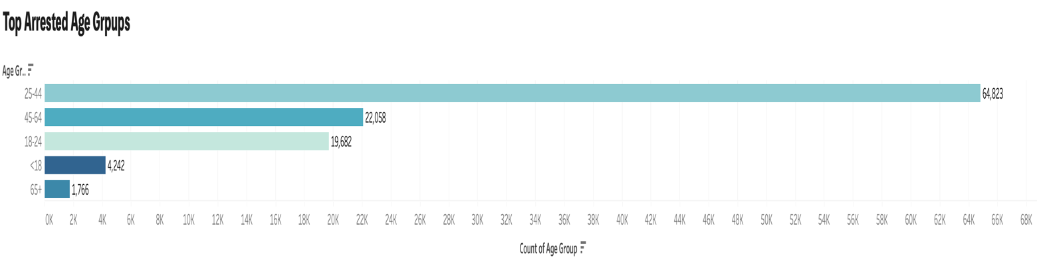

The graph Arrest by Age Group for Every Borough is depicting arrests by age group for every New York City borough. The age group with the highest number of arrests in every borough is individuals aged 25-44, highlighting a demographic segment frequently engaged in law enforcement interactions. Following closely behind are those aged 45-64, reflecting a substantial portion of arrests. The 18-24 age group, representing young adults, also shows a notable arrest rate, potentially due to factors like urban living and socioeconomic conditions. Conversely, individuals under 18, often benefiting from juvenile justice approaches, have fewer arrests. The 65+ age group consistently exhibits the lowest arrest count, underscoring minimal involvement in criminal activities among the elderly. This trend emphasizes the importance of understanding age-related arrest patterns to inform law enforcement strategies, social policies, and community initiatives aimed at reducing crime and enhancing public safety, particularly among the age groups most frequently implicated in arrests.

The visualization of Offenses Caused by Age Groups presents a clear pattern in New York City's crime data. Assault-related offenses stand out as the most frequently committed crimes, reflecting a significant concern for interpersonal violence. What's particularly striking is the consistent trend of individuals aged 25-44 having the highest offense count, especially in assault-related incidents. This demographic appears to be at the center of a significant portion of criminal activity.

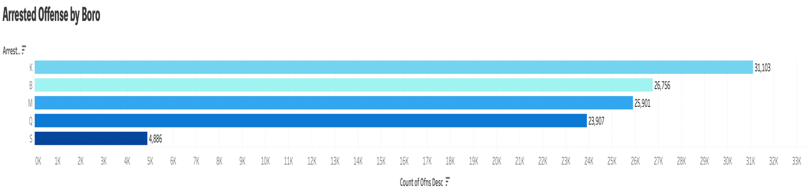

Looking at the second bar chart of regional criminal records, we can see that Brooklyn and the Bronx have consistently high criminal arrest records.

From above graph, it is a descriptive statistical analysis of the types of arrested offenses reveals the types of crimes that are most likely to win conflicts in New York City. Summarizing above three analysis of crime concentration areas, crime concentration age groups and top arrested offenses, we can draw the following insights and recommend that NYPD direct the development of targeted interventions and crime prevention strategies to reduce violence and enhance public safety, particularly in areas with high rates of assault-related crime.

The graph depicting the Number of Arrests Every Month, marked by recurring fluctuations, signifies the dynamic nature of law enforcement activities in New York City. These fluctuations can be attributed to various factors, including seasonal variations in criminal behavior, adjustments in policing strategies, the influence of special events and holidays, socioeconomic conditions, and potential data-related anomalies. This ever-changing pattern of arrests emphasizes the need for a responsive and adaptive approach to law enforcement and crime prevention. Understanding the driving forces behind these fluctuations is essential for law enforcement agencies and policymakers, enabling them to allocate resources effectively, time community engagement initiatives, and develop strategies that align with the evolving landscape of criminal activity and public safety concerns in the city.

The graph illustrating Offense by Area with longitude on the y-axis and latitude on the x-axis offers a geospatial perspective of arrest data in New York City. Each point on the graph corresponds to a specific location within the city, with information about the borough, and the type of crime committed. This geospatial representation enables a clear understanding of where different types of crimes occur, pinpointing crime hotspots and trends in specific areas across the city. Such visualizations are essential tools for law enforcement and policymakers as they provide actionable insights for resource allocation, targeted policing strategies, and crime prevention efforts tailored to the needs of specific geographic areas within New York City.

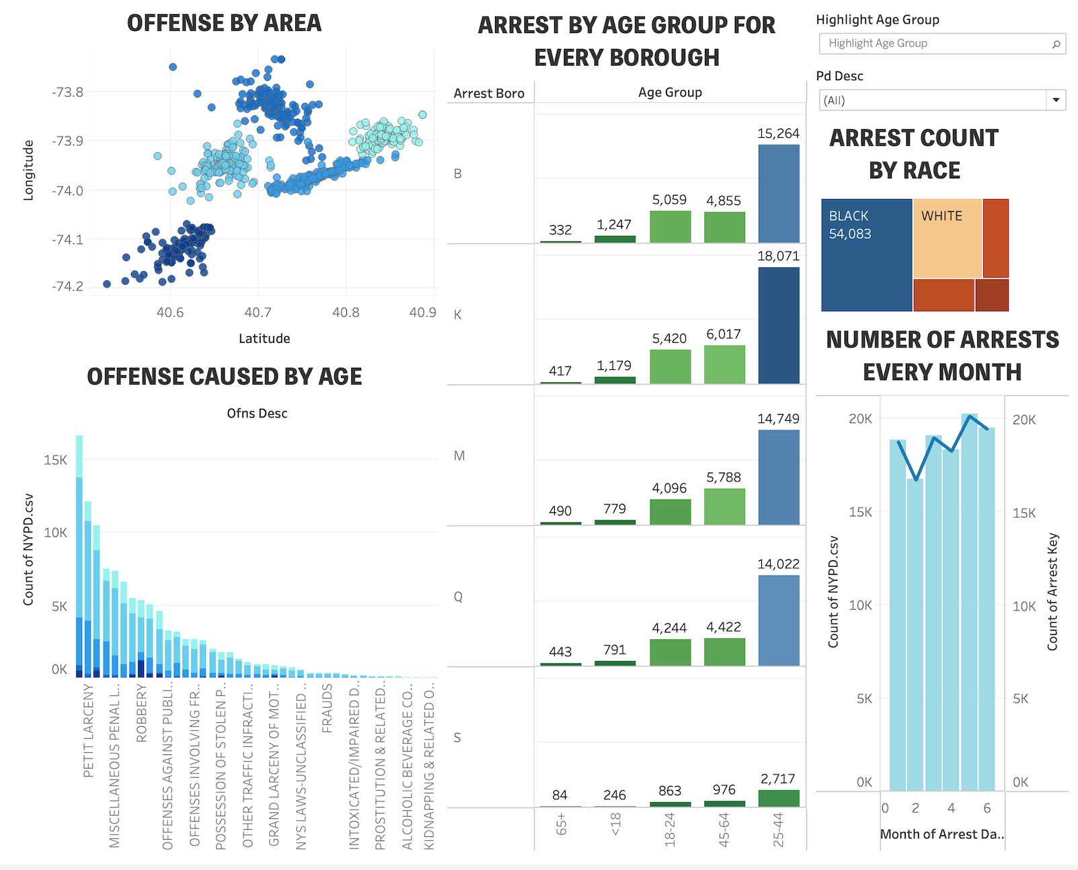

Dashboard 1

Dashboard 2

1. **Conclusion**

In this extensive analysis of the NYPD Arrest Data for the current year, we've embarked on a journey to unravel the intricate dynamics of law enforcement in the bustling metropolis of New York City. The dataset, comprising over 113,000 records, offers a window into the multifaceted world of policing, providing insights into the distribution of arrests by race, gender, age, geographic location, and time. Notably, we've uncovered disparities in arrests across racial groups, identified age-related patterns in law enforcement interactions, and visualized the geographic hotspots of various crimes. The fluctuating nature of arrests from month to month adds an element of dynamism to the law enforcement landscape. Our analysis aims to explore the interplay of these factors to inform evidence-based, regulated suggestions for the NYPD, ultimately striving for more transparent, equitable, and effective law enforcement practices in New York City. These insights are not only pertinent to law enforcement agencies but also offer valuable knowledge for policymakers, researchers, and the public, contributing to the pursuit of enhanced safety and justice in this diverse and dynamic urban setting.

**References**

1. *NYPD Arrest Data (Year to Date) | NYC Open Data*. (2023, July 14). <https://data.cityofnewyork.us/Public-Safety/NYPD-Arrest-Data-Year-to-Date-/uip8-fykc>
2. Criminal justice reports & statistics. (2023). NYS Division of Criminal Justice Services. <https://www.criminaljustice.ny.gov/crimnet/ojsa/stats.htm>