Optimal Smartphone Inventory Report

**Introduction**

Operating a brick-and-mortar retail store is more competitive than ever, not only does the business compete with other local shops, but also countless remote sellers. Being a new retail chain in the Indian market, it is crucial to understand the target customer base, and their preferences. The goal of this project is to analyze the referenced data to determine the optimal inventory and products a store should purchase every-month, given a budget of $25,000.

**Background**

The results of this analysis would help in the inventory ordering process. Inventory must be ordered ahead of time – therefore, it isn’t possible to analyze the sales of the current month to order inventory for the next month, because it’s likely the inventory wouldn’t be available in time. A positive impact would be optimizing inventory based on historical performance/patterns and automating the task of determining how much to buy and of what.

**Methodology**

A linear optimization, outlined in appendix A, was used to determine the number of products to purchase each month. Because the objective function and constraints are all linear, a linear optimization was chosen over non-linear to reduce complexity and run time. The objective function is maximized, where R is revenue from each product sold, L is penalizing revenue for products which don’t get sold in that month. This is then multiplied by our “weight” matrix, $Σ$, to give more/less emphasis on certain products based on the factors described below. The constraints are the monthly budget where total cost of products must be less than $25,000, and minimum order quantity for each product.

Some analysis on the reference data was conducted to create the “weight” matrix. Based on figure 1. in appendix A, mobiles are the primary source of sales for the referenced shop data, thus mobile devices were weighted more than other available products. Figure 2. summarizes the number of sales by each category, which showed the most popular mobile categories are the budget and midrange phones, while flagship phones only make up about 12% of the total devices sold. Figure 3. compares device brand prices amongst themselves, to help categorize different brands as budget, midrange, etc. and budget, midrange was weighted more than flagship. Within each category, the market share, from figure 4., was used to further weight higher-cap brands more over other brands in the same phone category.

**Results**

The results of the optimization yielded the quantity to order for each available product. Using a combination of these results, and historical orders/performance, the store operator can relatively quickly determine how much of which product to order for the upcoming months.

**Conclusion**

Being able to optimize decisions based on data and historical performance will help give shops a competitive advantage in reducing costs and increasing sales. By optimizing the inventory decision process, it reduces the work load on shop operators while employing optimal inventory management to increase revenue and inventory turnover. Additionally, in the future, the weight matrix can also consider historical performance of products to add more weight to products/brands which have done well in the past to further improve performance.

**Appendix A:**

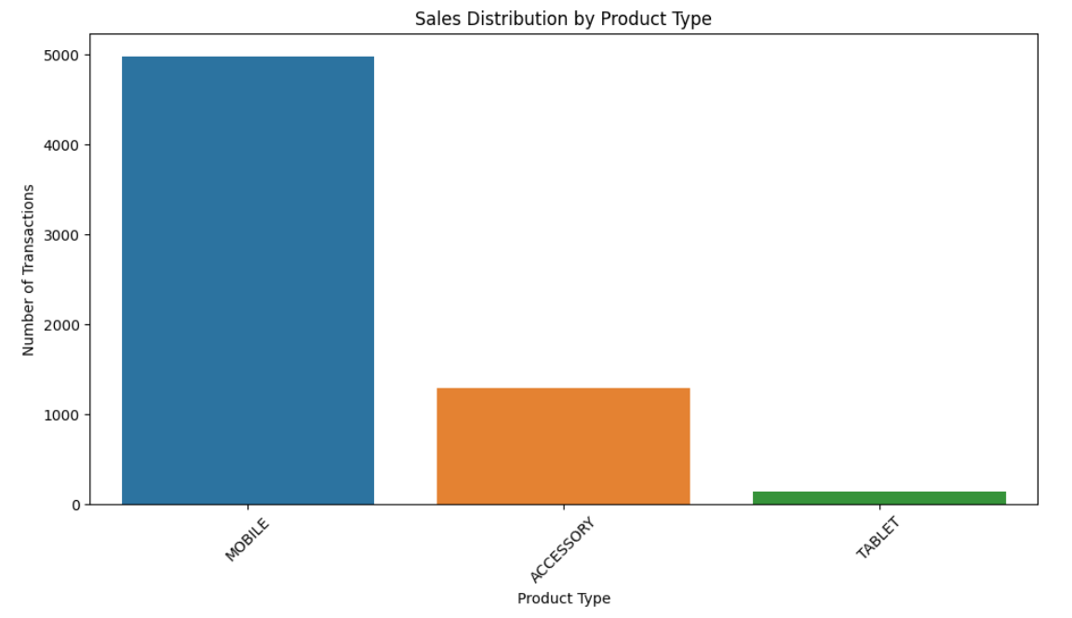

Figure 1: Count of product type sales [1]

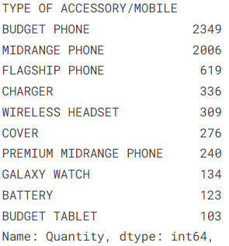

 Figure 2: Count of product sold by category [1]

$$s.t \sum_{p=1}^{P}{c_{p}*x_{p}}≤25,000$$

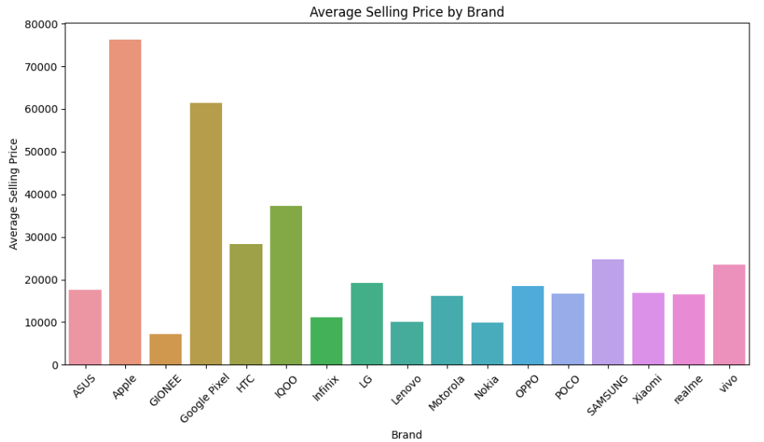

Figure 3: Average price by brand [2]

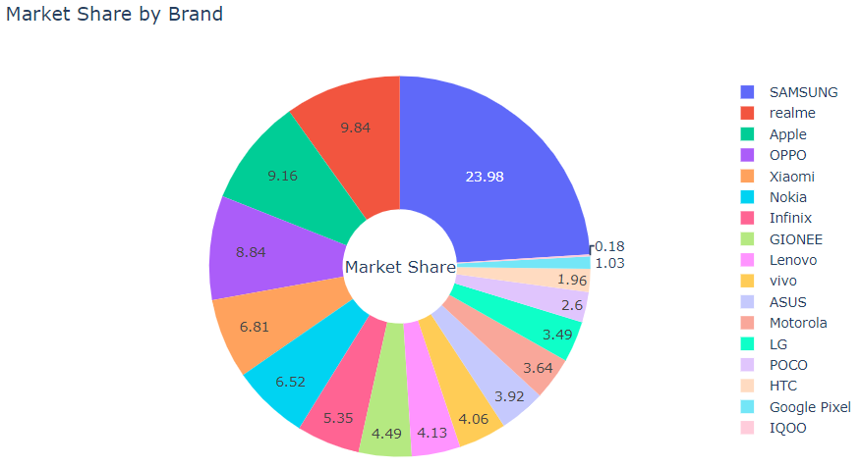Figure 4: Market share by brand [2]

$$x is an integer and ≥0$$

Optimization:

$$x_{i} ≥M_{i}$$

**Dataset References:**

[1] Shubham. "Smartphone Retail Outlet Sales Data." *Kaggle*, 2023, <https://www.kaggle.com/datasets/shubham2703/smartphone-retail-outlet-sales-data/data>

[2] Yaminh. "Smartphone Sale Dataset." *Kaggle*, <https://www.kaggle.com/datasets/yaminh/smartphone-sale-dataset>