

INFO 6205 Spring 2022 Project

MENACE
PRATHAMESH SAHASRABUDDHE (002117703)
VIVEK SHARMA (002105272)
PRAVIN DHURI (002138314)

Introduction

AIM
To design a Machine Educable Noughts and Crosses Engine (MENACE) that can play tic-tac-toe against a human player and return the move for any strategy that it has been trained on, as well as to enhance the tactic by learning from each game play

approach
Initially we have created an array with 9 position 1 position for each square. The ideal strategy or the states has been created in the different class file to train Menace. Also, we are training the Menace by placing the moves at the random position i.e., random state. All the trained sets have been stored for that instance. The traverse function is written to check each position and then comparing with the ideal state to decide the winning or losing factor. The trained Menace is then actioned to play against the human inputted symbol i.e., 0. Based on the result the state is saved. In case the Menace loses while playing with human, the state is saved for training the Menace. Finally, the Menace uses the state to refine the strategy and improve the result.

Program

DATA STRUCTure & Classes
We have used LinkedList since Menace uses the statistics of adding and deleting the beads as on when required according to the strategy, moreover the insertion and deletion operations are efficient and easily implemented using the LinkedList. The below are the classes used in our implementation:

- OptimalStrategy - Trains the Menace with the optimal strategies
- RandomTrainStrategy – Trains the Menace with the random state strategy
- Perfect_Tic_Tac_Toe – Created a strategy used in the class OptimalStrategy
- Player – Store the playoff stat result of wins, looses & draws
- StatesOfAnyGame - Initialize the state such as Draw, Menacewins etc.
- Symmetry – Used for matrix rotation
- TicTacToeGame – Used for matrix creation and contains rule for each playoff
- ValuesOfCell – Initialize values needed for playing e.g., X, 0
- HumanInput – Class to handle input from human player
- Menace_Tic_Tac_Toe - Class to handle input from Menace
- Execute_Tic_Tac_Toe – Main execution class to run the whole game

algorithm
We used LinkedList as our Data Structure to train our Menace. As we know that the entries of a HashMap are not ordered whereas LinkedList provides sequential access and is generally more efficient at inserting and deleting elements in the list.

flow chart

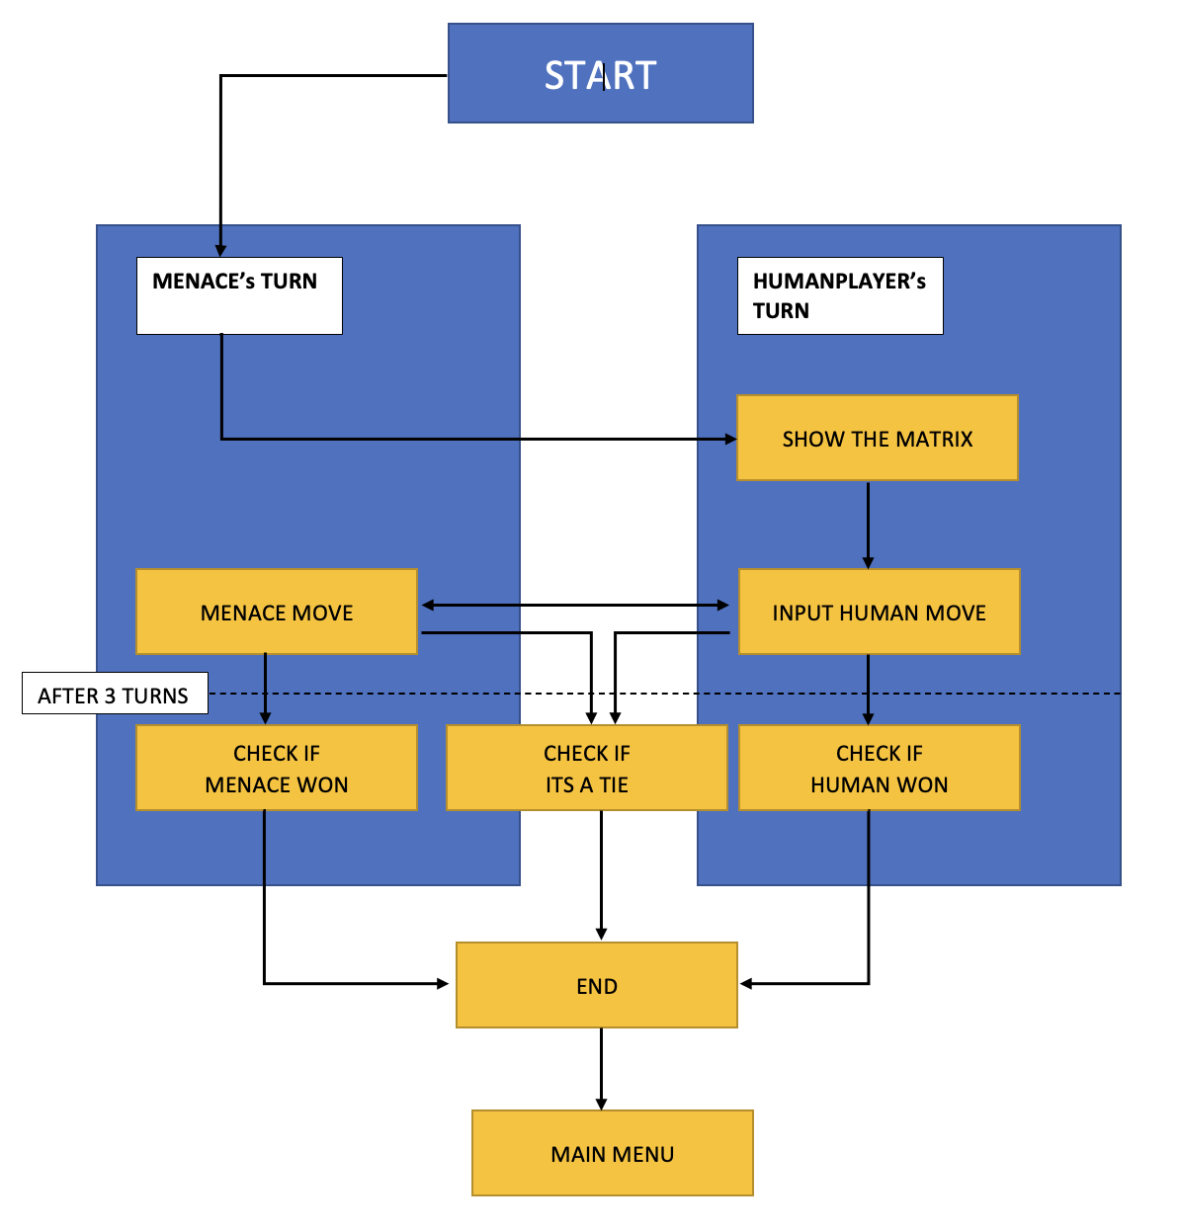

observation AND GRAphical analysis
Firstly, when we train the Menace with the strategies the probability losing is on higher side. But more the number of states we input to the Menace the better the probability of winning and draws has been observed. When training the Menace against the program we observed that it ran out of beads number of times and have lost so many times because of removal of all the beads.
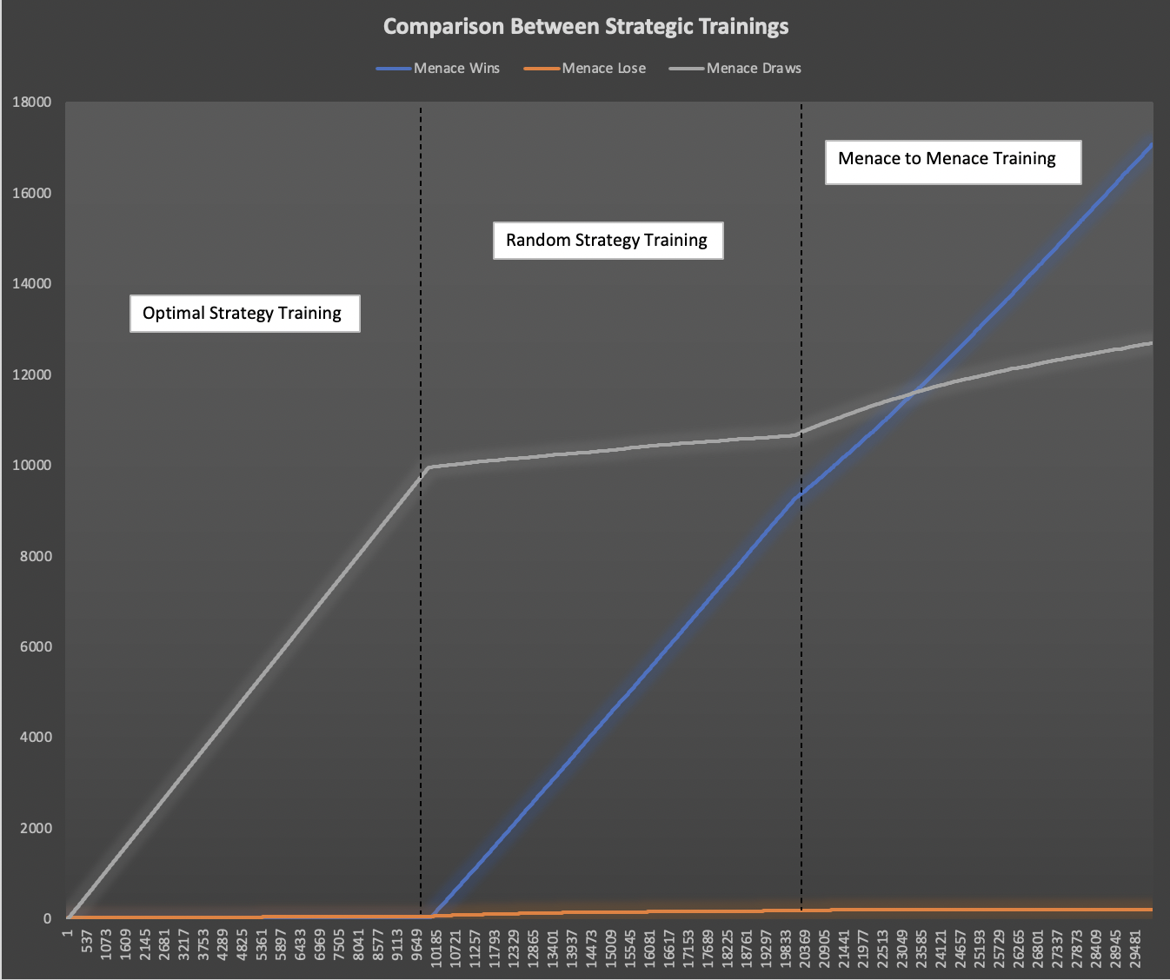

results

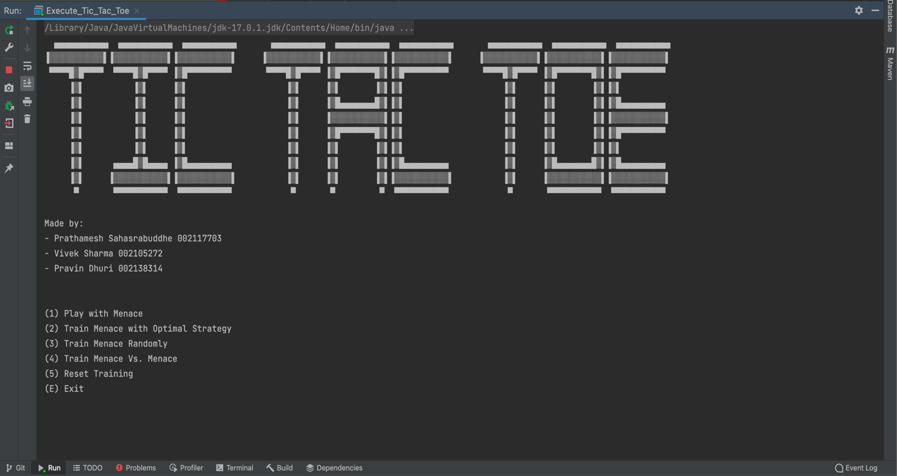
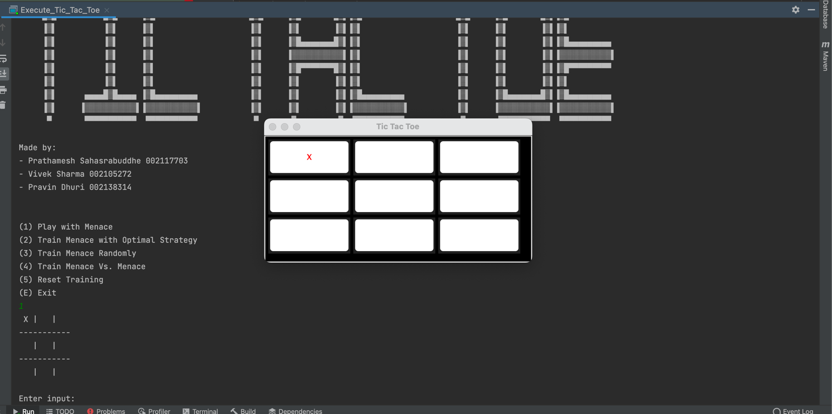
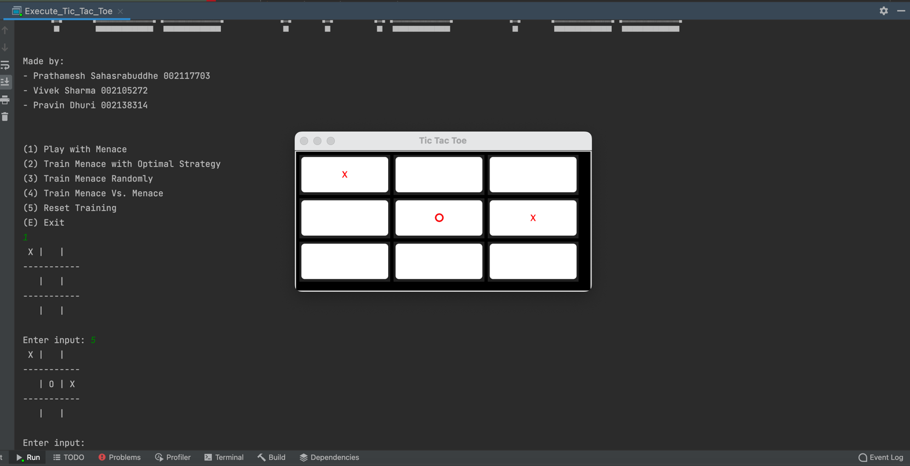
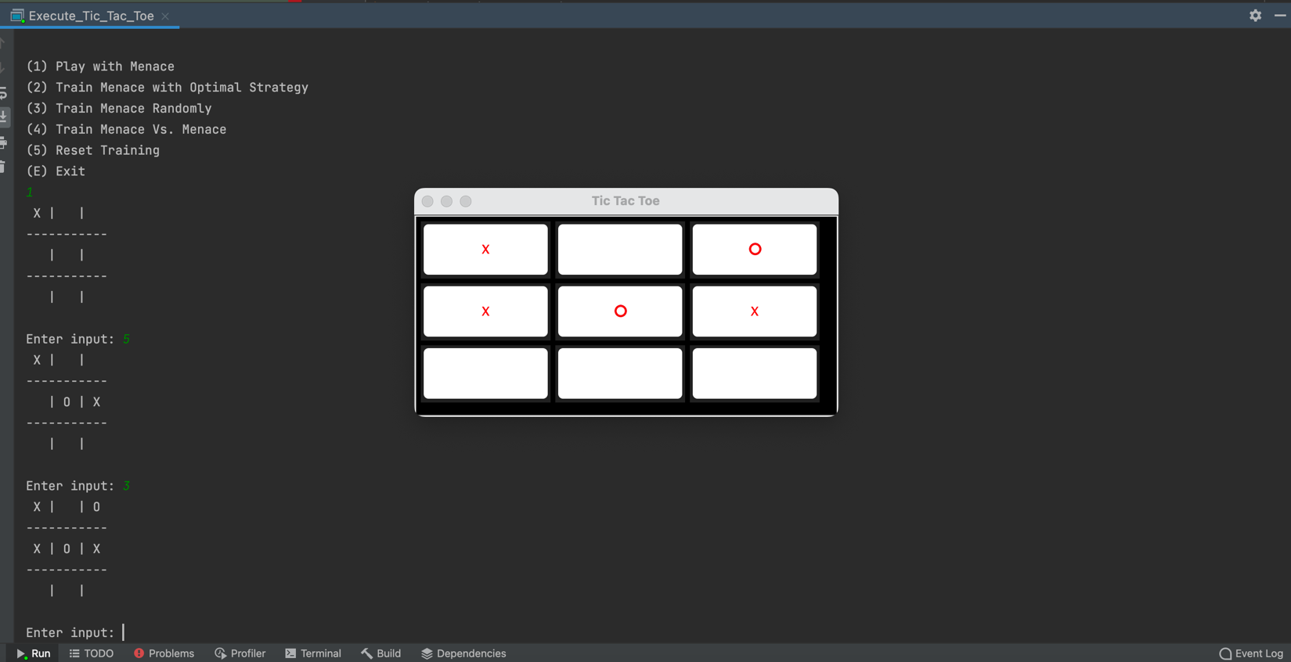
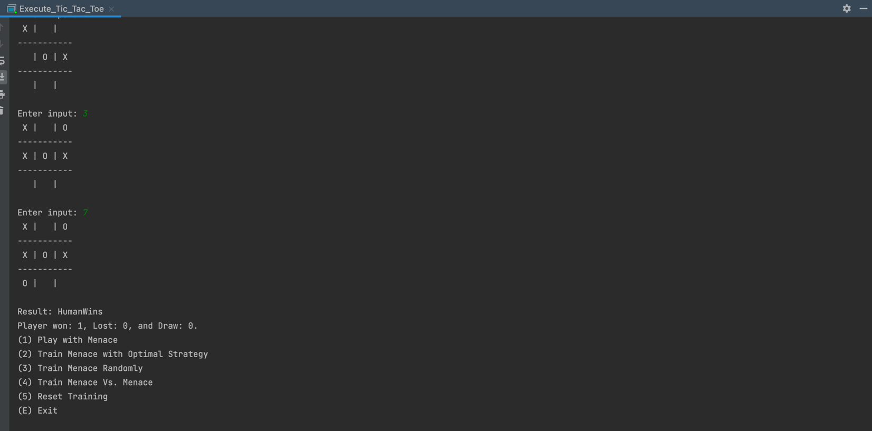

testcases
Test Case | Comment
CheckHorizontalFlips | Usecase tests whether there is row to row swap along the horizontal axis
CheckVerticalFlips | Usecase tests whether there is column to column swap along the vertical axis
CheckRotation | Usecase tests whether there is rotation along the axis
NullCheckHorizontalFlips | Usecase to check whether there are nulls in the horizontal flips
NullCheckVerticalFlips | Usecase to check whether there are nulls in the vertical flips
NullCheckRotation | Usecase to check whether there are nulls in the rotation

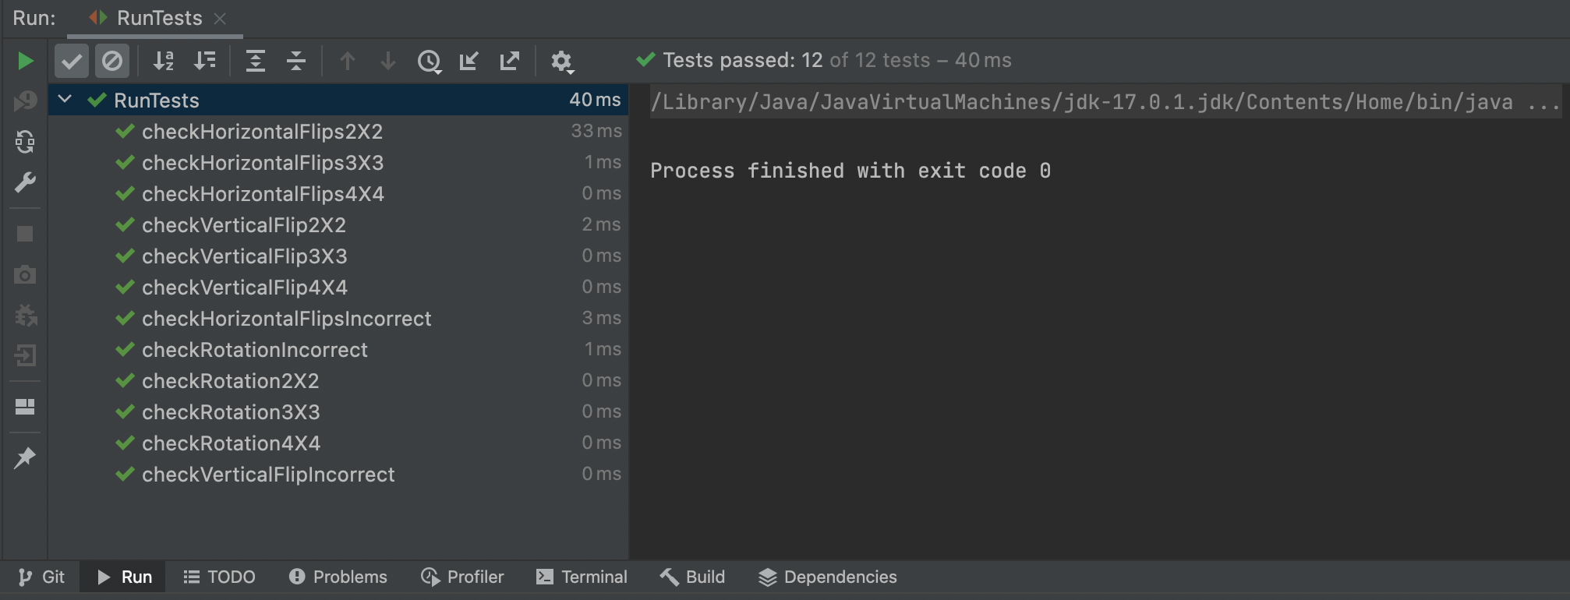

conclusion
We can conclude that before training the Menace the chances of Menace winning was very low, but after reinforcement learning with the various stages such as with perfect player, random state and using optimal strategy the performance of the Menace became far better. Menace was able to win or draw the games.

References

- https://en.wikipedia.org/wiki/Matchbox_Educable_Noughts_and_Crosses_Engine

- https://warwick.ac.uk/fac/sci/dcs/research/em/publications/web-em/10/cs405_-_1362452_-_menaceem.pdf

- https://odsc.medium.com/how-300-matchboxes-learned-to-play-tic-tac-toe-using-menace-35e0e4c29fc

- https://youtu.be/TtisQ9yZ2zo?t=2210

