**ALAGAPPA COLLEGE OF TECHNOLOGY**

**ANNA UNIVERSITY-600025**

**Project type:**

Instagram Reel: Create an Instagram reel for your business brand and promote it attract a minimum of 100 Likes

**Project name:**

**ProGreeners**

**Department:**

B.Tech-Pharmaceutical technology

**Team Details:**

| Name | Registration number | Naanmudhalvan Id |
| --- | --- | --- |
| Dineshkrishna H | 2020308007 | D335DFBB698AC408F454F0D7D1A27BCD |
| HANANIAH SHADRACH D | 2020308011 | E42CBE19524F147BAC44ECDAB8F47E5A |
| VASAN V | 2020308034 | 6D9619261263DBDBB6B4295E6809B76E |
| MOHANA KRISHNAN H | 2020308023 | 8BB5503E46D86329F5543221C7471E4C |

--------------------------------------------------------------

**Brand Name:** ProGreeners

**Instagram Id :** [progreeners](https://www.instagram.com/progreeners/)

**Github :** [Naanmudhalvan_Digitalmarketing_final_project](https://github.com/Dhuriyodhanan/Naanmudhalvan_Digitalmarketing_final_project)

(or) click here 👇 https://github.com/Dhuriyodhanan/Naanmudhalvan_Digitalmarketing_final_project

**Category:** Agricultural E-Commerce site

**Target Audience:** Peoples

**Email :** DecidersCreations@gmail.com

File Upload - Instagram Reel Video

Upload in Instagram Business Profile and Share the links.

**Aim :** To create a instagram reel for your brand and publish it and get at least 100 likes

**Overview :** we were created e-commerce site for helping farmers and we published the

promo video in instagram

**Purpose :** Making direct interaction with “Farmers and customers” for avoiding intermediators , “Farmers and Farmers” for making better understanding of cultivation of crops so that over cultivation and demand on product must be avoided, “Farmer and agricultural experts” to solve the current and crop problems and introducing the new methods and applications such as value added products , organic fertilizers and pesticides etc…

**Procedure:**

* create a instagram account
* Make it as a public and converted it into professional account
* uploaded the video in reels section
* view the insights and note it in results

**Result :** successfully reached more than 300+ likes from the society with in short time

**Advantages:**

* Basic problems of the farmer’s should be solved
* creating proper guidelines to them
* making better understanding between the farmers

**Disadvantages:**

* basic understanding internet is necessary
* language(English)

**Map:**step 1
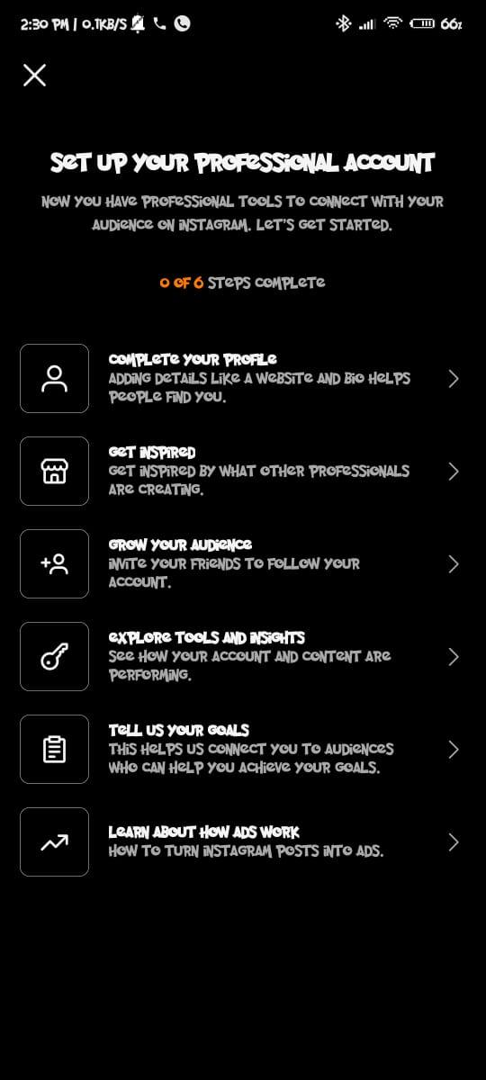

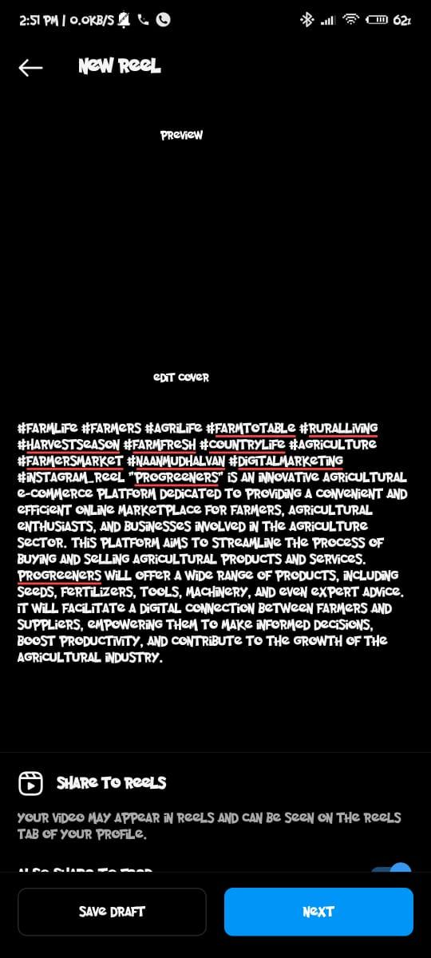

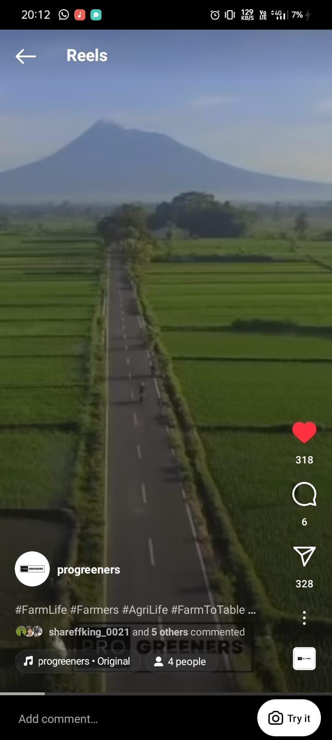

**Insight Results:**

