adding Website sitemapto google search console

[Documentation]

**A project documentation on:**

**Adding Website Sitemap to Google Search Console.**

Submitted in the fulfilment of requirements for the certificate of completion of the **digital marketing course given under Naan Mudhalvan Scheme by Govt of Tamilnadu.**

**By**

|  |  |
| --- | --- |
| **Name** | **Register Number** |
| Dhuvaraha Prasath.A[TL] | 810020106020 |
| Keerthyvaasan.A | 810020106041 |
| Mahendran.S | 810020106048 |
| Aravindh.S | 810020106709 |

Final Year,

Department of Electronics and Communication,

**University College of Engineering,BIT Campus,Tiruchirapalli.**

**Introduction:**

In the vast and ever-expanding digital landscape, having a strong online presence is crucial for any website or blog. Search engines play a pivotal role in helping users discover your content, and one of the most effective ways to ensure your site is properly indexed is by submitting a sitemap to Google Search Console. This simple yet powerful tool allows webmasters to communicate directly with Google, providing information about their site's structure and content, and ultimately improving its visibility in search results.

This project documentation will guide you through the process of adding your blogsite's sitemap to Google Search Console, offering a step-by-step approach to ensure that your valuable content is fully optimized for search engines. By the end of this documentation, you will understand the importance of sitemaps, how to generate one for your blogsite, and the exact steps needed to submit it to Google Search Console. Whether you are a seasoned webmaster or a beginner in the world of digital marketing, this resource will empower you to enhance your site's visibility and reach a broader audience.

**Abstract:**

The world of digital marketing and online content creation is constantly evolving. To stay relevant and competitive in the online space, it is imperative to optimize your blogsite for search engines, and Google Search Console is an indispensable tool in this process. This project documentation serves as a comprehensive guide on how to add your blogsite's sitemap to Google Search Console, emphasizing the importance of effective site indexing in search results.

This documentation will walk you through the fundamentals of sitemaps, why they are essential for your blogsite, and the role they play in improving search engine optimization (SEO). You will learn how to generate a sitemap for your blogsite, ensuring that it accurately represents your site's structure and content. Moreover, the step-by-step instructions provided in this document will guide you through the process of submitting your sitemap to Google Search Console, empowering you to take control of your site's visibility and its reach to a wider online audience.

Whether you are a seasoned webmaster looking to refine your SEO strategy or a novice blogger seeking to enhance your online presence, this documentation will equip you with the knowledge and practical skills necessary to make your blogsite more discoverable to users searching on Google.s.

**Brand Name: ADK_Design Community**

**Target Audience:Designing Students**



**Steps by step Procedure:**

**1.Open your Blogsite -🡪settings🡪search for “google search console” and click on it.** 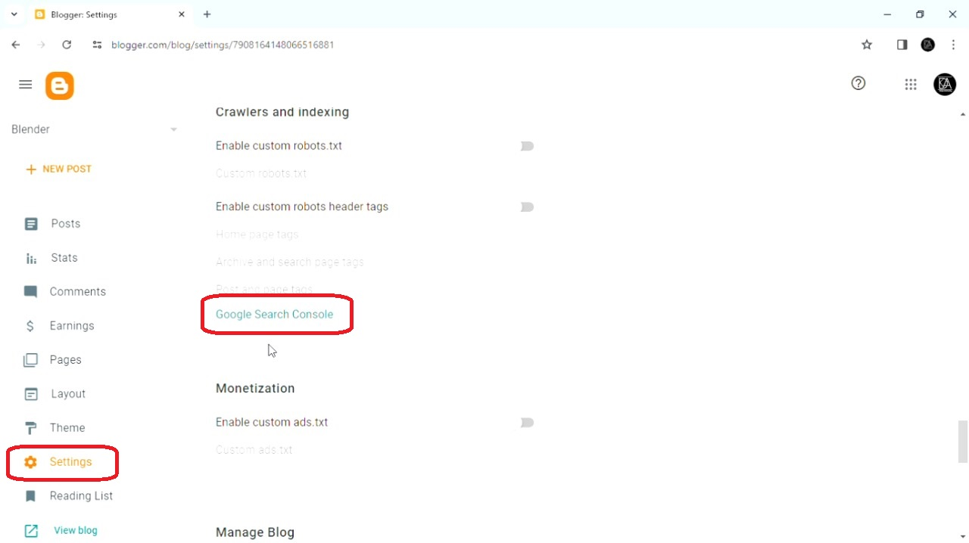

**2.In this window enter your blog site URL.** 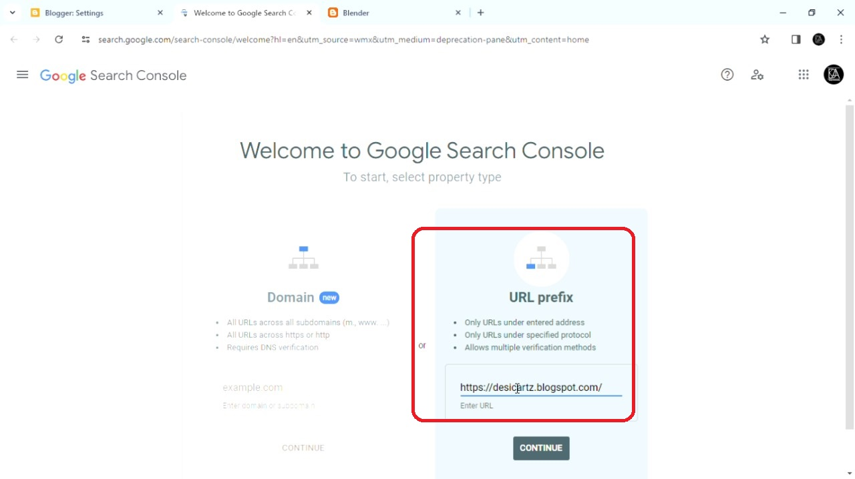

**3.The console will automatically verify the link if the same email address is used.then go to prperty.**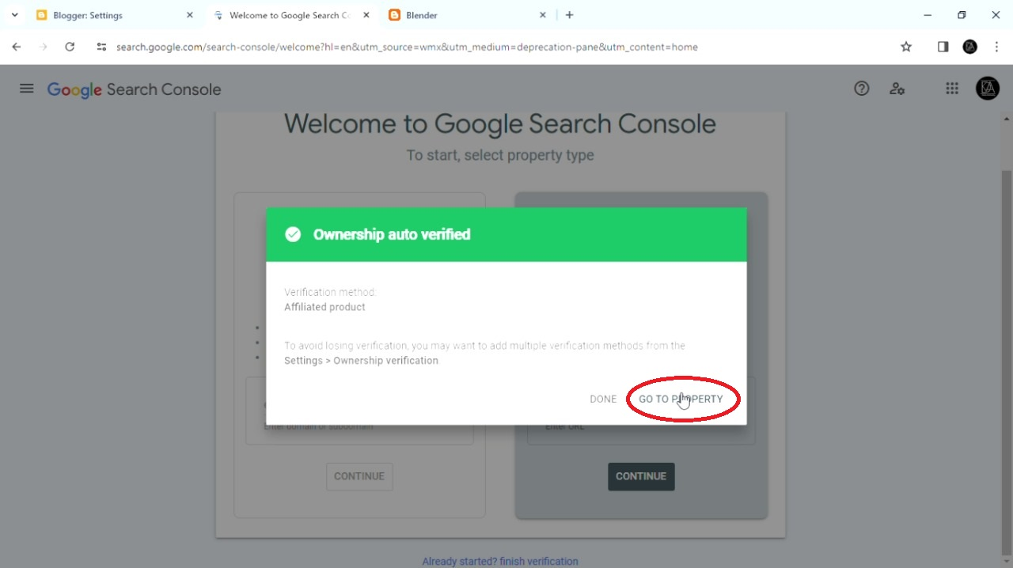

**4.In the google search console click on the start.**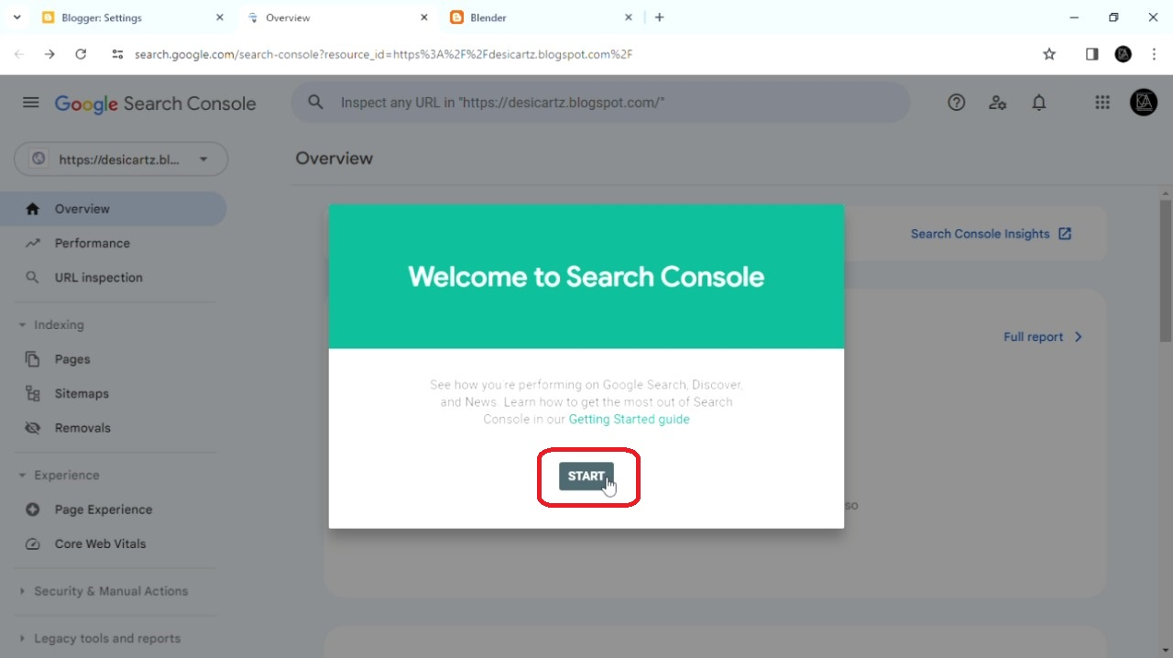

**5.In the options click on the sitemaps.**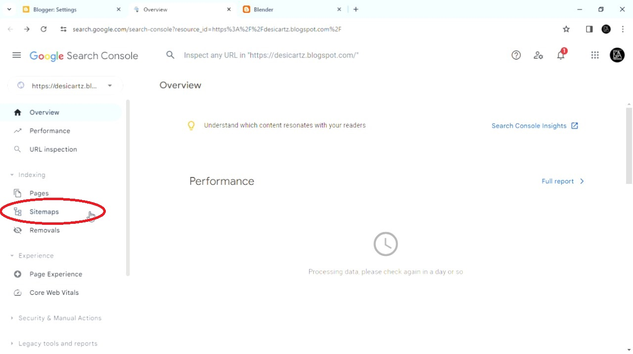

**6.Enter sitemap.xml and submit.**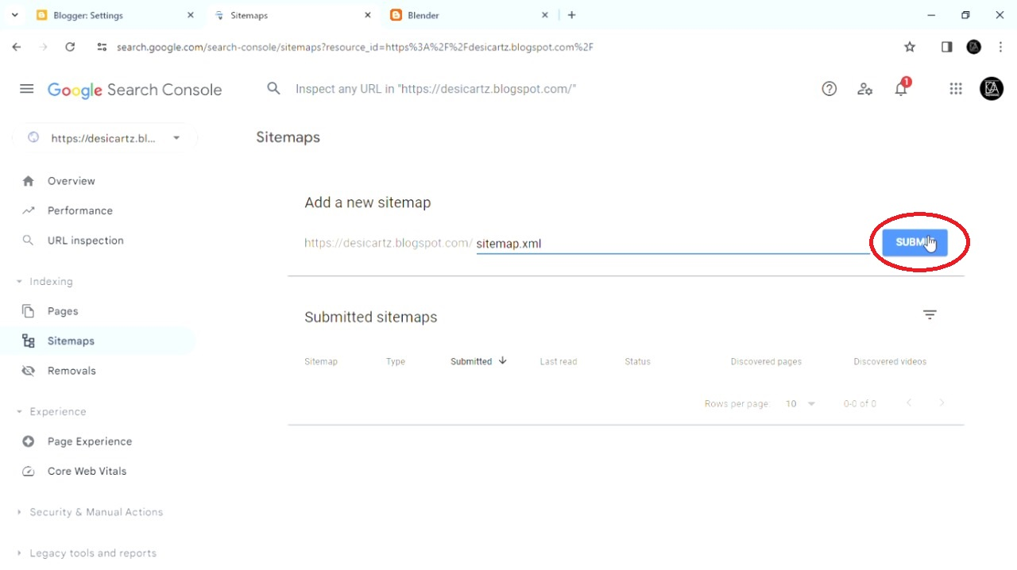

**7.You can view the perfomance and stats here.**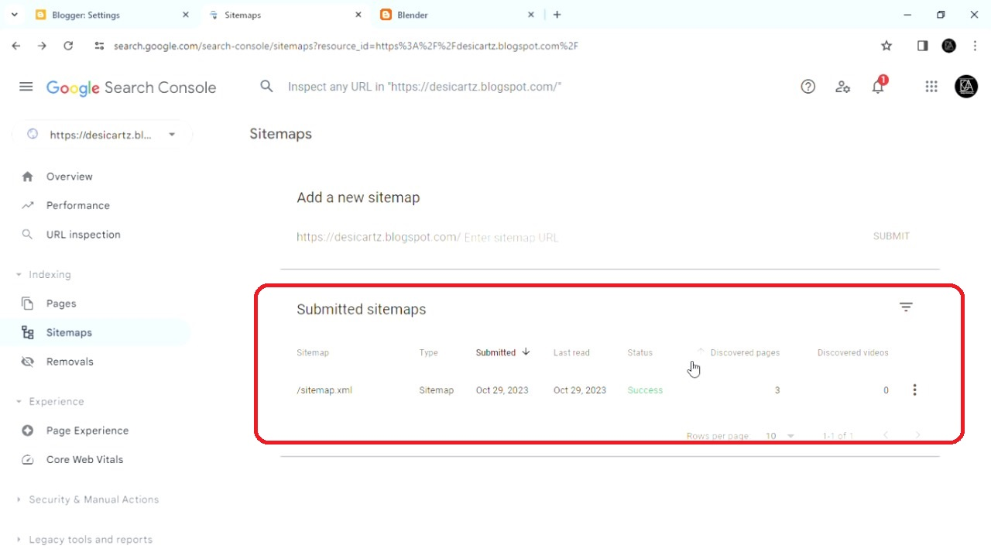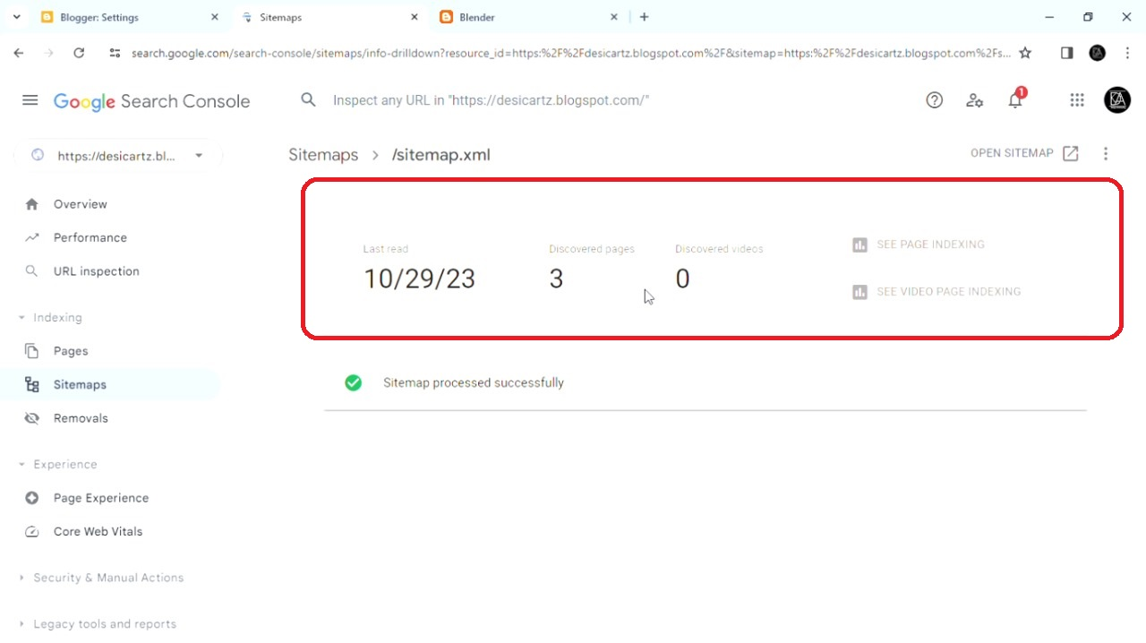

**Introduction:\***

**In the vast and ever-expanding digital landscape, having a strong online presence is crucial for any website or blog. Search engines play a pivotal role in helping users discover your content, and one of the most effective ways to ensure your site is properly indexed is by submitting a sitemap to Google Search Console. This simple yet powerful tool allows webmasters to communicate directly with Google, providing information about their site's structure and content, and ultimately improving its visibility in search results.**

**This project documentation will guide you through the process of adding your blogsite's sitemap to Google Search Console, offering a step-by-step approach to ensure that your valuable content is fully optimized for search engines. By the end of this documentation, you will understand the importance of sitemaps, how to generate one for your blogsite, and the exact steps needed to submit it to Google Search Console. Whether you are a seasoned webmaster or a beginner in the world of digital marketing, this resource will empower you to enhance your site's visibility and reach a broader audience.**

**\*Abstract:\***

**The world of digital marketing and online content creation is constantly evolving. To stay relevant and competitive in the online space, it is imperative to optimize your blogsite for search engines, and Google Search Console is an indispensable tool in this process. This project documentation serves as a comprehensive guide on how to add your blogsite's sitemap to Google Search Console, emphasizing the importance of effective site indexing in search results.**

**This documentation will walk you through the fundamentals of sitemaps, why they are essential for your blogsite, and the role they play in improving search engine optimization (SEO). You will learn how to generate a sitemap for your blogsite, ensuring that it accurately represents your site's structure and content. Moreover, the step-by-step instructions provided in this document will guide you through the process of submitting your sitemap to Google Search Console, empowering you to take control of your site's visibility and its reach to a wider online audience.**

**Whether you are a seasoned webmaster looking to refine your SEO strategy or a novice blogger seeking to enhance your online presence, this documentation will equip you with the knowledge and practical skills necessary to make your blogsite more discoverable to users searching on Google.Hereby,we have added our blogsite sitemap to google search console.The making cideo is attach as directed.**