**Task**

**Aim: Create and Design E-Commerce Website - UI (Front-End Only) with Shopping Cart Facility.**

**Description:**

* Create Product Listing Page with at least Five Products (Product image, Price,Discount, Add to Cart Button, Product Details)
* Create a Product Detail Page and Display appropriate Details About Product.
* Create Shopping Cart Page which will display
  + List of Product in Cart
  + Product Quantity modification
  + Product Remove From Cart Button
  + Discount
  + Total Price

**Source Code:**

**index.js**

import React from 'react';

import ReactDOM from 'react-dom';

import App from './App';

ReactDOM.render(<App />, document.getElementById('root'));

**CartItems.js**

import React from 'react';

const CartItem = ({ item, updateQuantity, removeFromCart }) => {

return (

<div className="product">

<img src={item.image} alt={item.title} />

<h3>{item.title}</h3>

<p>Price: ${item.price}</p>

<p>Quantity: {item.quantity}</p>

<button

className="cart-link"

onClick={() => updateQuantity(item.id, item.quantity + 1)}

>

+ Add

</button>

<button

className="cart-link"

onClick={() => updateQuantity(item.id, item.quantity - 1)}

disabled={item.quantity <= 1}

>

- Remove

</button>

<button

className="cart-link"

onClick={() => removeFromCart(item.id)}

>

Remove from Cart

</button>

</div>

);

};

export default CartItem;

**ProductDetail.js**

import React from 'react';

const ProductDetail = ({ product }) => {

return (

<div className="product-detail">

<img src={product.image} alt={product.name} />

<h2>{product.name}</h2>

<p>Price: ${product.price}</p>

<p>Discount: {product.discount}%</p>

<p>{product.details}</p>

</div>

);

};

export default ProductDetail;

**ProductList.js**

import React from 'react';

import products from '../data/products'; // Import the product data

const ProductList = ({ addToCart }) => {

return (

<div className="product-list">

{products.map(product => (

<div key={product.id} className="product">

<img src={product.image} alt={product.name} />

<h3>{product.name}</h3>

<p>Price: ${product.price}</p>

<p>Discount: {product.discount}%</p>

<button onClick={() => addToCart(product)}>Add to Cart</button>

</div>

))}

</div>

);

};

export default ProductList;

**ShoppingCart.js**

import React from 'react';

import CartItem from './CartItem';

const ShoppingCart = ({ cartItems, updateQuantity, removeFromCart }) => {

return (

<div className="product-list">

{cartItems.map(item => (

<CartItem

key={item.id}

item={item}

updateQuantity={updateQuantity}

removeFromCart={removeFromCart}

/>

))}

</div>

);

};

export default ShoppingCart;

**Products.json**

const products = [

{

id: 1,

name: "Product 1",

image: "https://m.media-amazon.com/images/I/71KkV4SFODL._AC_UF1000,1000_QL80_.jpg",

price: 19.99,

discount: 10,

details: "Product 1 details...",

},

{

id: 2,

name: "Product 2",

image: "https://images.meesho.com/images/products/131039114/ouglu_512.webp",

price: 19.99,

discount: 10,

details: "Product 1 details...",

},

{

id: 3,

name: "Product 3",

image: "https://5.imimg.com/data5/HZ/MC/WG/SELLER-13758313/kids-toys.jpg",

price: 19.99,

discount: 10,

details: "Product 1 details...",

},

{

id: 4,

name: "Product 4",

image: "https://img3.exportersindia.com/product_images/bc-full/2022/1/9826839/kids-jcb-toys-1643005623-6170783.jpeg",

price: 19.99,

discount: 10,

details: "Product 1 details...",

},

{

id: 5,

name: "Product 5",

image: "https://toyshine.in/cdn/shop/products/B0B8ZR7HW7_1_300x300.jpg?v=1664866024",

price: 19.99,

discount: 10,

details: "Product 1 details...",

},

{

id: 6,

name: "Product 6",

image: "https://images.jdmagicbox.com/quickquotes/images_main/car-toys-for-kids-386534834-5dtm0.jpg",

price: 19.99,

discount: 10,

details: "Product 1 details...",

},

{

id: 7,

name: "Product 7",

image: "https://image.made-in-china.com/2f0j00lqaVYCvETrUf/Amazon-Hot-Selling-Electronic-Automatic-EVA-Soft-Bullet-Gun-Toys-Kids-Shooting-Game-Foam-Bullet-Toy-Gun-for-Boys.webp",

price: 19.99,

discount: 10,

details: "Product 1 details...",

}

];

export default products;

**Output:**

Product Page

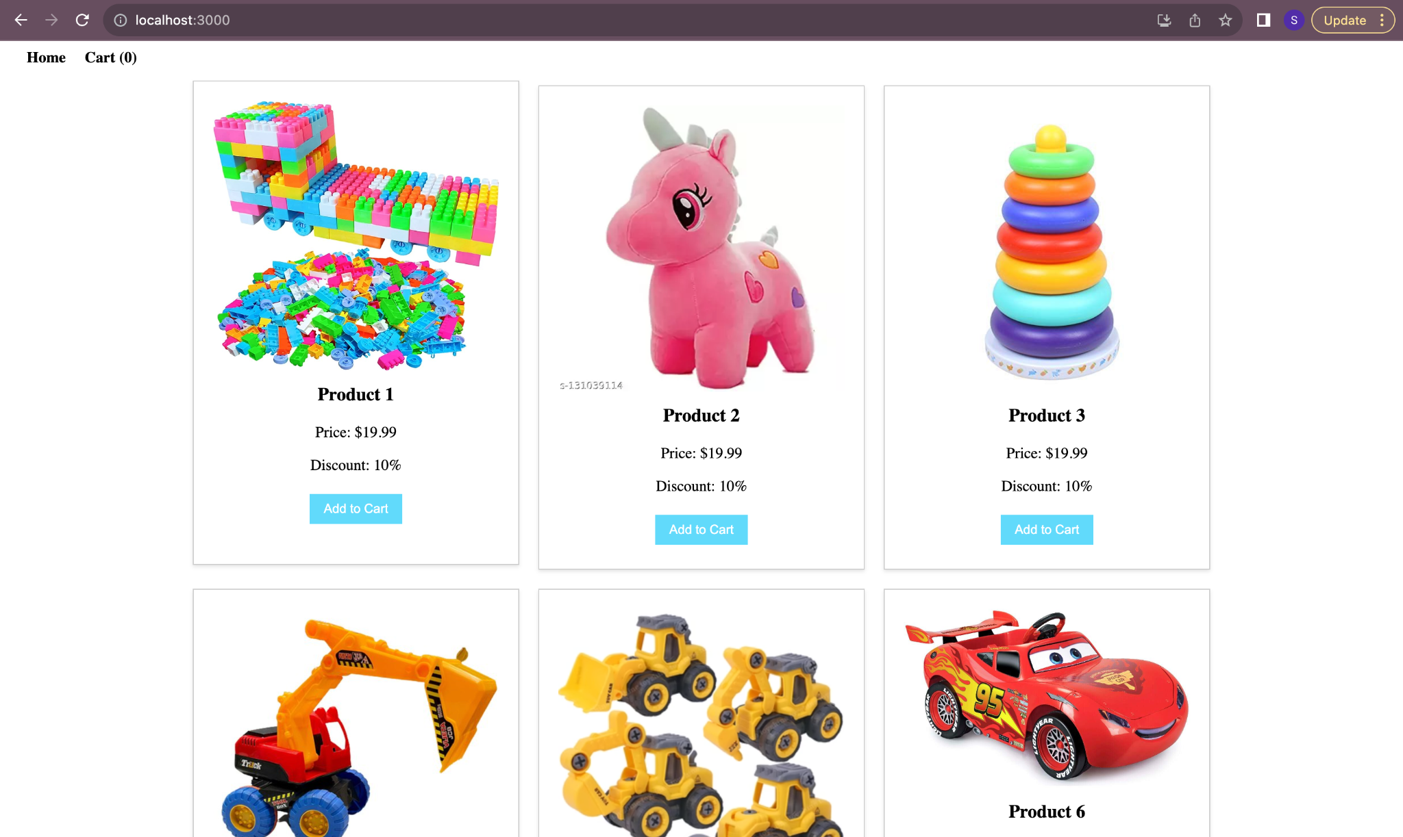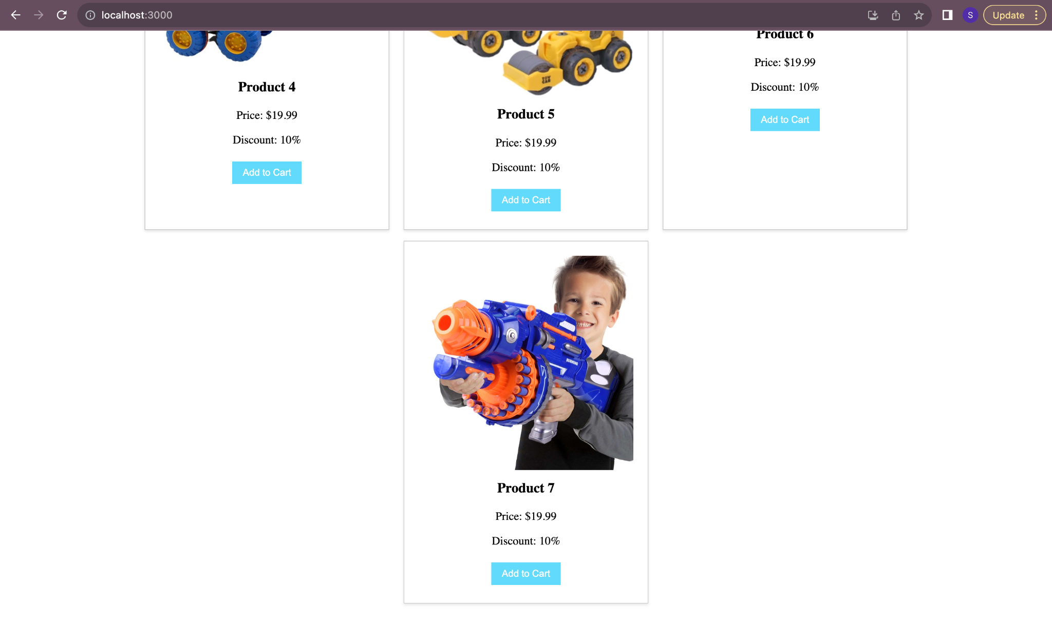

Cart Page

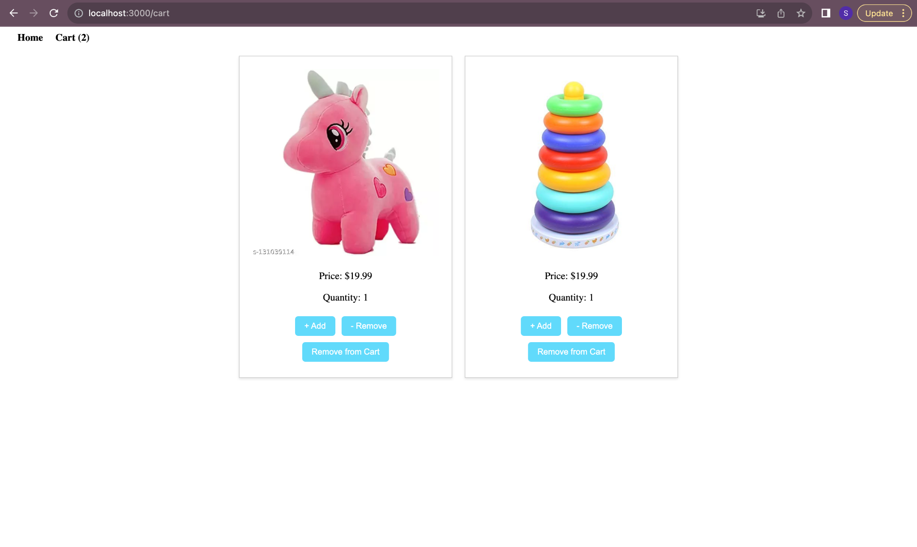

**Learning Outcome:**

In this practical, I have implemented different program logic to display product and event handlers using react and a Cart page to manage cart items. I have learned how to manage different functions and logic in different files and to access it.