Task-1
Aim: Experiments with React Hooks
Description:
● useState:
○ useState is a built-in React Hook used for managing and updating state in
functional components.
○ It allows you to declare a state variable and a function to update that variable
within a functional component.
○ When the state variable changes, React re-renders the component to reflect the
new state.
● useEffect:
○ useEffect is another built-in React Hook used for handling side effects in
functional components.
○ It takes two arguments: a function to run after rendering, and an optional array of
dependencies.
○ The function inside useEffect can perform tasks like data fetching, DOM
manipulation, or subscribing to external data sources.
● useRef:
○ useRef is a Hook used to create mutable references to DOM elements or other
values that persist across renders.
○ It is often used to interact with and manipulate DOM elements directly, like
focusing an input element or measuring its dimensions.
○ Unlike state variables, changes to useRef values do not trigger re-renders by
themselves.
● useContext:
○ useContext is a Hook that provides access to the context of a parent component in
a component tree.
○ Context is used for passing data, such as themes or authentication information, to
deeply nested components without manually passing props through every
intermediate component.
○ It allows functional components to subscribe to changes in the context and update
when the context changes.
● useMemo:
○ useMemo is a Hook used for memoization in functional components.
○ It helps optimize performance by memoizing the result of a computation so that it
is only recomputed when its dependencies change.
○ This can be useful for expensive calculations or when rendering components with
complex logic, preventing unnecessary re-renders.

Source Code:
index.js
import React from 'react';
import ReactDOM from 'react-dom/client';
import './index.css';
import App from './App';
import reportWebVitals from './reportWebVitals';
const root = ReactDOM.createRoot(document.getElementById('root'));
root.render(
<React.StrictMode>
<App />
</React.StrictMode>
);
reportWebVitals();

App.js
import React, { useState, useEffect, useRef, useContext, useMemo } from 'react';
// Create a context to manage the to-do list
const TodoContext = React.createContext();
// Custom hook to access the TodoContext
function useTodoContext() {
return useContext(TodoContext);
}
// TodoList component
function TodoList() {
const [todos, setTodos] = useState([]);
const [newTodo, setNewTodo] = useState('');
const todoInputRef = useRef();
const [completedCount, setCompletedCount] = useState(0);
// useEffect to update completedCount
useEffect(() => {
const completedTodos = todos.filter(todo => todo.completed);
setCompletedCount(completedTodos.length);
}, [todos]);
// useEffect to save todos to local storage
useEffect(() => {
const storedTodos = JSON.parse(localStorage.getItem('todos')) || [];
setTodos(storedTodos);
}, []);
// useEffect to update local storage whenever todos change
useEffect(() => {
localStorage.setItem('todos', JSON.stringify(todos));
}, [todos]);
// Handler to add a new todo
const addTodo = () => {
if (newTodo.trim() === '') return;
const newTodos = [...todos, { id: Date.now(), text: newTodo, completed: false }];
setTodos(newTodos);
setNewTodo('');
todoInputRef.current.focus();
};
// Handler to toggle todo completion status
const toggleTodo = (id) => {
const updatedTodos = todos.map(todo => {
if (todo.id === id) {
return { ...todo, completed: !todo.completed };
}
return todo;
});
setTodos(updatedTodos);
};
// useMemo to calculate the total number of todos
const totalTodos = useMemo(() => todos.length, [todos]);
const todoListStyle = {
display: 'flex',
flexDirection: 'column',
alignItems: 'center',
height: '100vh',
boxShadow: '0 4px 6px rgba(0, 0, 0, 0.1)',
padding: '20px',
borderRadius: '5px',
background: '#fff',
maxWidth: '400px',
margin: '0 auto',
};
const inputContainerStyle = {
display: 'flex',
marginBottom: '10px',
};
const addButtonStyle = {
background: '#007bff',
color: '#fff',
border: 'none',
padding: '10px 15px',
borderRadius: '5px',
cursor: 'pointer',
marginLeft: '10px',
};
const listItemStyle = {
listStyleType: 'none',
cursor: 'pointer',
};
// App component using useContext
function App() {
return (
<TodoContext.Provider>
<div className="App">
<TodoList />
</div>
</TodoContext.Provider>
);
}
export default App;

Output:
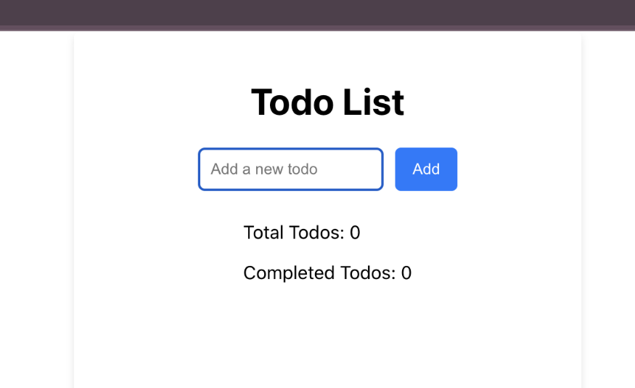
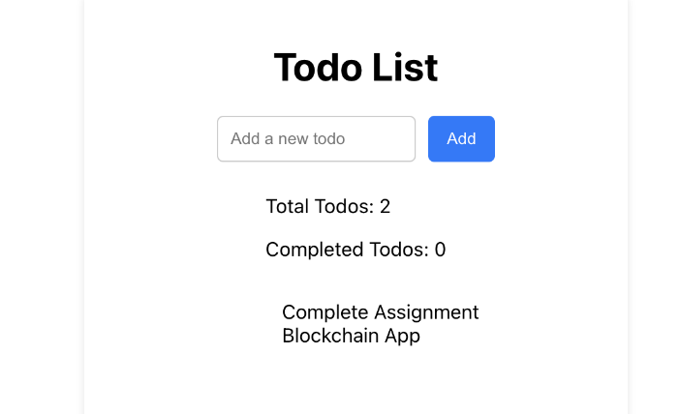

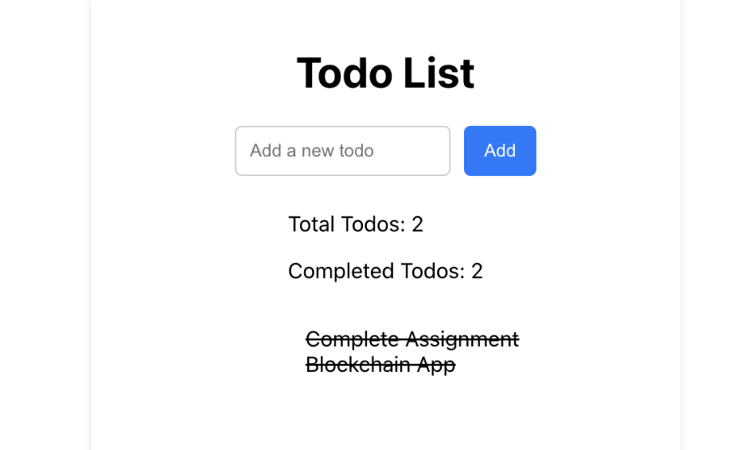

Aim: Create a Custom React Hook to Fetch PUBLIC API data and Display it
on the webpage.

Source Code:
index.js
import React from 'react';
import ReactDOM from 'react-dom/client';
import './index.css';
import App from './App';
import reportWebVitals from './reportWebVitals';
const root = ReactDOM.createRoot(document.getElementById('root'));
root.render(
<React.StrictMode>
<App />
</React.StrictMode>
);
reportWebVitals();

App.js
import React from 'react';
import Weather from './Weather';
function App() {
return (
<div className="App">
<Weather city="India" />
</div>
);
}
export default App;
Weather.js
import React from 'react';
import useWeather from './useWeather';
import './Weather.css'; // Import the CSS file
const Weather = ({ city }) => {
const weatherData = useWeather(city);
if (!weatherData) {
return <div>Loading...</div>;
}
if (!weatherData.main) {
return <div>No weather data available for {city}.</div>;
}
return (
<div className="weather-box"> {/* Apply the 'weather-box' class */}
<h2>Weather in {city}</h2>
<p>Temperature: {weatherData.main.temp}°C</p>
<p>Weather: {weatherData.weather[0].description}</p>
</div>
);
};
export default Weather;

Weather.css
.weather-box {
border: 2px solid #333;
padding: 20px;
width: 300px;
margin: 0 auto;
text-align: center;
}
useWeather.js
import { useState, useEffect } from 'react';
const useWeather = (city) => {
const [weatherData, setWeatherData] = useState(null);
const apiKey =
'https://api.openweathermap.org/data/2.5/weather?q=london&appid=b5fe7bf360c7cce65110619b
f0bdbba0&units=Metric'; // Replace with your OpenWeatherMap API key
useEffect(() => {
const fetchWeather = async () => {
try {
const response = await fetch(
`https://api.openweathermap.org/data/2.5/weather?q=london&appid=b5fe7bf360c7cce65110619
bf0bdbba0&units=Metric`
);
const data = await response.json();
setWeatherData(data);
}
catch (error) {
console.error('Error fetching weather data:', error);
}
};
fetchWeather();
}, [city, apiKey]);
return weatherData;
};
export default useWeather;

Output:
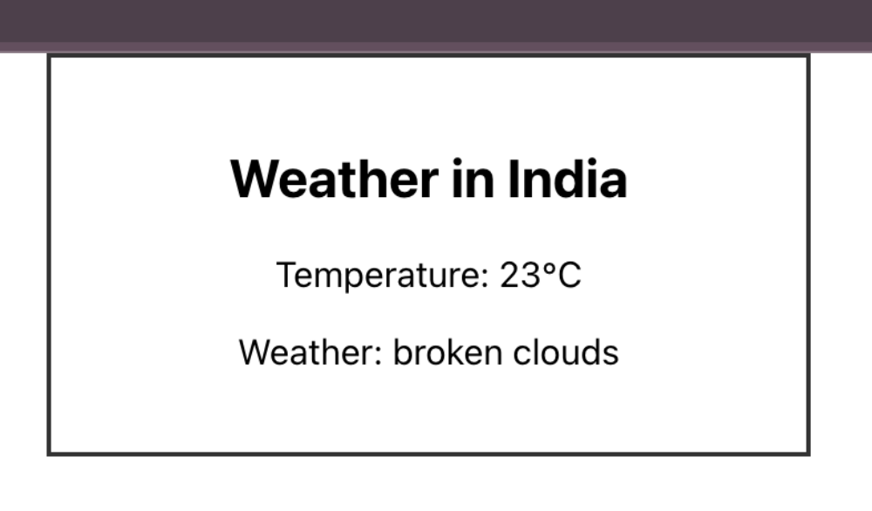

Learning Outcome:
In this practical, I have implemented what APIs are, why APIs are used, how to call an API, and
created a React App to fetch external/third party server to get particular data in JSON object and
how to use react hook function. I have displayed the fetched data extracted by hook function. I
have learnt concepts of hook i.e useState, useEffect, useRef, useContext, useMemo.

