ITC5315: Project Status Report WK 1

Created by: Dhvani Barot

Student ID: N01584917

Date: 04/10/2024

# Table of contents

Table of contents 2

Step 0 3

Step 1 4

Step 2 5

Step 3 9

Summary 11

## Step 0

Describe why you selected to use a git repository or not

I selected to use git repository because it helps to keep track of changes in the project.

It also provides a safety net, making it easy to undo mistakes and recover my lost work. Basically, as a backup plan.

## Step 1

Show a screenshot Atlas/Compass once the data has been loaded. Use the Mongosh terminal to run the command: db.<collection>.countDocuments() on the “restaurants“ collection in the “5315-project” database. Show a screenshot of the result. (see <https://www.mongodb.com/docs/manual/reference/method/db.collection.countDocuments/>)

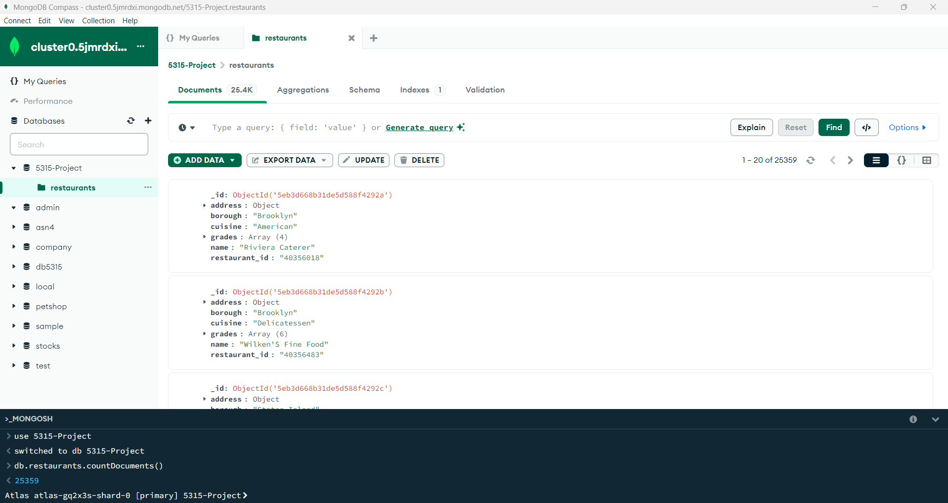

## Step 2

Use “npm run start” to start your server. Show a screenshot of it being started using this command.

Explain any challenges or new learnings that you encountered when implementing the routes. Use Postman to test all the routes. Make sure to include tests for errors / invalid data. List the response codes that you used and why you used them. Show screenshots of all your tests.

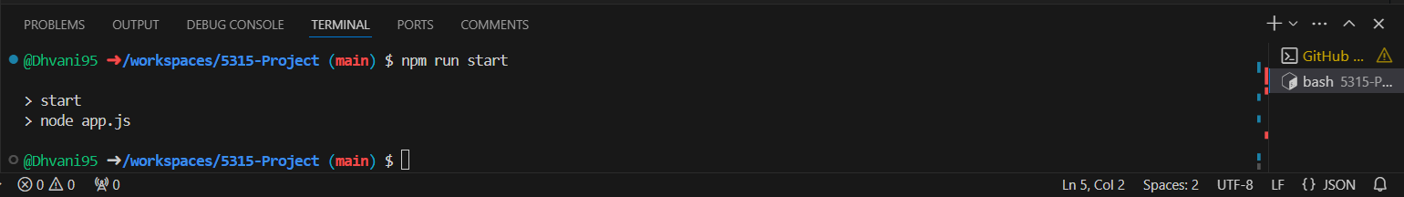

One of the challenges I encountered was implementing pagination and filtering in GET requests, as it required careful consideration of query parameters and database queries to retrieve the correct data.

I used 404 for not found, 3000 port to check the result, 201 to create or add new restaurant data, 400 for incorrect query.

Get all restaurants

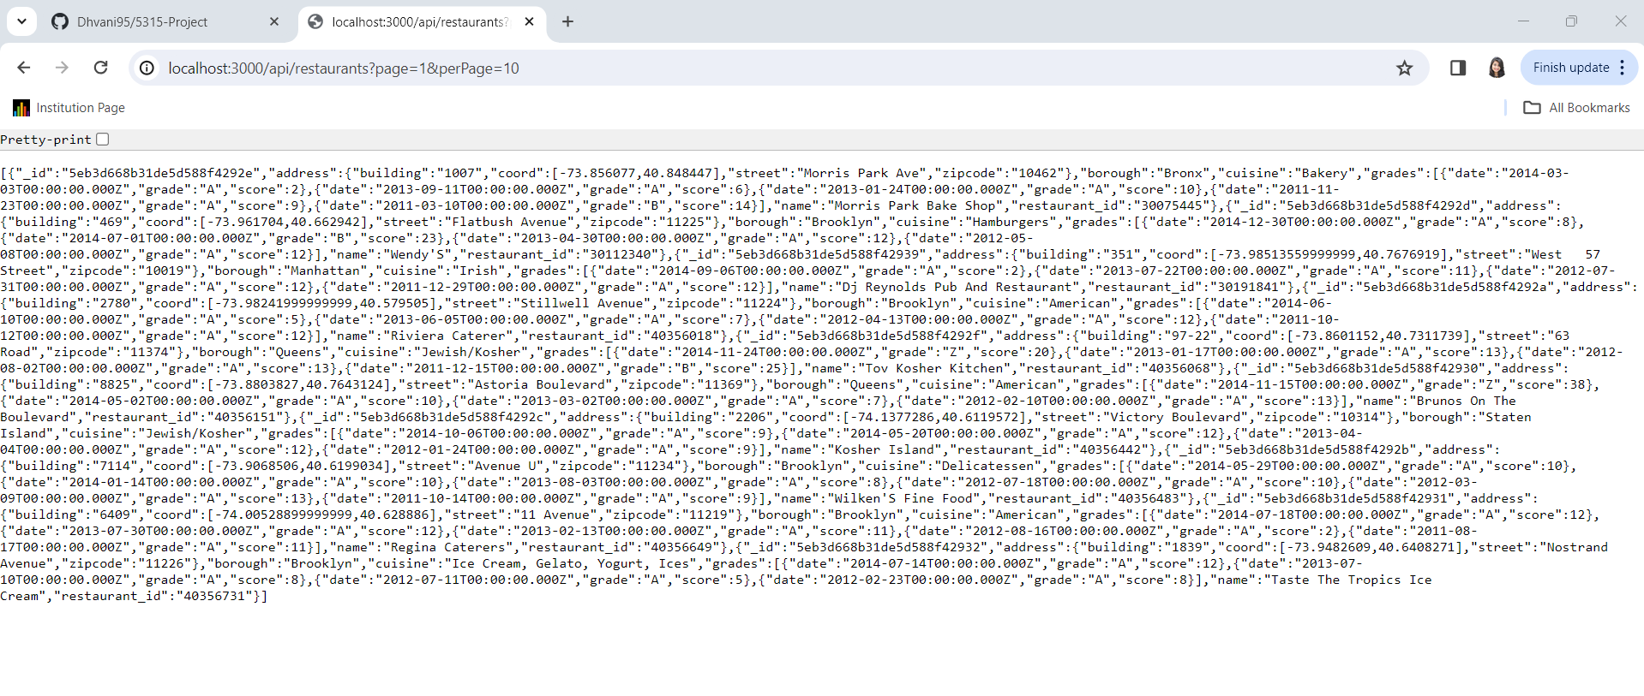

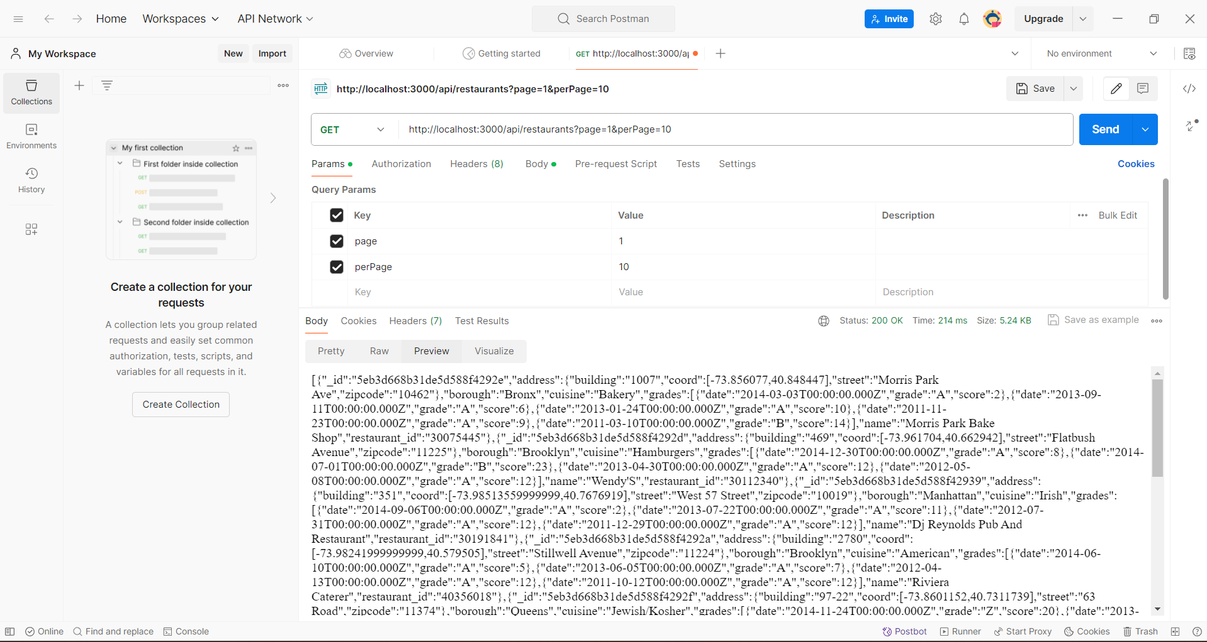

Add new restaurant

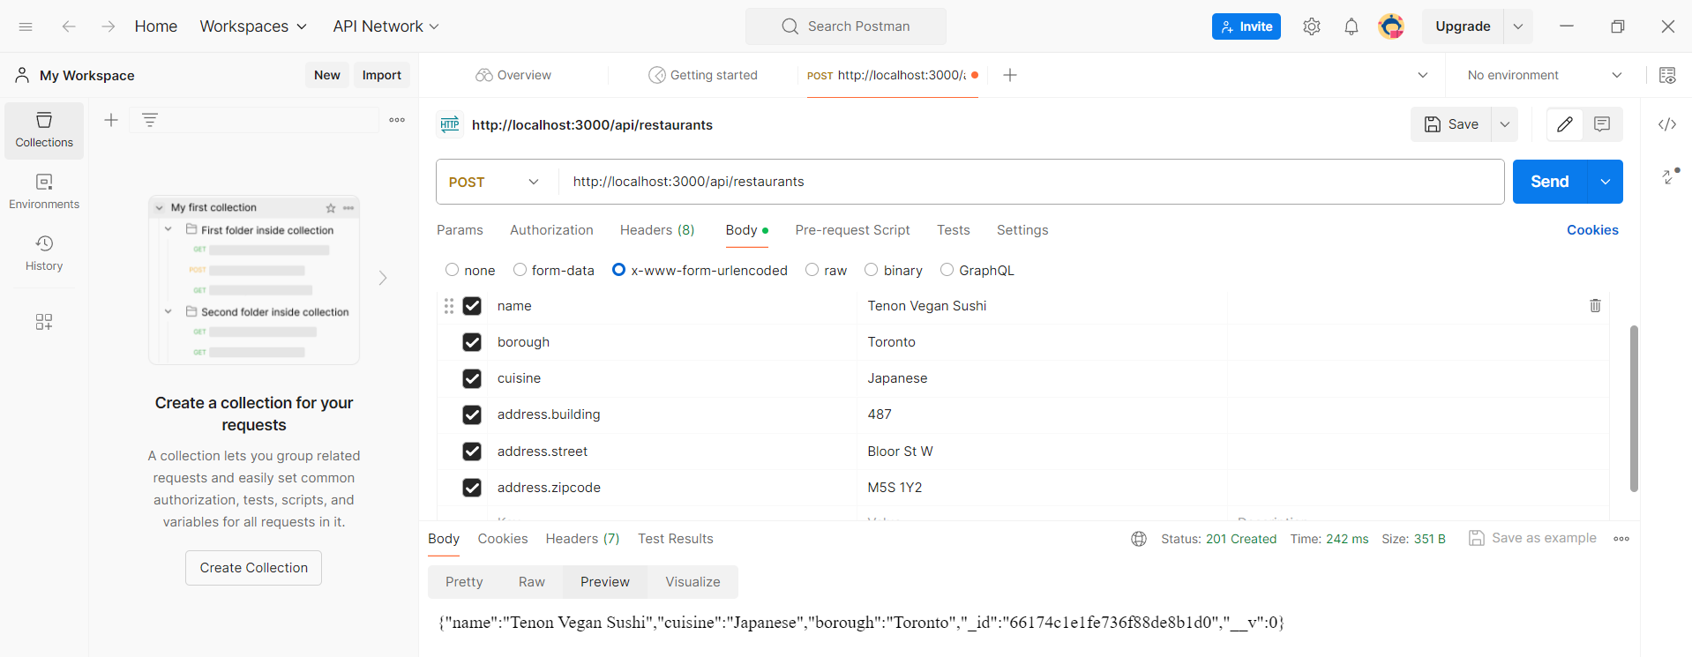

Get restaurants by ID

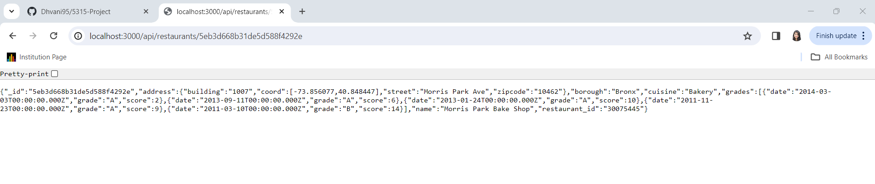

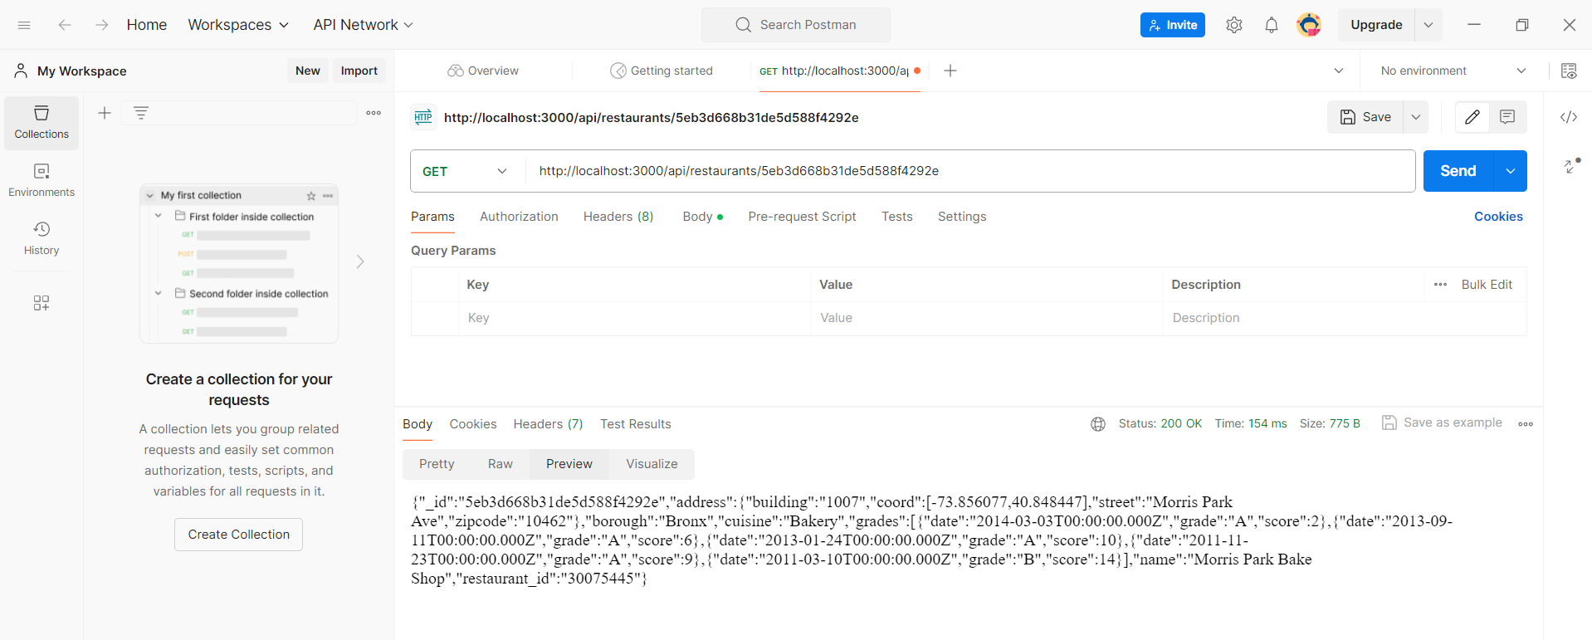

Update Restaurant by ID

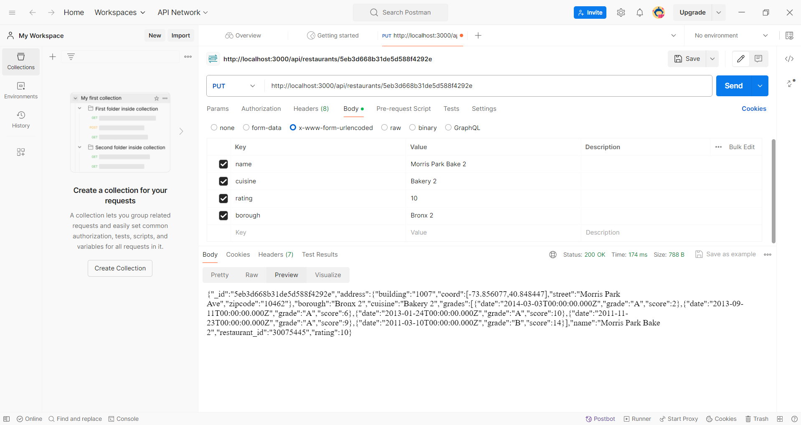

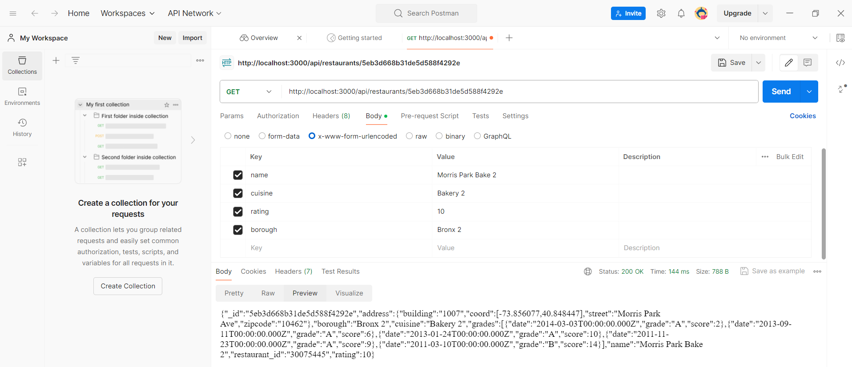

Delete Restaurant by ID

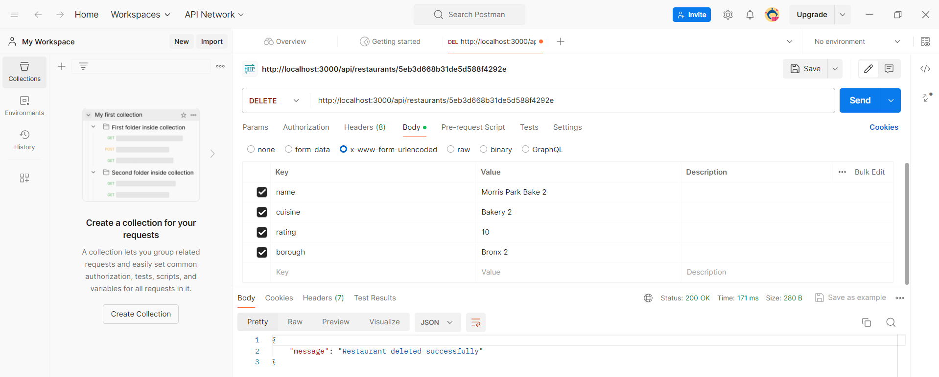

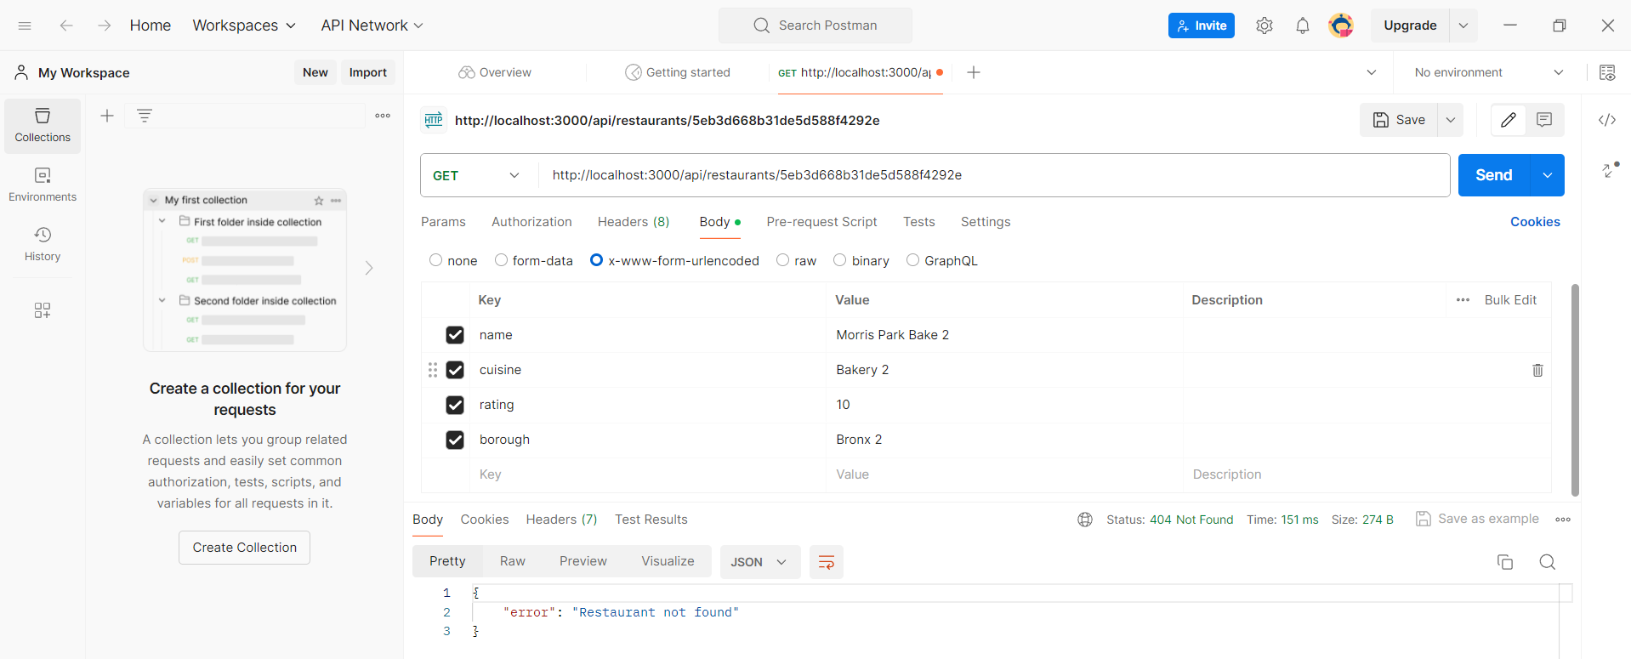

Step 3

Describe the steps you used to create the UI. Describe any challenges or new learnings that you encountered while developing the UI. Include screenshots of the UI and screenshots of Postman being used to test the new route.

Creating the UI involved planning layout, making HTML structure, styling with CSS for look and feel, using Handlebars for dynamic content, and handling form submission.

Challenges included learning Handlebars and CSS for layout. Ensuring form validation and managing routes were also hurdles. It improved my front-end skills and understanding of integrating with back-end.

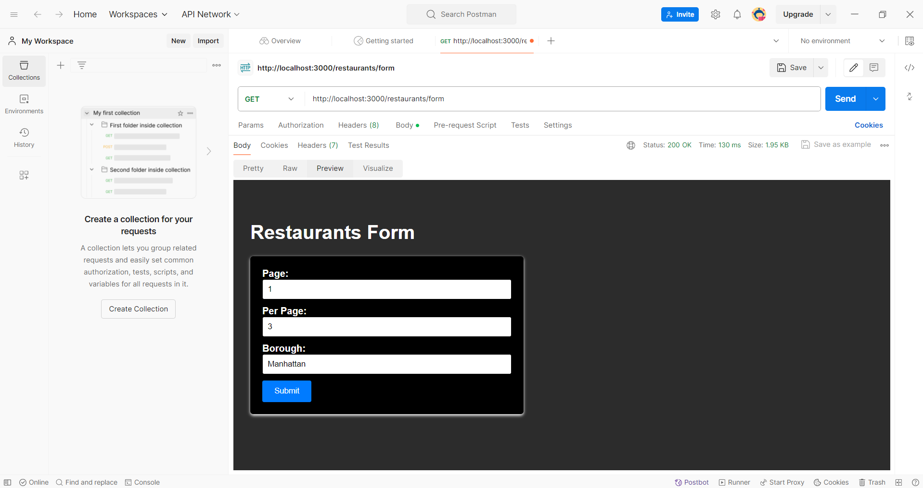

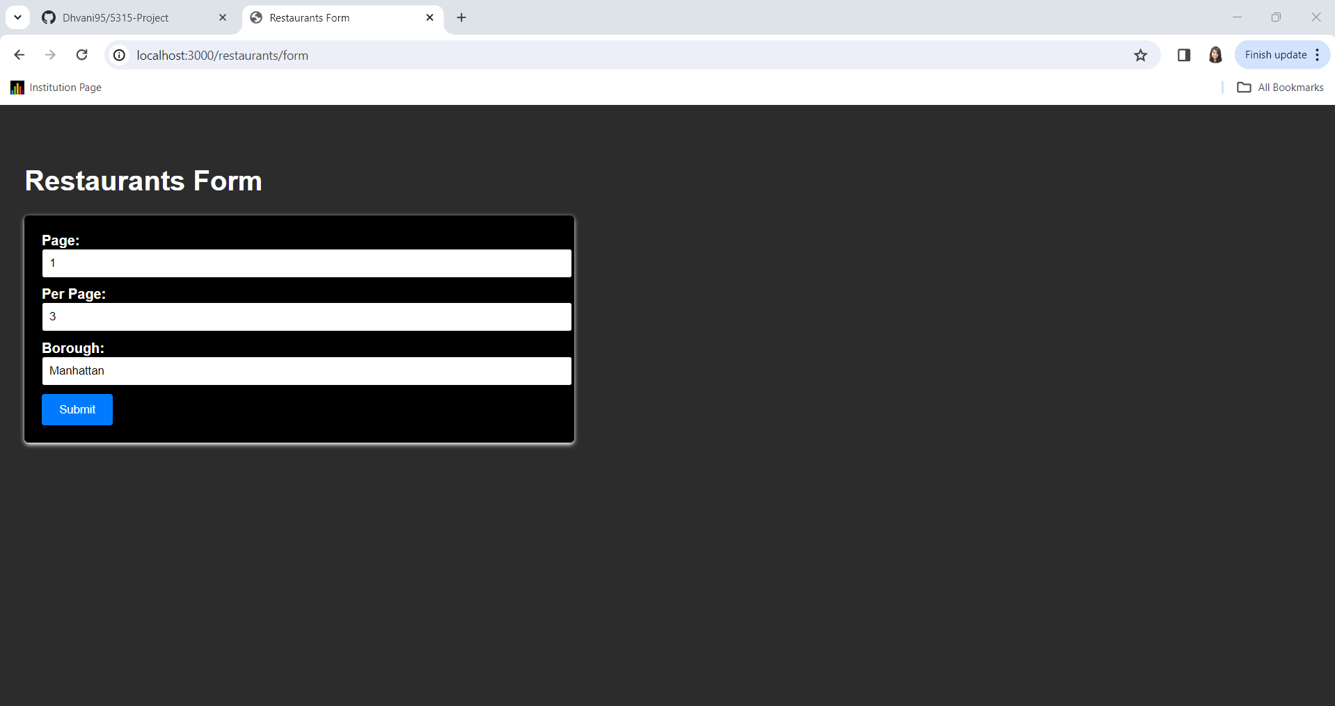

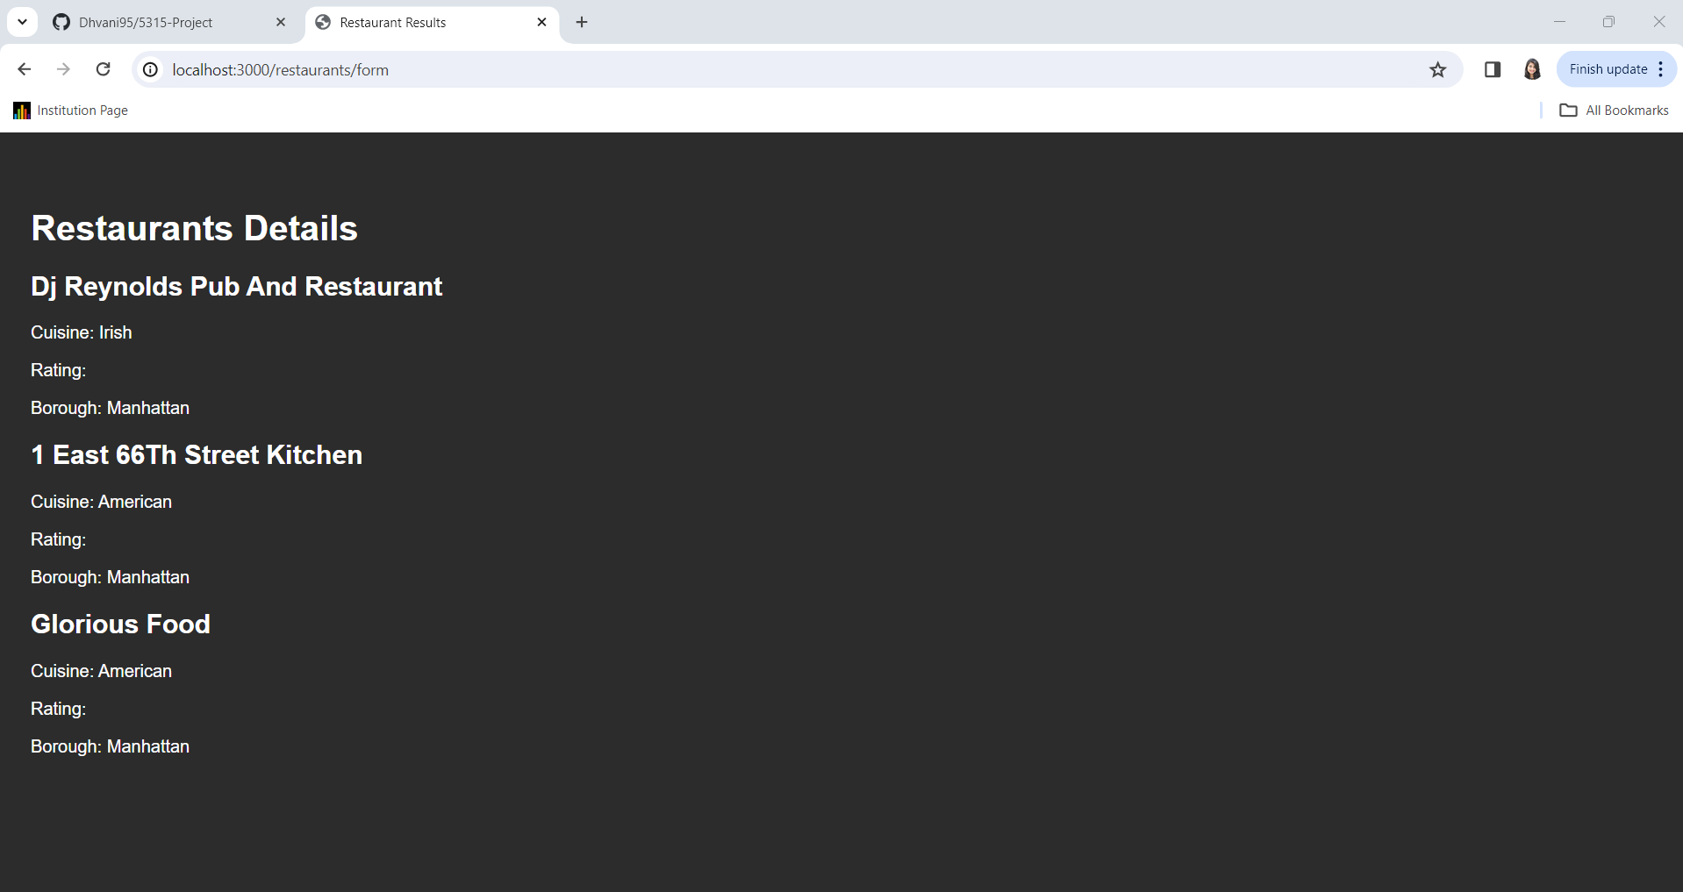

## Summary

Summarize your experience while working on this project for the first week. Do you have questions about the project for the next class? Questions you want to ask your peers or professor? Would you have done anything differently? Did anything take shorter/longer than you expected?

During the first week of the project, I learned how to set up a server, connect to a database, and create routes for handling data.

I faced some challenges with error handling, form validation, and working with the database. I also learned about using Git to manage project versions and collaborate with others.

I do not have any questions.

Looking back, I realize I could have spent more time planning and considering potential problems. Some tasks, like form validation and designing the user interface, took longer than I expected.

Overall, it was a good learning experience.