**PROBLEM STATEMENT:** Design a buck converter that has an input 24V- 1A max (24 watts max at input) and generates 5V output with circuit conversion efficiency of atleast 90 percent. (note: understand efficiency)

**COMPONENTS:**

The following components are used in the buck convertor circuit:

* 24V battery
* Two resistors of 95 Ω and 100 Ω respectively
* Switch
* Schottky diode
* Inductor of 68 µH
* Capacitor of 220 µF
* Voltmeter

**WORKING:**

The PCB (printed circuit board) is of dimensions 49 mm x 49 mm. The components mentioned above are added on the PCB. Then, footprint was added. A footprint is the physical layout of a component on the PCB, which includes the pads or through-holes where the component pins will be soldered. Each component has a different footprint owing to its pin configuration and shape. This was followed by routing which includes connecting the different components on a PCB to form electrical connections. Once the footprint and routing was done, the components were mounted on the PCB to generate a 3D model.

The circuit is that of a buck convertor. Our aim is to provide a 24V input that steps down to 5V at the output. Firstly, the 24V input from the battery is passed across two parallel resistors of 95 Ω and 100 Ω respectively. The switch is used to open and close the circuit. The diode prevents the voltage spike across the switch by providing a path for the inductor current to flow when the switch is off. Without the diode, when the switch is on, the energy stored in the inductor will have no path to flow, resulting in large voltage spikes. Due to the presence of inductor, there would be a sudden change in current, potentially damaging the components in the circuit. An inductor of 68 µH is used to limit the rate of current change. A capacitor of 220 µF is used to smooth out the rapid voltage fluctuations. Thus the voltmeter measures the stepped down voltage which can alternatively be given to a load using a connector on the PCB.

**CIRCUIT DIAGRAM:**

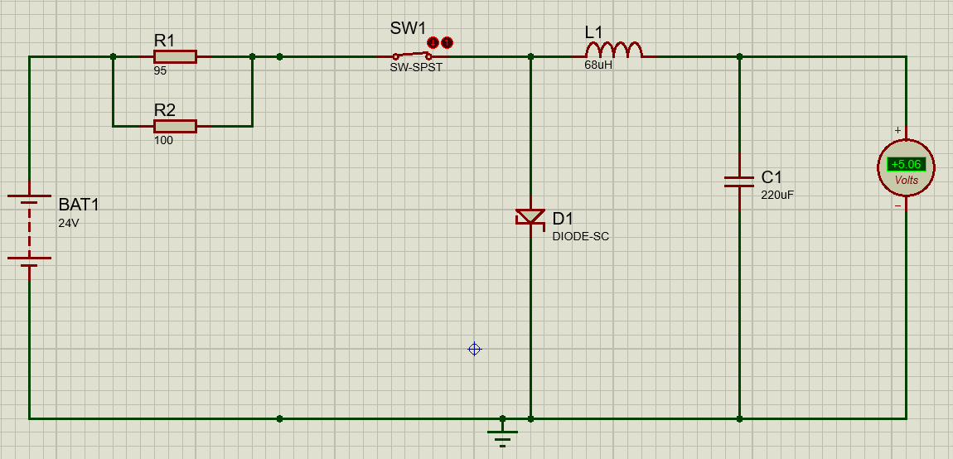

**CONCLUSION:**

A buck converter can thus be designed to step down a 24V input to a 5V output with an efficiency of at least 90% using components such as resistors, a switch, a Schottky diode, an inductor, and a capacitor to achieve the desired voltage regulation.