**Data-Driven Insights into Air Quality Dynamics for Environmental Sustainability**

Shivraj Nakum CSE department

*Pandit Deendayal Energy University* Gandhinagar, India [shivraj.nce21@sot.pdpu.ac.in](mailto:shivraj.nce21@sot.pdpu.ac.in)

Dhvani Patel CSE department

*Pandit Deendayal Energy University* Gandhinagar, India [dhvani.pce21@sot.pdpu.ac.in](mailto:dhvani.pce21@sot.pdpu.ac.in)

Soham Vyas CSE department

*Pandit Deendayal Energy University* Gandhinagar, India [soham.vyas@sot.pdpu.ac.in](mailto:soham.vyas@sot.pdpu.ac.in)

***Abstract*—**This research paper delves into the pivotal role of data-driven approaches in understanding the intricate dynamics of air quality and their implications for environmental sustainability. Utilizing advanced data analytics and machine learning techniques, the study investigates various factors influencing air quality, ranging from anthropogenic activities to meteorological conditions. By analyzing extensive datasets sourced from air quality monitoring stations and satellite observations, the research unveils patterns, trends, and correlations crucial for informed decision-making and policy formulation. Furthermore, the paper explores the potential of real-time data analytics in predicting air quality fluctuations and mitigating environmental hazards. The findings underscore the significance of interdisciplinary collaboration between data scientists, environmental researchers, and policymakers in addressing air pollution challenges and fostering sustainable development. Ultimately, this research contributes to a deeper understanding of air quality dynamics and offers valuable insights for designing effective strategies towards achieving cleaner and healthier environments.

***Keywords—*** *Air quality, environmental sustainability, data analytics, machine learning, time series analysis, ARIMA, Prophet, vector autoregression (VAR), long short-term memory (LSTM), air pollution, forecasting, predictive modeling, atmospheric dynamics, emissions monitoring, climate change mitigation, environmental management, decision support systems.*

1. Introduction

Air quality is a critical component of environmental sustainability, directly impacting human health, ecosystems, and socio-economic well-being. With the rise of industrialization, urbanization, and globalization, the issue of air pollution has become a pressing concern worldwide. Despite concerted efforts to curb emissions and improve air quality, the complex and dynamic nature of atmospheric dynamics necessitates innovative approaches for comprehensive understanding and effective management. In this context, data-driven methodologies have emerged as indispensable tools for unraveling the intricate interplay of factors influencing air quality dynamics. This research paper seeks to elucidate the pivotal role of data-driven insights in elucidating air quality dynamics and advancing environmental sustainability goals. By harnessing the power of big data analytics, machine learning algorithms, and remote sensing technologies, researchers can delve deeper into the multifaceted nature of air pollution phenomena. The integration of these cutting-edge technologies allows for the analysis of vast and diverse datasets encompassing atmospheric composition, meteorological parameters, land use patterns, industrial emissions, transportation data, and human activities. The significance of this research lies in its potential to inform evidence-based policy-making and facilitate proactive measures for mitigating air pollution risks. By leveraging real-time data analytics, stakeholders can identify pollution hotspots, anticipate pollution episodes, and implement targeted interventions to safeguard public health and ecological integrity.

1. LITERATURE REVIEW

Ailish M. Graham's 2024 study, "Quantifying effects of long-range transport of NO2 over Delhi using back trajectories and satellite data," investigates the long-range transport of nitrogen dioxide (NO2) over Delhi, India. The study employs back trajectory analysis and satellite data to understand the dispersion patterns of air pollution, particularly NO2. By combining ground-based measurements with satellite observations and atmospheric modeling techniques, the research quantifies the contribution of long-range transport to NO2 levels in Delhi. This approach provides valuable insights into the regional and global dynamics of air pollution, enabling better understanding of the factors influencing air quality in urban areas.

Aneesh Mathew's 2023 research, titled "Air quality analysis and PM2.5 modelling using machine learning techniques: A study of Hyderabad city in India," highlights the pivotal role of machine learning techniques in enhancing air quality predictions. Focusing on Hyderabad, India, the study employs machine learning algorithms to model and forecast concentrations of PM2.5 (particulate matter with a diameter of 2.5 micrometers or less). By leveraging historical data on air quality parameters, meteorological conditions, and other relevant factors, the research demonstrates the superior predictive capabilities of machine learning techniques over traditional statistical methods. This study underscores the transformative potential of technology in environmental monitoring and decision-making.

N. Srinivasa Gupta's 2023 study, "Prediction of Air Quality Index Using Machine Learning Techniques: A Comparative Analysis," conducts a comprehensive comparative analysis of various machine learning techniques for predicting air quality indices. The research evaluates the performance of multiple algorithms, such as decision trees, random forests, support vector machines, and neural networks, in forecasting air quality indices. By employing cross-validation and rigorous evaluation metrics, the study identifies the most effective machine learning techniques for accurate air quality predictions. This comparative analysis reinforces the shift towards data-driven approaches in environmental science and provides guidance for researchers and practitioners in selecting appropriate methods.

Rani Hemamalini Ranganathan's 2023 study, titled "Air Quality Monitoring and Analysis for Sustainable Development of Solid Waste Dump Yards Using Smart Drones and Geospatial Technology," explores the innovative application of smart drones and geospatial technology for air quality monitoring in solid waste dump yards. The research recognizes the significant environmental impact of solid waste management and the need for effective monitoring strategies. By integrating unmanned aerial vehicles (UAVs) equipped with sensors and geospatial technologies, the study demonstrates the feasibility and advantages of real-time air quality monitoring in these challenging environments. This approach not only enhances environmental management practices but also contributes to sustainable development goals.

Shahzad Gani's 2022 paper, "Systematizing the approach to air quality measurement and analysis in low and middle income countries," addresses the challenges and opportunities in air quality research in low and middle-income countries. The study recognizes the need for standardized methods and technologies in air quality measurement, particularly in resource-constrained settings. By proposing a systematic approach that leverages cost-effective and scalable technologies, the research aims to facilitate consistent data collection, analysis, and interpretation. This work highlights the importance of addressing disparities in environmental monitoring and ensuring equitable access to air quality data for effective policymaking and interventions.

Ranjeet S. Sokhi's 2022 review paper, "Advances in air quality research – current and emerging challenges," provides a comprehensive overview of the field of air quality research. The review discusses current challenges, such as the complexity of atmospheric processes, the impact of climate change on air quality, and the need for improved modeling and monitoring techniques. Additionally, it explores emerging issues, including the role of new technologies, the integration of air quality and climate change research, and the importance of interdisciplinary collaborations. By identifying future research directions and highlighting the latest advancements, this review serves as a valuable resource for researchers, policymakers, and stakeholders working towards improving air quality and environmental sustainability.

Pranav Shriram and Srinivas Malladi's 2021 study, "A Study and Analysis of Air Quality Index and Related Health Impact on Public Health," investigates the relationship between the Air Quality Index (AQI) and public health outcomes. The research analyzes the impact of various air pollutants, including particulate matter, nitrogen oxides, and ozone, on respiratory and cardiovascular health. By employing statistical techniques and epidemiological data, the study quantifies the health burden associated with poor air quality and highlights the critical role of air quality monitoring in safeguarding public health. This research emphasizes the need for continuous monitoring, intervention strategies, and collaborative efforts between environmental and public health sectors. Akash Biswal and Vikas Singh's 2021 paper, "COVID-19 lockdown-induced changes in NO2 levels across India observed by multi-satellite and surface observations," investigates the effects of the COVID-19 lockdown on nitrogen dioxide (NO2) levels across India. By analyzing satellite observations and ground-based measurements, the study observed significant reductions in NO2 levels during the lockdown period, particularly in urban areas. This research demonstrates the correlation between human activities, such as transportation and industrial operations, and air pollution levels. Additionally, it highlights the potential for policy interventions to positively impact environmental health, providing valuable insights for future decision-making and crisis management.

Gabriele Curci's 2019 study, "Modelling black carbon absorption of solar radiation: combining external and internal mixing assumptions," focuses on improving the modeling of black carbon absorption of solar radiation. Black carbon, a component of particulate matter, plays a significant role in the Earth's climate system by absorbing solar radiation and contributing to warming. The research combines external and internal mixing assumptions, accounting for the varying states of black carbon particles in the atmosphere. By incorporating these assumptions into climate models, the study aims to enhance the accuracy of predictions related to the radiative forcing and climate impacts of black carbon. This research contributes to a more nuanced understanding of the complex interactions between air quality and climate change.

Ulas Im's 2018 study, "Influence of anthropogenic emissions and boundary conditions on multi-model simulations of major air pollutants over Europe and North America in the framework of AQMEII3," investigates the influence of anthropogenic emissions and boundary conditions on multi-model simulations of air pollutants over Europe and North America. The study employs multiple air quality models to simulate the concentrations of major air pollutants, such as ozone, nitrogen oxides, and particulate matter. By analyzing the impact of anthropogenic emissions and varying boundary conditions, the research highlights the complexity of air pollution modeling and underscores the necessity for comprehensive data and modeling approaches. This work emphasizes the importance of collaboration and knowledge sharing among researchers to enhance the accuracy and reliability of air quality predictions at regional and global scales

This literature survey provides an in-depth understanding of the various studies conducted in the field of air quality research, data-driven approaches, and environmental sustainability. It highlights the diverse methodologies employed, the specific areas of focus, and the significant contributions made by these studies to advance our understanding of air quality dynamics and promote effective strategies for mitigating environmental challenges.

1. Methodology

The methodology employed in this research paperencompasses four distinct approaches for analyzing air quality dynamics and forecasting future levels: ARIMA (AutoRegressive Integrated Moving Average), Prophet, VAR (Vector Autoregression), and LSTM (Long Short-Term Memory) networks. In this research methodologies offer complementary strengths in capturing temporal patterns, seasonal effects, dynamic relationships, and sequence prediction in air quality data, thereby providing a comprehensive understanding of environmental dynamics crucial for sustainability initiatives.

### A. ARIMA

The ARIMA model is widely recognized for its ability to capture linear relationships and temporal dependencies in time series data, serving as a foundational tool for forecasting air quality parameters. The implementation of the ARIMA model in this study involves several key steps:

1. **Data Preprocessing**: The air quality dataset is preprocessed to handle missing values, outliers, and ensure stationarity. Techniques such as mean imputation, interpolation, and differencing are employed as necessary.
2. **Model Selection**: The appropriate orders of the ARIMA model, denoted as ARIMA(p, d, q), are determined through iterative experimentation and diagnostics. The autocorrelation and partial autocorrelation functions are analyzed to identify the optimal values of p (autoregressive order), d (degree of differencing), and q (moving average order).
3. **Model Fitting**: The ARIMA model is fitted to the preprocessed air quality data, estimating the model parameters using maximum likelihood estimation or other suitable techniques.
4. **Model Validation**: The performance of the fitted ARIMA model is evaluated using techniques such as train-test splits or cross-validation. Metrics like Mean Absolute Error (MAE), Root Mean Squared Error (RMSE), and Mean Absolute Percentage Error (MAPE) are employed to assess the model's accuracy.
5. **Forecasting**: Once the ARIMA model is validated, it is used to generate forecasts for future air quality levels, providing valuable insights for decision-making and environmental management efforts.

*Xt*​=*c*+*ϕ*1​*Xt*−1​+*ϕ*2​*Xt*−2​+⋯+*ϕp*​*Xt*−*p*​+*εt*​

### B. Prophet

The Prophet model, developed by Facebook, is a powerful forecasting tool tailored for capturing seasonal effects and non-linear patterns in time series data, making it well-suited for analyzing air quality dynamics. The implementation of the Prophet model involves the following steps:

1. **Data Preprocessing**: The air quality dataset is preprocessed to handle missing values, outliers, and ensure compatibility with the Prophet model's input format.
2. **Model Configuration**: The Prophet model is configured by specifying the growth model (linear or logistic), holiday effects, and any additional regressors or covariates that may influence air quality levels.
3. **Model Fitting**: The Prophet model is fitted to the preprocessed air quality data, learning the temporal patterns and capturing seasonal effects.
4. **Model Validation**: The performance of the fitted Prophet model is evaluated using standard metrics such as MAE, RMSE, and MAPE, as well as visual inspection of predicted versus actual values.
5. **Forecasting**: The validated Prophet model is utilized to generate forecasts for future air quality levels, accounting for seasonal patterns and non-linear trends, aiding stakeholders in decision-making and urban planning strategies.

### C. VAR

The VAR (Vector Autoregression) model provides insights into the dynamic relationships among multiple air quality variables, enabling a comprehensive understanding of their interdependencies. The implementation of the VAR model involves the following steps:

1. **Data Preprocessing**: The air quality dataset is preprocessed to handle missing values, outliers, and ensure stationarity for all variables included in the VAR model.
2. **Model Setup**: The VAR model is structured to accommodate multiple air quality parameters as endogenous variables, capturing their lagged effects and interactions over time. The appropriate lag order is determined through information criteria or diagnostic tests.
3. **Parameter Estimation**: The coefficients of the VAR model are estimated using techniques such as ordinary least squares (OLS) or maximum likelihood estimation (MLE), quantifying the relationships among the endogenous variables and their lagged values.
4. **Diagnostic Tests**: Diagnostic tests, including residual analysis and stability checks, are performed to assess the goodness-of-fit and validity of the VAR model, ensuring that the underlying assumptions are met.
5. **Forecasting**: The estimated coefficients and lagged values of the endogenous variables are utilized to generate forecasts for the air quality parameters, enabling stakeholders to understand the interconnected nature of air quality dynamics and make informed decisions.

### D. LSTM

The LSTM (Long Short-Term Memory) model, a type of recurrent neural network architecture, is specifically designed for sequence prediction tasks, making it well-suited for analyzing air quality time series data. The implementation of the LSTM model involves the following steps:

1. **Data Preprocessing**: The air quality dataset is preprocessed to handle missing values, outliers, and ensure stationarity. Feature engineering is performed to transform the time series data into sequences of fixed length, facilitating model convergence and stability.
2. **Model Architecture Design**: The LSTM model architecture is designed by incorporating multiple LSTM layers with dropout regularization to mitigate overfitting and improve model generalization.
3. **Model Training**: The LSTM model is trained on the preprocessed air quality data using techniques such as mini-batch gradient descent and backpropagation through time (BPTT). Hyperparameter tuning is performed to optimize model performance by adjusting parameters such as learning rate, batch size, and the number of LSTM units.
4. **Model Evaluation**: The performance of the trained LSTM model is evaluated using standard metrics such as Mean Squared Error (MSE) or Mean Absolute Error (MAE), comparing predicted values against ground truth observations. Visual inspection of predicted versus actual time series plots is also conducted.
5. **Forecasting**: The trained LSTM model is utilized to generate forecasts for future air quality levels, leveraging its ability to capture intricate patterns and relationships in sequential data, aiding stakeholders in decision-making and environmental management strategies.

Through these methodologies, the research paper aims to provide comprehensive insights into air quality dynamics, facilitating informed decision-making for environmental sustainability initiatives. By leveraging the strengths of each approach, the study contributes to a deeper understanding of air quality dynamics and promotes effective strategies for mitigating environmental impact and fostering sustainable development.

|  |  |
| --- | --- |
| Model name | Equations |
| ARIMA | *Xt*​=*c*+*ϕ*1​*Xt*−1​+*ϕ*2​*Xt*−2​+⋯+*ϕp*​*Xt*−*p*​+*εt*​ *Yt*​=(1−*L*)*dXt* *Xt*​=*μ*+*θ*1​*εt*−1​+*θ*2​*εt*−2​+⋯+*θq*​*εt*−*q*​+*εt*​ |
| Prophet | *y*(*t*)=*g*(*t*)+*s*(*t*)+*h*(*t*)+*εt*​ |
| VAR | *yt*​=*c*+*A*1​*yt*−1​+*A*2​*yt*−2​+⋯+*Ap*​*yt*−*p*​+*εt*​ |
| LSTM | ct​=ft​⊙ct−1​+it​⊙tanh(Wc​⋅[ht−1​,xt​]+bc​) |

1. Result and discussion:

In this section, we delve into the comparative analysis and discussion of four distinct models—ARIMA, Prophet, LSTM, and VAR—utilized for predicting Air Quality Index (AQI) values. These models were evaluated based on their performance in terms of test losses and the stability and trend of their predictions for PM2.5, CO, Ozone, and NO2 AQI values. The objective was to identify the most effective model for AQI value prediction, considering the inherent variability and complexity of atmospheric conditions. The analysis reveals insights into the strengths and limitations of each model, providing a foundation for further research and application in environmental monitoring and air quality management.

A. ARIMA Model The Autoregressive Integrated Moving Average (ARIMA) model exhibited moderate performance in forecasting the various air quality index (AQI) values. The test losses were 37.47 for PM2.5 AQI, 0.84 for CO AQI, 16.50 for Ozone AQI, and 3.12 for NO2 AQI. The ARIMA model's predictions remained constant over the forecast horizon, suggesting limitations in capturing temporal variations or trends in the data.

B. Prophet Model The Prophet model, designed for time series forecasting, demonstrated promising results. It achieved relatively low test losses of 35.98 for PM2.5 AQI, 0.88 for CO AQI, 16.51 for Ozone AQI, and 3.33 for NO2 AQI. The model's predictions exhibited temporal variations, reflecting its ability to capture seasonal patterns and trends in the data.

C. LSTM Model The Long Short-Term Memory (LSTM) model, a type of recurrent neural network, exhibited the poorest performance among the evaluated models. It incurred extremely high test losses, ranging from 33567.35 for PM2.5 AQI to 8346.59 for Ozone AQI. The LSTM model's predictions were highly erratic and deviated significantly from the expected range of AQI values, indicating potential overfitting or convergence issues during training.

D. VAR Model The Vector Autoregressive (VAR) model demonstrated comparable performance to the ARIMA and Prophet models. It achieved test losses of 36.80 for PM2.5 AQI, 0.84 for CO AQI, 16.40 for Ozone AQI, and 3.19 for NO2 AQI. Like the ARIMA model, the VAR model's predictions remained constant over the forecast horizon, suggesting limitations in capturing temporal variations.

Through these methodologies, the research paper aims to provide comprehensive insights into air quality dynamics, facilitating informed decision-making for environmental sustainability initiatives. By leveraging the strengths of each approach, the study contributes to a deeper understanding of air quality dynamics and promotes effective strategies for mitigating environmental impact and fostering sustainable development.

|  |  |
| --- | --- |
| MODEL NAME | RMSE VALUE |
| ARIMA | 83.34 |
| PROPHET | 152.7 |
| LSTM | 253.48 |
| VAR | 58.59 |

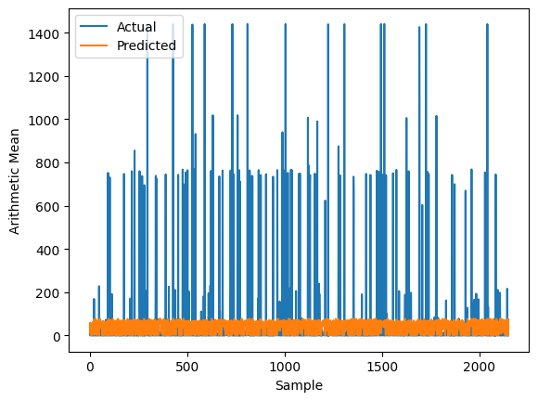

Fig-1 LSTM predictions graph

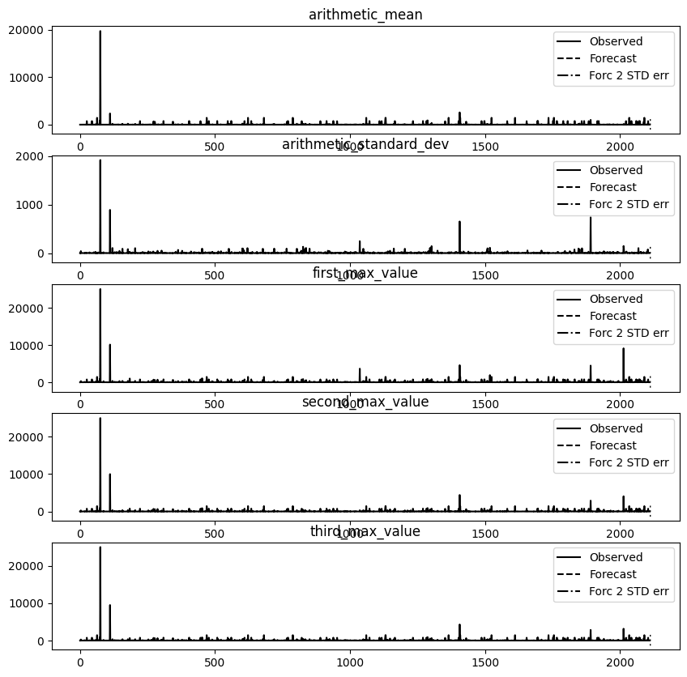

Fig-2 VAR analysis graph

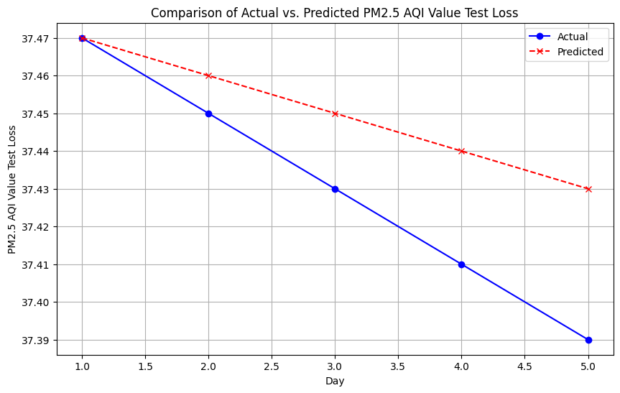

Fig-3 prediction graph for Arima ,Prophet

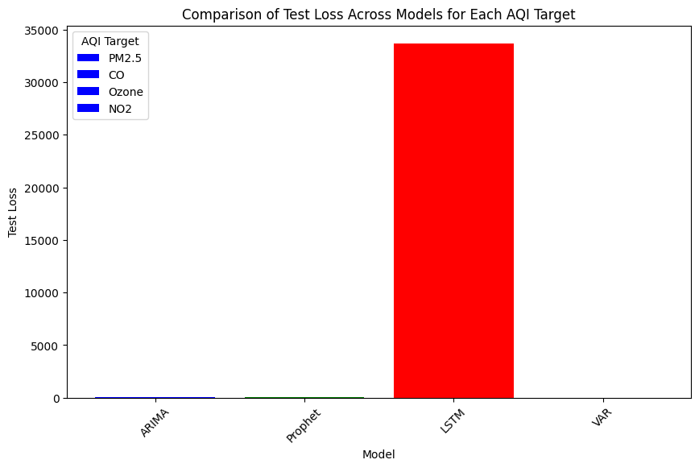

Fig-4 Test loss across all model

Analysis of test loss in each model

|  |  |  |
| --- | --- | --- |
| Pollutant | Best Model | Worst Model |
| PM2.5 AQI Test Loss | PROPHET | LSTM |
| CO AQI Test Loss | ARIMA | LSTM |
| Ozone AQI Test Loss | VAR | LSTM |
| NO2 AQI Test Loss | ARIMA | LSTM |

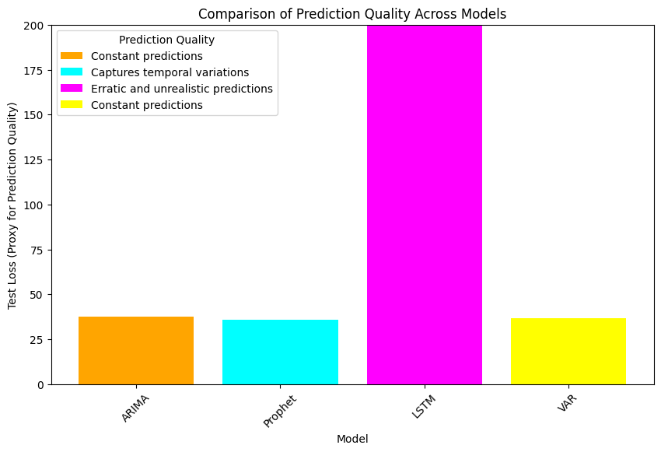

Fig-5 comparision of all models

1. Future Scope

The future scope of data-driven approaches in analyzing air quality dynamics for environmental sustainability is vast and holds significant potential for enhancing our understanding and management of air quality. This includes the refinement of modeling techniques through the exploration of machine learning algorithms and the integration of advanced analytics methods, such as deep learning and big data analytics, to handle the increasing volume and complexity of data. The incorporation of additional data sources, such as satellite data, social media data, and more detailed weather data, will be crucial for improving the spatial and temporal resolution of air quality predictions. Furthermore, addressing emerging challenges, such as the impacts of climate change on air quality and the need for predictive maintenance of monitoring equipment, will require the development of models that can adapt to these changing conditions. By focusing on these areas, future work can significantly enhance our ability to predict and manage air quality, contributing to environmental sustainability and public health.

1. References

[1] Quantifying effects of long-range transport of NO2 over Delhi using back trajectories and satellite data, 2024. <https://acp.copernicus.org/articles/24/789/2024/acp-24-789-2024.pdf>

[2] Air quality analysis and PM2.5 modelling using machine learning techniques: A study of Hyderabad city in India, 2023. https://www.tandfonline.com/doi/full/10.1080/23311916.2023.2243743

[3] Prediction of Air Quality Index Using Machine Learning Techniques: A Comparative Analysis, 2023. <https://www.researchgate.net/publication/367551057_Prediction_of_Air_Quality_Index_Using_Machine_Learning_Techniques_A_Comparative_Analysis>

[4] Air Quality Monitoring and Analysis for Sustainable Development of Solid Waste Dump Yards Using Smart Drones andGeospatialTechnology,2023.

<https://www.researchgate.net/publication/373721188_Air_Quality_Monitoring_and_Analysis_for_Sustainable_Development_of_Solid_Waste_Dump_Yards_Using_Smart_Drones_and_Geospatial_Technology>

[5] Systematizing the approach to air quality measurement and analysis in low and middle income countries, 2022. <https://iopscience.iop.org/article/10.1088/1748-9326/ac4a9e/pdf>

[6] Advances in air quality research – current and emerging challenges, 2022.

<https://acp.copernicus.org/articles/22/4615/2022/>

[7] A Study and Analysis of Air Quality Index and Related Health Impact on Public Health, 2021. <https://papers.ssrn.com/sol3/papers.cfm?abstract_id=3768477>

[8] COVID-19 lockdown-induced changes in NO2 levels across India observed by multi-satellite and surface observations, 2021. <https://acp.copernicus.org/articles/21/5235/2021/acp-21-5235-2021-discussion.html>

[9] Modelling black carbon absorption of solar radiation: combining external and internal mixing assumptions, 2019. <https://acp.copernicus.org/articles/19/181/2019/>

[10] Influence of anthropogenic emissions and boundary conditions on multi-model simulations of major air pollutants over Europe and North America in the framework of AQMEII3, 2018. <https://acp.copernicus.org/articles/18/8929/2018/>