## 1 Introduction

Banana fiber is a dialect cellulosic fiber, which got from the pseudo-stem of banana plant. Banana fiber is a bast fiber with generally great mechanical properties. Banana fiber has great explicit strength properties similar to those of ordinary material, similar to glass fiber. This material has a lower thickness at that point glass filaments. The pseudo-stem is a barrel shaped, grouped accumulation of leaf tail bases. Banana fiber at is a side-effect of banana development and either not appropriately used or in part done as such. Helpful utilizations of such strands would regularize the interest which would be reflected in a fall of the costs. Banana strands have profoundly strength, lightweight, more modest extension, imperviousness to fire quality, solid dampness ingestion quality, extraordinary possibilities and biodegradability. [1]

The banana plant contains good-quality textile-grade fibres popularly known as banana fibre. This fibre is another unexplored natural fibre used for the fashion and technical textile industries for sustainable product development. These fibres are extracted from the pseudo stem of the banana plant. Suitable banana fibre extractors can be used to extract the fibres from the pseudo stems of the banana plant. The fibres are bleached and blended with [jute](https://www.sciencedirect.com/topics/materials-science/jute-fiber) fibre for diverse value-added fashionable textiles (Debnath and Das, 2012). There are also different fashion products from banana-based textiles. Research contributed by Sinha (1974a,b) discloses a suitable process to spin in banana fibre in a jute spinning system. They made lot of effort for blending banana-based fibres and further different products development thereof. This work also elaborated on the use of white jute, tossa jute, and kenaf, which were blended with banana fibre at different proportions to develop different sustainable products. Anonymous (2012a) discussed conventional [hydrogen peroxide](https://www.sciencedirect.com/topics/materials-science/hydrogen-peroxide) bleaching of banana-based fibrous material, which has been used to bleach banana fibre and further dyed it for added value. Jute-banana blended yarns have been made with different blend ratios (100:0, 75:25, 50:50, 25:75 and 0:100) and the properties of the banana-blended yarns have been evaluated. Conventional jute spinning machinery has been used to spin these banana-based yarns. The authors concluded that because of coarseness and [brittleness](https://www.sciencedirect.com/topics/materials-science/brittleness) of the banana fibre, 100% banana fibre in spinning shows inferior results compared with banana-blended yarns. Furthermore, Anonymous (2012b) disclosed that bleached and dyed jute-banana fibre blended yarns are used to develop ornamental fibre using a jacquard attachment in hand looms. The decorated fabrics are used for fashion jackets and garment development. Hence there is enormous potential to design and develop green banana fibre textiles (sustainable production of bas fibres Sanjoy Debnath ,[2]

Banana production and availability: Banana belongs to Musa, particularly M. acuminata (Mohapatra et al., 2010). Cultivation of banana is one of the most popular agricultural practices in India as it is an important fruit crop. An area of around 830.5 thousand ha of land is used for banana cultivation with a production of around 29,779.91 thousand tons. Maharashtra, Tamil Nadu, Gujarat, Andhra Pradesh and Karnataka are the major banana producing states. About nineteen percent of total production are from these states accounting for productivity of 61.176 t/ha. Tamil Nadu has the highest banana cultivation area followed by Maharashtra. In Tamilnadu, Theni, Tiruchirappalli, Coimbatore, Tuticorin, Pudukkottai are the major banana producing districts. Huge quantity of waste is produced from the large area of cultivation which can supply a significant quantity of fibres (Pappu et al., 2015). Various parts of banana plant, like banana skins, leaves and stems generate about 28.8 lakh tonnes of banana remains and are are not directly utilized. Banana pseudo-stem can generate fibre with different dimensions. The pseudostem can yield 600 kg/ha of fibre which has been found to be useful for different end uses. Considering the year round availability of fruits, production of banana shows an increasing trend which indicates there is a lot of scope to improve the banana fibre production which might give more profit to the banana farmers. In India, banana cultivation is carried out in different climatic, soil conditions and production method. Dwarf Cavendish, Robusta, Monthan, Poovan, Nendran, Red banana, Nyali, Safed Velchi, Basarai, Ardhapuri, Rasthali, Karpurvalli, Karthali and Grandnaine etc. are the main varieties grown in India (Doshi and Karolia, 2016). Banana fibre extraction: Fibre is obtained from the pseudostem of banana tree. During the extraction process gummy substances which are non-cellulosic are removed and fibre is extracted. Mainly three methods, namely mechanical, chemical and biological are followed for fibre extraction. [3]

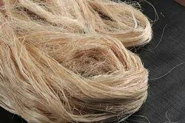

Various parts of banana plant such as fruit, fruit peel, fower bud, leaves and pseudo-stem (banana trunk) are utilized for diferent industrial purposes. Pseudo-stem is the major portion of banana waste biomass and yields good quality fbre that has the potential for industrial applications in the making of sanitary pads, textiles, pulp and paper, food and reinforced composite materials for automobiles, construction material, aerospace and other composite materials. Recently, Philippine Department of Science and Technology prepared masks from banana fbre which can cut the usage of single usage plastic. This review outlines various methods of extraction of fbre, biochemical and mechanical properties of banana fbre and its applications. [4]

**1.1. Uses / Application of Banana Fibre:**

Banana fibre is used in apparel garments and home furnishings. Being little rough in nature, ropes, mats and some composites are also made from it. It is being used in building construction, geo-textiles and even in sound engineering for sound-proof boards. Hand-made papers are made from the pulp of banana fibres. The paper made from bark is often used for artistic purpose.

Banana fibre has a wide range of applications. Here are some of the most common uses of banana fibres:

**1. Textile Industry:** Banana fibres are commonly used in the textile industry to produce clothing, accessories, and home textiles. The fibre’s softness, elasticity, and moisture absorption properties make it ideal for use in clothing and bedding products. It is also commonly used to make table runners, placemats, and other decorative textiles.

**2. Industrial Applications:** These fibres are often used in industrial applications due to its strength and durability. It is commonly used to reinforce concrete, to make ropes, twines, and mats, and as a raw material in the production of paper.

**3. Agriculture:** It is used in agriculture to make mulch and as a natural alternative to synthetic fibres in the production of compost. It helps to regulate soil temperature and moisture, promoting healthy plant growth.

**4. Medical Applications:** It has natural anti-bacterial properties, making it ideal for use in medical and hygiene applications. It is commonly used to make surgical masks, gowns, and other [medical textiles](https://textilelearner.net/medical-textiles/).

**5. Automotive Industry:** Banana fibre is used in the automotive industry as a lightweight and sustainable alternative to [**synthetic fibres**](https://textileengineering.net/types-properties-and-uses-of-synthetic-fibres/) in the production of car parts and components.

**6. Packaging:** They are used in the packaging industry to make biodegradable and sustainable packaging materials. It is also used to make bags, boxes, and other types of packaging products.

**7. Art and Crafts:** Banana fibers are also used in art and craft projects, due to its natural beauty and texture. It is commonly used to make baskets, coasters, and other decorative items [5]

**1.2 Abstract**

Natural fibers of plant and animal origin have been explored vastly over the last two decades and are gaining importance over synthetic counterparts owing to their biodegradability, renewability, lightweight and better biochemical and strength properties. Plant-based natural fibers such as banana, coir, sisal, jute, kenaf and many others have been studied for industrial applications. Among these, banana fiber is of major interest as banana is one of the most consumed fruit worldwide with annual production of 115.7 million tonnes in the year 2018 and is grown in 130 countries, which makes banana waste available locally. Various parts of banana plant such as fruit, fruit peel, fower bud, leaves and pseudo-stem (banana trunk) are utilized for different industrial purposes. Pseudo-stem is the major portion of banana waste biomass and yields good quality fiber that has the potential for industrial applications in the making of sanitary pads, textiles, pulp and paper, food and reinforced composite materials for automobiles, construction material, aerospace and other composite materials. Recently, Philippine Department of Science and Technology prepared masks from banana fbre which can cut the usage of single usage plastic. This review outlines various methods of extraction of fbre, biochemical and mechanical properties of banana fbre and its applications

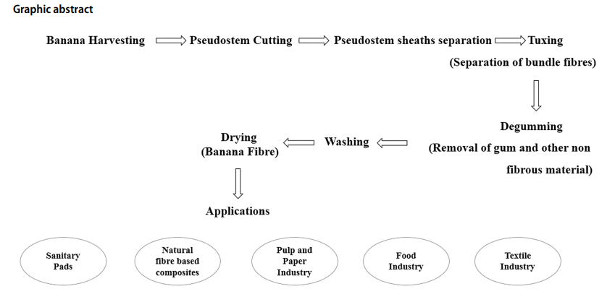

Fig :- 1 Flow Chart of Abstract

Banana is among the most popular health fruit in the world and is a rich source of fbre, iron, potassium, vitamin C, vitamin B6 and manganese. Owing to the increasing awareness about health, public is interested in hygienic food products and functional foods. Banana seems to be of special interest as it has various health benefits such as in controlling blood pressure and reducing the risk of neurodegenerative disorders. It helps in lowering the incidence of degenerative diseases such as arthritis, heart disease, inflammation, arteriosclerosis, brain dysfunction and cancer. [6]

Banana fiber, extracted from the pseudo stem of the banana plant (*Musa spp.*), is gaining global attention as an environmentally friendly, biodegradable, and renewable alternative to synthetic and petroleum-based fibers. With the rise in demand for sustainable materials in various industries—particularly in textiles, paper, packaging, and biodegradable composites—banana fiber stands out for its abundance, strength, and eco-compatibility. Traditionally considered agricultural waste, banana pseudo stems are now recognized as a valuable source of best fiber composed primarily of cellulose (around 60–65%), hemicellulose, and lignin. However, its natural rigidity, rough texture, and high lignin content make it unsuitable for direct use in fine textile applications without appropriate treatment.

The processed fibers were evaluated for changes in tensile strength, moisture absorption, surface texture, and flexibility. Results showed significant improvement in fiber softness, tensile strength, and visual appeal. These findings align with those from earlier studies [7] [8], confirming that wet-processing makes banana fiber more compatible with textile production requirements and broadens its industrial usability. Moreover, the processing methods adopted in this project were selected for being low-cost and relatively eco-friendly, making them suitable for decentralized or rural-scale fiber processing systems.

In conclusion, banana fiber, when properly extracted and processed, holds immense promise as a sustainable resource. Its utilization not only reduces agricultural waste but also supports circular economy goals and offers a green alternative to non-biodegradable materials. This project provides valuable insights into the processing techniques necessary to transform raw banana fiber into a high-value product suitable for commercial and industrial use. Further research into enzyme-based and bio-processing methods could enhance its scalability while maintaining environmental sustainability. [9] [10]

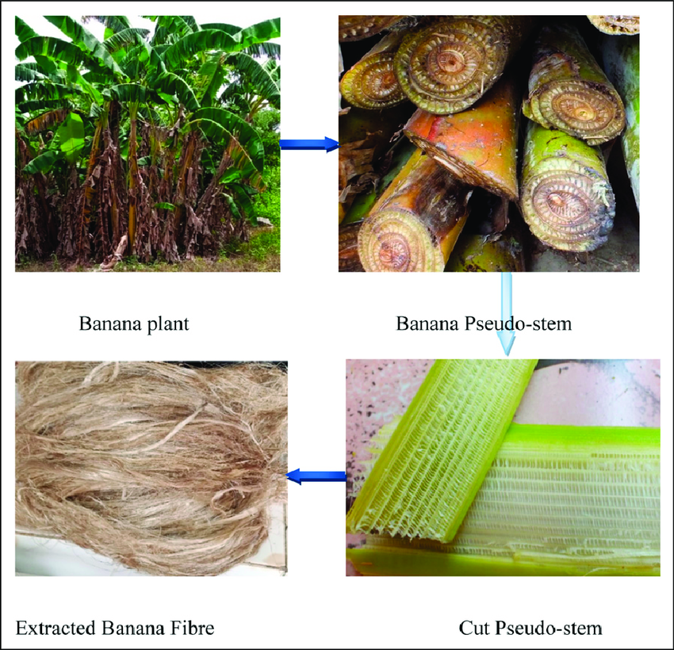

**Fig: - 2 Abstract** [11]

**1.3 Characteristics of Banana Fiber**

Banana fiber is a natural fiber derived from the pseudo stem of the banana plant (*Musa* species), known for its strength, biodegradability, and sustainability. This fiber has gained significant attention in the textile and composite materials industries due to its unique properties, which make it a valuable alternative to synthetic and other natural fibers.

**1.3.1. Physical Properties of Banana Fiber**

Banana fiber is recognized for its exceptional tensile strength and durability. The fiber's mechanical properties make it a viable alternative for various applications, including textiles, ropes, mats, and even as a reinforcement in composite materials [16] . The tensile strength of banana fiber is comparable to that of jute and flax, which positions it as a potential substitute for other commercial fibers [17] .

The fiber’s diameter typically ranges from 20 to 30 µm, which classifies it as a coarse fiber, making it suitable for applications that require abrasion resistance and durability [18] the fiber’s physical structure varies depending on the age of the plant and environmental factors, but it generally exhibits a hollow, tubular shape. This unique structural feature contributes to the fiber’s flexibility, even though it retains a relatively stiff texture.

In terms of its ability to absorb moisture, banana fiber has an excellent moisture absorption rate, making it comfortable for wear in humid and tropical climates [19] . Additionally, it exhibits good wicking properties, which allow it to draw moisture away from the skin. However, its coarse texture may limit its use in fine textiles unless subjected to appropriate wet-processing treatments to soften it.

| **S. No** | **Physical Properties** | **Banana Fiber\*** |
| --- | --- | --- |
| 1 | Single fiber tenacity (gf/tex) | 46–64 |
| 2 | Single fiber extension at break (%) | 2.9–4.3 |
| 3 | Fiber bundle tenacity (gf/tex) | 24–30 |
| 4 | True density (g/cm³) | 1.31–1.33 |
| 5 | Apparent density (g/cm³) | 0.62–0.86 |
| 6 | Flexural rigidity | 33–40 |
| 7 | Length of raw fiber (cm) | 34–85 |
| 8 | Moisture regain at 65% r.h | 14.0–15.2 |
| 9 | Fiber porosity (%) | 35–53 |

Table: - 1 Physical properties [12]

**1.3.2. Chemical Composition of Banana Fiber**

The chemical composition of banana fiber plays a crucial role in determining its behavior during processing, including dyeing, bleaching, and spinning. The primary constituents of banana fiber are cellulose, hemicellulose, lignin, and pectin. Cellulose is the most abundant component, ranging from 40% to 55%, which imparts strength and durability to the fiber [20] . The high cellulose content makes banana fiber one of the strongest natural fibers, particularly when compared to other plant fibers such as cotton and jute.

Hemicellulose, which typically accounts for 20% to 30% of the fiber, contributes to the fiber’s flexibility and its ability to absorb moisture. However, the presence of hemicellulose and pectin also affects the dye uptake and may require removal or modification during wet-processing treatments to enhance dye ability [17] .

Lignin, which constitutes about 10% to 15% of the fiber, provides structural rigidity but can hinder dye absorption due to its hydrophobic nature [16] . Therefore, it is often removed during scouring or bleaching to improve the fiber's receptivity to dyes and to enhance its softness.

The composition of banana fiber makes it ideal for textile and composite material applications, especially when combined with appropriate pre-treatment techniques.

| **Sr. No** | **Content** | **Banana Fiber (%)** |
| --- | --- | --- |
| 1 | Cellulose | 69.5 |
| 2 | Hemicellulose | 15.0 |
| 3 | Lignin | 5.45 |
| 4 | Pectin | 0.5 |
| 5 | Fats and waxes | 1.5 |

Table: - 2 Chemical Composition [13]

**1.3.3. Environmental Benefits and Sustainability**

One of the most significant advantages of banana fiber is its environmental sustainability. Unlike synthetic fibers, which are petroleum-based and non-biodegradable, banana fiber is completely biodegradable. As a natural fiber, it decomposes relatively quickly, reducing the burden of textile waste and promoting environmental sustainability [15]. Furthermore, banana fiber is derived from agricultural waste, specifically from the pseudo stems of banana plants, which are typically discarded after fruit harvesting. This makes the fiber a by-product of banana cultivation, contributing to waste reduction and creating an additional income stream for banana farmers.

The use of banana fiber also helps to mitigate the environmental impact of conventional textile production. Unlike cotton, which requires large quantities of water for cultivation, banana fibers are harvested in regions where bananas are grown without the need for extensive irrigation [19]. This reduces the water footprint associated with textile production, positioning banana fiber as a more sustainable alternative for eco-friendly textiles.

In addition to its biodegradability, banana fiber requires fewer chemicals during processing compared to conventional fibers like cotton or synthetic alternatives. This reduces the ecological footprint of processing, making it a desirable material in the pursuit of sustainable fashion and textile solutions.

**1.3.4. Aesthetic and Functional Properties**

Banana fiber offers aesthetic appeal due to its natural color, which ranges from off-white to light brown, and its texture, which can vary from coarse to fine depending on the treatment [14] . This versatility in appearance allows banana fiber to be used in various forms, such as raw fibers, yarns, and woven fabrics, with applications ranging from clothing to home textiles.

Due to its naturally sturdy structure, banana fiber can be spun into strong yarns that maintain their integrity over time, even under stress. This makes it suitable for use in a wide range of textile products, including eco-friendly clothing, upholstery, and industrial fabrics. Moreover, the fiber is highly adaptable to different dyeing processes, including natural and synthetic dyeing, when treated appropriately.

Banana fiber's unique texture and durability also make it suitable for crafting non-textile products such as ropes, mats, and paper. In some cultures, banana fiber is traditionally used for making various hand-crafted goods such as baskets and mats [16] the fiber's ability to withstand wear and tear and its resistance to environmental factors like UV radiation further contribute to its widespread use in such products.

**1.3.5. Challenges and Limitations**

Despite its numerous advantages, there are several challenges associated with the use of banana fiber. Its relatively coarse texture can make it less desirable for applications requiring soft, fine materials unless treated through appropriate methods like enzymatic or alkaline scouring. Additionally, its susceptibility to microbial degradation in humid conditions can limit its use in certain applications unless treated with preservatives or coatings [18] .

Another challenge lies in the inconsistent quality of the fiber, which can vary depending on the plant's age, the region of cultivation, and the methods of extraction. Variability in fiber properties may lead to inconsistent performance in industrial applications, which requires the development of standardization and quality control measures to ensure reliability [20] .

**1.3.6. Commercial Applications**

Given its unique properties, banana fiber has found a place in various commercial applications. In the textile industry, it is used for making eco-friendly clothing, including sarees, shawls, and shirts, especially in regions where banana cultivation is common, such as India and the Philippines [15] . Banana fiber is also used in the production of bio-composites, paper, and other non-woven products, capitalizing on its strength and sustainability.

As consumers become more aware of environmental issues and the need for sustainable materials, banana fiber presents a promising solution in the search for biodegradable and renewable alternatives in the textile and composite industries.

fiber Banana fbre obtained from the pseudo-stem of plant has appearance similar to that of ramie and bamboo fibers. Pseudo-stem is formed of about 14 to 18 sheaths and produces fibers of different quality depending upon position, viz. (a) course fbre (outermost 2–3 sheaths) that breaks easily so these sheaths are rejected, (b) soft lustrous fbre (middle sheaths) and (c) very soft fbre (some middle and inner sheaths excluding innermost sheaths). Pulpy matter is present in the innermost sheaths and is not processed for fbre production. Nearly 600 kg/ha of banana fbre can be produced from pseudo-stem [21].

**Here is the important properties of banana fiber:**

* **Strength:** Banana fiber is strong and durable, making it suitable for various textile and industrial applications.
* **Biodegradability:** It is biodegradable and environmentally friendly, meaning it decomposes naturally in the environment.
* **Moisture Absorption:** Banana fibers have high moisture absorption capacity, making it breathable and comfortable to wear.
* **Anti-bacterial:** It has natural anti-bacterial properties that make it ideal for medical and hygiene applications.
* **Elasticity:** Banana fibre has good elasticity, which gives it a natural stretchiness and makes it ideal for use in clothing.
* **Lightweight:** These fibres are lightweight, making it easy to handle and work with in various applications.
* **Softness:** Banana fibre is soft and comfortable, making it suitable for use in clothing and home textiles.

**2. Literature review & Scope of the study**

The wet-processing of banana fiber is an essential area of research as it explores the potential of banana pseudo stem fiber as a sustainable alternative to synthetic fibers in textiles and composite materials. Banana fiber, known for its strength, biodegradability, and eco-friendly characteristics, is derived from the pseudo stem of the banana plant (*Musa spp.*). However, due to its coarse texture, high cellulose content, and natural impurities such as lignin, hemicellulose, and pectin, banana fiber requires specific pre-treatment processes to enhance its textile qualities. Moreover, banana fiber’s dye ability and color fastness properties are crucial factors for its application in the textile industry.

This study investigates the wet-processing techniques for improving the dye ability, color fastness, and textile properties of banana fiber. The primary focus of the research is on evaluating the effectiveness of pre-treatment processes on improving the fiber's ability to absorb and retain dyes, as well as the resultant fastness properties, which are critical to its application in high-quality textiles. The study also aims to highlight the environmental impact of the chemical treatments involved in wet-processing.

**Specific Areas Covered in the Study**

**2.1 Pre-treatment of Banana Fiber:**

Pre-treatment is crucial to modify the structure of banana fiber to make it more suitable for dyeing and further textile applications. The primary goal of pre-treatment is to remove non-cellulosic materials, such as pectin, lignin, and hemicellulose, which can hinder the fiber’s interaction with dyes and affect its strength and texture. The following **2.1.1 pre-treatment processes are explored:**

* **Water Retting**: A traditional method in which the banana fibers are submerged in water for a period of time, allowing natural microorganisms to break down non-cellulosic substances. This process reduces the fiber’s coarseness and makes it more flexible for subsequent processing [48]
* **Alkaline Scouring**: This step involves treating the fibers with an alkaline solution, typically sodium hydroxide (NaOH), to remove waxes, fats, and impurities from the fiber’s surface. Alkaline scouring increases the fiber’s dye uptake, improves its tensile strength, and enhances its ability to be dyed uniformly [47] .
* **Bleaching**: The application of bleaching agents such as hydrogen peroxide (H₂O₂) is used to remove any natural color present in the fibers, resulting in a brighter, cleaner fiber. Bleaching also helps improve the fiber's compatibility with synthetic and natural dyes [46]

**2.1.2 Mechanical Pre-treatment**

Mechanical pre-treatment is a crucial first step in fiber extraction. It involves the use of physical methods to remove impurities such as pectin, waxes, and other non-cellulosic materials that may interfere with the fiber’s processing. Mechanical methods primarily aim to clean and prepare the fiber for further treatments.

**2.1.2.1Brushing and Combing**

**Process:** Brushing or combing involves physically separating the fibers from the surrounding plant material by scraping or combing them. This process is commonly performed in small-scale or artisanal settings.

**Effect:** It results in a cleaner and smoother fiber, which is beneficial for its subsequent use in textile and composite applications. However, it does not significantly alter the chemical structure or enhance the fiber’s mechanical properties.

**Advantages:**

* Simple, low-cost method.
* Does not require chemicals, making it an environmentally friendly option.

**Limitations:**

* The method is labor-intensive.
* It is not very effective at removing all non-cellulosic components, and thus, the fibers may require further chemical or biological treatments.

**2.1.2.2Rettling**

**Process:** Rattling is a traditional method used for fiber extraction. In this process, banana pseudo stems are soaked in water (or exposed to steam) for several days, allowing the fibers to separate from the surrounding tissues. Once softened, the fibers are mechanically separated.

**Effect:** Rattling improves fiber separation, reducing the amount of non-cellulosic substances and making the fibers more suitable for industrial applications.

**Advantages:**

* Low-cost and natural process.
* Suitable for small-scale production and eco-friendly.

**Limitations:**

* Time-consuming.
* It may not provide uniform fiber quality, and prolonged exposure to water can lead to fiber degradation if not properly controlled.

**2.1.3. Chemical Pre-treatment**

Chemical pre-treatment aims to modify the chemical composition of banana fibers, particularly by removing lignin, hemicellulose, and pectin, which may hinder the fiber's functionality. Chemical treatments are particularly effective in enhancing fiber strength, hydrophilicity, and its compatibility with other materials, especially in composite applications.

**2.1.3.1Alkaline Treatment (NaOH, Soda Ash)**

**Process:** One of the most commonly used chemical treatments, alkaline treatment involves soaking banana fibers in an alkaline solution, usually sodium hydroxide (NaOH), for a specific period. The alkaline solution breaks down hemicellulose, lignin, and other non-cellulosic components, resulting in a higher cellulose content.

**Effect:**

* Increased fiber strength and rigidity.
* Improved bonding properties when used in composites, such as polymer matrix composites.
* Enhanced dye uptake due to the removal of surface impurities.

**Advantages:**

* Effective at improving mechanical properties like tensile strength.
* Enhances fiber compatibility with other materials (e.g., resins, plastics).

**Limitations:**

* Excessive treatment can lead to the degradation of cellulose, weakening the fiber’s structure.
* Environmental concerns arise due to the chemical waste produced. [23]

**2.1.3.2. Acid Treatment**

**Process:** Acid treatment involves soaking banana fibers in dilute acids, such as hydrochloric acid (HCl) or sulfuric acid (H2SO4), which helps to remove pectin and hemicellulose without significantly affecting the cellulose.

**Effect:**

* Increased fiber flexibility and surface roughness, improving bonding with other materials.
* Enhanced dye ability due to the removal of impurities.

**Advantages:**

* Improved compatibility with resins and other matrix materials in composites.

**Limitations:**

* Acid treatment can degrade cellulose if overused, leading to a loss of fiber strength.
* Potential environmental concerns due to acid disposal and chemical waste. [24]

**2.1.3.3 Enzymatic Treatment**

**Process:** Enzymatic treatments utilize enzymes like cellulose, pectinase, and xylanase to break down non-cellulosic materials like pectin and hemicellulose without damaging the cellulose structure. Enzymatic treatments are more specific and mild compared to chemical treatments.

**Effect:**

* Increased fiber strength and flexibility.
* Enhanced fiber compatibility for use in bio composites.

**Advantages:**

* Eco-friendly, biodegradable process.
* Reduced chemical waste compared to alkaline or acid treatments.

**Limitations:**

* Enzyme treatments can be more costly and time-consuming.
* The efficiency of enzymatic treatment may depend on factors such as temperature, pH, and enzyme concentration. [25]

**2.1.4. Biological Pre-treatment**

Biological pre-treatment employs microorganisms (bacteria, fungi) or other biological agents to break down non-cellulosic components. This method is considered more environmentally sustainable than chemical treatments.

**2.1.4.1. Microbial Treatment**

**Process:** Certain microorganisms, such as bacteria or fungi, are used to decompose the hemicellulose, lignin, and pectin in banana fibers. The microbes naturally break down these components, resulting in cleaner and more flexible fibers.

**Effect:**

* Increased fiber strength and improved surface properties for bonding with matrices in composites.
* The fibers are more compatible with polymeric materials in composites.

**Advantages:**

* Environmentally friendly and sustainable.
* Can be more controlled compared to chemical treatments.

**Limitations:**

* The process is slower compared to chemical treatments and may not always provide uniform results.
* Requires careful control of temperature, humidity, and microbial strains. [26]

**2.1.5 Thermal Pre-treatment (Steam Explosion)**

Thermal pre-treatment involves exposing the banana fibers to high temperatures, usually in the presence of steam or hot water. This process helps break down hemicellulose and lignin, improving the separation of fibers and increasing their cellulose content.

**2.1.5.1 Steam Explosion**

**Process:** The banana fibers are treated under high-pressure steam, causing a rapid temperature rise. This process breaks down hemicellulose and lignin, softening the fibers and enhancing their reparability.

**Effect:**

* The fibers become more flexible and easier to handle in composites.
* Increased tensile strength due to improved fiber separation.

**Advantages:**

* Relatively fast process compared to traditional retting.

**Limitations:**

* Excessive exposure to steam can weaken the fibers and cause them to degrade.

**2.1.5.2 Hot Water Treatment**

**Process:** Similar to steam explosion, banana fibers are treated with hot water to soften and separate the fibers. Hot water treatment is less aggressive than steam explosion and is sometimes used for mild pre-treatment.

**Effect:**

* Enhanced fiber separation.
* Improved flexibility and reduced brittleness.

**Advantages:**

* Simple and inexpensive method.

**Limitations:**

* May not be as effective as steam explosion in breaking down non-cellulosic materials.

**2.1.6 Bleaching**

Bleaching is commonly used to remove natural color pigments in banana fibers, especially for textile applications where a white or light-colored fiber is preferred. Hydrogen peroxide (H2O2) is commonly used as a bleaching agent.

**2.1.6.1 Bleaching with Hydrogen Peroxide**

**Process:** Banana fibers are treated with hydrogen peroxide to remove color pigments and reduce the amount of non-cellulosic material. This process also helps in improving fiber whiteness.

**Effect:**

* Increased whiteness and improved appearance for use in textiles.
* Slight improvement in fiber flexibility.

**Advantages:**

* Simple and cost-effective.

**Limitations:**

* Can lead to slight fiber degradation if overused.

**2.1.7 UV Radiation and Ozone Treatment**

Ultraviolet (UV) radiation and ozone treatment can also be employed to modify the surface properties of banana fibers.

**2.1.7.1 UV Radiation Treatment**

**Process:** UV radiation is used to break down non-cellulosic components, particularly lignin, and improve the bonding of banana fibers with other materials.

**Effect:**

* Enhanced dye uptake and bonding with resins or matrices in composite materials.

**Advantages:**

* Quick and eco-friendly.

**Limitations:**

* Overexposure to UV radiation can degrade the fiber structure.

**3. Materials, Experimental & Evaluation Methods**

**3.1 Materials**

The primary raw material used for this study was the pseudo-stem of the banana plant (*Musa spp.*), which is rich in natural cellulose fiber. Pseudo-stems were sourced locally after the harvest of banana fruit. The tools and materials employed during the fiber extraction and cleaning process included:

* Banana pseudo-stems – source of lignocellulosic fiber
* Clean water – for initial washing and cleaning
* Knife or scraper – for manual fiber extraction
* Wide-toothed hand comb – for separating and aligning fibers
* Cotton cloth or drying tray – for drying the fibers
* Protective gloves (optional) – for safe handling

These materials were selected based on traditional and eco-friendly practices for natural fiber processing, as documented in previous studies [55].

**3.2 Methods**

Several contaminants, including gum, lignin, dust, dirt, and several other agricultural pollutants, can be found in raw banana fiber. Therefore, to get pure cellulose, it is important to eliminate all of these contaminants using processes like beating, cleaning, alkali treatment, bleaching, etc. The pretreatment process is described in the following order;

**3.2.1. Pretreatment of raw banana fber**

Initially, sticky material and other contaminants were removed from raw banana fber using a wooden rod. Cleaning is only done mechanically with a comb before being subjected to alkali treatment [56] .

**3.2.1.1 Conventional Scouring**

Scouring is a crucial preparatory process in textile manufacturing, particularly for natural fibers like cotton. It involves the removal of natural impurities (waxes, pectins, fats, and minerals) and processing residues (such as sizing agents) to ensure improved absorbency and whiteness of the fabric, thereby enhancing the subsequent dyeing and finishing processes.

**Process Description**

In the **Conventional Scouring** method, the following conditions are maintained:

* **Material to Liquor Ratio (M:L:R):**  
  1:30 (i.e., 1 part fabric to 30 parts liquor)

**Chemical Dosage:**

**Sodium Hydroxide (NaOH):** 4%

* Acts as the main alkaline agent to saponify natural fats and oils and to solubilize waxes.

**Sodium Carbonate (Na₂CO₃):** 1%

* Provides additional alkalinity, assisting in the breakdown of impurities without being as aggressive as NaOH.

**Wetting Agent:** 2 g/l

* Helps in reducing the surface tension of water, allowing better penetration of chemicals into the fabric structure.

**Sequestering Agent:** 1 g/l

* Binds metal ions (such as calcium and magnesium) in hard water, preventing unwanted precipitation and improving chemical efficiency.

**Non-ionic Detergent:** 1 g/l

* Aids in emulsifying and removing hydrophobic impurities from the fabric.

**Temperature:**

* Boiling (typically around 100°C) to enhance the chemical reaction rate and impurity removal.

**Time:**

* Two options are given depending on process intensity:
* 60 minutes for a thorough scouring.
* 30 minutes for a lighter or faster scouring process (depending on fabric type or desired results).

| **Parameter** | **Value** |
| --- | --- |
| M:L:R (Material:Liquor:Ratio) | 1:30 |
| NaOH | 4% |
| Na₂CO₃ | 1% |
| Wetting agent | 2 g/l |
| Sequestering agent | 1 g/l |
| Non-ionic detergent | 1 g/l |
| Temperature | Boil |
| Time | 1) 60 min 2) 30 min |

**Table -3 Conventional Scouring Recipe**

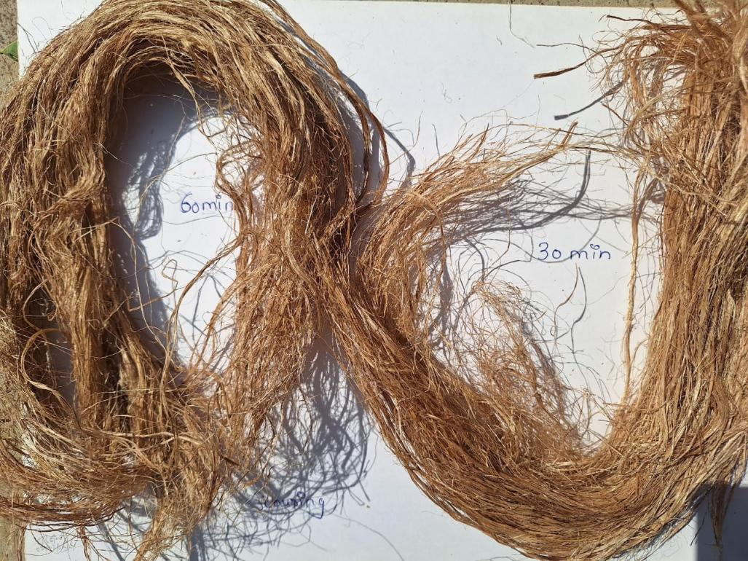

Fig: - 3 **Conventional Scouring of Banana Fiber**

**3.2.1.2 Bleaching treatment**

**1. Hydrogen Peroxide Bleaching Process**

Bleaching is a crucial step in textile pretreatment, aimed at improving the fabric’s whiteness and removing any natural or added color impurities. Hydrogen peroxide (H₂O₂) bleaching is a widely used eco-friendly method, suitable for cotton and cotton blends, providing a good balance between bleaching efficiency and fiber preservation.

**Process Description**

According to the provided recipe:

* **Material to Liquor Ratio (M:L:R):**  
  1:30 (1 part fabric to 30 parts liquor)

**Chemical Dosages:**

**Hydrogen Peroxide (H₂O₂):** 15 ml

* Acts as the main bleaching agent by releasing active oxygen, which oxidizes and decolorizes natural pigments.

**Stabilizer (assumed to be Na₂SiO₃ - Sodium Silicate):** 40 ml

* Controls the decomposition rate of H₂O₂, ensuring safe and effective bleaching without fiber damage.

**Sodium Hydroxide (NaOH):** 1.5 ml

* Provides an alkaline medium necessary for the efficient activation of hydrogen peroxide.

**Non-ionic Detergent (NID):** 1.5 ml

* Helps remove impurities and supports uniform bleaching by enhancing the wetting and penetration of chemicals.
* **Temperature:** 1.5 liters (probably referring to bath volume, not temperature; generally, peroxide bleaching is carried out at around 90–100°C). 30 minutes (short, efficient bleaching process)

Time :

30 minutes (short, efficient bleaching process)

|  |  |
| --- | --- |
| **M:L:R** | 1:30 |
| **Hydrogen Peroxide (H₂O₂)** | 15 ml |
| **Sodium Silicate (Na₂SiO₃ )** | 40ml |
| **Sodium Hydroxide (NaOH)** | 1.5ml |
| **Non-ionic Detergent (NID)** | ml |

**2. Sodium Hypochlorite Bleaching Process**

Bleaching is an important pretreatment step in textile processing to remove natural color impurities from fibers and prepare them for dyeing or printing. Sodium hypochlorite (NaOCl), commonly known as "hypo," is a traditional bleaching agent used for cellulosic fibers like cotton, especially when rapid bleaching at room temperature is desired.

**Process Description**

* Based on the recipe provided:

**Chemical Dosages:**

**Sodium Hypochlorite (Hypo):** 3 g/l

* Acts as the main bleaching agent, releasing active chlorine that breaks down color-causing substances.

**Sodium Hydroxide (NaOH):** 1 g/l

* Maintains an alkaline pH, which is essential for effective hypochlorite bleaching and fiber protection.

**Non-ionic Detergent (NID):** 1 g/l

* Assists in the wetting, penetration, and emulsification of impurities during bleaching.

**Temperature:**

**Room Temperature (R.T.)**

* Hypochlorite bleaching is effective even at room temperature, making it energy-saving compared to peroxide bleaching.

**Time:**

* 30 minutes
* A relatively short processing time sufficient for achieving a good level of whiteness.

**Water Volume:**

* 1.5 liters
* Ensures proper dilution and immersion of the fabric

|  |  |
| --- | --- |
| **M:L:R** | 1:30 |
| **Sodium Hypochlorite (Hypo)** | 3 gpl |
| **Sodium Hydroxide (NaOH)** | 1gpl |
| **Non-ionic Detergent (NID)** | 1gpl |

**Table: - 5** **Sodium Hypochlorite Bleaching Process**

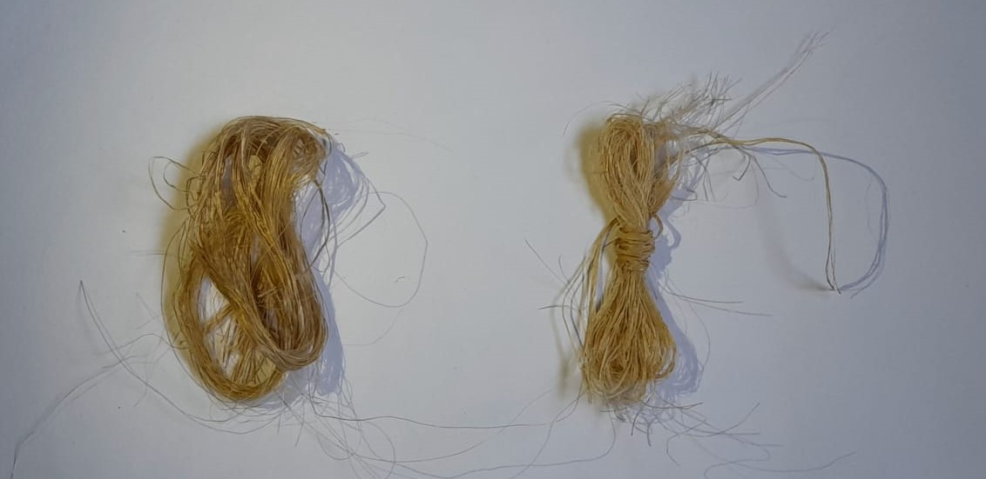

**Fig: - 4** **Hydrogen Peroxide / Sodium Hypochlorite Bleaching**

* Structure-Property Relationships of Needle-Punched Nonwoven Fabric

Abstract Needle-punched nonwoven fabrics are manufactured with

* suitable structures to develop specific property to serves specific application. This paper reviews the influence of structural parameters such as fiber orientations, packing density, specific surface area, thickness etc. on various mechanical and functional properties of nonwoven fabrics.
* Keywords Needle-Punched, Specific Property, Structural Parameters, Functional Properties

1. **Introduction**

The high rate of growth in nonwovens has led to a substantial increase in research aimed at establishing links between structure and desired properties of nonwovens. Needle-punched nonwoven materials with the required combination of functional properties are widely used in numerous technical applications, including, filters, composites, protective clothing, packaging, geo-te xtiles, home furnishings, heat and noise insulating, etc. As the properties of nonwovens depend on the structure of the material, a structure-property relationship will provide a tool to manipulate the nonwoven structure to achieve satisfactory product performance by both establishing appropriate manufacturing parameters and selecting proper fiber specifications. This requires quantification of the degree of bonding among the fibres and the establishment of relationships between the process parameters corresponding fabric properties.

Let at first discuss about the structural parameters of needle-punch nonwoven structure. A fiber segment can be cons idered for better understanding the characteristic behavior of nonwoven structure. Fiber segments are considered as fiber sections between any two crossover points and which can be treated as minimal units in a web. Owing to fiber bonds

or surface contacts at crossover points, even the segments on the same fiber may differ significantly in their mechanical performance. The influence of a fiber segment on the stress-strain property of the fabric depends mainly on its structural characteristics: length, thickness, curl, and orientation. A thin nonwoven fabric can be treated as a two dimensional fiber network in which fibers (staple or filament) lie in various directions and are bonded or in contact with one another at fiber crossover points. Here fiber-to-fiber bonds maintain fabric integrity[1]. Length distribution of fiber segments is useful information for assessing the compactness and other properties of a web. Short segments are often accompanied by a compact web structure. More the open structure more will be segment length[1]. Fiber or fiber bundle thickness has a direct influence on web mechanical properties. It is desirable to know fiber thickness distribution in a web where fibers have different diameters or fiber bundles are commonly present. In addition, thickness is often used as a weighting factor in analyzing fiber orientation distribution[2]. Segment curl is another important structural parameter. Curl of a fiber segment refers to its degree of curvature, which is a primary factor influencing the in itial modulus of a nonwoven fabric. Hearle and Stevenson defined a fiber curl factor as the rat io of the length of a fiber segment that spans two selected points on the segment to the shortest distance between these two points[3]. Segment orientation of fiber orientation is the most important structural parameter which governs ultimate functional properties of nonwoven structure. An uneven distribution in fiber orientation results in anisotropic behaviours in mechanical properties[1].

# **2. Mechanical Property & Structure Relationship**

Anisotropy[4] is important to the structure and application of nonwoven fabrics. The arrangement of the fibers and their orientation distribution are related to the mechanical structure of the web. Nonwoven fabrics are defined as web structures made by bonding or interlocking fibers or

filaments using mechanical, thermal, chemical, or solvent methods. The failu res of nonwoven fabrics can include bond failure, fiber rupture, and fibre slippage[5]. Genera lly, fibers in the web are oriented in various directions following a random or known statistical distribution.

The mechanical properties of nonwoven fabrics depend on raw materials, fiber fineness, fiber length, fiber arrangement, and structural differences resulting from different manufacturing processes[6-7]. Thus, test has been conducted to see the effect of such fiber arrangements on the tensile strength, tearing strength, and bursting strength of the nonwoven fabrics. the specimen for strength measurement. Elongation was higher in the horizontal direction or cross direction.

It was also reported that the coefficient of variation of the parallel web was below 10% for tensile strength. Due to uneven thickness, the variation coefficient of the random webs was above 10%; with the random arrangement, there were more fibers in the horizontal direction than in the vertical direction. The tensile strength of the horizontal direction increased, but that of the vertical direction decreased[2].

## Influence of Fiber Arrangement on Te nsile Strength

Fiber orientation has a big influence on the tensile strength of the nonwoven material. Because the fibers were arranged along the machine direction (vertical direction) by the conventional method of manufacturing nonwoven fabrics, tensile strength was best in the vertical direction. The tensile strength of the parallel web or random web decreased with increasing angle of cut of horizontal direction is more than that of the vertical direction for both the method.

## Influence of Fiber Arrangement on Te aring Strength

A study was conducted for accessing the tearing strength of the nonwoven material and the influence of fiber arrangement on it also reported[2]. It

was reported that both for parallel and random webs the tearing strength in Permeability[8] affects criteria such as sound absorption, filtration, and thermal properties. The pressure gradient through a bed of porous material is a function of fluid viscosity, flu id and material densities, rate of fluid flow, and material porosity. When considering the flow through porous materials, the shape, arrangement, and size distribution of voids through which flow must occur are e xtre mely important. In fact, there is no simple correlation between permeability and porosity because of the strong dependence of flow rate on the width, shape, and tortuosity of the conducting channels[9-10]. Tortuosity, the rat io of effective channel length and sample thickness, is an important factor in determining flow through nonwoven materials[11-12].

The researchers had been determined and discussed the e xperimental and theoretical air permeability of multilayer, glass/ceramic nonwoven samples. The Frazier permeability tester was used for e xperimenta l measurements. Theoretical permeability was determined using a modified Kozeny equation[8] along with weighted averages for fiber diameter and density. The fabric structure was varied by changing the number of glass and ceramic webs, and by varying the number of needle barbs used in needle punching the samples.

## Influence of Fiber Arrangement on Bursting Strength

The bursting strength in the random webs was lower than that in the parallel webs. One possible e xplanation could be that the fiber arrangement in the random webs was anisotropic, so there were more interlacing spots and voids in these webs. The failure e xtended from these voids to the perimeter under breaking conditions. The bursting strength in the parallel webs was better[2].

## 2.4Air Permeability& Structure Relationship

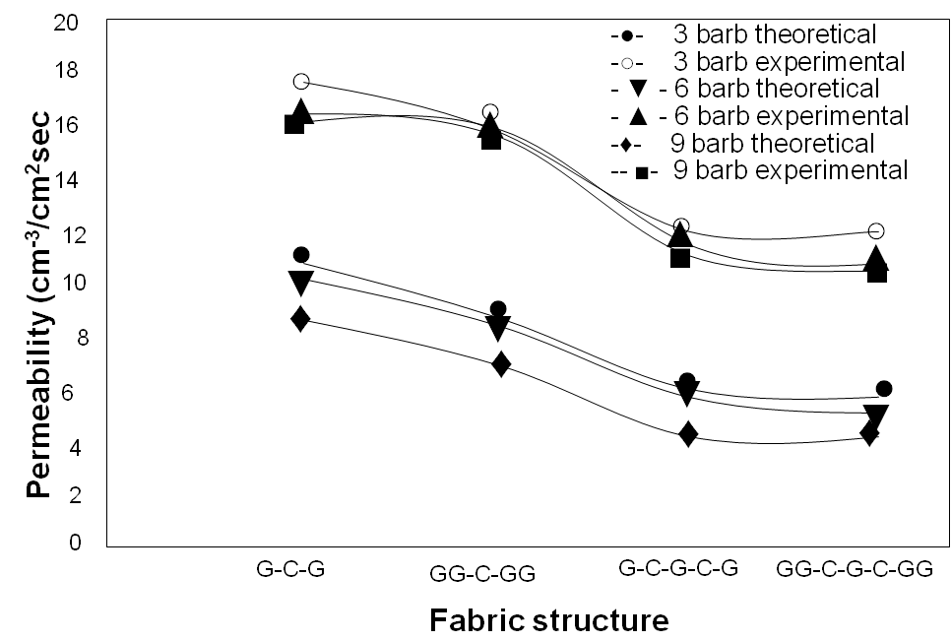

**Figure 1. Comparison of experimental and Theoretical permeability[8]**

As shown in figure 1, the theoretical permeability was lower than the experimental permeability in all cases. According to the author this difference in permeability is mainly associated with the non random distribution of fibers,

and this lack of randomness is due to two factors. First, needled nonwovens have areas that have not been needled and where the fibers are still randomly oriented. However, the areas where the needle penetrates the fibers are not

considered to be randomly distributed. In these areas, a channel may be formed that reduces tortuosity, thus increasing permeability.

# **3. Thermal Conductivity & Structure Relationship**

One of the[13] major applications for nonwoven fibrous systems is as thermal insulation materials. Because of savings in both space and weight, low-density insulating nonwoven materials are being used in consumer appliances, homes, and automobiles, in aircraft, and in industrial process equipment. Heat flux passing through a participating medium may in general be represented by several mechanis ms: free and forced convection, conduction through solid fibers, and conduction through air in the inter fiber spaces, and radiation[14]. Thermal conductivity is one mode of heat transfer in which an energy exchange takes place from the higher temperature to lower temperature. Based on the Fourier[15] heat transfer equation,

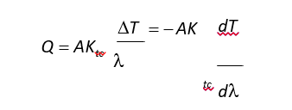

Where Ktc = thermal conductivity of the sample[w/(m°C)], A = cross-sectional area of the sample (m2), ΔT = temperature difference (°C), Q = heat flow rate (w), λ= thickness of the sample (m), and ΔT/ λ = gradient of temperature in the X direction (°C/ m). A number of different methods and apparatuses are available for determining effective thermal conductivity[16-19].

Measuring effective thermal conductivity

Temperature difference was measured[4] per unit thickness and thermal conductivity of the samples were measured using the Holometrix guard hot plate (model GHP-200), designed to accommodate material samples up to

20.32 cm (8 inches) in diameter and 5.08 cm (2 inches) thick. Any test temperature between -180°C and +650°C can be reached, and test environments of air, vacuum, or inert gas can be used.

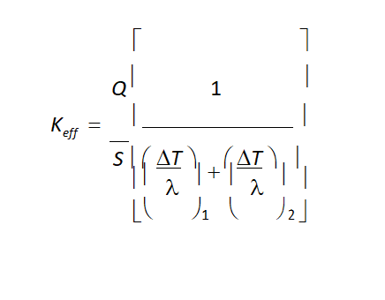

The governing equation for effective thermal conductivity

Where Ktc = thermal conductivity of the sample[w/(m°C)], A = cross-

sectional area of the sample (m2), ΔT = temperature difference (°C), Q =

heat flow rate (w), λ= thickness of the sample (m), and ΔT/ λ = gradient of

where Keff = elective thermal conductivity (W/ m°C), Q =

heat generated by the electrical source (W), and Q = (N)(EI), S = main heater surface area (0.00835 m2), λ = thickness of the upper and lower samples being tested (m), ΔT temperature gradient (°C), E = voltage reading at switch position 22 ( 1 mV = I volt), I = current reading at switch position 23 ( mV = 0.1 amp), and N = power correction factor determined e xperimentally by Holometrix to account for s mall systematic errors in the power measurement. The sample was considered to be at steady state when the temperature difference between the hot and cold sides was constant for a 30 minute interval.

was reported that temperature difference is highest for each individual fabric structure when nine barbs are used to bond the fabric. The overall increase in T, which shows less heat transfer through the samples (or otherwise more heat blocked), results from an increase in packing density. A higher packing density increases tortuosity, and less heat flows through

the channels. The nine-barb, G-C-G-C-G sample is the only exception to this trend. When considering the characteristics of this sample, no c e xp lanation arises for this discrepancy.

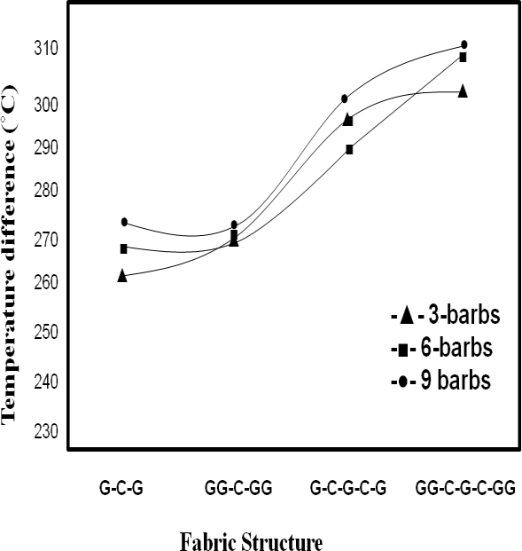

Figure 2. Effect of fabric structure on temperature difference at an applied temperature of 400°C[13]

The fabric weight is higher, while thickness, pore size, and porosity are lower than for the three-barb and six barb structures. This means that the nine-barb structure is more packed, thus having higher tortuosity or a lower mean free path, which should result in more heat being blocked. Also, as revealed in figure 2, as the number of glass webs increased,

T at 400°C increased for all cases. Though glass fibers have

high thermal conductivity, when they are placed in a nonwoven structure where the tortuosity is increased, i.e., mean free path is reduced, the conductivity will be reduced

due to increased forward and backward reflection of the radiation component. Also as the number of ceramic webs increases, T at 400°C increases. This again is due to the decrease in mean free path, resulting in a higher reflection of the radiation component. Also, the increase in T when the number of ceramic webs increases is much higher than that

observed when glass webs increase. Ceramic fibers have a lower thermal conductivity than glass fibers. Also, the fibers used in the ceramic webs were slightly finer than the glass’ fibers, causing ceramic webs to have

higher packing densities and thus a higher tortuosity. Finally, ceramic fibers have a higher glass transition temperature than glass fibers; 145ºC and 750°C, respectively. Thus, more time is required for ceramic fibers to heat up and radiate energy, which causes an increase in T, the amount of heat blocked.

## 3.1 Effect of Fabric Structure on Coefficient of Thermal Conducti vity

The effect of the number of barbs and the fiber content on the effective thermal conductivity (Keff) has been discussed following. All discussion is based on sample behavior at steady state. Keff is determined from equation and is a function of flow rate, T and thickness.

Effect of number o f barbs

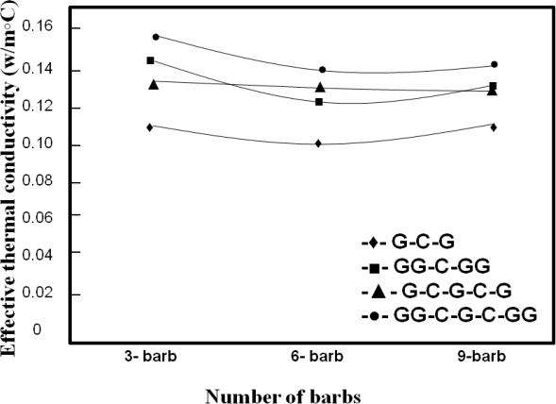

**Figure 3. Effect of no. of barbs on effective thermal conductivity[13]**

Figure 3 shows that as the number of barbs increases from three to six, Keff decreases, but when the number of barbs increases further from six to nine, Keff increases slightly. In considering fabric properties, two trends can e xpla in the initial decrease in Keff with an increased number of barbs. In the G-C-G and GG-C-G-C-GG Structures, weight and pore size increase while the thickness decreases. When the weight increases with decreasing thickness sample becomes more packed. This means that the tortuosity increases or the mean free path for photons decreases.

In the GG-C-GG and G-C-G-C-G structures, weight and thickness decrease while pore size increases as the number of barbs increases from three to six. In the GG-C-GG structure, there is a small decrease in weight compared to the decrease in thickness, i.e., the six-barb structure is more packed than the three-barb structure. This again means that Keff will decrease. In the G-C-G-C-G structure, there is a very small

decrease in weight, thickness, and pore size, which leads to only a s mall decrease in Keff. In discussing the increase in Keff when moving from six to nine barbs, two factors must be considered. In the GG-C-GG, G-C-G-C-G, and GG-C-G-C-GG structures, the weight to thickness ratio using nine barbs is higher than when six barbs are used, and the pore sizes for the nine-barb structures are less than that of the six-barb structures. This implies that the nine-barb structures are more packed than the six-barb structures.

However, the weight-to thickness ratio of the G-C-G structure is higher for the six-barb structure than for the nine-barb structure. The pore size of the nine-barb structure is bigger than that of the six-barb structure. This implies that the nine-barb structure is more open, and thus the rate of heat transfer by radiation increases.

Effect of number of layers

Increasing the number of glass webs always causes an increase in Keff, but this is not the expected trend. As the number of glass webs increases, Keff should decrease. The e xpected decrease in effective thermal conductivity when glass, with a high conductivity, used in the web form is associated

with an increased scattering of photons. In comparing the G-C-G and GG-C-GG structures for all barbs, we see that Keff increases for the GG-C-GG structures. As shown in Equation 2, Keff is a function of several factors, including heat flow Q, thickness L, and temperature difference ∆T. There are several e xp lanations for the unexpected increase in Keff. There is a slight increase in the mean ∆T, which should cause a decrease in Keff. At the same time, there is an increase in thickness, which, assuming all other factors to be constant, should increase in Keff. Though

∆T is not constant, the slight increase in ∆T (<50°C) is not enough to counter the effect of increasing the sample thickness. Finally, there is a slight increase in Q, which makes only a negligible increase in Keff. If the problem is associated with increased thickness, then for a fixed number of needle barbs, an increase in number of glass webs results in increased thickness, i.e., a more packed structure. The increased packing causes an increase I conduction and thus increase thermal conductivity. Again, this is not the expected trend and may be a result of increased packing density leading to increased thermal conductivity[13].

# **4. Moisture Diffusivity and Structure Relationship**

Fiber volume fraction and shape coefficient are the most important structural parameters affecting water vapor diffusivity through non hydrophilic nonwoven fabrics. Water vapor diffusivity decreases with increasing fiber volume fraction and decreases as the flatness of the fiber cross section increases[20

## Effects of Fiber Vol ume Fraction

Fiber volume fraction is playing a strong role in controlling moisture diffusion through fibrous structures [20].

Figure 4 shows that for melt blown nonwovens, water vapor diffusivity decreases with increasing fiber volume fraction. But in many cases, moisture vapor transmission cannot be adequately exp lained solely on the basis of fiber volume fraction.

This is because of the complex interactions between fiber volume fraction and other parameters including fiber shape coefficient and the kind of fiber used in the nonwoven construction. The differences between semi-permeable, permeable, and highly permeable nonwoven barrier fabrics are illustrated in Figure 5.

## of Shape Coefficient

Beside fiber volume fraction, fiber shape factor is key parameter controlling moisture permeability of nonwoven fabric. It was reported that water vapor diffusivity is inversely proportional to the fiber shape coefficient. This means that flat fibers provide more cover than round or trilobal fibers. Higher fiber cover reduces moisture penetration[20].

## Effects of Fabric Thickness and Fiber Diameter

Fabric thickness and fiber fineness affect water vapor diffusivity because these variables control optical porosity. The finer the component fibers, the more will be the filament separation and the higher the cover factor. Thicker fabrics also have lower optical porosities as is shown in figure 6. This paper[20] shows, however, that the effects of fabric thickness and

fiber fineness on total water vapor diffusivity are s mall. Figure 7 shows

the relationship between water vapor diffusivity and fiber fineness.

Unfortunately, because of the interaction with fiber volume fraction, this comparison does not give enough information about the effects of fiber fineness. However, this comparison shows that there is litt le difference in the water vapor diffusivity of nonwoven samples made with 2.5 μm fibers ( M 1 ~ M9) and melt blown samples containing fibers in the 10 μm range (M 10 ~ M 18 ).

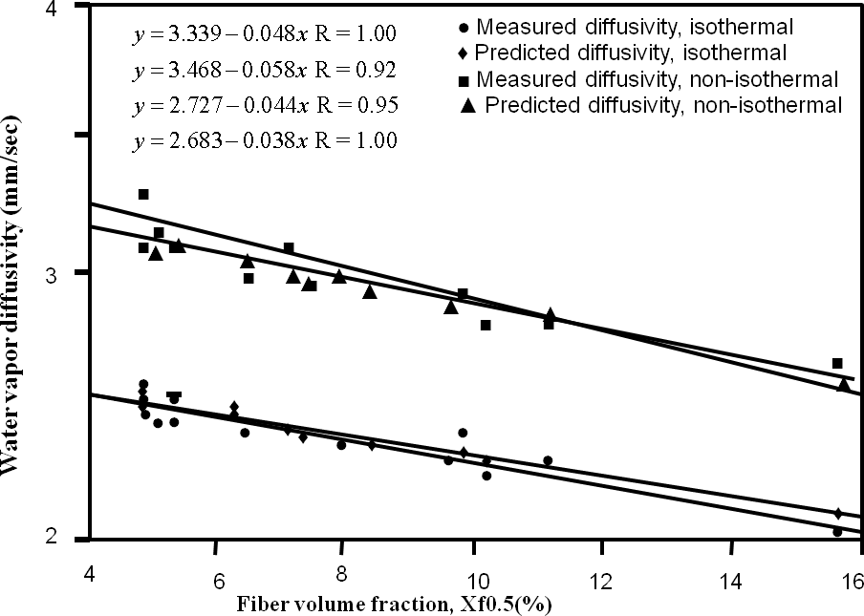

**Figure 4. Relationships between water vapor diffusivity and fiber volume fraction of melt blown webs[20]**

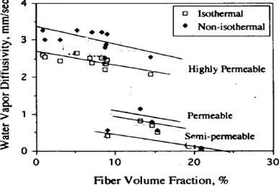

**Figure 5. Relationships between water vapor diffusivity and fiber volume fraction of barr**

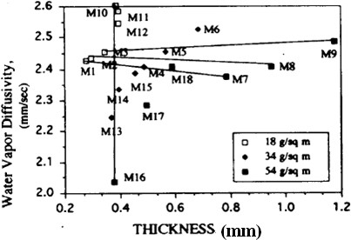

**Figure 6. Relationship between fabric thickness and water vapor diffusivity[20]**

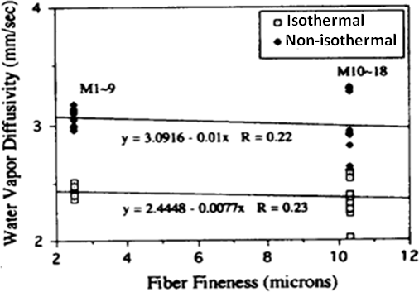

**Figure 7. Relationship between water vapor diffusivity and fiber fineness[20]**

# **5. Acoustical Behavior and Structural Relationship**

Nonwoven fabrics[21] are ideal materials for use as acoustical insulation products because they have high total surface. The surface area of the fabric is directly related to the denier and cross sectional shape of the fibers in the fabric. Smaller deniers yield more fibers per unit weight of the material, higher total fiber surface area and greater possibilities for a sound wave to interact with the fibers in the structure. Another important parameter is the packing density of the fibers in the nonwoven material. More fibers per unit volume at the same fabric thickness yield greater possibilities for sound waves to interact with the fibers.

To obtain an indication of the effect of fiber shape on acoustical properties, needle punched nonwoven fabrics made from 3 and 15 den polyester round fibers, 15 den polyester trilobal fibers, and 3 and 15 den polyester

e xpanded surface area fibers (4DG) with comparable thicknesses and densities were selected. To obtain an indication of the effect of fiber denier on acoustical properties, fabrics made from 3 and 15 den polyester rounds, 15 den polyester trilobal, and 3 and 15 den polyester 4DG fibers with comparable thicknesses and densities were selected.

As shown in Figure 8, needlepunched nonwoven test materials made from 3 den round fibers were better sound insulators than test materials made from 15 den round polyester fibers. Results showed that the difference in transmitted sound between test materials made from 3 den round polyester fibers and 15 den round polyester fibers did not change with density for each fabric density level. Sound insulation of nonwoven test material made from 3 denier round fibers was much better than the sound insulation of nonwoven test material made from 15 den round fibers. The results for trilobal and 4DG shapes showed the same trend

with round shape fiber, as shown in Figure 9. The acoustical insulation comparison for the nonwoven test materials made from 15 den round-, trilobal- and 4DG shaped fibers was used to study the effect of e xpanded surface area. As shown in Figure 9, the needlepunched nonwoven fabrics made from 4DG and trilobal fibers had better sound insulation results than nonwoven fabrics made from round fibers. The reason for this result may be because of the effect of surface area in the fabric. 4DG fibers had appro ximately three times more surface area than round fibers. Higher surface area in the nonwoven fabric increased the possibility of the sound wave interaction with the fibers and resulted in more effective sound deadening in the nonwoven fabric. Fro m the results shown in Figures 8 and 9, it could be concluded that surface area affected sound insulation properties of nonwoven fabrics positively.

To obtain an indication of the effect of fabric density on acoustical properties, nonwoven fabrics with comparable densities at the same thicknesses and weights were selected. An acoustical insulation comparison for all fibers at five fabric density levels is shown in Figure 10. At a fabric density level of appro ximately 1.18 g/cm3, fibers were

mostly crushed and there was no difference in the acoustical behavior of the test materials. The material was no longer a needlepunched nonwoven fabric; it was more like a polyester sheet film. The surface was very smooth and, therefore, most of the sound wave was reflected instead of moving into the material. This property resulted in sound transmitted values that were much lower for the polyester sheet film than nonwoven fabrics. Increasing sound reflection rather than increasing sound absorption is not an effective way to insulate the sound because there will be noise pollution on the environment with increasing reflection value of the sound wave.

As indicated in Figure 10, needlepunched nonwoven fabrics with higher densities yielded better sound insulation properties than nonwoven fabrics at lower densities. Therefore, we concluded that fabric density affected the sound insulation property of the nonwoven fabrics positively. The effect of fabric density on the transmitted sound data for needlepunched nonwoven fabrics made from different deniers and different shapes was consistent with the results, as shown in Figure 10

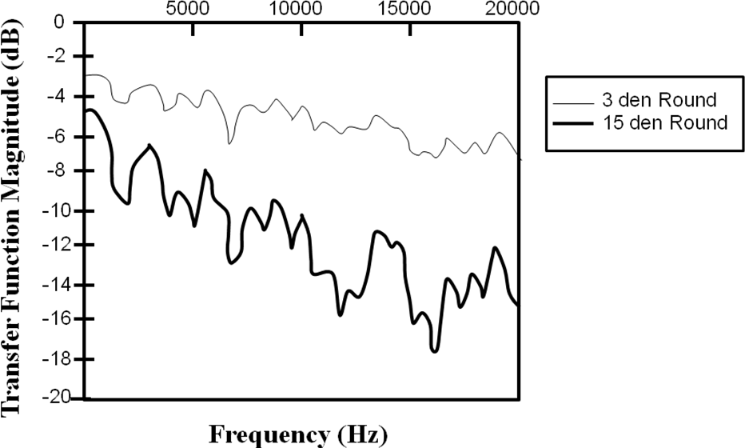

Figure 8. Transmitted sound results for needlepunchd nonwoven fabrics made from 3 and 15 denier fibres with 0.16 g/cc density[21]

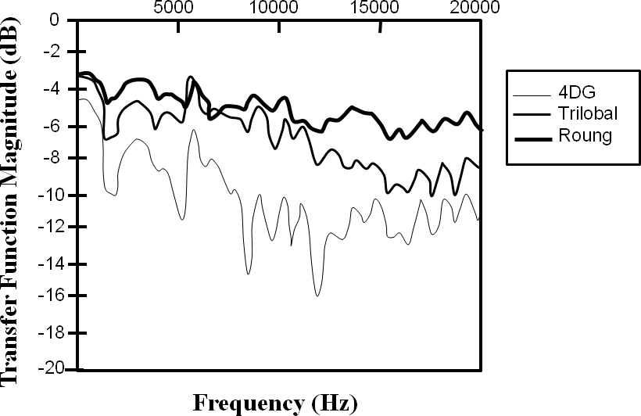

Figure 9. Transmitted sound results for needlepunchd nonwoven fabrics made from15 denier 4DG, trilobal and round fibres with 0.27 g/cc density[21]

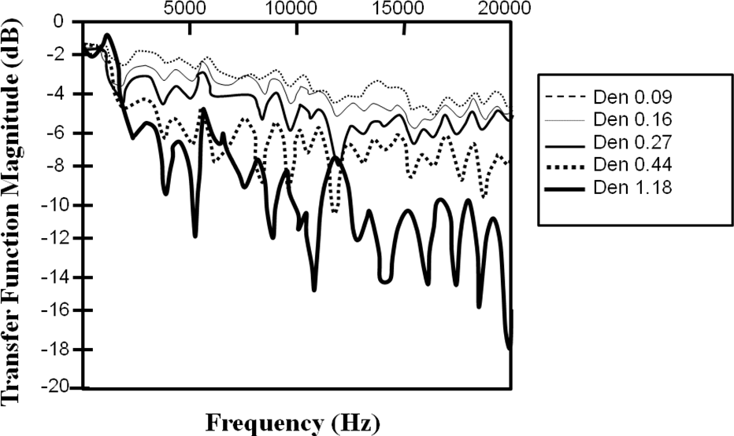

Figure 10. Transmitted sound results for needlepunchd nonwoven fabrics made from 3 denier 4DG fibres with various densities 0.09g/cc, 0.16 g/cc, 0.27 g/cc, 0.44 g/cc and 1.18 g/cc[21]

**6 Bibliography**

[1] Asian Journal of Pharmaceutical Research and Development, A Review on Banana Fiber and Its Properties V. Kavitha and Aparna

[2] <https://www.sciencedirect.com/topics/engineering/banana-fibre>)

[3] Banana fibre – A potential source of sustainable textiles K. Sangamithirai* and N. Vasug )

[4] Banana fbre: a natural and sustainable bioresource for eco friendly applications

[5] https://textileengineering.net/types-properties-and-uses-of-banana-fibre/

[7] Sannapapamma, K. J., Kolli, S. D., & Shashidhar, T. R. (2024). Influence of wet processing treatments on physical properties of banana fibre. Journal of Farm Sciences, 37(02), 202–204. (https://journaloffarmsciences.in/index.php/JFM/article/view/473 )

[8] Wang, Y., et al. (2023). Effect of warm-water retting pretreatment on the physical properties of banana stem and its fibre. PubMed. (https://pubmed.ncbi.nlm.nih.gov/36499958/ )

[9] Bledzki, A. K., & Gassan, J. (1999). Composites reinforced with cellulose-based fibers. Progress in Polymer Science, 24(2), 221–274.

[10] Mohanty, A. K., Misra, M., & Drzal, L. T. (2005). Natural fibers, biopolymers, and biocomposites. CRC Press.

[11] https://www.researchgate.net/figure/Extraction-process-of-banana-fibre_fig2_371971379

[12] https://www.researchgate.net/figure/Physical-properties-of-banana-fiber_tbl1_324363864

[13] https://www.researchgate.net/figure/Chemical-composition-of-gray-banana-fiber_tbl1_29338959

[14] Basu, A., Bhattacharya, S., & Das, A. (2022). Influence of fiber composition on dyeability and color fastness of natural fibers. Textile Research Journal, 92(5–6), 501–512.

[15] Chakraborty, S., Banerjee, S., & Roy, A. (2021). A review on the application of banana fiber in textile and composites. Fibers and Polymers, 22(1), 34–42.

[16] Ghosh, A., Mahapatra, N. N., & Satpathy, S. (2018). Banana fibers: A green alternative for sustainable textiles. Indian Journal of Fibre & Textile Research, 43(4), 438–445.

[17] Kumar, M., Singh, R. P., & Shukla, S. R. (2019). Chemical and enzymatic processing of banana fiber for textile applications. Journal of Cleaner Production, 234, 636–644.

[18] Nayak, R. K., Misra, P., & Behera, B. K. (2021). Effect of alkaline treatment on banana fiber properties for textile end use. Journal of Natural Fibers, 18(11), 1523–1534.

[19] Rout, J., Misra, M., & Tripathy, S. S. (2018). Enzymatic treatment of banana fiber for better textile utilization. Bioresource Technology, 263, 78–84.

[20] Singh, V., Gupta, D., & Kothari, V. K. (2017). Scouring and bleaching of banana fiber for improved textile quality. Textile Progress, 49(1), 1–19.

[21] Senthilkumar K, Siva I, Rajini N et al (2018) Mechanical characteristics of tri-layer eco-friendly polymer composites for interior parts of aerospace application. Sustainable composites for aerospace applications. Woodhead Publishing, Cambridge, pp 35–53).

[22] https://textileengineering.net/types-properties-and-uses-of-banana-fibre/

[23] Rajendran, S. et al. (2012) Effect of alkaline treatment on mechanical properties of banana fiber - Journal of Applied Polymer Science.

[24] Bourtoom, T. (2011) The use of banana fibers as reinforcements in biodegradable composites - International Journal of Biological Macromolecules.

[25] Yuan, W., et al. (2013) Chemical modification of banana fibers for composite applications - International Journal of Polymer Science.

[26] Siqueira, G. et al. (2008) Surface modification of banana fibers for composite applications - Materials Science and Engineering A.

[27] Rajendran, S. et al. (2012). "Effect of alkaline treatment on mechanical properties of banana fiber." Journal of Applied Polymer Science.

[28] Bourtoom, T. (2011). "The use of banana fibers as reinforcements in biodegradable composites." International Journal of Biological Macromolecules.

[29] Yuan, W., et al. (2013). "Chemical modification of banana fibers for composite applications." International Journal of Polymer Science.

[30] Siqueira, G. et al. (2008). "Surface modification of banana fibers for composite applications." Materials Science and Engineering A.

[31] Patel, R., & Gupta, S. (2021). A Review on the Dyeing of Natural Fibers: Banana Fiber Focus. International Journal of Textile Science, 5(2), 80-91.

[32] Bhattacharya, S., & Ghosh, S. (2022). Eco-friendly Dyeing of Banana Fiber: Techniques and Challenges. Journal of Sustainable Textiles, 19(3), 120-134.

[33] Singh, N., & Sharma, P. (2020). Natural Dyeing of Cellulose Fibers: A Study of Banana Fiber. Textile Research Journal, 90(7), 1501-1510.

[34] Chandran, S., & Sharma, N. (2023). Sustainable Dyeing Practices for Banana Fiber: An Overview. Journal of Environmental Impact and Textile Sustainability, 10(1), 45-60.

[35] Patel, R., & Gupta, S. (2021). Low-Impact Dyeing Techniques for Banana Fiber. Textile Sustainability Review, 8(4), 200-215.

[36] Patel, R., & Gupta, S. (2021). A Review on the Dyeing of Natural Fibers: Banana Fiber Focus. International Journal of Textile Science, 5(2), 80-91.

[37] Bhattacharya, S., & Ghosh, S. (2022). Eco-friendly Dyeing of Banana Fiber: Techniques and Challenges. Journal of Sustainable Textiles, 19(3), 120-134.

[38] Singh, N., & Sharma, P. (2020). Natural Dyeing of Cellulose Fibers: A Study of Banana Fiber. Textile Research Journal, 90(7), 1501-1510.

[39] Chandran, S., & Sharma, N. (2023). Sustainable Dyeing Practices for Banana Fiber: An Overview. Journal of Environmental Impact and Textile Sustainability, 10(1), 45-60.

[40] "Dyeing of Banana Fibers: Dye Uptake and Fastness" by S. Sharma and R. Kumar (2019): This study investigates the dye uptake properties of banana fiber using various dye types and dyeing conditions.

[41] "Banana Fiber: Properties, Extraction, and Dyeing with Reactive Dyes" by M. J. S. Khan et al. (2020): Focuses on the role of dye types and processing conditions in maximizing dye uptake in banana fibers.

[42]"Dyeing of Banana Fiber with Reactive Dyes and Its Color Strength" by S. N. Garg (2018): This research explores how dyeing parameters like concentration, temperature, and time influence color strength in banana fiber.

[43] "Spectrophotometric Evaluation of Color Strength in Natural Fibers" by R. A. Patil (2016): This paper discusses the use of spectrophotometry in measuring color strength and assessing dye performance on various natural fibers, including banana fiber.

[44]"Banana Fiber: Dyeing, Color Strength, and Shade Consistency" by S. K. Tripathi and R. S. Sharma (2017): Investigates shade consistency in banana fiber when dyed with reactive and natural dyes.

[45] "Color Consistency in Natural Fiber Dyeing: A Comparative Study" by K. R. Bhat (2021): Discusses the challenges of maintaining consistent shades in natural fibers like banana fiber and methods to improve uniformity.

[46] Sannapapamma, K. J., Kolli, S. D., & Shashidhar, T. R. (2024). Influence of wet processing treatments on physical properties of banana fibre. Journal of Farm Sciences, 37(02), 202–204. (https://journaloffarmsciences.in/index.php/JFM/article/view/473 )

[47] Wang, Y., et al. (2023). Effect of warm-water retting pretreatment on the physical properties of banana stem and its fibre. PubMed. (https://pubmed.ncbi.nlm.nih.gov/36499958/ )

[48] Patil, P. R., & Gohil, J. M. (2021). Dyeing of natural fibers: An overview of processes and fastness properties. Journal of Textile Science & Engineering, 11(5), 370–380. Link

[49] Bledzki, A. K., & Gassan, J. (1999). Composites reinforced with cellulose-based fibers. Progress in Polymer Science, 24(2), 221–274.

[50] Mishra, S., Mohanty, A. K., Drzal, L. T., Misra, M., & Parija, S. (2001). Studies on mechanical performance of biofibre-glass hybrid composites. Composites Science and Technology, 61(9), 1259–1268.

[51] Kandasamy, M., et al. (2020). Dyeing Properties of Banana Fibre Dyed with Different Dyes. Academia.edu

[52] Premalatha, M., & Srinivasan, C. (2020). Analysis of Banana Fibre Dyed with Natural and Synthetic Dyes. Polymer Engineering & Science. Wiley Online Library

[53] Kandasamy, M., et al. (2020). Dyeing Properties of Banana Fibre Dyed with Different Dyes. Retrieved from Academia.edu

[54] Premalatha, M., & Srinivasan, C. (2020). Analysis of Banana Fibre Dyed with Natural and Synthetic Dyes. Polymer Engineering & Science. Retrieved from Wiley Online Library

[55] Jadhav, S. D., & Kulkarni, R. D. (2018). Utilization of Banana Fiber in Textile Applications: A Review. International Journal of Research in Engineering and Technology, 7(6), 40–43.

[56] Per acetic acid efect on separation of banana fber and their dyeing with natural dyes B. H. Patel ·D. P. Panchal · S. B. Chaudhari

[57] Kubelka, P., & Munk, F. (1931). "A contribution to the optics of paint layers." Zeitschrift für technische Physik.

[58] Pavia, D. L., Lampman, G. M., Kriz, G. S. (2015). Introduction to Spectroscopy.

[59] International Organization for Standardization. (2010). ISO 105-C06:2010 Textiles — Colour fastness to washing.

[60] International Organization for Standardization. (2014). ISO 105-B02:2014 Textiles — Colour fastness to artificial light.