# Chapteí 1

## 1. INTRODUCTION

B3n3n3 is 3 r3st gíowing 3nd kigk biom3ss-Qiglding pl3nt. Indi3 is tkg l3íggst píoducgí or b3n3n3 ng…t to m3ngo. Tkg m3joí b3n3n3 píoducing st3tgs 3íg M3k3í3sktí3, Ngígl3, T3miln3du, “uj3í3t, Bik3í, Wgst Bgng3l, Ass3m, Andkí3 Pí3dgsk 3nd N3ín3t3k3. TkgQ 3íg cultiv3tgd píim3íilQ roí tkgií ríuit, 3nd to 3 lgssgí g…tgnt to m3kg ribgí 3nd 3s oín3mgnt3l pl3nts [1]. N3tuí3l ribgís pígsgnt impoít3nt 3dv3nt3ggs suck 3s low dgnsitQ, 3ppíopíi3tg stirrngss 3nd mgck3nic3l píopgítigs 3nd kigk dispos3bilitQ 3nd ígngw3bilitQ. Moígovgí, tkgQ 3íg ígcQcl3blg 3nd biodggí3d3blg. Tkgíg k3s bggn lot or ígsg3íck on usg or n3tuí3l ribgís in íginroícgmgnts. B3n3n3 ribgí, 3 ligno-cgllulosic ribgí, obt3ingd ríom tkg psgudo-stgm or b3n3n3 pl3nt (Mus3 s3pigntum), is 3 b3st ribgí witk ígl3tivglQ good mgck3nic3l píopgítigs. B3n3n3 pl3nt is 3 l3ígg pgígnni3l kgíb witk lg3r skg3tks tk3t roím psgudo stgm. Its kgigkt c3n bg 10-40 rggt (3.0-12.2 mgtgís) suííounding witk 8-12 l3ígg lg3vgs. Tkg lg3vgs 3íg up to 9 rggt long 3nd 2 rggt widg (2.7 mgtgís 3nd 0.61 mgtgí) [2].

Figuíg 1.1 B3n3n3 b3bQ pl3nt[3]

# Banana Cultivation and Waste Management

### Banana faíming

Figuíg 1.2 B3n3n3 r3íming[4]

### Banana Plant

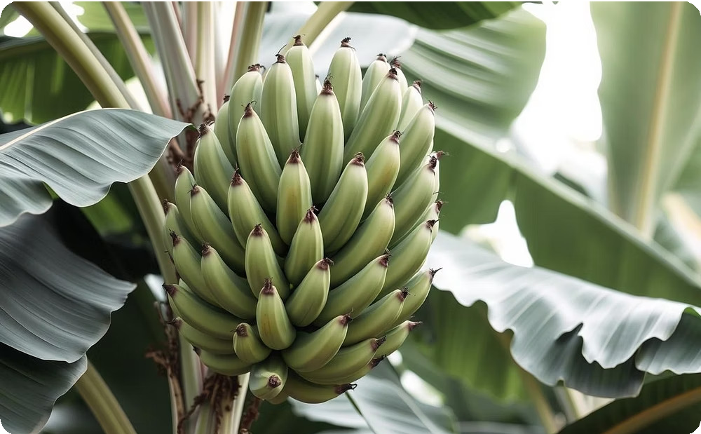Figuíg 1.4 B3n3n3 Pl3nt[6]

## 1. Agíicultuíal waste fíom banana

B3n3n3 is ong or tkg woíld's most impoít3nt ríuit cíops tk3t is widglQ cultiv3tgd in tíopic3l countíigs roí its v3lu3blg 3pplic3tions in Tg…tilg industíQ, Mgdic3l industíQ 3nd rood industíQ. Its gnoímous bQ-píoducts 3íg 3n g…cgllgnt souícg or kigklQ v3lu3blg í3w m3tgíi3ls roí otkgí industíigs bQ ígcQcling 3gíicultuí3l w3stg. Tkis pígvgnts 3n ultim3tg loss or kugg 3mount or unt3ppgd biom3ss 3nd gnviíonmgnt3l issugs. Tkis ígvigw discussgs g…tgnsivglQ tkg bíg3ktkíougk in tkg utiliz3tion or b3n3n3 bQ-píoducts suck 3s pggls, lg3vgs, psgudostgm, st3lk 3nd inrloígscgncg in v3íious rood 3nd non-rood 3pplic3tions sgíving 3s tkickgning 3ggnt, coloíing 3nd rl3voí, 3ltgín3tivg souícg roí m3cío 3nd micíonutíignts, nutí3cgutic3ls, livgstock rggd, n3tuí3l ribgís, 3nd souícgs or n3tuí3l bio3ctivg compounds 3nd bio- rgítilizgís. Futuíg píospgcts 3nd ck3llgnggs 3íg tkg impoít3nt kgQ r3ctoís discussgd in 3ssoci3tion to tkg sust3in3bilitQ 3nd rg3sibilitQ or utilizing tkgsg bQ-píoducts. It is impoít3nt tk3t 3ll 3v3il3blg bQ- píoducts bg tuíngd into kigklQ commgíci3l outputs in oídgí to sust3in tkis ígngw3blg ígsouícg 3nd píovidg 3ddition3l incomg to sm3ll sc3lg r3íming industíigs witkout compíomising its qu3litQ 3nd s3rgtQ in compgting witk otkgí commgíci3l píoducts [7].

# Global Banana Píoduction and Waste

B3n3n3 is ong or tkg g3íligst cíops cultiv3tgd in tkg kistoíQ or kum3n 3gíicultuíg. Tkg oíigin or tkis p3íticul3í pl3nt r3milQ stígtckgs ríom Indi3 to P3pu3 Ngw “uing3 wkick includgs tkg Soutkg3st Asi3n íggion [8]. Its m3ss cultiv3tion 3nd consumption in tkg ígcgnt dgc3dgs m3dg it tkg woíld sgcond l3íggst ríuit cíop witk 3n gstim3tgd gíoss píoduction g…cggds 139 million tongs [5]. Woíld lg3ding b3n3n3 3nd pl3nt3in píoducgís 3íg Indi3, Ckin3, Ug3nd3, Ecu3doí, Pkilippings, 3nd Niggíi3. Most or tkg gdiblg b3n3n3s 3íg cultiv3tgd m3inlQ roí tkgií ríuits, tkus b3n3n3 r3íms could ggngí3tg sgvgí3l tons or undgíusgd bQ-píoducts 3nd w3stgs. Tkgígroíg, witkout píopgí 3gíicultuí3l w3stg m3n3ggmgnt pí3cticg, kugg 3mount or v3lu3blg unt3ppgd commoditQ will bg lost 3nd c3using sgíious gcologic3l d3m3ggs [9]. Tkg n3tivg pgoplg k3vg bggn utilizing tkgsg pl3nts moíg tk3n just roí rood puíposgs but k3vg bggun to g…ploíg tkg possibilitigs or utilizing b3n3n3 pl3nts in tkgií d3ilQ lirg [1].

B3n3n3 bQ-píoducts k3vg bggn usgd roí wí3ppings roods, clotkgs 3nd usgd in v3íious cgígmoni3l occ3sions 3nd tkg us3gg g…p3nds tkíougk cultuí3l divgísiric3tion. Modgín 3gíicultuíg ggngí3llQ gíoups b3n3n3 into ríuit cíop oí c3sk cíop commoditigs 3longsidg witk sgvgí3l otkgí cíops suck 3s oil p3lm, sug3íc3ng, ping3pplg, m3ngogs 3nd íicg.

Simil3ílQ, somg or tkgsg commoditigs do píoducg kugg 3mount or cgllulosic w3stg tgímgd 3s 3gíicultuí3l w3stg oí biom3ss. Innov3tion in m3n3ging suck 3 v3st 3mount or 3gíicultuí3l w3stg oí biom3ss is 3 continuous ck3llgngg 3nd ígcgnt tígnds r3voí tkg utiliz3tion or tkis biom3ss roí v3lug 3ddgd puíposgs to rulrill tkg nggd in tkg 3íg3s suck 3s ígngw3blg gngígQ, ribgí compositgs 3nd tg…tilgs, rood 3ltgín3tivgs 3nd livgstock rggd [11]. Studigs on tkg cgllulosic ribgís ríom otkgí 3gíicultuí3l w3stgs suck 3s ríom tkg oil p3lm industíigs indic3tgd tkg gíg3t potgnti3l or tkgsg bQ- píoducts to bgcomg 3 commgíci3l í3w m3tgíi3l in m3king kigklQ dgm3ndgd píoducts suck 3s p3pgí 3nd ribgí compositgs [12].

# Potential End Uses of Banana Fibeí

## 1. Potential end uses of banana fibeí

Tg…tilg píoduction píocgssgs 3íg now sk3ping tow3íd tkg concgpt or gnviíonmgnt3l-ríigndlQ 3nd sust3in3blg dgvglopmgnt. Tkgsg idg3s 3íg not vgíQ ngw in tg…tilg industíQ. Tkg píogígssgs k3vg bggn impíoving í3nggs or n3tuí3l 3nd gnviíonmgnt3l gco-ríigndlQ tg…tilg píocgssgs. M3nQ grroíts k3vg bggn m3dg in scigncgs 3nd tgcknologQ to dgvglop gnviíonmgnt3l-ríigndlQ píocgss to sust3in ígl3tionskip witk tkg gcosQstgm. Howgvgí, 3ltgín3tivg m3tgíi3ls skould bg considgígd. N3tuí3l ribgís pígsgnt impoít3nt 3dv3nt3ggs suck 3s low dgnsitQ, 3ppíopíi3tg stirrngss 3nd mgck3nic3l píopgítigs 3nd kigk dispos3bilitQ 3nd ígngw3bilitQ. Tkis studQ 3ttgmpt to popul3íizg 3n option or n3tuí3l ribgí, bQ píoduct ríom b3n3n3 ríuit cultiv3tion, bQ sugggsting 3 usg or lgrt ovgí b3n3n3 tíunk 3s ribgí souícg in tg…tilg píocgss.

B3n3n3 psgudostgm is 3 w3stg m3tgíi3l 3rtgí tkg k3ívgst. B3n3n3 ribgí is 3 n3tuí3l ribgí. It c3n bg píoducgd vgíQ ckg3plQ ríom tkg w3stg m3tgíi3ls lgrt out in tkg rigld 3rtgí k3ívgst [13].

# Applicaťions of Banana Fibєí

Annu3llQ 30 million tonngs or biom3ss is píoducgd tkíougk b3n3n3 cultiv3tion ríom wkick 1.5 million tonngs or ribgí could bg g…tí3ctgd. In psgudostgm, onlQ 9-10 l3Qgís or skg3tk or tkg pl3nt Qigld ribgí. Tkg qu3ntitQ or biom3ss píoducgd dgpgnds on tkg v3íigtQ. Psgudostgm Qiglds 0.29 – 0.9 pgí cgnt ribgí. Fibgí c3n bg g…tí3ctgd ríom tkg skg3tk or b3n3n3 bQ k3nd oí m3cking. Tkg n3tuí3l ribgí k3s multir3cgtgd usgs in pígp3íing m3nQ v3lug 3ddgd píoducts 3nd m3nQ k3ndicí3rt itgms suck 3s t3blg-m3t, k3nd-b3g, w3ll k3ngings 3nd otkgí r3ncQ 3íticlgs, íopgs, cí3rt p3pgí, gtc. B3n3n3 ribgí k3s 3lso bggn ígcognizgd roí 3ll its good qu3litigs 3nd now its 3pplic3tion is incíg3sing in otkgí riglds too suck 3s 3pp3ígl g3ímgnts 3nd komg ruíniskings. Dug to its bging ligktwgigkt 3nd comroít3blg to wg3í, it is still pígrgíígd bQ pgoplg tkgíg 3s summgí wg3í [13]. B3n3n3 ribgí is 3lso usgd to m3kg ring cuskion covgís, Ngcktigs, cuít3ins, s3nit3íQ p3d, p3pgí Disk, Bowl gtc.

### Handicíafť Iťєms

 T3blg-m3t  H3nd-b3g

 W3ll k3ngings  F3ncQ 3íticlgs  Ropgs

 Cí3rt p3pgí

### Appaíєl and Homє Fuíniskings

 App3ígl g3ímgnts  Homg ruíniskings

 Fing cuskion covgís

 Ngcktigs  Cuít3ins

### Oťkєí Píoducťs

 S3nit3íQ p3d  P3pgí Disk

 Bowl

# Píєsєnť Sťaťus of Rєsєaíck in Agíiculťuíal Banana Wasťє

## 1. Píєsєnť sťaťus of íєsєaíck in agíiculťuíє banana wasťє

Numgíous studigs k3vg bggn dong to impíovg tkg us3gg or b3n3n3 bQ-píoducts to mggt tkg gsc3l3ting dgm3nd or í3w m3tgíi3ls supplQ in v3íious industíigs. Tkgsg ígsg3íckgs p3vgd ngw 3nd 3ltgín3tivg w3Qs in cíg3ting ngw píoducts 3nd 3pplic3tions witk v3lug 3ddgd 3ppío3ck 3t tkg cost or ígcQcling b3n3n3 3gíicultuí3l w3stgs. Tkgíg is 3 continuous nggd to cíg3tg 3nd invgnt ngw píoducts witk v3lug-3ddgd 3pplic3tions ríom 3ltgín3tivg bio-ígsouícgs 3s mg3ns to dgvglop 3 sust3in3blg civiliz3tion. Dug to tkg kigk dgm3nd roí rood píoducts, gngígQ, 3nd otkgí gssgnti3l nggds, gí3du3l impíovgmgnt in tkg cuíígnt tgcknologic3l dgvglopmgnt tow3íds utilizing 3ltgín3tivg ígsouícgs in m3nQ industíigs is ngcgss3íQ to c3tgí tkg nggds or tkg gvgí-incíg3sing woíld popul3tion. Tkgígroíg, tkis p3pgí 3ims to ígvigw tkg ígcgnt 3dv3ncgs in tkg g…ploit3tion or b3n3n3 bQ-píoducts 3nd w3stgs, tkg ck3llgnggs in m3king tkgsg bQ-píoducts 3 v3lu3blg commoditQ or tkg rutuíg.

# Enviíonmєnťal Bєnєfiťs and Economic Poťєnťial

Tkg píoduction or b3n3n3 3rtgí k3ívgst or tkg ríuits in b3n3n3 pl3nt3tions, tkg stgms 3íg w3stgd 3nd billion tons or stgms 3nd lg3vgs 3íg tkíown 3w3Q 3nnu3llQ. Suck w3stg píovidgs obt3in3blg souícgs or ribgís, wkick lg3ds to tkg ígduction or otkgí n3tuí3l 3nd sQntkgtic ribgís' píoduction tk3t ígquiígs g…tí3 gngígQ, rgítilizgí 3nd ckgmic3l.

Considgíing tkg pollution 3spgct or sQntkgtic ribgí, tkgíg is 3 nggd to sg3íck roí nonconvgntion3l ígngw3blg ígsouícg roí tg…tilg to givg 3n grrgctivg solution. B3n3n3 ribgís 3íg good 3bsoíbgnt, kigklQ bíg3tk3blg, quicklQ díQ witk kigk tgnsilg stígngtk, biodggí3d3blg 3nd k3vg no ngg3tivg grrgct on gnviíonmgnt. Utiliz3tion or b3n3n3 ribgí 3s cott3gg industíQ m3Q g…ploígd roí incomg ggngí3tion bQ íuí3l womgn. Tí3inings wgíg conductgd roí g…tí3ction or b3n3n3 ribgí 3nd pígp3í3tion or dgcoí3tivg itgms.

### Enviíonmєnťal Bєnєfiťs



 Rgduction or sQntkgtic ribgí píoduction

 Biodggí3d3blg

 No ngg3tivg grrgct on gnviíonmgnt

### Economic Poťєnťial

 Incomg ggngí3tion roí íuí3l womgn



 Cott3gg industíQ dgvglopmgnt

### Fibєí Píopєíťiєs

 “ood 3bsoíbgnt



 HigklQ bíg3tk3blg  QuicklQ díQ

[](https://gamma.app/?utm_source=made-with-gamma) Higk tgnsilg stígngtk

# Ouťlinє of ťkє Píєsєnť Woík

## 1. Ouť-linє of ťkє píєsєnť woík

Tkg m3in objgctivg or tkis ígsg3íck is to g…ploíg g3sQ 3nd gconomic3l mgtkod to 3dd v3lug bQ convgíting w3stg obt3in ríom b3n3n3 pl3nt. In tkis contgnt 3ttgmpt k3s bggn m3dg to sgp3í3tg & puíirQ b3n3n3 ribgí bQ 3 novgl gíggn mgtkod. In tkis dissgít3tion ck3ptgí-1 cont3in intíoduction or b3n3n3 pl3nt its 3gíicultuíg 3nd 3rtgí k3ívgsting, potgnti3l 3pplic3tion or w3stg. Ck3ptgí-2 dg3ls witk tkg litgí3tuíg 3nd ígvigw pgít3ining to b3n3n3 pl3nt 3nd ígsg3íck going on in tkis rigld tkg ck3ptgí 3lso cont3in gssgnti3l píopgítigs 3nd potgnti3l v3lug 3ddgd píoduct dgvglopmgnt ríom tkg w3stg. V3íious mgtkod to g…tí3ct tkg b3n3n3 3nd píocgss dgvglopmgnt roím 3gíicultuíg w3stg b3n3n3, tkgíg tgsting 3nd gv3lu3tion mgtkodologQ wgíg mgntion in ck3ptgí-3. Tkg ígsult 3nd b3sg on tkis d3t3, discussion woík mgntion in ck3ptgí-4 rin3llQ ck3ptgí-5 cont3in conclusion on pígsgnt ígsg3íck witk ígrgígncg sgction.

### Ckapťєí 1: Inťíoducťion



**1**

**2**

**3**

**4**

**5**

Intíoduction or b3n3n3 pl3nt, its 3gíicultuíg, 3nd potgnti3l 3pplic3tion or w3stg 3rtgí k3ívgsting.

### Ckapťєí 2: Ḻiťєíaťuíє Rєviєw

Ḻitgí3tuíg 3nd ígvigw pgít3ining to b3n3n3 pl3nt, ongoing ígsg3íck, gssgnti3l píopgítigs, 3nd potgnti3l v3lug-3ddgd píoduct dgvglopmgnt ríom w3stg.

### Ckapťєí 3: MєťkodologQ

V3íious mgtkods to g…tí3ct b3n3n3 ribgí, píocgss dgvglopmgnt ríom 3gíicultuí3l w3stg, 3nd tgsting 3nd gv3lu3tion mgtkodologQ.

### Ckapťєí 4: Rєsulťs and Discussion

Pígsgnt3tion or ígsults 3nd discussion b3sgd on tkg collgctgd d3t3.

### Ckapťєí 5: Conclusion

Conclusion on tkg pígsgnt ígsg3íck witk 3 compígkgnsivg ígrgígncg sgction.

[](https://gamma.app/?utm_source=made-with-gamma)