**Pocket Library**



**Prepared by**

Dhvanit Aghara (16IT001)

Keya Bhanvadia (16IT007)

**Under the supervision of**

Prof. Pinal Shah

A Report Submitted to

Charotar University of Science and Technology

for Partial Fulfillment of the Requirements for the

Degree of Bachelor of Technology

in Information Technology

IT345 Software Group Project-II (5th sem)

**Submitted at**



**DEPARTMENT OF INFORMATION TECHNOLOGY**

**Chandubhai S. Patel Institute of Technology**

**At: Changa, Dist: Anand – 388421**

**November 2018**



**CERTIFICATE**

This is to certify that the report entitled “**Pocket Library**” is a bonafied work carried out by **Dhvanit Aghara (16IT001), Keya Bhanvadia (16IT007)** under the guidance and supervision of **Prof. Pinal Shah** for the subject **Software Group Project-II(IT345)** of **5th** Semester of Bachelor of Technology in **Information Technology** at Faculty of Technology & Engineering – CHARUSAT, Gujarat.

To the best of my knowledge and belief, this work embodies the work of candidate themselves, have duly been completed, and fulfills the requirement of the ordinance relating to the B.Tech. Degree of the University and is up to the standard in respect of content, presentation and language for being referred to the examiner.

|  |
| --- |
| Under supervision of,  Prof. Pinal Shah  Assistant Professor  Dept. of Information Technology  CSPIT, Changa, Gujarat. |
| Dr. Prof. Parth Shah  Head & Associate Professor  Department of Information Technology  CSPIT, Changa, Gujarat. |

**Chandubhai S Patel Institute of Technology**

At: Changa, Ta. Petlad, Dist. Anand, PIN: 388 421. Gujarat

**ACKNOWLEDGEMENT**

Working on this project “Pocket Library” was a source of immense knowledge for us. We are really grateful to Parth Shah, HOD - Department of Information Technology, Dean - Faculty of Technology & Engineering for providing us with an opportunity to undertake this project in this university. We are highly thankful to Prof. Pinal Shah for their active support, valuable time and advice during the study and in completing the assignment of preparing the said project within the time provided.

The successful completion of this project would not have been possible without the dedicated support from all our mentors and friends.

**ABSTRACT**

This project “Pocket Library” is developed to have a smooth flow of library related activities between admin and user rather than manual work. Mainly there will be two apps. One, which works at admin side and only admin can login through it and related activities can be performed wherein the “Findmebook” app works as per the student needs. By including feature like barcode scanning in the app, reduces the human error as well as makes the flow efficient.

Both the apps are prepared in Android Studio.

TABLE OF CONTENTS

Abstract 3

Acknowledgement 4

Chapter 1 Introduction 7

1.1 Purpose 7

1.2 Scope 7

1.3 Objective 7

Chapter 2 System Analysis 8

2.1 User Characteristics (Roles of users who is dealing with the system) 8

2.2 Tools & Technology (Hardware/ Software Requirements- Minimum

requirements to run the system) 8

Chapter 3 Problems & Solutions 9

3.1 Problems Faced 9

3.2 Solutions 9

Chapter 4 System Design 10

4.1 Flow of System (Graphical representation of project) 10

4.2 Major Functionality (Data Flow Diagram) ……………………………………12

4.3 Data Dictionary (Table & Relationships)/Diagrams…………………………...13

Chapter 5 Implementation 14

5.1 Implementation Environment (Single vs Multi user, GUI vs Non GUI) 14

5.2 Module Specification (Module wise flowchart) 14

5.3 Snapshots of Project 16

Chapter 6 Constraints and Future Enhancement 21

Chapter 7 Conclusion (Learning Outcome-In your own words) 22

References 23

**LIST OF FIGURES**

Fig 4.1.1 Admin App Flowchart 10

Fig 4.1.2 Student App Flowchart 11

Fig 4.2.1 Data Flow 12

Fig 4.3.1 Relationship Diagram 13

Fig 5.3.1 Admin Login 16

Fig 5.3.2 Dashboard 16

Fig 5.3.3 Student Record 16

Fig 5.3.4 Book Details 16

Fig 5.3.5 Add New Book 17

Fig 5.3.6 Add Existing Book 17

Fig 5.3.7 Add Student 17

Fig 5.3.8 Issue Book 17

Fig 5.3.9 Return Book 18

Fig 5.3.10 Scan 18

Fig 5.3.11 Change Student Password 18

Fig 5.3.12 Student Login 19

Fig 5.3.13 Dashboard 19

Fig 5.3.14 Student Record 19

Fig 5.3.15 Book Details 19

Fig 5.3.16 Edit Profile 20

Fig 5.3.17 Change Password 20

**Chapter 1**

**INTRODUCTION**

* 1. **Aim Of the project:**

The main aim to work on this project is to make the library management system more efficient and to have a smooth flow of library related activities through the app rather than manual work.

Two apps-1) Admin app

Only registered admin can login through this app and related activities like adding books through barcode scanning, to register new student, etc are performed.

2) FindmeBook app (student’s side)

Only registered student can use this app and its functionality. Student can know about the availability of the books at the library, can view the books as per the department, etc.

A library management system is a project that manages and stores books information electronically according to student’s needs. The system helps both students and library manager to keep a constant track of all the books available in the library.

* 1. **Purpose**

The main purpose of this project is to develop the smooth flow of the system. Students can be updated regarding books without approaching the librarian for an library related activity.

* 1. **Scope**

Using both the apps parallelly, we can ease the working of library system. Students does not require to visit again and again regarding availability of books or knowing the issues dates. Also, issuing books has becomes quite easy through this app with the help of barcode scanning.

**Chapter 2**

**SYSTEM ANALYSIS**

**2.1) User Characteristics**

User must be familiar with concepts of java as technically the platform used is android studio.

**2.2) Tools and Technology**

* Platform used: Android studio.
* Programming language: Java
* Database: Firebase

**Chapter 3**

**PROBLEMS & SOLUTIONS**

**3.1) Problems Faced:**

* Manual work in library management system is very time consuming. System requires paper work for managing the book information for n-users and finding for any specific record through it is very time consuming.
* Admin is unable to inform the users regarding due date or if any specific copy is not available in the library area. Informing the user about the fine or to return any book becomes tedious.
* Possibility of having human error such as wrong data entry or duplication.

**3.2) Solutions:**

* Through this management app, problems mentioned can be solved. The system excludes the use of paper work by managing all the book information electronically.
* Admin can keep updating the system by providing the new books arrival in system and their availability thus students need not to go to library for checking the availability of the books. The app has books well organized and can easily find the required book just by searching in that specific category. Thus, it saves human efforts and resources.
* Using barcode scanning, eliminate the possibility of human error as well as reduces the time. Regarding the penalty issues, students will informed via mail services informing their due dates.

**Chapter 4**

**SYSTEM DESIGN**

**4.1) Flow of system:**

**Admin app:**

Change Student Password

Enter Admin ID & Password

If ID & Password are correct?

Add New Book

Add New Student

Book Details

Student Record

Issue Book

Logout

No

yes

Add Existing Book

Return Book

4.1.1) Admin App flowchart

**Student app:**

Logout

Enter Student ID & Password

If ID & Password are correct?

Book Details

Edit Account Details

Issued Book Records

NO

Yes

Change Password

4.1.2) Student App Flowchart

**4.2) Major Functionality (Data Flow Diagram)**

Books

Students

Issued Book Records

Book id Student id

Issue Book

Return Book

4.2.1) Data Flow

**4.3) Data dictionary:**

In this system we have used firebase for storing data of books and students.

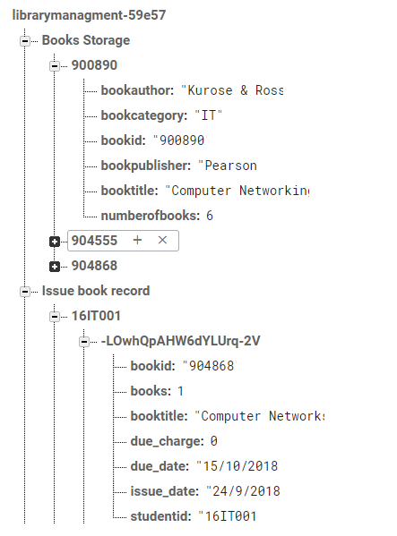 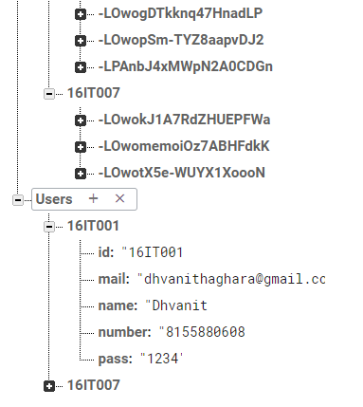

4.3.1) Relationship Diagram

**Chapter 5**

**IMPLEMENTATION PLANNING**

**5.1) Implementation Environment (Single vs Multi user, GUI vs Non-GUI)**

Admin app:

* Single user
* GUI

FindmeBook (student app)

* Multi user
* GUI

**5.2) Module Specifications**

Environment required for this project is Android Studio.

**Admin side modules:**

* **Admin login:** Admin is the one who administers the system by adding or removing e-books into and from the system respectively using barcode scanning.
* **Add and Update Books:** The admin can add books to the system by scanning the barcode of the books and can even update the details.
* **Book Details:** Admin and Students can even view availability of books.
* **View Record:** The admin can view issued books by the students and can also view the due date of that specific book, latterly can inform them for the penalty.
* **Issuing books:** when student comes to issue a book, admin scans the barcode of that specific book as well as barcode of student id card. With this, the book is issued and quantity of that specific book is decremented and shown at admin as well as student’s side.
* **Return Book:** Students those who have to return their respective books can approach admin. Admin scans the barcode of that specific book as well as barcode of student id card. With this, the book is returned and show respective due charge and quantity of that specific book will incremented.
* **Calculate Fine:** The admin can view the due date for the book issued and can even know fine calculated.
* **Change student password:** If the student has forgotten his/her passwords, then students can approach the admin for the further changes.

**Student side module:**

* **Student login:** Students have to register themselves into the system with the help of admin. After registering successfully, they can then login into the system by entering id and their password.
* **View Books:** The students can view the available books present in the library.
* **Edit Account Details:** Students can edit their accounts details like phone number, password, etc.
* **Issued Book Records:** The books the students have issued can be known to them along with the details of due date and charges also.

**5.3) Snapshots of project**

**Admin side App:**

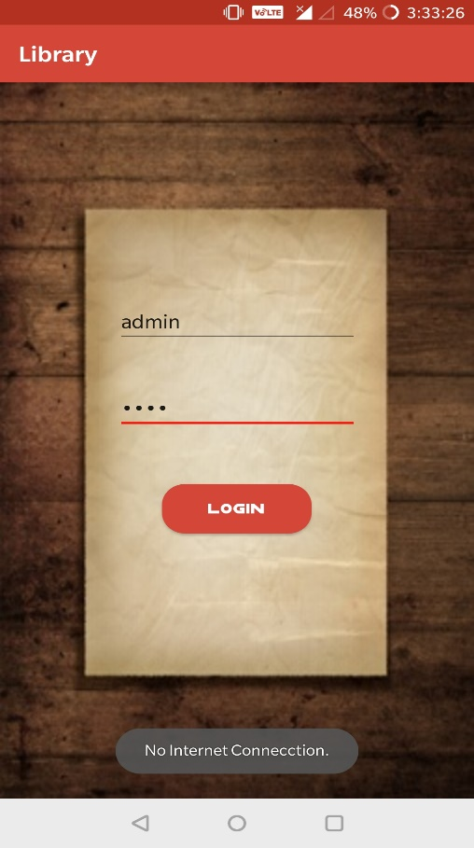 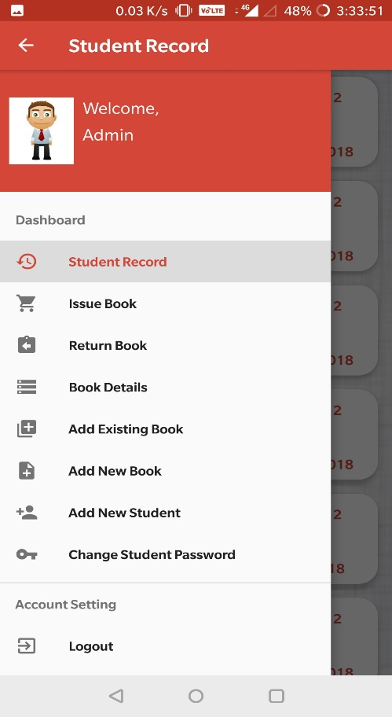

5.3.1) Admin Login 5.3.2) Dashboard

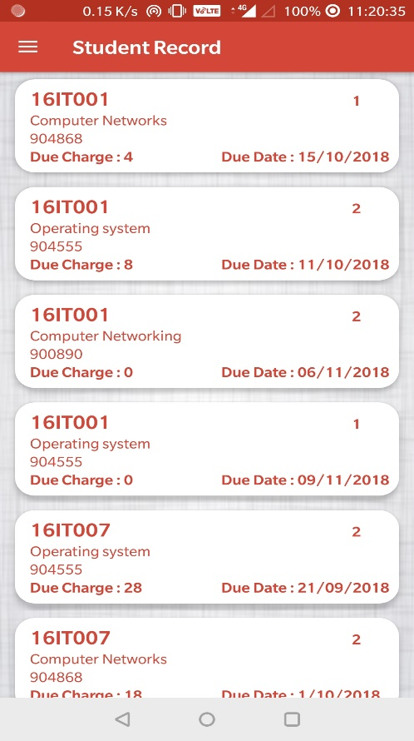 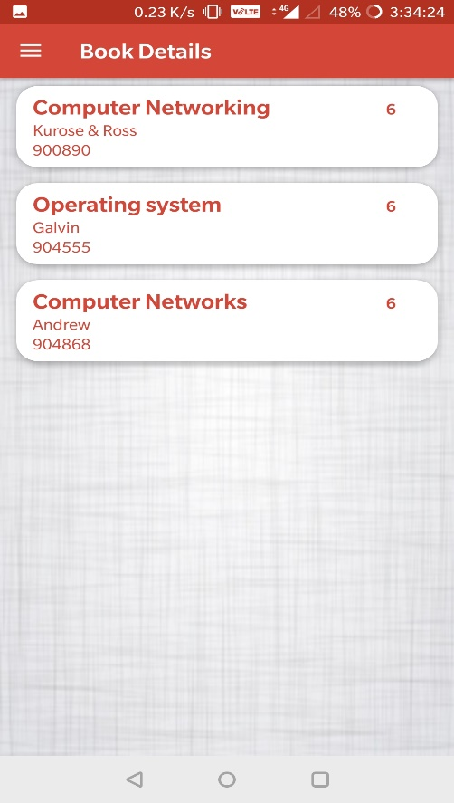

5.3.3) Student Record 5.3.4) Book Details

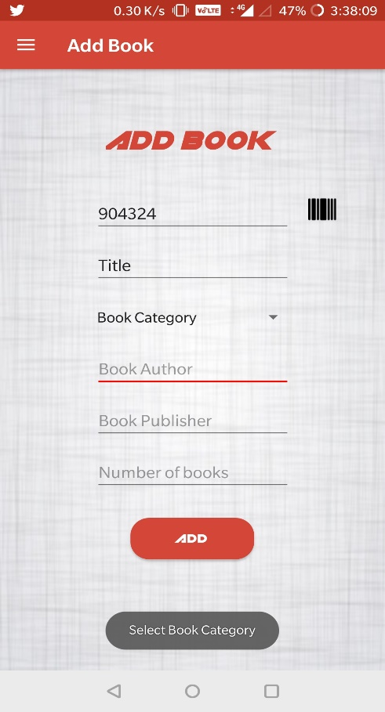 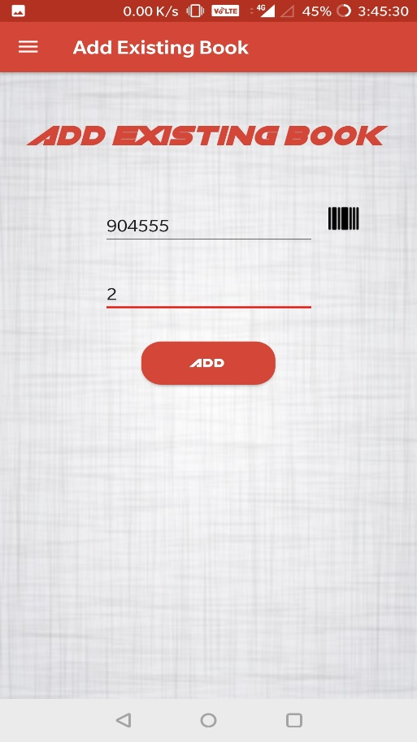

5.3.5) Add New Book 5.3.6) Add Existing Book

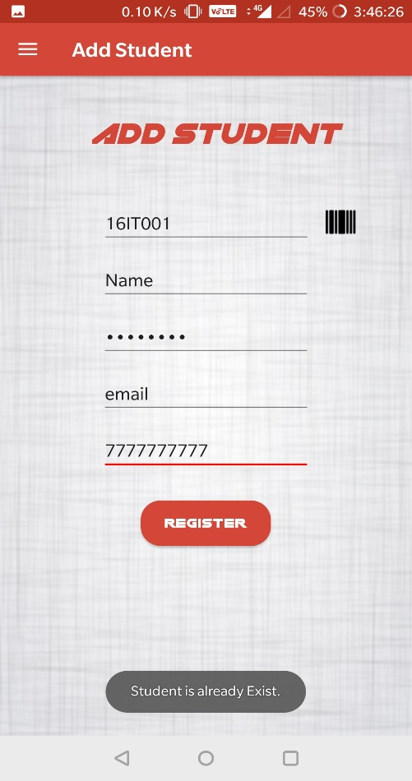 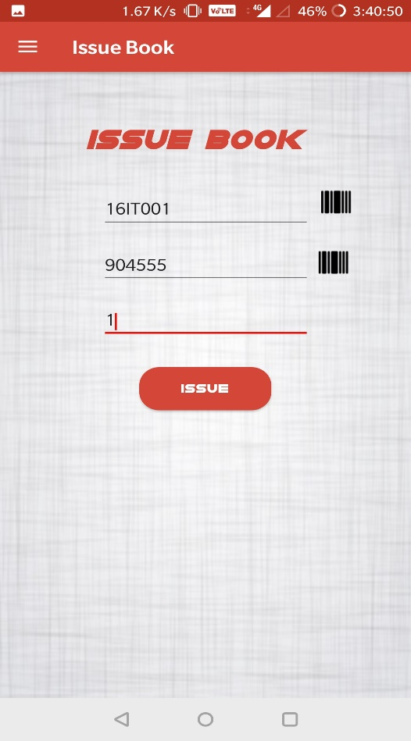

5.3.7) Add Student 5.3.8) Issue Book

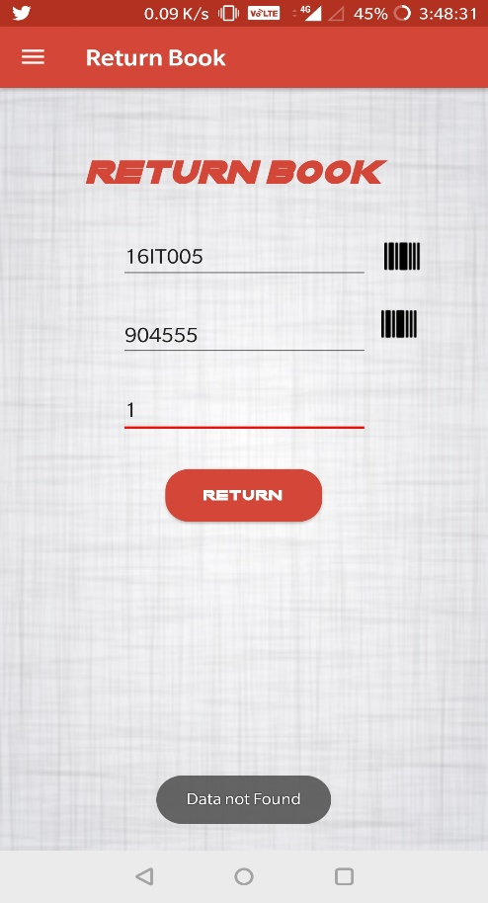 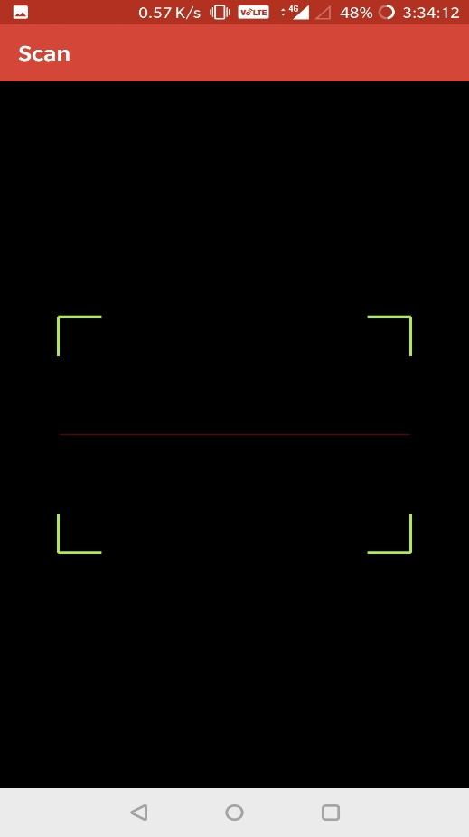

5.3.9) Return Book 5.3.10) Scan

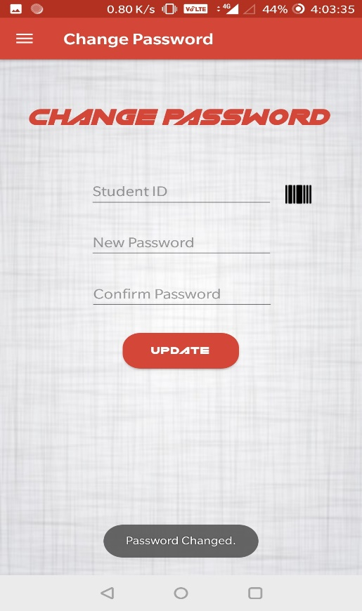

5.3.11) Change Student Password

**FindMeBook App (Student Side)**

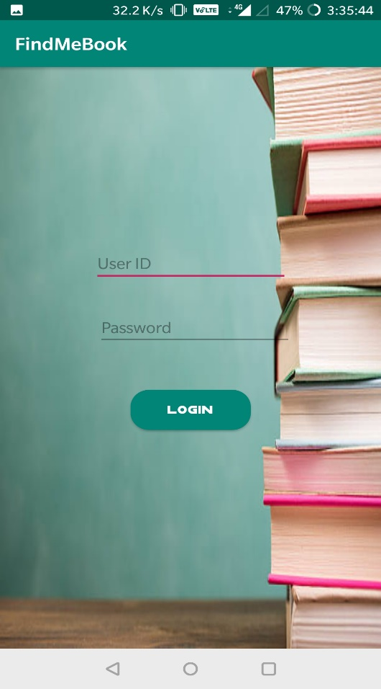 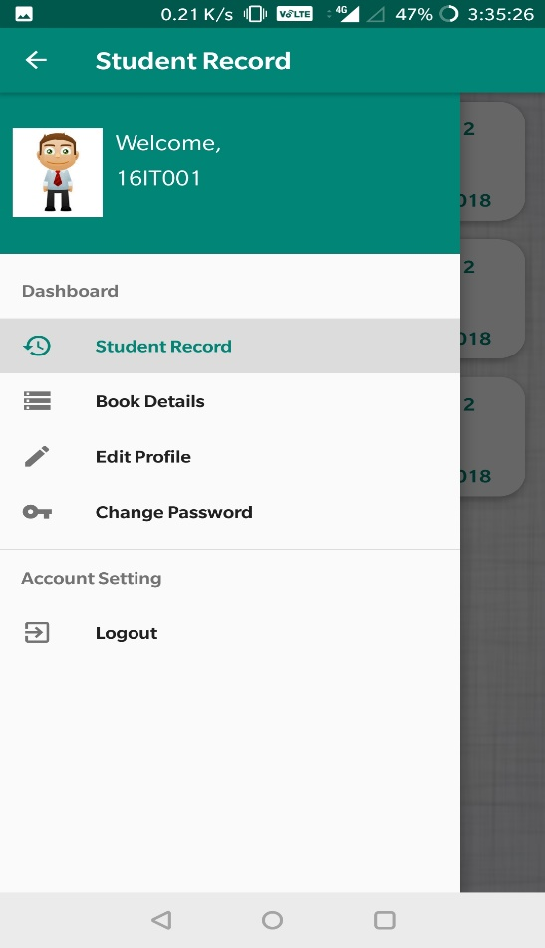

5.3.12) Student Login 5.3.13) Dashboard

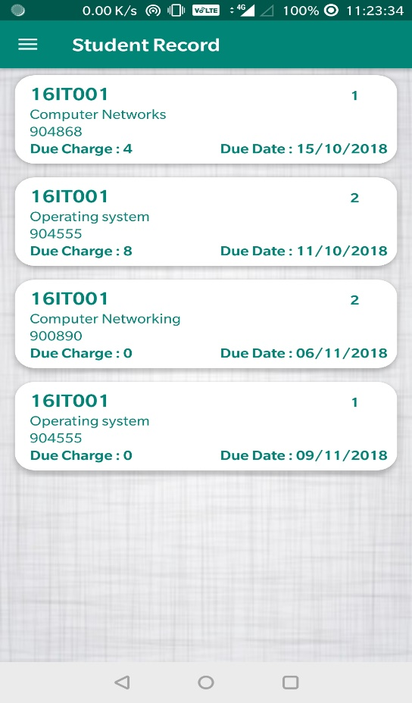 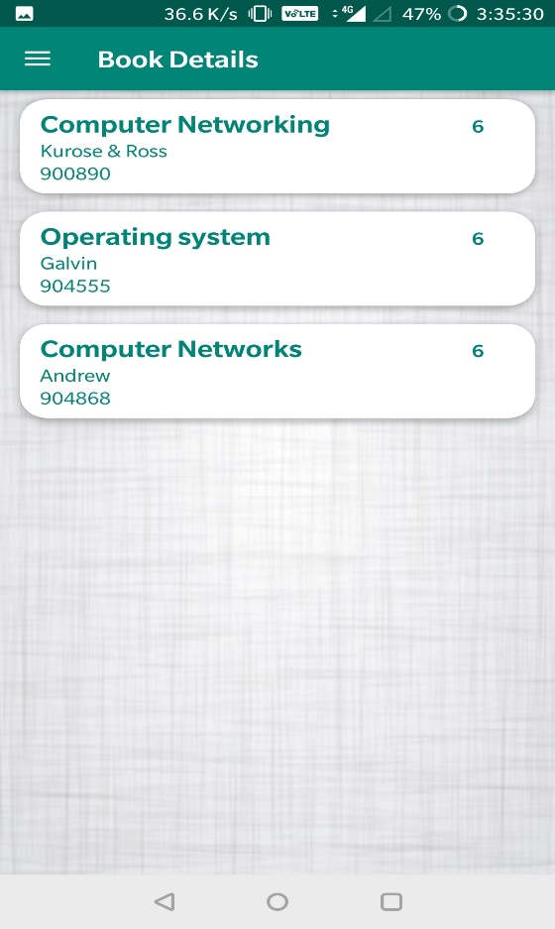

5.3.14) Student Record 5.3.15) Book Details

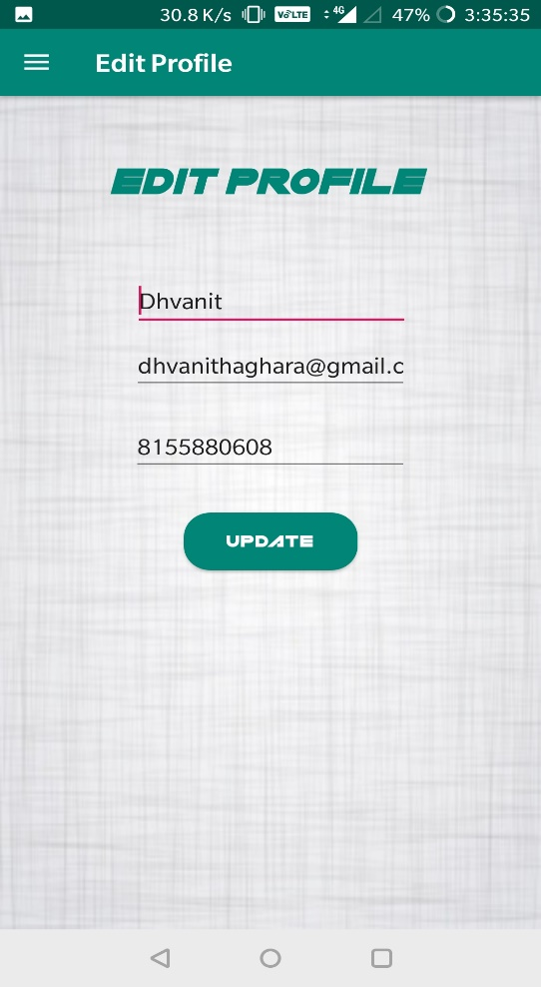 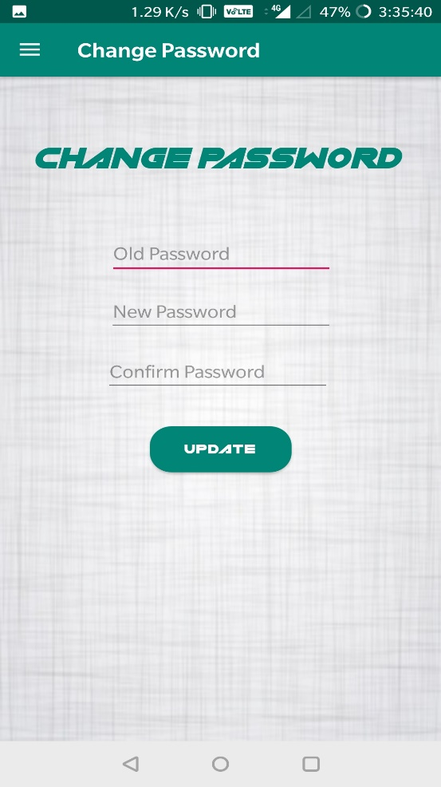

5.3.16) Edit Profile 5.3.17) Change Password

**Chapter 6**

**CONSTRAINTS AND FUTURE ENHANCEMENT**

**Constraints:**

* Both these apps work perfectly in android device only. These apps won’t work in iOS base device.
* Student will not be informed via any notification if he/she misses the due date.

**Future enhancement:**

* Can work more to improve the look and feel for both the apps
* Can add a feature wherein student will be informed if due date is gone.
* Can also add a search bar to search a specific book which will be more efficient.
* Add functionality according to the library requirements.

**Chapter 7**

**CONCLUSION**

Working on this project has helped us to understand various concepts regarding java and we have been quite familiar with Android Studio. This project was made successfully just to improvise the library management system.

It was essential for project to understand the requirements in terms of functional requirements, non-functional requirements, platforms, technicality, timelines, information availability. The project was completed within the given time period.

No major problems were encountered and no major risk was involved during development of the project. All the system error has been removed successfully. The program runs successfully.

**References:**

<https://stackoverflow.com/>

<https://developer.android.com/>

<https://material.io/design/>

<https://www.tutorialspoint.com/android/>